Supplementary material

“Restoring Shank3ab in a rostral sensorimotor brainstem nucleus rescues reduced light-evoked behaviors in shank3ab-/- zebrafish.”

Supplementary Figure S1. shank3abΔN and shank3abΔC mutations and restriction digest assays used for genotyping.
Supplementary Figure S2. Zebrafish Shank3 is expressed in the cerebellum and medulla oblongata of 6 dpf wildtype larvae.
Supplementary Figure S3. shank3abΔN and shank3abΔC models exhibit little lights-off activity across the brain in comparison to broad increases in wildtype.
Supplementary Figure S4. shank3abΔN-/- larvae with wildtype-zebrabow-derived hindbrain neurons (ΔN-/-:Zb-T) exhibit increased lights-off activity.
Supplementary Figure S5. Wildtype derived hindbrains rescue hyporeactive VMR behavior in shank3ΔN-/- larvae.
Supplementary Figure S6. VMR behavior is largely unchanged when hindbrain transplants are made between embryos of the same genotype.
Supplementary Table 1. Oligonucleotides used to generate shank3abaΔN single stranded guide RNAs.
Supplementary Table 2. Primers used to genotype CRISPR-Cas9 generated shank3abaΔN mutations.
Supplementary Table 3. shank3abΔN grouped analysis of 30 second transition from lights-on to lights-off.
Supplementary Table 4. shank3abΔN Kruskal-Wallis ANOVA test for first 30 seconds following lights-off.
Supplementary Table 5. shank3abΔN Dunn’s multiple comparisons test for first 30 seconds following lights-off.
Supplementary Table 6. shank3abΔC grouped analysis of 30 second transition from lights-on to lights-off
Supplementary Table 7. shank3abΔC Kruskal-Wallis ANOVA test for first 30 seconds following lights-off.
Supplementary Table 8. shank3abΔC Dunn’s multiple comparisons test for first 30 seconds following lights-off.
Supplementary Table 9. shank3abΔN-/-:Zb-T grouped analysis of 30 second transition from lights-on to lights-off.
Supplementary Table 10. shank3abΔN-/-:Zb-T larvae Kruskal-Wallis ANOVA test for first 30 seconds following lights-off.
Supplementary Table 11. shank3abΔN:Zb-T Dunn’s comparisons test for first 30 seconds following lights-off.
Supplementary Table 12. shank3abΔN-/-:Zb-T grouped analysis of 30 second transition from lights-on to lights-off.
Supplementary Table 13. shank3abΔC-/-:Zb-T larvae Kruskal-Wallis ANOVA test for first 30 seconds following lights-off.
Supplementary Table 14. shank3abΔC-/-:Zb-T Dunn’s multiple comparisons test for the first 30 seconds following lights-off.
Supplementary Table 15. shank3abΔN-/-:ΔWT-T Kruskal-Wallis ANOVA test for the first 30 seconds following lights-off.
Supplementary Table 16. shank3abΔN-/-:ΔWT-T Dunn’s multiple comparison test for the first 30 seconds following lights-off.
Supplementary Table 17. Regions of interest with zebrabow positive neurons in the majority of shank3abΔ:ZbT larvae.
Supplementary Table 18. WT:WT-T Mann-Whitney U test for the first 30 seconds following lights-off.
Supplementary Table 19. WT:WT-T Mann-Whitney U test for 5 minutes following lights-off.
Supplementary Table 20. shank3abΔN-/-:ΔN-/-T Kruskal-Wallis ANOVA test for the first 30 seconds following lights-off.
Supplementary Table 21. shank3abΔN-/-:ΔN-/-T Dunn’s multiple comparisons test for the first 30 seconds following lights-off.
Supplementary Table 22. shank3abΔC-/-:ΔC-/-T Kruskal-Wallis ANOVA test for the first 30 seconds following lights-off.
Supplementary Table 23. shank3abΔC-/-:ΔC-/-T Dunn’s multiple comparisons test for the first 30 seconds following lights-off.

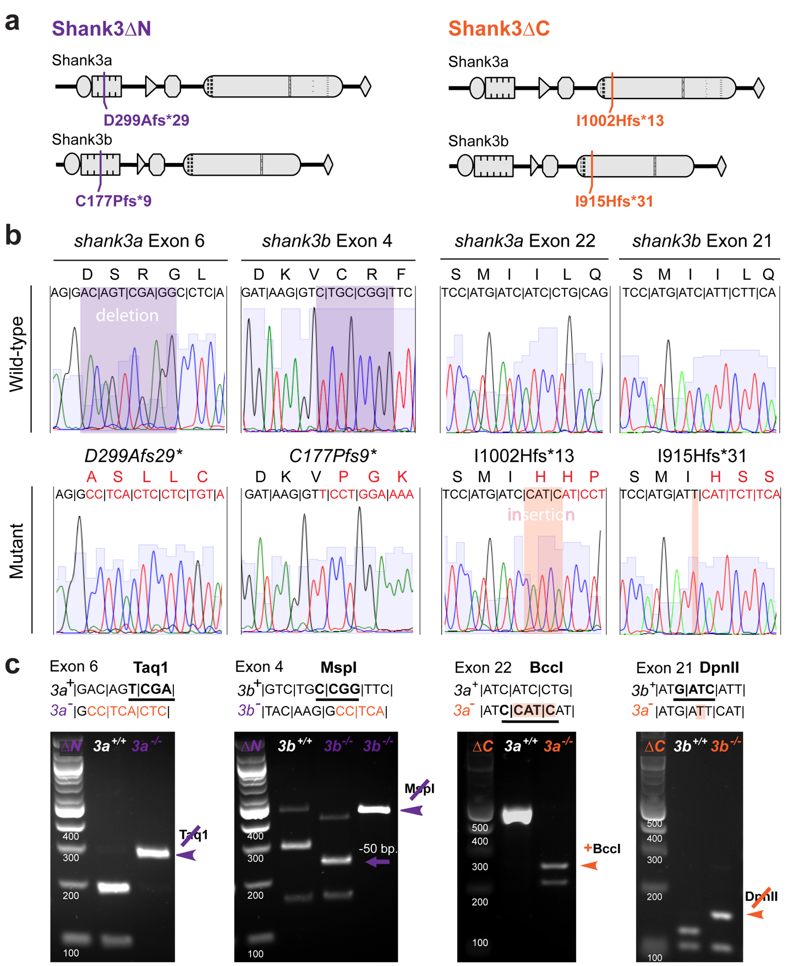
Supplementary Figure S1. shank3abΔN and shank3abΔC mutations and restriction digest assays used for genotyping. (a) Shank3a and Shank3b protein diagrams show where predicted protein truncations would occur in shank3abΔN (purple) and shank3abΔC (orange) mutants. Abbreviations describe the amino acid changes downstream of a frame-shift mutation (e.g. D299Afs*29; Aspartic Acid at position 299 changes to an Arginine with 29 novel amino acids, terminating in a premature stop codon). (b) Raw sequence traces illustrating the insertion and deletion mutations (shaded regions) for both mutant models. Mutant traces show the predicted changes in amino acids (red) downstream of mutagenic indels. (c) Mutations were chosen that either created (BccI) or eliminated (Taqa1, MspI and DpnII) restriction digest sites. Larvae were genotyped following behavioral experiments using these digestion assays.

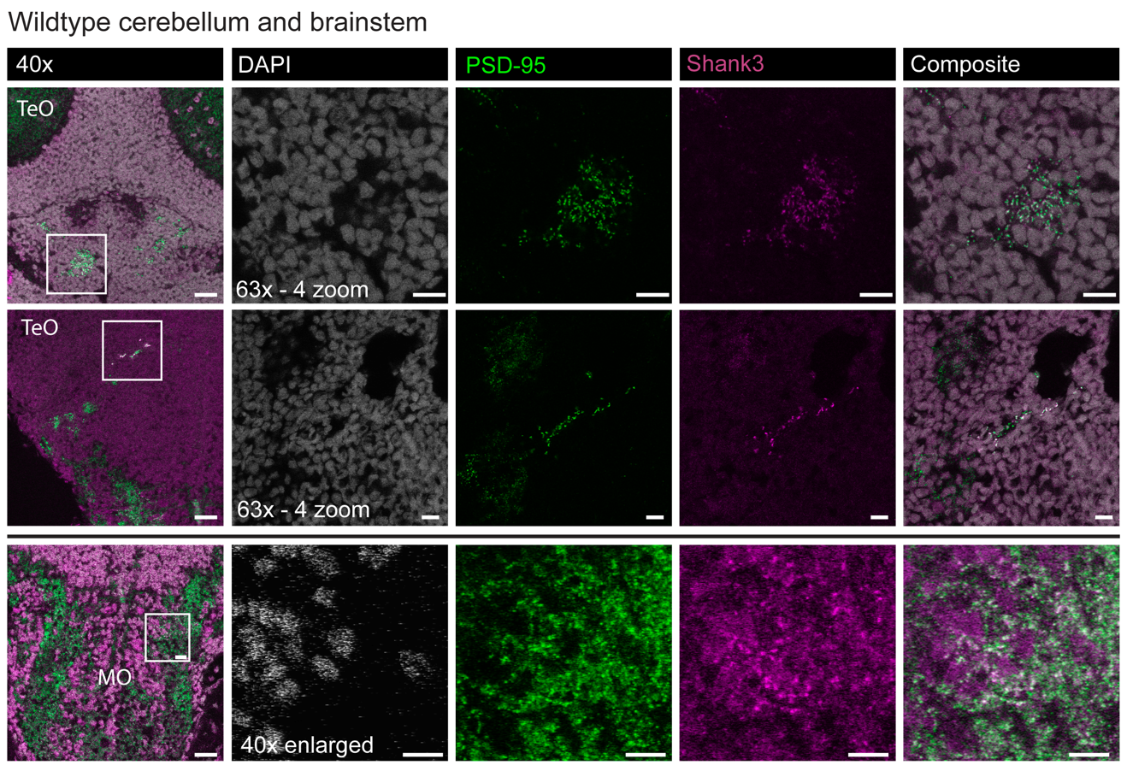

Supplementary Figure S2. Zebrafish Shank3 expression in the cerebellum and medulla oblongata of 6 dpf wildtype larvae. Horizontal sections of the optic tectum (TeO), cerebellum (Ce) and medulla obongata (MO). Shank3 and PSD-95 puncta colocalize in the dorsal (top row) and ventral (middle row) cerebellum, along with neuropil regions of the medulla oblongata (bottom row). The cerebellar sections (top and middle row) represent 40x and 63X (insets) objective magnification. 40x objective images in the bottom row inset were enlarged to show Shank3 and PSD-95 colocalization. Shank3 channel levels were increased to accentuate Shank3 puncta, causing increased background noise across the image (magenta). 40x scale bar = 20 μm, 63X and 40x zoom scale bars = 10 μm.

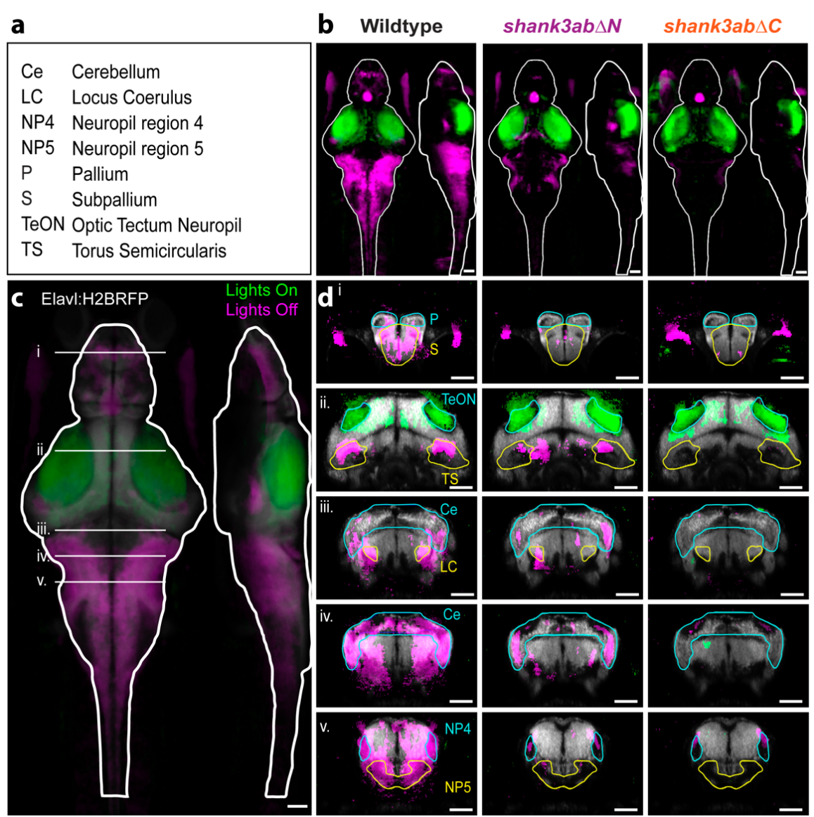
Supplementary Figure S3. shank3abΔN-/- and shank3abΔC-/- models exhibit little lights-off activity across the brain in comparison to broad increases in wildtype. Optical sections with outlined regions of interest (ROI), highlighting brain areas with different patterns of pERK staining in WT and shank3abΔN-/- and shank3abΔC-/- mutant models. (a) ROI key for brain region abbreviations in cyan and yellow. (b) Projections, horizontal (left) and sagittal (right), are colored for statistically significant differences in pERK staining, green (lights-on) and magenta (lights-off). Significant median stacks were generated using the MakeTheMAPmap.m matlab script (Engert Lab, Randlett et al. 2015). (c) Horizontal and sagittal wildtype projection key illustrating the location of each transverse optical section across the entire brain (i.-v.). To visualize ROIs exhibiting significant changes in neuronal activity, significant delta median stacks were uploaded to the Z-brain atlas (Engert Lab, Harvard), and overlaid with the Elavl3-H2BRFP reference brain (grey) (d) Coronal optical sections comparing ROI’s across wildtype and shank3abΔ-/- mutant models. In comparison to wildtype lights-off significance, shank3abΔ-/- mutant models exhibit less significant differences across ROI’s in the forebrain (i.), midbrain (ii.) and hindbrain (iii.,iv.,v.). Stacks and slices were exported at varying aspect ratios (b) 300x679, (c) 621x1406 and (d) 621x350 pixels. All scale bars = 50 μm.

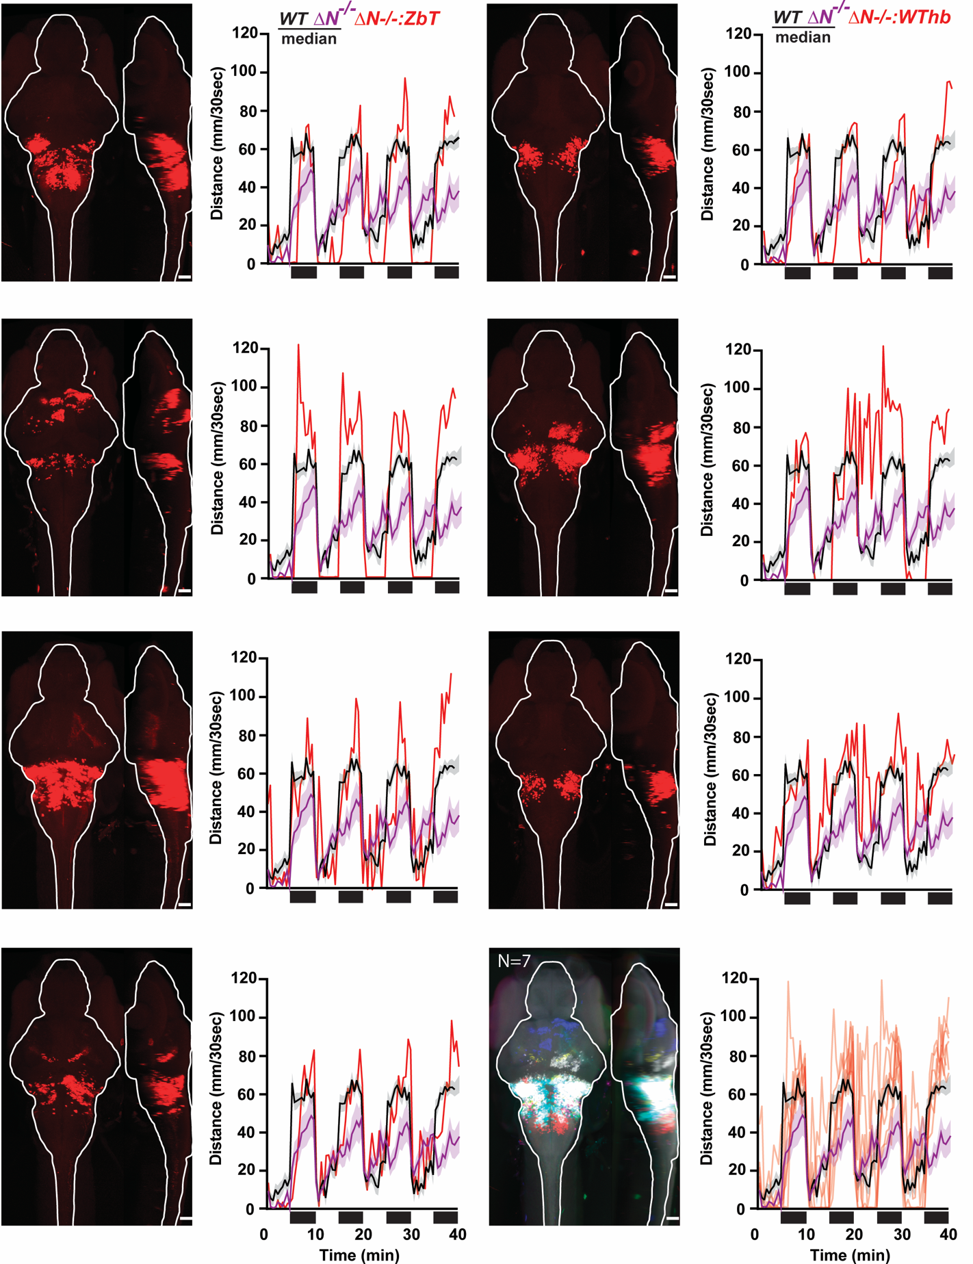
Supplementary Figure S4. Confocal projections show 6 dpf shank3abΔN-/- larvae with transplanted wildtype-zebrabow-derived hindbrain neurons (shank3abΔN-/-:Zb-T). shank3abΔN-/-:Zb-T VMR behaviors are graphed as median values for shank3abΔN-/-:Zb-T individuals (red), and median + SEM (shading) for shank3abΔN (purple; N=27) and wildtype (black, N=28). Scale bar = 50 μm

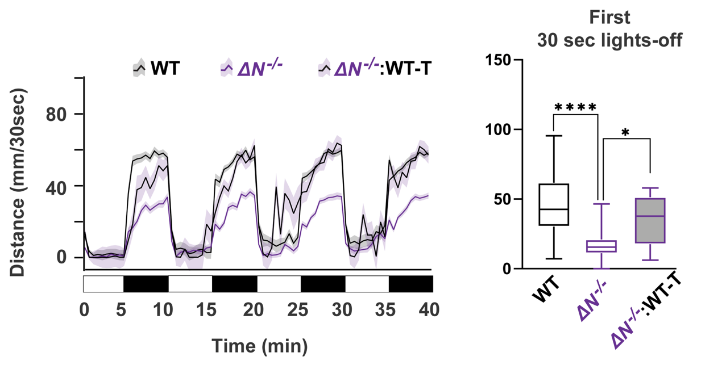Supplementary Figure S5. Wildtype derived hindbrains rescue hyporeactive VMR behavior in shank3abΔN-/- larvae. shank3abΔN-/- hindbrain transplants were initially performed with AB/TL wildtype (shank3abΔN-/-:WT-T), rather than zebrabow, donor embryos. shank3abΔN-/-:WT-T chimeric larvae showed an increase in lights-off swimming distances for the first 30 seconds following lights-off. Sample sizes for shank3abΔN-/-:WT-T; WT = 36, shank3abΔN-/- = 36, shank3abΔN-/-:WT-T = 12. Larval median values were calculated from the first 30 seconds following lights-off (four cycles). The line graph displays median + SEM (shading) swimming distances. Boxes denote median, first quartile and third quartile, while whiskers represent min and max. Swimming distances were statistically compared using a Kruskal-Wallis one-way ANOVA, followed by a Dunn’s corrected multiple values comparison. Significance values; *p<0.05, **p<0.01, ** p<0.001, ****p>0.0001.

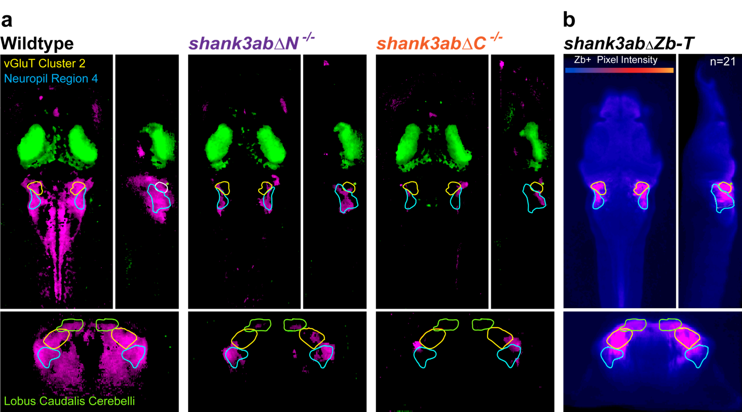

Supplementary Figure S6. Wildtype derived neurons show common integration into glutamatergic neurons of the rostral brain stem. (a) Whole brain optical slices of MAP-Mapping significant delta medians. Wildtype exhibit significant lights-off pERK intensity in vGlut cluster 2 (yellow) and Neuroil Region 4 (cyan) of the rostral brainstem. shank3abΔN-/- and shank3abΔC-/- show little to moderate significant pERK intensity in vGluT cluster 2 and Neuropil Region 4. (b) Heat map colored median stack of shank3abΔZb-T larvae. A majority of shank3abΔZb-T chimeras exhibit donor positive neurons in vGluT cluster 2 and Neuropil region 4. Sample sizes (n=lights-on/lights-off). Wildtype (n=16/19), shank3abΔN (n=19/21) and shank3abΔC (n=16/15). Sample size shank3abΔZb-T (n=21). Scale bars = 50 µm

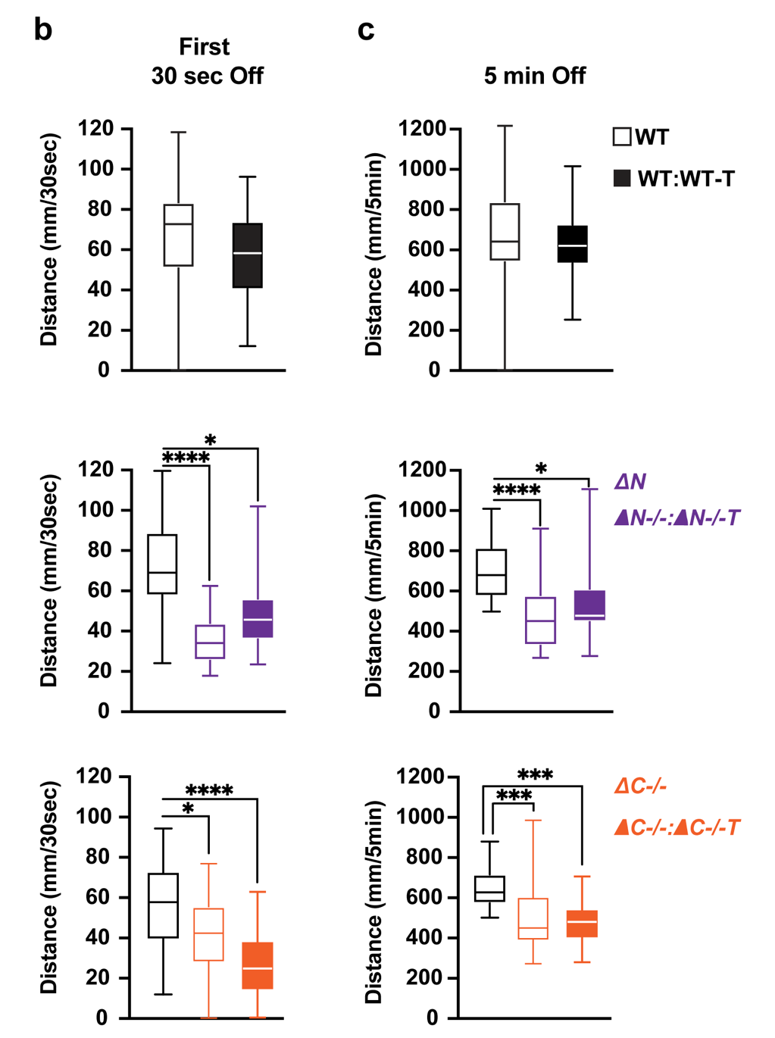

Supplementary Figure S7. VMR behavior is largely unchanged when hindbrain transplants are made between embryos of the same genotype. (a&b) Larval swimming distances during the first 30 seconds following lights-off (a) and 5 minutes lights-off (b). Behavior was unchanged in WT:WT-T and shank3abΔN-/-:ΔN-/-T larvae, while shank3abΔC-/-:ΔC-/-T larvae had a more severe hyporeactivity. Boxes represent the first quartile, median and third quartile, while the whiskers represent minimum and maximum values. Median values for the four light cycles were calculated for each individual, and used to calculate group statistics. Sample sizes for WT-T; WT = 40, WT:WT-T = 29. Sample sizes for shank3abΔN-/-:ΔN-/-T; WT = 22, shank3abΔN-/- = 26, shank3abΔN-/-:ΔN-/--T = 14. Sample sizes for shank3abΔC-/-:ΔC-/-T; WT = 29, shank3abΔC-/- = 30, shank3abΔC-/-:ΔC-/-T = 23.Groups were compared using a Kruskal-Wallis analysis of variance, followed by Mann Whitney U individual group comparisons; *p<0.05, **p<0.01, ***p<0.001.

Supplemental Tables.
Supplementary Table 1. Oligonucleotides used to generate shank3abaΔN single stranded guide RNAs.
Name | Sequence
shank3a exon 6 | TAATACGACTCACTATAGGGATCAAAGTTTCTGGAGAAGTTTTAGAGCTAGAAATAGC
shank3b exon 4 | TAATACGACTCACTATAGGGTGTGTGGATAAGGTCTGCGTTTTAGAGCTAGAAATAGC
Universal tracRNA backbone | AAAAGCACCGACTCGGTGCCACTTTTTCAAGTTGATAACGGACTAGCCTTATTTTAACTTGCTATTTCTAGCTCTAAAAC

Supplementary Table 2. Primers used to genotype CRISPR-Cas9 generated shank3abaΔN mutations.
Primer | Sequence
shank3a exon 6 forward | GCTTGGGAAAACTCGTCTGT
shank3a exon 6 reverse | GGGTCATGGCACCAATTTAC
shank3b exon 4 forward | GCATTCATCTTTTCCCCTTC
shank3b exon 4 reverse | TCAACACAGGTCCCAAAATG

Supplementary Table 3. shank3abΔN grouped analysis of 30 second transition from lights-on to lights-off.
Genotype | Sign.? | P value | Mean of On | Mean of Off | Diff. | SE of Diff. | t ratio | df | Adjusted P Value
WT | Yes | <0.000001 | 30.16 | 61.05 | -30.88 | 4.198 | 7.356 | 331 | <0.000001
shank3abΔN-/+ | Yes | 0.001484 | 25.4 | 42.53 | -17.12 | 5.343 | 3.205 | 331 | 0.004452
shank3abΔN-/- | No | 0.071854 | 11.08 | 18.43 | -7.351 | 4.071 | 1.806 | 331 | 0.215562

Supplementary Table 4. shank3abΔN-/- Kruskal-Wallis ANOVA test for first 30 seconds following lights-off.
Kruskal-Wallis ANOVA test | shank3abΔC first 30 seconds following lights-off
Kruskal-Wallis test
P value | <0.0001
Exact or approximate P value? | Approximate
P value summary | ****
Do the medians vary signif. (P < 0.05)? | Yes
Number of groups | 3
Kruskal-Wallis statistic | 76.77
Data summary
Number of treatments (columns) | 3
Number of values (total) | 157

Supplementary Table 5. shank3abΔN-/- Dunn’s multiple comparisons test for first 30 seconds following lights-off.
Number of families | 1
Number of comparisons per family | 3
Alpha | 0.05
Dunn's multiple comparisons test | Mean rank diff. | Significant? | Summary | Adjusted P Value
WT vs. shank3abΔN-/+ | 17.21 | No | ns | 0.2559 | A-B
WT vs. shank3abΔN-/- | 69.17 | Yes | **** | <0.0001 | A-C
shank3abΔN-/+ vs. shank3abΔN-/- | 51.97 | Yes | **** | <0.0001 | B-C
Test details | Mean rank 1 | Mean rank 2 | Mean rank diff. | n1 | n2 | Z
WT vs. shank3abΔN-/+ | 110.6 | 93.39 | 17.21 | 62 | 31 | 1.721
WT vs. shank3abΔN-/- | 110.6 | 41.42 | 69.17 | 62 | 64 | 8.538
shank3abΔN-/+ vs. shank3abΔN-/- | 93.39 | 41.42 | 51.97 | 31 | 64 | 5.223

Supplementary Table 6. shank3abΔC-/- grouped analysis of 30 second transition from lights-on to lights-off.
Genotype | Sign.? | P value | Mean of On | Mean of Off | Diff. | SE of Diff. | t ratio | df | Adjusted P Value
WT | Yes | <0.000001 | 50.18 | 78.83 | -28.65 | 4.148 | 6.907 | 339 | <0.000001
shank3abΔC-/+ | Yes | <0.000001 | 41.75 | 63.94 | -22.19 | 3.468 | 6.396 | 339 | <0.000001
shank3abΔC-/- | Yes | <0.000001 | 25.18 | 50.79 | -25.61 | 4.654 | 5.503 | 339 | <0.000001

Supplementary Table 7. shank3abΔC-/- Kruskal-Wallis ANOVA test for first 30 seconds following lights-off.
Kruskal-Wallis ANOVA test | shank3abΔC first 30 seconds following lights-off
Kruskal-Wallis test
P value | <0.0001
Exact or approximate P value? | Approximate
P value summary | ****
Do the medians vary signif. (P < 0.05)? | Yes
Number of groups | 3
Kruskal-Wallis statistic | 24.71
Data summary
Number of treatments (columns) | 3
Number of values (total) | 174

Supplementary Table 8. shank3abΔC-/- Dunn’s multiple comparisons test for first 30 seconds following lights-off.
Number of families | 1
Number of comparisons per family | 3
Alpha | 0.05
Dunn's multiple comparisons test | Mean rank diff. | Significant? | Summary | Adjusted P Value
WT vs. shank3abΔC-/+ | 26.56 | Yes | ** | 0.0089 | A-B
WT vs. shank3abΔC-/- | 50.9 | Yes | **** | <0.0001 | A-C
shank3abΔC-/+ vs. shank3abΔC-/- | 24.34 | Yes | * | 0.0334 | B-C
Test details | Mean rank 1 | Mean rank 2 | Mean rank diff. | n1 | n2 | Z
WT vs. shank3abΔC-/+ | 111.8 | 85.27 | 26.56 | 54 | 77 | 2.971
WT vs. shank3abΔC-/- | 111.8 | 60.93 | 50.9 | 54 | 43 | 4.944
shank3abΔC-/+ vs. shank3abΔC-/- | 85.27 | 60.93 | 24.34 | 77 | 43 | 2.538

Supplementary Table 9. shank3abΔN-/-:Zb-T grouped analysis of 30 second transition from lights-on to lights-off.
Genotype | Sign.? | P value | Mean of On | Mean of Off | Diff. | SE of Diff. | t ratio | df | Adjusted P Value
WT | Yes | <0.000001 | 27.25 | 55.77 | -28.52 | 4.842 | 5.89 | 178 | <0.000001
Zebrabow | Yes | <0.000001 | 5.918 | 57.5 | -51.58 | 7.862 | 6.56 | 178 | <0.000001
shank3abΔN-/- | No | 0.369348 | 23.74 | 28.18 | -4.435 | 4.928 | 0.9 | 178 | >0.999999
shank3abΔN-/-:Zb-T | Yes | 0.001724 | 27.29 | 43.89 | -16.6 | 5.215 | 3.182 | 178 | 0.006897

Supplementary Table 10. Kruskal-Wallis ANOVA test for transplant shank3abΔN-/-:Zb-T larvae first 30 seconds following lights-off.
Table Analyzed | shank3abΔN:ZbT first 30 seconds following lights-off
Kruskal-Wallis test
P value | <0.0001
Exact or approximate P value? | Approximate
P value summary | ****
Do the medians vary signif. (P < 0.05)? | Yes
Number of groups | 4
Kruskal-Wallis statistic | 29.86
Data summary
Number of treatments (columns) | 4
Number of values (total) | 93

Supplementary Table 11. shank3abΔN-/-:Zb-T Dunn’s comparisons test for first 30 seconds following lights-off.
Number of families | 1
Number of comparisons per family | 6
Alpha | 0.05
Dunn's multiple comparisons test | Mean rank diff. | Significant? | Summary | Adjusted P Value
WT vs. zebrabow | -2.618 | No | ns | >0.9999 | A-B
WT vs. shank3abΔN-/- | 35.51 | Yes | **** | <0.0001 | A-C
WT vs. shank3abΔN-/-:Zb-T | 12.18 | No | ns | 0.5902 | A-D
zebrabow vs. shank3abΔN-/- | 38.13 | Yes | *** | 0.0004 | B-C
zebrabow vs. shank3abΔN-/-:Zb-T | 14.79 | No | ns | 0.779 | B-D
shank3abΔN-/- vs. shank3abΔN-/-:Zb-T | -23.34 | Yes | * | 0.0101 | C-D
Test details | Mean rank 1 | Mean rank 2 | Mean rank diff. | n1 | n2 | Z
WT vs. zebrabow | 60.66 | 63.27 | -2.618 | 29 | 11 | 0.2739
WT vs. shank3abΔN-/- | 60.66 | 25.14 | 35.51 | 29 | 28 | 4.966
WT vs. shank3abΔN-/-:Zb-T | 60.66 | 48.48 | 12.18 | 29 | 25 | 1.653
zebrabow vs. shank3abΔN-/- | 63.27 | 25.14 | 38.13 | 11 | 28 | 3.97
zebrabow vs. shank3abΔN-/-:Zb-T | 63.27 | 48.48 | 14.79 | 11 | 25 | 1.515
shank3abΔN-/- vs. shank3abΔN-/-:Zb-T | 25.14 | 48.48 | -23.34 | 28 | 25 | 3.142

Supplementary Table 12. shank3abΔN-/-:Zb-T grouped analysis of 30 second transition from lights-on to lights-off.
Genotype | Sign.? | P value | Mean of On | Mean of Off | Diff. | SE of Diff. | t ratio | df | Adjusted P Value
WT | Yes | 0.000001 | 19.83 | 56.17 | -36.34 | 7.147 | 5.084 | 118 | 0.000006
Zebrabow | Yes | <0.000001 | 15.43 | 52.04 | -36.62 | 6.92 | 5.291 | 118 | 0.000002
shank3abΔC-/- | No | 0.015268 | 17.57 | 34.61 | -17.04 | 6.92 | 2.462 | 118 | 0.061072
shank3abΔC-/-:Zb-T | Yes | <0.000001 | 20.22 | 59.09 | -38.86 | 6.92 | 5.616 | 118 | <0.000001

Supplementary Table 13. shank3abΔC-/-:Zb-T larvae Kruskal-Wallis ANOVA test for first 30 seconds following lights-off.
Table Analyzed | shank3abΔN:Zb-T 30 seconds Off
Kruskal-Wallis test
P value | 0.003
Exact or approximate P value? | Approximate
P value summary | **
Do the medians vary signif. (P < 0.05)? | Yes
Number of groups | 4
Kruskal-Wallis statistic | 13.78
Data summary
Number of treatments (columns) | 4
Number of values (total) | 63

Supplementary Table 14. shank3abΔC-/-:Zb-T Dunn’s multiple comparisons test for the first 30 seconds following lights-off.
Number of families | 1
Number of comparisons per family | 6
Alpha | 0.05
Dunn's multiple comparisons test | Mean rank diff. | Significant? | Summary | Adjusted P Value
WT vs. zebrabow | 0.7833 | No | ns | >0.99 | A-B
WT vs. shank3abΔC-/- | 17.78 | Yes | * | 0.04 | A-C
WT vs. shank3abΔC-/-:Zb-T | -4.654 | No | ns | >0.99 | A-D
zebrabow vs. shank3abΔC-/- | 17 | No | ns | 0.05 | B-C
zebrabow vs. shank3abΔC-/-:Zb-T | -5.438 | No | ns | >0.99 | B-D
shank3abΔC-/- vs. shank3abΔC-/-:Zb-T | -22.44 | Yes | ** | 0.003 | C-D
Test details | Mean rank 1 | Mean rank 2 | Mean rank diff. | n1 | n2 | Z
WT vs. zebrabow | 35.53 | 34.75 | 0.7833 | 15 | 16 | 0.1189
WT vs. shank3abΔC-/- | 35.53 | 17.75 | 17.78 | 15 | 16 | 2.699
WT vs. shank3abΔC-/-:Zb-T | 35.53 | 40.19 | -4.654 | 15 | 16 | 0.7065
zebrabow vs. shank3abΔC-/- | 34.75 | 17.75 | 17 | 16 | 16 | 2.623
zebrabow vs. shank3abΔC-/-:Zb-T | 34.75 | 40.19 | -5.438 | 16 | 16 | 0.839
shank3abΔN-/- vs. shank3abΔC-/-:Zb-T | 17.75 | 40.19 | -22.44 | 16 | 16 | 3.462

Supplementary Table 15. shank3abΔN:ΔWT-T Kruskal-Wallis ANOVA test for the first 30 seconds following lights-off.

Table Analyzed | Kruskal-Wallis 30 sec lights-off
Kruskal-Wallis test
P value | <0.0001
Exact or approximate P value? | Approximate
P value summary | ****
Do the medians vary signif. (P < 0.05)? | Yes
Number of groups | 3
Kruskal-Wallis statistic | 38.99
Data summary
Number of treatments (columns) | 3
Number of values (total) | 84

Supplementary Table 16. shank3abΔN:ΔWT-T Dunn’s multiple comparison test for the first 30 seconds following lights-off.

Number of families | 1
Number of comparisons per family | 3
Alpha | 0.05
Dunn's multiple comparisons test | Mean rank diff. | Significant? | Summary | Adjusted P Value
WT vs. shank3abN-/- | 35.61 | Yes | **** | <0.0001 |  | A-B
WT vs. shank3abN-/--WT | 11.78 | No | ns | 0.4424 |  | A-C
shank3abN-/- vs. shank3abN-/--WT | -23.83 | Yes | * | 0.0101 |  | B-C
Test details | Mean rank 1 | Mean rank 2 | Mean rank diff. | n1 | n2 | Z
WT vs. shank3abN-/- | 59.44 | 23.83 | 35.61 | 36 | 36 | 6.194
WT vs. shank3abN-/--WT | 59.44 | 47.67 | 11.78 | 36 | 12 | 1.449
shank3abN-/- vs. shank3abN-/--WT | 23.83 | 47.67 | -23.83 | 36 | 12 | 2.931

Supplementary Table 17. Regions of interest with zebrabow positive neurons in the majority of shank3abΔ:ZbT larvae.
Regions of Interest | Percent Positive (n=21)
vGluT cluster 2 | 0.904761905
ptf1a cluster 1 | 0.857142857
s1181t cluster | 0.761904762
cere gad1b enriched area | 0.666666667
gad1b cluster 4 | 0.666666667
GlyT cluster 1 | 0.666666667
hcrt stripe 4 | 0.666666667
vGlut stripe 1 | 0.619047619
anterior cluster of nV trigeminal | 0.619047619
GlyT cluster 13 | 0.619047619
cere olig2 enriched | 0.571428571
hcrt cluster 1 | 0.571428571

Supplementary Table 18. WT:WT-T Mann-Whitney U test for the first 30 seconds following lights-off.
Table Analyzed | 30secOff
Column B | WT-WT
vs. | vs.
Column A | WT
Mann Whitney test
P value | 0.0877
Exact or approximate P value? | Exact
P value summary | ns
Significantly different (P < 0.05)? | No
One- or two-tailed P value? | Two-tailed
Sum of ranks in column A,B | 1541 , 874
Mann-Whitney U | 439
Difference between medians
Median of column A | 72.46, n=40
Median of column B | 58.09, n=29
Difference: Actual | -14.37
Difference: Hodges-Lehmann | -10.58

Supplementary Table 19. WT:WT-T Mann-Whitney U test for 5 minutes following lights-off.
Table Analyzed | 5minOff
Column B | WT-WT
vs. | vs.
Column A | WT
Mann Whitney test
P value | 0.5258
Exact or approximate P value? | Exact
P value summary | ns
Significantly different (P < 0.05)? | No
One- or two-tailed P value? | Two-tailed
Sum of ranks in column A,B | 1453 , 962
Mann-Whitney U | 527
Difference between medians
Median of column A | 632.4, n=40
Median of column B | 611.0, n=29
Difference: Actual | -21.4
Difference: Hodges-Lehmann | -25.5

Supplementary Table 20. shank3abΔN-/-:ΔN-/-T Kruskal-Wallis ANOVA test for the first 30 seconds following lights-off.

Table Analyzed | 30secOff
Kruskal-Wallis test
P value | <0.0001
Exact or approximate P value? | Approximate
P value summary | ****
Do the medians vary signif. (P < 0.05)? | Yes
Number of groups | 3
Kruskal-Wallis statistic | 40.4
Data summary
Number of treatments (columns) | 3
Number of values (total) | 62

Supplementary Table 21. shank3abΔN-/-:ΔN-/-T Dunn’s multiple comparisons test for the first 30 seconds following lights-off.
Compare each cell mean with the other cell mean in that row.
Number of families | 1
Number of comparisons per family | 3
Alpha | 0.05
Dunn's multiple comparisons test | Mean rank diff. | Significant? | Summary | Adjusted P Value
WT vs. shank3abΔN | 32.71 | Yes | **** | <0.0001 |  | A-B
WT vs. shank3abΔN:ΔN-/-T | 23.81 | Yes | *** | 0.0003 |  | A-C
shank3abΔN vs. shank3abΔN:ΔN-/-T | -8.901 | No | ns | 0.41 |  | B-C
Test details | Mean rank 1 | Mean rank 2 | Mean rank diff. | n1 | n2 | Z
WT vs. shank3abΔN | 50.59 | 17.88 | 32.71 | 22 | 26 | 6.258
WT vs. shank3abΔN:ΔN-/-T | 50.59 | 26.79 | 23.81 | 22 | 14 | 3.859
shank3abΔN vs. shank3abΔN:ΔN-/-T | 17.88 | 26.79 | -8.901 | 26 | 14 | 1.488

Supplementary Table 22. shank3abΔC-/-:ΔC-/-T Kruskal-Wallis ANOVA test for the first 30 seconds following lights-off.
Table Analyzed | Genotype versus Treatment
Kruskal-Wallis test
P value | <0.0001
Exact or approximate P value? | Approximate
P value summary | ****
Do the medians vary signif. (P < 0.05)? | Yes
Number of groups | 3
Kruskal-Wallis statistic | 26.02
Data summary
Number of treatments (columns) | 3
Number of values (total) | 82

Supplementary Table 23. shank3abΔC-/-:ΔC-/-T Dunn’s multiple comparisons test for the first 30 seconds following lights-off.
Compare each cell mean with the other cell mean in that row.
Number of families | 1
Number of comparisons per family | 3
Alpha | 0.05
Dunn's multiple comparisons test | Mean rank diff. | Significant? | Summary | Adjusted P Value
WT vs. shank3abΔC | 17.61 | Yes | * | 0.0135 |  | A-B
WT vs. shank3abΔC-/-:ΔC-/-T | 33.76 | Yes | **** | <0.0001 |  | A-C
shank3abΔC vs. shank3abΔC-/-:ΔC-/-T | 16.15 | Yes | * | 0.0433 |  | B-C
Test details | Mean rank 1 | Mean rank 2 | Mean rank diff. | n1 | n2 | Z
WT vs. shank3abΔC | 57.41 | 39.8 | 17.61 | 29 | 30 | 2.84
WT vs. shank3abΔC-/-:ΔC-/-T | 57.41 | 23.65 | 33.76 | 29 | 23 | 5.077
shank3abΔC vs. shank3abΔC-/-:ΔC-/-T | 39.8 | 23.65 | 16.15 | 30 | 23 | 2.447

Materials and Methods

Fish maintenance and husbandry
Zebrafish were housed in the University of Miami zebrafish core facility. Both adult and larval zebrafish were maintained at 28°C in system-water and exposed to a 14:10 hour circadian light:dark cycle. Zebrafish were cared for in accordance with NIH guidelines and all experiments were approved by the University of Miami Institutional Care and Use Committee protocol #’s 15-128 and 18-128.

shank3abΔN CRISPR-Cas9 mutant generation
Zebrafish used for this study include AB-TL wildtype, shank3abΔN and shank3abΔC ¹³. Previously published CRISPR-Cas9 mutagenesis methods ¹³ were used to target the N-terminal ankyrin rich domain shank3aba and shank3abb (referred to as shank3abΔN).

Visual Motor Behavior Assay (VMR)
VMR experiments were performed using a DanioVision system^{tm} (Noldus, Wageningen, NTD) with a DanioVision observation chamber (DVOC-0040). Videos were collected at 25 fps with 1280 x 960 resolution using a Basler acA1300-60gm camera fitted with a 12 mm Megapixel lens. All DanioVision experiments were run using an ANSI SBS compatible 96 well microtiter plate. Data was collected and analyzed using the DanioVision EthoVision XT software version 11.5 (Noldus). White light for the visual motor response assay was set at 12% intensity on the high power setting. Fish were acclimated to the observation chamber at 28 °C in the dark for at least 1 hr. VMR experiments were run using white light cycles on-off 4 times for 5 min intervals. All behavioral experiments were recorded between 11am and 3pm, with 2-5 independent trials per condition. Larvae were genotyped following behavioral experiments using a restriction digest assay described in Supplementary Fig. 1.

Statistics
Data was analyzed using PRISM Version 8.1.2 (GraphPad Software Inc.) with Noldus generated raw data. Behavior was statistically assessed using t-tests (Dunn and Bonferroni alpha corrected) and non-parametric Wilcoxon rank score test (Mann-Whitney rank scores). When there were more than two groups, a Kruskal-Wallis ANOVA test was first calculated to determine statistical significance, and when significant, followed by a Dunn’s multiple comparisons test.

Immunohistochemistry
Larvae were flash frozen, sectioned and stained following previously published methods ²⁴. Anti-PSD-95 (1:500; Abcam; Cambridge, UK; ab-18258) and anti-shank3ab (1:200; sc-30193, Santa Cruz Biotechnology, CA) were used as primary antibodies, with secondary antibodies conjugated to Alexa Fluor 568 (Abcam, ab175472) and Alexa Fluor 633 (Thermo Fisher Scientific, R21070), respectively. Images were collected using a Leica Sp6 confocal microscope, with 40x and 63X oil immersion lenses.

Brain-wide phospho-ERK MAP-mapping
Zebrafish were processed using a previously published protocol for comparing ERK phosphorylation or mitogen-activated protein kinase (MAP)-mapping ¹². Chemical fixation was performed using 6 well-plate baskets to quickly transfer larvae into 4% formaldehyde in 1% PBSTx (0.25%). Larvae were digested with room temperature 0.25% Trypsin, incubated on ice for 45 min. Primary total ERK (tERK; 1:500) and phosphorylated-ERK (pERK; 1:500) antibodies were incubated for three days at 4 °C. Z-stacks of zebrafish brains were collected on a SP5 confocal microscope (Leica; Wetzlar, DE) using a dry 20x objective, with a voxel resolution of 1.5 x 1.5 x 1.98 μm. Anterior and posterior brain stacks were stitched using the Fiji pairwise stitching application ²⁵. Zebrafish stacks were then registered to a reference brain using CMTK ²⁶ on the University of Miami’s super computer, Pegasus . Prior to MAP-mapping, zebrafish stacks were inspected for artifacts associated with brain registration and distorted or poorly warped stacks were discarded. MAP-mapping was then performed and analyzed using Fiji and MATLAB scripts from the Engert lab (https://github.com/owenrandlett/Z-Brain). These scripts normalize each Z-stack by dividing pERK by total ERK (tERK), then combine groups of ERK stacks, to produce a median value for each voxel across the brain and rostral spinal cord. Median stack pERK intensity is then compared, between the first and second group, to provide a statistical difference for each voxel. Statistically significant voxel z-scores are displayed as z and zy stack projections. Statistically significant voxels are then color-coded, green for group one and magenta for group two. Transverse images and regional delineation of neuronal populations were created using Z-Brain reference libraries and the Z-brain viewer MATLAB application.

Cell Transplantation
All cell transplantations were completed using a CellTram Oil transplantation rig (#920002030, Eppendorf, Hamburg, DEU) and SMZ-1B dissecting scope (Nikon, Shinagawa, Tokyo, JPN). 1.0 mm borosilicate glass capillaries were pulled using a Sutter Instruments P-97 micropipette puller (Sutter, Novato, CA, USA) and broken at a 45º angle, producing a 35-45 µm inner diameter. To prevent jagged edges, the microinjection needles were then heat polished slightly using a custom microforge.
Donor embryos were injected with a stable dextran based fluorescent dye (#D22910, Invitrogen, Waltham, MA, USA) at the one cell stage, and both donor and recipient embryos were grown to the end of the germ ring stage (approximately 6 hpf) before dechorionation. Embryos were dechorionated using a pronase solution (1mg/ml in system water) for approximately 6 min or until visible dechorionation was achieved. Embryos were then immediately transferred to system water, and washed 3x for 5 min. Dechorionated embryos were transferred to a penstrep solution (100 I.U./mL penicillin and 100 μg/mL streptomycin) and moved to an agarose transplantation mold in an alternating pattern of donor and recipient embryos.
Using a blunt glass pipette or the transplantation needle, donor embryos were oriented to pull cells from the top of the embryo. Approximately 40-50 cells were slowly removed from a donor embryo to prevent shearing and placed in presumptive hindbrain region of recipient embryos, based on neural fate map ¹⁵. Recipient embryos with donor cells were then moved to a glass petri dish with system water with penstrep and allowed to grow for 24 hours at 28ºC before screening. Successful transplantations were screened for brain regions of interest. Following behavioral screening, transplanted larvae were imaged to visualize donor derived hindbrain neurons.

1. Robertson, C.E. & Baron-Cohen, S. Sensory perception in autism. Nat Rev Neurosci 18, 671-684 (2017).
2. De Rubeis S, S.P., Durkin A, Weissman J, Muratet F, Halpern D, Trelles MdP, Frank Y, Lozano R, Wang AT, Holder Jr JL, Betancur C, Buxbaum JD, Kolevzon A. Delineation of the genetic and clinical spectrum of Phelan-McDermid syndrome caused by SHANK3 point mutations. Molecular Autism (2018).
3. Mieses, A.M., et al. Brief Report: Sensory Reactivity in Children with Phelan-McDermid Syndrome. J Autism Dev Disord 46, 2508-2513 (2016).
4. Phelan, K. & McDermid, H.E. The 22q13.3 Deletion Syndrome (Phelan-McDermid Syndrome). Mol Syndromol 2, 186-201 (2012).
5. Han, Q., et al. SHANK3 Deficiency Impairs Heat Hyperalgesia and TRPV1 Signaling in Primary Sensory Neurons. Neuron 92, 1279-1293 (2016).
6. Engineer, C.T., et al. Shank3-deficient rats exhibit degraded cortical responses to sound. Autism Res 11, 59-68 (2018).
7. Kozol, R.A., et al. Two knockdown models of the autism genes SYNGAP1 and SHANK3 in zebrafish produce similar behavioral phenotypes associated with embryonic disruptions of brain morphogenesis. Hum Mol Genet 24, 4006-4023 (2015).
8. Liu, C.X., et al. CRISPR/Cas9-induced shank3b mutant zebrafish display autism-like behaviors. Mol Autism 9, 23 (2018).
9. Lutz, A.K., et al. Autism-associated SHANK3 mutations impair maturation of neuromuscular junctions and striated muscles. Sci Transl Med 12 (2020).
10. Portugues, R., Severi, K.E., Wyart, C. & Ahrens, M.B. Optogenetics in a transparent animal: circuit function in the larval zebrafish. Curr Opin Neurobiol 23, 119-126 (2013).
11. Wee, C.L., et al. A bidirectional network for appetite control in larval zebrafish. Elife 8 (2019).
12. Randlett, O., et al. Whole-brain activity mapping onto a zebrafish brain atlas. Nat Methods 12, 1039-1046 (2015).
13. James, D.M., et al. Intestinal dysmotility in a zebrafish (Danio rerio) shank3a;shank3b mutant model of autism. Mol Autism 10, 3 (2019).
14. Burgess, H.A. & Granato, M. Modulation of locomotor activity in larval zebrafish during light adaptation. J Exp Biol 210, 2526-2539 (2007).
15. Woo, K. & Fraser, S.E. Order and coherence in the fate map of the zebrafish nervous system. Development 121, 2595-2609 (1995).
16. Privat, M., et al. Sensorimotor Transformations in the Zebrafish Auditory System. Curr Biol 29, 4010-4023 e4014 (2019).
17. Ahrens, M.B., et al. Brain-wide neuronal dynamics during motor adaptation in zebrafish. Nature 485, 471-477 (2012).
18. Chen, X., et al. Brain-wide Organization of Neuronal Activity and Convergent Sensorimotor Transformations in Larval Zebrafish. Neuron 100, 876-890 e875 (2018).
19. Peca, J., et al. Shank3 mutant mice display autistic-like behaviours and striatal dysfunction. Nature 472, 437-442 (2011).
20. Dadalko, O.I. & Travers, B.G. Evidence for Brainstem Contributions to Autism Spectrum Disorders. Front Integr Neurosci 12, 47 (2018).
21. Fatemi, S.H., et al. Consensus paper: pathological role of the cerebellum in autism. Cerebellum 11, 777-807 (2012).
22. Hoffman, E.J., et al. Estrogens suppress a behavioral phenotype in zebrafish mutants of the autism risk gene, CNTNAP2. Neuron 89, 725-733 (2016).
23. Bruni, G., et al. Zebrafish behavioral profiling identifies multitarget antipsychotic-like compounds. Nat Chem Biol 12, 559-566 (2016).
24. Yan, Q., Zhai, L., Zhang, B. & Dallman, J.E. Spatial patterning of excitatory and inhibitory neuropil territories during spinal circuit development. J Comp Neurol 525, 1649-1667 (2017).
25. Preibisch, S., Saalfeld, S. & Tomancak, P. Globally optimal stitching of tiled 3D microscopic image acquisitions. Bioinformatics 25, 1463-1465 (2009).
26. Rohlfing, T. & Maurer, C.R., Jr. Nonrigid image registration in shared-memory multiprocessor environments with application to brains, breasts, and bees. IEEE Trans Inf Technol Biomed 7, 16-25 (2003).

