Supplementary material
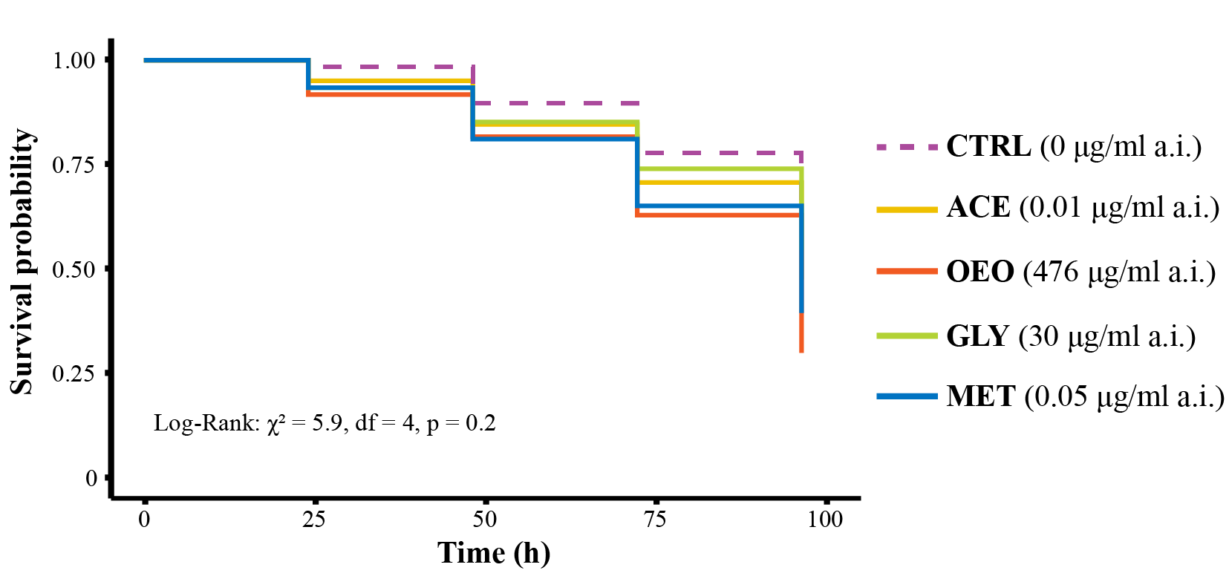
Fig. S1. Survival probability of Bombus terrestris individuals during 96 hours of exposure. Honey syrup treatments were: (CTRL) uncontaminated (control); (ACE) contaminated with acetamiprid; (OEO) contaminated with sweet orange essential oil; (GLY) contaminated with glyphosate; and (MET) contaminated with metalaxyl-M. Each colony was considered a treatment replicate, with three replicates per treatment, totaling 15 colonies. Five workers were collected from each colony for the individual-level test, totaling 75 individuals observed. There was no significant difference in survival between pesticide-contaminated treatments (ACE, OEO, GLY, and MET) and the control (p > 0.05).
Table S1. Comparison of walking behavior parameters between treated and untreated Bombus terrestris workers after one week of pesticide exposure at colony and individual levels. Bees were submitted to (CTRL) uncontaminated honey syrup (control); (ACE) honey syrup contaminated with acetamiprid (0.01 μg/ml); (OEO) honey syrup contaminated with sweet orange essential oil (476 μg/ml); (GLY) honey syrup contaminated with glyphosate (30 μg/ml); and (MET) honey syrup contaminated with metalaxyl-M (0.05 μg/ml). The values of the Dunnett’s multiple comparison test refers to the contrasts between the pesticide treatments (ACE, OEO, GLY, and MET) and the CTRL. P values lower than 0.05 indicate significant difference between the pesticide treatment (ACE, OEO, GLY, and MET) and the CTRL. Positive t-ratios indicate that the pesticide treatment was higher than the CTRL, while negative t-ratios indicate the opposite.
Behavioral parameter | Pesticide treatment | Social level of exposure | Model distribution  fitted | Dunnett's multiple comparison test
 |  |  |  | Estimate | SE | DF | t-ratio | p value
Distance walked | ACE | Colony | NO | -365 | 134 | 68 | -2.726 | 0.029 *
 |  | Individual | NO | -40.7 | 199 | 41 | -0.204 | 0.992
 | OEO | Colony | NO | -801 | 134 | 68 | -5.981 | <0.001 *
 |  | Individual | NO | -326.2 | 220 | 41 | -1.485 | 0.391
 | GLY | Colony | NO | -413 | 134 | 68 | -3.087 | 0.011 *
 |  | Individual | NO | -21.1 | 195 | 41 | -0.108 | 0.998
 | MET | Colony | NO | -631 | 134 | 68 | -4.715 | <0.001 *
 |  | Individual | NO | 73.9 | 205 | 41 | 0.361 | 0.968
Mean walking speed | ACE | Colony | NO | -0.608 | 0.223 | 68 | -2.724 | 0.029 *
 |  | Individual | NO | -0.0676 | 0.332 | 41 | -0.204 | 0.992
 | OEO | Colony | NO | -1.334 | 0.223 | 68 | -5.974 | <0.001 *
 |  | Individual | NO | -0.543 | 0.366 | 41 | -1.485 | 0.391
 | GLY | Colony | NO | -0.689 | 0.223 | 68 | -3.085 | 0.011 *
 |  | Individual | NO | -0.035 | 0.324 | 41 | -0.109 | 0.998
 | MET | Colony | NO | -1.052 | 0.223 | 68 | -4.710 | <0.001 *
 |  | Individual | NO | 0.123 | 0.341 | 41 | 0.362 | 0.968
Meandering | ACE | Colony | BCCG | 88.4 | 37.9 | 67 | 2.331 | 0.077
 |  | Individual | NO | 286.7 | 290 | 41 | 0.987 | 0.695
 | OEO | Colony | BCCG | 353.8 | 81.2 | 67 | 4.359 | <0.001 *
 |  | Individual | NO | 283.2 | 320 | 41 | 0.886 | 0.755
 | GLY | Colony | BCCG | 75.6 | 36.5 | 67 | 2.068 | 0.137
 |  | Individual | NO | 19.3 | 284 | 41 | 0.068 | 0.999
 | MET | Colony | BCCG | 260.1 | 71.2 | 67 | 3.652 | 0.002 *
 |  | Individual | NO | 104.8 | 298 | 41 | 0.351 | 0.97
Resting time | ACE | Colony | NO | -7.01 | 9.21 | 68 | 0.762 | 0.822
 |  | Individual | NO | -6.85 | 17.1 | 41 | -0.4 | 0.959
 | OEO | Colony | NO | 11.90 | 9.21 | 68 | 1.293 | 0.501
 |  | Individual | NO | 20.56 | 18.9 | 41 | 1.088 | 0.633
 | GLY | Colony | NO | -8.76 | 9.21 | 68 | -0.952 | 0.715
 |  | Individual | NO | 4.49 | 16.8 | 41 | 0.268 | 0.984
 | MET | Colony | NO | 19.51 | 9.21 | 68 | 2.119 | 0.123
 |  | Individual | NO | -10.91 | 17.6 | 41 | -0.619 | 0.888
Mean movement time | ACE | Colony | NO | -7.174 | 8.36 | 68 | -0.859 | 0.77
 |  | Individual | NO | -7.00 | 17.5 | 41 | -0.4 | 0.959
 | OEO | Colony | NO | -12.01 | 8.36 | 68 | -1.437 | 0.413
 |  | Individual | NO | -13.85 | 19.3 | 41 | -0.718 | 0.844
 | GLY | Colony | NO | 3.986 | 8.36 | 68 | 0.477 | 0.938
 |  | Individual | NO | -5.61 | 17.1 | 41 | -0.328 | 0.974
 | MET | Colony | NO | -12.73 | 8.36 | 68 | -1.523 | 0.365
 |  | Individual | NO | -8.26 | 18.0 | 41 | -0.46 | 0.944
Mean fast time | ACE | Colony | NO | 4.51 | 2.77 | 68 | 1.627 | 0.31
 |  | Individual | NO | 4.83 | 5.30 | 41 | 0.911 | 0.741
 | OEO | Colony | NO | -11.01 | 2.77 | 68 | -3.971 | <0.001 *
 |  | Individual | NO | -4.15 | 5.84 | 41 | -0.711 | 0.847
 | GLY | Colony | NO | -2.88 | 2.77 | 68 | -1.039 | 0.661
 |  | Individual | NO | 2.29 | 5.17 | 41 | 0.443 | 0.948
 | MET | Colony | NO | -3.78 | 2.77 | 68 | -1.364 | 0.457
 |  | Individual | NO | 15.01 | 5.44 | 41 | 2.758 | 0.031 *
Group density network | ACE | Colony | BCCG | -156.1 | 84.9 | 53 | -1.839 | 0.217
 |  | Individual | NO | 83.4 | 382 | 7 | 0.218 | 0.981
 | OEO | Colony | BCCG | -175.1 | 82.9 | 53 | -2.114 | 0.127
 |  | Individual | NO | -130.2 | 382 | 7 | -0.341 | 0.953
 | GLY | Colony | BCCG | -75.1 | 96.2 | 53 | -0.78 | 0.813
 |  | Individual | NO | -469.7 | 382 | 7 | -1.229 | 0.514
 | MET | Colony | BCCG | -143.6 | 84.0 | 53 | -1.709 | 0.273
NO = Normal; BCCG = Box-Cox-Cole-Green.
*Significant difference between the pesticide treatment and the control.

Table S2. Effects of social context (colony vs. individual) and pesticide exposure on Bombus terrestris walking behavior. Bees were submitted to (CTRL) uncontaminated honey syrup (control); (ACE) honey syrup contaminated with acetamiprid (0.01 μg/ml); (OEO) honey syrup contaminated with sweet orange essential oil (476 μg/ml); (GLY) honey syrup contaminated with glyphosate (30 μg/ml); and (MET) honey syrup contaminated with metalaxyl-M (0.05 μg/ml). The values of the Dunnett’s multiple comparison test refers to the contrasts between colony and individual exposure within a treatment. P values lower than 0.05 indicate significant difference between individual and colony exposure levels.
Behavioral Parameter | Treatment | Test (t) | df | p-value | Significant? | Direction of Effect (Colony vs Individual)
Distance Walked (DW) | CTRL | t = 4.758 | 336 | < 0.001 | Yes | Higher in Colony
 | GLY | t = 2.313 | 336 | 0.021 | Yes | Higher in Colony
 | ACE | t = 0.843 | 336 | 0.400 | No | -
 | OEO | t = 1.556 | 336 | 0.121 | No | -
 | MET | t = -0.569 | 336 | 0.569 | No | -
Mean Speed (MS) | CTRL | t = 4.534 | 336 | < 0.001 | Yes | Higher in Colony
 | GLY | t = 2.332 | 336 | 0.020 | Yes | Higher in Colony
 | ACE | t = 0.865 | 336 | 0.387 | No | -
 | OEO | t = 1.545 | 336 | 0.123 | No | -
 | MET | t = -0.539 | 336 | 0.590 | No | -
Meandering (ME) | CTRL | t = -3.328 | 336 | 0.001 | Yes | Lower in Colony
 | GLY | t = -2.304 | 336 | 0.022 | Yes | Lower in Colony
 | ACE | t = -1.512 | 336 | 0.131 | No | -
 | OEO | t = -1.785 | 336 | 0.075 | No | -
 | MET | t = 0.318 | 336 | 0.751 | No | -
Resting Time (RT) | CTRL | t = -1.178 | 336 | 0.240 | No | -
 | GLY | t = -3.429 | 336 | < 0.001 | Yes | Lower in Colony
 | ACE | t = -0.523 | 336 | 0.601 | No | -
 | OEO | t = -0.869 | 336 | 0.386 | No | -
 | MET | t = 0.915 | 336 | 0.361 | No | -
Mean Movement Time (MT) | CTRL | t = 1.106 | 336 | 0.269 | No | -
 | GLY | t = 2.362 | 336 | 0.019 | Yes | Higher in Colony
 | ACE | t = 1.425 | 336 | 0.155 | No | -
 | OEO | t = -0.098 | 336 | 0.922 | No | -
 | MET | t = 0.672 | 336 | 0.502 | No | -
Mean Fast Time (MF) | CTRL | t = 4.43 | 336 | < 0.001 | Yes | Higher in Colony
 | GLY | t = 2.738 | 336 | 0.006 | Yes | Higher in Colony
 | ACE | t = 1.831 | 336 | 0.068 | No | -
 | OEO | t = 1.326 | 336 | 0.186 | No | -
 | MET | t = -2.352 | 336 | 0.019 | Yes | Higher in Individual

Table S3. Walking behavior of Bombus terrestris workers from colonies exposed to different pesticide treatments over four weeks. Treatments are: (CTRL) uncontaminated honey syrup (control); (ACE) honey syrup contaminated with acetamiprid (0.01 μg/ml); (OEO) honey syrup contaminated with sweet orange essential oil (476 μg/ml); (GLY) honey syrup contaminated with glyphosate (30 μg/ml); and (MET) honey syrup contaminated with metalaxyl-M (0.05 μg/ml). P values lower than 0.05 indicate significant effect of time on the behavior within a treatment.
Behavioral Parameter | Overall Effect of Weeks? | Treatment | Test (t) or χ² | df | p-value | Direction of Change Over Time
Distance Walked (DW) | Yes (χ² = 5.961, p = 0.015) | CTRL | t = 1.045 | 289 | 0.297 | -
 |  | ACE | t = -0.673 | 289 | 0.502 | -
 |  | OEO | t = 1.909 | 289 | 0.057 | -
 |  | GLY | t = 1.015 | 289 | 0.311 | -
 |  | MET | t = 2.035 | 289 | 0.043* | Increased
Mean Speed (MS) | Yes (χ² = 4.982, p = 0.026) | CTRL | t = 0.379 | 289 | 0.705 | -
 |  | ACE | t = -0.680 | 289 | 0.497 | -
 |  | OEO | t = 1.796 | 289 | 0.074 | -
 |  | GLY | t = 0.992 | 289 | 0.322 | -
 |  | MET | t = 2.053 | 289 | 0.041* | Increased
Meandering (ME) | No (χ² = 3.657, p = 0.056) | All | - | - | > 0.05 | -
Resting Time (RT) | Yes (χ² = 20.581, p < 0.001) | CTRL | t = -1.013 | 289 | 0.312 | -
 |  | ACE | t = -0.692 | 289 | 0.489 | -
 |  | OEO | t = -2.637 | 289 | 0.009* | Decreased
 |  | GLY | t = -2.560 | 289 | 0.011* | Decreased
 |  | MET | t = -5.307 | 289 | < 0.001* | Decreased
Mean Movement Time (MT) | Yes (χ² = 9.232, p < 0.001) | CTRL | t = 0.774 | 289 | 0.439 | -
 |  | ACE | t = 1.429 | 289 | 0.154 | -
 |  | OEO | t = 3.528 | 289 | < 0.001* | Increased
 |  | GLY | t = -0.114 | 289 | 0.909 | -
 |  | MET | t = 1.327 | 289 | 0.185 | -
Mean Fast Time (MF) | Yes (χ² = 4.337, p = 0.037) | CTRL | t = 1.077 | 289 | 0.282 | -
 |  | ACE | t = -2.513 | 289 | 0.012* | Decreased
 |  | OEO | t = 2.027 | 289 | 0.044* | Increased
 |  | GLY | t = 1.722 | 289 | 0.086 | -
 |  | MET | t = 2.474 | 289 | 0.014* | Increased
Group Density Network (GN) | No (χ² = 2.022, p = 0.155) | All | - | - | > 0.05 | -
*Significant effect of time on the behavior within a treatment.

