Supplementary Methods
Face Stimulus Ratings
At the end of the attention capture task, we asked participants (N = 51) if they had noticed a face during the task. If participants indicated that they noticed a face (N = 51), we next asked them to indicate if they recognized the faces and to enter the names/identities of any faces that they recognized. Of the 51 participants that completed these ratings, 11.76% of participants left this question blank. Of the 45 participants that entered a name, 75% reported that they recognized themselves (e.g., “myself”, “my face”, “me”), 91% reported that they recognized their friend (e.g., “my friend”, or their friends name), and 44% reported that they recognized the stranger (e.g. “ a stranger”, “someone I don’t know”, “unknown”). Next, participants provided familiarity and preference ratings for the stranger, familiar, and self faces. The same cropped image of each face type (300 x 300 pixels) that had been used in the attention capture task appeared on the left side of the screen. Participants first rated the familiarity of the face (1 = “Not at all familiar” to 5 = “Extremely familiar”) followed by a second trial in which they rated how much they liked the person (i.e., preference; 1 = “Dislike very much” to 5 = “Like very much”). All participants rated the stranger face first, followed by the familiar face and then the self-face.

Questionnaires
Participants completed two questionnaires to assess individual differences in self-esteem and self-consciousness. However, due to previous work linking self-esteem specifically to reward processing, analyses for the current study focused on the measure of self-esteem assessed via the Rosenberg Self-Esteem Scale (Rosenberg, 1965; Salehinejad et al., 2020), a 10-item scale that measures global self-esteem, defined as the extent to which the individual holds a positive or negative attitude toward the self. Participants used a 0 (“Strongly Disagree”) to 3 (“Strongly Agree”) Likert scale to respond to each statement on the questionnaire (e.g., “On the whole, I am satisfied with myself”). A fifth response option, “Prefer not to answer” was also available for each statement. We scored the Rosenberg self-esteem scale as a Likert scale, such that the scales were summed to compute a composite score that ranged from 0-30, consistent with recent work (García et al., 2019; Sinclair et al., 2010; Xu & Leung, 2018).

Supplementary Results
Familiarity and Preference Ratings
We tested whether participants’ familiarity and preference ratings varied across face types to confirm that self- and familiar-other faces were equally familiar and favorable to participants. Results of a Friedman test indicated a main effect of face type on familiarity ratings, χ²(2) = 98.09, p < .001. Post-hoc comparisons using Wilcoxon signed rank tests showed that participants rated the stranger face (M = 1.33, SD = .59) as less familiar than both the self-face (M = 4.92, SD = .39; Z = 6.46, p < .001) and the familiar face (M = 4.96, SD = .20; Z = 6.49, p < .001). There was no difference in familiarity ratings across the familiar and self faces (p = .458). There was a similar effect of face type on preference ratings, χ²(2) = 85.01, p <.001, with lower preference ratings for the stranger face (M = 3.00, SD = .45) compared to both the self-face, M = 4.75, SD = .56; Z = 6.34, p < .001, and the familiar face, M = 4.82, SD = .48; Z = 6.38, p < .001. There was no difference in preference ratings across the familiar and self faces (p = .470). Thus, participants reported that both the self- and familiar faces were more familiar and preferred compared to the stranger faces, but there were no differences in these ratings across the self and familiar face types, although the self and familiar face ratings may have been at ceiling. Overall, these results confirm that the stranger faces used were not known to the test subjects, and therefore appropriately selected.

Effects of Self-Esteem
We conducted an exploratory analysis to examine whether self-esteem moderates the effects of face type on target detection performance during the attention capture task. We examined target detection performance using a repeated-measures ANCOVA with within-subject factors of target presence (present, absent), face type (self, familiar, stranger), and set size (three, six, nine) with the self-esteem composite score centered as a covariate. We conducted separate analyses for accuracy and reaction time measures and used Greenhouse-Geisser corrections when necessary to correct for violations of sphericity.
Accuracy. Results indicated that there were no main effects of face type, target type, or set size on accuracy when we included self-esteem in the model (p’s > .382). Results also indicated that there were no interactions with self-esteem (p’s > .100).
Reaction Time. Participants were overall faster to respond during the target present vs. target absent trials, (F(1, 64) = 16.78, p < .001, η_{p}² = .21; M_{Present} = 651.36, SD = 111.42; M_{Absent} = 795.85, SD = 176.86). There was also a main effect of set size on reaction time, (F(1.39, 88.70) = 6.53, p = .006, η_{p}² = .09), such that participants were slower to respond as the number of distractors in the set size increased (M_{SetSize3} = 642.91, SD = 110.49; M_{SetSize6} = 722.95, SD = 138.61; M_{SetSize9} = 804.95, SD = 179.97; p’s < .001). Although these effects of target presence and set size were similar to those observed in primary analyses, they did not interact with self-esteem (p’s > .338).
The main effect of face type was not significant (p = .528), but there was a face type x set size interaction, (F(3.12, 199.73) = 4.20, p = .006, η_{p}² = .06) that was further moderated by a marginally significant face type x set size x self-esteem interaction (F(3.12, 199.73) = 2.60, p = .051, η_{p}² = .04). Follow-up analyses revealed a face type x self-esteem interaction only during the set size 3 trials (F(1.59, 101.55) = 4.60, p = .019, η_{p}² = .067), but not during set size 6 or set size 9 trials (p’s > .340). During set size 3 trials, self-esteem was not related to raw reaction times during trials with the self, familiar, or stranger faces (p’s > .260). To further examine the interaction, we conducted a tertiary split on our data, resulting in groups of low (M = 18.81, SD = 3.05), medium (M = 20.05, SD = 1.47) and high (M = 26.61, SD = 1.88) self-esteem. Next, we conducted a repeated measures ANOVA of face type for each self-esteem group. There were no effects of face type in any self-esteem group (p’s > .154).
Summary. Participants showed overall slower response times during the target present condition and as the set size increased, indicating poorer target detection. Although there was a marginally significant omnibus interaction between face type, set, size and self-esteem, follow-up analyses indicated that self-esteem was not related to reaction time in the presence of the self, familiar or stranger distractor faces. Additionally, there were no differences in reaction time across face types within the low, medium and high self-esteem groups.

Supplementary Figure 1
Stimuli used in the attention capture task.
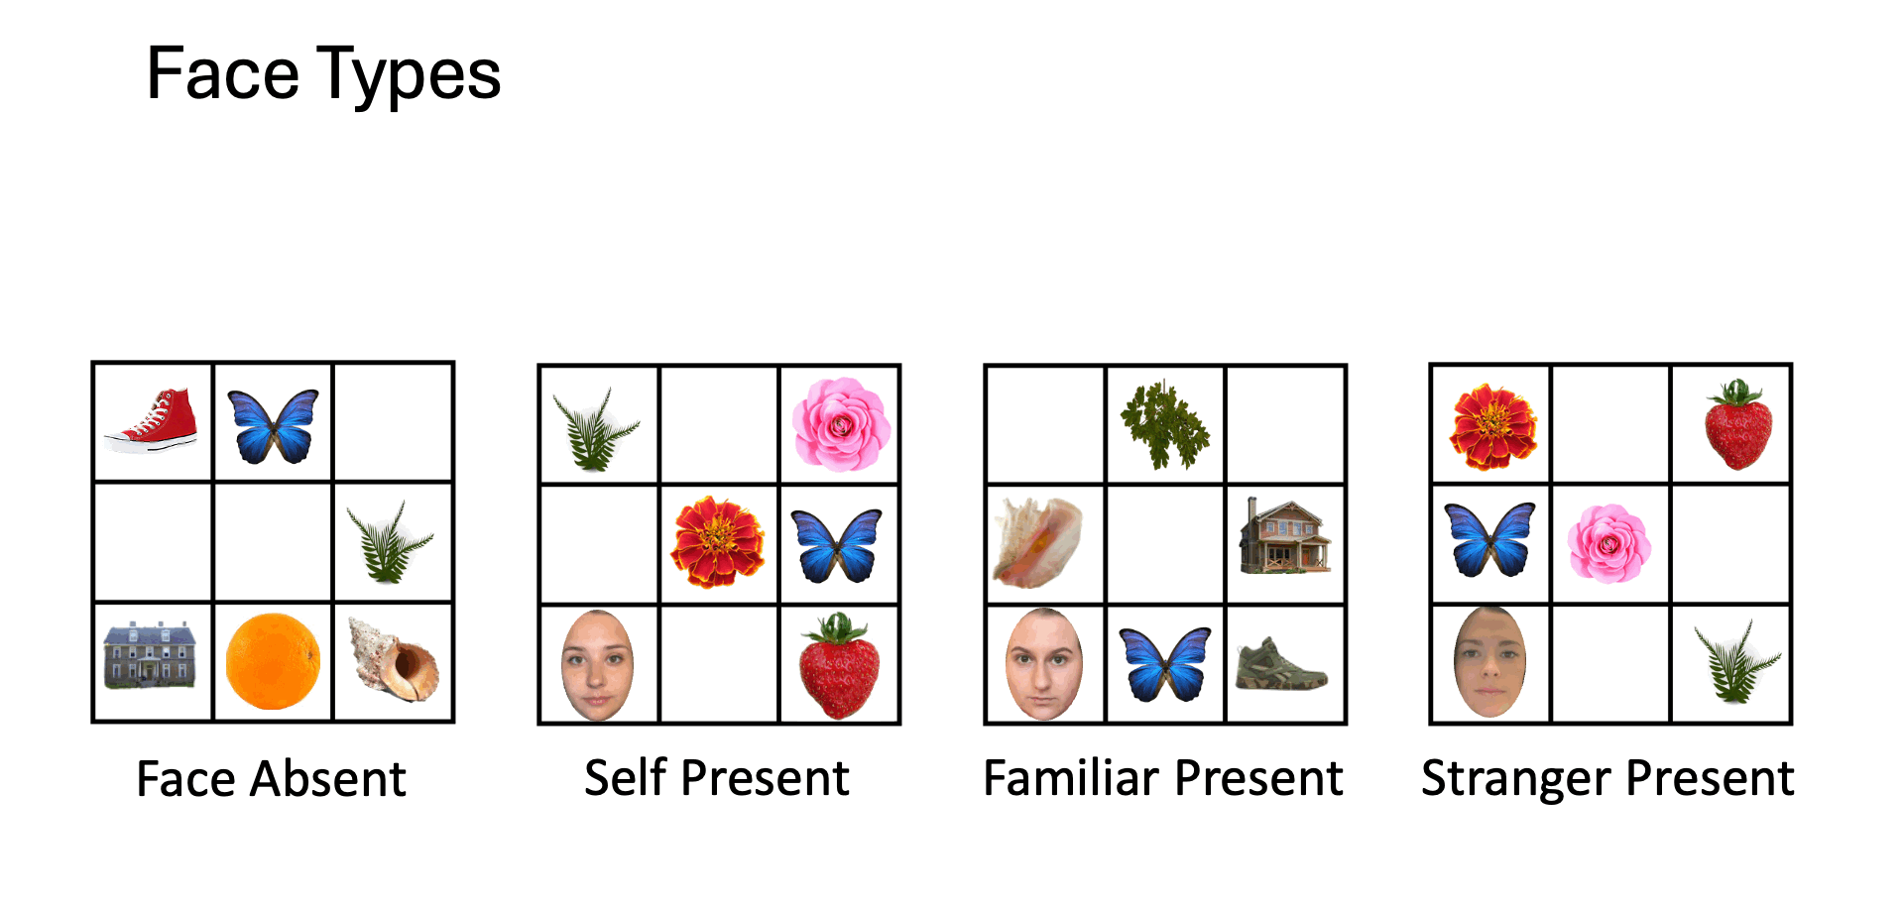

We were unable to obtain these ratings for N = 15 participants.

