Table1. Demographic characteristics and clinical comorbidities of 137 patients with IE at baseline
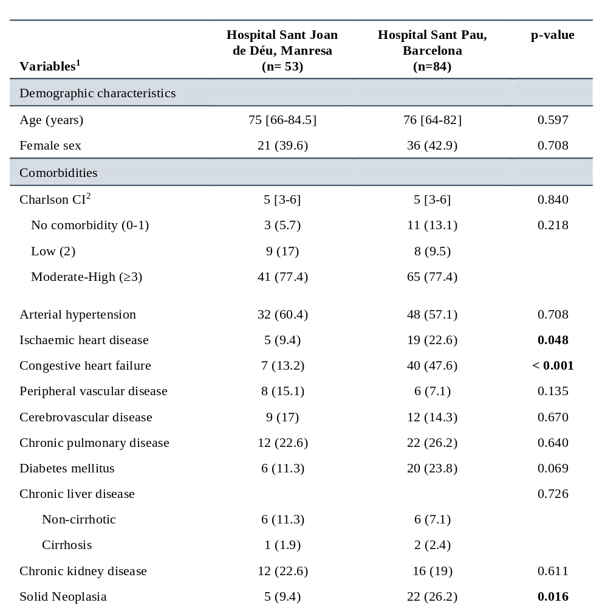
Footnotes to Table 1.
1. Continuous variables are expressed as a median and interquartile range [IQR] and categorical variables as absolute number and frequency, n (%).
2. Charlson CI: Charlson Comorbidity Index

Table 2. Characterisation of Infective Endocarditis episodes.
Variables | Hospital Sant Joan de Déu, Manresa  (n= 53) | Hospital Sant Pau, Barcelona  (n=84) | p-value
Diagnostic characterization
Classification, n (%)  Definite  Probable | 29 (54.7)  24 (45.3) | 70 (83.3)  14 (16.7) | <0.001
Mode of acquisition, n (%)  Community  Health-related  Nosocomial | 37 (69.8)  13 (24.5)  3 (5.7) | 48 (57.1)  16 (19)  5 (6) | 0.999
Type of IE, n (%)  Native valve  Biological valve  Mechanical valve  TAVI  Electronic device  Non-valvular | 35 (66)  11 (20.8)  4 (7.5)  1 (1.9)  2 (3.8)  4 (7.5) | 48 (57.1)  16 (19)  11 (13.1)  2 (2.4)  6 (7.1)  7 (8.3) | 0.527
Previous valve disease n (%) | 5 (9.4) | 6 (7.1) | 0.749
Endocarditis-team involvement, n (%) | 28 (54.9) | 69 (82.1) | <0.001
Diagnostic Procedures
Positive blood culture, n (%)  Positive blood samples per patient | 46 (86.8)  4 [2-4] | 77 (91.7)  4 [2-6.5] | 0.359  0.295
TTE, n (%)  Performed  Signs of IE | 49 (92.5)  16 (33.3) | 58 (69)  25 (43.1) | 0.001  0.304
TOE, n (%)  Performed  Signs of IE | 32 (60.4)  17 (56.7) | 62 (73.8)  54 (88.5) | 0.099  < 0.001
Cardiac CT, n (%)  Performed  Signs of IE | 6 (11.3)  3 (50) | 19 (22.9)  16 (84.2) | 0.089  0.125
PET-CT scan, n (%)  Performed  Signs of IE | 11 (20.8)  4 (36.4%) | 36 (44.4)  22 (62.9) | 0.005  0.169
IE signs
Vegetation, n (%) | 28 (52.8) | 68 (81) | <0.01
Perivalvular abscess, n (%) | 7 (13.2) | 14 (16.7) | 0.584
Pseudoaneurysm, n (%) | 2 (3.8) | 4 (4.8) | 0.783
Fistula, n (%) | 1 (1.9) | 2 (2.4) | 0.847
Prosthetic dehiscence, n (%) | 0 | 2 (2.4) | 0.258
New valvular regurgitation, n (%) | 9 (17) | 22 (26.2) | 0.210
Episode complications
Sepsis, n (%) | 16 (30.2) | 20 (23.8) | 0.409
ICU, n (%) | 19 (35.8) | 49 (35.8) | 0.987
Acute kidney injury, n (%) | 11 (20.8) | 41 (48.8) | < 0.001
Heart Failure, n (%) | 28 (52.8) | 43 (53.6) | 0.933
CNS complication, n (%) | 16 (30.2) | 20 (23.8) | 0.611
Aetiology
Staphylococcus aureus, n (%) | 12 (22.6) | 19 (22.6) | 0.648
MRSA, n (%) | 0 (0) | 3 (3.6) | 0.164
Viridans group streptococci, n (%) | 10 (18.9) | 18 (21.4) | 0.717
Enterococcus spp, n (%) | 9 (17) | 15 (17.9) | 0.895
Streptococcus gallolyticus, n (%) | 4 (7.5) | 7 (8.3) | 0.869
Coagulase-negative staphylococci, n (%) | 3 (5.7) | 7 (8.3) | 0.225
Beta-haemolytic Streptococcus spp, n (%) | 4 (7.5) | 1 (1.2) | 0.053
Propionibacterium spp, n (%) | 2 (3.8) | 1 (1.2) | 0.314
Gram-negative non-HACEK group, n (%) | 1 (1.9) | 2 (2.4) | 0.847
Other, n (%) | 1 (1.9) | 4 (4.8) | 0.382
Non-identified, n (%) | 6 (11.3) | 7 (8.3) | 0.561
Footnotes to Table 2.
1. Continuous variables are expressed as medians and interquartile ranges (IQRs), and categorical variables are expressed as absolute numbers and frequencies, n (%).
ICU, intensive care unit; HACEK: Haemophilus species, Aggregatibacter species, Cardiobacterium hominis, Eikenella corrodens, and Kingella species; MRSA, methicillin-resistant S. aureus; PET-CT: F-fluorodeoxyglucose positron emission tomographic–computed tomographic scanning; TAVI, transcatheter aortic valve implantation; TTE, transthoracic echocardiogram; TOE, transoesophageal echocardiography.

Table 3. Therapeutic management and clinical outcomes.
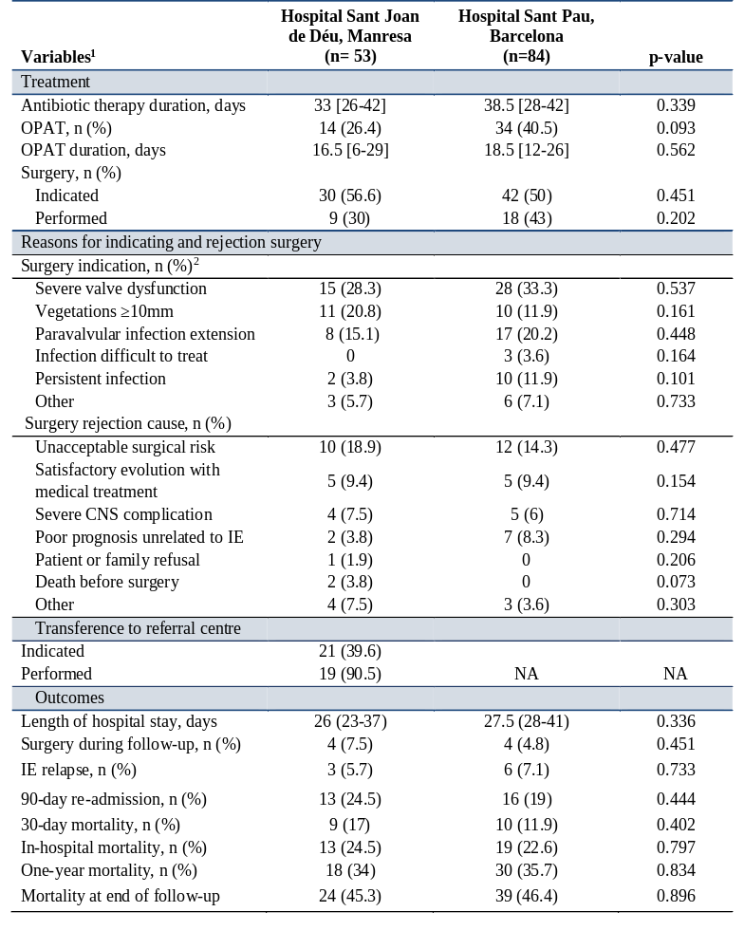
Footnotes to table 3.
1. Continuous variables are expressed as a median and interquartile range [IQR] and categorical variables as absolute number and frequency, n (%).
2. The total percentage exceeds 100% because patients may have more than one surgical indication.
CNS: central nervous System; IE: infective endocarditis; NA: not applicable; OPAT: outpatient parenteral antibiotic therapy

Table 4. Predictors of mortality within 30 days and one year using Cox regression models. 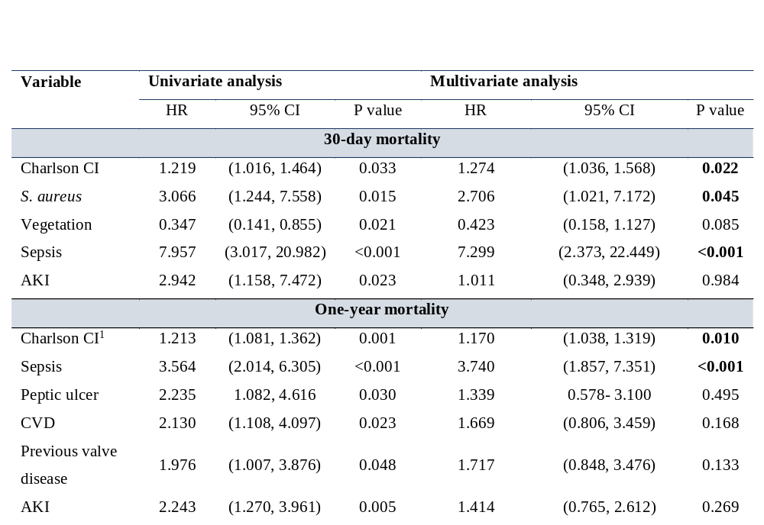
Footnotes to Table 4.
AKI: Acute kidney injury; CVD: cerebrovascular disease
1. Charlson CI: Charlson Comorbidity index

Table 5. The impact of surgery on mortality among patients with a surgical indication, at both hospitals
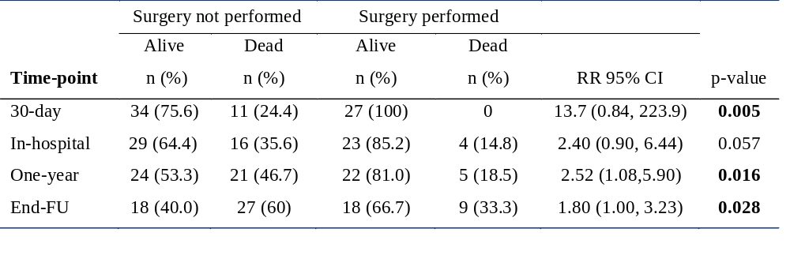

Table 6. Analysis of mortality stratified by surgical intervention in patients transferred and by surgery indication in patients non-transferred, among patients diagnosed at HSJD
