Supplementary Figures

DNA Methylation Changes Associated with Antipsychotic Serum Concentrations in Patients with Psychosis.

Jonelle D. Villar^{1,2}, Anne-Kristin Stavrum^{1,2}, Leticia M. Spindola^{1,2}, Tetyana Zayats^{3,4,5}, Markos Tesfaye^{1,2,6,7}, Thomas Bjella⁸, Nils Eiel Steen^{8,9}, Ingrid Melle⁸, Ole A. Andreassen^{8,10}, Vidar M. Steen^{1,2}, and Stephanie Le Hellard^{1,2}

¹Department of Clinical Science, University of Bergen, Bergen, Norway.
²Dr. Einar Martens Research Group for Biological Psychiatry, Department of Medical Genetics, Haukeland University Hospital, Bergen, Norway.
³Analytic and Translational Genetics Unit, Department of Medicine, Massachusetts General Hospital and Harvard Medical School, Boston, Massachusetts, USA.
⁴Stanley Center for Psychiatric Research, Broad Institute of MIT and Harvard, Cambridge, Massachusetts, USA.
⁵Program in Medical and Population Genetics, Broad Institute of MIT and Harvard, Cambridge, Massachusetts, USA.
⁶Department of Psychiatry and Behavioral Sciences, SUNY Downstate Health Sciences University, Brooklyn, NY., USA.
⁷Institute for Genomics in Health, SUNY Downstate Health Sciences University, Brooklyn, NY., USA.
⁸Division of Mental Health and Addiction, Oslo University Hospital and Institute of Clinical Medicine, University of Oslo, Norway.
⁹Division of Mental Health and Substance Abuse, Diakonhjemmet Hospital, Oslo, Norway.
¹⁰Centre for Precision Psychiatry, University of Oslo, Norway

Supplementary Figure 1 page 2
Supplementary Figure 2 page 3
Supplementary Figure 3 page 4
Supplementary Figure 4 page 4
Supplementary Figure 5 page 5
Supplementary Figure 6 page 6
Supplementary Figure 7 page 7
Supplementary Figure 8 page 8
Supplementary Figure 9 page 9

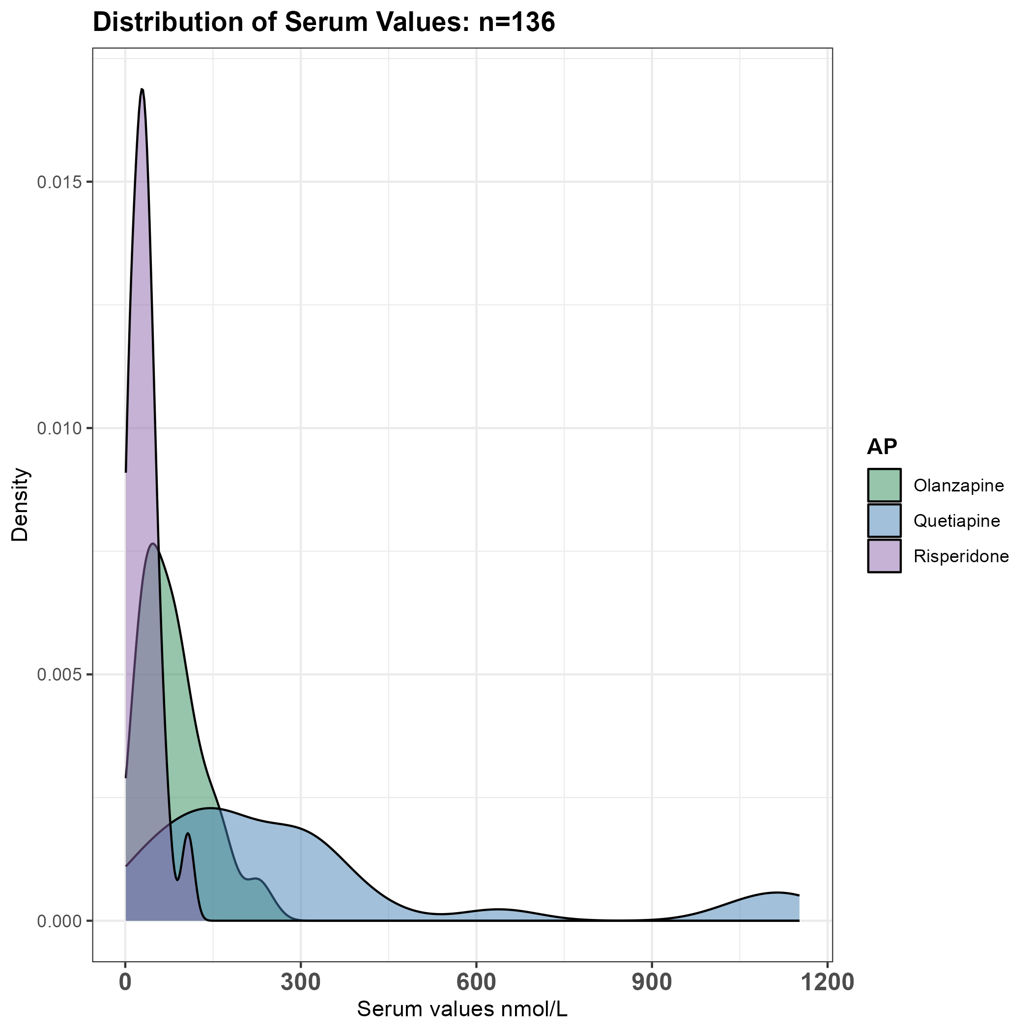

SM Fig.1: Distribution of measured serum values for olanzapine, quetiapine, and risperidone. We observed greater variation in the range of serum values for quetiapine than for olanzapine and risperidone.

Olanzapine | Quetiapine
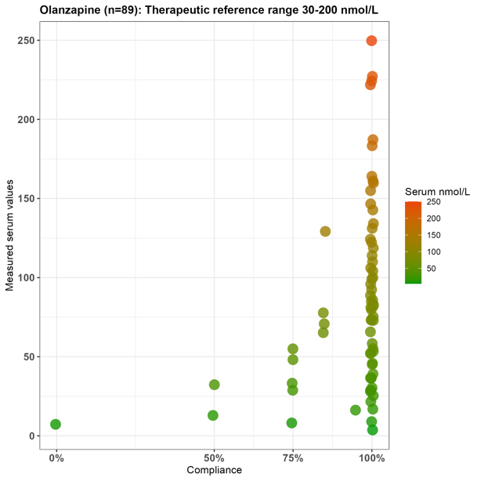 | 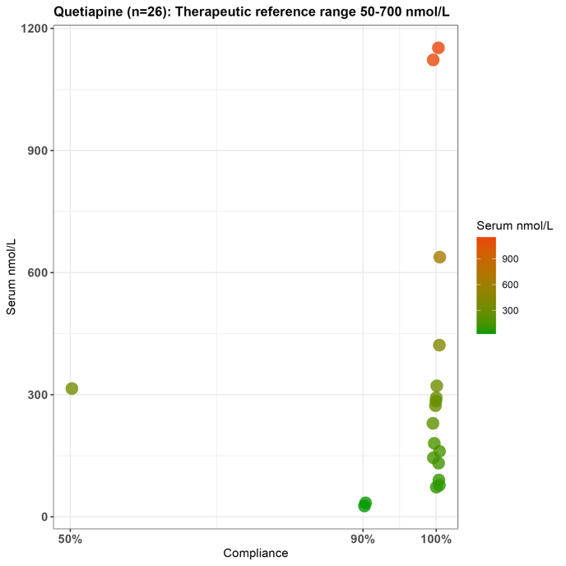
Risperidone
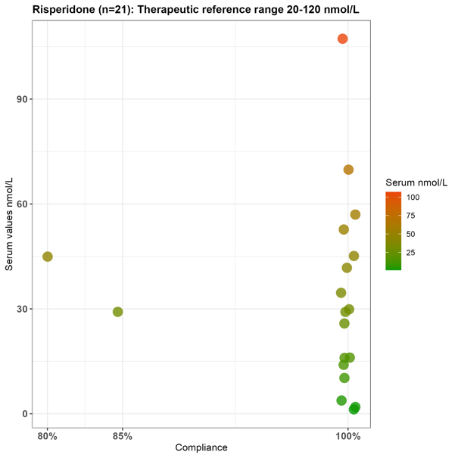

SM Fig.2: Distribution of measured serum values nmol/L vs. reported adherence. Therapeutic reference ranges are listed for reference although factors such as smoking, health status, age, sex, and genetics influence serum values measured in peripheral blood. The measurement for risperidone represents the sum of risperidone and the active metabolite 9-hydroxy-risperidone.

Olanzapine (n=89): ƛ = 0.958 | Quetiapine (n=26): ƛ = 1.032 | Risperidone (n=21): ƛ = 0.969
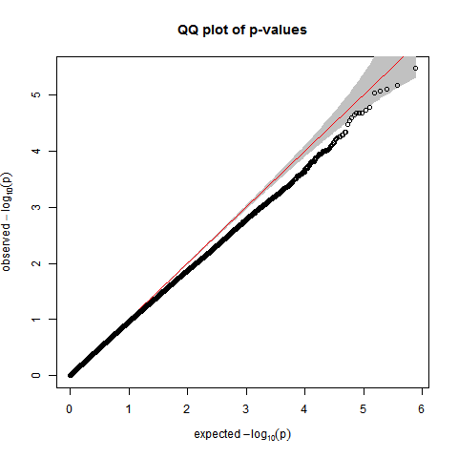 | 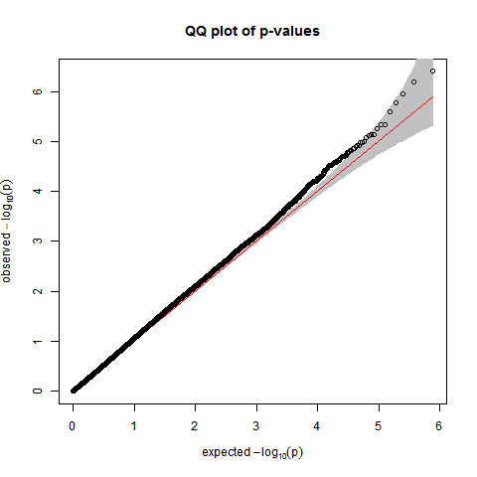 | 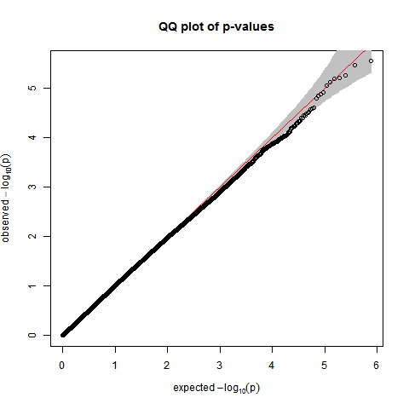

SM Fig.3: QQ plots for AP monotherapy with serum values > 0 nmol/L EWAS. The qq plots were employed to assess the underlying distribution of the samples to be incorporated into the Shared Effects model. By comparing expected (x-axis) and theoretical (y-axis) p-values, we observed a tendency toward deflated p-values in the olanzapine samples. Nevertheless, lambda (ƛ) values close to 1.0 indicate that the observed p-values are consistent with the expected distribution for this sample size. We continued our analysis with these samples.

Olanzapine (n=89) vs no olanzapine (n=174)  ƛ = 1.029 | Quetiapine (n=26) vs no quetiapine (n=237) ƛ = 0.932 | Risperidone (n=21) vs no risperidone (n=242) ƛ = 0.926
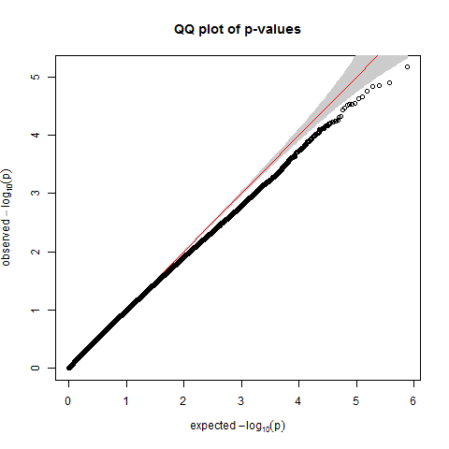 | 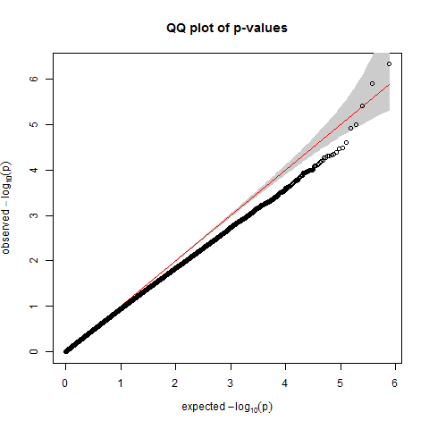 | 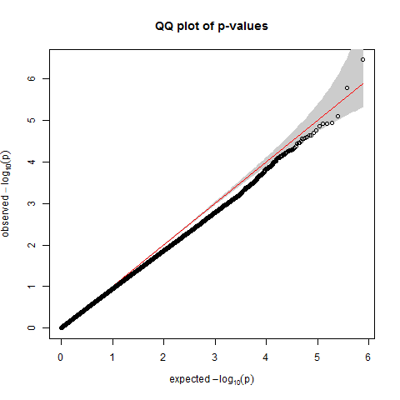

SM Fig.4: QQ plots for EWAS performed for each AP monotherapy vs. 2 other APs and medication-free samples. The qq plots were employed to assess the underlying distribution of the samples to be incorporated into the Specific Effects model. By comparing expected (x-axis) and theoretical (y-axis) p-values, we observed a tendency toward deflated p-values in the samples possibly due to low power. Nevertheless, lambda (ƛ) values close to 1.0 indicate that the observed p-values are consistent with the expected distribution for this sample size

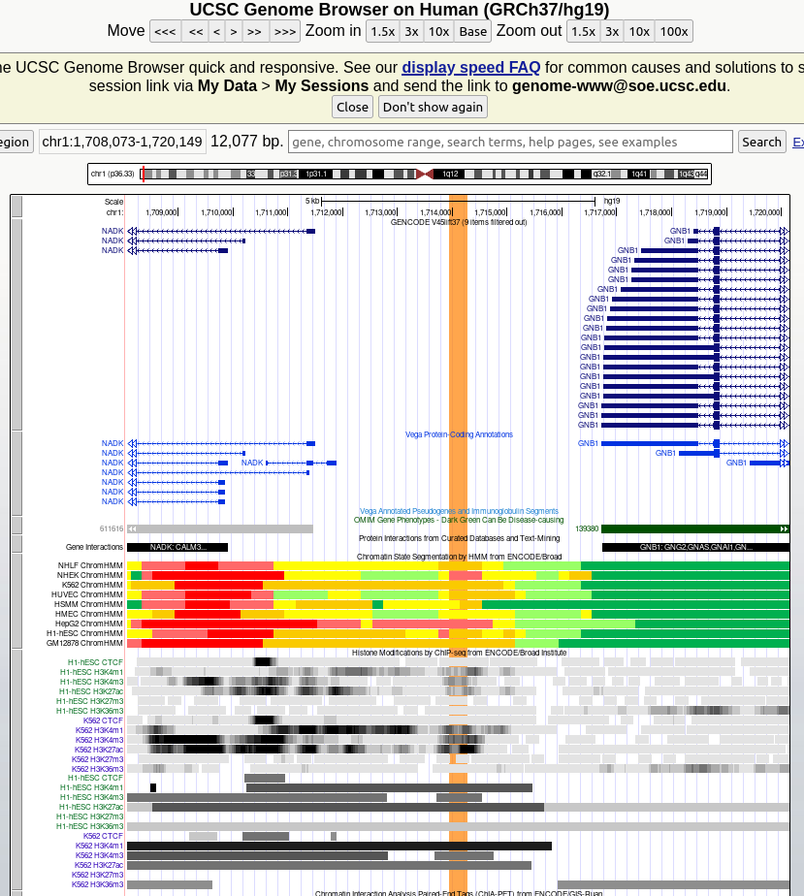

SM Fig.5: The DMR located on chr1: 1713950-1714271 (position highlighted in orange) was annotated using the UCSC genome browser (GRCH37/hg19) to assign nearest genes to the genomic region, GNB1.

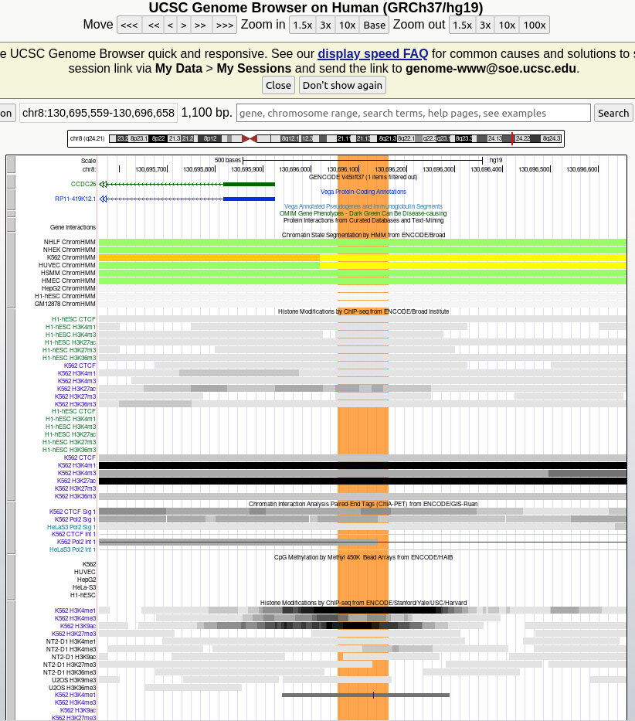

SM Fig.6: The DMR located on chr8: 130696056-130696161 (highlighted in orange) was annotated using the UCSC genome browser (GRCH37/hg19) to assign nearest genes to the genomic region: CCDC26.

MSLN | ZNF471 | F) CCDC26
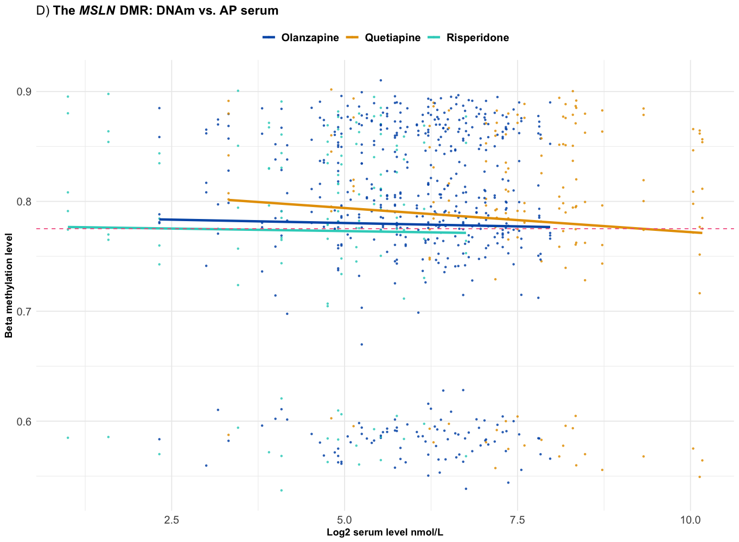 | 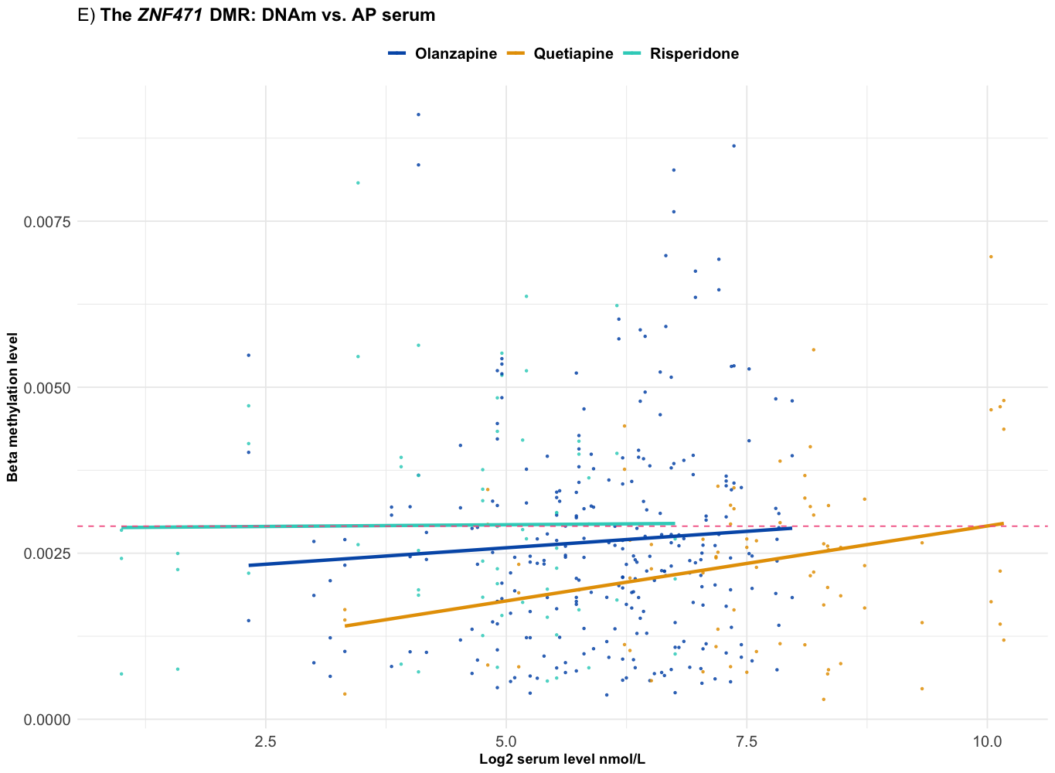 | 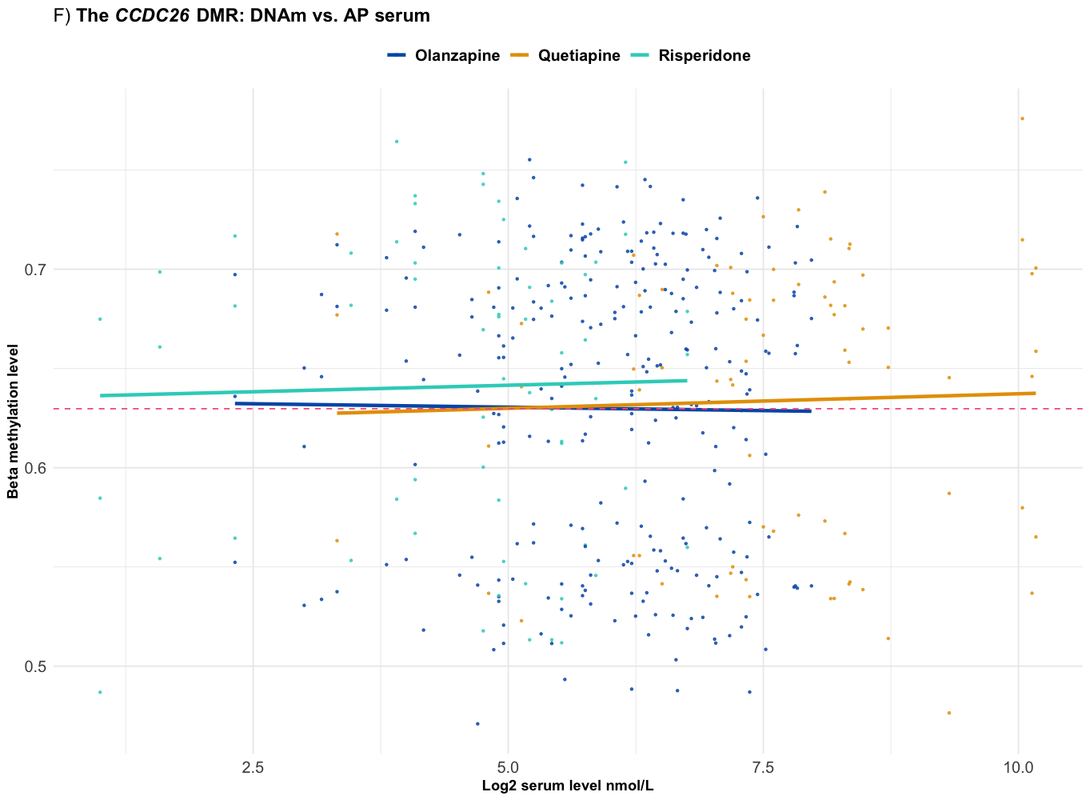

SM Fig.7: Dose-dependent relationship between 𝛽-methylation levels and log2-transformed serum concentrations (nmol/L) and. X = log2 serum values for the remaining 3 DMRs identified in the Shared Effects model: MSLN, ZNF471, CCD26C. Blue: olanzapine, Teal green: risperidone, Orange: quetiapine, Red dotted line: Medication-free.

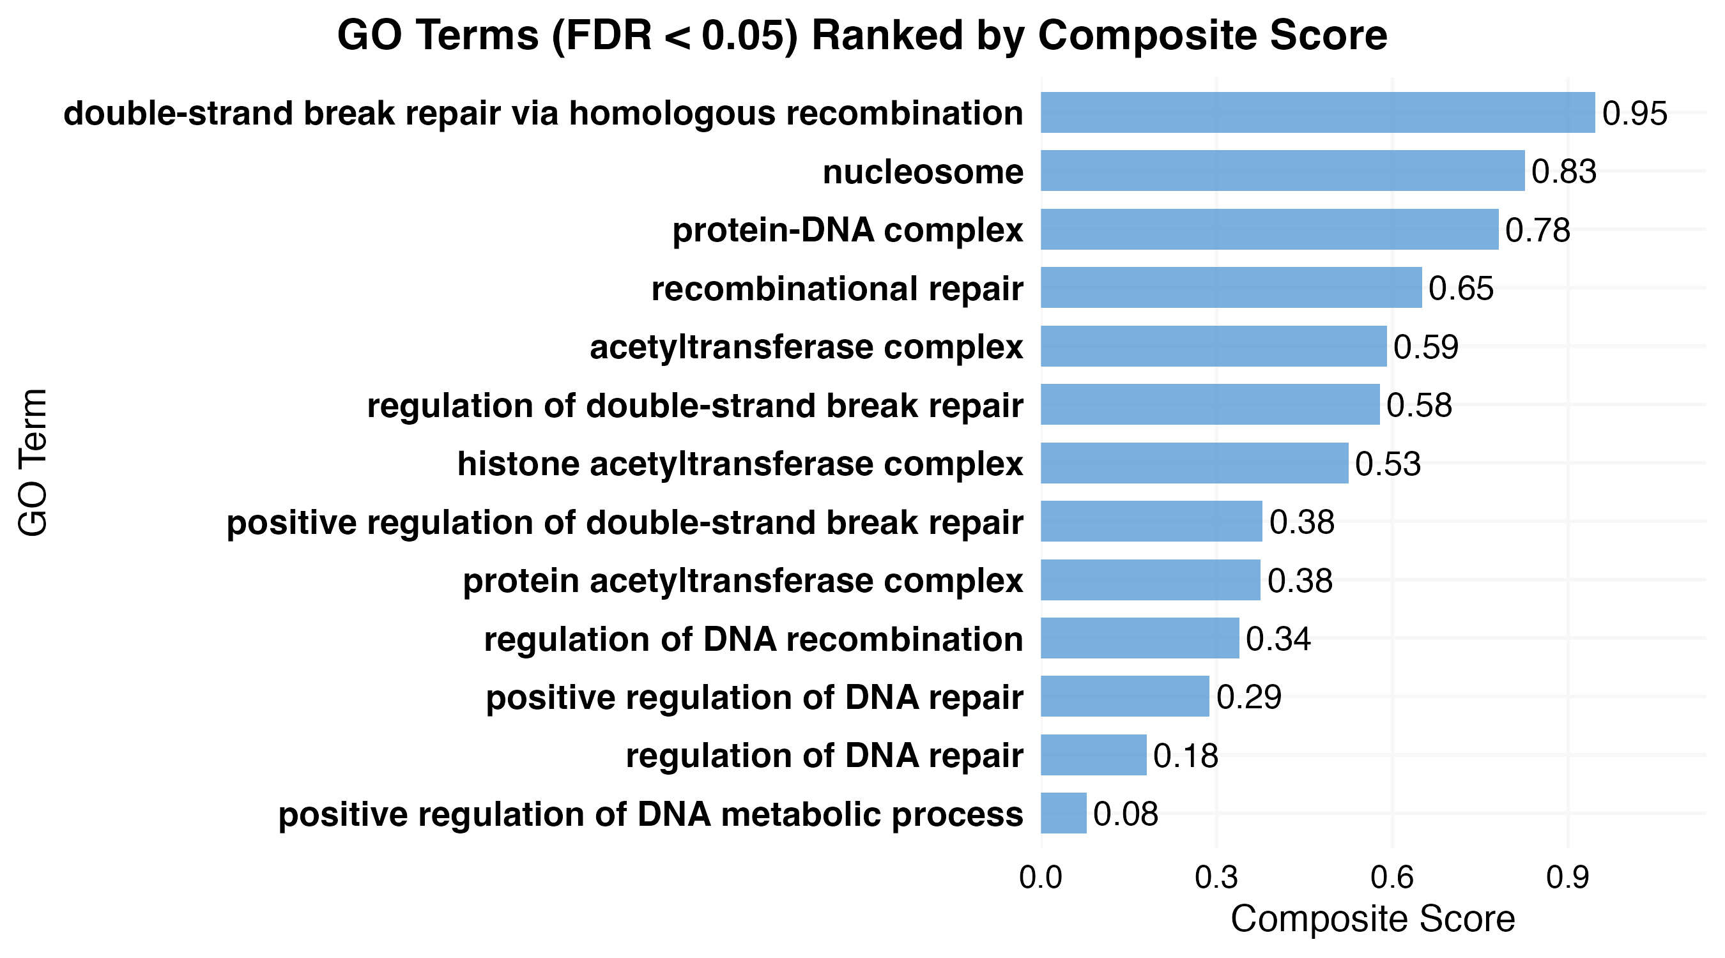

SM Fig. 8: GO terms derived from DMPs (FDR p < 0.05) ranked by composite score. Enriched GO terms were processed using REVIGO to reduce redundancy, and scores were derived from three semantic metrics: dispensability, uniqueness, and frequency. Terms with higher composite scores represent more biologically specific and semantically distinct functions. Top terms highlight processes involved in double-strand break repair and protein structure.

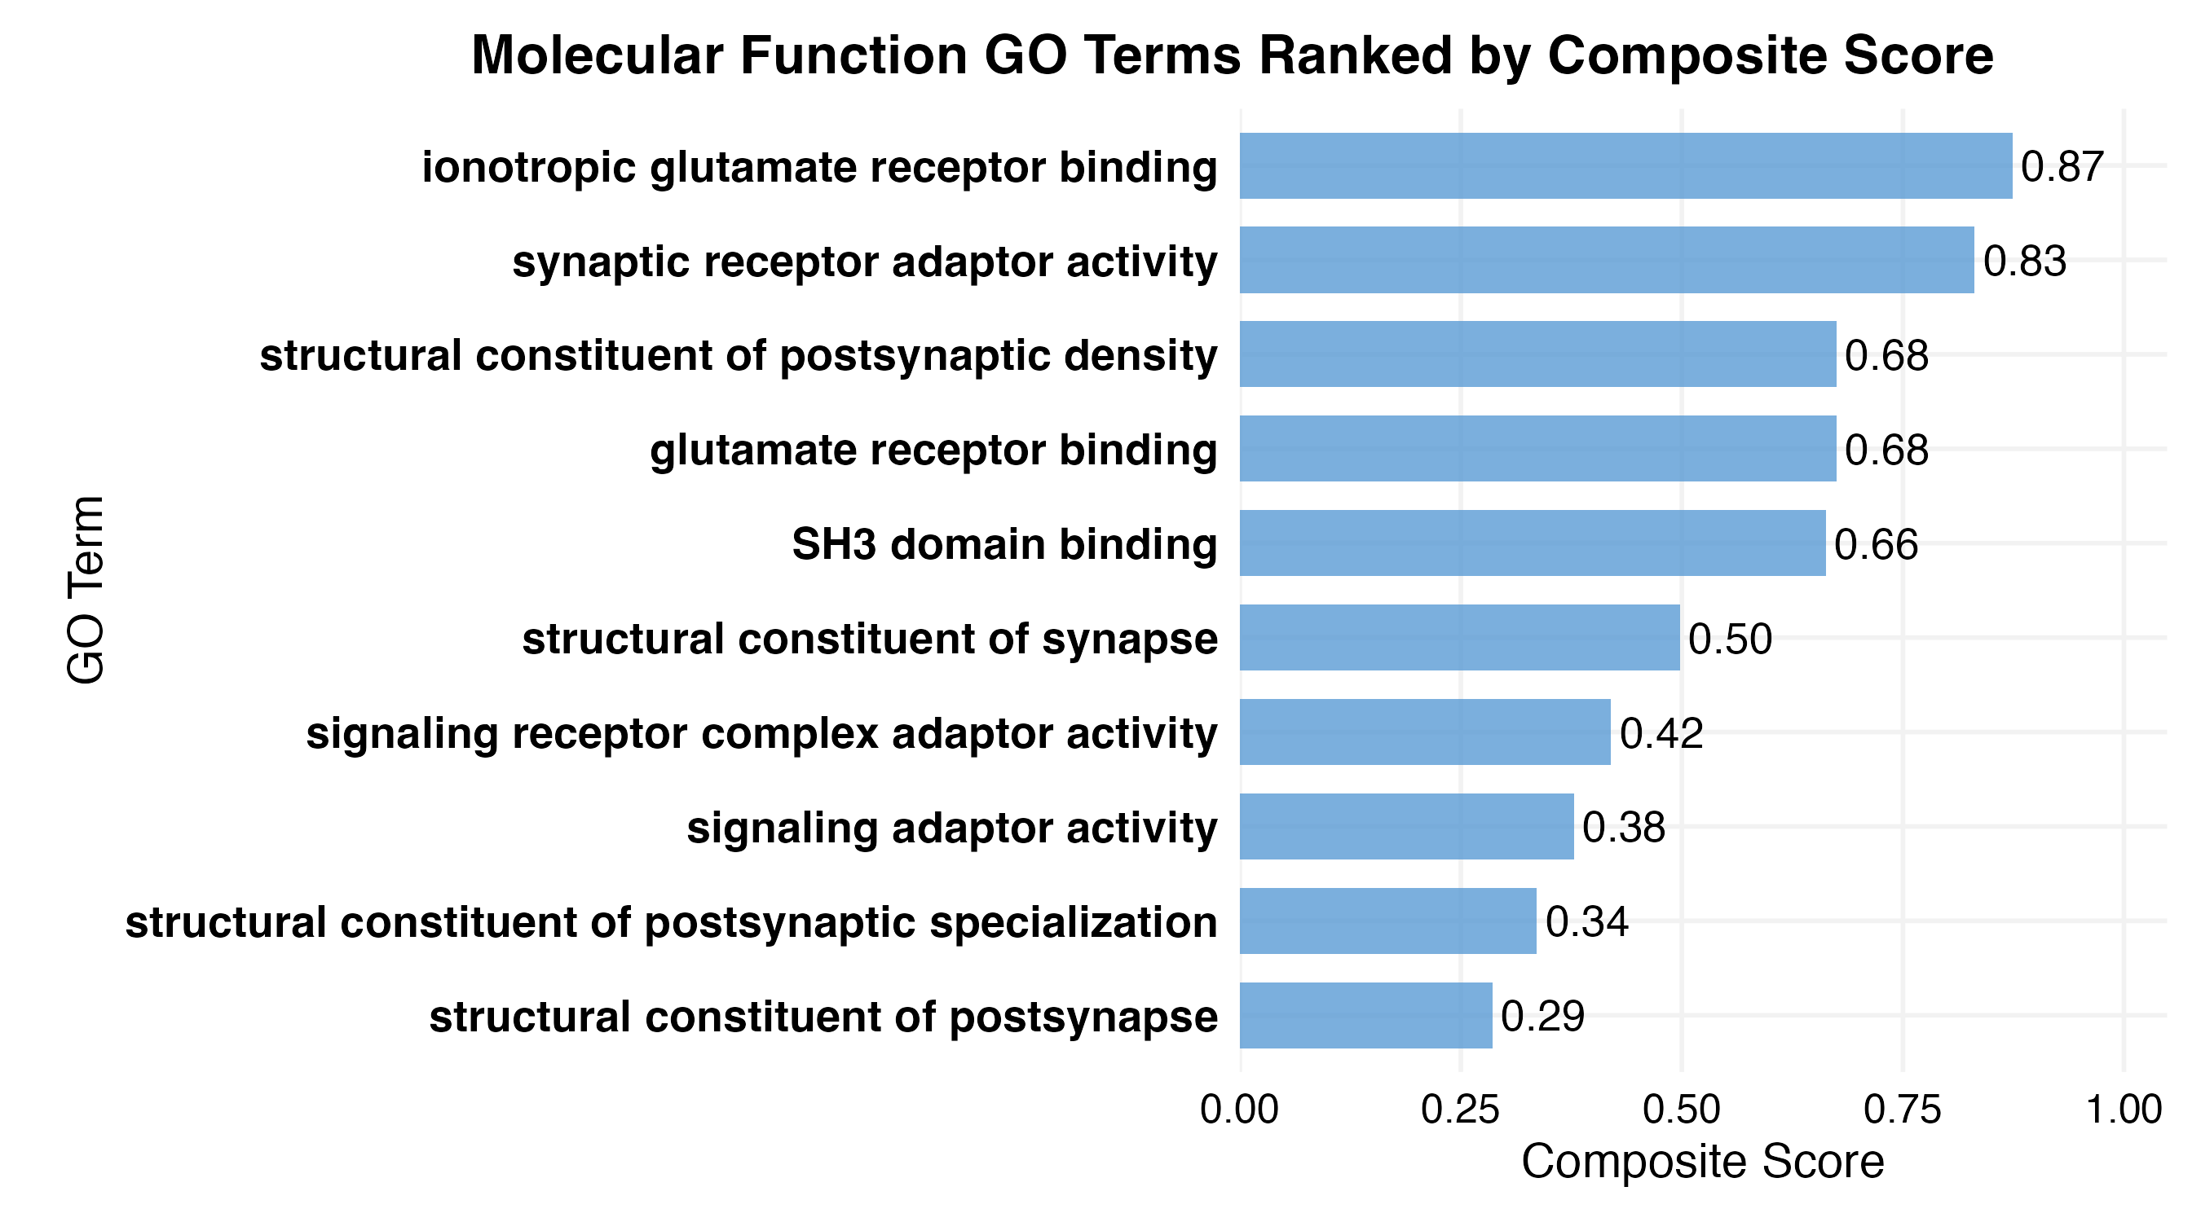

SM Fig. 9: Molecular Function GO terms derived from DMRs (nominal p < 0.05) ranked by composite score. Enriched GO terms were processed using REVIGO to reduce redundancy, and scores were derived from three semantic metrics: dispensability, uniqueness, and frequency. Terms with higher composite scores represent more biologically specific and semantically distinct functions. Top terms highlight processes involved in postsynaptic structure and glutamate receptor signaling.

