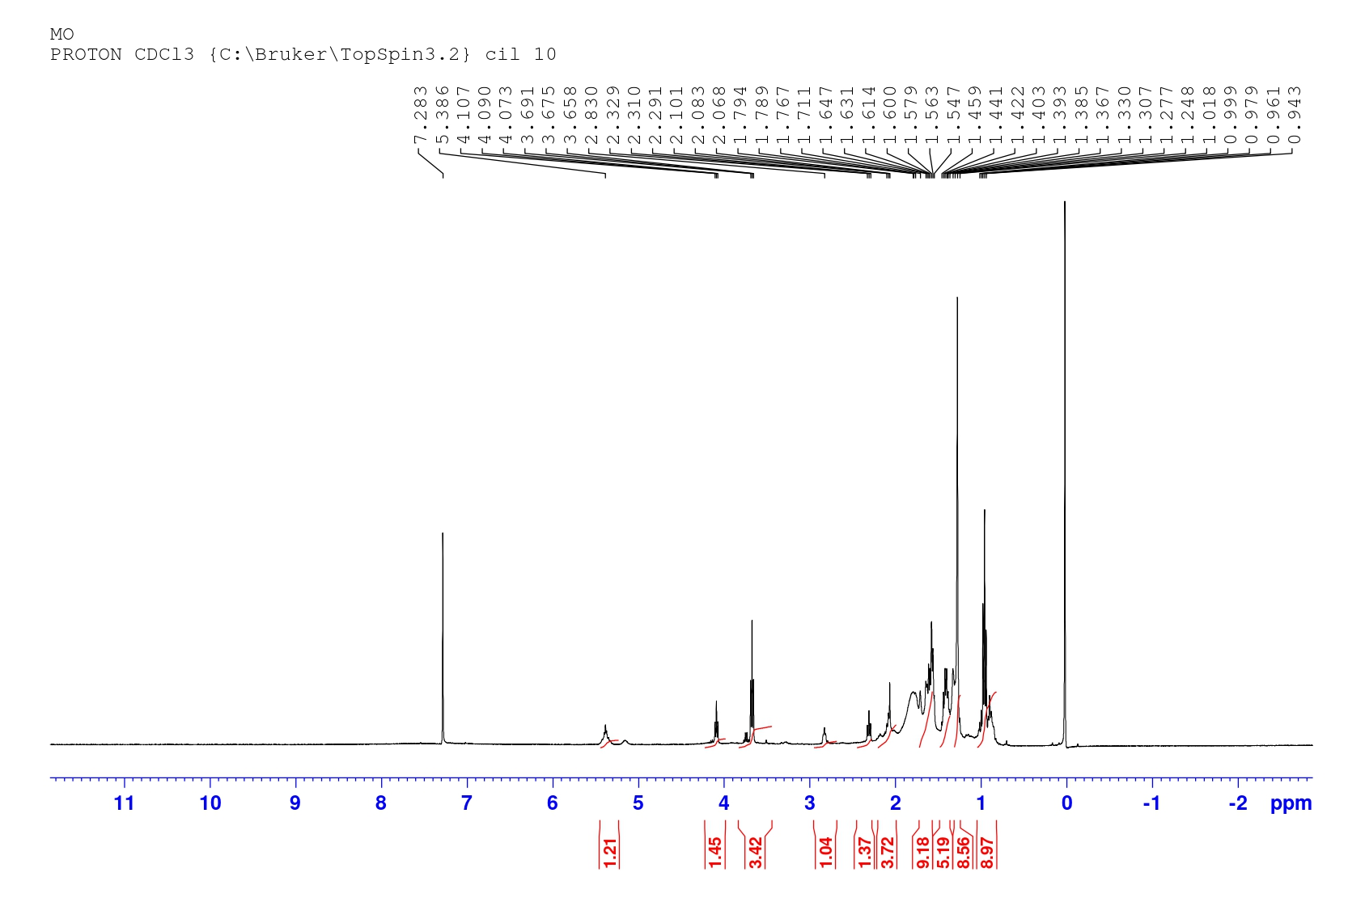
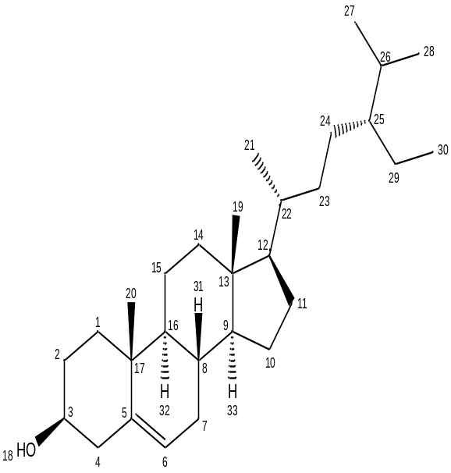
Figure 1: ^{H}NMR spectrum of different chromatographic peaks of Moringa oleifera fraction
Table 1: Proton shift position on carbon atom of Moringa oleifera fraction
Sr. No | Carbon | Proton shift (ppm)
1 | C₁ | 1.39, 1.38
2 | C₂ | 1.579, 1.307
3 | C₃ | 3.658
4 | C₄ | 2.291, 2.068
5 | C₅ | No proton
6 | C₆ | 5.386
7 | C₇ | 2.068, 1.794
8 | C₈ | 1.459
9 | C₉ | No proton
10 | C₁₀ | 1.600, 1.367
11 | C₁₁ | 1.547; 1.367
12 | C₁₂ | 1.563
13 | C₁₃ | No proton
14 | C₁₄ | 1.403
15 | C₁₅ | 1.600, 1.307
16 | C₁₆ | 1.600, 1.307
17 | C₁₇ | 1.47
18 | C₁₈ | No proton
19 | C₁₉ | 1.30
20 | C₂₀ | 1.459
21 | C₂₁ | No proton
22 | C₂₂ | 1.647
23 | C₂₃ | 1.307
24 | C₂₄ | 1.307
25 | C₂₅ | 1.459
26 | C₂₆ | 1.794
27 | C₂₇ | 1.307
28 | C₂₈ | 1.307
29 | C₂₉ | 1.563
30 | C₃₀ | 1.307
31 | C₃₁ | 1.459
32 | C₃₂ | 1.411
33 | C₃₃ | 1.403

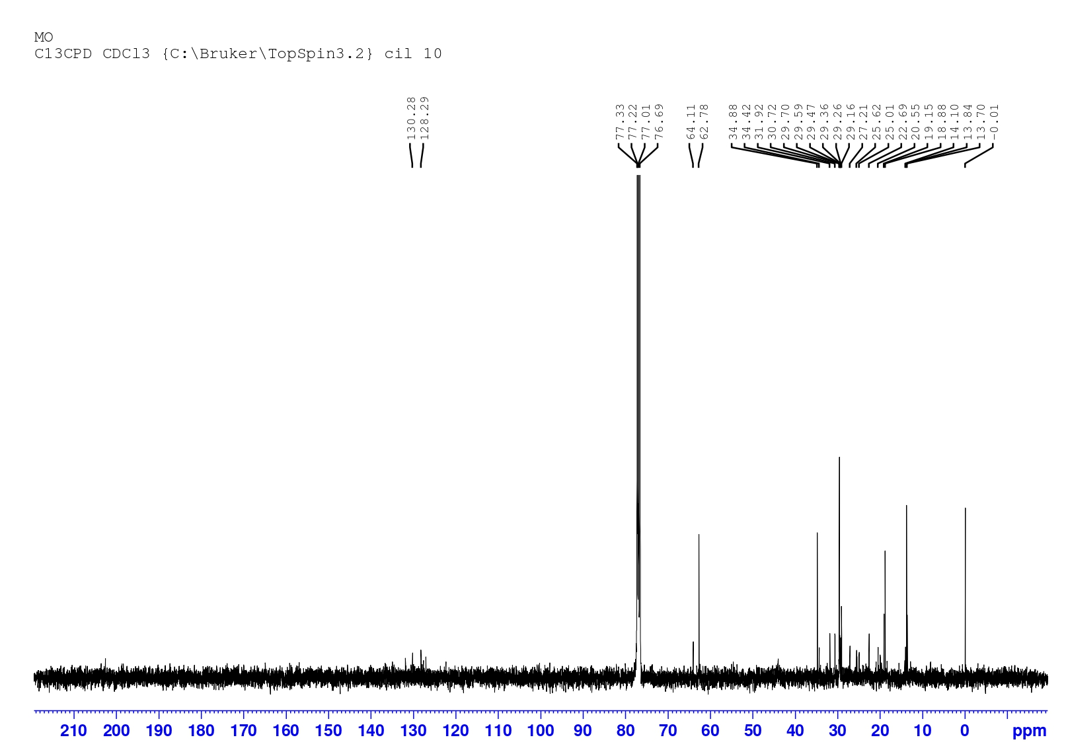
Figure 2: ^{C}NMR spectrum of different chromatographic peaks of Moringa oleifera fraction

Table 2: Carbon shift position on carbon atom of Moringa oleifera fraction
Sr. No. | Carbon | Carbon shift (ppm)
1 | C₁ | 34.88
2 | C₂ | 31.92
3 | C₃ | 64.11
4 | C₄ | 34.88
5 | C₅ | 34.88
6 | C₆ | 64.11
7 | C₇ | 31.92
8 | C₈ | 31.92
9 | C₉ | 62.78
10 | C₁₀ | 25.62
11 | C₁₁ | 25.62
12 | C₁₂ | 62.78
13 | C₁₃ | 34.88
14 | C₁₄ | 34.88
15 | C₁₅ | 20.55
16 | C₁₆ | 62.78
17 | C₁₇ | 34.88
18 | C₁₈ | No carbon
19 | C₁₉ | 13.70
20 | C₂₀ | 19.3
21 | C₂₁ | 19.3
22 | C₂₂ | 34.88
23 | C₂₃ | 34.42
24 | C₂₄ | 22.69
25 | C₂₅ | 34.88
26 | C₂₆ | 30.72
27 | C₂₇ | 20.55
28 | C₂₈ | 22.69
29 | C₂₉ | 22.69
30 | C₃₀ | 13.70
31 | C₃₁ | No carbon
32 | C₃₂ | No carbon
33 | C₃₃ | No carbon

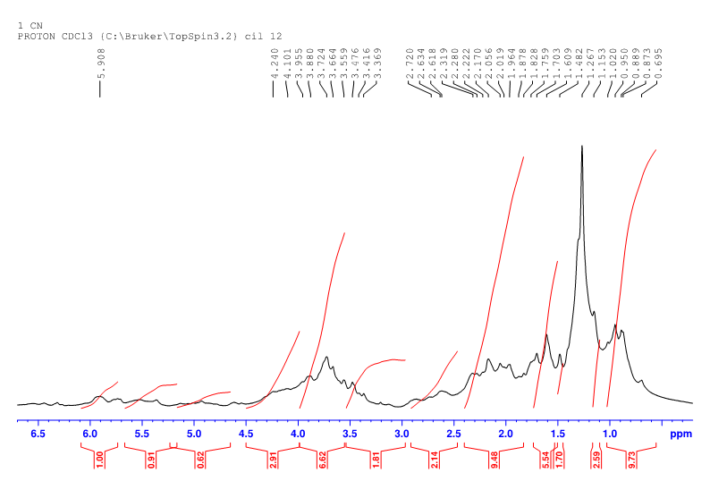
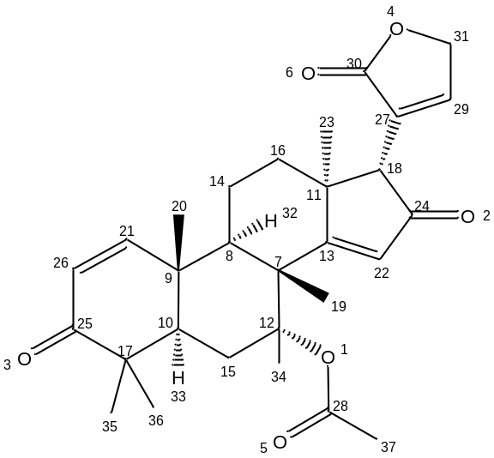
Figure 3: ^{H}NMR spectrum of different chromatographic peaks of Azadirachta indica fraction
Table 3: Proton shift position on carbon atom of Azadirachta indica fraction
Sr. No. | Carbon neem | Proton shift (ppm)
1 | C₁ | No proton
2 | C₂ | No proton
3 | C₃ | No proton
4 | C₄ | No proton
5 | C₅ | No proton
6 | C₆ | No proton
7 | C₇ | No proton
8 | C₈ | No proton
9 | C₉ | No proton
10 | C₁₀ | No proton
11 | C₁₁ | No proton
12 | C₁₂ | No proton
13 | C₁₃ | No proton
14 | C₁₄ | 1.153, 1.267
15 | C₁₅ | 1.759, 1.482
16 | C₁₆ | 1.153, 1.267
17 | C₁₇ | No proton
18 | C₁₈ | 2.720
19 | C₁₉ | 1.267
20 | C₂₀ | 1.267
21 | C₂₁ | 5.908
22 | C₂₂ | 4.240
23 | C₂₃ | 1.267
24 | C₂₄ | No proton
25 | C₂₅ | 2.720
26 | C₂₆ | 5.908
27 | C₂₇ | No proton
28 | C₂₈ | No proton
29 | C₂₉ | No proton
30 | C₃₀ | No proton
31 | C₃₁ | 4.240
32 | C₃₂ | 1.482
33 | C₃₃ | 1.609
34 | C₃₄ | 1.482
35 | C₃₅ | 1.267
36 | C₃₆ | 1.267
37 | C₃₇ | 2.222
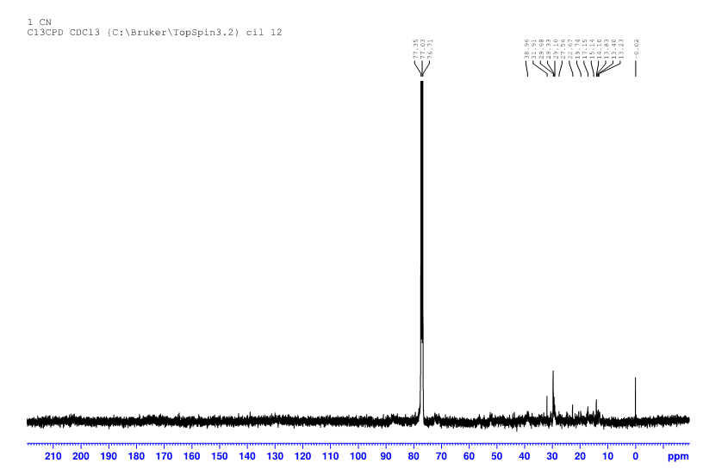
Figure 4: ^{C}NMR spectrum of different chromatographic peaks of Azadirachta indica fraction
Table 4: Carbon shift position on carbon atom of Azadirachta indica fraction
Sr. No. | Carbon | Carbon shift (ppm)
1 | C₁ | No carbon
2 | C₂ | No carbon
3 | C₃ | No carbon
4 | C₄ | No carbon
5 | C₅ | No carbon
6 | C₆ | No carbon
7 | C₇ | 38.96
8 | C₈ | 38.96
9 | C₉ | 38.96
10 | C₁₀ | 38.96
11 | C₁₁ | 38.96
12 | C₁₂ | 76.71
13 | C₁₃ | 77.53
14 | C₁₄ | 15.14
15 | C₁₅ | 29.10
16 | C₁₆ | 29.68
17 | C₁₇ | 38.96
18 | C₁₈ | 38.96
19 | C₁₉ | 15.14
20 | C₂₀ | 19.74
21 | C₂₁ | 77.53
22 | C₂₂ | 77.53
23 | C₂₃ | 22.67
24 | C₂₄ | 77.53
25 | C₂₅ | 77.53
26 | C₂₆ | 77.53
27 | C₂₇ | 77.53
28 | C₂₈ | 77.53
29 | C₂₉ | 77.53
30 | C₃₀ | 77.53
31 | C₃₁ | 76.71
32 | C₃₂ | No carbon
33 | C₃₃ | No carbon
34 | C₃₄ | 19.74
35 | C₃₅ | 22.67
36 | C₃₆ | 22.67
37 | C₃₇ | 22.67

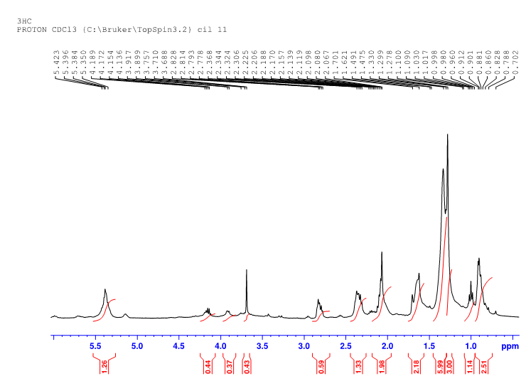
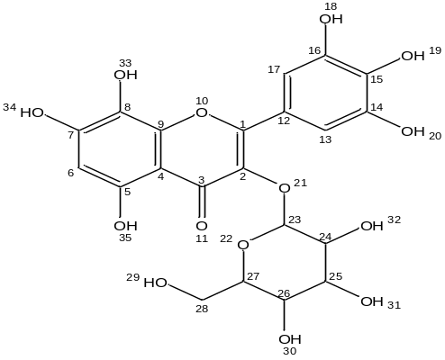
Figure 5: ^{H}NMR spectrum of different chromatographic peak of Hibiscus sabdariffa fraction
Table 5: Proton shift position on carbon atom of Hibiscus sabdariffa fraction
Sr. No. | Carbon | Proton shift (ppm)
1 | C₁ | No proton
2 | C₂ | No proton
3 | C₃ | No proton
4 | C₄ | No proton
5 | C₅ | No proton
6 | C₆ | 5.423
7 | C₇ | No proton
8 | C₈ | No proton
9 | C₉ | No proton
10 | C₁₀ | No proton
11 | C₁₁ | No proton
12 | C₁₂ | No proton
13 | C₁₃ | 5.423
14 | C₁₄ | No proton
15 | C₁₅ | No proton
16 | C₁₆ | No proton
17 | C₁₇ | 5.423
18 | C₁₈ | 5.350
19 | C₁₉ | 5.350
20 | C₂₀ | 5.350
21 | C₂₁ | No proton
22 | C₂₂ | No proton
23 | C₂₃ | 5.423
24 | C₂₄ | 3.710
25 | C₂₅ | 3.688
26 | C₂₆ | 3.688
27 | C₂₇ | 3.757
28 | C₂₈ | 3.757; 2.828
29 | C₂₉ | 2.206
30 | C₃₀ | 3.688
31 | C₃₁ | 2.828
32 | C₃₂ | 2.306
33 | C₃₃ | 5.350
34 | C₃₄ | 5.350
35 | C₃₅ | 5.350

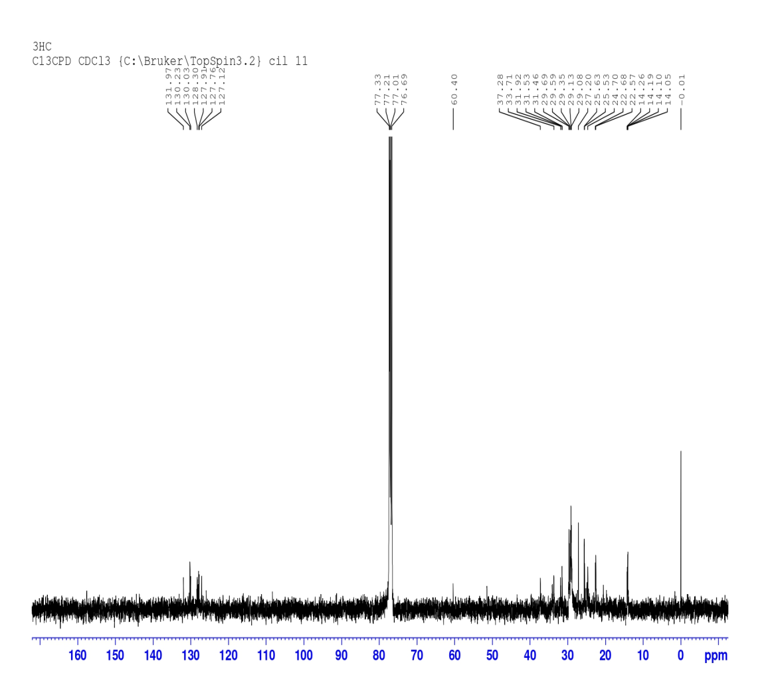
Figure 6: ^{C}NMR spectrum of different chromatographic peaks of Hibiscus sabdariffa fraction
Table 6: Carbon shift position on carbon atom of Hibiscus sabdariffa fraction
Sr. No. | Carbon | Carbon shift (ppm)
1 | C₁ | 131.97
2 | C₂ | 131.97
3 | C₃ | 131.97
4 | C₄ | 127.12
5 | C₅ | 131.97
6 | C₆ | 77.33
7 | C₇ | 131.97
8 | C₈ | 128.30
9 | C₉ | 131.97
10 | C₁₀ | No carbon
11 | C₁₁ | No carbon
12 | C₁₂ | 127.12
13 | C₁₃ | 127.12
14 | C₁₄ | 127.12
15 | C₁₅ | 130.23
16 | C₁₆ | 131.97
17 | C₁₇ | 77.33
18 | C₁₈ | No carbon
19 | C₁₉ | No carbon
20 | C₂₀ | No carbon
21 | C₂₁ | No carbon
22 | C₂₂ | No carbon
23 | C₂₃ | 127.12
24 | C₂₄ | 76.69
25 | C₂₅ | 77.01
26 | C₂₆ | 76.69
27 | C₂₇ | 60.04
28 | C₂₈ | 60.04
29 | C₂₉ | No carbon
30 | C₃₀ | No carbon
31 | C₃₁ | No carbon
32 | C₃₂ | No carbon
33 | C₃₃ | No carbon
34 | C₃₄ | No carbon
35 | C₃₅ | No carbon

