Supplementary Materials
Evolutionary drivers of invasion: hybridization and local adaptation in the Amazon sailfin catfish
Supplementary Methods
Riparian Quality Index Method (RQI)
We evaluated the ecological status of riparian systems using the Riparian Quality index (RQI) developed by [1] and enhanced in 2011 by [2]. Here, we considered the main sources of riparian ecological functions and environmental services, and initially, we characterized the hydromorphological and ecological conditions of riparian systems. For the evaluation of the slopes, we conducted a route by boat and by foot in sections of 250-meters, where we evaluated each of the seven characteristics established in the index (described below).
The index is based on ecological principles of river behavior to evaluate the deviation from “natural” or reference conditions of riparian systems and thereby establish a scoring system to determine existing differences. The RQI evaluates riparian systems using three physical attributes of riparian structure (terrain dimensions, longitudinal continuity and vegetation structure) and other four attributes related to riparian function (natural regeneration, bank condition, lateral connectivity and riparian substrate).
Current conditions are compared with theoretical “natural or reference” conditions, defined as the absence of human impacts and based on river typology. RQI scores for the assessment of each attribute are shown.
For the riparian system assessment, we assessed the attributes of riparian structure following the score tables provided by [2], which consider several degrees of impact from human activities from low impact to completely transformed based on five categories (very good, good, moderate, poor and bad). These assessments were applied to each riverbank separately, from which six scores were obtained. We also assessed the attributes related to riparian function following the same method as before. The assessment was applied to both riverbanks, from which four scores were obtained. The final RQI score for each study site/location is obtained by summing the values of the 10 scores. The summed values will range from 150-130 (very good), 129-100 (good), 99-70 (moderate), 69-40 (poor), 39- 10 (bad), <10 (very bad), see details in [2].

References
- González del Tánago, M., García De Jalón, D., Lara, F. & Garilleti, R. Riparian Quality Index (RQI) for Assessing Riparian Conditions in the Context of the Water Framework Directive. Ing. Civ. 143, 97–108 (2006).
- González del Tánago, M. & García de Jalón, D. Riparian Quality Index (RQI): A methodology for characterising and assessing the environmental conditions of riparian zones. Limnetica 30, 235–254 (2011).

Supplementary material
Table S1. Functional annotation of candidate loci under selection identified in the armored catfish (Pterygoplichthys sp.) from the Grijalva-Usumacinta River basins, retrieved from two of three analyses (pcadapt, LFMM and Bayescan*). The posterior probability (P), false discovery rate (FDR), locus-specific component (alpha value; a positive alpha value suggests diversifying selection, whereas negative values suggest balancing or purifying selection), and annotation are shown.
Method | Locus ID | P | qval (FDR) | Alpha | F_{ST} | Annotation
LFMM_sal | 1064 | 0.0864 | 0.9041 | -0.0240 | 0.0099 | Teneurin3
LFMM_sal | 1036 | 0.0880 | 0.9022 | -0.0004 | 0.0102 | Histone acetyltransferase KAT7 isoform
LFMM_sal | 1287 | 0.0824 | 0.9071 | -0.0191 | 0.0099 | -
LFMM_sal | 1368 | 0.0920 | 0.8949 | -0.0122 | 0.0101 | -
LFMM_sal | 1566 | 0.0846 | 0.9058 | -0.0321 | 0.0098 | Transcriptional regulator ERG
LFMM_sal | 1666 | 0.0912 | 0.8968 | -0.01 | 0.0101 | General transcription factor 3C polypeptide
LFMM_sal | 1734 | 0.0828 | 0.9069 | -0.0088 | 0.0101 | Spermidine/spermine N1-acetyltranferase  Diamine acetyltransferase
LFMM_sal | 1827 | 0.0880 | 0.9023 | -0.0065 | 0.0101 | Rab11 family-interaction protein 5-like isoform
LFMM_sal | 1828 | 0.0862 | 0.9043 | -0.0201 | 0.0099 | Histone deacetylase complex subunit SAP30L
LFMM_sal | 1829 | 0.0896 | 0.8998 | -0.0154 | 0.0100 | probable E3 ubiquitin-protein ligase makorin-2
LFMM_sal | 1902 | 0.0830 | 0.9068 | -9.00E-04 | 0.0102 | Nardilisyn
LFMM_sal | 2165 | 0.0916 | 0.8957 | -0.0094 | 0.0101 | ectonucleoside triphosphate diphosphohydrolase 6
LFMM_sal | 224 | 0.0828 | 0.9069 | -0.0073 | 0.0101 | rhamnose binding lectin-like precursor  1 L-rhamnose-binding lectin CSL2
LFMM_sal | 235 | 0.0878 | 0.9026 | -0.0076 | 0.0100 | FYVE, RhoGEF and PH domain-containing protein 3
LFMM_sal | 2536 | 0.0772 | 0.9082 | -0.0117 | 0.0100 | C-myc promoter-binding protein isoform
LFMM_sal | 288 | 0.0890 | 0.9008 | -0.0225 | 0.0099 | protein disulfide-isomerase A3 precursor
LFMM_sal | 413 | 0.0876 | 0.9028 | -0.0145 | 0.0100 | colony stimulating factor 2 receptor, beta, low-affinity (granulocyte-macrophage)
LFMM_sal | 789 | 0.0962 | 0.8821 | -0.0098 | 0.0101 | catenin alpha-1
LFMM_sal | 988 | 0.0886 | 0.9014 | -0.007 | 0.0101 | COP9 signalosome complex subunit 8
LFMM_RQI | 1129 | 0.0838 | 0.9063 | -0.0135 | 0.0100 | poly(U)-specific endoribonuclease-C precursor
LFMM_RQI | 1142 | 0.0878 | 0.9026 | -0.0095 | 0.0100 | dnaJ homolog subfamily A member 2
LFMM_RQI | 135 | 0.0874 | 0.903 | -0.0203 | 0.0099 | protein yippee-like 5  ADP-ribosylation factor-like protein 6-interacting protein 1
LFMM_RQI | 1624 | 0.0828 | 0.9069 | -0.0238 | 0.0098 | glutamic acid-rich protein isoform
LFMM_RQI | 1699 | 0.0828 | 0.9069 | -0.0031 | 0.0102 | RNA-binding protein 10-like isoform
LFMM_RQI | 1827 | 0.0880 | 0.9023 | -0.0065 | 0.0101 | rab11 family-interacting protein 5-like isoform
LFMM_RQI | 1828 | 0.0862 | 0.9043 | -0.0201 | 0.0099 | histone deacetylase complex subunit SAP30L
LFMM_RQI | 1829 | 0.0896 | 0.8998 | -0.0154 | 0.0100 | probable E3 ubiquitin-protein ligase makorin-2 isoform
LFMM_RQI | 2192 | 0.0930 | 0.892 | -0.0256 | 0.0099 | nucleoporin p58/p45 isoform
LFMM_RQI | 2217 | 0.0856 | 0.9049 | -0.0141 | 0.0100 | -
LFMM_RQI | 2218 | 0.0848 | 0.9056 | -0.0172 | 0.0099 | glucose-6-phosphate exchanger SLC37A2
LFMM_RQI | 2221 | 0.0836 | 0.9064 | -0.0136 | 0.0101 | ankyrin repeat domain-containing protein 13C
LFMM_RQI | 2223 | 0.0832 | 0.9067 | -0.0025 | 0.0101 | mitochondrial fission regulator 1
LFMM_RQI | 2536 | 0.0772 | 0.9082 | -0.0117 | 0.0100 | C-myc promoter-binding protein isoform
LFMM_RQI | 269 | 0.0818 | 0.9073 | -0.0187 | 0.0099 | gamma-aminobutyric acid receptor-associated protein
LFMM_RQI | 360 | 0.0932 | 0.8915 | -0.0347 | 0.0098 | importin-5 isoform
LFMM_RQI | 362 | 0.0782 | 0.9081 | -0.014 | 0.0100 | kinesin-like protein KIF13A isoform  EF-hand calcium-binding domain-containing protein 14  E3 ubiquitin-protein ligase TRIP12 isoform  probable C-mannosyltransferase DPY19L1  phosphorylated CTD-interacting factor 1
LFMM_RQI | 414 | 0.0852 | 0.9053 | -0.0145 | 0.0100 | charged multivesicular body protein 5
LFMM_RQI | 555 | 0.0838 | 0.9063 | -0.0296 | 0.0098 | max-interacting protein 1 isoform
LFMM_RQI | 675 | 0.0844 | 0.9059 | -0.0125 | 0.0100 | restin homolog isoform
LFMM_RQI | 862 | 0.0832 | 0.9067 | -0.0031 | 0.0101 | pendrin isoform
LFMM_RQI | 898 | 0.0948 | 0.887 | -0.0202 | 0.0100 | arginine vasopressin-induced protein  integrin alpha-2-like isoform  sarcospan
LFMM_RQI | 971 | 0.08116 | 0.9073 | -0.0161 | 0.0099 | lysine-specific demethylase 5C  lysine-specific demethylase 5B isoform
LFMM_RQI | 973 | 0.0888 | 0.9011 | -0.0129 | 0.0100 | ATP synthase, H+ transporting, mitochondrial F0 complex, subunit c3 (subunit 9) b isoform
LFMM_RQI | 385 | 0.1196 | 0.8014 | 0.0818 | 0.0117 | Mitogen-activated protein Kinase (MAPK)
LFMM_RQI | 542 | 0.0906 | 0.8979 | 0.0216 | 0.0106 | Mitogen-activated protein Kinase (MAPK)
pcadapt | 1538 | 0.0944 | 0.8882 | -0.0082 | 0.0102 | Interferon-induced protein 35
pcadapt | 1982 | 0.0894 | 0.9001 | -0.0149 | 0.0100 | TSC22 domain family protein 1 isoform
*BayeScan does not appear because only those SNPs that were recovered by at least two of the three methods were annotated.

Fig. S1. a) Principal component analysis (PCA) (explains 4.43 % of variance), and b) Discriminant analysis of principal components (DACP) (explains 2.64 % of variance), based on 22,595 de novo SNPs database, depicting the distribution of genetic variation according to morphotypes reported for the armored catfish from the Grijalva-Usumacinta region in Mexico. Pd: P. disjunctivus, Pd: P. pardalis and Psp: Pterygoplichthys sp.

Fig. S2. a) Cross validation of admixture analysis, and b) genetic lineages in armored catfish from the Grijalva-Usumacinta region with ADMIXTURE.

Fig. S3. Venn diagram of candidate loci identified by three methods (pcadapt, LFMM and BayeScan) and their interactions. Candidate loci analyses were conducted on the 3,059 SNPs dataset from transcriptome-based SNP calling.

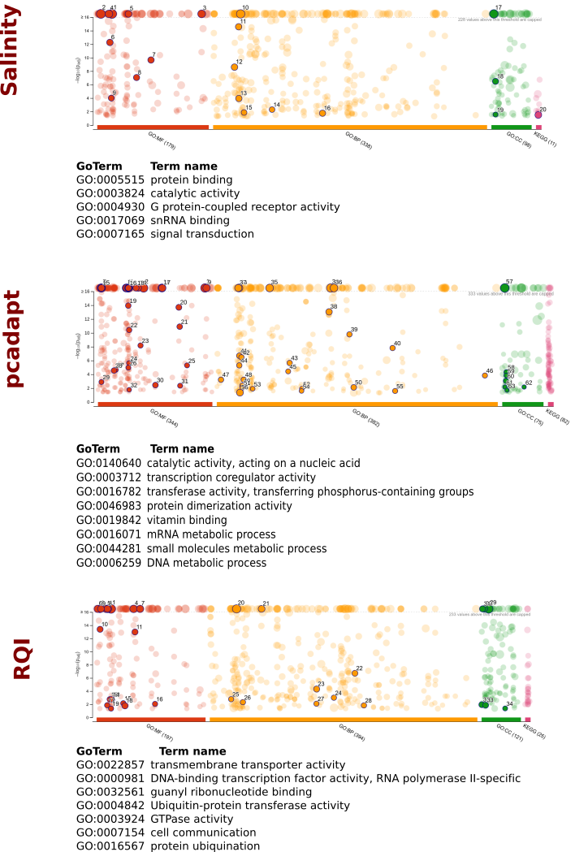
Fig. S4. GoTerms enrichment analysis of unigenes associated with salinity and RQI variables.

