Supplemental Figures and Legends

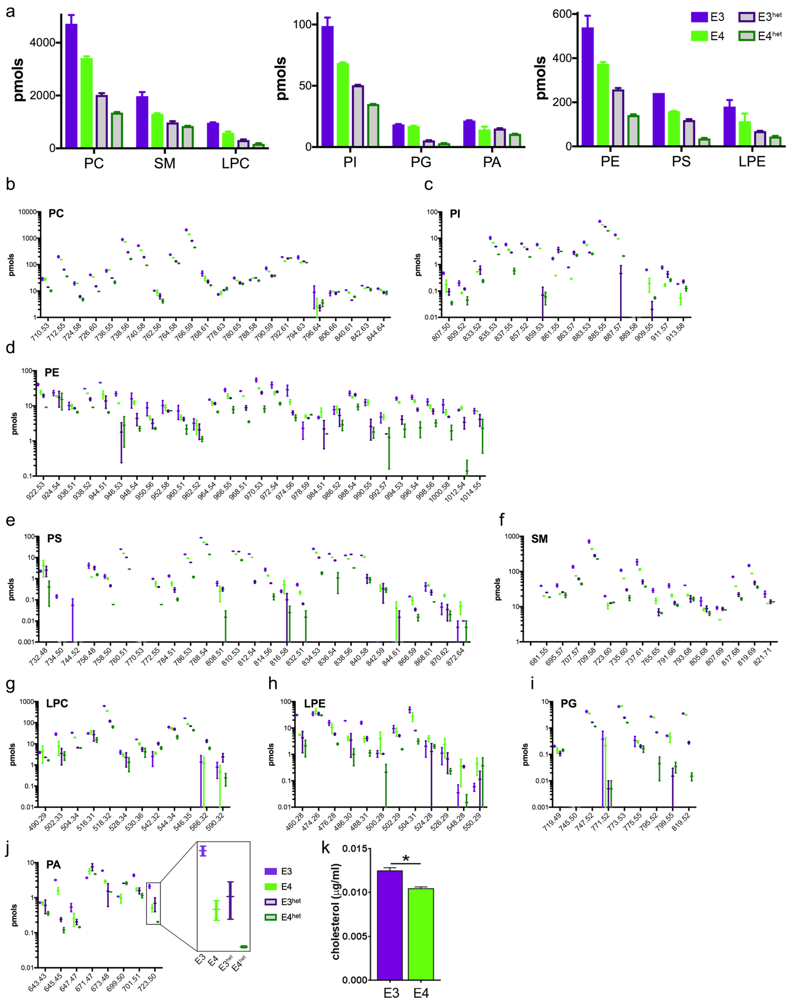Supplemental Figure 1: APOE4 native lipoproteins are less lipidated with unique lipid specie profiles. (supplemental to Figure 1)
(a) E3 or E4 native lipoproteins were derived from pooled samples of astrocyte conditioned media from APOE3 or APOE4 primary astrocytes as well as lipoproteins derived from APOE3/Abca1^{het} and APOE4/Abca1^{het} astrocytes and analyzed by shotgun lipidomics. Lipoproteins derived from E3^{het} and E4^{het} astrocytes were used as negative controls and demonstrated half of the phospholipid amount of their wild-type counterparts. Note the reduction of phospholipid level in the following order: E3 > E4 > E3^{het} > E4^{het}. Lipid species-specific analysis of Phosphatidylcholine, PC (b); Phosphatidylinositol, PI (c); Phosphatidylethanolamine, PE (d); Phosphatidylserine, PS (e); Sphingomyelin, SM (f); Lysophosphatidylcholine, LPC (g); Lysophosphatidylethanolamine, LPE (h); Phosphatidylglycerol, PG (i); and Phosphatidic acid, PA (j). (k) Cholesterol concentration of the native E3 and E4 was measured using a commercial kit. Bars represent mean ± SEM and Box and Whiskers represent the interquartile range and mean.

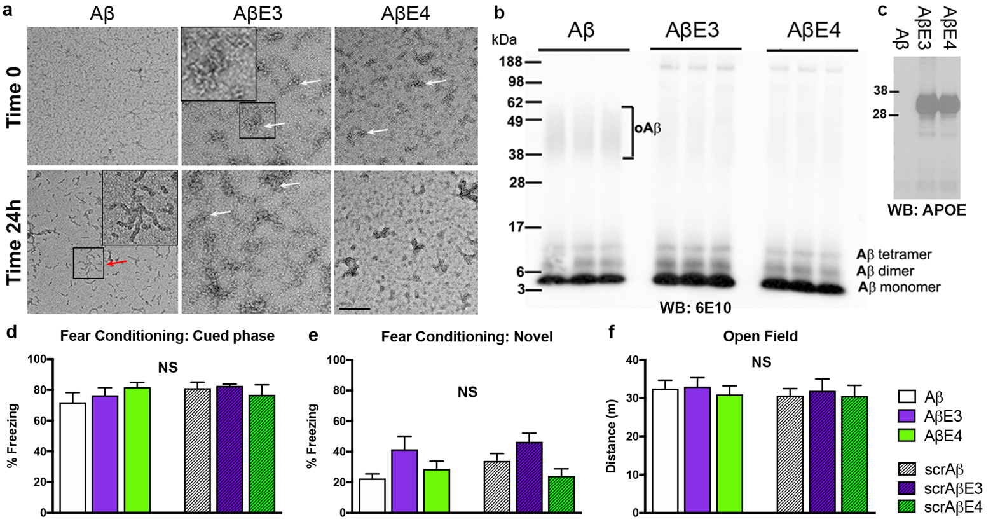Figure 2: Effect of native E3 and E4 lipoproteins on Aβ aggregation and behavior. (supplemental to Figure 2)
(a-c) The effect native E3 and E4 lipoproteins on Aβ aggregation was tested using a disaggregated Aβ monomer as before²⁹. Monomeric Aβ42 (10 µM) was pre-incubated with either PBS or native E3 or E4 lipoproteins (1 µM) for 24 h at oligomer forming conditions. The presence of Aβ oligomers after 24 h incubation was determined by electron microscopy (a) and Western blotting (b). (a) Electron micrographs of Aβ +/- APOE at the start of incubation (Time 0) and after 24 h (Time 24 h). Red arrow and inset point to Aβ oligomers in Aβ + PBS preparations. White arrows and inset point to native APOE lipoproteins that are visualized as discs. Scale bar is 100 nm. (b) Aliquots from the same Aβ42 preparations were resolved on SDS-NuPAGE gel and probed with anti-Aβ antibody (6E10). Brackets point toward Aβ oligomers. (c) WB for APOE demonstrates the same amount of E3 and E4 was used. (d-f). Behavior controls show no significant differences between the groups for fear conditioning and novel object recognition tests. Aβ, AβE3 and AβE4 were infused into the cortex of WT mice and cognition examined. Scrambled Aβ (scrAβ) was used as negative controls (scrAβ, scrAβE3, and scrAβE4). All mice were infused 30 min prior to training on days 2 through 6 of behavioral testing. (d-e) There is no significant difference in percent freezing during the cued phase (d) or novel phase (e) of the contextual-cued fear conditioning for all experimental groups assessed. (f) There is no significant difference in total distance (m) traveled during the open field during day 1 of the novel object recognition. Both suggest that differences in performance during fear conditioning and novel object recognition are due to changes in cognitive function. Analysis by one-way ANOVA followed by Tukeys multiple comparison test. N=12 for Aβ +/- E3 or E4, and N=8 for scrAβ controls. Bars represent mean ± SEM. NS= no significance.

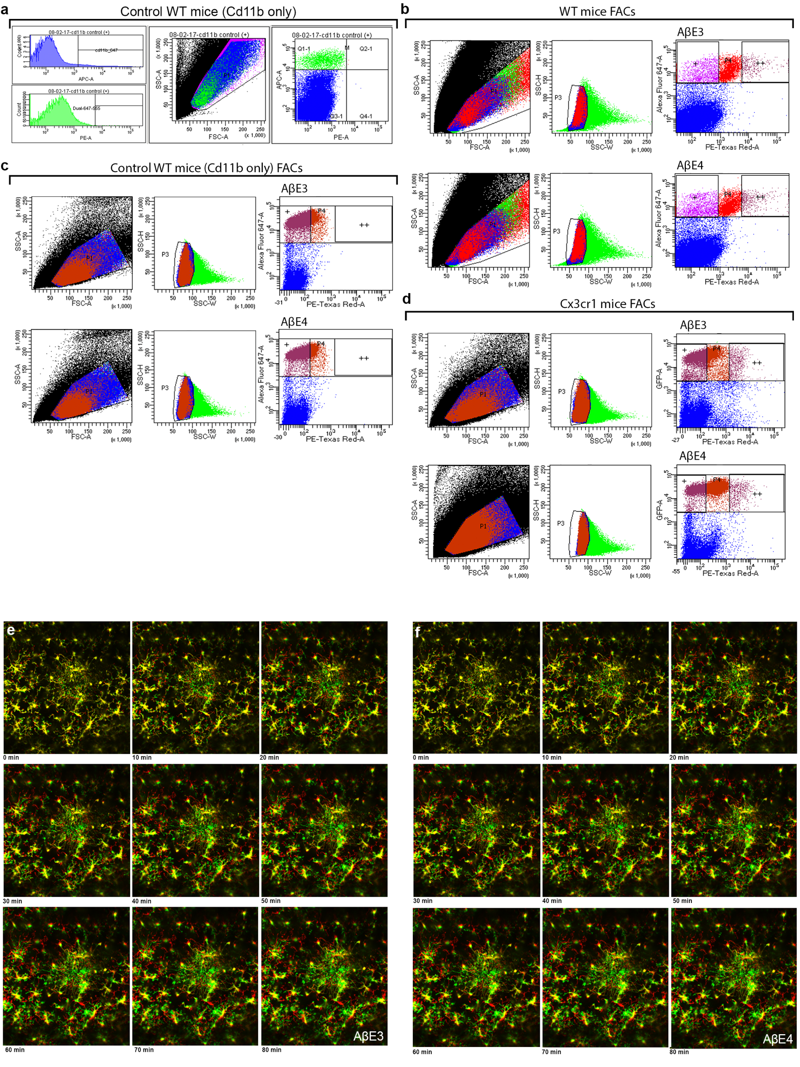Supplemental Figure 3: In vivo microglial interaction with Aβ is affected by APOE isoform over time. (supplemental to Figure 3)
WT and Cx3cr1^{GFP} mice were infused with control, 555-labeled Aβ42 pre-incubated with E3 (AβE3) or E4 (AβE4). Q1-1 corresponds to cells that are CD11b^{High}/Aβ-555^{Low} and are counted as single+ cells. The Q2-1 correspond to CD11b^{High}/Aβ-555^{High} cells counted as dual+. (a) WT control injected mice show no cells in Q2-1 quadrant labeled as dual positive. (b-d) Flow cytometry results showing all cells, followed by removing multiple cells, and finally separating by microglia marker high (CD11b or Cx3cr1^{GFP}) and 555-labeled Aβ. This allows for the identification of single+ and dual+ cells in control (b), WT (c), and Cx3cr1^{GFP} (d) mice. Hilyte™-555-labeled Aβ pre-incubated with native E3 or E4 particles and microglia tracked in real time using two-photon imaging. Time series are color coded with infused Aβ in white; and initial time point in green and later time points in red as indicated below each image from 0-80 min post injection from AβE3 (e) or AβE4 (f) groups.

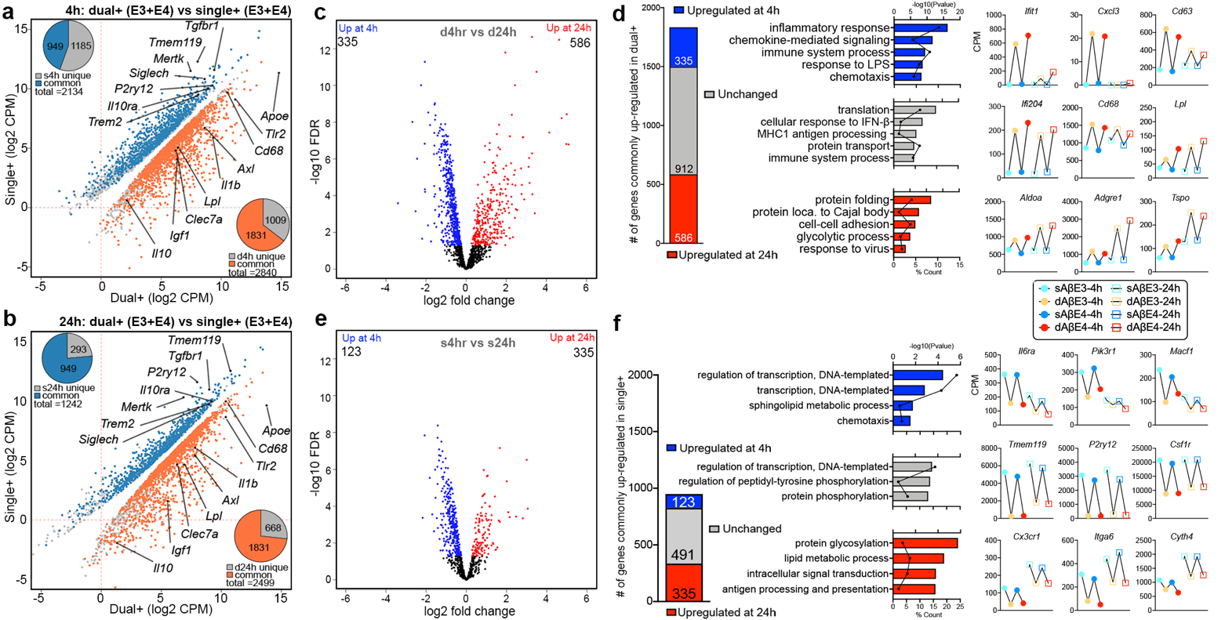Supplemental Figure 4. Comparisons of microglial transcriptome from Cx3cr1^{GFP} mice at 4- and 24-hours post-injection. (supplemental to Figure 4)
(a-b) Scatterplots represent significantly affected transcripts (FDR<0.05) of dual+ vs single+ microglia from Cx3cr1^{GFP} mice at the 4 h (a) or 24 h (b) timepoint. X and Y axes correspond to the log2 average of the count per million (CPM) for dual+ and single+ microglia respectively. Pie charts in the upper left (single+), and lower right (dual+) represent the genes common between, or unique to a single timepoint. (c-f) Comparison of common DEGs in 4 vs 24 h post-injection. Volcano plots and bar plots depict the 1831 commonly differentially expressed in dual+ cells (c) and 949 commonly differentially expressed in single+ cells (e). Grey box indicates non-significantly affected genes; blue, a higher expression at 4h, and red with a higher expression at 24 h (d and f). For each group the GO term bar plots indicate the -log10P value for each term, and the associated center point of each bar represents the percent of submitted genes found in each GO term. Line-patterning graphs show examples of genes from each category.

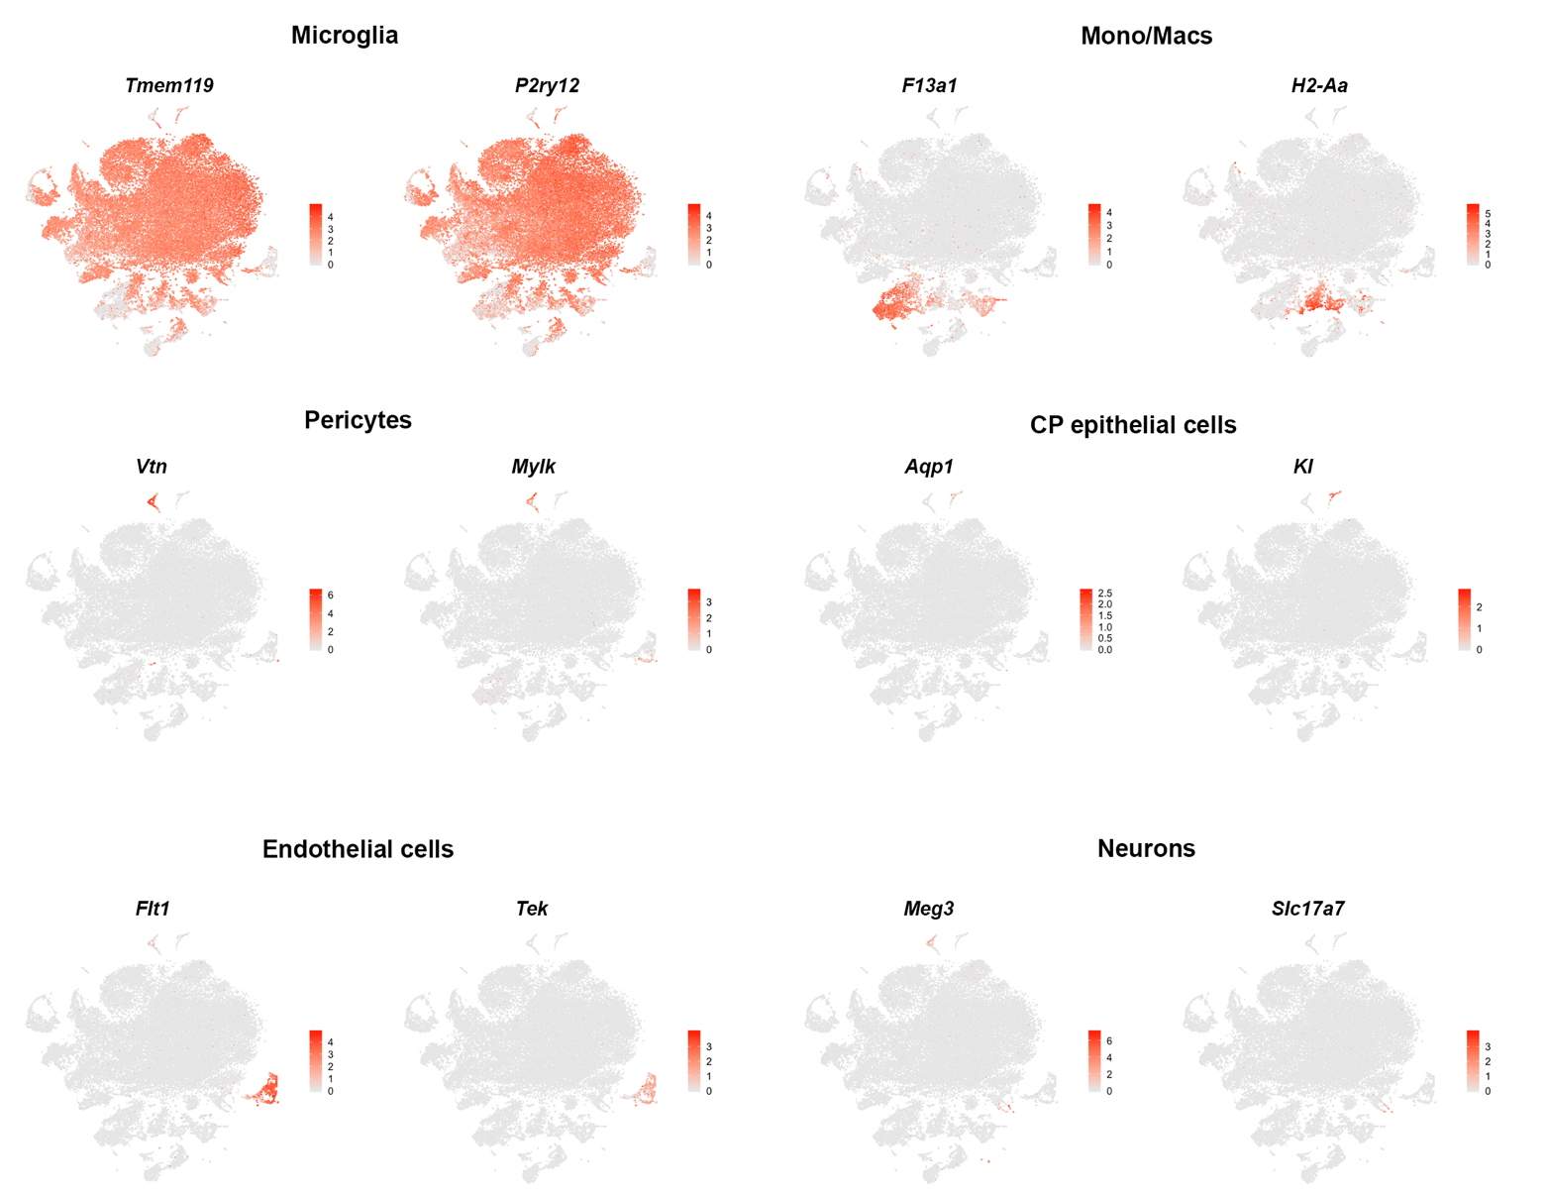Supplemental Figure 5. scRNA-seq cell type specific cluster identification. (supplemental to Figure 5)
Feature plots showing expression of established cell-type specific genes.

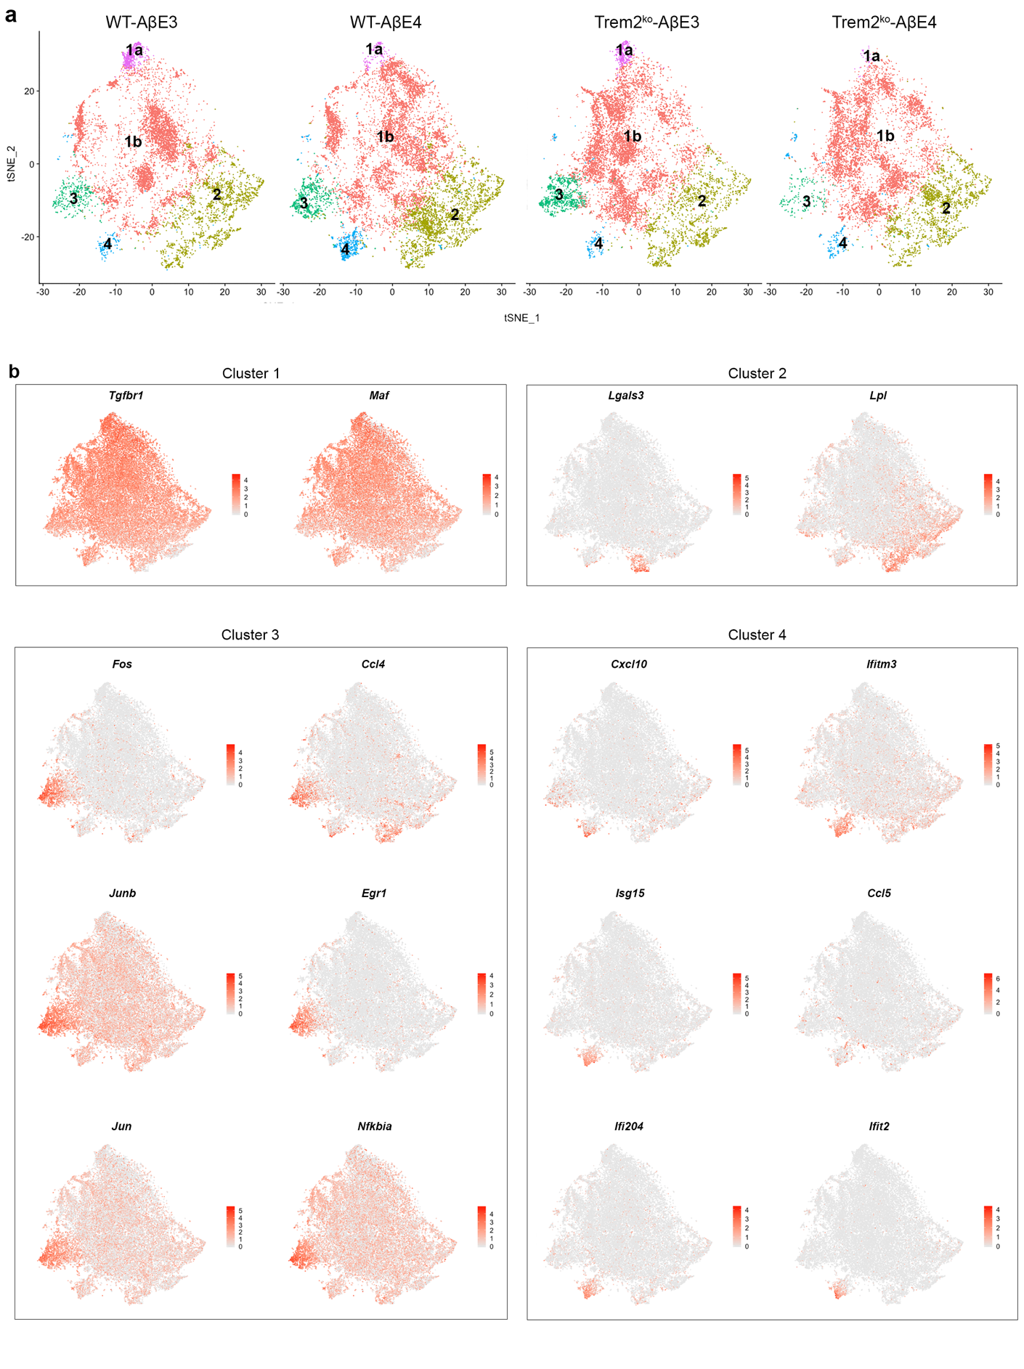Supplemental Figure 6. scRNA-seq Microglia specific sub-clustering. (supplemental to Figure 5-6)
(a) t-SNE plots of microglia from each experimental condition. (b) Feature plots of representative genes in each cluster.

