Supplementary Information
Tailoring Crystal Phase of High-Entropy Alloy Nanoparticles via Redox-Mediated Engineering
Yile Zhang¹, Xingjie Peng², Ziyue Zeng¹, Wu Zhou²*, Mengqi Zeng¹*, Lei Fu^{1,3}*
¹College of Chemistry and Molecular Sciences, Wuhan University, Wuhan 430072, China. ²School of Physical Sciences, University of Chinese Academy of Sciences, Beijing 100049, China. ³Institute for Advanced Studies, Wuhan University, Wuhan 430072, China.
*E-mail: leifu@whu.edu.cn; zengmq_lan@whu.edu.cn; wuzhou@ucas.ac.cn
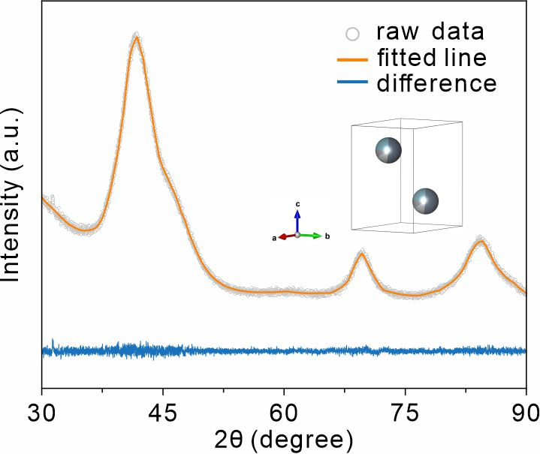
Supplementary Fig. 1 | The fitting of XRD data of fcc-RuPtIrRhOs. The inset shows the unit cell model.
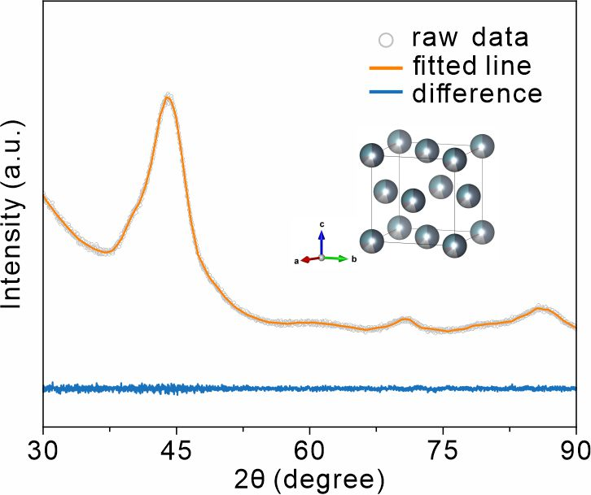
Supplementary Fig. 2 | The fitting of XRD data of hcp-RuPtIrRhOs. The inset shows the unit cell model.
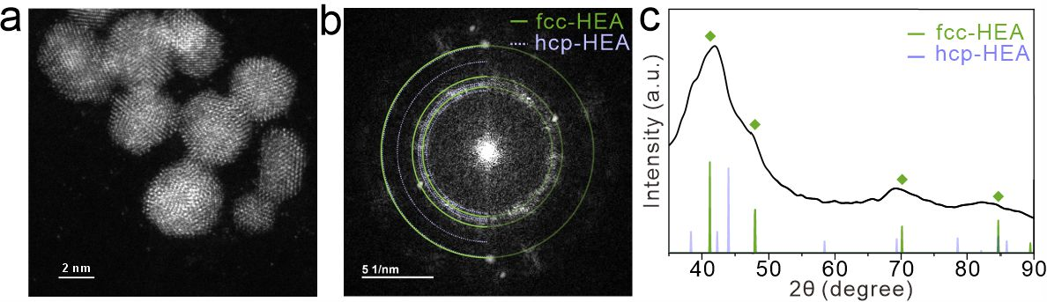
Supplementary Fig. 3 | Structural characterization of multi-element fcc-RuPtIrRhOs nanoparticles. (a) The high-angle annular dark-field scanning transmission electron microscopy (HAADF-STEM) image of multiple fcc-RuPtIrRhOs nanoparticles on a small scale, (b) the corresponding fast Fourier transform (FFT) pattern of (a), and (c) the radial intensity distribution of the FFT in (b).
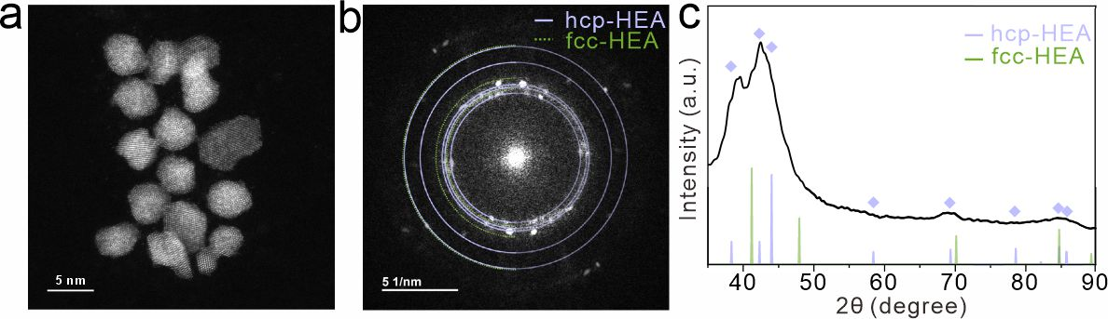
Supplementary Fig. 4 | Structural characterization of multi-element hcp-RuPtIrRhOs nanoparticles. (a) The HAADF-STEM image of of multiple hcp-RuPtIrRhOs nanoparticles on a small scale, (b) the corresponding FFT pattern of (a), and (c) the radial intensity distribution of the FFT in (b).

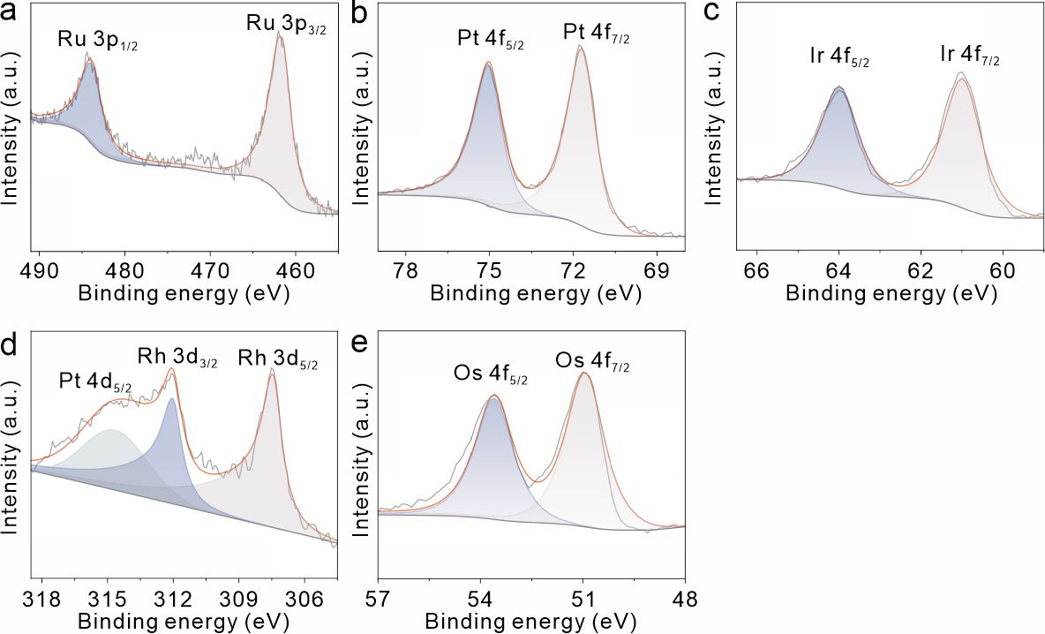
Supplementary Fig. 5 | X-ray photoelectron spectroscopy (XPS) spectra of fcc-RuPtIrRhOs. (a) Ru 3p, (b) Pt 4f, (c) Ir 4f, (d) Rh 3d, and (d) Os 4f.
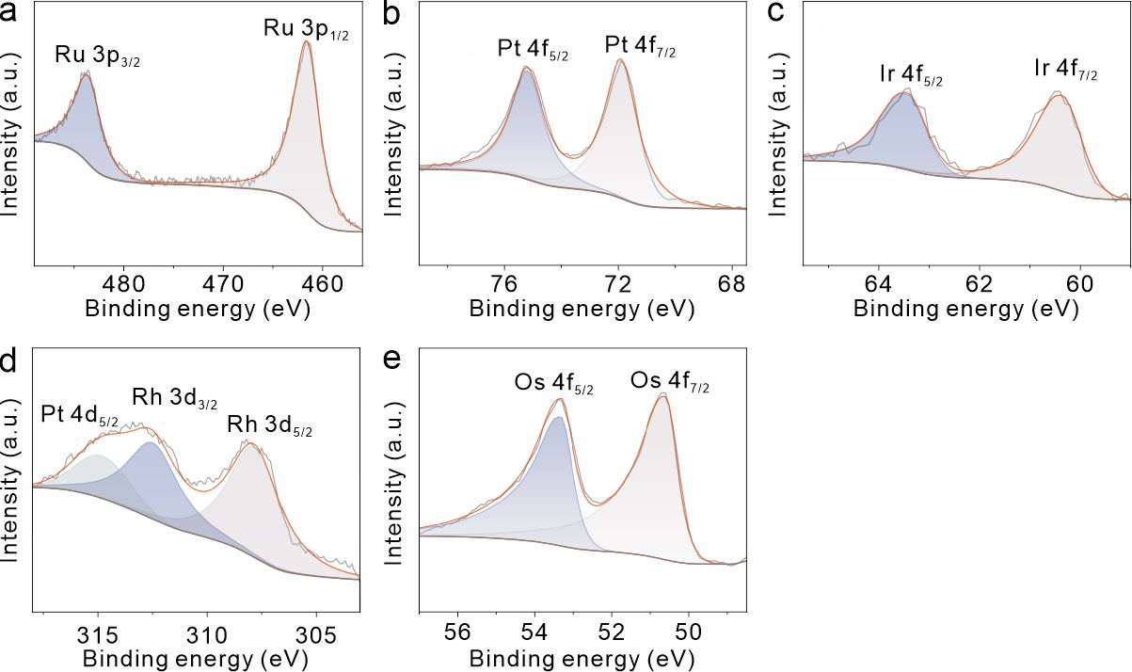
Supplementary Fig. 6 | XPS spectra of hcp-RuPtIrRhOs. (a) Ru 3p, (b) Pt 4f, (c) Ir 4f, (d) Rh 3d, and (d) Os 4f.
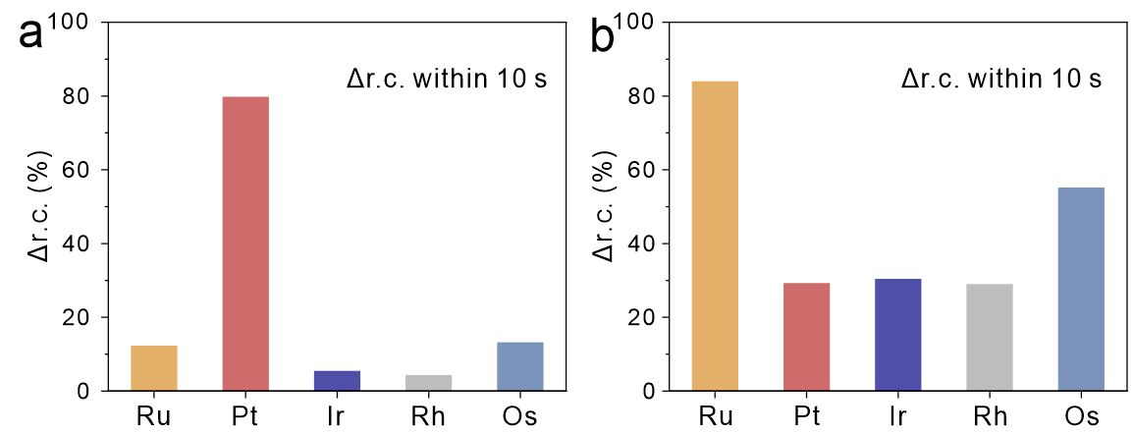
Supplementary Fig. 7 | The average disparity in the relative concentration (∆r.c.) within 10 s of (a) fcc-RuPtIrRhOs and (b) hcp-RuPtIrRhOs.

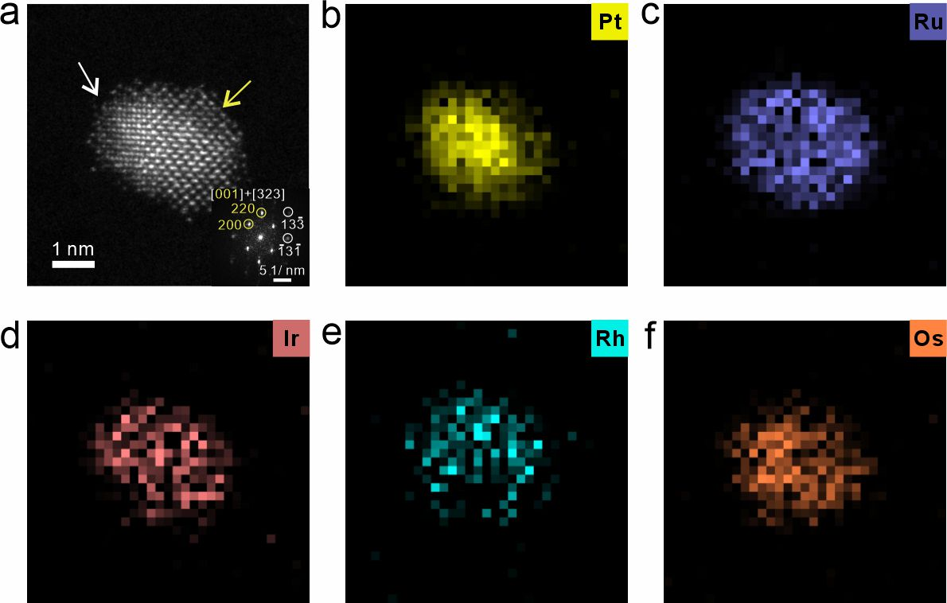
Supplementary Fig. 8 | Elemental maps of a fcc-RuPtIrRhOs nanoparticle. (a) Atomic-resolution HAADF-STEM image. (b-f) STEM energy-dispersive X-ray spectroscopy (STEM-EDS) elemental maps of Ru, Pt, Ir, Rh, and Os, respectively.
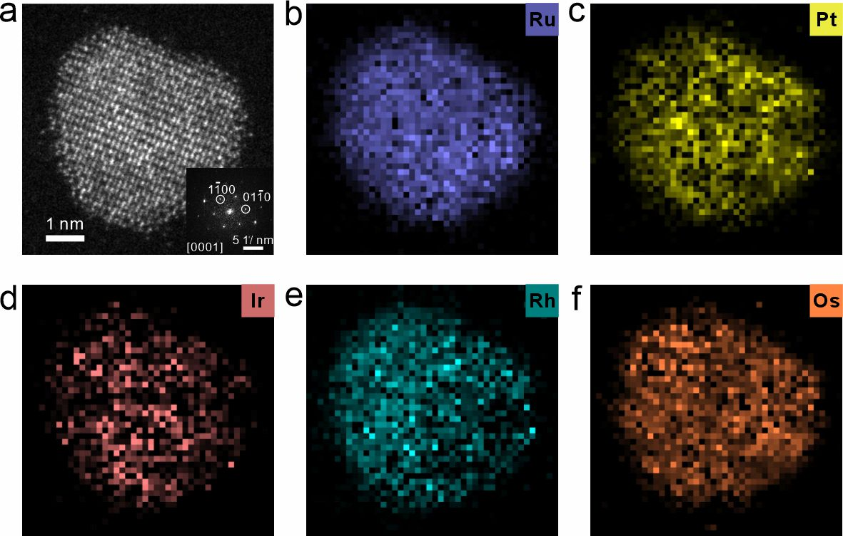
Supplementary Fig. 9 | Elemental maps of a hcp-RuPtIrRhOs nanoparticle. (a) Atomic-resolution HAADF-STEM image. (b–f) STEM energy-dispersive X-ray spectroscopy (STEM-EDS) elemental maps of Ru, Pt, Ir, Rh, and Os, respectively.

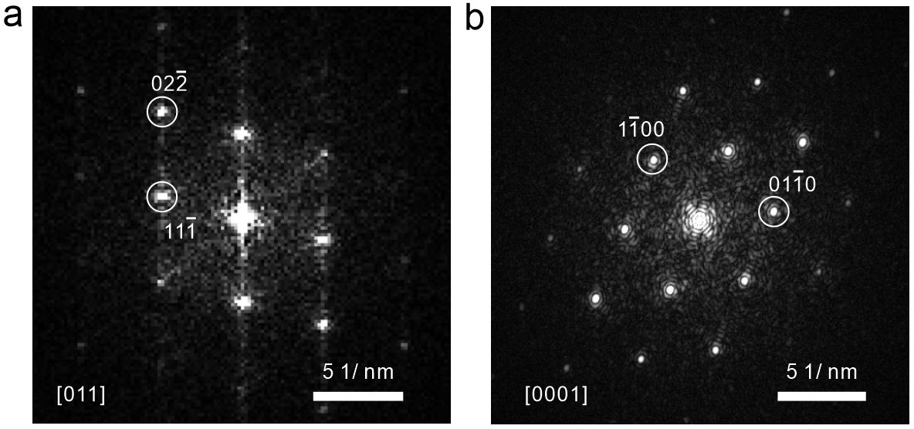
Supplementary Fig. 10 | The corresponding FFT patterns of Figure 3(a) and 3(b), presenting fcc and hcp characteristics, respectively.

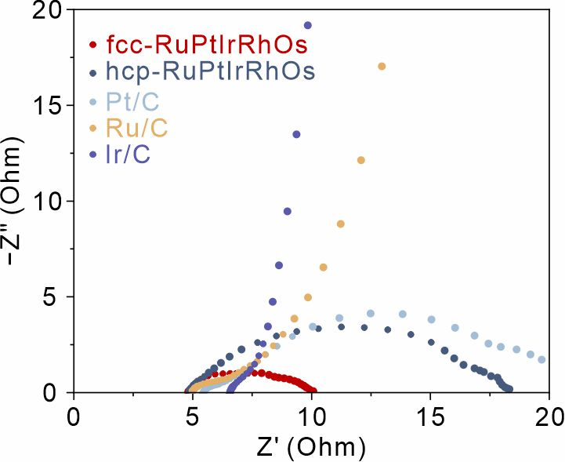
Supplementary Fig. 11 | Electrochemical impedance spectroscopy plots of fcc-RuPtIrRhOs, hcp-RuPtIrRhOs, Pt/C, Ru/C and Ir/C.

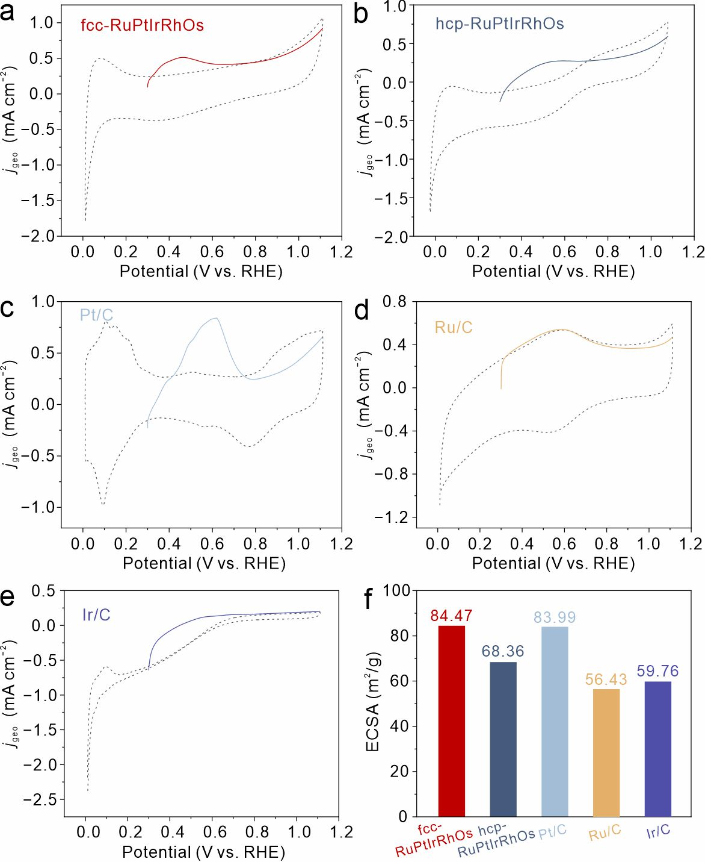
Supplementary Fig. 12 | Electrochemical active surface area (ECSA) comparison of various catalysts. Cyclic voltammetry curves (dashed lines, recorded in 0.5 M H₂SO₄ at 10 mV s⁻¹) and Cu stripping curves (solid lines, recorded in 0.5 M H₂SO₄ and 5 mM CuSO₄ at 10 mV s⁻¹) of (a) fcc-RuPtIrRhOs, (b) hcp-RuPtIrRhOs, (c) Pt/C, (d) Ru/C and (e) Ir/C respectively and (f) the comparison of the ECSAs of the five catalysts.

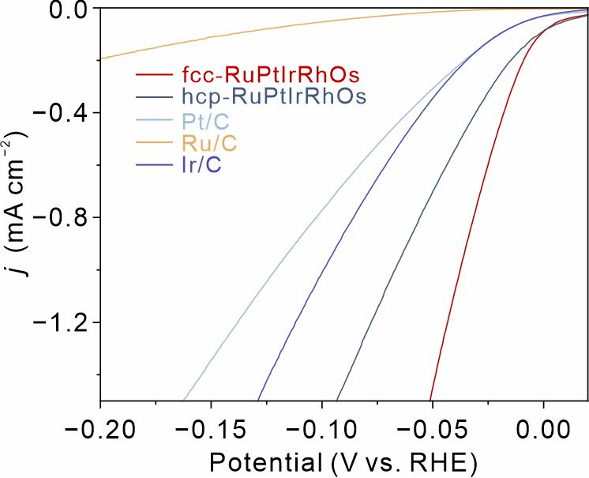
Supplementary Fig. 13 | Polarization curves normalized by ECSAs.
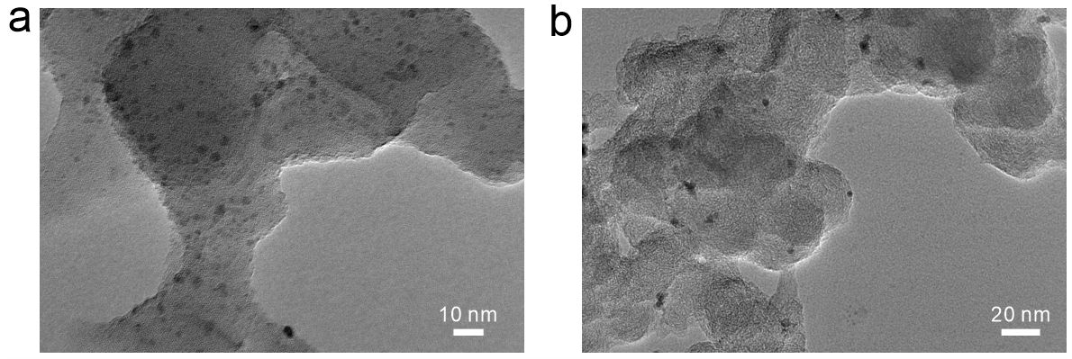
Supplementary Fig. 14 | Structural characterization of fcc- and hcp-RuPtIrRhOs nanoparticles after durability testing. Transmission electron microscopy images of (a) fcc-RuPtIrRhOs and (b) hcp-RuPtIrRhOs after 10,000 cycles of repeated catalytic electrocatalytic hydrogen evolution reaction measurements.
Table S1. Crystal data and structure refinement for fcc-RuPtIrRhOs of Fig. 2a.
Temperature | 298 K
Wavelength | 1.5406 Å
Crystal system | Cubic
Space group | F m −3 m
Unit cell dimensions | a = b = c = 3.83008 Å;  α = β = γ = 90°
R_{ωp} | 1.62%
R_{p} | 2.15%
χ² | 0.928

Table S2. Crystal data and structure refinement for hcp-RuPtIrRhOs of Fig. 2c.
Temperature | 298 K
Wavelength | 1.5406 Å
Crystal system | Hexagonal
Space group | P63/mmc
Unit cell dimensions | a = b = 4.1145(9) Å, c = 5.1410(4) Å;  α = β = 90°, γ = 120°
R_{ωp} | 1.11%
R_{p} | 1.48%
χ² | 0.972

Table S3. XPS binding energy (eV) of the metallic component of each element in fcc-RuPtIrRhOs and hcp-RuPtIrRhOs, along with the reference value for comparison.
 | Ru 3p_{3/2} | Pt 4f_{7/2} | Ir 4f_{7/2} | Rh 3d_{5/2} | Os 4f_{7/2}
fcc-RuPtIrRhOs | 461.6 | 71.7 | 61.0 | 307.5 | 51.0
hcp-RuPtIrRhOs | 461.6 | 71.9 | 60.4 | 307.8 | 50.6
Reference^{a)} | 460.0 | 71.2 | 61.5 | 307.0 | 57.0
^{a)}The reference value corresponding to the metallic state of each element was obtained from the Handbook of X-ray Photoelectron Spectroscopy. Modulder, J. F.; Stickle, W. F.; Sobol, P. E.; Bomben, K. D. Perkin Elmer Corp. 1992.

Table S4. The inductively coupled plasma-optical emission spectrometry (ICP-OES) analysis of fcc-RuPtIrRhOs and hcp-RuPtIrRhOs.
 | Ru | Pt | Ir | Rh | Os
fcc-RuPtIrRhOs (at%) | 45.64 | 9.33 | 7.57 | 7.62 | 29.84
hcp-RuPtIrRhOs (at%) | 52.37 | 7.51 | 7.21 | 7.95 | 24.96

Table S5. The relative concentration (r.c.) of M^{x+} remained in fcc-RuPtIrRhOs solution relative to the initial concentration versus reaction time.
fcc-RuPtIrRhOs | Count | Ru (r.c./%) | Pt (r.c./%) | Ir (r.c./%) | Rh (r.c./%) | Os (r.c./%)
0 s | 1 | 100 | 100 | 100 | 100 | 100
10 s | 1 | 88.66 | 24.31 | 94.86 | 95.35 | 92.40
10 s | 2 | 89.30 | 18.93 | 94.10 | 95.31 | 82.99
10 s | 3 | 85.06 | 17.29 | 95.35 | 96.33 | 84.97
40 s | 1 | 64.38 | 6.26 | 47.35 | 89.57 | 77.78
40 s | 2 | 86.30 | 1.13 | 40.40 | 91.86 | 70.03
40 s | 3 | 70.82 | 2.66 | 40.32 | 98.57 | 81.45
120 s | 1 | 19.95 | 3.06 | 10.78 | 37.07 | 77.78
120 s | 2 | 13.37 | 0 | 8.68 | 38.90 | 60.95
120 s | 3 | 21.26 | 0 | 12.23 | 56.53 | 63.22

Table S5. The relative concentration (r.c.) of M^{x+} remained in hcp-RuPtIrRhOs solution relative to the initial concentration versus reaction time.
hcp-RuPtIrRhOs | Count | Ru (r.c./%) | Pt (r.c./%) | Ir (r.c./%) | Rh (r.c./%) | Os (r.c./%)
0 s | 1 | 100 | 100 | 100 | 100 | 100
10 s | 1 | 16.43 | 66.57 | 83.93 | 66.73 | 40.82
10 s | 2 | 6.85 | 74.44 | 64.82 | 65.71 | 44.09
10 s | 3 | 18.80 | 71.09 | 59.93 | 80.45 | 49.48
40 s | 1 | 7.41 | 59.64 | 17.71 | 55.31 | 18.27
40 s | 2 | 7.63 | 57.58 | 31.45 | 59.19 | 17.77
40 s | 3 | 16.75 | 55.27 | 31.02 | 71.49 | 22.61
120 s | 1 | 5.20 | 23.65 | 2.34 | 44.78 | 9.58
120 s | 2 | 10.20 | 27.19 | 5.57 | 37.15 | 7.38
120 s | 3 | 7.45 | 21.47 | 2.52 | 40.33 | 8.27
Table S7. The average disparity in the relative concentration (∆r.c.) of fcc-RuPtIrRhOs and hcp-RuPtIrRhOs solution in different reaction time.
fcc-RuPtIrRhOs | Ru (∆r.c./%) | Pt (∆r.c./%) | Ir (∆r.c./%) | Rh (∆r.c./%) | Os (∆r.c./%)
0−10 s | 12.33 | 79.82 | 5.51 | 4.34 | 13.21
10−40 s | 13.84 | 16.83 | 51.92 | 2.33 | 10.36
40−120 s | 55.64 | 2.33 | 32.01 | 49.17 | 9.10
hcp-RuPtIrRhOs | Ru (∆r.c./%) | Pt (∆r.c./%) | Ir (∆r.c./%) | Rh (∆r.c./%) | Os (∆r.c./%)
0−10 s | 83.97 | 29.30 | 30.44 | 29.04 | 55.20
10−40 s | 3.43 | 13.20 | 42.83 | 8.97 | 25.25
40−120 s | 2.98 | 33.39 | 23.25 | 21.24 | 11.14

