SUPPLEMENTARY MATERIALS

Synthesis, crystal structure and thermal behavior of Sr[B₈O₁₁(OH)₄] – synthetic analog of strontioborite

Kopylova Yu. O.,^{a,b,c*} Vaitieva Yu. A.,^{c} A. M. Banaru.,^{d} Gosteva A. N.,^{e,f}. Arsentev M. Yu.,ª Krzhizhanovskaya M. G.,^{b,a} Zhang F.,^{g} Volkov S. N.,^{c,b*} Aksenov S. M.,^{c} Bubnova R. S.ª
ª Grebenshchikov Institute of Silicate Chemistry, NRC Kurchatov Institute, Makarov emb. 2, St Petersburg, Russia
^{b} Saint Petersburg State University, Universitetskaya emb. 7/9, St Petersburg, Russia
^{c} Laboratory of Arctic Mineralogy and Material Sciences, FRC Kola Science Centre, Russian Academy of Sciences, Fersman St, 14, Apatity, Russia.
^{d} Shenzhen MSU-BIT University, 1 International University Park Road, Dayun New Town, Shenzhen, China
^{e} I.V. Tananaev Institute of Chemistry and Technology of Rare Elements and Mineral Raw Materials, Kola Science Centre, Russian Academy of Sciences, Apatity, Russia
^{f} Federal State Autonomous Educational Institution of Higher Education «Murmansk Arctic University», Murmansk 183038, Russia
^{g} Research Center for Crystal Materials, State Key Laboratory of Functional Materials and Devices for Special Environmental Conditions, Xinjiang Key Laboratory of Functional Crystal Materials, Xinjiang Technical Institute of Physics and Chemistry, Chinese Academy of Sciences, Urumqi, China.
Correspondence e-mail: yuliua.kopylova@gmail.com, s.n.volkov@inbox.ru

Table S1. The IR data of the sample of Sr[B₈O₁₁(OH)₄].
λ, cm⁻¹ | Intensity | Assignment* | Reference
3398 | w | ν [O–H] | (Pekov et al. 2024)
3354 | s | ν [O–H] | (Sun et al. 2010; Pekov et al. 2024)
3164 | m | ν [O–H] | (Pekov et al. 2024)
3015 | w | ν [O–H] | (Pekov et al. 2024)
1628 | sh | δ [H–O–H] | (Sun et al. 2010; Pekov et al. 2024)
1410 | sh | ν_{as} B(3)–O | (Sun et al. 2010b; Ortner et al. 2015; Pekov et al. 2024)
1369 | m | ν_{as} B(3)–O | (Sun et al. 2010b; Wang and Liang 2019; Pekov et al. 2024a)
1327 | m | ν_{as} B(3)–O | (Sun et al. 2010b; Ortner et al. 2015; Pekov et al. 2024a)
1217 | w | ν B(4)–O / in-plane δ [B–O–H] | (Sun et al. 2010; Pekov et al. 2024)
1195 | w | ν B(4)–O | (Ortner et al. 2015; Pekov et al. 2024)
1175 | m | ν B(4)–O / in-plane δ [B–O–H] | (Sun et al. 2010b; Ortner et al. 2015; Pekov et al. 2024)
1112 | S | ν_{as} B(4)–O | (Sun et al. 2010; Pekov et al. 2024)
1042 | S | ν_{as} B(4)–O | (Sun et al. 2010; Pekov et al. 2024)
1011 | w | ν_{as} B(4)–O | (Wang and Liang 2019)
969 | m | ν_{s} B(3)–O | (Sun et al. 2010; Pekov et al. 2024
939 | m | ν_{s} B(3)–O | (Sun et al. 2010; Pekov et al. 2024)
889 | S | ν_{s} B(4)–O / δ [O–B–O] | (Sun et al. 2010; Pekov et al. 2024)
843 | m | δ [O–B–O] | (Pekov et al. 2024)
820 | S | ν_{s} B(4)–O / δ [O–B–O] | (Wang and Liang 2019; Pekov et al. 2024)
786 | m | δ [O–B–O] | (Pekov et al. 2024)
744 | S | Out-of-plane δ B(3)–O / δ [O–B–O] | (Sun et al. 2010b; Ortner et al. 2015; Pekov et al. 2024)
733 | m | the out-of-plane δ B(3)–O / δ [O–B–O] | (Wang and Liang 2019; Pekov et al. 2024)
700 | m | Out-of-plane δ BO3 groups / δ [O–B–O] | (Wang and Liang 2019; Pekov et al. 2024)
672 | w | out-of-plane δ B(3)–O / δ [O–B–O] | (Wang and Liang 2019; Pekov et al. 2024)
664 | m | Out-of-plane δ B(3)–O / δ [O–B–O] | (Sun et al. 2010; Pekov et al. 2024)
649 | m | deformation modes of tetrahedrally coordinated boron/ δ [O–B–O] | (Ortner et al. 2015; Pekov et al. 2024)
625 | sh | δ B(3)–O and B(4)–O, terminal δ [O–B–O] | (Sun et al. 2010; Pekov et al. 2024)
612 | m | δ of tetrahedrally coordinated boron / δ B(3)–O and B(4)–O, terminal δ [O–B–O] | (Sun et al. 2010b; Ortner et al. 2015; Pekov et al. 2024)
594 | m | δ of tetrahedrally coordinated boron / δ [O–B–O] | (Ortner et al. 2015; Pekov et al. 2024)
536 | s | δ B(3)–O and B(4)–O, terminal δ [O–B–O] | (Sun et al. 2010; Pekov et al. 2024)
492 | w | δ B(4)–O | (Sun et al. 2010; Pekov et al. 2024)
454 | w | mixed lattice mode | (Pekov et al. 2024)
444 | w | mixed lattice mode | (Pekov et al. 2024)
428 | w | mixed lattice mode | (Pekov et al. 2024)
* Some characteristic bands may be assigned to several types of atomic groups simultaneously. In such situations, vibration assignments are indicated by the "/" sign. s - strong, m - medium, w – weak, sh – shoulder, ν – stretching, δ – bending, as – antisymmetric, s- symmetric.

Table S2. Effective coordination numbers (ECoNs) and parameters <G₃> for strontioborite analogues.
M²⁺ | ECoN(M²⁺) | <G₃>·10² (M²⁺) | <G₃>·10² (O^{III})
Ca²⁺ | 8.87(2) | 8.19 | 8.19
Sr²⁺ | 8.84(4) | 8.19 | 8.20
Ba²⁺ | 8.69(3) | 8.29 | 8.16
Sn⁺ | 7.02(1) | 8.21 | 8.18
Pb⁺ | 8.37(5) | 8.23 | 8.17
Eu²⁺ | 8.82(4) | 8.19 | 8.21

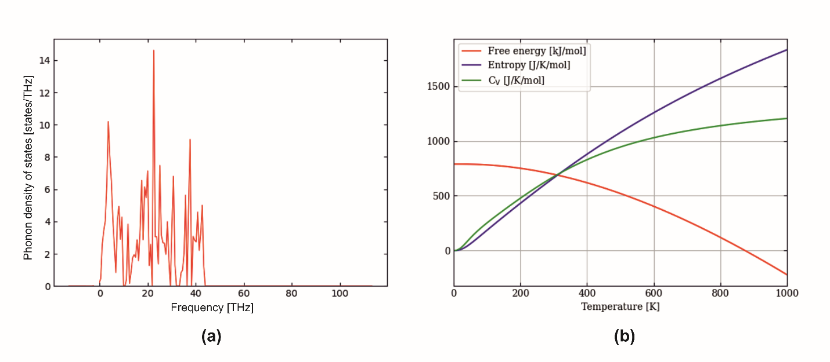
Fig. S1. (a) The phonon density of states for Sr[B₈O₁₁(OH)₄] (per formula unit) calculated by DFT (phonopy (Togo et al. 2023)) and (b) thermal properties (Free energy is Helmholtz free energy, C_{v} – heat capacity at constant volume, S – vibrational entropy).

Table S2. Thermal properties (Free energy is Helmholtz free energy, C_{v} – heat capacity at constant volume; S – vibrational entropy) for Sr[B₈O₁₁(OH)₄] (per formula unit) calculated by DFT (phonopy (Togo et al. 2023)).
T, K | F, kJ/mol | S, J/K/mol | C_{V}, J/K/mol | E, kJ/mol
550 | 464.6 | 1169.3 | 990.2 | 1107.7

Ortner T S, Wurst K, Perfler L, Tribus M, Huppertz H (2015) Hydrothermal synthesis and characterization of the first mixed alkali borate-nitrate K₃Na[B₆O₉(OH)₃]NO₃. J Solid State Chem 221:66–72. https://doi.org/10.1016/j.jssc.2014.09.016
Pekov I V., Zubkova N V., Chukanov N V., Yapaskurt V O, Britvin S N, Ksenofontov D A, Pushcharovsky D Yu (2024) Strontioborite: revalidation as a mineral species and new data. Mineral Mag 88:585–593. https://doi.org/10.1180/mgm.2024.58
Sun H, Sun W, Huang Y, Mi J (2010) Low Temperature Flux Synthesis and Characterizations of a New Layered Barium Borate BaB₈O₁₁(OH)₄. Z Anorg Allg Chem 636:977–981. https://doi.org/10.1002/zaac.201000066
Togo A, Chaput L, Tadano T, Tanaka I (2023) Implementation strategies in phonopy and phono3py. J Phys Condens Matter 35:353001. https://doi.org/10.1088/1361-648X/acd831
Wang J-F, Liang P (2019) Thermochemical properties of alkaline-earth metals borates of a series of MB₈O₁₁(OH)₄·xH₂O (M = Ca, Sr, Ba; x = 0, 3). J Chem Thermodyn 134:1–4. https://doi.org/10.1016/j.jct.2019.02.030

