Investigation of the electronic and optical properties of the isomers of bixin and norbixin present in the achiote seeds

Igo Tôrres Lima¹, Josiel da Silva Crispim², Olímpio Pereira de Sá Neto³, Rafael Timóteo de Sousa Júnior⁴, Luiz Antônio Ribeiro Junior⁵, Demétrio Antonio da Silva Filho⁵

¹ Coordenação do Bacharelado Interdisciplinar em Ciência e Tecnologia, Universidade Federal do Maranhão, Campus Dom Delgado, 65080-805, São Luís, MA, Brazil.
² PPGQ, Universidade Estadual do Piauí, Rua João Cabral 2231, 64002-150, Teresina, PI, Brazil.
³ Coordenação de Ciência da Computação, Universidade Estadual do Piauí, 65202-220, Parnaiba, PI, Brazil.
⁴ Departamento de Engenharia Elétrica, Universidade de Brasília, Campus Darcy Ribeiro, 70919-970, Brasília, DF, Brazil.
⁵ Instituto de Física, Universidade de Brasília, Campus Darcy Ribeiro, 70919-970, Brasília, DF, Brazil.

List of Figures & Tables.

Figure S1. Schematic representation of the frontier molecular orbitals HOMO (left) and LUMO (right) of the molecular dyes in chloroform solution. These results were obtained by employing the B3LYP/6-31+g(d,p) level of theory. S10
Figure S2. Schematic representation of the frontier molecular orbitals HOMO (left) and LUMO (right) of the molecular dyes in chloroform solution. These results were obtained by employing the M06/6-31+g(d,p) level of theory. S11
Figure S3. Schematic representation of the frontier molecular orbitals HOMO (left) and LUMO (right) of the molecular dyes in gas phase. These results were obtained by employing the CAM-B3LYP/6-31+g(d,p) level of theory. S12
Figure S4. Absorption spectra of molecular dyes in gas phase (top) and chloroform solution (bottom). These results were obtained by employing the 6-31G basis set. S22
Figure S5. Absorption spectra of molecular dyes in gas phase (top) and chloroform solution (bottom). These results were obtained by employing the 6-31G(d,p) basis set. S23

Table S1. Single-double bonds and local BLA values (Å) of the molecular dyes in gas phase. These results were obtained by employing the B3LYP/6-31+g(d,p) level of theory. S4
Table S2. Single-double bonds and local BLA values (Å) of the molecular dyes in gas phase. These results were obtained by employing the CAM-B3LYP/6-31+g(d,p) level of theory. S5
Table S3. Single-double bonds and local BLA values (Å) of the molecular dyes in gas phase. These results were obtained by employing the M06/6-31+g(d,p) level of theory. S6
Table S4. Single-double bonds and local BLA values (Å) of the molecular dyes in chloroform solution. These results were obtained by employing the B3LYP/6-31+g(d,p) level of theory. S7
Table S5. Single-double bonds and local BLA values (Å) of the molecular dyes in chloroform solution. These results were obtained by employing the CAM-B3LYP/6-31+g(d,p) level of theory. S8
Table S6. Single-double bonds and local BLA values (Å) of the molecular dyes in chloroform solution. These results were obtained by employing the M06/6-31+g(d,p) level of theory. S9
Table S7. Frontier MOs and gap energy values for the dyes in gas phase. These results were obtained by employing the 6-31G basis set. All values are in electron-Volt (eV). S13
Table S8. Frontier MOs and gap energy values for the dyes in gas phase. These results were obtained by employing the 6-31G(d,p) basis set. All values are in electron-Volt (eV). S14
Table S9. Frontier MOs and gap energy values for the dyes in gas phase. These results were obtained by employing the 6-31+G(d,p) basis set. All values are in electron-Volt (eV). S15
Table S10. Frontier MOs and gap energy values for the dyes in chloroform solution. These results were obtained by employing the 6-31G basis set. All values are in electron-Volt (eV). S16
Table S11. Frontier MOs and gap energy values for the dyes in chloroform solution. These results were obtained by employing the 6-31G(d,p) basis set. All values are in electron-Volt (eV). S17
Table S12. Frontier MOs and gap energy values for the dyes in chloroform solution. These results were obtained by employing the 6-31+G(d,p) basis set. All values are in electron-Volt (eV). S18
Table S13. Dipole moment (µ), average linear polarizability (α), and vector component of the first (β_{vec}) hyperpolarizability of the dyes in gas phase. These results were obtained by employing the 6-31G basis set. S19
Table S14. Dipole moment (µ), average linear polarizability (α), and vector component of the first (β_{vec}) hyperpolarizability of the dyes in chloroform solution. These results were obtained by employing the 6-31G basis set. S19
Table S15. Dipole moment (µ), average linear polarizability (α), and vector component of the first (β_{vec}) hyperpolarizability of the dyes in gas phase. These results were obtained by employing the 6-31G(d,p) basis set. S20
Table S16. Dipole moment (µ), average linear polarizability (α), and vector component of the first (β_{vec}) hyperpolarizability of the dyes in chloroform solution. These results were obtained by employing the 6-31G(d,p) basis set. S20
Table S17. S₀→S₁ vertical transition energies (E₀₁), wavelength (λ₀₁), oscillator strength (f), and transition dipole moments (µ₀₁). These results were obtained by employing the 6-31G basis set. S23
Table S18. S₀→S₁ vertical transition energies (E₀₁), wavelength (λ₀₁), oscillator strength (f), and transition dipole moments (µ₀₁). These results were obtained by employing the 6-31G(d,p) basis set. S24

 | bixin |  |  | isobixin
bonds | single | double | local BLA | single | double | local BLA
b₁ – b₂ | 1.479 | 1.356 | 0.123 | 1.479 | 1.356 | 0.123
b₃ – b₄ | 1.451 | 1.371 | 0.079 | 1.451 | 1.371 | 0.080
b₅ – b₆ | 1.434 | 1.367 | 0.067 | 1.434 | 1.367 | 0.067
b₇ – b₈ | 1.443 | 1.376 | 0.067 | 1.443 | 1.376 | 0.067
b₉ – b₁₀ | 1.429 | 1.370 | 0.059 | 1.429 | 1.371 | 0.059
b₁₁ – b₁₂ | 1.430 | 1.375 | 0.054 | 1.429 | 1.376 | 0.053
b₁₃ – b₁₄ | 1.445 | 1.366 | 0.079 | 1.444 | 1.367 | 0.077
b₁₅ – b₁₆ | 1.438 | 1.372 | 0.065 | 1.435 | 1.371 | 0.064
b₁₇ – b₁₈ | 1.451 | 1.355 | 0.097 | 1.450 | 1.354 | 0.095
 | norbixin |  |  | isonorbixin
bonds | single | double | local BLA | single | double | local BLA
b₁ – b₂ | 1.479 | 1.356 | 0.123 | 1.465 | 1.356 | 0.109
b₃ – b₄ | 1.451 | 1.371 | 0.080 | 1.450 | 1.372 | 0.078
b₅ – b₆ | 1.434 | 1.367 | 0.067 | 1.434 | 1.367 | 0.067
b₇ – b₈ | 1.443 | 1.376 | 0.067 | 1.443 | 1.376 | 0.067
b₉ – b₁₀ | 1.429 | 1.370 | 0.059 | 1.429 | 1.371 | 0.059
b₁₁ – b₁₂ | 1.430 | 1.375 | 0.054 | 1.429 | 1.376 | 0.053
b₁₃ – b₁₄ | 1.445 | 1.366 | 0.079 | 1.443 | 1.367 | 0.076
b₁₅ – b₁₆ | 1.437 | 1.373 | 0.064 | 1.434 | 1.372 | 0.062
b₁₇ – b₁₈ | 1.450 | 1.356 | 0.094 | 1.448 | 1.356 | 0.092
Table S1. Single-double bonds and local BLA values (Å) of the molecular dyes in gas phase. These results were obtained by employing the B3LYP/6-31+g(d,p) level of theory.

 | bixin |  |  | isobixin
bonds | single | double | local BLA | single | double | local BLA
b₁ – b₂ | 1.480 | 1.344 | 0.137 | 1.480 | 1.344 | 0.137
b₃ – b₄ | 1.457 | 1.356 | 0.101 | 1.457 | 1.356 | 0.101
b₅ – b₆ | 1.444 | 1.351 | 0.092 | 1.444 | 1.351 | 0.092
b₇ – b₈ | 1.453 | 1.358 | 0.095 | 1.453 | 1.358 | 0.095
b₉ – b₁₀ | 1.441 | 1.353 | 0.088 | 1.441 | 1.353 | 0.088
b₁₁ – b₁₂ | 1.441 | 1.358 | 0.083 | 1.441 | 1.358 | 0.083
b₁₃ – b₁₄ | 1.454 | 1.350 | 0.104 | 1.454 | 1.351 | 0.103
b₁₅ – b₁₆ | 1.446 | 1.356 | 0.090 | 1.444 | 1.356 | 0.088
b₁₇ – b₁₈ | 1.457 | 1.343 | 0.114 | 1.455 | 1.343 | 0.112
 | norbixin |  |  | isonorbixin
bonds | single | double | local BLA | single | double | local BLA
b₁ – b₂ | 1.481 | 1.344 | 0.137 | 1.481 | 1.344 | 0.137
b₃ – b₄ | 1.457 | 1.356 | 0.101 | 1.457 | 1.356 | 0.101
b₅ – b₆ | 1.444 | 1.351 | 0.093 | 1.444 | 1.351 | 0.093
b₇ – b₈ | 1.453 | 1.358 | 0.095 | 1.453 | 1.358 | 0.095
b₉ – b₁₀ | 1.441 | 1.353 | 0.088 | 1.441 | 1.353 | 0.088
b₁₁ – b₁₂ | 1.441 | 1.358 | 0.083 | 1.441 | 1.358 | 0.083
b₁₃ – b₁₄ | 1.454 | 1.350 | 0.104 | 1.453 | 1.351 | 0.102
b₁₅ – b₁₆ | 1.446 | 1.357 | 0.089 | 1.444 | 1.356 | 0.087
b₁₇ – b₁₈ | 1.456 | 1.344 | 0.112 | 1.454 | 1.344 | 0.110
Table S2. Single-double bonds and local BLA values (Å) of the molecular dyes in gas phase. These results were obtained by employing the CAM-B3LYP/6-31+g(d,p) level of theory.

 | bixin |  |  | isobixin
bonds | single | double | local BLA | single | double | local BLA
b₁ – b₂ | 1.474 | 1.349 | 0.124 | 1.474 | 1.349 | 0.124
b₃ – b₄ | 1.446 | 1.364 | 0.082 | 1.446 | 1.364 | 0.082
b₅ – b₆ | 1.431 | 1.360 | 0.071 | 1.431 | 1.360 | 0.071
b₇ – b₈ | 1.439 | 1.368 | 0.071 | 1.439 | 1.368 | 0.071
b₉ – b₁₀ | 1.426 | 1.362 | 0.064 | 1.426 | 1.362 | 0.063
b₁₁ – b₁₂ | 1.427 | 1.367 | 0.059 | 1.426 | 1.368 | 0.058
b₁₃ – b₁₄ | 1.441 | 1.358 | 0.082 | 1.439 | 1.359 | 0.080
b₁₅ – b₁₆ | 1.434 | 1.365 | 0.069 | 1.431 | 1.364 | 0.068
b₁₇ – b₁₈ | 1.446 | 1.349 | 0.098 | 1.444 | 1.348 | 0.096
 | norbixin |  |  | isonorbixin
bonds | single | double | local BLA | single | double | local BLA
b₁ – b₂ | 1.474 | 1.349 | 0.125 | 1.474 | 1.349 | 0.124
b₃ – b₄ | 1.446 | 1.364 | 0.082 | 1.446 | 1.364 | 0.082
b₅ – b₆ | 1.430 | 1.360 | 0.071 | 1.431 | 1.360 | 0.071
b₇ – b₈ | 1.439 | 1.368 | 0.071 | 1.439 | 1.368 | 0.071
b₉ – b₁₀ | 1.426 | 1.363 | 0.063 | 1.426 | 1.362 | 0.064
b₁₁ – b₁₂ | 1.426 | 1.368 | 0.059 | 1.426 | 1.368 | 0.058
b₁₃ – b₁₄ | 1.440 | 1.359 | 0.081 | 1.439 | 1.359 | 0.080
b₁₅ – b₁₆ | 1.433 | 1.365 | 0.068 | 1.431 | 1.364 | 0.067
b₁₇ – b₁₈ | 1.445 | 1.350 | 0.095 | 1.443 | 1.349 | 0.094
Table S3. Single-double bonds and local BLA values (Å) of the molecular dyes in gas phase. These results were obtained by employing the M06/6-31+g(d,p) level of theory.

 | bixin |  |  | isobixin
bonds | single | double | local BLA | single | double | local BLA
b₁ – b₂ | 1.469 | 1.359 | 0.110 | 1.469 | 1.359 | 0.111
b₃ – b₄ | 1.447 | 1.374 | 0.073 | 1.447 | 1.374 | 0.073
b₅ – b₆ | 1.433 | 1.369 | 0.064 | 1.433 | 1.369 | 0.064
b₇ – b₈ | 1.443 | 1.377 | 0.065 | 1.442 | 1.377 | 0.065
b₉ – b₁₀ | 1.430 | 1.371 | 0.058 | 1.429 | 1.371 | 0.058
b₁₁ – b₁₂ | 1.430 | 1.376 | 0.054 | 1.429 | 1.377 | 0.052
b₁₃ – b₁₄ | 1.445 | 1.367 | 0.078 | 1.444 | 1.368 | 0.076
b₁₅ – b₁₆ | 1.437 | 1.374 | 0.063 | 1.434 | 1.373 | 0.061
b₁₇ – b₁₈ | 1.449 | 1.357 | 0.093 | 1.448 | 1.357 | 0.091
 | norbixin |  |  | isonorbixin
bonds | single | double | local BLA | single | double | local BLA
b₁ – b₂ | 1.469 | 1.359 | 0.110 | 1.470 | 1.359 | 0.111
b₃ – b₄ | 1.448 | 1.374 | 0.074 | 1.448 | 1.374 | 0.074
b₅ – b₆ | 1.433 | 1.369 | 0.064 | 1.433 | 1.369 | 0.065
b₇ – b₈ | 1.443 | 1.377 | 0.066 | 1.443 | 1.377 | 0.065
b₉ – b₁₀ | 1.430 | 1.371 | 0.058 | 1.429 | 1.371 | 0.058
b₁₁ – b₁₂ | 1.430 | 1.377 | 0.053 | 1.429 | 1.377 | 0.052
b₁₃ – b₁₄ | 1.445 | 1.367 | 0.078 | 1.443 | 1.368 | 0.075
b₁₅ – b₁₆ | 1.436 | 1.375 | 0.062 | 1.434 | 1.374 | 0.060
b₁₇ – b₁₈ | 1.448 | 1.358 | 0.090 | 1.446 | 1.358 | 0.088
Table S4. Single-double bonds and local BLA values (Å) of the molecular dyes in chloroform solution. These results were obtained by employing the B3LYP/6-31+g(d,p) level of theory.

 | bixin |  |  | isobixin
bonds | single | double | local BLA | single | double | local BLA
b₁ – b₂ | 1.472 | 1.346 | 0.126 | 1.473 | 1.346 | 0.127
b₃ – b₄ | 1.455 | 1.358 | 0.097 | 1.455 | 1.358 | 0.097
b₅ – b₆ | 1.443 | 1.352 | 0.091 | 1.443 | 1.352 | 0.091
b₇ – b₈ | 1.453 | 1.359 | 0.094 | 1.453 | 1.359 | 0.094
b₉ – b₁₀ | 1.441 | 1.354 | 0.087 | 1.441 | 1.354 | 0.087
b₁₁ – b₁₂ | 1.442 | 1.359 | 0.083 | 1.441 | 1.359 | 0.082
b₁₃ – b₁₄ | 1.455 | 1.351 | 0.104 | 1.454 | 1.352 | 0.102
b₁₅ – b₁₆ | 1.447 | 1.358 | 0.089 | 1.444 | 1.357 | 0.087
b₁₇ – b₁₈ | 1.456 | 1.345 | 0.111 | 1.454 | 1.345 | 0.109
 | norbixin |  |  | isonorbixin
bonds | single | double | local BLA | single | double | local BLA
b₁ – b₂ | 1.472 | 1.346 | 0.126 | 1.473 | 1.346 | 0.127
b₃ – b₄ | 1.455 | 1.358 | 0.097 | 1.455 | 1.357 | 0.097
b₅ – b₆ | 1.443 | 1.352 | 0.091 | 1.443 | 1.352 | 0.091
b₇ – b₈ | 1.453 | 1.359 | 0.094 | 1.453 | 1.359 | 0.094
b₉ – b₁₀ | 1.441 | 1.354 | 0.087 | 1.441 | 1.354 | 0.087
b₁₁ – b₁₂ | 1.441 | 1.359 | 0.083 | 1.441 | 1.359 | 0.082
b₁₃ – b₁₄ | 1.455 | 1.351 | 0.103 | 1.453 | 1.352 | 0.102
b₁₅ – b₁₆ | 1.446 | 1.358 | 0.088 | 1.443 | 1.358 | 0.085
b₁₇ – b₁₈ | 1.454 | 1.346 | 0.108 | 1.452 | 1.346 | 0.106
Table S5. Single-double bonds and local BLA values (Å) of the molecular dyes in chloroform solution. These results were obtained by employing the CAM-B3LYP/6-31+g(d,p) level of theory.

 | bixin |  |  | isobixin
bonds | single | double | local BLA | single | double | local BLA
b₁ – b₂ | 1.465 | 1.352 | 0.113 | 1.465 | 1.352 | 0.113
b₃ – b₄ | 1.443 | 1.366 | 0.077 | 1.443 | 1.366 | 0.077
b₅ – b₆ | 1.430 | 1.361 | 0.068 | 1.430 | 1.361 | 0.069
b₇ – b₈ | 1.439 | 1.369 | 0.070 | 1.439 | 1.369 | 0.070
b₉ – b₁₀ | 1.427 | 1.363 | 0.063 | 1.426 | 1.363 | 0.063
b₁₁ – b₁₂ | 1.427 | 1.368 | 0.059 | 1.426 | 1.369 | 0.058
b₁₃ – b₁₄ | 1.441 | 1.359 | 0.081 | 1.439 | 1.360 | 0.079
b₁₅ – b₁₆ | 1.433 | 1.366 | 0.067 | 1.431 | 1.365 | 0.065
b₁₇ – b₁₈ | 1.445 | 1.351 | 0.094 | 1.443 | 1.351 | 0.092
 | norbixin |  |  | isonorbixin
bonds | single | double | local BLA | single | double | local BLA
b₁ – b₂ | 1.465 | 1.352 | 0.113 | 1.465 | 1.352 | 0.113
b₃ – b₄ | 1.443 | 1.366 | 0.077 | 1.443 | 1.366 | 0.077
b₅ – b₆ | 1.430 | 1.361 | 0.069 | 1.430 | 1.361 | 0.069
b₇ – b₈ | 1.439 | 1.369 | 0.070 | 1.439 | 1.369 | 0.070
b₉ – b₁₀ | 1.427 | 1.363 | 0.063 | 1.426 | 1.363 | 0.063
b₁₁ – b₁₂ | 1.427 | 1.368 | 0.058 | 1.426 | 1.369 | 0.057
b₁₃ – b₁₄ | 1.440 | 1.360 | 0.081 | 1.439 | 1.361 | 0.078
b₁₅ – b₁₆ | 1.433 | 1.367 | 0.066 | 1.430 | 1.366 | 0.064
b₁₇ – b₁₈ | 1.443 | 1.352 | 0.091 | 1.441 | 1.352 | 0.089
Table S6. Single-double bonds and local BLA values (Å) of the molecular dyes in chloroform solution. These results were obtained by employing the M06/6-31+g(d,p) level of theory.

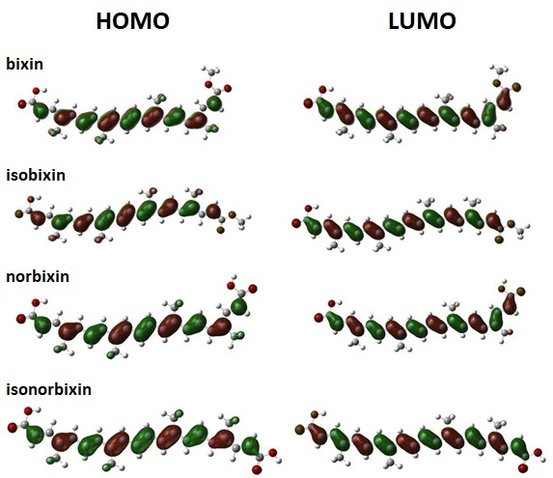
Figure S1. Schematic representation of the frontier molecular orbitals HOMO (left) and LUMO (right) of the molecular dyes in chloroform solution. These results were obtained by employing the B3LYP/6-31+g(d,p) level of theory.

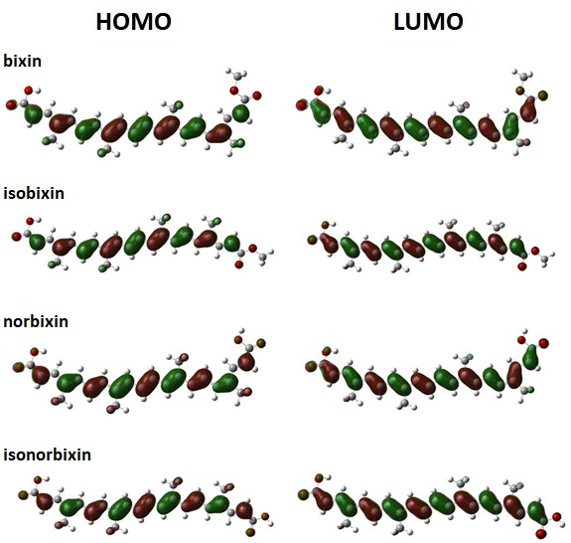
Figure S2. Schematic representation of the frontier molecular orbitals HOMO (left) and LUMO (right) of the molecular dyes in chloroform solution. These results were obtained by employing the M06/6-31+g(d,p) level of theory.

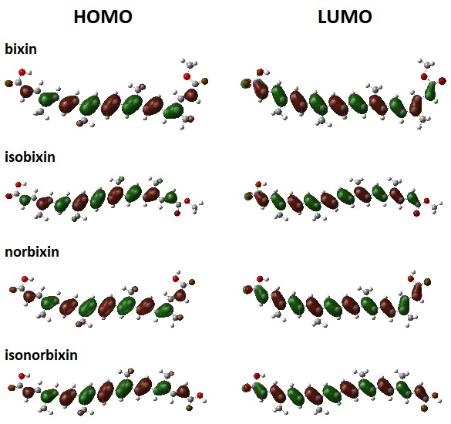
Figure S3. Schematic representation of the frontier molecular orbitals HOMO (left) and LUMO (right) of the molecular dyes in gas phase. These results were obtained by employing the CAM-B3LYP/6-31+g(d,p) level of theory.

Molecule | HOMO-2 | HOMO-1 | HOMO | LUMO | LUMO+1 | LUMO+2 | gap
B3LYP
Bixin | -6.884 | -6.068 | -5.116 | -2.939 | -2.122 | -1.333 | 2.177
Isobixin | -6.857 | -6.041 | -5.116 | -2.966 | -2.095 | -1.252 | 2.150
Norbixin | -6.912 | -6.123 | -5.170 | -2.966 | -2.177 | -1.388 | 2.204
isonorbixin | -6.912 | -6.095 | -5.170 | -2.993 | -2.177 | -1.306 | 2.177
CAM-B3LYP
Bixin | -8.245 | -7.320 | -6.259 | -1.714 | -0.898 | -0.027 | 4.544
Isobixin | -8.245 | -7.293 | -6.259 | -1.742 | -0.898 | 0.054 | 4.517
Norbixin | -8.299 | -7.347 | -6.286 | -1.742 | -0.952 | -0.082 | 4.544
isonorbixin | -8.272 | -7.347 | -6.286 | -1.769 | -0.952 | 0.000 | 4.517
M06
Bixin | -7.184 | -6.340 | -5.361 | -2.830 | -2.014 | -1.170 | 2.531
Isobixin | -7.184 | -6.340 | -5.361 | -2.857 | -1.986 | -1.088 | 2.503
Norbixin | -7.211 | -6.395 | -5.415 | -2.857 | -2.068 | -1.225 | 2.558
isonorbixin | -7.211 | -6.395 | -5.415 | -2.884 | -2.041 | -1.143 | 2.531
Table S7. Frontier MOs and gap energy values for the dyes in gas phase. These results were obtained by employing the 6-31G basis set. All values are in electron-Volt (eV).

Molecule | HOMO-2 | HOMO-1 | HOMO | LUMO | LUMO+1 | LUMO+2 | gap
B3LYP
bixin | -6.803 | -5.987 | -5.089 | -2.830 | -1.959 | -1.197 | 2.259
isobixin | -6.776 | -5.987 | -5.061 | -2.857 | -1.959 | -1.088 | 2.204
norbixin | -6.830 | -6.041 | -5.116 | -2.857 | -2.014 | -1.225 | 2.259
isonorbixin | -6.830 | -6.014 | -5.089 | -2.884 | -1.986 | -1.143 | 2.204
CAM-B3LYP
bixin | -8.191 | -7.265 | -6.231 | -1.578 | -0.735 | 0.136 | 4.653
isobixin | -8.163 | -7.238 | -6.231 | -1.605 | -0.707 | 0.245 | 4.626
norbixin | -8.218 | -7.293 | -6.259 | -1.605 | -0.762 | 0.109 | 4.653
isonorbixin | -8.191 | -7.265 | -6.259 | -1.633 | -0.762 | 0.218 | 4.626
M06
bixin | -7.102 | -6.286 | -5.333 | -2.694 | -1.823 | -1.007 | 2.640
isobixin | -7.075 | -6.259 | -5.306 | -2.694 | -1.823 | -0.925 | 2.612
norbixin | -7.129 | -6.313 | -5.361 | -2.721 | -1.878 | -1.061 | 2.640
isonorbixin | -7.129 | -6.286 | -5.361 | -2.721 | -1.850 | -0.952 | 2.640
Table S8. Frontier MOs and gap energy values for the dyes in gas phase. These results were obtained by employing the 6-31G(d,p) basis set. All values are in electron-Volt (eV).

Molecule | HOMO-2 | HOMO-1 | HOMO | LUMO | LUMO+1 | LUMO+2 | gap
B3LYP
Bixin | -7.102 | -6.313 | -5.388 | -3.184 | -2.340 | -1.578 | 2.204
isobixin | -7.075 | -6.286 | -5.361 | -3.184 | -2.313 | -1.469 | 2.177
norbixin | -7.157 | -6.340 | -5.415 | -3.211 | -2.395 | -1.660 | 2.204
isonorbixin | -7.048 | -6.231 | -5.333 | -3.157 | -2.286 | -1.442 | 2.177
CAM-B3LYP
Bixin | -8.463 | -7.538 | -6.531 | -1.959 | -1.088 | -0.299 | 4.572
isobixin | -8.436 | -7.510 | -6.504 | -1.986 | -1.088 | -0.163 | 4.517
norbixin | -8.517 | -7.592 | -6.558 | -1.986 | -1.170 | -0.354 | 4.572
isonorbixin | -8.490 | -7.565 | -6.558 | -2.014 | -1.170 | -0.218 | 4.544
M06
Bixin | -7.347 | -6.531 | -5.578 | -2.993 | -2.150 | -1.388 | 2.585
isobixin | -7.320 | -6.504 | -5.551 | -3.020 | -2.122 | -1.279 | 2.531
norbixin | -7.402 | -6.558 | -5.606 | -3.020 | -2.204 | -1.442 | 2.585
isonorbixin | -7.374 | -6.558 | -5.606 | -3.048 | -2.177 | -1.333 | 2.558
Table S9. Frontier MOs and gap energy values for the dyes in gas phase. These results were obtained by employing the 6-31+G(d,p) basis set. All values are in electron-Volt (eV).

Molecule | HOMO-2 | HOMO-1 | HOMO | LUMO | LUMO+1 | LUMO+2 | gap
B3LYP
bixin | -6.776 | -5.959 | -4.980 | -2.857 | -2.095 | -1.279 | 2.122
isobixin | -6.776 | -5.932 | -4.980 | -2.884 | -2.095 | -1.225 | 2.095
norbixin | -6.803 | -5.987 | -5.007 | -2.884 | -2.150 | -1.333 | 2.122
isonorbixin | -6.776 | -5.959 | -5.007 | -2.912 | -2.122 | -1.252 | 2.095
CAM-B3LYP
bixin | -8.136 | -7.184 | -6.123 | -1.633 | -0.871 | 0.000 | 4.490
isobixin | -8.136 | -7.184 | -6.123 | -1.660 | -0.898 | 0.082 | 4.463
norbixin | -8.163 | -7.211 | -6.123 | -1.660 | -0.925 | -0.027 | 4.463
isonorbixin | -8.163 | -7.211 | -6.123 | -1.687 | -0.925 | 0.054 | 4.435
M06
bixin | -7.075 | -6.231 | -5.225 | -2.748 | -1.986 | -1.143 | 2.476
isobixin | -7.075 | -6.231 | -5.252 | -2.776 | -1.959 | -1.061 | 2.476
norbixin | -7.102 | -6.259 | -5.252 | -2.776 | -2.014 | -1.170 | 2.476
isonorbixin | -7.102 | -6.259 | -5.252 | -2.803 | -2.014 | -1.088 | 2.449
Table S10. Frontier MOs and gap energy values for the dyes in chloroform solution. These results were obtained by employing the 6-31G basis set. All values are in electron-Volt (eV).

Molecule | HOMO-2 | HOMO-1 | HOMO | LUMO | LUMO+1 | LUMO+2 | gap
B3LYP
bixin | -6.694 | -5.905 | -4.952 | -2.748 | -1.932 | -1.143 | 2.204
isobixin | -6.694 | -5.878 | -4.952 | -2.776 | -1.932 | -1.061 | 2.177
norbixin | -6.721 | -5.905 | -4.980 | -2.776 | -1.959 | -1.170 | 2.204
isonorbixin | -6.721 | -5.905 | -4.980 | -2.803 | -1.959 | -1.088 | 2.177
CAM-B3LYP
bixin | -8.082 | -7.157 | -6.123 | -1.497 | -0.707 | 0.190 | 4.626
isobixin | -8.082 | -7.129 | -6.123 | -1.524 | -0.707 | 0.272 | 4.599
norbixin | -8.109 | -7.184 | -6.123 | -1.524 | -0.735 | 0.163 | 4.599
isonorbixin | -8.109 | -7.157 | -6.123 | -1.551 | -0.735 | 0.245 | 4.572
M06
bixin | -6.993 | -6.177 | -5.197 | -2.612 | -1.796 | -0.980 | 2.585
isobixin | -6.993 | -6.150 | -5.197 | -2.640 | -1.796 | -0.898 | 2.558
norbixin | -7.021 | -6.204 | -5.225 | -2.612 | -1.823 | -1.007 | 2.612
isonorbixin | -7.021 | -6.177 | -5.225 | -2.640 | -1.823 | -0.898 | 2.585
Table S11. Frontier MOs and gap energy values for the dyes in chloroform solution. These results were obtained by employing the 6-31G(d,p) basis set. All values are in electron-Volt (eV).

Molecule | HOMO-2 | HOMO-1 | HOMO | LUMO | LUMO+1 | LUMO+2 | gap
B3LYP
bixin | -6.973 | -6.165 | -5.221 | -3.073 | -2.287 | -1.530 | 2.148
isobixin | -6.965 | -6.153 | -5.220 | -3.099 | -2.278 | -1.424 | 2.121
norbixin | -7.003 | -6.194 | -5.244 | -3.104 | -2.341 | -1.572 | 2.141
isonorbixin | -6.996 | -6.185 | -5.249 | -3.134 | -2.324 | -1.466 | 2.115
CAM-B3LYP
bixin | -8.338 | -7.408 | -6.360 | -1.853 | -1.073 | -0.251 | 4.507
isobixin | -8.326 | -7.390 | -6.353 | -1.879 | -1.076 | -0.126 | 4.474
norbixin | -8.365 | -7.433 | -6.379 | -1.879 | -1.130 | -0.294 | 4.499
isonorbixin | -8.354 | -7.419 | -6.376 | -1.911 | -1.123 | -0.167 | 4.465
M06
bixin | -7.223 | -6.400 | -5.428 | -2.889 | -2.102 | -1.339 | 2.538
isobixin | -7.215 | -6.388 | -5.426 | -2.918 | -2.096 | -1.221 | 2.508
norbixin | -7.248 | -6.424 | -5.447 | -2.915 | -2.147 | -1.374 | 2.532
isonorbixin | -7.241 | -6.416 | -5.450 | -2.948 | -2.136 | -1.257 | 2.503
Table S12. Frontier MOs and gap energy values for the dyes in chloroform solution. These results were obtained by employing the 6-31+G(d,p) basis set. All values are in electron-Volt (eV).

DFT-functional | µ (Debye) | α (10⁻²⁴ esu) | β_{vec} (10⁻³⁰ esu)
bixin
B3LYP | 6.23 | 108.91 | 122.63
CAM-B3LYP | 5.51 | 82.24 | 69.87
M06 | 6.26 | 105.7 | 110.09
isobixin
B3LYP | 6.96 | 114.44 | 99.48
CAM-B3LYP | 6.50 | 85.14 | 45.94
M06 | 7.06 | 110.67 | 87.54
norbixin
B3LYP | 6.34 | 107.06 | 93.68
CAM-B3LYP | 5.75 | 80.6 | 56.05
M06 | 6.33 | 104.08 | 85.86
isonorbixin
B3LYP | 5.67 | 111.21 | 62.25
CAM-B3LYP | 5.47 | 82.71 | 28.56
M06 | 5.83 | 107.5 | 57.52
Table S13. Dipole moment (µ), average linear polarizability (α), and vector component of the first (β_{vec}) hyperpolarizability of the dyes in gas phase. These results were obtained by employing the 6-31G basis set.

DFT-functional | µ (Debye) | α (10⁻²⁴ esu) | β_{vec} (10⁻³⁰ esu)
bixin
B3LYP | 7.16 | 150.63 | 332.61
CAM-B3LYP | 6.04 | 103.28 | 132.25
M06 | 7.03 | 145.28 | 286.75
isobixin
B3LYP | 7.89 | 158.01 | 219.69
CAM-B3LYP | 7.34 | 106.54 | 66.06
M06 | 7.99 | 151.95 | 184.02
norbixin
B3LYP | 7.32 | 149.53 | 266.03
CAM-B3LYP | 6.39 | 101.78 | 110.87
M06 | 7.26 | 143.84 | 229.14
isonorbixin
B3LYP | 6.52 | 155.39 | 133.3
CAM-B3LYP | 6.30 | 104.4 | 38.54
M06 | 6.70 | 149.01 | 116.7
Table S14. Dipole moment (µ), average linear polarizability (α), and vector component of the first (β_{vec}) hyperpolarizability of the dyes in chloroform solution. These results were obtained by employing the 6-31G basis set.
DFT-functional | µ (Debye) | α (10⁻²⁴ esu) | β_{vec} (10⁻³⁰ esu)
bixin
B3LYP | 5.17 | 106.29 | 85.36
CAM-B3LYP | 4.64 | 81.33 | 47.88
M06 | 5.1 | 102.34 | 76.80
isobixin
B3LYP | 6.08 | 111.55 | 71.24
CAM-B3LYP | 5.73 | 84.13 | 31.17
M06 | 6.05 | 106.72 | 60.45
norbixin
B3LYP | 5.29 | 104.30 | 65.79
CAM-B3LYP | 4.85 | 79.57 | 38.94
M06 | 5.28 | 100.11 | 61.7
isonorbixin
B3LYP | 5.10 | 108.27 | 44.22
CAM-B3LYP | 4.93 | 81.63 | 19.26
M06 | 5.19 | 103.52 | 41.55
Table S15. Dipole moment (µ), average linear polarizability (α), and vector component of the first (β_{vec}) hyperpolarizability of the dyes in gas phase. These results were obtained by employing the 6-31G(d,p) basis set.

DFT-functional | µ (Debye) | α (10⁻²⁴ esu) | β_{vec} (10⁻³⁰ esu)
bixin
B3LYP | 5.88 | 143.81 | 225.45
CAM-B3LYP | 5.06 | 100.93 | 87.75
M06 | 5.74 | 136.84 | 189.44
isobixin
B3LYP | 6.90 | 150.53 | 142.5
CAM-B3LYP | 6.52 | 103.95 | 39.71
M06 | 6.87 | 142.58 | 111.24
norbixin
B3LYP | 6.10 | 142.13 | 179.24
CAM-B3LYP | 5.39 | 99.19 | 75.02
M06 | 5.99 | 135.01 | 156.21
isonorbixin
B3LYP | 5.88 | 147.65 | 85.7
CAM-B3LYP | 5.73 | 101.63 | 22.20
M06 | 5.98 | 139.67 | 71.32
Table S16. Dipole moment (µ), average linear polarizability (α), and vector component of the first (β_{vec}) hyperpolarizability of the dyes in chloroform solution. These results were obtained by employing the 6-31G(d,p) basis set.

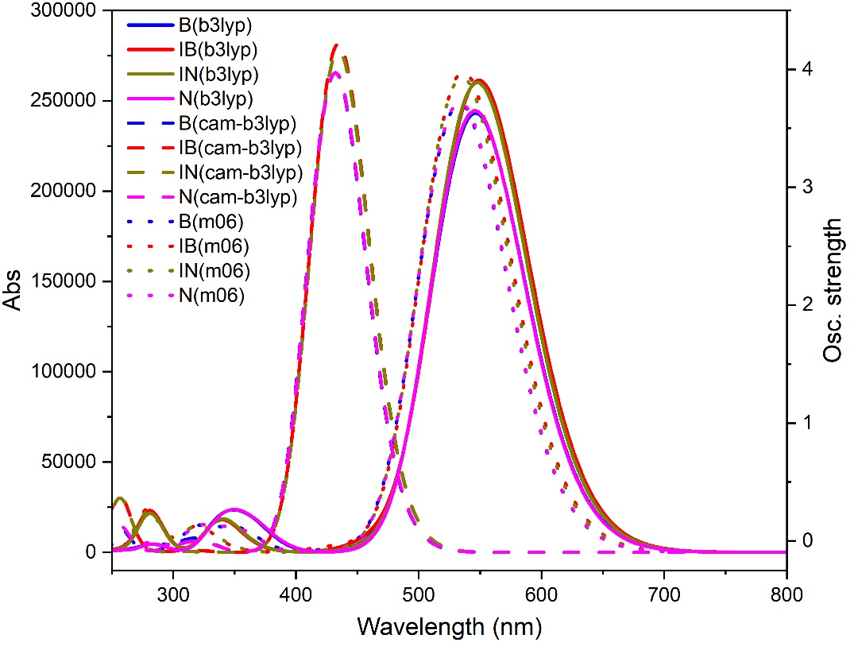

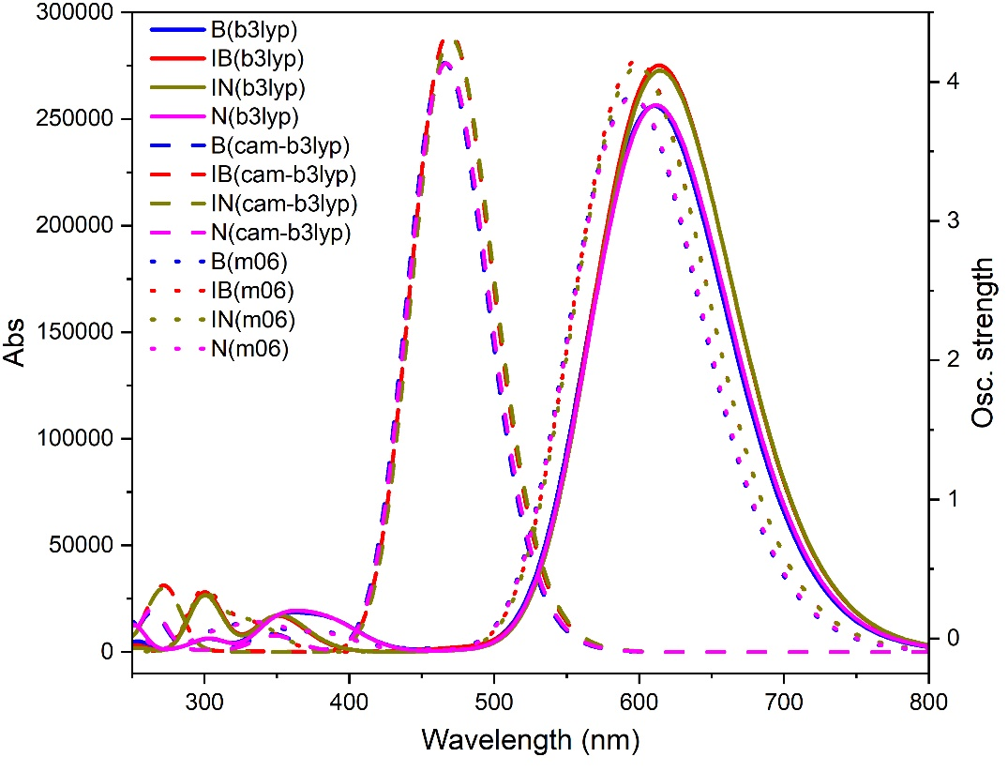
Figure S4. Absorption spectra of molecular dyes in gas phase (top) and chloroform solution (bottom). These results were obtained by employing the 6-31G basis set.

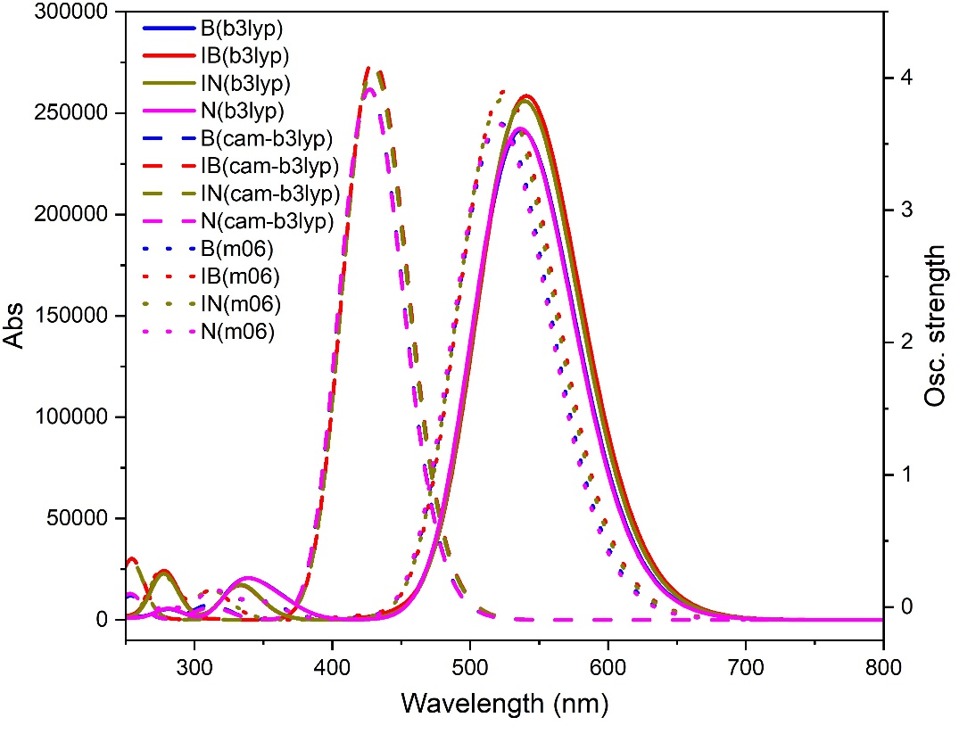

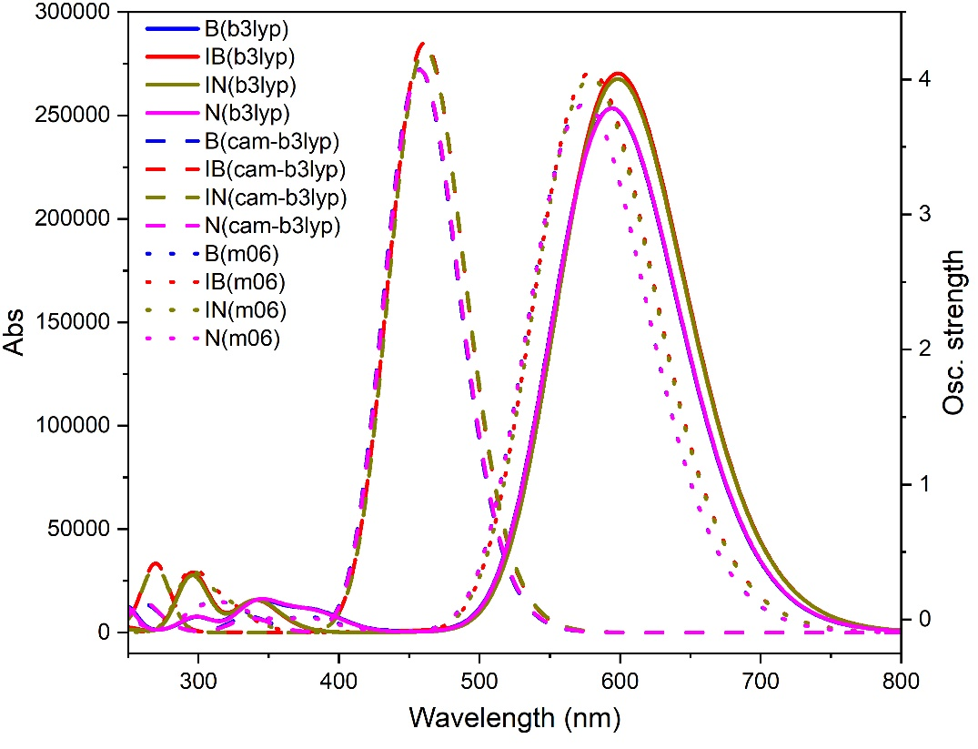
Figure S5. Absorption spectra of molecular dyes in gas phase (top) and chloroform solution (bottom). These results were obtained by employing the 6-31G(d,p) basis set.

molecule | E₀₁ | λ₀₁ | f | µ₀₁(Debye)
 |  |  |  | x | y | z | Tot
B3LYP
gas
bixin | 2.270 | 546.16 | 3.353 | 19.722 | -0.151 | 0.012 | 19.722
isobixin | 2.258 | 549.01 | 3.601 | 20.441 | -1.426 | -0.006 | 20.490
norbixin | 2.272 | 545.74 | 3.373 | 19.763 | -0.613 | -0.004 | 19.772
isonorbixin | 2.264 | 547.67 | 3.585 | 20.383 | -1.244 | 0.007 | 20.421
chloroform
bixin | 2.032 | 610.11 | 3.533 | 21.397 | -0.130 | 0.037 | 21.397
isobixin | 2.020 | 613.73 | 3.796 | 22.190 | -1.575 | -0.020 | 22.246
norbixin | 2.028 | 611.47 | 3.539 | 21.427 | -0.669 | -0.011 | 21.438
isonorbixin | 2.018 | 614.26 | 3.763 | 22.115 | -1.361 | 0.006 | 22.157
CAM-B3LYP
gas
bixin | 2.872 | 431.72 | 3.663 | -18.310 | 0.769 | -0.010 | 18.326
isobixin | 2.856 | 434.19 | 3.883 | 18.809 | 2.067 | -0.019 | 18.922
norbixin | 2.870 | 431.95 | 3.664 | -18.295 | 1.200 | 0.001 | 18.334
isonorbixin | 2.855 | 434.22 | 3.832 | -18.704 | 1.882 | -0.018 | 18.799
chloroform
bixin | 2.663 | 465.52 | 3.813 | 19.397 | -0.852 | 0.022 | 19.416
isobixin | 2.644 | 468.89 | 4.017 | 19.871 | 2.272 | -0.016 | 20.000
norbixin | 2.657 | 466.56 | 3.810 | -19.383 | 1.347 | 0.014 | 19.430
isonorbixin | 2.639 | 469.9 | 3.973 | -19.805 | 2.072 | -0.013 | 19.913
M06
gas
bixin | 2.325 | 533.2 | 3.426 | -19.695 | 0.351 | -0.016 | 19.699
isobixin | 2.313 | 536.1 | 3.669 | -20.368 | 1.710 | -0.017 | 20.440
norbixin | 2.325 | 533.37 | 3.440 | 19.725 | -0.796 | -0.004 | 19.741
isonorbixin | 2.317 | 535.06 | 3.631 | -20.256 | 1.526 | -0.015 | 20.313
chloroform
bixin | 2.086 | 594.31 | 3.592 | 21.290 | -0.361 | 0.033 | 21.293
isobixin | 2.073 | 598.23 | 3.826 | 21.968 | -1.888 | 0.013 | 22.049
norbixin | 2.083 | 595.17 | 3.589 | 21.282 | -0.890 | -0.023 | 21.301
isonorbixin | 2.071 | 598.7 | 3.787 | 21.879 | -1.678 | 0.007 | 21.943
Table S17. S₀→S₁ vertical transition energies (E₀₁), wavelength (λ₀₁), oscillator strength (f), and transition dipole moments (µ₀₁). These results were obtained by employing the 6-31G basis set.

molecule | E₀₁ | λ₀₁ | f | µ₀₁(Debye)
 |  |  |  | x | y | z | Tot
B3LYP
gas
bixin | 2.309 | 536.94 | 3.334 | 19.500 | -0.174 | 0.004 | 19.500
isobixin | 2.293 | 540.64 | 3.565 | 20.170 | -1.574 | -0.015 | 20.232
norbixin | 2.312 | 536.23 | 3.344 | 19.505 | -0.601 | 0.003 | 19.514
isonorbixin | 2.299 | 539.26 | 3.531 | -20.061 | -1.392 | -0.017 | 20.109
chloroform
bixin | 2.088 | 593.88 | 3.497 | 21.002 | -0.174 | 0.007 | 21.003
isobixin | 2.072 | 598.31 | 3.731 | 21.700 | -1.775 | -0.013 | 21.773
norbixin | 2.087 | 594.22 | 3.497 | 20.998 | -0.680 | -0.003 | 21.009
isonorbixin | 2.072 | 598.29 | 3.693 | -21.606 | -1.569 | -0.014 | 21.663
CAM-B3LYP
gas
bixin | 2.905 | 426.73 | 3.612 | -18.078 | 0.748 | -0.001 | 18.093
isobixin | 2.886 | 429.67 | 3.809 | -18.517 | 2.167 | 0.028 | 18.643
norbixin | 2.906 | 426.62 | 3.611 | -18.052 | 1.150 | -0.008 | 18.089
isonorbixin | 2.887 | 429.42 | 3.757 | -18.403 | 1.989 | -0.028 | 18.510
chloroform
bixin | 2.713 | 457.01 | 3.756 | -19.074 | 0.847 | 0.023 | 19.093
isobixin | 2.692 | 460.61 | 3.934 | -19.467 | 2.424 | 0.020 | 19.617
norbixin | 2.710 | 457.46 | 3.752 | -19.048 | 1.309 | -0.022 | 19.093
isonorbixin | 2.689 | 461.06 | 3.892 | -19.396 | 2.228 | -0.027 | 19.523
M06
gas
bixin | 2.377 | 521.67 | 3.380 | -19.348 | -0.358 | -0.001 | 19.351
isobixin | 2.364 | 524.58 | 3.595 | 19.930 | -1.831 | -0.024 | 20.014
norbixin | 2.382 | 520.42 | 3.376 | 19.301 | -0.776 | -0.003 | 19.316
isonorbixin | 2.368 | 523.49 | 3.547 | -19.790 | -1.656 | -0.026 | 19.859
chloroform
bixin | 2.158 | 574.47 | 3.527 | -20.741 | -0.399 | 0.003 | 20.745
isobixin | 2.141 | 579 | 3.737 | 21.336 | -2.069 | -0.011 | 21.436
norbixin | 2.158 | 574.61 | 3.523 | 20.718 | -0.885 | 0.004 | 20.737
isonorbixin | 2.142 | 578.88 | 3.695 | -21.231 | -1.871 | -0.022 | 21.314
Table S18. S₀→S₁ vertical transition energies (E₀₁), wavelength (λ₀₁), oscillator strength (f), and transition dipole moments (µ₀₁). These results were obtained by employing the 6-31G(d,p) basis set.

