Supplemental Materials for “Transdiagnostic latent factors dissociating depression and anxiety through reinforcement learning”

Supplementary Methods

S1. Additional self-report psychopathological questionnaires in Experiment 1
In Experiment 1, a set of questionnaires designed to assess additional prevalent psychopathological conditions was also employed, including the Schizotypal Personality Questionnaire-Brief (SPQ-B, Raine et al., 1995), the Mood Disorder Questionnaire (MDQ, Hirschfeld et al., 2000), the Obsessive-Compulsive Inventory (OCI, Foa et al., 2002), the Brief Barratt Impulsiveness Scale (BBIS, Morean et al., 2014), the Eating Attitudes Test (EAT, Garner et al., 2009), and the Mobile phone addiction index (MPAI, Leung et al., 2008). The distributions of these additional questionnaires are shown in Figure S1.
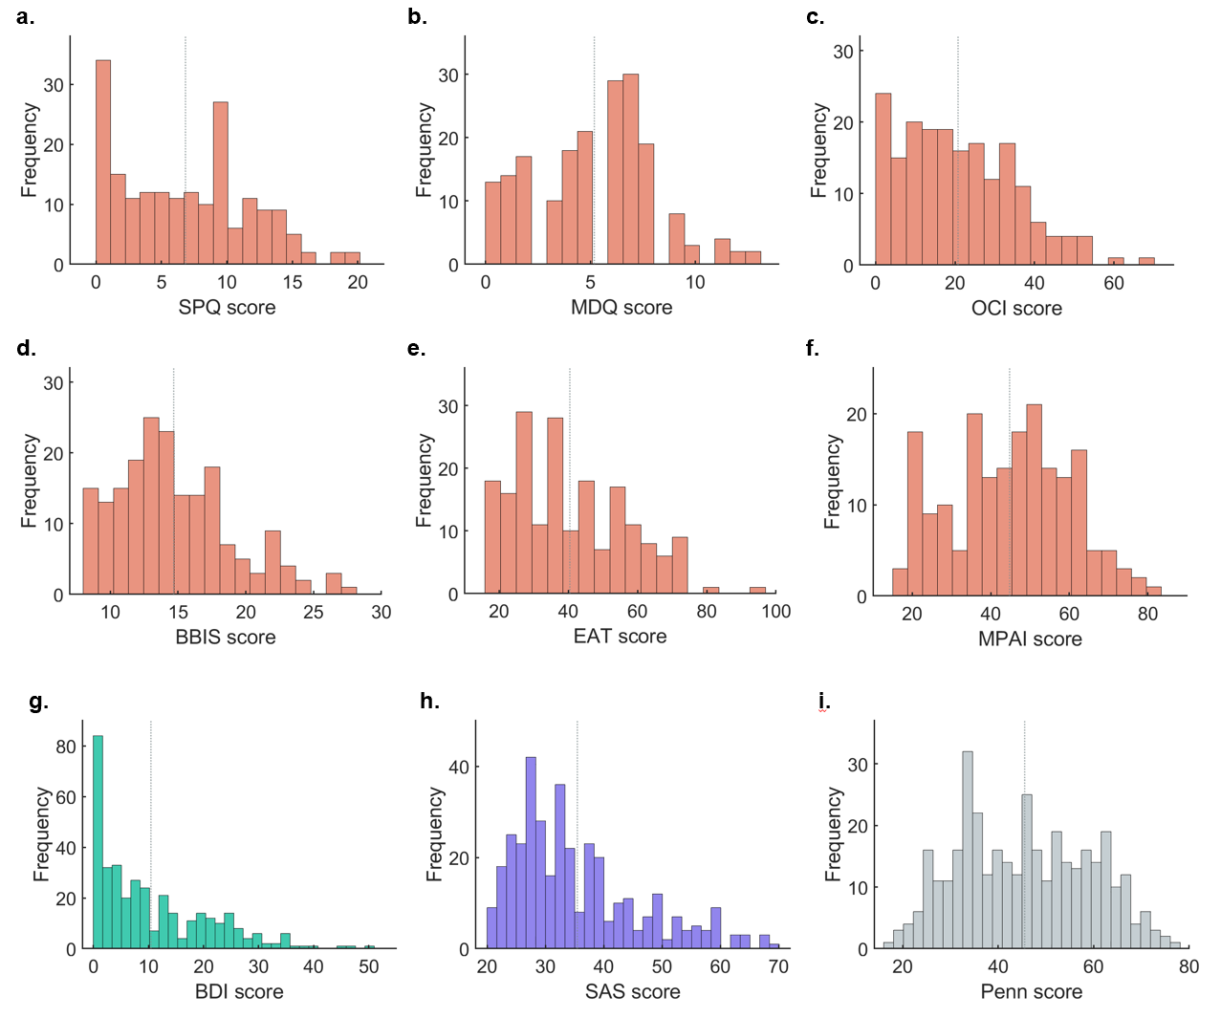
Figure S1. The sample distribution of other questionnaires. Figures a-f are the sample distribution for the SPQ-B (a), the MDQ (b), the OCI (c), the BBIS (d), the EAT (e), and the Mobile phone addiction index MPAI (f) in Experiment 1. Figures g-i are the sample distribution for the Beck Depression Inventory-II (BDI, g), the Self-rating Anxiety Scale (SAS, h), and the Penn State Worry Questionnaire (Penn, i) in Experiment 2. The gray dashed line denotes the mean of scores.

Supplementary Results

S2. Confirmatory factor analysis
We performed a confirmatory factor analysis (CFA) to assess the reliability of the four-factor structure in Experiment 2 using the split-half validation procedure. The comparative fit index (CFI = 0.740 > 0.7), Tucker-Lewis index (TLI = 0.734 > 0.7), and the root mean square error of the approximation (RMSEA = 0.069 < 0.1) of the CFA model all indicated the validity of the EFA process. These results implied that our four-factor structure sufficiently characterized the latent structure across the depression and anxiety scales.

S3. Model simulation and parameter recovery
We assessed the reliability of the best-performing model using a parameter recovery procedure. We generated hypothetical choices of the probabilistic instrumental learning task using the full model with the parameters fitted in Experiment 2 as true parameters (n = 361), resulting in a total of 361 datasets. For each dataset, we fitted the full model using the same Bayesian model fitting method described in the main article. The correlations between true parameters and fitted parameters were calculated to test the robustness of the model. The results of parameter recovery are exhibited in Figure S2. As the initial values were poorly recovered, we repeated the main analysis using the parameters from the model without initial values (the Persev model). The results were consistent with the full model.
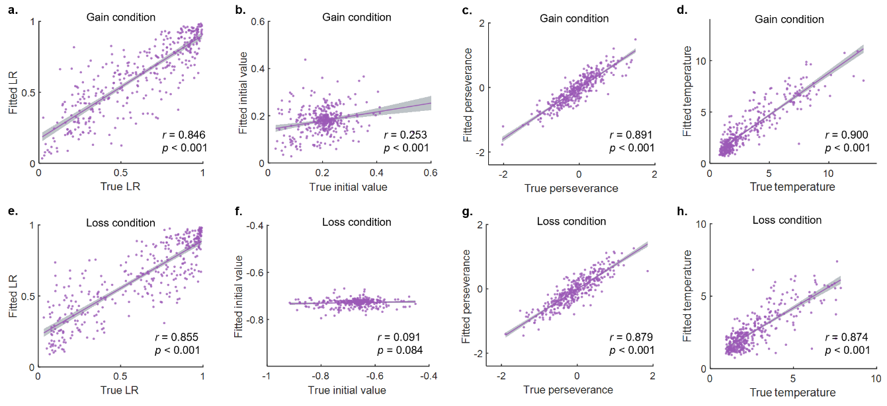
Figure S2. Parameter recovery. We analyzed the correlations between true parameters (the x-axis) and the fitted parameters (the y-axis). Figures a-d exhibit the parameter recovery results in the Gain condition, while figures e-h show the parameter recovery results in the Loss condition. The learning rates, perseverance, and inverse temperature all demonstrated strong correlations between the true parameters and the fitted ones. However, the initial values were not well recovered. The purple line illustrates the fitted linear function between x and y. The purple dots show the individual parameters. The gray shaded area represents the confidence interval.

S4. Effects of control variables
We have regressed learning rates on Sex, Age, IQ, the SDS score, and the STAI score in both Experiment 1 (n = 190) and Experiment 2 (n = 361). The negative regression coefficient for Sex indicated that, on average, males had lower learning rates than females (except for the Gain condition of Exp2). In addition, Age revealed a negative but non-significant trend in relation to learning rates. IQ was positively correlated with learning rates only in the Gain condition of Experiment 2 (Table S1–S4).
Table S1. Regression of SDS and STAI in the Gain condition in Exp1
 | Estimate | Estimated error | 95% HPDI
Intercept | 0.665 | 0.0332 | [0.601, 0.728]
Sex | -0.149 | 0.0464 | [-0.246, -0.0644]
Age | -0.0241 | 0.0234 | [-0.0728, 0.0203]
IQ | 0.0173 | 0.0230 | [-0.0283, 0.0609]
SDS | -0.118 | 0.0388 | [-0.1954, -0.0439]
STAI | 0.131 | 0.0395 | [0.0538, 0.207]
*The regression model was fitted using Bayesian modeling. We used the mean of the posterior samples as the point estimates for the regression coefficients. The 95% highest posterior density interval (HPDI) for each regression coefficient was also reported. These results were consistently presented in Tables S2–S6.

Table S2. Regression of SDS and STAI in the Loss condition in Exp1
 | Estimate | Estimated error | 95% HPDI
Intercept | 0.688 | 0.0305 | [0.628, 0.747]
Sex | -0.115 | 0.0442 | [-0.209, -0.0343]
Age | -0.00550 | 0.0215 | [-0.0481, 0.0354]
IQ | 0.00110 | 0.0216 | [-0.0409, 0.0428]
SDS | -0.0791 | 0.0359 | [-0.154, -0.0127]
STAI | 0.125 | 0.0371 | [0.0497, 0.1958]

Table S3. Regression of SDS and STAI in the Gain condition in Exp2
 | Estimate | Estimated error | 95% HPDI
Intercept | 0.634 | 0.0224 | [0.590, 0.679]
Sex | -0.0502 | 0.0307 | [-0.111, 0.00990]
Age | -0.0039 | 0.0155 | [-0.0326, 0.0277]
IQ | 0.0478 | 0.0152 | [0.0166, 0.0769]
SDS | -0.0875 | 0.0388 | [-0.1624, -0.00910]
STAI | 0.0915 | 0.0390 | [0.0125, 0.165]

Table S4. Regression of SDS and STAI in the Loss condition in Exp2
 | Estimate | Estimated error | 95% HDI
Intercept | 0.662 | 0.024 | [0.616, 0.709]
Sex | -0.103 | 0.034 | [-0.168, -0.0300]
Age | -0.0145 | 0.0179 | [-0.0505, 0.0193]
IQ | 0.0114 | 0.0172 | [-0.0227, 0.0446]
SDS | -0.0893 | 0.0423 | [-0.168, -0.00351]
STAI | 0.0578 | 0.0419 | [-0.0273, 0.137]

The effects of control variables on learning rates were similar in Experiment 2, where learning rates were regressed on the four factors and the three control variables. Sex exhibited a negative correlation with learning rates, but only in the Loss condition. Age showed no significant correlations with learning rates. IQ was positively associated with learning rates in the Gain condition (Table S5–S6).
Table S5. Regression of factors in the Gain condition in Exp2
 | Estimate | Estimated error | 95% HPDI
Intercept | 0.622 | 0.0209 | [0.582, 0.663]
Sex | -0.0288 | 0.0302 | [-0.0857, 0.0314]
Age | -0.0061 | 0.0160 | [-0.0383, 0.0235]
IQ | 0.0420 | 0.0154 | [0.0122, 0.0718]
An | 0.0110 | 0.0242 | [-0.0338, 0.0586]
Cog | 0.0270 | 0.0223 | [-0.0221, 0.0676]
Neg | 0.0253 | 0.0233 | [-0.0201, 0.0698]
Som | -0.0692 | 0.0199 | [-0.1067, -0.0293]

Table S6. Regression of factors in the Loss condition in Exp2
 | Estimate | Estimated error | 95% HPDI
Intercept | 0.6537 | 0.0239 | [0.608, 0.701]
Sex | -0.0868 | 0.0343 | [-0.156, -0.0226]
Age | -0.0190 | 0.0175 | [-0.0541, 0.0131]
IQ | 0.00518 | 0.0175 | [-0.0283, 0.0399]
Anh | -0.0554 | 0.0273 | [-0.114, -0.00701]
Cog | 0.0334 | 0.0250 | [-0.0158, 0.0811]
Neg | 0.0449 | 0.0262 | [-0.00426, 0.0983]
Som | -0.0603 | 0.0222 | [-0.104, -0.0170]

S5. Regression of other questionnaires in Experiment 1
We ran additional Bayesian regressions to investigate the effects of other mental disorders (or traits) on learning rates in Experiment 1 (n = 190). Learning rates in both Gain and Loss conditions were regressed on questionnaires measuring the tendencies of eight distinct psychiatric conditions, including schizophrenia (measured by SPQ), depression (measured by SDS), anxiety (measured by STAI), mania (measured by MDQ), obsessive-compulsive disorder (measured by OCI), impulsivity (measured by BBIS), eating disorder (measured by EAT), and addiction (measured by MPAI). We fitted the Bayesian regression models using the same protocols as in the main article. The estimated coefficients, estimated error, and the 95% HPDI are exhibited in Tables S7–S8.

Table S7. The effect of various psychiatric conditions on learning rates in the Gain condition
 | Estimate | Estimated error | 95% HPDI
Intercept | 0.668 | 0.0327 | [0.602, 0.729]
Sex | -0.149 | 0.0489 | [-0.242, -0.0520]
Age | -0.0284 | 0.0242 | [-0.0741, 0.0198]
IQ | 0.0080 | 0.0236 | [-0.0377, 0.0537]
SDS | -0.114 | 0.0396 | [-0.193, -0.0417]
STAI | 0.148 | 0.0455 | [0.0612, 0.239]
SPQ | -0.0675 | 0.0365 | [-0.135, 0.00677]
MDQ | 0.0367 | 0.0298 | [-0.0187, 0.0993]
OCI | -0.0337 | 0.0346 | [-0.101, 0.0337]
BBIS | 0.0312 | 0.0321 | [-0.0285, 0.0971]
EAT | -0.0135 | 0.0332 | [-0.0817, 0.0468]
MPAI | 0.0355 | 0.0339 | [-0.0294, 0.101]

Table S8. The effect of various psychiatric conditions on learning rates in the Loss condition
 | Estimate | Estimated error | 95% HPDI
Intercept | 0.684 | 0.0310 | [0.624, 0.743]
Sex | -0.106 | 0.0451 | [-0.193, -0.0178]
Age | -0.0111 | 0.0223 | [-0.0547, 0.0327]
IQ | 0.000667 | 0.0220 | [-0.0427, 0.0439]
SDS | -0.0856 | 0.0365 | [-0.159, -0.0171]
STAI | 0.141 | 0.0417 | [0.0639, 0.223]
SPQ | -0.0705 | 0.0326 | [-0.138, -0.00936]
MDQ | 0.0241 | 0.0273 | [-0.0282, 0.0797]
OCI | -0.0318 | 0.0324 | [-0.0958, 0.0307]
BBIS | 0.0247 | 0.0282 | [-0.0307, 0.0804]
EAT | 0.0102 | 0.0306 | [-0.0483, 0.0720]
MPAI | 0.0560 | 0.0320 | [-0.00655, 0.1119]

S6. Regression on other model parameters
Although we primarily focused on learning rates in the main text, we also conducted Bayesian regressions on other model parameters (Fig. S3). In Experiment 1 (n = 190), we regressed the other 6 parameters on Sex, Age, IQ, the SDS score, and the STAI score. In Experiment 2 (n = 361), we regressed the 6 parameters on Sex, Age, IQ, and the four factors derived from factor analysis. The estimates and 95% HPDI of coefficients were displayed in Figure S4.

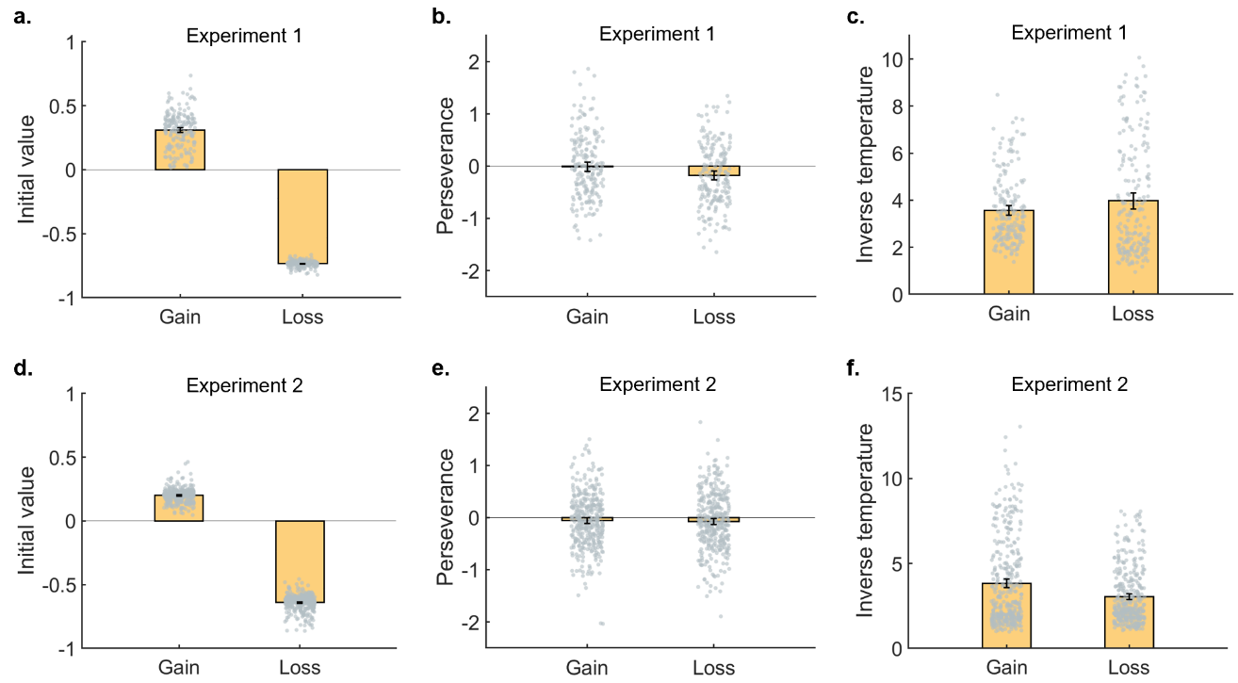
Figure S3. The fitted individual model parameters. a and d exhibited the fitted initial value in Experiment 1 and Experiment 2. b and e exhibited the fitted perseverance in Experiment 1 and Experiment 2. c and f exhibited the fitted inverse temperature in Experiment 1 and Experiment 2. The height of each bar represents the mean of each parameter. Error bars are the standard error. The gray dots represent the fitted parameters of each participant.

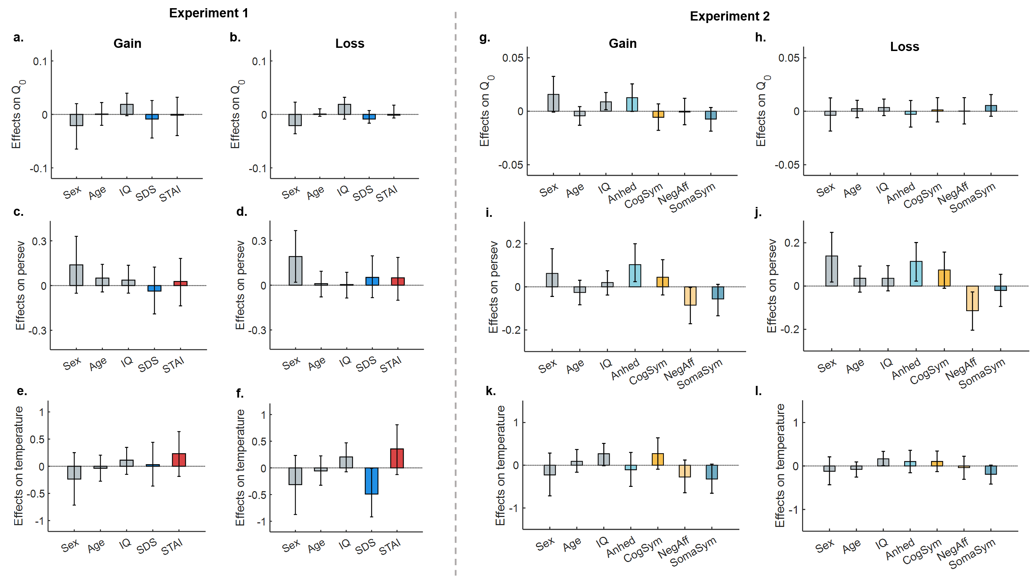
Figure S4. Regression on the model parameters. The left two columns (Gain condition for column 1, Loss condition for column 2) showed the regression results of Experiment 1 (regressions including Sex, Age, IQ, the SDS score, and the STAI score as independent variables); the right two columns (Gain condition for column 3, Loss condition for column 4) exhibited the regression results of Experiment 2 (regressions including Sex, Age, IQ, Anh, Cog, Neg, and Som as independent variables). The three rows represent regressions on three parameters, which are the initial value (Q₀), the perseverance, and the inverse temperature, respectively. The height of bars represents the estimates of regression coefficients. Error bars are the 95% HDPI of each coefficient.

S7. The dual-learning rates model
We additionally fitted a dual-learning rates model, which assumes that positive and negative prediction errors are integrated to different extents. The Q-values are computed as follows:
$$Q_{i,t+1}=\left\{\begin{aligned}Q_{i,t}+α_{P}×\left(R_{t}-Q_{i,t}\right), if R_{t}>Q_{i,t} \\ Q_{i,t}+α_{N}×\left(R_{t}-Q_{i,t}\right), if R_{t}<Q_{i,t}\end{aligned}\right.$$
In the above equation, $α_{P}$ denotes positive learning rates, while $α_{N}$ denotes negative learning rates. The rest of the model and the model-fitting procedure remained the same as in the main text.

After obtaining the positive and negative learning rates, we regressed the four learning rates (positive and negative learning rates in Gain and Loss conditions) on the SDS scores and STAI scores using Bayesian regressions. Again, Sex, Age, and IQ were included as control variables. Regression coefficients and the 95% HDPI were displayed in Figure S5. As the figure shows, the SDS score was negatively correlated with learning rates, while the STAI score was positively associated with learning rates. These effects were consistent for positive and negative learning rates. In regard to this, although the dual-model fits better than the full model in the main text, we did not consider double learning rates in our major analysis.
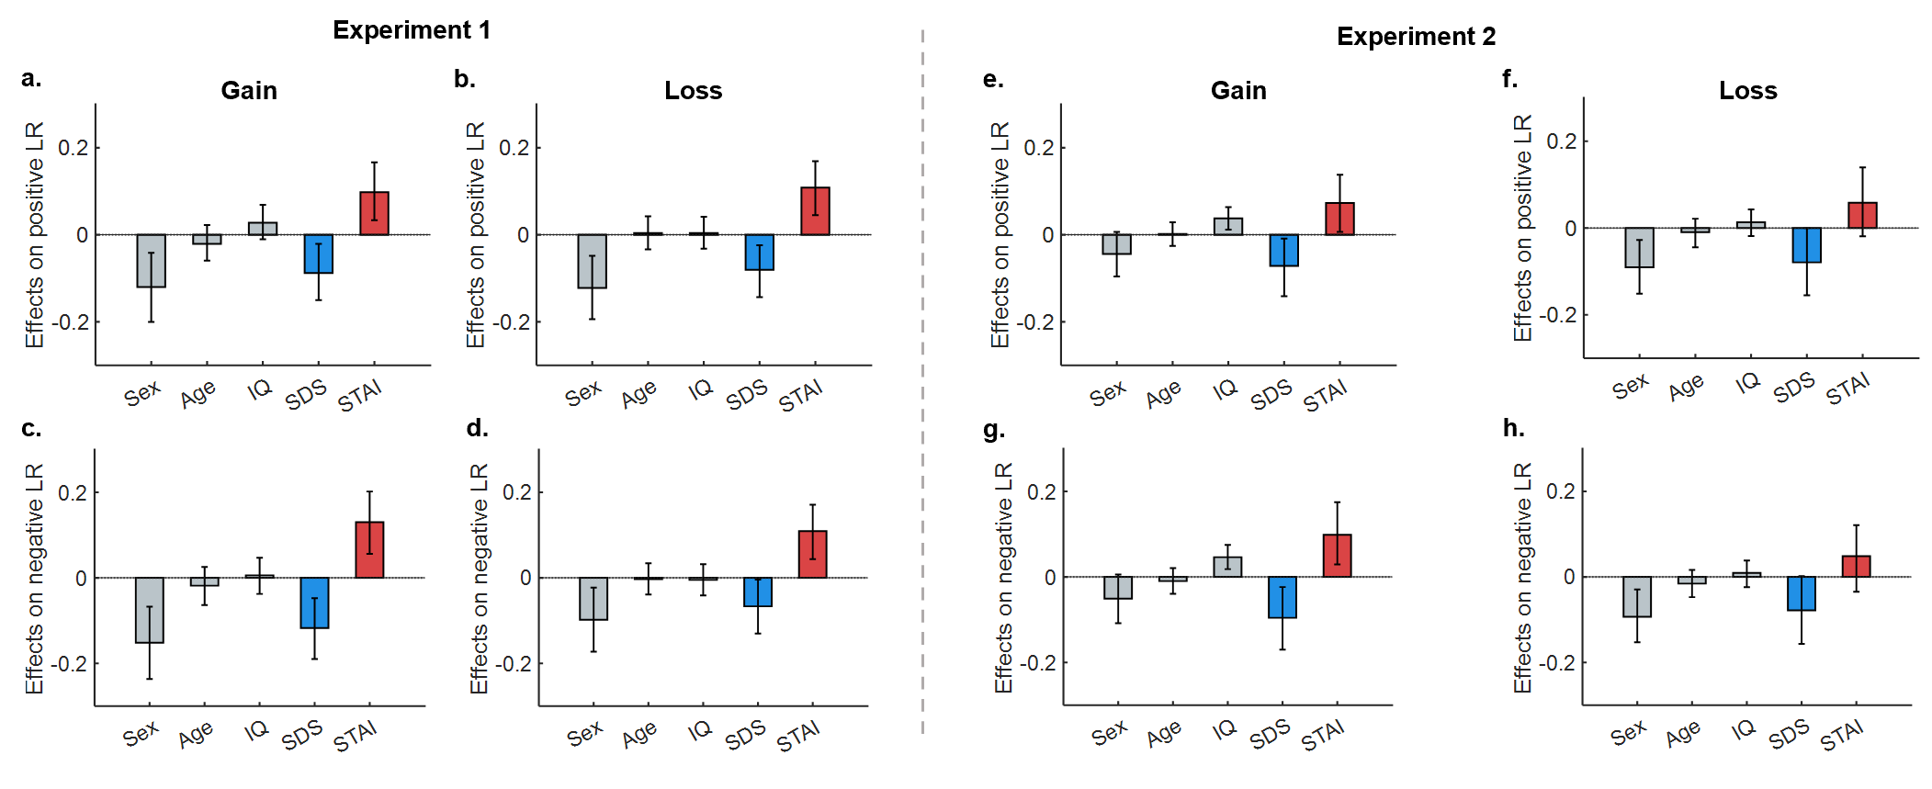
Figure S5. Regression on the learning rates from the dual model. a-d. The regression of learning rates on Sex, Age, IQ, the SDS score, and the STAI score in Experiment 1. e-h. The regression of learning rates on Sex, Age, IQ, the SDS score, and the STAI score in Experiment 2. These regressions used the positive and negative learning rates in the Gain and Loss conditions as dependent variables, separately. The height of bars represents the estimates of regression coefficients. Error bars are the 95% HDPI of each coefficient.

References
Foa, E. B., Huppert, J. D., Leiberg, S., Langner, R., Kichic, R., Hajcak, G., & Salkovskis, P. M. (2002). The Obsessive-Compulsive Inventory: development and validation of a short version. Psychological assessment, 14(4), 485–496. http://doi.org/10.1037/1040-3590.14.4.485
Garner, D. M., Olmsted, M. P., Bohr, Y., & Garfinkel, P. E. (1982). The eating attitudes test: psychometric features and clinical correlates. Psychological medicine, 12(4), 871–878. https://doi.org/10.1017/s0033291700049163
Hirschfeld, R. M., Williams, J. B., Spitzer, R. L., Calabrese, J. R., Flynn, L., Keck, P. E., Jr, Lewis, L., McElroy, S. L., Post, R. M., Rapport, D. J., Russell, J. M., Sachs, G. S., & Zajecka, J. (2000). Development and validation of a screening instrument for bipolar spectrum disorder: the Mood Disorder Questionnaire. The American journal of psychiatry, 157(11), 1873–1875. https://doi.org/10.1176/appi.ajp.157.11.1873
Leung, L. (2008). Leisure boredom, sensation seeking, self-esteem, and addiction: Symptoms and patterns of cell phone use.
Morean, M. E., DeMartini, K. S., Leeman, R. F., Pearlson, G. D., Anticevic, A., Krishnan-Sarin, S., Krystal, J. H., & O'Malley, S. S. (2014). Psychometrically improved, abbreviated versions of three classic measures of impulsivity and self-control. Psychological assessment, 26(3), 1003–1020. https://doi.org/10.1037/pas0000003
Raine, A., & Benishay, D. (1995). The SPQ-B: A Brief Screening Instrument for Schizotypal Personality Disorder. Journal of Personality Disorders, 9(4), 346-355. https://doi.org/10.1521/pedi.1995.9.4.346

