Supplementary Material

Benchmarking large language models for cardiovascular risk stratification using clinical vignettes

Index
Supplementary Figures (Section I) 3
Supplementary Figure S1. Gold-standard ESC 3-class risk categories by age and sex 3
Supplementary Figure S2. Expected (a priori) vs observed (gold-standard) ESC 3-class risk distribution 4
Supplementary Figure S3. Micro-averaged performance metrics across models for cardiovascular risk factors 5
Supplementary Figure S4. Micro-averaged versus macro-averaged F1 Scores for cardiovascular risk factors 6
Supplementary Figure S5. Three-class ESC risk classification: quadratic-weighted κ (κw) by model (pooled PT+EN) 7
Supplementary Figure S6. Confusion matrices for three-class cardiovascular risk classification across LLMs (PT+EN; κw order) 8
Supplementary Figure S7. Numeric agreement with SCORE2: Bland–Altman plots by model 9
Supplementary Figure S8. Bilingual consistency across key analytical domains (Portuguese vs English) 10
Supplementary Figure S9. Confusion Matrix: Pooled Clinicians vs Gold Standard (Three-class ESC risk classification) 11
Supplementary Tables (Section II) 12
Supplementary Table S1. Per-model extraction metrics for cardiovascular risk factors 12
Supplementary Table S2. Per-model extraction metrics for SCORE2 core risk factors 13
Supplementary Table S3. Pooled per-factor extraction metrics across models (cardiovascular risk factors) 14
Supplementary Table S4. Per-model extraction metrics for risk modifiers 15
Supplementary Table S5. Pooled per-modifier extraction metrics across models (risk modifiers) 16
Supplementary Table S6. High-risk (High + Very-High) vs Low-to-Moderate — binary performance by model (ordered by κw) 17
Supplementary Table S7. Numeric agreement with SCORE2 18
Supplementary Table S8. SCORE2 Override: Extraction Performance 19
Supplementary Table S9. SCORE2 Override reasons: overall usage & validity 20
Supplementary Table S10. Exploratory human benchmark: clinician agreement with Gold Standard (Three-class ESC risk classification) 21
Supplementary Table S11. Specifications and configurations of LLM evaluated 22
Supplementary Appendices (Section III) 23
Supplementary Appendix S1. Example simulated outpatient vignette 23
Supplementary Appendix S2. Standardized Prompt Template 24

Supplementary Figures (Section I)

Supplementary Figure S1. Gold-standard ESC 3-class risk categories by age and sex

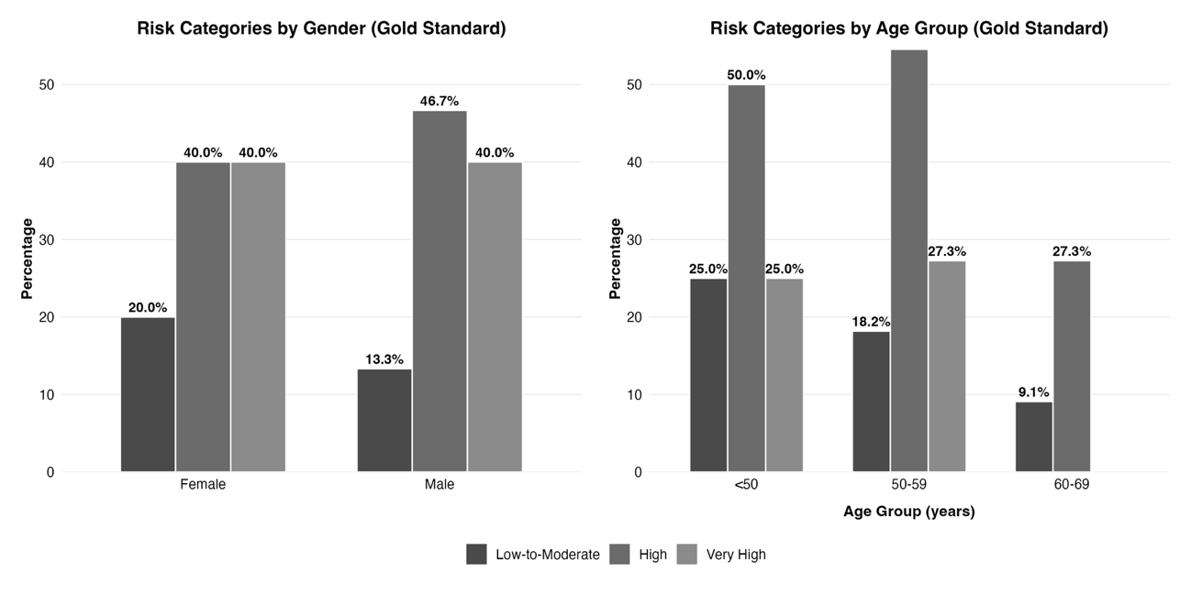

Legend. Distribution of gold-standard 10-year ESC cardiovascular risk categories (low-to-moderate, high, very-high) across the 30 simulated outpatient vignettes, stratified by sex (left panel) and age (right panel). Bars show absolute counts and percentages within each stratum.

Supplementary Figure S2. Expected (a priori) vs observed (gold-standard) ESC 3-class risk distribution

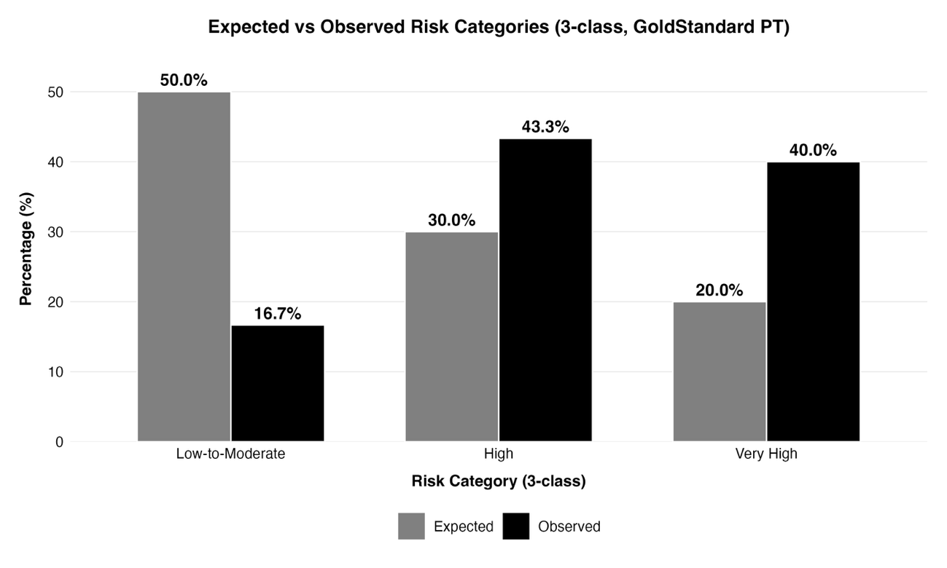

Legend. Comparison between the prespecified design targets for the three ESC risk categories (50% low-to-moderate, 30% high, 20% very-high) and the adjudicated gold-standard distribution across all 30 vignettes. Bars/points show proportions, with exact counts annotated for each risk category.

Supplementary Figure S3. Micro-averaged performance metrics across models for cardiovascular risk factors

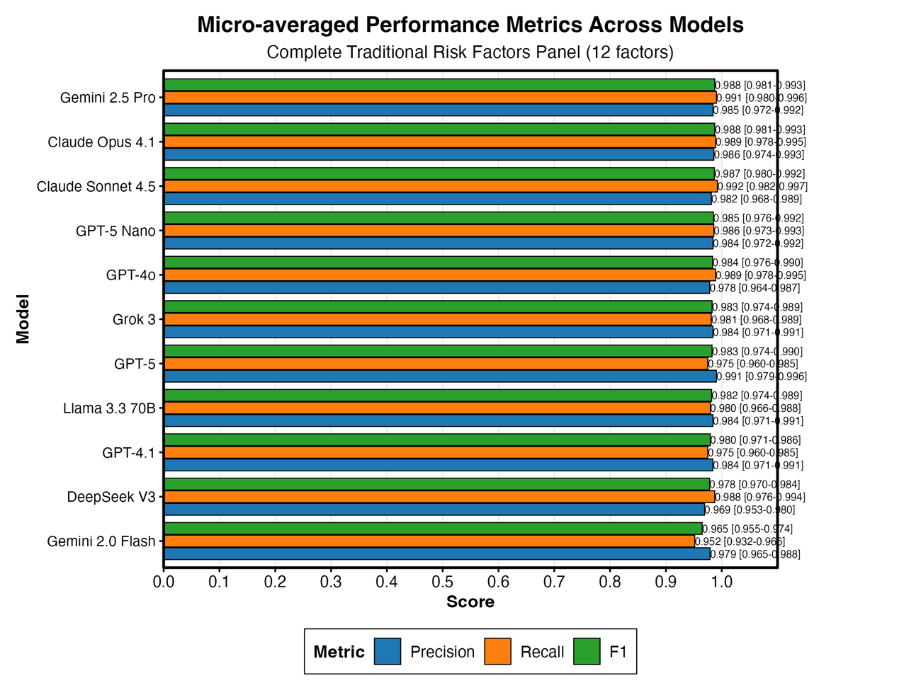

Legend. Micro-averaged extraction performance for traditional cardiovascular risk factors across all 11 large language models, pooling 60 vignettes (30 Portuguese and 30 English). The figure displays, for each model, micro-F1, micro-precision and micro-recall (with 95% confidence intervals), summarizing the results reported numerically in Table S4.

Supplementary Figure S4. Micro-averaged versus macro-averaged F1 Scores for cardiovascular risk factors

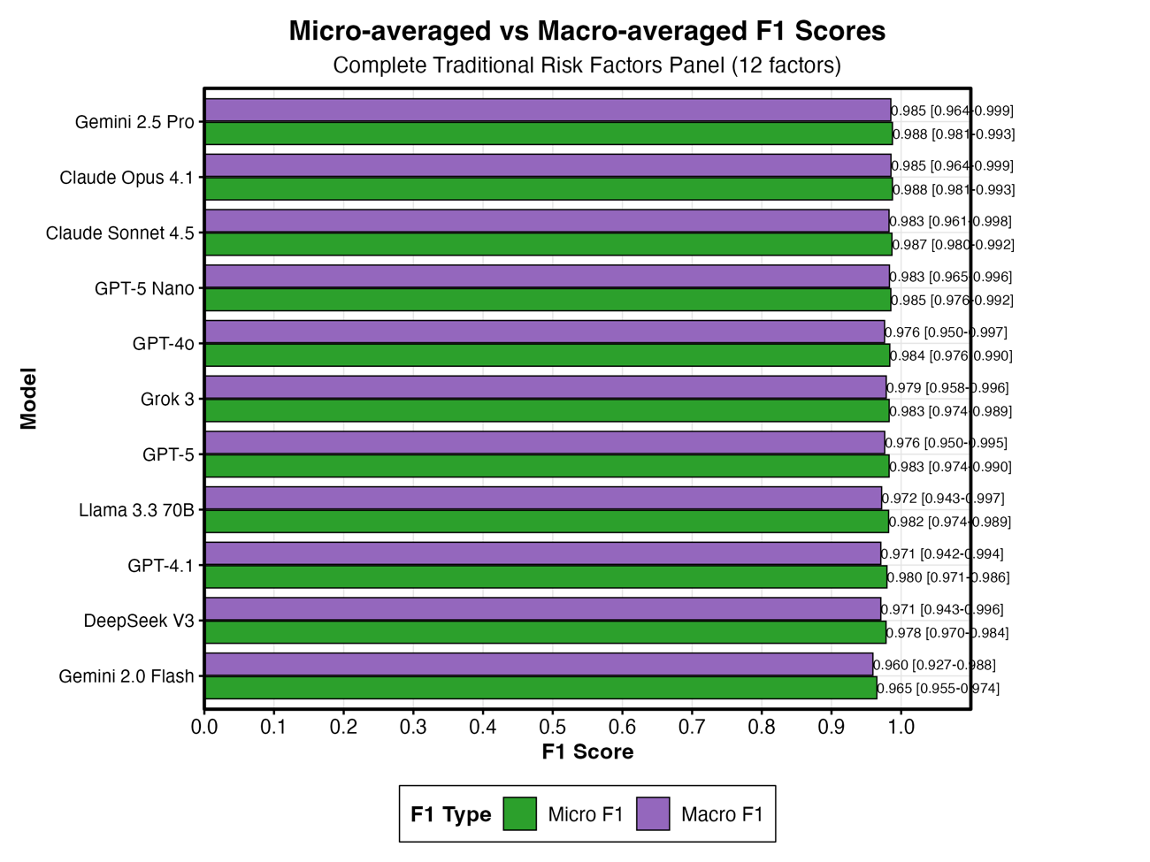

Legend. Micro and macro-averaged extraction performance for traditional cardiovascular risk factors across all 11 large language models, pooling 60 vignettes (30 Portuguese and 30 English). The figure displays, for each model, micro-F1 and macro F1 (with 95% confidence intervals), summarizing the results reported numerically in Table S4.

Supplementary Figure S5. Three-class ESC risk classification: quadratic-weighted κ (κw) by model (pooled PT+EN)

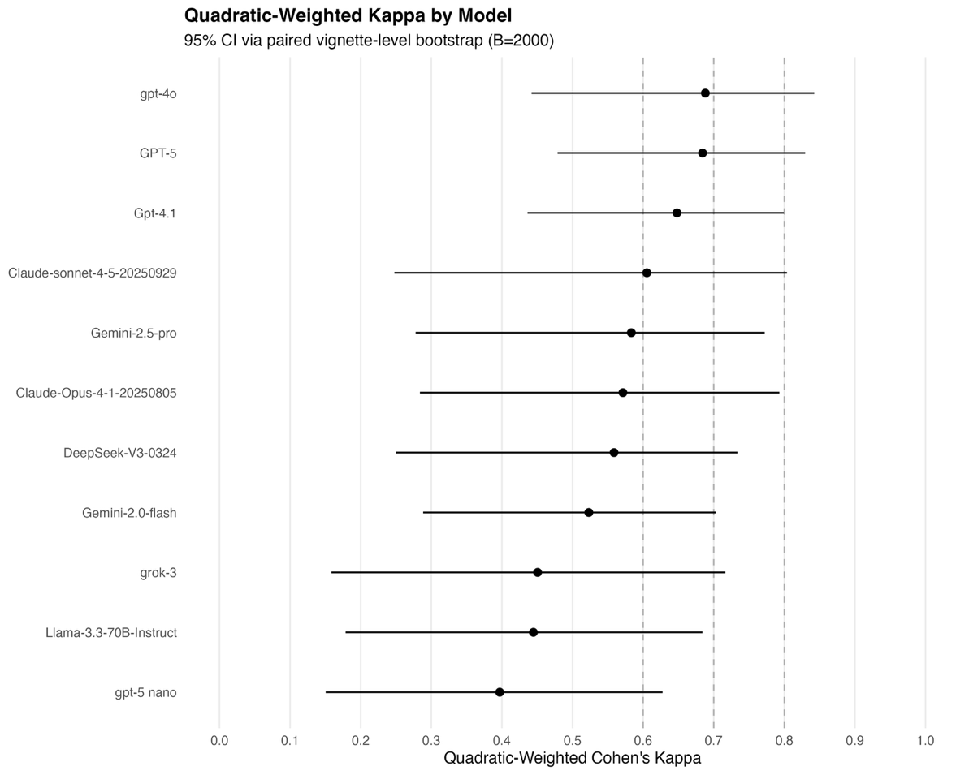

Legend. Points show κw estimates; horizontal bars indicate 95% confidence intervals. Models are ordered by descending κw. Vertical dashed lines at κw = 0.60 and 0.70 are visual reference markers only. Evaluations pool Portuguese and English vignettes; N per model as in Table 3 (typically 60). “Unknown” predictions were counted as incorrect for accuracy and excluded from per-class rates; they do not affect this κw display.

Supplementary Figure S6. Confusion matrices for three-class cardiovascular risk classification across LLMs (PT+EN; κw order)
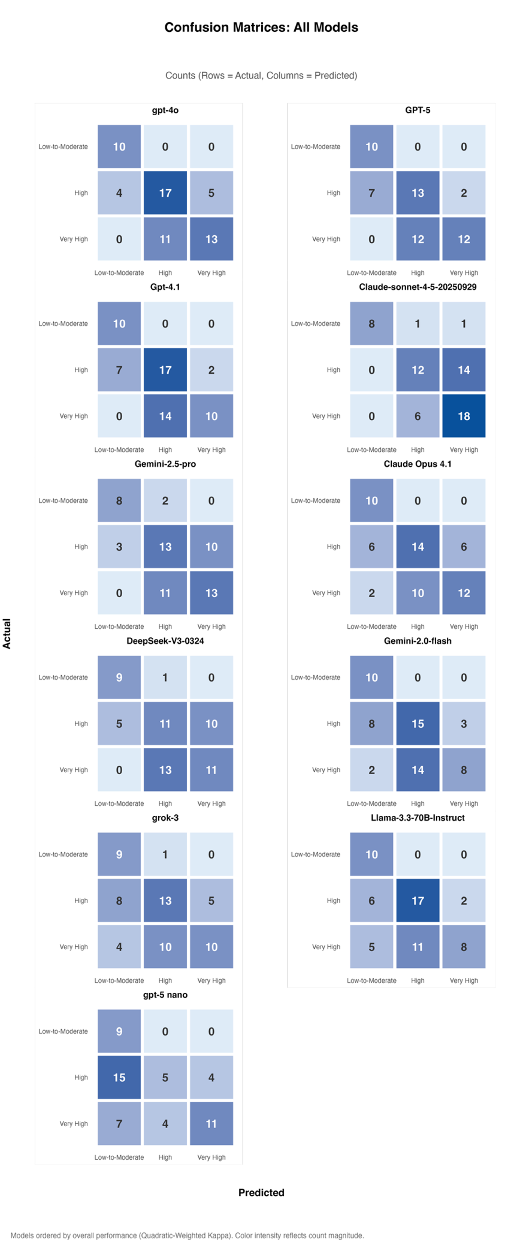

Supplementary Figure S7. Numeric agreement with SCORE2: Bland–Altman plots by model

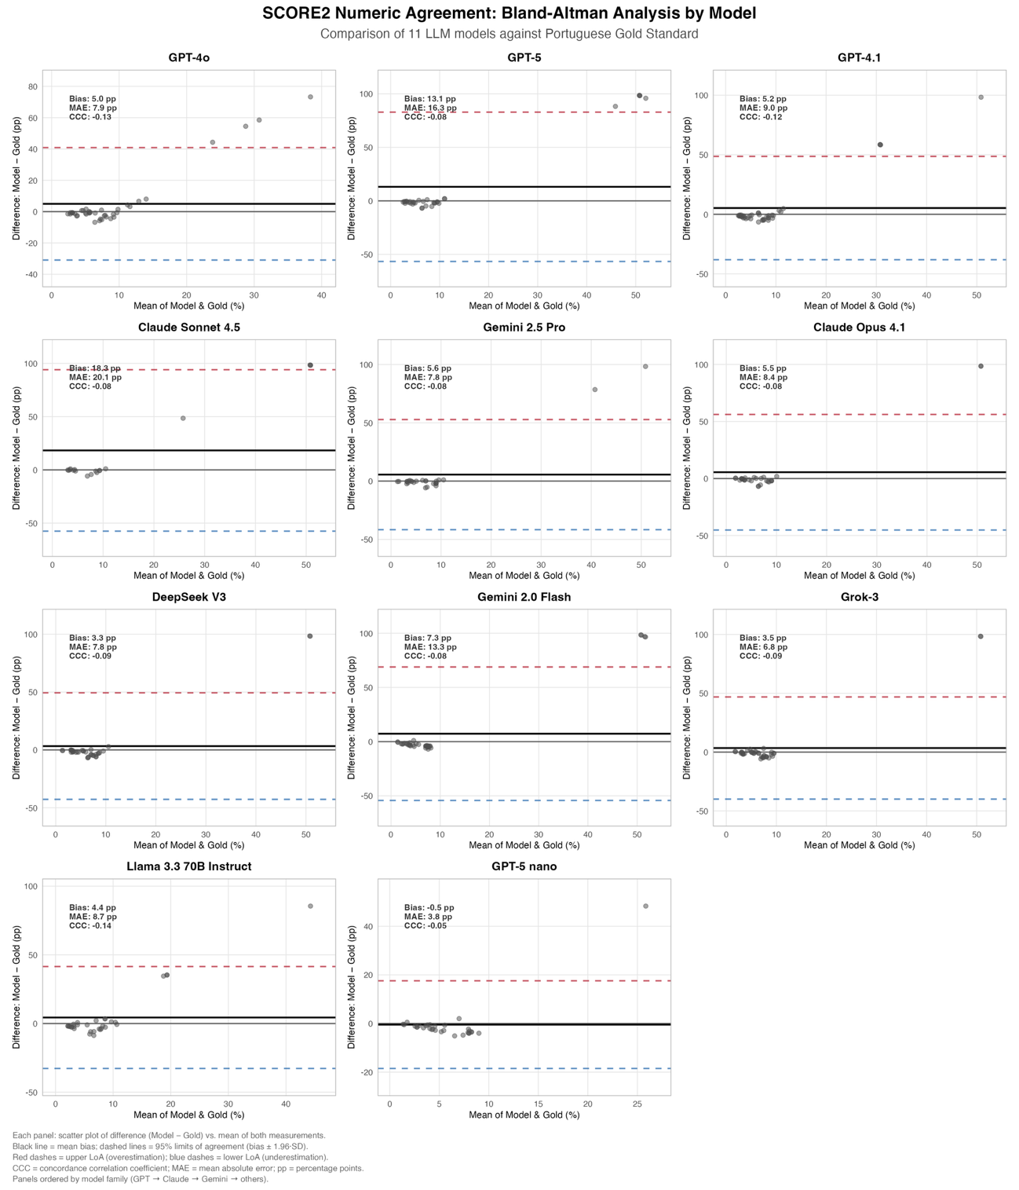

Legend. Bland–Altman plots for LLM-predicted vs. Gold Standard SCORE2 (Portuguese dataset). Y-axis: difference (Model − Gold, percentage points, pp); X-axis: mean of paired estimates (%). Solid black line = mean bias; red/blue dashed lines = 95% limits of agreement (bias ±1.96 SD). Panel insets report bias, MAE (mean absolute error), and CCC (concordance correlation coefficient. Models are ordered by the primary ordinal metric (κw). N varies by model (eligible vignettes only)

Supplementary Figure S8. Bilingual consistency across key analytical domains (Portuguese vs English)

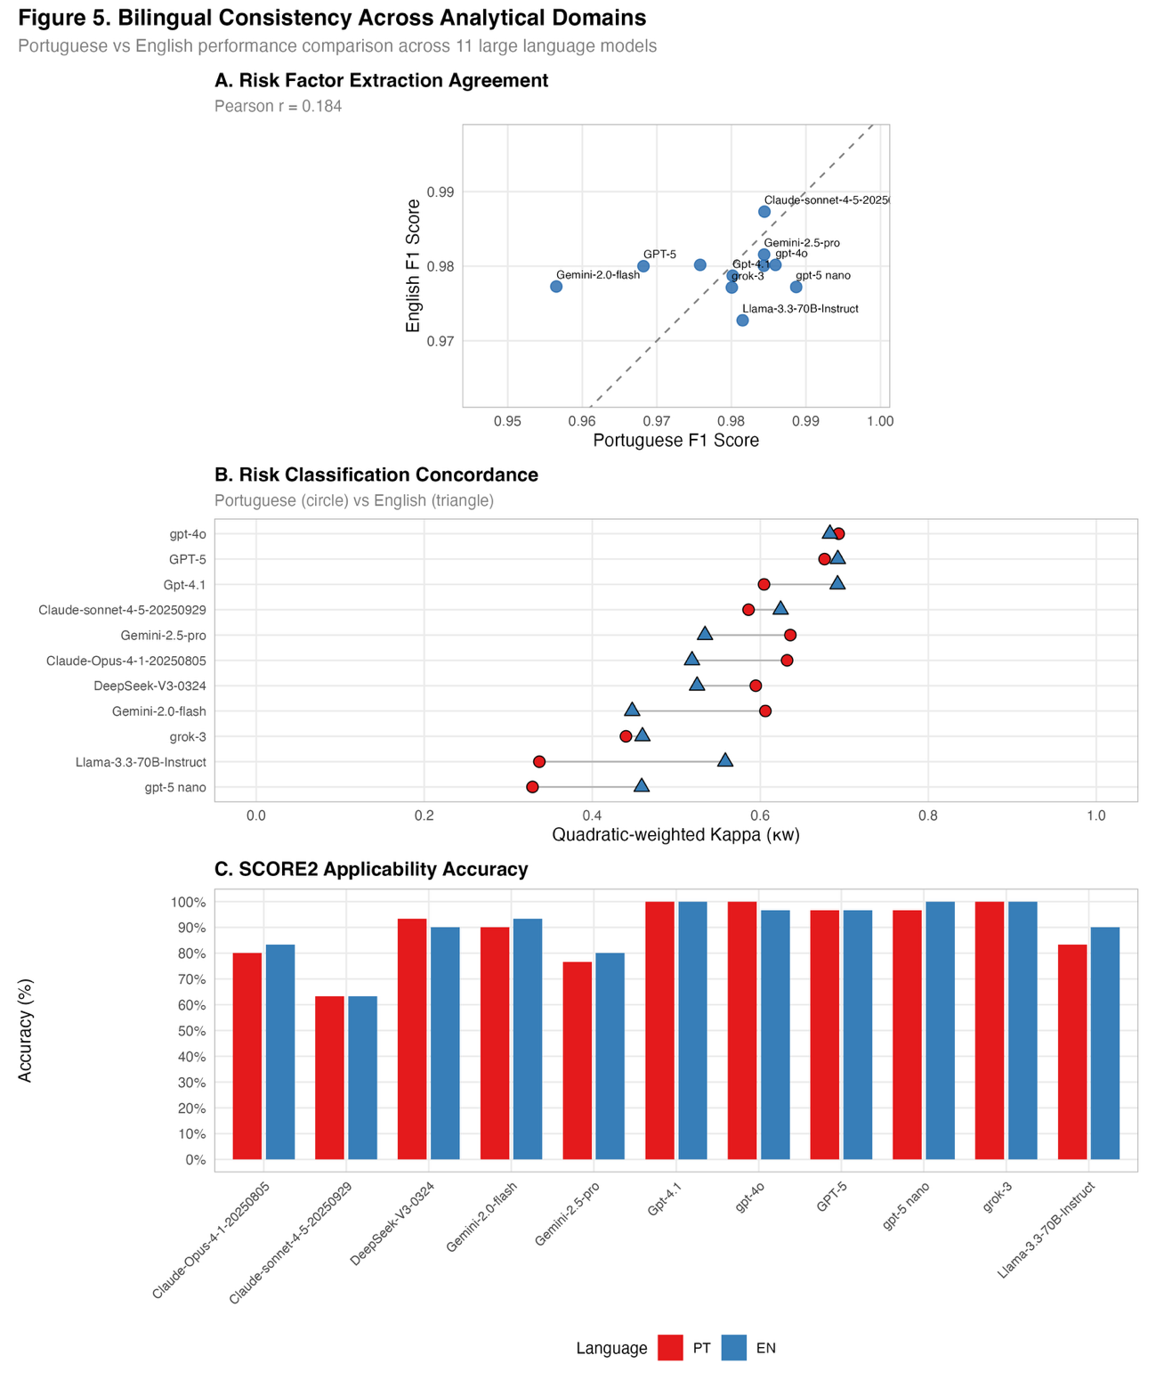

Legend: Comparison of Portuguese (PT) vs English (EN) performance for 11 large language models across three prespecified domains.
(A) Risk-factor extraction agreement: Scatterplot of Micro-F1 (traditional factors only), EN on the y-axis vs PT on the x-axis; the dashed line is the identity (perfect parity). Each point is one model; labels indicate model names.
(B) Risk classification concordance: Quadratic-weighted Cohen’s κ (κw) for ESC three-class risk categories. Circles = PT; triangles = EN; models listed on the y-axis.
(C) SCORE2 applicability accuracy: Bar chart of binary “Use SCORE2 vs Do-Not-Use (override)” accuracy by language.

Supplementary Figure S9. Confusion Matrix: Pooled Clinicians vs Gold Standard (Three-class ESC risk classification)

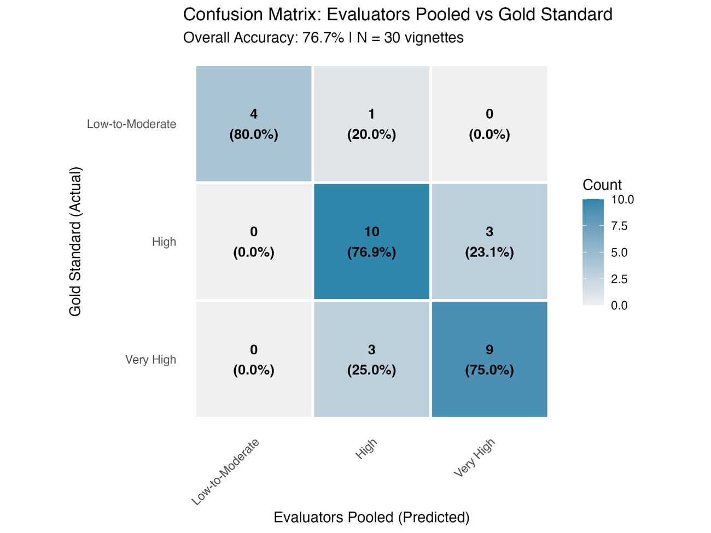

Legend. Cells report counts with row-wise percentages (within each actual class); shading encodes counts. Overall accuracy was 76.7% (23/30). Misclassifications were only adjacent (Low/Moderate↔High, High↔Very High)

Supplementary Tables (Section II)

Supplementary Table S1. Per-model extraction metrics for cardiovascular risk factors

Model | Micro-F1 (95% CI) | Micro-Precision (95% CI) | Micro-Recall (95% CI) | Macro-F1 (95% CI) | Macro-Precision (95% CI) | Macro-Recall (95% CI) | Jaccard (95% CI)
GPT-4o | 0.98  [0.98, 0.99] | 0.98  [0.96, 0.99] | 0.99  [0.98, 0.99] | 0.98  [0.95, 1.00] | 0.97  [0.92, 1.00] | 0.98  [0.97, 1.00] | 0.97  [0.95, 0.98]
GPT-5 | 0.98  [0.97, 0.99] | 0.99  [0.98, 1.00] | 0.97  [0.96, 0.98] | 0.98  [0.95, 0.99] | 0.99  [0.96, 1.00] | 0.97  [0.94, 0.99] | 0.97  [0.95, 0.98]
GPT-4.1 | 0.98  [0.97, 0.99] | 0.98  [0.97, 0.99] | 0.97  [0.96, 0.98] | 0.97  [0.94, 0.99] | 0.97  [0.94, 1.00] | 0.97  [0.94, 0.99] | 0.96  [0.94, 0.97]
Claude Sonnet 4.5 | 0.99  [0.98, 0.99] | 0.98  [0.97, 0.99] | 0.99  [0.98, 1.00] | 0.98  [0.96, 1.00] | 0.98  [0.94, 1.00] | 0.99  [0.98, 1.00] | 0.97  [0.96, 0.98]
Gemini 2.5 Pro | 0.99  [0.98, 0.99] | 0.98  [0.97, 0.99] | 0.99  [0.98, 1.00] | 0.99  [0.96, 1.00] | 0.98  [0.95, 1.00] | 0.99  [0.98, 1.00] | 0.98  [0.96, 0.99]
Claude Opus 4.1 | 0.99  [0.98, 0.99] | 0.99  [0.97, 0.99] | 0.99  [0.98, 0.99] | 0.99  [0.96, 1.00] | 0.98  [0.96, 1.00] | 0.99  [0.97, 1.00] | 0.98  [0.96, 0.99]
DeepSeek V3 | 0.98  [0.97, 0.98] | 0.97  [0.95, 0.98] | 0.99  [0.98, 0.99] | 0.97  [0.94, 1.00] | 0.96  [0.92, 0.99] | 0.99  [0.97, 1.00] | 0.96  [0.94, 0.97]
Gemini 2.0 Flash | 0.97  [0.95, 0.97] | 0.98  [0.96, 0.99] | 0.95  [0.93, 0.97] | 0.96  [0.93, 0.99] | 0.97  [0.93, 1.00] | 0.95  [0.90, 0.99] | 0.93  [0.92, 0.95]
Grok 3 | 0.98  [0.97, 0.99] | 0.98  [0.97, 0.99] | 0.98  [0.97, 0.99] | 0.98  [0.96, 1.00] | 0.98  [0.95, 1.00] | 0.98  [0.96, 0.99] | 0.97  [0.95, 0.98]
Llama 3.3 70B | 0.98  [0.97, 0.99] | 0.98  [0.97, 0.99] | 0.98  [0.97, 0.99] | 0.97  [0.94, 1.00] | 0.98  [0.95, 1.00] | 0.97  [0.92, 0.99] | 0.96  [0.95, 0.98]
GPT-5 Nano | 0.99  [0.98, 0.99] | 0.98  [0.97, 0.99] | 0.99  [0.97, 0.99] | 0.98  [0.96, 1.00] | 0.98  [0.95, 1.00] | 0.99  [0.97, 1.00] | 0.97  [0.96, 0.98]

Legend. Per-model performance for extraction of all predefined cardiovascular risk factors across 60 vignettes (30 Portuguese and 30 English). Metrics include Micro-F1, Micro-precision, Micro-recall, Macro-F1, Macro-precision, Macro-recall, and mean Jaccard index, each reported with 95% confidence intervals.

Supplementary Table S2. Per-model extraction metrics for SCORE2 core risk factors

Model | Micro-F1  (CI 95%) | Micro-Precision (CI 95%) | Micro-Recall  (CI 95%) | Macro-F1 (CI 95%) | Macro-Precision (CI 95%) | Macro-Recall  (CI 95%) | Jaccard  (CI 95%)
GPT-4o | 0.99  [0.98, 1.00] | 0.99  [0.97, 1.00] | 0.99  [0.98, 1.00] | 0.99  [0.98, 1.00] | 0.99  [0.97, 1.00] | 0.99  [0.98, 1.00] | 0.98  [0.97, 0.99]
GPT-5 | 0.98  [0.97, 0.99] | 1.00  [0.99, 1.00] | 0.97  [0.95, 0.98] | 0.98  [0.96, 1.00] | 1.00  [1.00, 1.00] | 0.97  [0.92, 1.00] | 0.97  [0.95, 0.98]
GPT-4.1 | 0.99  [0.98, 0.99] | 0.99  [0.97, 1.00] | 0.98  [0.96, 0.99] | 0.99  [0.97, 1.00] | 0.99  [0.97, 1.00] | 0.98  [0.96, 1.00] | 0.98  [0.96, 0.99]
Claude Sonnet 4.5 | 0.99  [0.99, 1.00] | 0.99  [0.98, 1.00] | 0.99  [0.98, 1.00] | 0.99  [0.98, 1.00] | 0.99  [0.98, 1.00] | 0.99  [0.98, 1.00] | 0.99  [0.97, 1.00]
Gemini 2.5 Pro | 0.99  [0.98, 0.99] | 1.00  [0.98, 1.00] | 0.98  [0.96, 0.99] | 0.99  [0.97, 1.00] | 1.00  [0.99, 1.00] | 0.98  [0.95, 1.00] | 0.98  [0.96, 0.99]
Claude Opus 4.1 | 0.99  [0.98, 0.99] | 1.00  [0.99, 1.00] | 0.98  [0.95, 0.99] | 0.99  [0.97, 1.00] | 1.00  [1.00, 1.00] | 0.97  [0.94, 1.00] | 0.98  [0.96, 0.99]
DeepSeek V3 | 0.99  [0.98, 1.00] | 0.99  [0.97, 1.00] | 0.99  [0.98, 1.00] | 0.99  [0.98, 1.00] | 0.99  [0.97, 1.00] | 0.99  [0.98, 1.00] | 0.98  [0.97, 0.99]
Gemini 2.0 Flash | 0.99  [0.98, 0.99] | 0.99  [0.97, 1.00] | 0.98  [0.96, 0.99] | 0.99  [0.97, 1.00] | 0.99  [0.97, 1.00] | 0.98  [0.95, 1.00] | 0.97  [0.96, 0.99]
Grok-3 | 0.98  [0.97, 0.99] | 1.00  [0.99, 1.00] | 0.97  [0.95, 0.98] | 0.98  [0.96, 1.00] | 1.00  [1.00, 1.00] | 0.97  [0.93, 1.00] | 0.97  [0.96, 0.99]
Llama 3.3 70B Instruct | 0.98  [0.97, 0.99] | 1.00  [0.99, 1.00] | 0.97  [0.95, 0.98] | 0.98  [0.95, 1.00] | 1.00  [1.00, 1.00] | 0.97  [0.91, 1.00] | 0.98  [0.97, 0.99]
GPT-5 nano | 0.99  [0.98, 1.00] | 1.00  [0.98, 1.00] | 0.99  [0.97, 0.99] | 0.99  [0.98, 1.00] | 1.00  [0.99, 1.00] | 0.99  [0.96, 1.00] | 0.98  [0.97, 0.99]

Legend. Extraction performance by model for SCORE2 core variables (age, sex, smoking status, systolic blood pressure, total cholesterol, HDL cholesterol, and non-HDL cholesterol) across 60 vignettes. Micro- and macro-averaged F1, precision, recall, and Jaccard index are presented with 95% confidence intervals for each LLM.

Supplementary Table S3. Pooled per-factor extraction metrics across models (cardiovascular risk factors)

Factor | F1 (95% CI) | Precision (95% CI) | Recall (95% CI) | N determinable | N excluded
Age | 1.00 [1.00, 1.00] | 1.00 [0.99, 1.00] | 1.00 [0.99, 1.00] | 660 | 0
Sex | 1.00 [1.00, 1.00] | 1.00 [0.99, 1.00] | 1.00 [0.99, 1.00] | 660 | 0
Systolic BP | 0.97 [0.96, 0.98] | 1.00 [0.99, 1.00] | 0.95 [0.93, 0.96] | 660 | 0
Diastolic BP | 0.99 [0.98, 0.99] | 1.00 [0.99, 1.00] | 0.98 [0.96, 0.98] | 660 | 0
Total Cholesterol | 1.00 [1.00, 1.00] | 1.00 [0.99, 1.00] | 1.00 [0.99, 1.00] | 660 | 0
HDL Cholesterol | 1.00 [1.00, 1.00] | 1.00 [0.99, 1.00] | 1.00 [0.99, 1.00] | 660 | 0
Non-HDL-Chol | 0.98 [0.98, 0.99] | 1.00 [0.99, 1.00] | 0.97 [0.95, 0.98] | 660 | 0
LDL Cholesterol | 1.00 [1.00, 1.00] | 1.00 [0.99, 1.00] | 1.00 [0.99, 1.00] | 660 | 0
Triglycerides | 1.00 [1.00, 1.00] | 1.00 [0.99, 1.00] | 1.00 [0.99, 1.00] | 660 | 0
Hypertension | 0.96 [0.94, 0.97] | 0.97 [0.95, 0.98] | 0.94 [0.92, 0.96] | 660 | 0
Dyslipidemia | 0.88 [0.86, 0.90] | 0.82 [0.79, 0.85] | 0.94 [0.92, 0.96] | 655 | 5
Smoking | 0.94 [0.91, 0.96] | 0.92 [0.88, 0.95] | 0.95 [0.92, 0.97] | 636 | 24

Legend. Factor-level extraction performance aggregated across all 11 LLMs for each traditional cardiovascular risk factor. For every factor, the table reports F1, precision, and recall with 95% confidence intervals, alongside the number of vignettes in which the factor was determinable and the number excluded.

Supplementary Table S4. Per-model extraction metrics for risk modifiers

Model | Micro-F1 (CI 95%) | Micro-Precision (CI 95%) | Micro-Recall (CI 95%) | Macro-F1 (CI 95%) | Macro-Precision (CI 95%) | Macro-Recall (CI 95%) | Jaccard (CI 95%)
GPT-4o | 0.77  [0.66, 0.87] | 0.73  [0.57, 0.87] | 0.83  [0.70, 0.95] | 0.68  [0.40, 0.69] | 0.70  [0.38, 0.74] | 0.75  [0.42, 0.74] | 0.76  [0.66, 0.86]
GPT-5 | 0.80  [0.67, 0.90] | 0.80  [0.65, 0.92] | 0.81  [0.66, 0.94] | 0.78  [0.37, 0.81] | 0.81  [0.39, 0.83] | 0.79  [0.37, 0.82] | 0.76  [0.63, 0.87]
GPT-4.1 | 0.74  [0.61, 0.84] | 0.74  [0.59, 0.88] | 0.74  [0.60, 0.88] | 0.65  [0.36, 0.66] | 0.71  [0.37, 0.72] | 0.67  [0.36, 0.69] | 0.70  [0.56, 0.82]
Claude Sonnet 4.5 | 0.58  [0.45, 0.68] | 0.52  [0.36, 0.66] | 0.66  [0.56, 0.75] | 0.70  [0.35, 0.71] | 0.75  [0.36, 0.79] | 0.79  [0.40, 0.78] | 0.47  [0.35, 0.59]
Gemini 2.5 Pro | 0.81  [0.70, 0.90] | 0.68  [0.54, 0.81] | 1.00  [1.00, 1.00] | 0.80  [0.45, 0.83] | 0.72  [0.40, 0.77] | 1.00  [0.50, 1.00] | 0.74  [0.61, 0.86]
Claude Opus 4.1 | 0.64  [0.47, 0.77] | 0.58  [0.40, 0.73] | 0.72  [0.55, 0.86] | 0.75  [0.36, 0.77] | 0.75  [0.37, 0.79] | 0.87  [0.42, 0.86] | 0.52  [0.38, 0.67]
DeepSeek V3 | 0.67  [0.52, 0.78] | 0.59  [0.43, 0.74] | 0.78  [0.62, 0.90] | 0.64  [0.33, 0.66] | 0.63  [0.32, 0.66] | 0.76  [0.38, 0.76] | 0.63  [0.50, 0.76]
Gemini 2.0 Flash | 0.67  [0.54, 0.77] | 0.55  [0.41, 0.68] | 0.86  [0.75, 0.96] | 0.68  [0.37, 0.69] | 0.63  [0.34, 0.67] | 0.84  [0.46, 0.82] | 0.55  [0.41, 0.69]
Grok-3 | 0.60  [0.43, 0.73] | 0.55  [0.36, 0.71] | 0.67  [0.50, 0.83] | 0.56  [0.30, 0.58] | 0.56  [0.30, 0.61] | 0.67  [0.35, 0.69] | 0.53  [0.38, 0.68]
Llama 3.3 70B Instruct | 0.67  [0.52, 0.78] | 0.56  [0.40, 0.71] | 0.83  [0.71, 0.92] | 0.77  [0.39, 0.79] | 0.76  [0.39, 0.81] | 0.91  [0.46, 0.90] | 0.56  [0.41, 0.70]
GPT-5 nano | 0.82  [0.69, 0.90] | 0.73  [0.58, 0.86] | 0.93  [0.81, 1.00] | 0.79  [0.39, 0.82] | 0.77  [0.38, 0.82] | 0.93  [0.46, 0.92] | 0.74  [0.61, 0.86]

Legend. Per-model performance for extraction of predefined cardiovascular risk modifiers. The table reports Micro-F1, Micro-precision, Micro-recall, Macro-F1, Macro-precision, Macro-recall, and Jaccard index with 95% confidence intervals, pooling results across 60 bilingual vignettes.

Supplementary Table S5. Pooled per-modifier extraction metrics across models (risk modifiers)

Modifier | N positives (Gold) | F1  (CI 95%) | Precision  (CI 95%) | Recall  (CI 95%) | N determinable | N excluded
Calcium Score = 0 | 22 | 0.96  [0.88, 1.00] | 0.92  [0.74, 0.98] | 1.00  [0.85, 1.00] | 660 | 0
Cancer | 44 | 0.87  [0.78, 0.94] | 1.00  [0.90, 1.00] | 0.77  [0.63, 0.87] | 660 | 0
Inflammatory Disease | 22 | 0.61  [0.40, 0.77] | 0.58  [0.39, 0.76] | 0.64  [0.43, 0.80] | 660 | 0
COPD | 22 | 0.92  [0.82, 0.98] | 0.85  [0.67, 0.94] | 1.00  [0.85, 1.00] | 660 | 0
Elevated Calcium Score | 88 | 0.88  [0.84, 0.93] | 0.80  [0.71, 0.86] | 0.99  [0.94, 1.00] | 660 | 0
Elevated hs-CRP | 22 | 0.81  [0.67, 0.93] | 1.00  [0.80, 1.00] | 0.68  [0.47, 0.84] | 660 | 0
Elevated Lp(a) | 22 | 0.43  [0.26, 0.60] | 0.38  [0.23, 0.56] | 0.50  [0.31, 0.69] | 660 | 0
Family History of ASCVD | 22 | 0.32  [0.21, 0.42] | 0.19  [0.13, 0.28] | 0.96  [0.78, 0.99] | 660 | 0
Increased Arterial Stiffness | 22 | 0.71  [0.52, 0.83] | 0.65  [0.46, 0.81] | 0.77  [0.57, 0.90] | 660 | 0
Obesity | 44 | 0.45  [0.36, 0.53] | 0.29  [0.23, 0.37] | 1.00  [0.92, 1.00] | 660 | 0
Obstructive Sleep Apnea | 66 | 0.87  [0.80, 0.93] | 0.98  [0.90, 1.00] | 0.79  [0.68, 0.87] | 660 | 0
Pre-Diabetes | 242 | 0.76  [0.72, 0.81] | 0.82  [0.76, 0.86] | 0.72  [0.66, 0.77] | 660 | 0

Legend. Modifier-level extraction performance aggregated across all 11 LLMs for each predefined risk modifier. The table shows the number of positive cases in the gold standard, F1, precision, and recall (with 95% confidence intervals), plus the number of vignettes in which each modifier was determinable or excluded.

Supplementary Table S6. High-risk (High + Very-High) vs Low-to-Moderate — binary performance by model (ordered by κw)

Model | N / Unknown (%) | High-risk prevalence (%) | Sensitivity  (95% CI) | Specificity  (95% CI) | PPV  (95% CI) | NPV  (95% CI)
GPT-4o | 60 / 0.0% | 83.3 | 92.0  (81.2, 96.8) | 100.0  (72.2, 100.0) | 100.0  (92.3, 100.0) | 71.4  (45.4, 88.3)
GPT-5 | 56 / 6.7% | 82.1 | 84.8  (71.8, 92.4) | 100.0  (72.2, 100.0) | 100.0  (91.0, 100.0) | 58.8  (36.0, 78.4)
GPT-4.1 | 60 / 0.0% | 83.3 | 86.0  (73.8, 93.0) | 100.0  (72.2, 100.0) | 100.0  (91.8, 100.0) | 58.8  (36.0, 78.4)
Claude Sonnet 4.5 | 60 / 0.0% | 83.3 | 100.0  (92.9, 100.0) | 80.0  (49.0, 94.3) | 96.2  (87.0, 98.9) | 100.0  (67.6, 100.0)
Gemini 2.5 Pro | 60 / 0.0% | 83.3 | 94.0  (83.8, 97.9) | 80.0  (49.0, 94.3) | 95.9  (86.3, 98.9) | 72.7  (43.4, 90.3)
Claude Opus 4.1 | 60 / 0.0% | 83.3 | 84.0  (71.5, 91.7) | 100.0  (72.2, 100.0) | 100.0  (91.6, 100.0) | 55.6  (33.7, 75.4)
DeepSeek V3 | 60 / 0.0% | 83.3 | 90.0  (78.6, 95.7) | 90.0  (59.6, 98.2) | 97.8  (88.7, 99.6) | 64.3  (38.8, 83.7)
Gemini 2.0 Flash | 60 / 0.0% | 83.3 | 80.0  (67.0, 88.8) | 100.0  (72.2, 100.0) | 100.0  (91.2, 100.0) | 50.0  (29.9, 70.1)
Grok-3 | 60 / 0.0% | 83.3 | 76.0  (62.6, 85.7) | 90.0  (59.6, 98.2) | 97.4  (86.8, 99.5) | 42.9  (24.5, 63.5)
Llama 3.3 70B Instruct | 59 / 1.7% | 83.1 | 77.6  (64.1, 87.0) | 100.0  (72.2, 100.0) | 100.0  (90.8, 100.0) | 47.6  (28.3, 67.6)
GPT-5 nano | 55 / 8.3% | 83.6 | 52.2  (38.1, 65.9) | 100.0  (70.1, 100.0) | 100.0  (86.2, 100.0) | 29.0  (16.1, 46.6)

Legend. Binary endpoint: High risk (High + Very-High) vs Low-to-Moderate per Gold Standard; pooled Portuguese and English (PT+EN). Models are ordered by the primary ordinal metric (κw) from Table 3. N / Unknown (%) = number of evaluated predictions / share of missing predictions out of 60 vignettes (30 PT + 30 EN). High-risk prevalence (%) is the Gold Standard proportion of High + Very-High within the evaluated set for each model (may differ slightly across models due to N differences). Sensitivity, specificity, PPV, and NPV are point estimates with 95% CIs (percentages shown to one decimal) and are calculated only on evaluated cases (unknown/abstain excluded from their denominators).

Supplementary Table S7. Numeric agreement with SCORE2

Model | N | MAE | RMSE | Bias | LoA lower | LoA upper | CCC
GPT-4o | 40 | 7.9  (2.0, 16.3) | 18.8  (2.7, 29.6) | 5.0  (-1.4, 13.8) | -30.9  (-38.3, -5.9) | 40.9  (4.1, 65.7) | -0.1  (-0.2, 0.6)
GPT-5 | 33 | 16.3  (2.2, 33.9) | 37.4  (3.0, 56.0) | 13.1  (-1.6, 31.3) | -56.6  (-62.6, -6.4) | 82.9  (2.7, 123.6) | -0.1  (-0.1, 0.5)
GPT-4.1 | 40 | 9.0  (2.2, 19.1) | 22.5  (2.6, 36.2) | 5.2  (-2.2, 15.7) | -38.1  (-49.4, -5.6) | 48.6  (1.7, 80.4) | -0.1  (-0.2, 0.6)
Claude Sonnet 4.5 | 18 | 20.1  (0.9, 44.9) | 41.8  (1.1, 64.5) | 18.3  (-1.4, 43.6) | -57.5  (-63.1, -2.5) | 94.1  (1.7, 139.3) | -0.1  (-0.1, 0.9)
Gemini 2.5 Pro | 27 | 7.8  (1.1, 17.3) | 24.3  (1.6, 38.5) | 5.5  (-1.4, 15.6) | -41.7  (-55.3, -3.5) | 52.8  (1.7, 85.7) | -0.1  (-0.1, 0.8)
Claude Opus 4.1 | 29 | 8.4  (1.1, 22.1) | 26.0  (1.4, 44.9) | 5.5  (-2.2, 19.7) | -45.1  (-61.9, -3.1) | 56.2  (1.6, 100.1) | -0.1  (-0.1, 0.9)
DeepSeek V3 | 36 | 7.8  (2.2, 15.6) | 23.4  (2.9, 36.3) | 3.3  (-2.7, 11.5) | -42.8  (-57.3, -6.1) | 49.4  (1.6, 79.9) | -0.1  (-0.1, 0.5)
Gemini 2.0 Flash | 38 | 13.3  (5.8, 22.1) | 31.9  (16.1, 44.1) | 7.3  (-1.1, 17.2) | -54.3  (-62.8, -32.7) | 68.9  (31.1, 97.9) | -0.1  (-0.1, -0.1)
Grok-3 | 40 | 6.8  (1.7, 13.9) | 22.1  (2.3, 34.9) | 3.5  (-2.0, 11.1) | -40.0  (-54.6, -5.1) | 46.9  (1.9, 76.7) | -0.1  (-0.1, 0.6)
Llama 3.3 70B Instruct | 31 | 8.7  (2.6, 17.1) | 19.1  (3.2, 30.7) | 4.4  (-2.5, 13.9) | -32.7  (-43.6, -7.0) | 41.5  (2.8, 68.4) | -0.1  (-0.3, 0.5)
GPT-5 nano | 31 | 3.8  (1.9, 6.8) | 9.1  (2.3, 15.4) | -0.5  (-2.6, 3.1) | -18.5  (-27.1, -4.6) | 17.6  (0.2, 33.2) | -0.1  (-0.1, 0.6)

Legend. Values are percentage points. MAE = mean absolute error; RMSE = root mean square error; Bias = mean (Model − Gold); LoA = 95% Bland–Altman limits of agreement; CCC = Lin’s concordance correlation coefficient. Rows ordered by κw from the primary classification analysis.

Supplementary Table S8. SCORE2 Override: Extraction Performance

Model | Micro-Precision  (95% CI) | Micro-Recall  (95% CI) | Micro-F1  (95% CI) | Macro-F1  (95% CI) | Mean Jaccard  (95% CI)
GPT-4o | 1.00 (1.00–1.00) | 0.95 (0.85–1.00) | 0.97 (0.92–1.00) | 0.98 (0.48–1.00) | 1.00 (1.00–1.00)
GPT-5 | 0.91 (0.71–1.00) | 1.00 (1.00–1.00) | 0.95 (0.83–1.00) | 0.97 (0.47–1.00) | 0.97 (0.94–1.00)
GPT-4.1 | 1.00 (1.00–1.00) | 1.00 (1.00–1.00) | 1.00 (1.00–1.00) | 1.00 (0.50–1.00) | 1.00 (1.00–1.00)
Claude Sonnet 4.5 | 0.56 (0.32–0.78) | 1.00 (1.00–1.00) | 0.71 (0.48–0.88) | 0.80 (0.33–0.90) | 0.77 (0.65–0.89)
Gemini 2.5 Pro | 0.69 (0.43–0.90) | 1.00 (1.00–1.00) | 0.82 (0.61–0.94) | 0.86 (0.41–0.95) | 0.83 (0.74–0.95)
Claude Opus 4.1 | 0.67 (0.41–0.88) | 1.00 (1.00–1.00) | 0.80 (0.58–0.94) | 0.87 (0.37–0.95) | 0.80 (0.70–0.91)
DeepSeek V3 | 1.00 (1.00–1.00) | 0.95 (0.83–1.00) | 0.97 (0.91–1.00) | 0.98 (0.48–1.00) | 0.97 (0.94–1.00)
Gemini 2.0 Flash | 0.94 (0.79–1.00) | 0.85 (0.61–1.00) | 0.90 (0.72–1.00) | 0.93 (0.42–0.99) | 0.93 (0.88–1.00)
Grok-3 | 1.00 (1.00–1.00) | 1.00 (1.00–1.00) | 1.00 (1.00–1.00) | 1.00 (0.50–1.00) | 1.00 (1.00–1.00)
Llama 3.3 70B Instruct | 0.83 (0.59–1.00) | 0.95 (0.83–1.00) | 0.88 (0.71–0.98) | 0.92 (0.43–0.98) | 0.90 (0.83–1.00)
GPT-5 nano | 1.00 (1.00–1.00) | 0.95 (0.83–1.00) | 0.97 (0.91–1.00) | 0.98 (0.48–1.00) | 0.97 (0.94–1.00)

Legend. Within true overrides (ASCVD, Diabetes, CKD, FH), multilabel extraction performance. Micro/Macro-F1 and Mean Jaccard reported with 95% CIs). Rows ordered by quadratic-weighted κ (κw) from the primary 3-class analysis.

Supplementary Table S9. SCORE2 Override reasons: overall usage & validity

Model | Do Not Use  (n/N; %) | Reason Provided % | Valid Reason % | Invalid %  (Other CVD; Other) | Mix %  (ASCVD / DM / CKD / FH)
GPT-4o | 19/60; 31.7 | 95.0 | 100.0 | 0.0 (0.0; 0.0) | 42.1 / 26.3 / 21.1 / 10.5
GPT-5 | 22/60; 36.7 | 100.0 | 100.0 | 0.0 (0.0; 0.0) | 45.5 / 27.3 / 18.2 / 9.1
GPT-4.1 | 20/60; 33.3 | 100.0 | 100.0 | 0.0 (0.0; 0.0) | 40.0 / 30.0 / 20.0 / 10.0
Claude Sonnet 4.5 | 42/60; 70.0 | 100.0 | 85.7 | 14.3 (14.3; 0.0) | 31.0 / 38.1 / 11.9 / 4.8
Gemini 2.5 Pro | 33/60; 55.0 | 100.0 | 87.9 | 12.1 (12.1; 0.0) | 39.4 / 18.2 / 24.2 / 6.1
Claude Opus 4.1 | 31/60; 51.7 | 100.0 | 96.8 | 3.2 (0.0; 3.2) | 41.9 / 35.5 / 12.9 / 6.5
DeepSeek V3 | 23/60; 38.3 | 95.0 | 82.6 | 17.4 (17.4; 0.0) | 34.8 / 21.7 / 17.4 / 8.7
Gemini 2.0 Flash | 19/60; 31.7 | 85.0 | 94.7 | 5.3 (0.0; 5.3) | 31.6 / 31.6 / 21.1 / 10.5
Grok-3 | 20/60; 33.3 | 100.0 | 100.0 | 0.0 (0.0; 0.0) | 40.0 / 30.0 / 20.0 / 10.0
Llama 3.3 70B Instruct | 26/60; 43.3 | 95.0 | 88.5 | 11.5 (7.7; 3.8) | 26.9 / 38.5 / 15.4 / 7.7
GPT-5 nano | 19/60; 31.7 | 95.0 | 100.0 | 0.0 (0.0; 0.0) | 36.8 / 31.6 / 21.1 / 10.5

Legend: Do Not Use = model flagged SCORE2 as not applicable (shown as n/N; %). Reason provided = proportion of override calls that included a stated reason. Valid/Invalid are evaluated among reason-provided calls; Invalid is split into Other CVD (cardiovascular reasons other than ASCVD) and Other (reasons not related to heart disease). Mix shows the distribution of stated reasons across the predefined classes: ASCVD = atherosclerotic cardiovascular disease; DM = diabetes mellitus; CKD = chronic kidney disease; FH = familial hypercholesterolaemia. Rows ordered by quadratic-weighted κ (κw) from the primary 3-class analysis.

Supplementary Table S10. Exploratory human benchmark: clinician agreement with Gold Standard (Three-class ESC risk classification)

Rater | N vignettes | Quadratic-weighted κ (κw) (95% CI)
Evaluator #1 | 30 | 0.55 (0.27–0.80)
Evaluator #2 | 30 | 0.58 (0.31–0.80)
Evaluator #3 | 30 | 0.68 (0.46–0.87)
Evaluator #4 | 30 | 0.93 (0.85–1.00)
Evaluator #5 | 30 | 0.42 (0.14–0.66)
Evaluator #6 | 30 | 0.15 (−0.10–0.40)
Evaluator #7 | 30 | 0.34 (0.04–0.63)
Evaluator #8 | 30 | 0.55 (0.28–0.70)
Evaluators Pooled | 30 | 0.76 (0.58–0.89)

Legend. The prespecified primary metric is quadratic-weighted Cohen’s kappa (κw), which gives partial credit for adjacent one-level disagreements. “Evaluators Pooled” reflects a simple majority-vote ensemble across clinicians, with ties resolved per median tie-breaking to represent the collective physician consensus.

Supplementary Table S11. Specifications and configurations of LLM evaluated

Model | Version | Run Date | Decoding Parameters | Inference Mode | Hardware / API Endpoint
Claude Opus 4.1 | claude-sonnet-4-5-20250929 | 2025-10-04 | max_tokens = 8192; temperature = Default (≈ 0.2); top_p = Default (1.0); no stop sequences | Deterministic single-pass | Anthropic API (Python SDK)
Claude Sonnet 4.5 | claude-opus-4-1-20250805 | 2025-10-04 | max_tokens = 8192; temperature = Default (≈ 0.2); top_p = Default (1.0); no stop sequences | Deterministic single-pass | Anthropic API (Python SDK)
DeepSeek-V3-0324 | DeepSeek-V3-0324 (version:1) | 2025-09-24 | max_tokens = 4096; temperature = default; top_p = default | Stochastic; single-pass | Azure AI Foundry (Azure OpenAI Python SDK)
Gemini 2.0 Flash | gemini-2.0-flash | 2025-09-25 | Temperature: 1.0; topP: 0,95; topK: 64 (default) | Stochastic; single pass | Gemini API (Python SDK)
Gemini 2.5 Pro | gemini-2.5-pro | 2025-09-25 | Temperature:1.0; top:0.95; topK:64 (default) | Stochastic; single pass | Gemini API (Python SDK)
GPT-4.1 | gpt-4.1 (version:2025-04-14) | 2025-08-26 | max_tokens = 4096; temperature = default; top_p = default | Stochastic; single-pass | Azure AI Foundry (Azure OpenAI Python SDK)
GPT-4o | gpt-4o (version:2024-11-20) | 2025-08-27 | max_tokens = 4096; temperature = default; top_p = default) | Stochastic; single-pass | Azure AI Foundry (Azure OpenAI Python SDK)
GPT-5 | gpt-5 | 2025-09-25 | Max_tokens=none; temperature =1.0: top_p=1.0 (default) | Stochastic; single pass | OpenAI API (Python SDK)
GPT-5 nano | gpt-5-nano | 2025-09-25 | Max_tokens=none; temperature =1.0: top_p=1.0 (default) | Stochastic; single pass | OpenAI API (Python SDK)
Grok-3 | grok-3 (version:1) | 2025-08-27 | max_tokens = 4096; temperature = default; top_p = default | Stochastic; single-pass | Azure AI Foundry (Azure OpenAI Python SDK)
Llama-3.3-70B-Instruct | Llama-3.3-70B-Instruct (version:5) | 2025-09-23 | max_tokens = 4096; temperature = default; top_p = default | Stochastic; single-pass | Azure AI Foundry (Azure OpenAI Python SDK)

Legend. Specifications of the 11 large language models (LLMs) included in the study, detailing model identifier and version, run date, decoding parameters (e.g. temperature, top_p, max_tokens), inference mode (stochastic vs deterministic, single-pass), and hardware or API endpoint used for inference.

Supplementary Appendices (Section III)

Supplementary Appendix S1. Example simulated outpatient vignette

Full vignette text in Portuguese and English as used in the study. The full set of vignettes is available at the Open Science Framework project (DOI:10.17605/OSF.IO/J2ZK9).

Portuguese Version

Homem 48, anos, guarda prisional. Veio encaminhado da consulta do médico de família por hipertensão arterial.

Sem dor torácica, síncope, palpitações ou cansaço. Quando interrogado, refere roncopatia e sonolência diurna (embora esposa não note apneias).
Sem antecedentes cardiovasculares pessoais ou familiares. Nega tabagismo. Consumo ocasional de bebidas alcoólicas. Não faz qualquer medicação. Refere que o seu posto de trabalho envolve alguma actividade física, mas não faz activamente desporto.

Exame objectivo: peso 94Kg (IMC 28.2); pressão arterial 161/102mmHg, frequência cardíaca 81bpm.

Analiticamente, apresenta uma creatinina 1.4mg/dL, glicémia em jejum 104mg/dL, HbA1c 6.2%, triglicerideos 197mg/dL, colesterol total 231mg/dL, colesterol HDL 43mg/dL, colesterol LDL 149mg/dL, lipoproteína (a) 29mg/dL, ácido úrico 7.5mg/dL.

Realizou um electrocardiograma e um ecocardiograma, sem alterações valorizáveis. MAPA confirmou HTA (média 24h 138-86mmHg) com perfil não-Dipper. Rigidez arterial com VOP 9.3m/s.

English Version

48-year-old male, correctional officer. Referred from his primary care physician for hypertension.

Denies chest pain, syncope, palpitations, or fatigue. On review of systems, reports snoring and daytime sleepiness (although his wife has not noted apneas).
No personal or family history of cardiovascular disease. Denies tobacco use. Occasional alcohol consumption. Takes no medications. Reports that his work involves some physical activity but does not actively practice sports.

Physical examination: weight 207 lbs (BMI 28.2); blood pressure 161/102 mmHg; heart rate 81 bpm.

Laboratory data: creatinine 1.4 mg/dL; fasting glucose 104 mg/dL; HbA1c 6.2%; triglycerides 197 mg/dL; total cholesterol 231 mg/dL; HDL cholesterol 43 mg/dL; LDL cholesterol 149 mg/dL; lipoprotein(a) 29 mg/dL; uric acid 7.5 mg/dL.

He underwent an electrocardiogram and echocardiogram, both without significant findings. Ambulatory blood pressure monitoring confirmed hypertension (24-hour average 138/86 mmHg) with a non-dipper pattern. Arterial stiffness with pulse wave velocity of 9.3 m/s.

Supplementary Appendix S2. Standardized Prompt Template

This appendix provides the complete Portuguese and English language prompts used for querying all LLMs. Each vignette was submitted using this template, with the text inserted in place of [Vignette]. The format, structure, and variable naming conventions were identical across all models.

PROMP RISCO CV PORTUGUÊS

Função: És um assistente virtual especializado em cardiologia preventiva que apoia a consulta médica.

Objetivo: Analisar a vinheta clínica abaixo, extrair de forma estruturada todos os fatores relevantes para avaliar o risco cardiovascular e calcular o risco segundo as recomendações da Sociedade Europeia de Cardiologia de 2021 (ESC 2021), para a Prevenção Cardiovascular, em países de risco moderado (Portugal).

[Vinheta]

1. Extração estruturada dos fatores de risco:
- Preenche uma tabela em Markdown com os fatores de risco necessários ao cálculo do risco cardiovascular
- Para cada fator: Valor (tal como aparece na vinheta ou indica “desconhecido”); Unidade se aplicável (mmHg, mg/dL, anos);
- Mantém exatamente o mesmo nome de cada variável indicado na lista-referência abaixo.
- Lista-referência (não alterar nomes):
[Fator de Risco -> Valores; Idade -> Numérico; Género->Masculino; Feminino; Tabagismo -> Não fumador; Ex-Fumador; Fumador; Pressão Arterial Sistólica -> Numérico; Colesterol Total -> Numérico, Colesterol HDL -> Numérico, Colesterol não HDL (se necessário calcular) -> Numérico.]

2. Estratificação de risco segundo recomendações da sociedade europeia de cardiologia 2021 (2021 ESC Guidelines on cardiovascular disease prevention in clinical practice)

- Verifica se o SCORE2 é aplicável (Sim / Não).
- Se existir algum critério de exceção que impeça a aplicação do SCORE2, indica-o e classifica o doente de acordo com os grupos de risco definidos nas recomendações ESC 2021 (exceções possíveis: Diabetes Mellitus, Dislipidemia Familiar, Doença Renal Crónica, Doença Cardiovascular Aterosclerótica).
- Sempre que aplicável, calcula o SCORE2 (risco cardiovascular a 10 anos, em percentagem), utilizando exclusivamente: 1) os fatores de risco identificados no ponto 1; 2 usando a calculadora online oficial da Sociedade Europeia de Cardiologia para países de risco moderado https://heartscore.escardio.org/Calculate/quickcalculator.aspx?model=moderate;
3) em alternativa, usando a tabela SCORE2 para países de risco moderado, constante nas recomendações; 4) não devem ser utilizadas aproximações nem estimativas baseadas em julgamento clínico subjetivo para determinar o SCORE2.
- De acordo com o resultado do SCORE2, identifica a categoria de risco, tendo em conta a idade (Baixo-a-Moderado; Alto; Muito-Alto)
- Indica o grau de confiança da decisão sobre categoria de risco indicada no ponto anterior (Escolhe apenas uma categoria -> Baixa, Intermédia, Alta, Muito-Alta).
- Apresenta as saídas numa tabela Markdown: | SCORE2 Aplicável | Exceção (se não aplicável) | SCORE2 (%)| Categoria Risco | Grau de Confiança

3. Breve explicação clínica

Máximo 150 palavras. Realça os fatores que mais contribuíram para a classificação de risco (p. ex. HTA mal controlada, tabagismo, LDL elevado, modificadores de risco, etc.).

4. Extracção estruturada dos fatores de risco:
- Preenche uma tabela Markdown com as duas categorias fixas: “Fatores de Risco” e “Modificadores de Risco”.
- Para cada variável apresenta o valor tal como aparece na vinheta ou “desconhecido”; inclui unidade se aplicável (mmHg, mg/dL, anos);
- Mantém exatamente o mesmo nome de cada variável indicado na lista-referência abaixo.
- Quando mais do que uma opção é possível (p. ex. Modificadores de Risco), lista-as separadas por “;”.
- Lista-referência (não alterar nomes):
[Fator de Risco -> Valores; Idade -> Numérico; Género->Masculino; Feminino; Tabagismo -> Não fumador; Ex-Fumador; Fumador; Hipertensão Arterial -> Sim, Não; Pressão Arterial Sistólica -> Valor; Pressão Arterial Diastólica -> Valor; Dislipidemia -> Sim, Não; Colesterol Total -> Numérico; Colesterol HDL -> Numérico; Triglicéridos -> Numérico; Colesterol LDL -> Numérico; Colesterol não HDL (se necessário calcular) -> Numérico; Diabetes Mellitus-> Sim, Não
Modificadores de Risco -> Valores; Pode selecionar mais do que um -> Score de Cálcio elevado; Score de Cálcio = 0; Placas Carótidas; Obesidade; Pre-Diabetes; História Familiar de doença cardiovascular aterosclerótica; Lp (a) aumentada; Rigidez Arterial aumentada; PCR alta sensibilidade elevada; Doença Inflamatória Crónica; Infecção HIV; Sindrome Apneia Obstrutiva do Sono; Esteatose Hepática Não Alcoólica; Disfunção erétil; Menopausa precoce; Antecedentes de Gravidez com complicações (Pre-eclampsia, Hipertensão arterial ou diabetes); Doença pulmonar obstrutiva crónica (DPOC); Cancro; Outro (especificar)]

5. Formato geral
- Usa Markdown; não incluas texto fora das secções acima
- Quando um valor não se encontra nos dados, escreve “desconhecido”
- Usa sempre “,” como separador decimal e “.” para milhares (padrão português)

6. Criação de um json file
- No final, cria um json file que sumarize as informações, com a seguinte estrutura:
json_file ={
"Risco':{'SCORE2 Aplicável': '..', 'Exceção': '..','Categoria': '..', 'SCORE2': '..', ‘confiança’: ’..’ },"
"Fatores de risco':{'Fator1':'valor1','Fator2':'valor2', …}"
"Modificadores de risco' : 'FactorM1:'valorM1', 'FactorM2': 'valorM2'}}."

PROMPT CV RISK ENGLISH

Function: You are a virtual assistant specialized in preventive cardiology that supports clinical decision-making in medical consultations.

Objective: To analyze the clinical vignette below, extract in a structured manner all relevant factors for cardiovascular risk assessment, and calculate risk according to the 2021 European Society of Cardiology Guidelines (ESC 2021) for cardiovascular prevention in moderate-risk countries (Portugal).

[Vignette]

1. Structured extraction of risk factors:

- Fill in a Markdown table with all risk factors required for cardiovascular risk calculation
- For each factor: provide the value as presented in the vignette or “unknown”; include units where applicable (e.g., mmHg, mg/dL, years).
Use exactly the same variable names as indicated in the reference list below.
- Reference list (do not change names):
[Risk Factor -> Values; Age -> Numeric; Gender -> Male; Female; Smoking -> Non-smoker; Former Smoker; Smoker; Systolic Blood Pressure -> Numeric; Total Cholesterol -> Numeric; HDL-Cholesterol -> Numeric; non-HDL Cholesterol (calculate if necessary) -> Numeric].

2. Risk stratification according to the 2021 ESC Guidelines on cardiovascular disease prevention in clinical practice

- Check whether SCORE2 is applicable (Yes / No).
- If any exception criteria are present that preclude SCORE2 use, specify them and classify the patient based on ESC 2021 recommended risk groups (possible exceptions: Diabetes Mellitus, Familial Dyslipidemia, Chronic Kidney Disease, Atherosclerotic Cardiovascular Disease).
- When applicable, calculate the SCORE2 (10-year cardiovascular risk, in percentage), using only: 1)The risk factors identified in section 1; 2) the official online calculator for moderate-risk countries provided by the European Society of Cardiology:
https://heartscore.escardio.org/Calculate/quickcalculator.aspx?model=moderate; 3)
Alternatively, use the SCORE2 risk tables for moderate-risk countries as published in the ESC 2021 Guidelines; 4) do not use approximations or clinical judgment-based estimates for SCORE2 calculation.
- Based on the SCORE2 result, determine the risk category, taking age into account (Low-to-Moderate; High; Very High).
- Indicate the confidence level of the assigned risk category (choose one only: Low, Moderate, High, Very High).
- Present the output in a Markdown table as follows: | SCORE2 Applicable | Exception (if not applicable) | SCORE2 (%) | Risk Category | Confidence Level

3. Brief Clinical Explanation
Provide a brief clinical summary (maximum 150 words) highlighting the main factors that contributed to the assigned risk classification (e.g., uncontrolled hypertension, smoking, elevated LDL, presence of risk modifiers, etc.).

4. Structured extraction of risk factors:

- Fill in a Markdown table with two fixed categories: “Risk Factors” and “Risk Modifiers”.
- For each variable, report the value as shown in the vignette or “unknown”; include units, where applicable.
- Maintain exactly the same variable names listed in the reference list below.
- If more than one option applies (e.g., multiple risk modifiers), list them separated by semicolons (;).

Reference list (do not alter names):
[Risk Factor -> Values; Age -> Numeric; Gender -> Male, Female; Smoking -> Non-smoker, Former Smoker, Smoker; Arterial Hypertension -> Yes, No; Systolic Blood Pressure -> Numeric; Diastolic Blood Pressure -> Numeric; Dyslipidemia -> Yes; No; Total Cholesterol -> Numeric; HDL-Cholesterol -> Numeric; Triglycerides -> Numeric; LDL-Cholesterol -> Numeric; non-HDL Cholesterol -> Numeric; Diabetes Mellitus -> Yes, No
Risk Modifiers -> Values; More than one can be selected -> Elevated Coronary Calcium Score; Calcium Score = 0; Carotid Plaques; Obesity; Pre-Diabetes; Family History of atherosclerotic cardiovascular disease (ASCVD); Elevated Lp(a); Increased Arterial Stiffness; Elevated High-sensitivity CRP; Chronic Inflammatory Disease; HIV Infection; Obstructive Sleep Apnea (OSA); Non-Alcoholic Fatty Liver Disease; Erectile Dysfunction; Premature Menopause; Past history of Pregnancy Complications (Preeclampsia, Hypertension, or Diabetes); Chronic Obstructive Pulmonary Disease (COPD); Cancer; Other (specify)]

6. General Formatting
- Use Markdown; do not include any text outside the sections above.
- If a value is not available, write “unknown”.
- Always use a comma (,) as a decimal separator and a dot (.) for thousands (Portuguese format).

7. Json File Creation
- In the end, create a json file that sumarizes the details with the following structure:
json_file ={
"Risk:{' SCORE2 Applicable': '..', ' Exception': '..',‘Category: '..', 'SCORE2': '..', ‘Confidence Level: ’..’ },"
"Risk Factors:{'Factor1':'value1','Factor2':'value2', …}
"Risk Modifiers: {FactorM1: 'ValueM1', FactorM2: 'valueM2', ...}}."

