Supplementary Material

Supplementary Figure 1. The lung environment of IPF promotes lung metastasis of cancer cells. (A) The establishment of a mouse model of bleomycin (BLM)-induced idiopathic pulmonary fibrosis (IPF). Hematoxylin and eosin (HE) staining and Masson trichrome (MT) staining of collagen revealed severe pulmonary damage and collagen deposition after BLM administration. (B)BLM-induced induced a significant elevation of pulmonary hydroxyproline when compared to PBS administration. (C) Quantitative histology according to Ashcroft’s method showed that the score significantly increased with BLM administration compared to PBS administration.
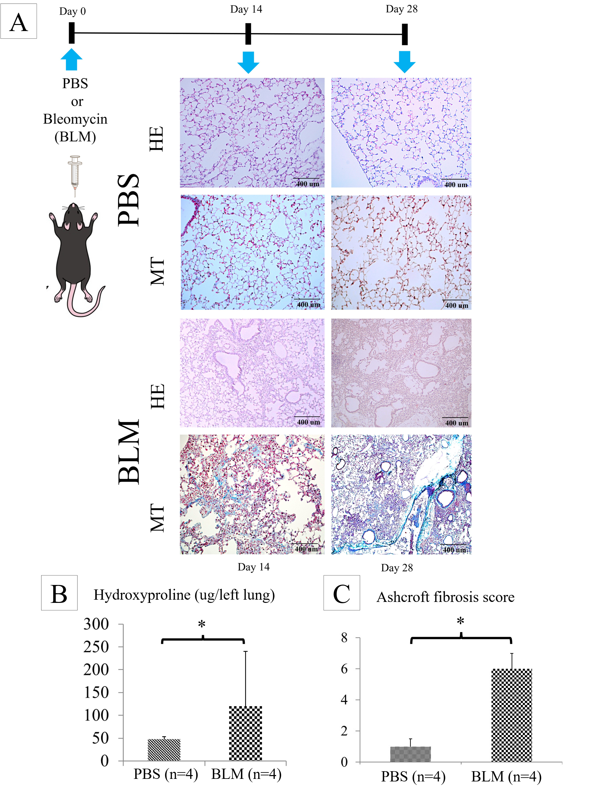
Supplementary Figure 2. The pharmacological treatment of IPF by Pirfenidone (PFD) (A) PFD (300 mg/kg/day, orally) was administered twice daily. HE and MT staining revealed that severe pulmonary damage and BLM-induced collagen deposition were clearly suppressed by PFD. (B) The BLM-induced elevation of pulmonary hydroxyproline was significantly suppressed. *P < 0.05. (C) Quantitative histology, which was performed according to Ashcroft’s method, showed that PFD significantly attenuated the score in BLM-treated mice. *P < 0.05.
