Supplementary data

Table 1 The name, origin and ecotype of the oilseed rape genotypes used in this study.
 | Name of genotype | Origin | Ecotype
Nt-responder | 6020-1 | China | Semi-winter
Nt-responder | 71-8 | China | Semi-winter
Nt-responder | Moneta | Canada | Spring
Nt-responder | Jian 72 | China | Semi-winter
Nt-responder | Zheyou 18 | China | Semi-winter
Nt-nonresponder | Wesbery-1 | Australia | Spring
Nt-nonresponder | 28960 | Germany | Winter
Nt-nonresponder | Bridger | Germany | Winter
Nt-nonresponder | Sollux | Germany | Winter
Nt-nonresponder | H 49 | Soviet Union | Winter
Nt-efficient | Guiyou 3 | China | Semi-winter
Nt-efficient | Zhongshuang 10 | China | Semi-winter
Nt-efficient | Zhongshuang 9 | China | Semi-winter
Nt-efficient | Zheyou 18 | China | Semi-winter
Nt-inefficient | 77023 | China | Semi-winter
Nt-inefficient | 85-110 | China | Semi-winter
Nt-inefficient | Zhongshuang 4 | China | Semi-winter
Nt-inefficient | Sollux | Germany | Winter

Table 2 Primers used in this study.
Genes | Primers for real-time RT-PCR
BnACTIN | Forward: 5'-ACGAGCTACCTGACGGACAAG-3'  Reverse: 5'-GAGCGACGGCTGGAAGAGTA-3'
BnARF18 | Forward: 5'-GTGAACAAGTATATGGAAGCTAT-3'  Reverse: 5'-CTGTTGTTGGCTCATCCCAT-3'
BnLCR | Forward: 5'-AAGGAGGTTTAAGGGATATGAGA-3'  Reverse: 5'-CTACAAAATGGATTCGAGGACTC-3'
BnaC9.SMG7b | Forward: 5'-CCCTGGAATTGCTGACCGTA-3'  Reverse: 5'-TGGAAAGTGCTGAGGGATGC-3'
BnDA1 | Forward: 5'-ACGAGCTACCTGACGGACAAG-3'  Reverse: 5'-GAGCGACGGCTGGAAGAGTA-3'

Table 3 Means of agronomic traits of contrasting NUtE oilseed rape genotypes in the field and pot-culture experiments.
 | Plant height  (cm) |  | Stem diameter  (mm) |  | First valid branch height  (cm) |  | Number of first valid branches
 | Field experiment | Pot experiment | Field experiment | Pot experiment | Field experiment | Pot experiment | Field experiment | Pot experiment
Nt-responder | 149.7 a | 132.1 a | 9.2 a | 10.6 a | 31.5 a | 25.9 b | 9.2 a | 7.1 a
Nt-nonresponder | 148.5 a | 141.7 a | 9.1 a | 10.1 a | 33.2 a | 43.7 a | 9.5 a | 7.1 a
Nt-efficient | 136.6 a | 144.3 a | 9.3 a | 9.5 a | 27.8 a | 41.4 a | 8.1 a | 5.5 a
Nt-inefficient | 130.9 a | 138.0 a | 9.1 a | 8.8 a | 27.2 a | 36.2 a | 7.9 a | 5.7 a
Means in a column followed by different letters indicate significant differences according to ANOVA-protected LSD_{0.05} test.

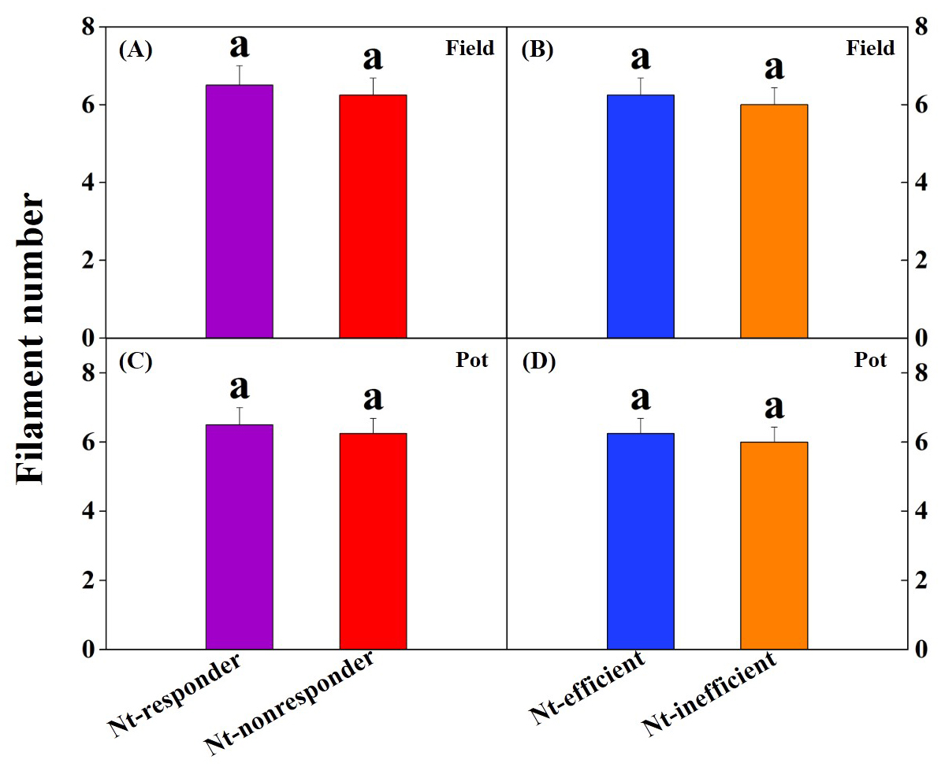
Fig.1 Filament number under field and pot experiments. Each bar represents a mean plus SE of four biological replicates, and different letters above the bars indicate significant differences according to ANOVA-protected LSD_{0.05} test.

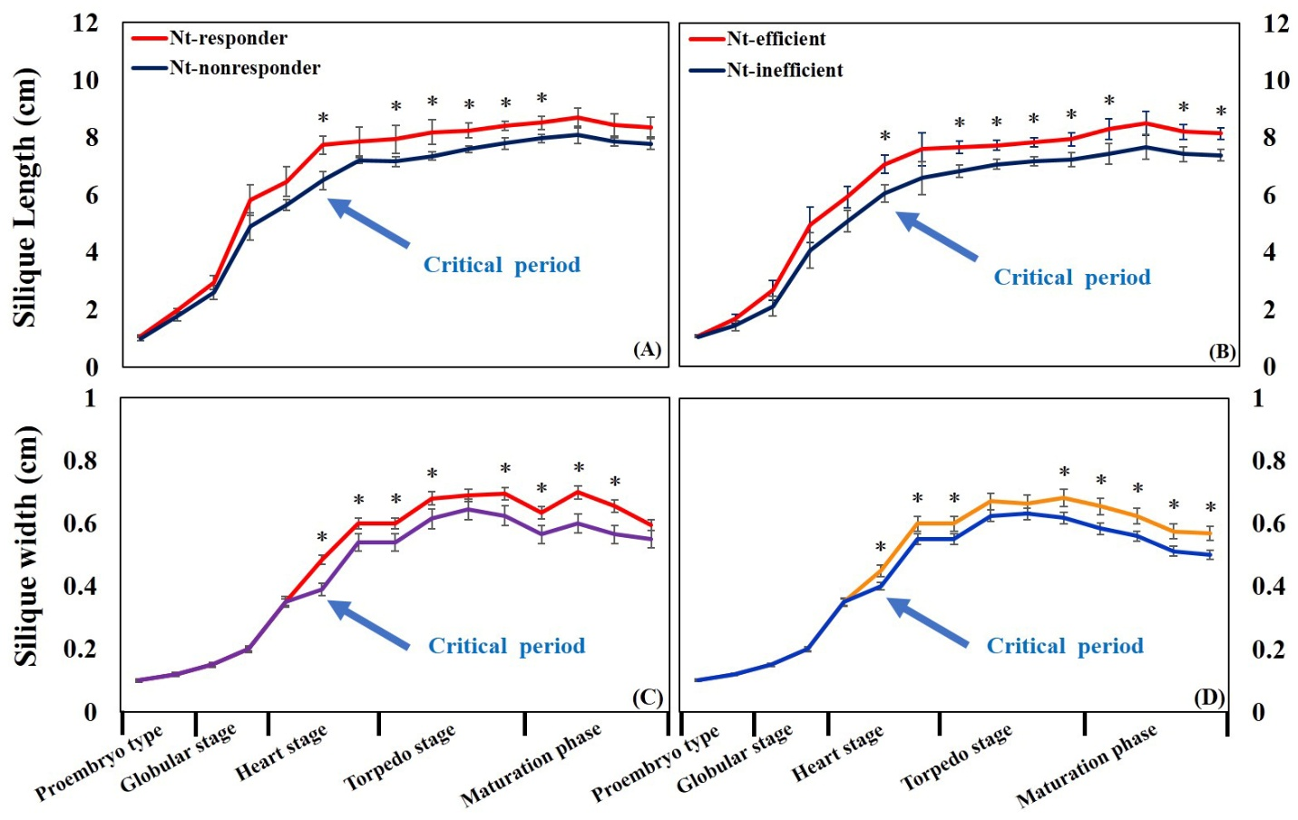
Fig.2 Silique length (A and B) and width (C and D) at proembryo, globular, heart, torpedo and maturation stages in a pot experiment. * indicates significant difference among contrasting NUtE genotypes (P < 0.05).

