Supplementary

The detailed TGA plot for each of the material with weight loss percentage is given in the supplementary document (Fig. S1).
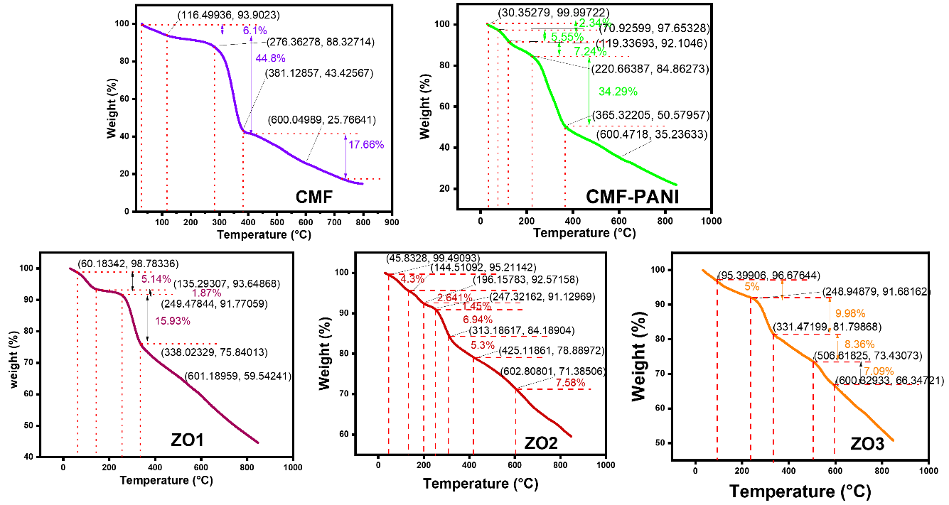
Figure S1. The TGA plot with weight loss indications for CMF, CMF-PANI, ZO1, ZO2, ZO3
Table S1. The weight loss percentage at each stage for the materials
S. No | Material | Wt. loss percentage up to 250 °C | Remaining Wt. % at 600 °C | Remaining Wt.% at 800 °C
 | CMF | 10.11 | 25.76 | 14.77
 | CMF-PANI | 19.36 | 35.23 | 24.21
 | ZO1 | 8.6 | 59.50 | 47.05
 | ZO2 | 9.3 | 71.4 | 61.79
 | ZO3 | 8.6 | 66.29 | 53.75

Gas sensing setup (microliter to ppm conversion)
To calculate the concentration of 2 μL of acetone in 500 mL empty bubbler at a temperature of 333 K we assume that the entire 2 μL of acetone is vaporised by heating, the bubbler volume is 0.5 L (0.0005 m³) the gas behaves ideally and the pressure is 1 atm. The volume of the acetone 2 μL is first converted into moles which is approximately $2.716×{10}^{-5}$ mol by using density of acetone and molar mass of acetone.
$$\text{Mass}= 0.002 m L×0.789\frac{g}{mL}=0.001578 g$$$\text{Moles, }n_{VOC}=\frac{0.001578 g}{58.08 g/mol}=2.716×{10}^{-5}$ mol
$$\text{Molar concentration}, C_{mol}=\frac{n}{V}=\frac{2.716×{10}^{-5}mol}{0.0005 { m}^{3}}=0.0543\frac{mol}{m^{3}}$$
$$\text{Mass Concentration,} C_{mass}=0.0543\frac{mol}{m^{3}}×58.08\frac{g}{mol}=3.155\frac{g}{m^{3}}$$
At 333 K and 1 atm, using ideal gas law the total moles of air in 500 mL is calculated by,
$$n_{air}=\frac{PV_{air}}{RT}=101325×\frac{0.0005}{8.314}×333=0.0183 mol$$
Mole fraction is obtained by,
$$ppm=\frac{n_{VOC}}{n_{air}+n_{VOC}}{10}^{6}=\frac{{2.716×10}^{-5}}{0.0183+2.716×{10}^{-5}}×{10}^{6}≈1480 ppm$$

