Supplementary Information for

Bioinspired supramolecular polymers with water-triggered dense domains: achieving mechanical robustness, programmability, and weather resistance
Changhong Lin¹, Geyuan Jiang¹, Minxin Wang¹, Guanglei Chen^{3,*}, Haipeng Yu^{2,*}, Dawei Zhao^{1,2,*}
- Key Laboratory on Resources Chemicals and Materials of Ministry of Education, Shenyang University of Chemical Technology, Shenyang 110142, P. R. China
- Key laboratory of Bio-based Material Science and Technology of Ministry of Education, Northeast Forestry University, Harbin 150040, P. R. China
- Department of Oncology, Shengjing Hospital of China Medical University, Shenyang, China

*Corresponding authors:
daweizhao@syuct.edu.cn;
yuhaipeng20000@nefu.edu.cn;
glchen@cmu.edu.cn;

Supplementary information file includes:
I. Supplementary Methods
II. Supplementary Figures 1 to 20
III. Supplementary Tables 1 to 2
IV. Supplementary References
I. Supplementary Methods
Materials
Lignocellulose with a polymerization degree of approximately 1172 was purchased from Taobao (China). 1-butyl-3-methylimidazolium chloride ([Bmim]Cl) was prepared by our reported work¹. Dimethyl sulfoxide (DMSO), methyl methacrylate (MMA), ammonium persulfate (APS), N,N'-methylenebisacrylamide (BIS), sodium hydroxide (NaOH), sodium carbonate (Na₂CO₃), and potassium chloride (KCl) were purchased from Aladdin (China). Hydrochloric acid (HCl) and heptane (C₇H₁₆) were purchased from Fuyu Chemical (China).
Preparation of cellulose molecular system
First, a homogeneous molecular system containing 4 wt% cellulose was prepared by mechanically stirring approximately 30 g of the ionic liquid [Bmim]Cl with 1.25 g of cellulose at 85 °C for 4 h. The resulting cellulose molecular system was then left static in an 85 °C circulating drying oven for at least 12 h to thoroughly remove air bubbles. Subsequently, the degassed sample was subjected to approximately 12 h of humidity conditioning at ambient temperature, yielding the final Cel–IL gel.
Construction of T-polymer
The Cel–IL gel was subjected to multiple rounds of water exchange to obtain a cellulose hydrogel. A polymerization solution was prepared by mixing 0.1 g of BIS, 0.5 g of APS, 100 g of MMA, and 80 g of DMSO, followed by stirring at room temperature for 30 min. The cellulose hydrogel was immersed in the polymer solution for 6 h, and then the polymer solution containing the cellulose hydrogel was placed in an 80 ℃ oven for in-situ polymerization for 6 h, yielding a double-network molecular system with around 20 wt% cellulose and 80 wt% PMMA. This double-network system was then placed in water and subjected to at least 2 h of water-triggering to produce T-polymer.
Dimensional stability tests of T-polymer
In high humidity environment, these T-polymers with 30 mm × 30 mm × 2 mm were placed in a constant temperature and relative humidity chamber (25 ℃, 50% RH or 90% RH) for dimensional stability testing. The dimensions are measured every 3 d, repeating five times. The volume change rate (V_{c}) is calculated through the following equation:
V_{c} = (V−V_{t}) ×100%/V
where V represents the original volume of samples, V_{t} represents the volume of samples at respective exposure time.
[Bmim]Cl recycling
The exchange solution obtained from multiple water replacements of the Cel–IL gel was collected. The mixture was filtered to remove impurities, followed by removal of water via rotary evaporation under vacuum to recover and recycle the IL.
DMSO recycling
The aqueous solution obtained after water-triggering of T-polymer was collected. To prevent potential disproportionation of DMSO at elevated temperatures, water was removed by reduced-pressure distillation at moderately low temperatures, allowing the recovery and recycling of DMSO.
Characterizations. The Scanning electron microscopy (SEM) microstructure of samples was characterized by a JSM-IT800 microscope (JEOL, Tokyo, Japan) at an operating voltage of 10 kV. The small-angle X-ray scattering (SAXS) of sample was measured using an SAXS mc² instrument with Cu-Kα X-ray radiation and a wavelength of 0.154 nm (Anton Paar, Graz, Austria). The sample-to-detector distance was 2658.5 mm and exposure time 5 min. The XRD pattern of sample was measured by a D/max 2200 X-ray diffractometer (Rigaku, Tokyo, Japan) equipped with Ni-filtered Cu-Kα radiation (λ = 0.154 nm). The samples were scanned within 5-90° 2θ at 30 kV and 30 mA with a scanning rate of 5°·min⁻¹. The FTIR spectra of samples were obtained by a Nicolet IS50 FTIR instrument (Thermo Fisher Scientific Inc., Waltham, MA, USA). All spectra were measured in ATR mode, with data recorded in the range of 400-3600 cm⁻¹. X-ray photoelectron spectroscopy (XPS) spectra were obtained by the Shimadzu Model Axis Supra (Japan) equipped with monochromator Al target (λ = 0.05 eV). Raman spectra of the samples were acquired using an HR Evolution spectrometer (HORIBA JY, France). Measurements were performed with a 532 nm excitation laser, with spectral data collected over the range of 500–2500 cm⁻¹. 2D Raman mapping was conducted by acquiring spectra across a 1×1 cm surface area, where the intensity of the characteristic Raman peak at 814 cm⁻¹ was converted into spatial contrast to generate the 2D Raman mapping. The scanning procedure was performed with a step size of 1 μm and an integration time of 1 s per data point. Three-dimensional surface topography was characterized using a DMS1000 microscope (Sunny Optical Technology, China).
Mechanical properties. The tensile mechanical properties of the original state, T-polymer, ABS, PMMA, PLA, T-polymers with different water-triggering durations, recycled T-polymer, plastics after high-temperature treatment and plastics after liquid nitrogen treatment were measured using a UTM2503 universal testing machine (Suns Technology Stock Co., Ltd., ShenZhen, China) at a tensile speed of 5 mm/min at room temperature. Bending stress-deflection testing of the T-polymer and various plastics were operated through the three points bending method (the span between two support points was 60 mm). The specimens were tested at a constant speed of 5 mm/min at room temperature. Fatigue testing of T-polymer was similarly conducted using a UTM2503 universal testing machine, under cyclic loading-unloading conditions with a maximum stress of 30 MPa and a constant speed of 2 mm/min for 50 consecutive cycles.
Impact and puncture resistance test. For the impact resistance test of iron ball, we used a 256 g metal iron ball as a free-falling impactor, the velocity of iron ball just touching sample was calculated by free-fall formula, according to eq. (1):
ν₀ = (2hg)^{1/2} (1)
where h is the free-fall distance (m), and g is the acceleration of gravity (9.8 m·s⁻²). We adjusted h until the iron ball broke the samples. This was repeated five times for each material.
The energy absorption of destruction of the test samples was defined by loss of kinetic energy after iron ball attacking samples. The impact resistance is calculated according to eq. (2):
Breakage resistance = (mν₀²)/2dρ (2)
where m is the mass of iron ball, d is the thickness of sample, ρ is the density of sample, and ν₀ is the velocity of iron ball touching sample.
When puncture resistance testing was performed using a 60° conical probe weighing 80.75 g, the calculation formula remained consistent with that used for the impact resistance test.
Nanoindentation experiment. Quasi-static nanoindentation tests were performed on T-polymer, ABS, PMMA, and PLA using a Nano Indenter G200 (Agilent, USA) with a displacement resolution of 0.01 nm. The sample dimension was 20×20×1 mm and tested in the peak load set to 50 mN and the loading rate of 0.50 mN/s. The indentation hardness parameter was averaged over the 5 indentations with associated ± standard deviations.
Dynamic mechanical analysis (DMA). The samples were tested using TA Q800 (TA, USA) under air atmosphere, with a temperature range of -80 °C ~ 250 °C, all samples measured at a speed of 5 °C/min, measurements performed in single-cantilever mode.
Thermogravimetry (TG) test. The thermal decomposition temperatures of T-polymer and various other plastics were investigated using an HTG-4 thermogravimetric analyzer (Beijing Permanent Experimental Equipment Co., Ltd.). Measurements were conducted under a nitrogen atmosphere with a heating rate of 10 °C/min over a temperature range from ambient to 700 °C.
Molecular dynamics (MD) simulations
Classical Molecular dynamics (MD) simulations were employed to investigate the interaction between PMMA and cellulose under different solvent conditions by using the GROMACS 2019.4 software package². The force-field parameters of PMMA and DMSO were generated by the Sobtop script based on GAFF force field. Atomic charges were derived from the optimized geometry using the restrained electrostatic potential (RESP) method³. In addition, the force field parameter of cellulose was described by GLYCAM06 force-field⁴.
Each of the cellulose monomer chain contains 10 glucoses repeat unit, and the polymerization degree of PMMA monomer chain is 20. For the PMMA monomer chain system, 6942 water molecules and 600 DMSO molecules were respectively filled into the simulation box. For the mixed system of cellulose and PMMA, 6 cellulose and PMMA chains were randomly mixed with 10,000 water molecules and 1,200 DMSO molecules, respectively. All systems are constructed by the Packmol program⁵. The simulation process for all of these systems is carried out according to the following methods: the energy minimization was first performed to remove the bad contact between atoms. Then, the system is under the NVT ensemble lasts for 1 ns with the Berendsen thermostat. After reaching the expected temperature, the subsequent equilibrium is carried out in the NPT ensemble lasts for 1 ns to maintain 1 bar of pressure via the Berendsen pressure coupling algorithm⁶. Finally, for each system, 50 ns MD simulation was performed without any restrictions under the NPT ensemble with a time step of 2 fs. The Lennard−Jones and electrostatic interactions were truncated at cutoff distances of 1.2 nm. The long-ranged electrostatic terms were evaluated using the particle mesh Ewald summation⁷. Bond lengths with hydrogen were constrained with the LINCS algorithm⁸. Periodic boundary conditions were applied in all three dimensions. The trajectories were visualized via the visual molecular dynamics (VMD) 1.9.3 software⁹.
Cytotoxicity test for human skin tissue cells. For cytotoxicity assessment, an extraction method was employed. Following 30-minute UV sterilization, the samples were immersed in cell culture medium for 24 hours to obtain extracts. These extracts were then added at varying concentrations to experimental groups for cytotoxicity evaluation. The specific steps are as follows: Human skin tissue cells (NHDF) were quickly removed from the liquid nitrogen tank and shaken in a 37 °C water bath until all melted. The cell suspension was quickly added to the pre-warmed media and placed in a centrifuge at 1,000 rpm and centrifuged for 5 min. The centrifuge tube was removed, the supernatant was discarded, and fresh preheated medium was added to the tube. The cell suspension was added to a 100-mm culture dish and incubated at 37 °C with 5% CO₂. When the cells are 80% to 90% full in the culture dish, digest the cells with 0.25% Trypsin EDTA, resuspend the cells with new medium, and passage at a ratio of 1:3 to 1:5 every 2 to 3 d. Take NHDF cells in logarithmic growth phase and in good growth condition, seed 4×103 cells per well in a 96-well cell culture plate, and incubate overnight in a 37 °C, 5% CO₂ incubator. Add 100 μl of sterile PBS to the wells around the cell wells. The orifice plate was set up with the control group and experimental group: sample 1 (freestanding device) at 200, 100, 50, 25, and 12.5 μg ml⁻¹, with 3 replicate wells in each group. There were 2 control groups, 10 experimental groups, and 1 blank group in this experiment. The culture time was set at 24 h. After culturing NHDF cells for 24 h, removed the supernatant removed, and added 100 μL of medium containing 10% CCK-8. The cells were then incubated in a 5% CO₂, 37 °C incubator for an additional 1.0 hour. The medium to be tested was transferred to a new 96-well plate and measured the absorbance at 450 nm by a microplate reader.
Ⅱ. Supplementary Figures

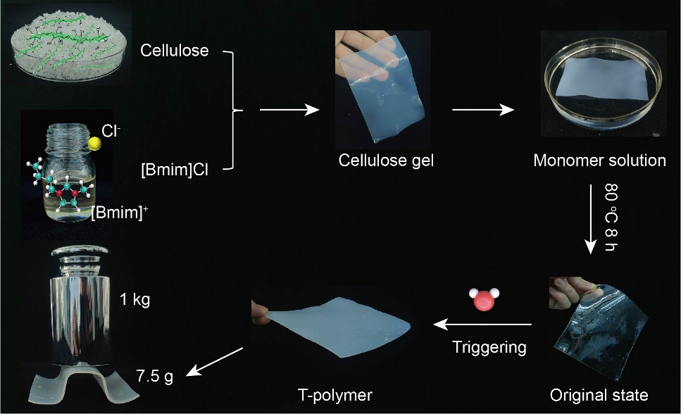
Supplementary Figure 1. The preparation of the dual-network molecular system and enhancement of T-polymer via water-triggering

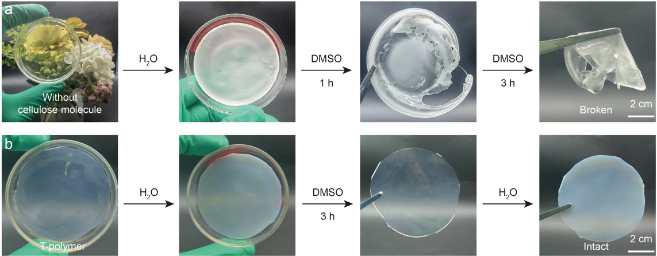
Supplementary Figure 2. The role of the cellulose molecular framework. (a) Sample without cellulose molecular framework. (b) This work which has a dual-network.
As shown in Supplementary Figure 2b, the present system exhibits excellent capability for cyclic water-triggering. In contrast, the PMMA mono-component system without cellulose molecules undergoes structural collapse under identical processing conditions (Supplementary Figure 2a). These results clearly demonstrate that the cellulose molecular scaffold plays an indispensable role in maintaining structural integrity and preventing mechanical failure.

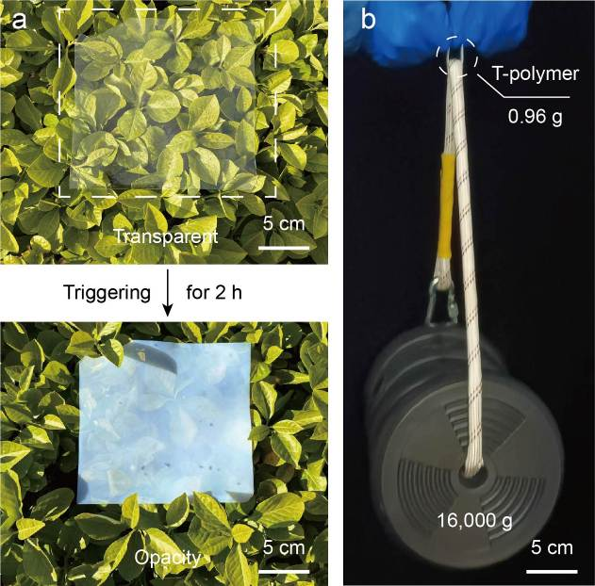
Supplementary Figure 3. The changes of T-polymer before and after water triggering. (a) Optical images comparing the haze characteristics of T-polymer before and after water-triggering. (b) A demonstration of the mechanical robustness exhibited by T-polymer, which has a thickness of 1 mm.

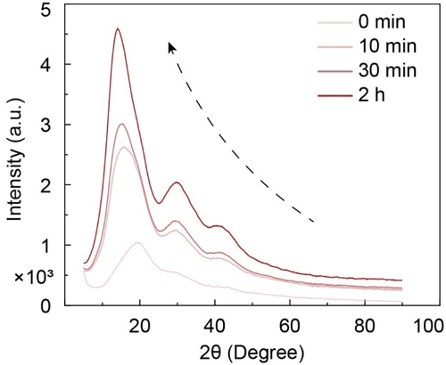
Supplementary Figure 4. XRD analysis of T-polymers subjected to varied water-triggering durations.

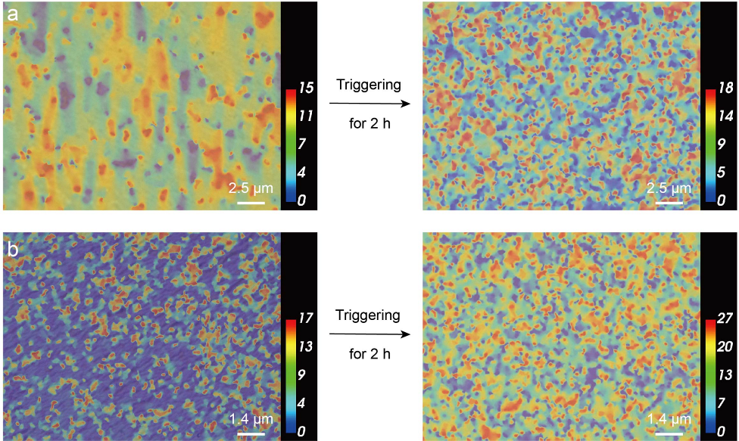
Supplementary Figure 5. Comparison of 3D surface microtopography of T-polymer before and after water triggering. (a) The images at 4000× magnification. (b) The images at 7000× magnification.
Compared to the untriggered materials, T-polymer exhibits a substantial increase in surface roughness, with a 58% growth in height differential. This observation provides direct visual evidence of the aggregation and reorganization processes occurring within the material.

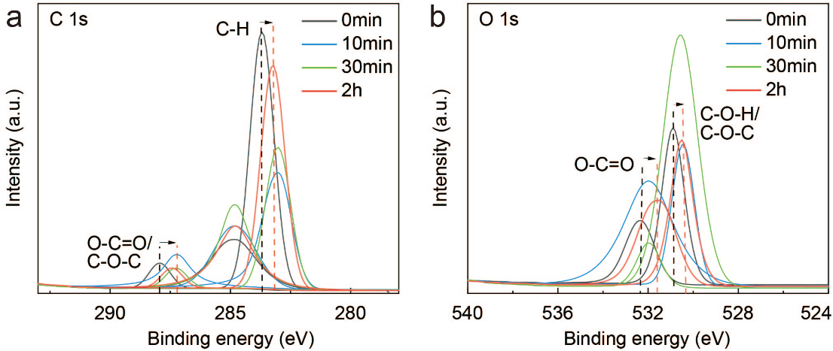
Supplementary Figure 6. XPS analysis of T-polymers with varied water-triggering durations. (a) XPS spectra of C1s. (b) XPS spectra of O1s.

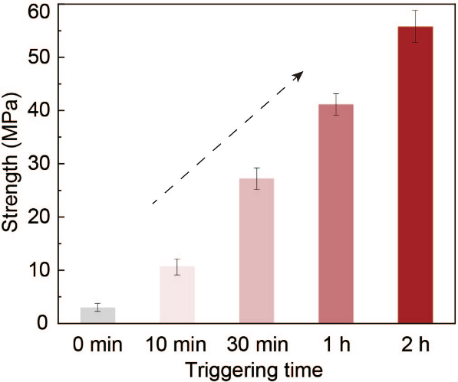
Supplementary Figure 7. Comparison of tensile strength of T-polymer with different triggering times.

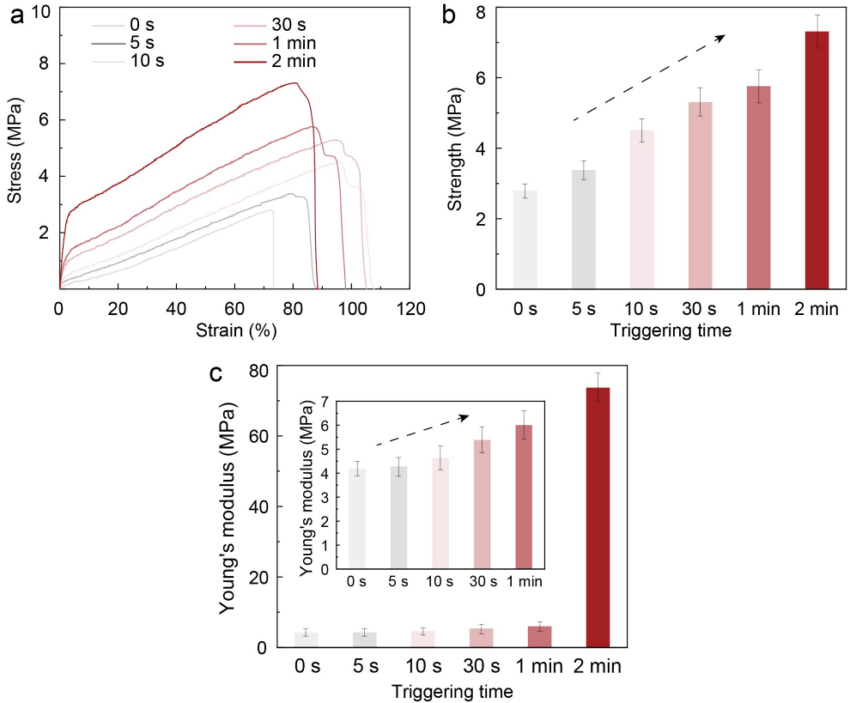
Supplementary Figure 8. Investigating the tensile behavior of T-polymer under short-duration triggering. (a) Tensile stress-strain curves. (b) Comparison of tensile strength. (c) Comparison of Young's modulus.
As shown in Supplementary Figure 8, both the tensile strength and Young's modulus of T-polymer exhibit a continuous increase with prolonged water-triggering duration. Concurrently, we observe an intriguing pattern in the material's elongation at break: it initially increases before gradually decreasing with extended triggering time. Specifically, during the early stages of triggering, water molecules primarily interact with the surface regions, while the internal architecture retains considerable ductility. This differential structural state between surface and inside contributes to enhanced overall toughness. With further aqueous treatment, water progressively permeates the material's inside, inducing global structural compaction and restricting segmental mobility of polymer chains. This microstructural evolution consequently impedes deformation capacity, leading to a gradual reduction in elongation at break that eventually stabilizes.

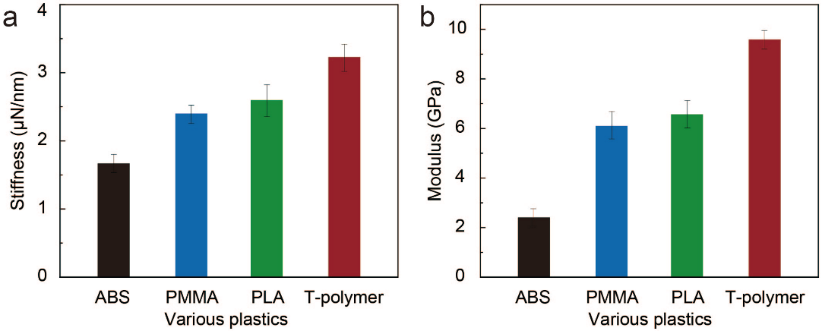
Supplementary Figure 9. Nanoindentation experiment. (a) Comparison of stiffness. (b) Comparison of modulus.

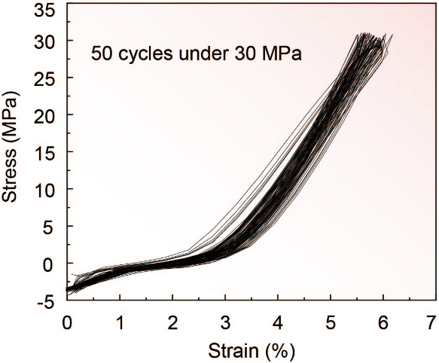
Supplementary Figure 10. Fatigue testing of T-polymer with a maximum stress of 30 MPa for 50 consecutive cycles.

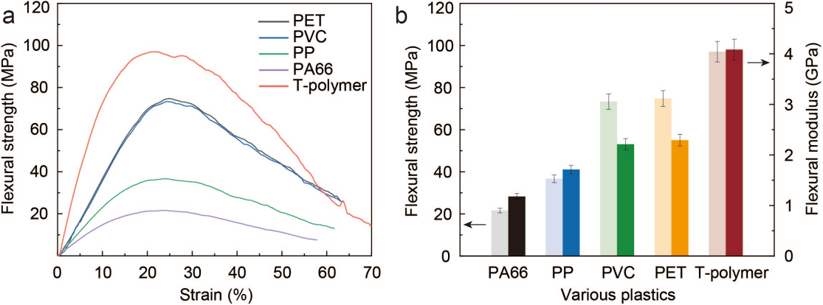
Supplementary Figure 11. Three-Point Bending Tests of T-polymer and Other Plastics. (a) Flexural strength-strain curves of PET, PVC, PP, PA66, and T-polymer. All samples with thickness of 1.00 ± 0.01mm. (b) Comparison of flexural strength and flexural modulus of PET, PVC, PP, PA66, and T-polymer.

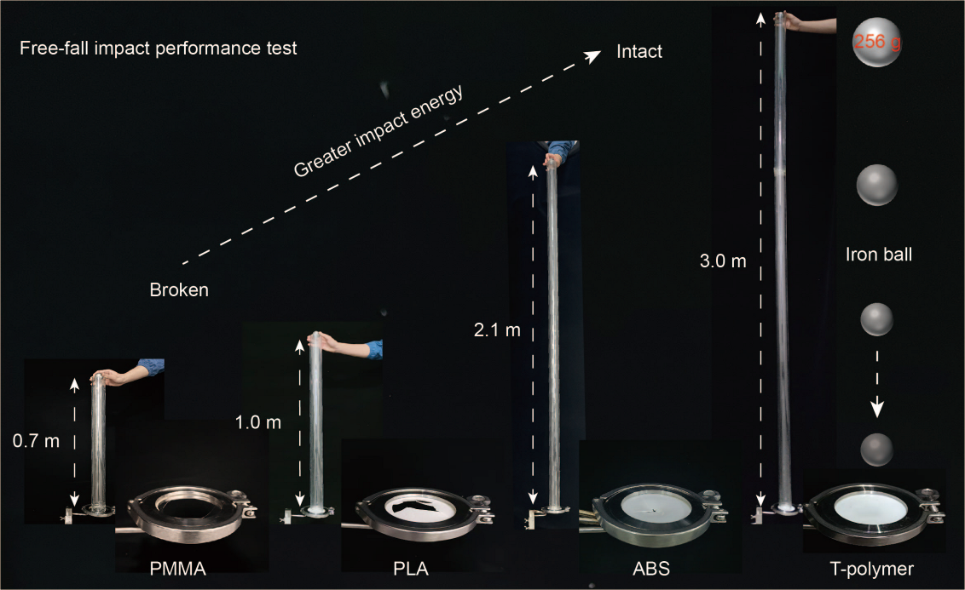
Supplementary Figure 12. Free-fall impact performance test.

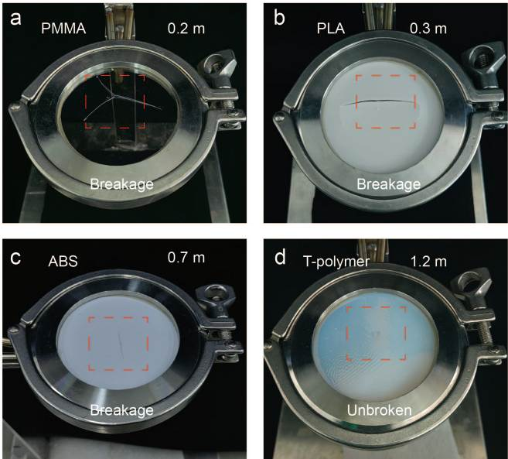
Supplementary Figure 13. Optical images of several plastics after the puncture test. (a) PMMA. (b) PLA. (c) ABS. (d) T-polymer. In the puncture experiment, only T-polymer maintained the integrity of the structure.

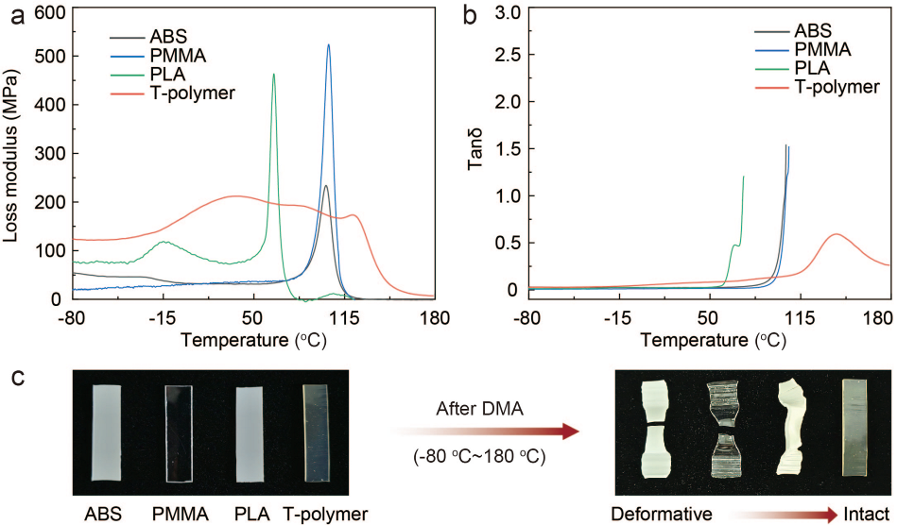
Supplementary Figure 14. Investigating the thermal-mechanical properties of ABS, PMMA, PLA, and T-polymer using thermomechanical analysis (DMA). (a) Loss modulus of PET, PVC, PP, PA66, and T-polymer. All samples with thickness of 1.00 ± 0.01mm. (b) Comparison of Tanδ of PET, PVC, PP, PA66, and T-polymer. (c) Optical images of the structural changes of various plastics before and after DMA testing.

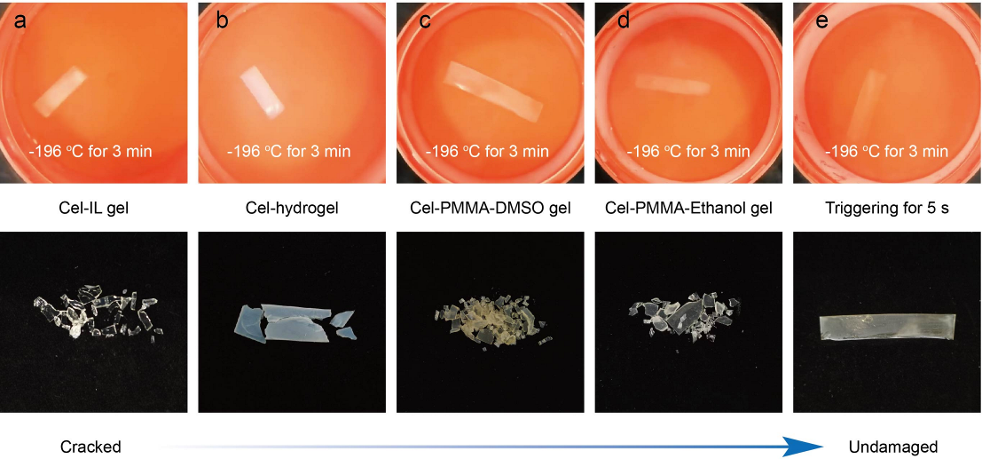
Supplementary Figure 15. The mechanism of T-polymer's resistance to liquid nitrogen (optical images). (a) Cel-IL gel. (b) Cel-hydrogel. (c) Cel-PMMA-DMSO gel. (d) Cel-PMMA-Ethanol gel. (e) T-polymer triggered for 5 s.
Results in Supplementary Fig. 15 show that materials a, b, c, and d all suffered structural fragmentation after liquid nitrogen exposure, whereas T-polymer subjected to only 5 seconds of water-triggering remained intact. This indicates that the cryogenic stability arises not merely from the cellulose framework (a, b), synergistic interactions among multiple macromolecules (c), or a strong hydrogen-bonding network (d). Rather, it results from the synergistic interplay of multiple factors, predominantly governed by the cluster domains generated through water-triggering, endowing T-polymer with its unique performance.

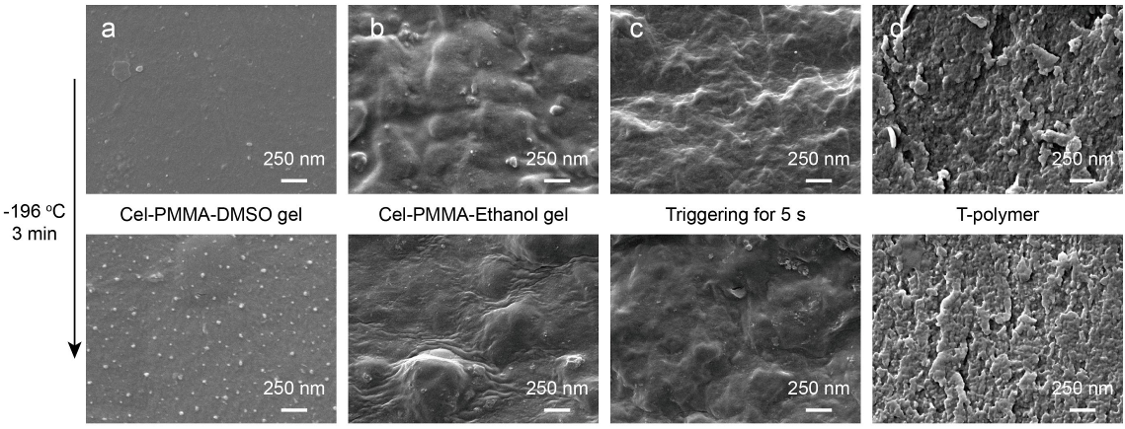
Supplementary Figure 16. The mechanism of T-polymer's resistance to liquid nitrogen (SEM). (a) Cel-PMMA-DMSO gel. (b) Cel-PMMA-Ethanol gel. (c) T-polymer triggered for 5 s. (d) T-polymer.
SEM images (Supplementary Fig. 16) further reveal that materials a and b developed varying degrees of crystallization and wrinkling after low-temperature treatment, leading to structural rupture. In contrast, both the briefly (5-second) and fully water-triggered T-polymer samples maintained similar clustered morphologies before and after cryogenic exposure, suggesting that this structural characteristic is key to their superior cryogenic performance.

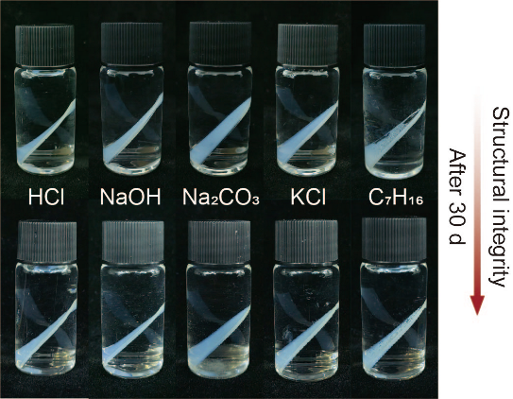
Supplementary Figure 17. The solvent resistance of T-polymer.

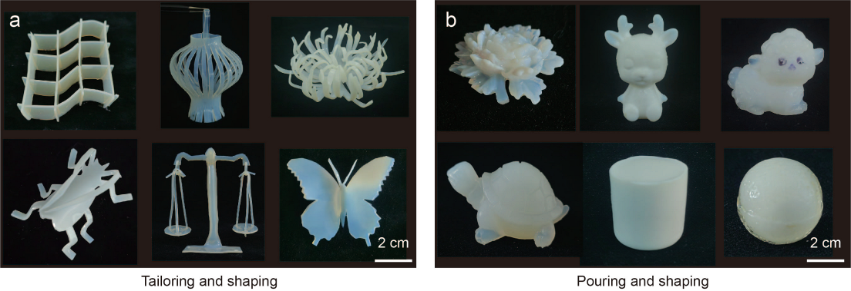
Supplementary Figure 18. The shaping methods of T-polymer and its various applications. (a) Tailoring and shaping of T-polymer. (b) Pouring and shaping of T-polymer.

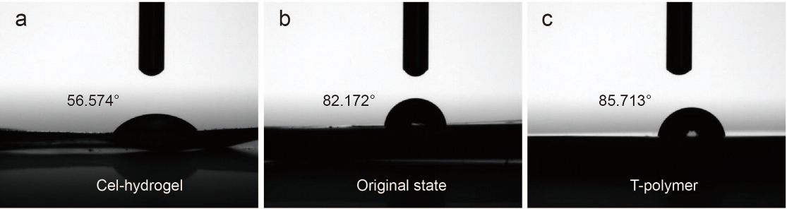
Supplementary Figure 19. Contact angle measurement. The selected solvent is water. (a) Cel-hydrogel. (b) Original state. (c) T-polymer.

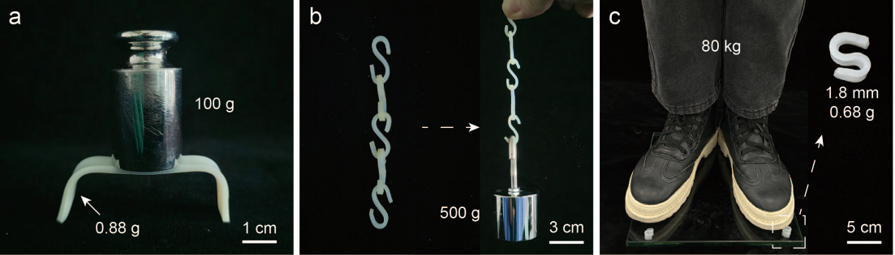
Supplementary Figure 20. The load-bearing conditions of various structures after water triggering shaping
III. Supplementary Tables

Supplementary Table 1. Price estimation for T-polymer after 6 cycles. Each cycle involving 17.4 wt% [Bmim]Cl, and 40 wt% DMSO as wastage.
Feedstocks | Price  ($/t) | Consumption  (t) | Cost  ($) | Source
lignocellulose | 150 | 0.1500 | 22.50 | https://www.alibaba.com/product-detail/Hot-Sales-Bleached-Hardwood-Kraft-Pulp_11000024528447.html?spm=a2700.details.you_may_like.3.4b0d4927Kyh5Pr
[Bmim]Cl | 2000 | 0.8492 | 1698.34 | https://www.alibaba.com/product-detail/1-Butyl-3-methylimidazolium-Chloride-CAS_1601300481883.html?spm=a2700.galleryofferlist.normal_offer.d_title.180a13a0XHmZZq&priceId=d32a95b35d7042fb94a8789fc52c5e87
MMA | 1350 | 0.6000 | 810.00 | https://www.alibaba.com/product-detail/CAS-80-62-6-99-9_1601495423445.html?spm=a2700.galleryofferlist.topad_classic.d_title.57f513a0ZVxNSz&priceId=6d508f34041845b2a8c4f3d62462945d
DMSO | 1500 | 0.2136 | 320.36 | https://www.alibaba.com/product-detail/KJ-DMSO-with-99-9-min_1601510882684.html?spm=a2700.galleryofferlist.normal_offer.d_title.6f1013a0lFziKE&priceId=932493afe7a243e09736b61b5d64dfc7
Water | 0.32759 | 50 | 16.38 | https://scj.shenyang.gov.cn/zwgk/fdzdgknr/gsgg/202503/t20250331_4829895.html
Electricity | 0.0697 | 1130.2000 | 78.78 | https://scj.shenyang.gov.cn/zwgk/fdzdgknr/gsgg/202503/t20250331_4829895.html
Total cost | 2946.36

Supplementary Table 2. Comparative prices among T-polymer, PP, ABS, PMMA, PA66, and PLA.
Materials | Price  ($/t) | Source
T-polymer | 2946.36 | This work
PP | 1100 | https://www.alibaba.com/product-detail/Pp-Ep300h-PP-3090-PPK8009-PP_1601299875592.html?spm=a2700.galleryofferlist.p_offer.2.da2213a01028h3&priceId=d27739d0d73f4fc8821e5ba309b8cd7a
ABS | 1500 | https://www.alibaba.com/product-detail/Resin-POLYLAC-PA757-PA-757-High_1600790871882.html?spm=a2700.galleryofferlist.p_offer.d_title.19d24bc4XmNMHB&s=p
PMMA | 2100 | https://www.alibaba.com/product-detail/High-Quality-Poly-Methyl-Methacrylate-Sheet_1600161027202.html?spm=a2700.galleryofferlist.normal_offer.d_title.513b13a0dM6ujY&priceId=21696ffde62a45d39acc2c1867ffee00
PA66 | 2000 | https://www.alibaba.com/product-detail/Virgin-Nylon-PA66-Plastic-Polyamide-66_1601577977829.html?spm=a2700.galleryofferlist.normal_offer.d_title.4a9613a08DQmbg&priceId=2221fa2be4c6478abc794835f38f920c
PLA | 2850 | https://www.alibaba.com/product-detail/ZOVGOV-100-biodegradable-Compostable-Bio-Plant_1601028355454.html?spm=a2700.galleryofferlist.normal_offer.d_title.2731abf5Vm0ZGd
IV. Supplementary References

1. Wang, X., Zhou, J., Pang, B., & Zhao, D. Rapid microwave-assisted ionothermal dissolution of cellulose and its regeneration properties. J. Renew. Mater. 7, 1363 (2019).
2. Abraham M. J. et al. GROMACS: High performance molecular simulations through multi-level parallelism from laptops to supercomputers. SoftwareX 1, 19-25 (2015).
3. Wang, J., Cieplak, P., & Kollman, P. A. How well does a restrained electrostatic potential (RESP) model perform in calculating conformational energies of organic and biological molecules? J. Comput. Chem. 21, 1049-1074 (2000).
4. Kirschner, K. N. et al. GLYCAM06: A generalizable biomolecular force field. Carbohydrates. J. Comput. Chem. 29, 622-655 (2008).
5. Martínez, L., Andrade, R., Birgin, E. G., & Martínez, J. M. PACKMOL: A package for building initial configurations for molecular dynamics simulations. J. Comput. Chem. 30, 2157-2164 (2009).
6. Berendsen, H. J., Postma, J. V., Van Gunsteren, W. F., DiNola, A. R. H. J., & Haak, J. R. Molecular dynamics with coupling to an external bath. J. Chem. Phys. 81, 3684-3690 (1984).
7. Feller, S. E., & MacKerell, A. D. An improved empirical potential energy function for molecular simulations of phospholipids. J. Phys. Chem. B 104, 7510-7515 (2000).
8. Hess, B., Bekker, H., Berendsen, H. J., & Fraaije, J. G. LINCS: A linear constraint solver for molecular simulations. J. Comput. Chem. 18, 1463-1472 (1997).
9. Humphrey, W., Dalke, A., & Schulten, K. VMD: Visual molecular dynamics. J. Mol. Graph. 14, 33-38 (1996).

