Supplementary information

S1 Text

DEPs related to digestion

DENV2 infection of human foreskin fibroblasts requires glycolysis ¹. Upregulation of several glycolytic pathway- and tricarboxylic acid cycle (TCA)-related proteins in A. aegypti SG (Sup. Table 2), primarily by DENV2 infection, suggest similar requirements in mosquitoes. Alternatively, glycolytic enolase (upregulated in this study) is a DENV2 receptor in mosquito cells ².

DEPs related to metabolism

DENV2-induced expression of pyruvate carboxylase, involved in de novo fatty acid (FA) synthesis ³, and reduced expression of saposin, involved in FA catabolism ⁴, suggest that virus multiplication alters host lipid metabolism ^{5,6}. Aspartate amino transferase, the key enzyme in amino acid metabolism, was upregulated by DENV2 infection in SG as previously observed in dengue patients ⁷.

DEPs related to RSM
The modulation of several RSM-related proteins by all three viruses suggests a disruption of intracellular redox homeostasis in response to infection. PDIs are essential components of endoplasmic reticulum (ER) and emerge as redox chaperone proteins that play key roles in pathogen attachment-internalization, antigen processing in the ER/phagosome, and regulation of reactive oxygen species production by NADPH oxidases ^{8,9}. Inhibition of PDI suppresses viral replication and production during antibody dependent enhancement of DENV2 infection in human monocytic cells ⁹. Finally, increased expression of enzymatic anti-oxidant, TPX2 ¹⁰, by CHIKV infection implies a defensive action to protect oxidative damage.

Re-annotation of SGBAP (AAEL019996) on VB AAegL 5.3
Translation initiation site (TIS): TIS can be predicted by correct Kozak sequence G/AXXATGG. TIS predicted for current AAEL019996 has cXXATGG sequence (highlighted in teal blue, Fig. S4), while ATG starting at position 59 (highlighted in pruple, Fig. S4) shows ideal Kozak sequence AXXATGG ^{11,12}. Further, signal peptide (SP) cannot be predicted from current protein sequence starting MDSAA (highlighted in grey, Fig. S4), whereas SP can be predicted from the re-annotated protein sequence (highlighted in red, Fig. S4) starting from MVALG (highlighted in grey, Fig S4.) using SignalP 5.0. This TIS was also predicted in an earlier study ¹³.
Prediction of intron: Predicted intron (highlighted in yellow, Fig. S4) does not have canonical splice sites, i.e. it has neither the GT at the 5’ nor AG at the 3’ end ^{14,15}. It also lacks the cis-acting sequence, a polypyrimidine track at the 3’ end of the intron needed for splicing ¹⁶. Thus, the intro is incorrectly annotated. Despite the above points, mRNA sequencing supports the presence of the transcripts (NCBI GenBank accession No: DQ440144.1 and DQ440022.1) ¹³ and the authors identified one of them (DQ440144.1) as encoding a truncated 34 kDa family protein. Without this intron, SGBAP protein sequence continues as shown in the re-annotated sequence.
Mass-spectrometry data: Our MS/MS data identified two unique peptides in the current sequence and three peptides in the re-annotated protein sequence (highlighted in green, Fig. S4). The third peptide is located in the re-annotated protein sequence, providing direct experimental evidence for the re-annotated sequence. The re-annotated protein contains a second Cys residue (position 113, Fig. S4), which may form a disulfide bond with the other Cys (position 67, Fig. S4).

Supplementary figure legends

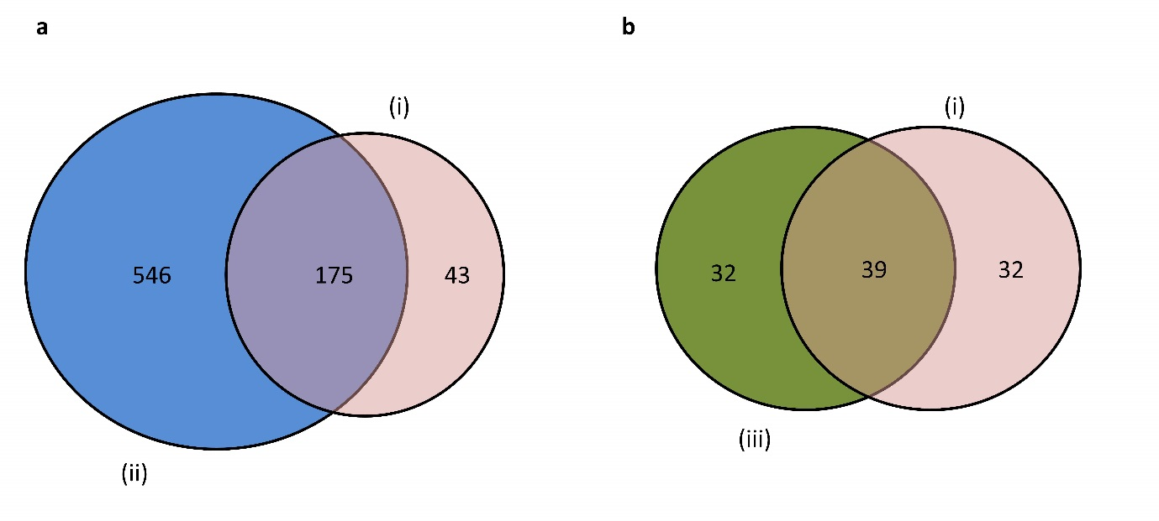
Fig S1. Comparisons of A. aegypti SGs proteome between our dataset and two previous studies. Venn diagram between SG proteins detected in (i) Singapore A. aegypti colony (this study) and (ii) India A. aegypti colony¹⁷ (a). In the comparison, we only used the 721 proteins from Dhawan et al. 2017¹⁷ with at least two unique peptides. Venn diagram between (i) SG proteins in Singapore A. aegypti colony (this study) and (iii) saliva protein in Rockefeller A. aegypti colony¹⁸ (b).

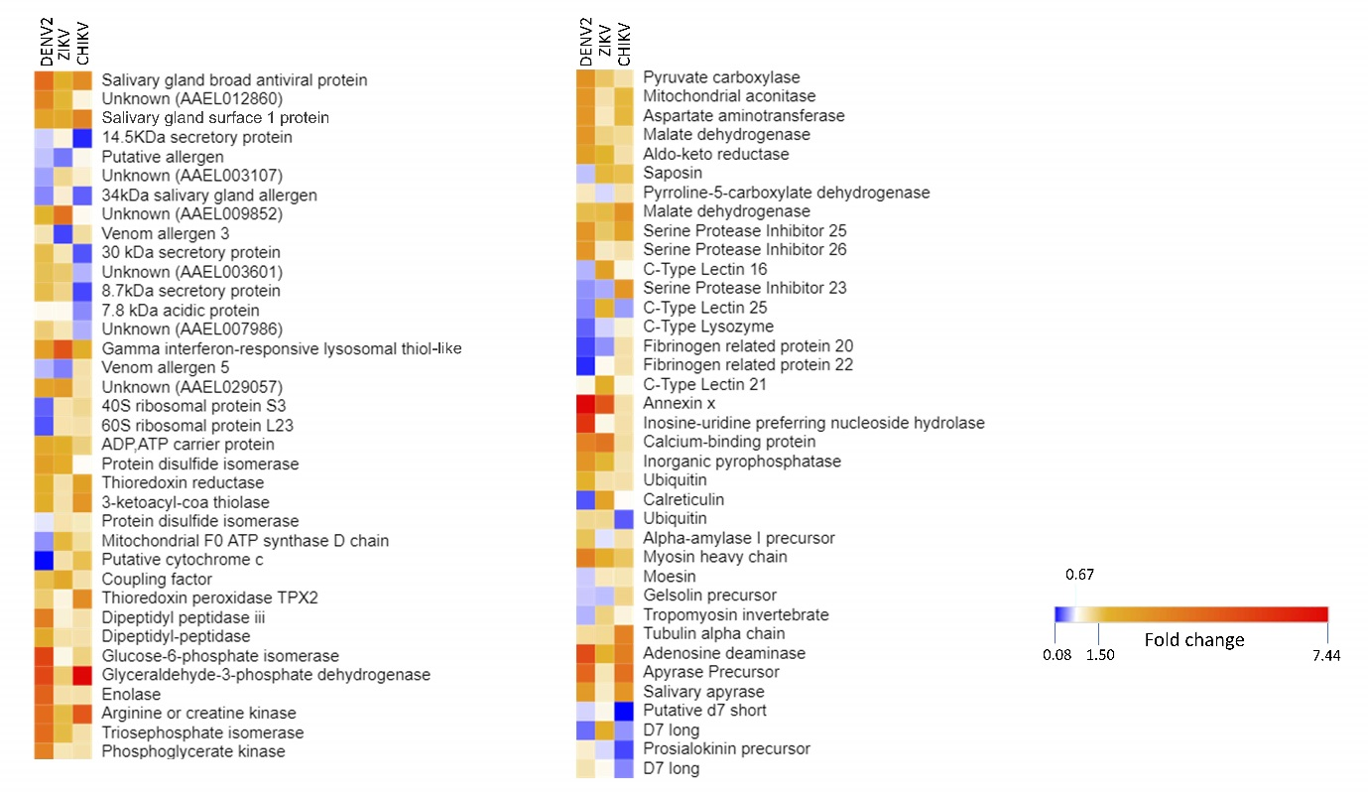
Fig S2. Heat map showing protein regulations in response to DENV2, ZIKV and CHIKV infection in salivary glands. Differentially expressed proteins were considered when fold change relative to control was below 0.67 or above 1.5.

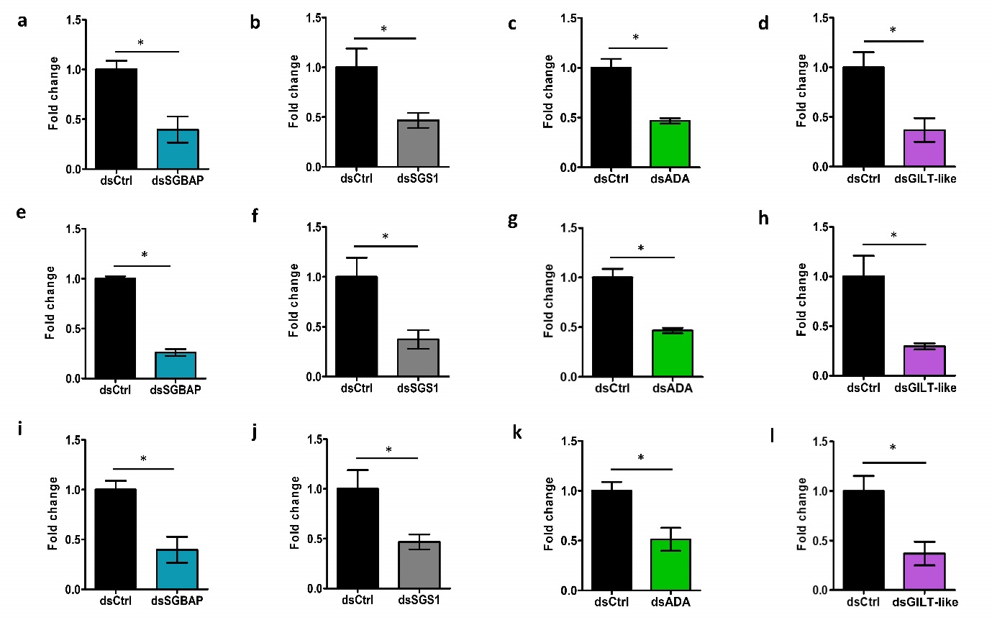
Fig S3. Silencing efficiencies in SGs. Each mosquito was injected with dsRNA against the candidate gene. Same quantity of dsCtrl was injected as control. Four days later, mRNA was quantified using RT-qPCR in pools of 10 SGs. Actin expression was used for normalization. Silencing efficiency of SGBAP (a), SGS1 (b), ADA (c) and GILT-like (d) in SGs for DENV2 infection. Silencing efficiency of SGBAP (e), SGS1 (f), ADA (g) and GILT-like (h) in SGs for ZIKV infection. Silencing efficiency of SGBAP (i), SGS1 (j), ADA (k) and GILT-like (l) in SGs for CHIKV infection. dsCtrl, dsRNA against LacZ; dsSGBAP, dsRNA against salivary gland broad spectrum antiviral protein; dsSGS1, dsRNA against salivary gland surface protein 1; dsADA, dsRNA against adenosine deaminase protein; dsGILT-like, dsRNA against gamma interferon responsive lysosomal thiol protein-like. Bars show means ± s.e.m. from three repeats.

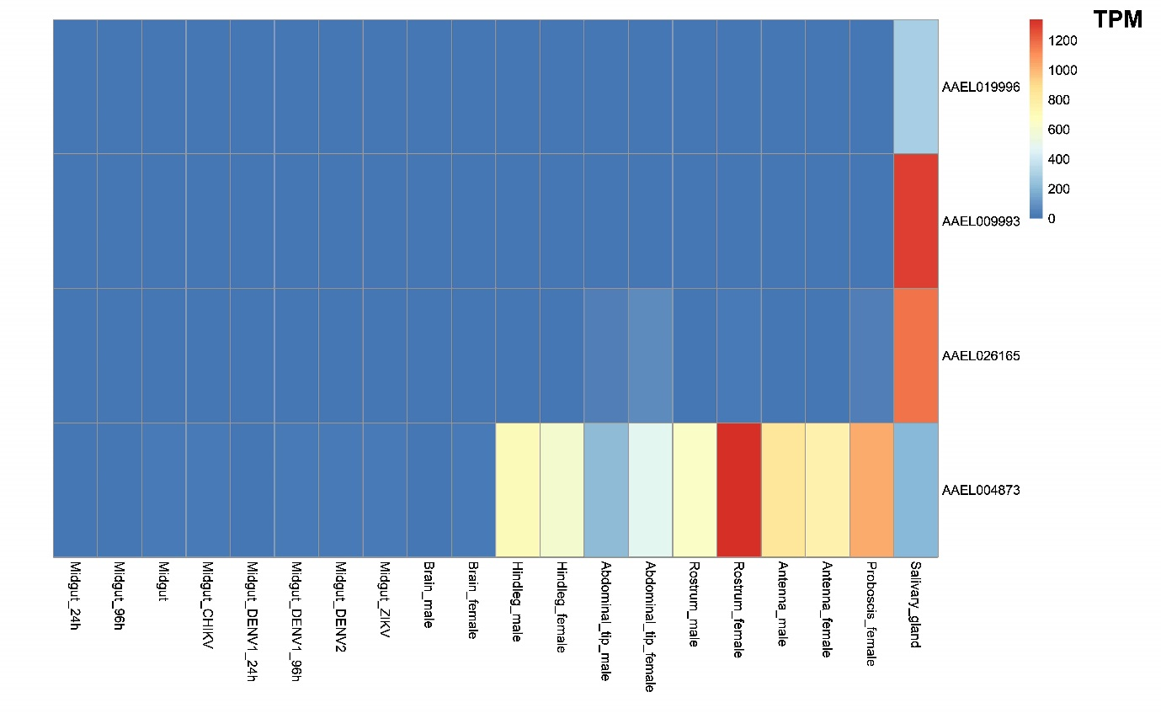
Fig S4. Tissue expression analysis for SGBAP (AAEL01996), SGS1 (AAEL009993), ADA (AAEL026165) and GILT-like (AAEL004873) proteins. Transcripts per million (TPM) in different A. aegypti tissues were retrieved using VectorBase from Raquin et al. ¹⁹, Mathews et al. ²⁰, Anglero-Rodriguez et al. ²¹, Dong et al. ²² and Ribeiro et al. ¹³.

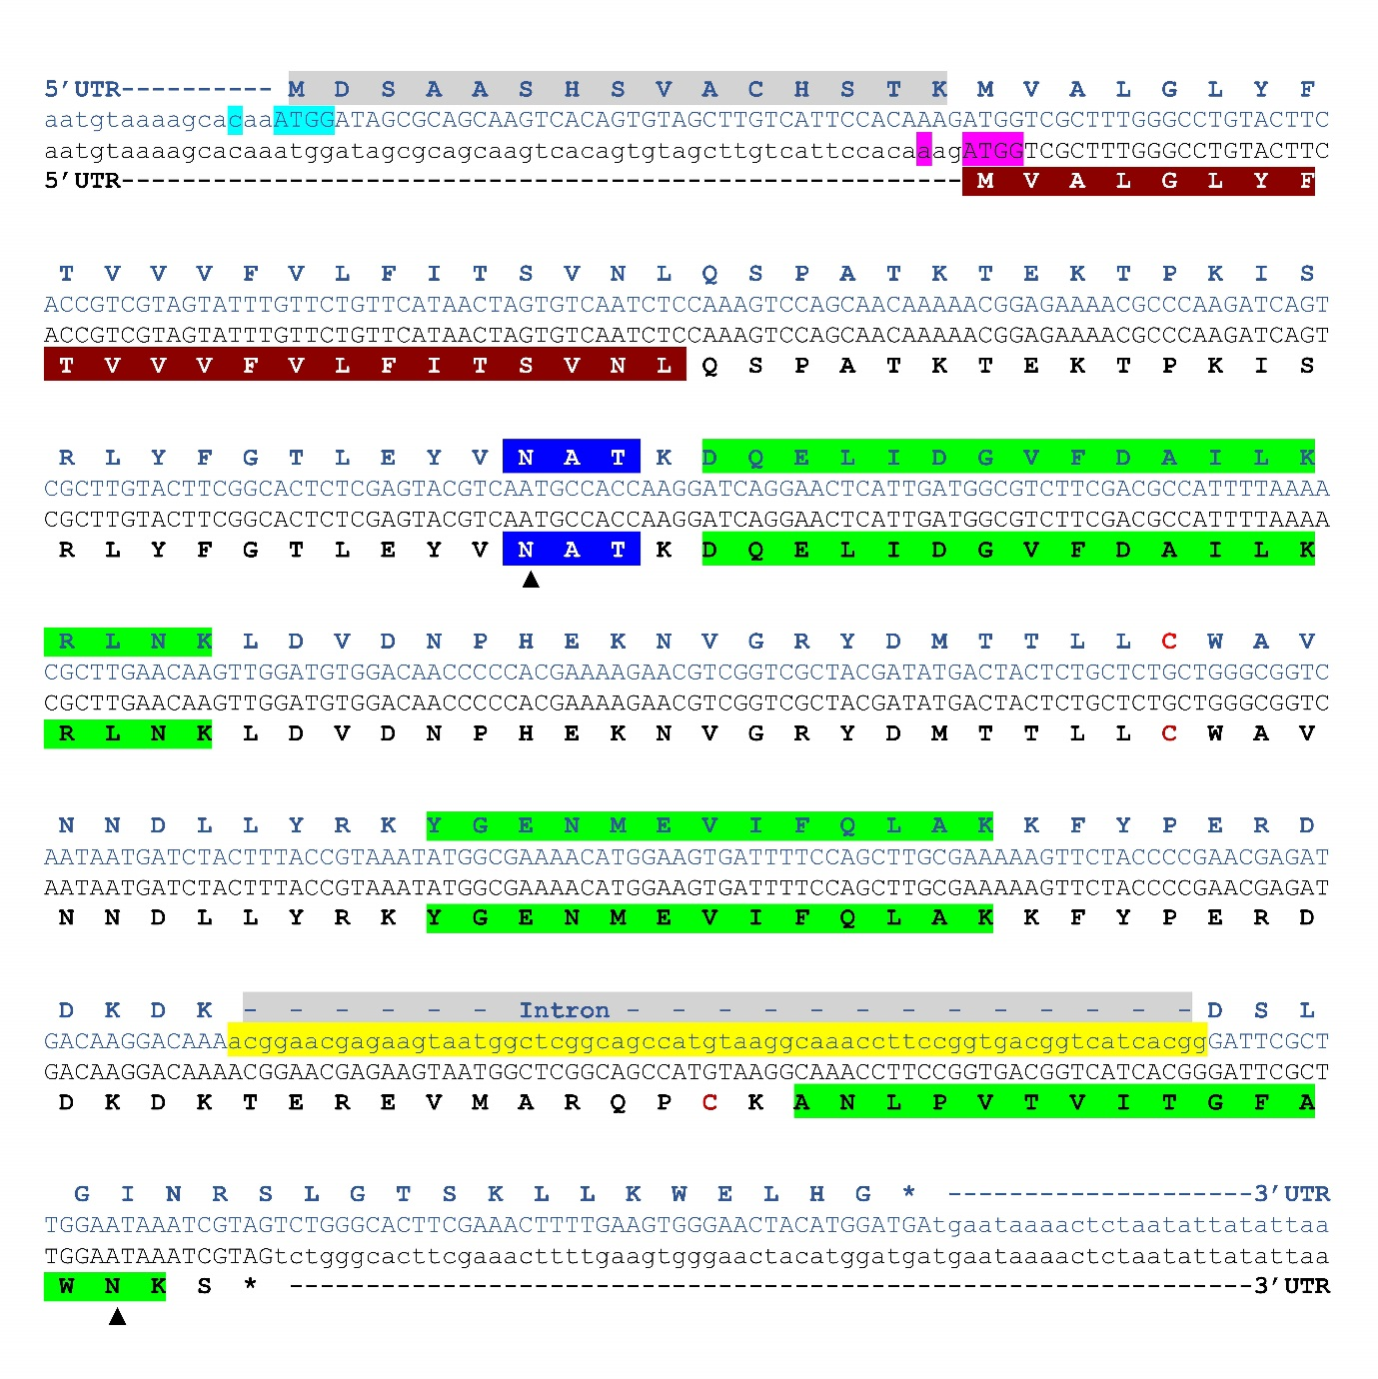
Fig S5. Re-annotation of SGBAP (AAEL019996) protein sequence. Genomic sequence of SGBAP gene is translated in current VB (blue) and re-annotated (black) protein sequences. Teal blue and purple highlighted regions are the translation initiation site (TIS) of current and re-annotated protein sequences. Yellow highlighted region indicates the current intron sequence. Green highlighted regions indicate unique peptide sequences as detected in i-TRAQ MS/MS analysis. Dark red highlighted region indicates the signal peptide on the re-annotated sequence. The upward arrow in the region highlighted in blue indicates the N-glycosylation site. The upward arrow in the region highlighted in green indicates a N-glycosylation site at the C-terminal that is either not or partially glycosylated. Cysteines are denoted in red.

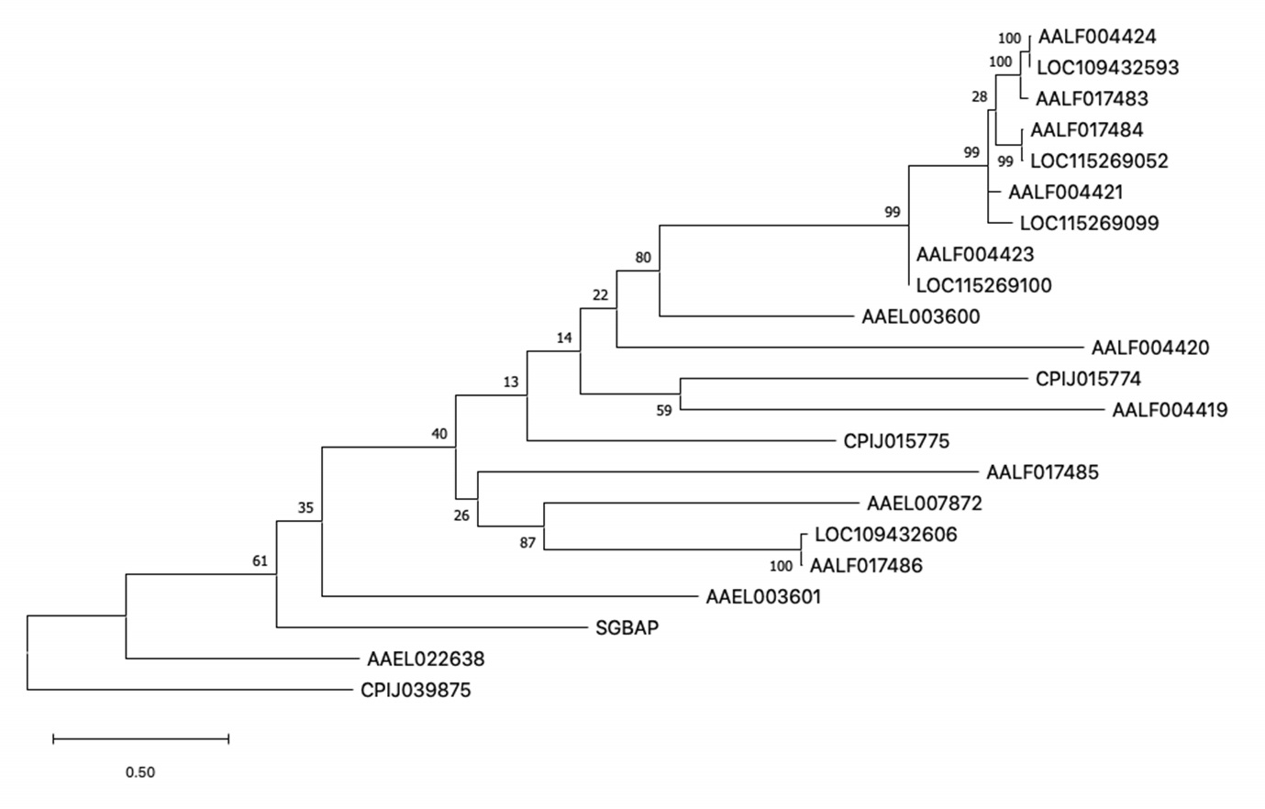
Fig S6. Phylogenetic tree of SGBAP (AAEL019996) and 21 homologs in Aedes aegypti (AAEL), Aedes albopictus (AALF) and Culex quinquefasciatus (CPIJ). Bootstraps are noted at each node. Branch length indicates the number of substitutions per site.

Table legends

Table S1. Proteins identified in uninfected A. aegypti SGs

Table S2. Differentially expressed proteins in A. Aegypti SGs in response to DENV2, ZIKV and CHIKV infections

Table S3. Primer sequences for candidate gene RNAi silencing and RT-qPCR quantification
Gene name/ Acc. No. | dsRNA primers | RT-qPCR primers
Actin / AAEL011197 |  | Fw: GAACACCCAGTCCTGCTGACA  Rv: TGCGTCATCTTCTCACGGTTAG
Lac Z | Fw: TACCCGTAGGTAGTCACGCA  Rv: TACGATGCGCCCATCTACAC
ADA/ AAEL005672 | Fw: GGTATCACATGGGCCACAAT  Rv: ATTCCGGATGATTCGATTTG | Fw: TGCTTGACCGTTTCGGACAG  Rv: CAGTGCTGCCCAAAGCCATA
GILT-like/ AAEL004873 | Fw: AGTTGAGTTTGAACGGTCCC  Rv: GTCCGGACAGAGCGATTC | Fw: TTTCCGTCAGACCTTCGACA  Rv: CCAAAGTCAGCAGACCCAAC
SGS1/ AAEL009993 | Fw: CTTCTGGAAGCCGGAGGT  Rv: CACCACTCTTCACCAACACAA | Fw: ACAAAGTCGGACATCCAGGT  Rv: TAGACCACCACGTGCTTCTT
SGAP/ AAEL019996 | Fw: ATTCCACAAAGATGGTCGCT  Rv: CTGCCGAGCCATTACTTCTC | Fw: TTCGCTTGGAATAAATCGTAGTCTG  Rv: TATTCATCATCCATGTAGTTCCCAC

Table S4. Primer sequences for virus quantification
Virus name | RT-qPCR primers
CHIKV | Fw: AAAGGGCAAACTCAGCTTCAC  Rv: GCCTGGGCTCATCGTTATTC
DENV2 | Fw: CAGGTTATGGCACTGTCACGAT  Rv: CCATCTGCAGCAACACCATCTC  Probe:/5HEX/CTCTCCGAGAACAGGCCTCGACTTAAA/3BHQ1/
ZIKV | Fw: CCGCTGCCCAACACAAG  Rv: CCACTAACGTTCTTTTGCAGACAT

Supplementary references
1. Fontaine, K. A., Sanchez, E. L., Camarda, R. & Lagunoff, M. Dengue virus induces and requires glycolysis for optimal replication. J. Virol. 89, 2358–2366 (2015).
2. Muñoz, M. de L. et al. Proteomic identification of dengue virus binding proteins in Aedes aegypti mosquitoes and Aedes albopictus cells. BioMed Res. Inter. 2013, e875958 (2013).
3. Park, S.-S., Kim, S.-J., Choi, H., Chang, C. & Kim, E. TR4 promotes fatty acid synthesis in 3T3-L1 adipocytes by activation of pyruvate carboxylase expression. FEBS Lett. 588, 3947–3953 (2014).
4. Geoghegan, V. et al. Perturbed cholesterol and vesicular trafficking associated with dengue blocking in Wolbachia -infected Aedes aegypti cells. Nat. Commun. 8, 526 (2017).
5. Martín-Acebes, M. A., Blázquez, A.-B., Jiménez de Oya, N., Escribano-Romero, E. & Saiz, J.-C. West Nile virus replication requires fatty acid synthesis but is independent on phosphatidylinositol-4-phosphate lipids. PLoS One 6, (2011).
6. Vial, T. et al. Dengue virus reduces AGPAT1 expression to alter phospholipids and enhance infection in Aedes aegypti. PLoS Pathog. 15, e1008199 (2019).
7. Lee, L. K. et al. Clinical relevance and discriminatory value of elevated liver aminotransferase levels for dengue severity. PLoS Negl. Trop. Dis. 6, e1676 (2012).
8. Stolf, B. S. et al. Protein disulfide isomerase and host-pathogen interaction. Sci. World J. 11, 1749–1761 (2011).
9. Rawarak, N., Suttitheptumrong, A., Reamtong, O., Boonnak, K. & Pattanakitsakul, S. Protein disulfide isomerase inhibitor suppresses viral replication and production during antibody-dependent enhancement of dengue virus infection in human monocytic cells. Viruses 11, 155 (2019).
10. Radyuk, S. N., Klichko, V. I., Spinola, B., Sohal, R. S. & Orr, W. C. The peroxiredoxin gene family in Drosophila melanogaster. Free Radic. Biol. Med. 31, 1090–1100 (2001).
11. Kozak, M. Point mutations define a sequence flanking the AUG initiator codon that modulates translation by eukaryotic ribosomes. Cell 44, 283–292 (1986).
12. Kozak, M. Possible role of flanking nucleotides in recognition of the AUG initiator codon by eukaryotic ribosomes. Nucleic Acids Res 9, 5233-5252 (1981).
13. Ribeiro, J. M. et al. An annotated catalogue of salivary gland transcripts in the adult female mosquito, Aedes aegypti. BMC Genomics 8, 6 (2007).
14. Breathnach, R. & Chambon, P. Organization and expression of eucaryotic split genes coding for proteins. Annu. Rev. Biochem. 50, 349–383 (1981).
15. Breathnach R, Benoist C, O'Hare K, Gannon F, Chambon P. Ovalbumin gene: evidence for a leader sequence in mRNA and DNA sequences at the exon-intron boundaries. Proc Natl Acad Sci 75, 4853-7 (1978).
16. Coolidge, C. J., Seely, R. J. & Patton, J. G. Functional analysis of the polypyrimidine tract in pre-mRNA splicing. Nucleic Acids Res. 25, 888–896 (1997).
17. Dhawan, R. et al. Mosquito-borne diseases and omics: salivary gland proteome of the female Aedes aegypti mosquito. Omics J. Integr. Biol. 21, 45–54 (2017).
18. Sun, P. et al. A mosquito salivary protein promotes flavivirus transmission by activation of autophagy. Nat. Commun. 11, 260 (2020).
19. Raquin, V. et al. Individual co-variation between viral RNA load and gene expression reveals novel host factors during early dengue virus infection of the Aedes aegypti midgut. PLoS Negl. Trop. Dis. 11, e0006152 (2017).
20. Matthews, B. J., McBride, C. S., DeGennaro, M., Despo, O. & Vosshall, L. B. The neurotranscriptome of the Aedes aegypti mosquito. BMC Genomics 17, 32 (2016).
21. Angleró-Rodríguez, Y. I. et al. Aedes aegypti Molecular Responses to Zika Virus: modulation of infection by the toll and JAK/STAT immune pathways and virus host factors. Front. Microbiol. 8, (2017).
22. Dong, S., Behura, S. K. & Franz, A. W. E. The midgut transcriptome of Aedes aegypti fed with saline or protein meals containing chikungunya virus reveals genes potentially involved in viral midgut escape. BMC Genomics 18, (2017).

