Supplementary Figs
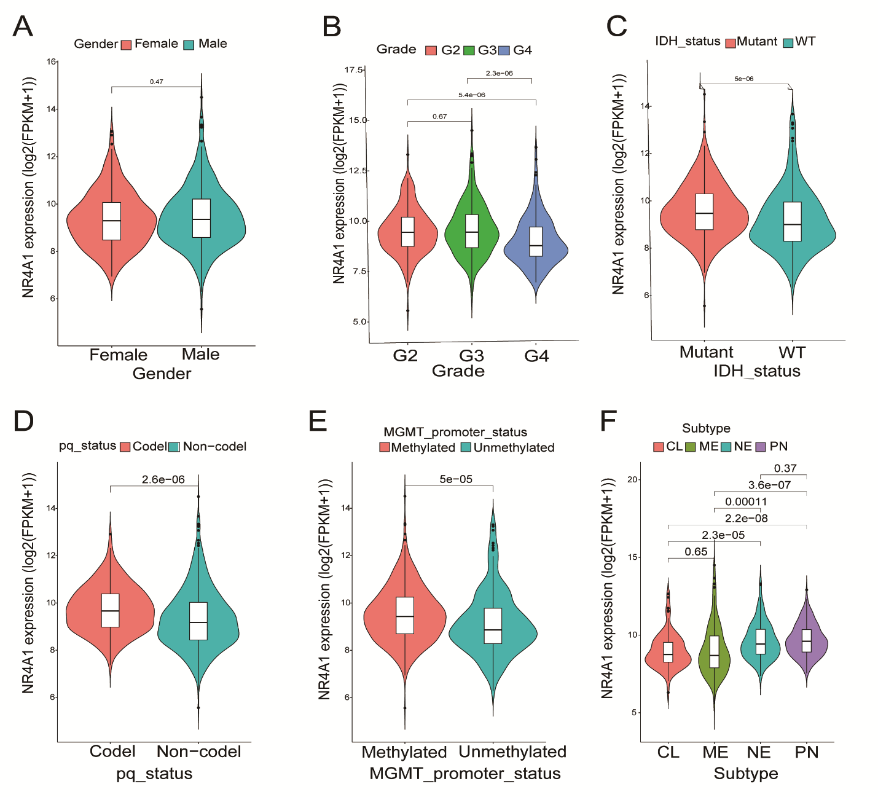
Supplementary Figure. 1 (A-F) The expression levels of NR4A1 in different genders (A), grades (B), IDH status (C), chromosome 1p/19q co-deletion status (D), methylation status of MGMT promoter (E), and subtypes (F) in TCGA-glioma database were analyzed.

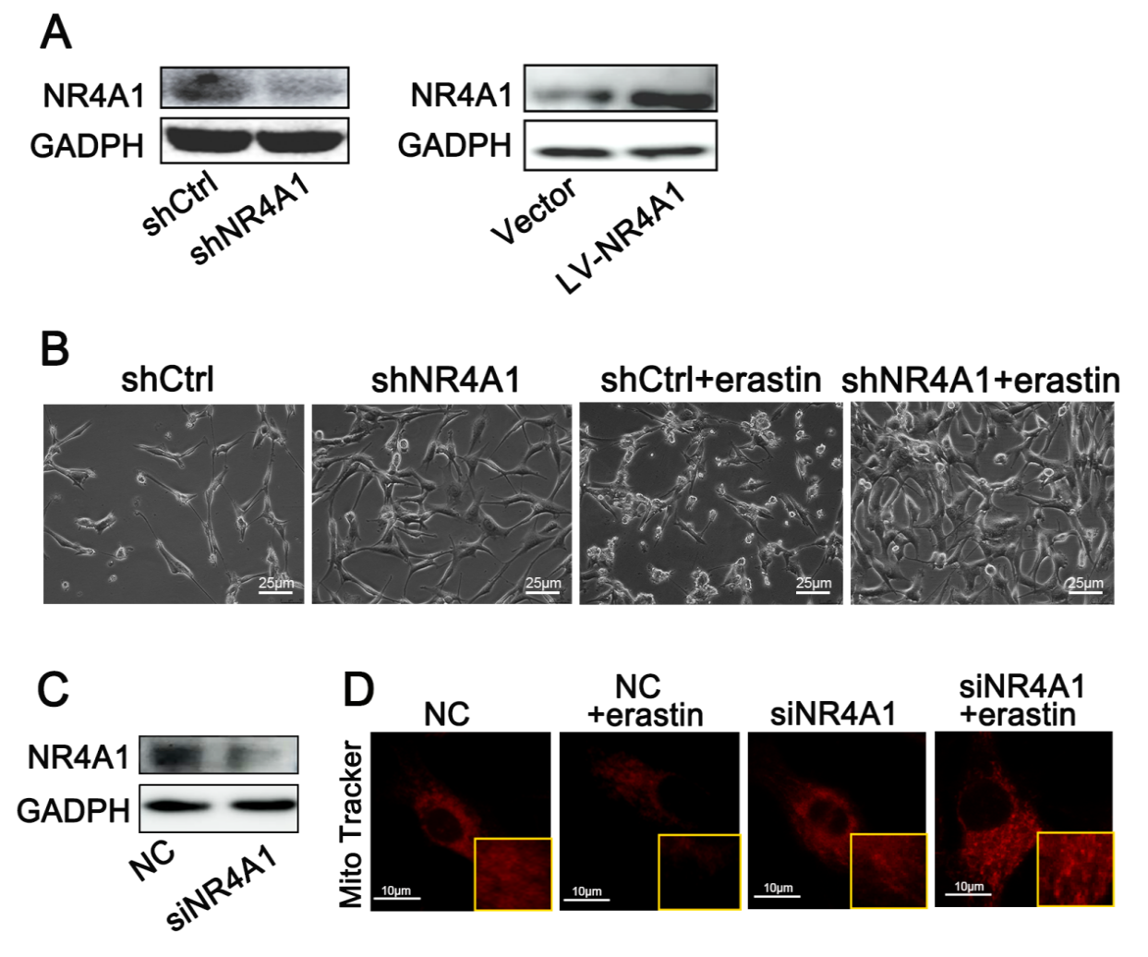
Supplementary Figure. 2 (A) Western blot analysis of NR4A1 protein levels in U87MG cells infected with lentiviral constructs expressing sh-NR4A1 and Lv-NR4A1. (B) Representative images showing the cell morphological change in U87MG cells. Scale bars, 25 μm. (C) Western blot analysis of NR4A1 protein levels in U87MG cells transfected with si-NR4A1. (D) Representative images of Mito-tracker (red) staining in U87MG cells. DAPI was used to stain cell nuclei. Scale bars, 10 μm.
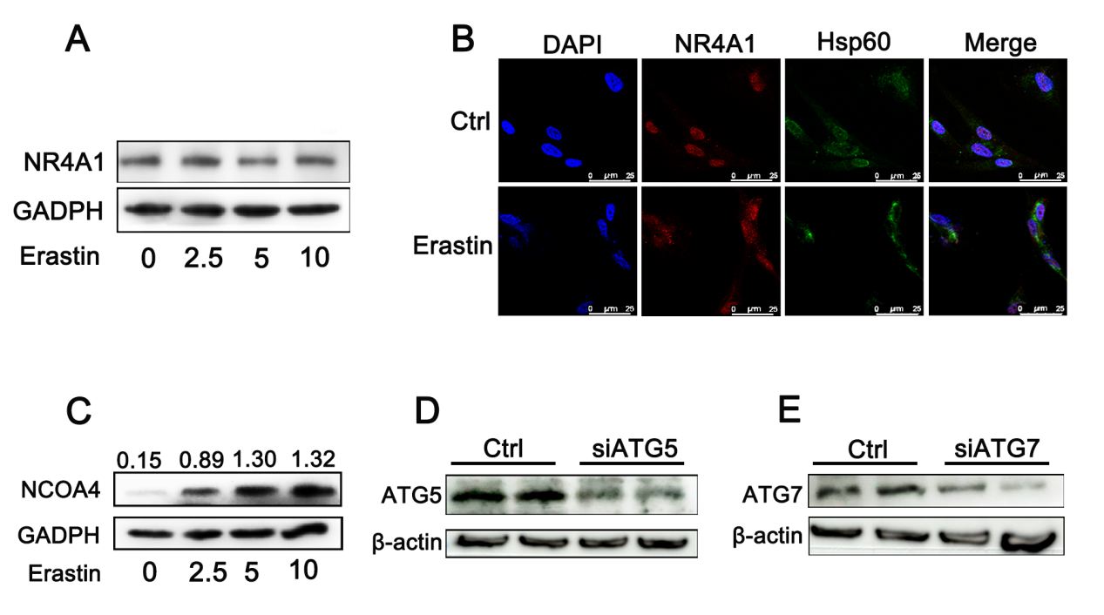
Supplementary Figure. 3 (A) After treatment with different concentration of erastin for 24 h，the expression of NR4A1 in U87MG cells was determined by Western blots. (B) Confocal images showed colocalization of NR4A1 (red) and Hsp60(green) in U87MG cells. U87MG cells were treated with or without Erastin (5μM) for 24 h, and then cells were co-stained, Nuclei were counterstained with Hoechst (blue). Scale bars: 10 μ m. (C) U87MG cells were treated different concentration of erastin for 24 h, NCOA4 protein levels in U87MG were determined by Western blot .(D-E) Western blot analysis of ATG5 and ATG7 protein levels in U87MG cells after transfected with si-ATG5 and si-ATG7 for 36h.

