Supporting Information for
Interfacial dipolar interactions drive giant second-harmonic generation in 2D organic–inorganic heterostructures
Ye-Tao Chen¹, Shi-Yi Yuan¹, Xiu-Bin Liu², Xiu-Qi Shi¹, Xi Xu¹, Yi-Neng Bao¹, Keng Chen¹, Jun-Rong Zheng¹, Zi-Feng Guo¹, Zhao-Dong Meng¹, Kai-Qiang Lin¹, Hua-Lei Yin^{2,*}, Jun Yi^{1,*}
¹School of Electronic Science and Technology, State Key Laboratory of Physical Chemistry of Solid Surfaces, Xiamen University, Xiamen, Fujian 361005, China.
² School of Physics and Key Laboratory of Quantum State Construction and Manipulation (Ministry of Education), Renmin University of China, Beijing 100872, China.
*Email: junyi@xmu.edu.cn (J. Yi); hlyin@ruc.edu.cn (H.L. Yin);

This supplementary information includes:
Supplementary Figs. S1-S18
Supplementary Tables 1-2
Supplementary Note 1-3

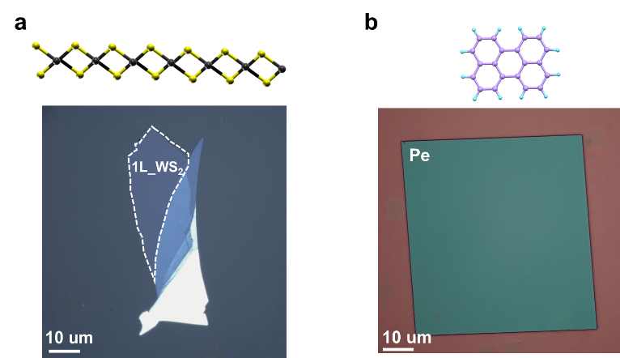
Fig. S1 | Optical microscopy images of the individual components used for heterostructure fabrication. a, Monolayer (1L) WS₂ mechanically exfoliated onto PDMS. b, Single-crystalline α-perylene (α-Pe) microplate grown on a Si/SiO₂ substrate through a spatially confined self-assembly method. The corresponding molecular structures of WS₂ and α-Pe are shown above.

Fig. S2 | x-ray diffraction (XRD) pattern of the α-Pe crystals. Diffraction peaks were observed at 2θ = 8.73°, 17.55°, and 26.47°, which are in excellent agreement with the (001) peak of α-Pe with an interlayer spacing of 10.109 Å.¹ Furthermore, the sharp intense peaks together with the flat baseline provide compelling evidence of the high crystalline quality of the two-dimensional organic crystal α-Pe that we synthesized.

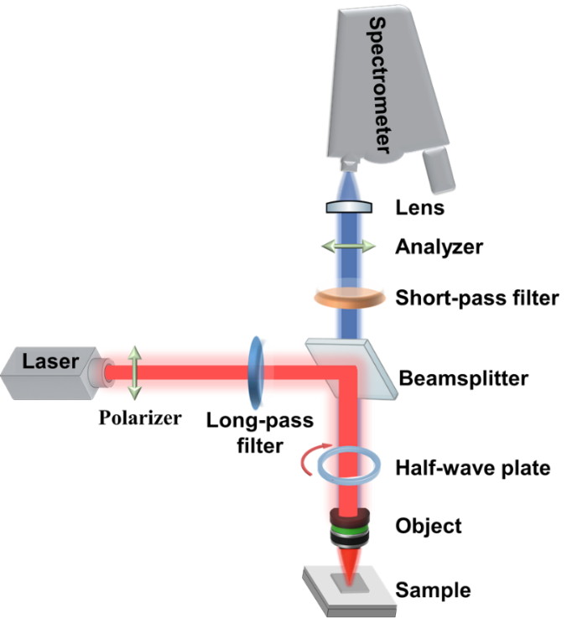
Fig. S3 | Schematic illustration of the optical setup employed for second-harmonic generation (SHG) and polarization-resolved photoluminescence (PL) measurements. A femtosecond (or continuous-wave) laser is polarized, filtered and focused onto the sample through an objective, and the generated signals are collected in reflection and analyzed by a spectrometer. Integration of an XYZ nano-positioning stage enables spatially resolved SHG mapping of heterostructure samples.

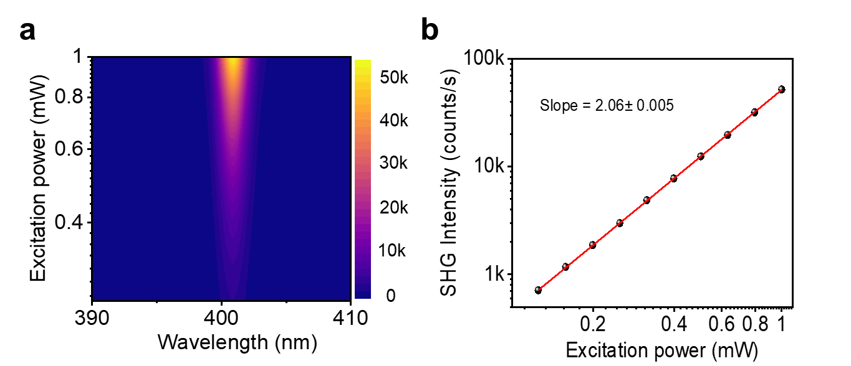
Fig. S4 | Power-dependent SHG response of the α-Pe/WS₂ heterostructure. a, Mapping of SHG intensity from the heterostructure under different excitation powers. b, Power dependence of the integrated SHG intensity from 1L WS₂ in the heterostructure plotted on a logarithmic scale, together with a linear fit. The fitted slope is close to 2, confirming that the observed emission originates from SHG.

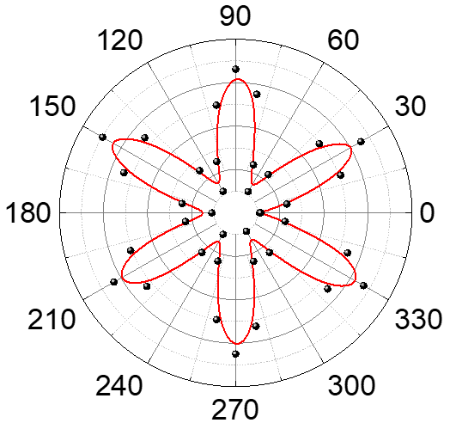
Fig. S5 | Polarization-dependent SHG response of 1L WS₂. Polar plot of the SHG intensity of monolayer WS₂ under 800 nm excitation. The SHG intensity exhibits a characteristic six-lobed pattern, reflecting the threefold crystal symmetry (D₃h point group) of 1L WS₂. The sixfold symmetry in SHG intensity arises from the quadratic dependence of SHG on the fundamental field and confirms the high crystalline quality and intrinsic second-order nonlinearity of the monolayer.

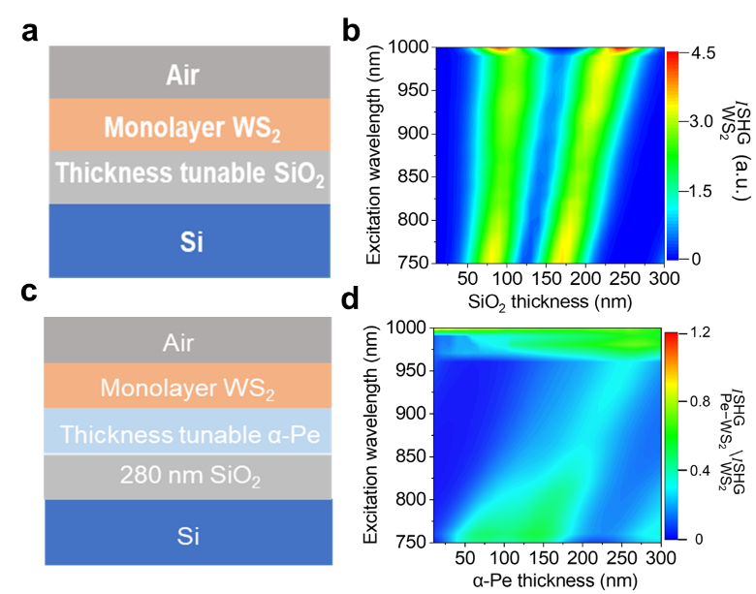
Fig. S6 | Control calculations of cavity-effect-induced SHG modulation in α-Pe/WS₂ heterostructures. a, Schematic of the air/Monolayer WS₂/SiO₂/Si stack with tunable SiO₂ thickness, used to evaluate the influence of dielectric cavity length. b, Calculated SHG intensity of WS₂ as a function of excitation wavelength and SiO₂ thickness called as$I_{{WS}_{2}}^{SHG}$. c, Schematic of the air/1L WS₂/α-Pe/SiO₂/Si stack, where the α-Pe thickness is varied while the SiO₂ thickness is fixed at 280 nm. d, Corresponding SHG intensity ratio $I_{{α-Pe-WS}_{2}}^{SHG}/$​$I_{{WS}_{2}}^{SHG}$ as a function of α-Pe thickness and excitation wavelength. The SHG intensity is expressed as $I={\left|E_{ex}\right|}^{4 }$*${\left|E_{em}\right|}^{2 }$, where ${\left|E_{ex}\right|}^{ }$ and ${\left|E_{em}\right|}^{ }$ are the effective excitation and emission fields at the WS₂ layer, respectively. This expression, established in previous literature,² already accounts for multiple reflections and refractions at different interfaces. Following this method, we calculated the SHG response in the present structures. Importantly, even at the optimal α-Pe thickness, the cavity-induced enhancement remains below a factor of 2, indicating that the giant SHG enhancement observed experimentally cannot be explained by cavity effects alone.

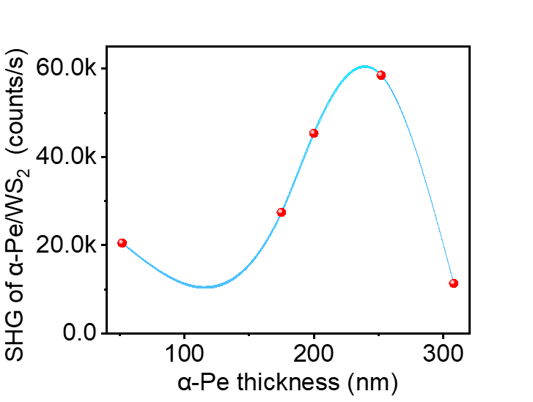
Fig. S7 | SHG intensity of α-Pe/WS₂ heterostructures with varying α-Pe thickness. Measured SHG intensity as a function of α-Pe layer thickness. The SHG response exhibits a dependence on α-Pe thickness, with the maximum signal appearing around ~250 nm. However, the overall variation in SHG intensity across the entire thickness range remains below a factor of 2, indicating that cavity-induced effects alone cannot account for the giant enhancement observed experimentally.

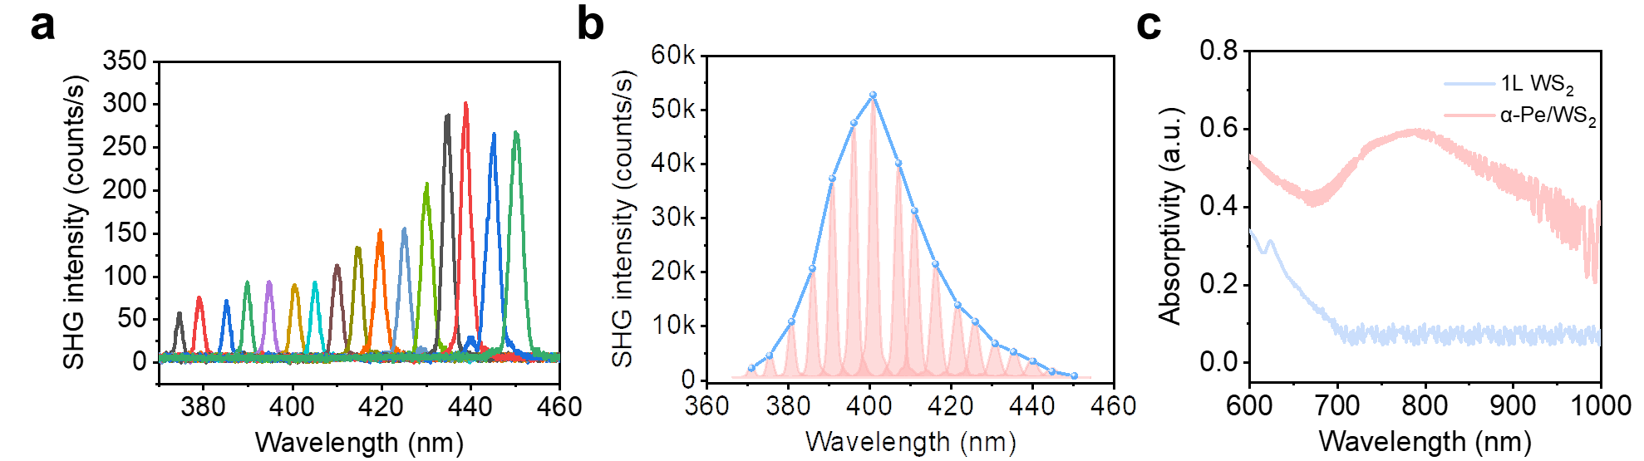
Fig. S8 | SHG enhancement in α-Pe/WS₂ heterostructures under different excitation wavelengths. a, SH emission of 1L WS₂ on a Si/SiO₂ substrate as a function of excitation wavelength. b, SHG response of WS₂ in the α-Pe/WS₂ heterostructure as a function of excitation wavelength in the range of 750–900 nm. c, Absorption spectra of monolayer WS₂ and the α-Pe/WS₂ heterostructure. While 1L WS₂ exhibits negligible absorption near 800 nm, the α-Pe/WS₂ heterostructure shows a pronounced absorption feature in this region, which directly accounts for its markedly enhanced SHG response under 800 nm excitation. The interference fringes observed in the spectra (λ > 800 nm) arise from the etalon effect in the back‑illuminated CCD detector.
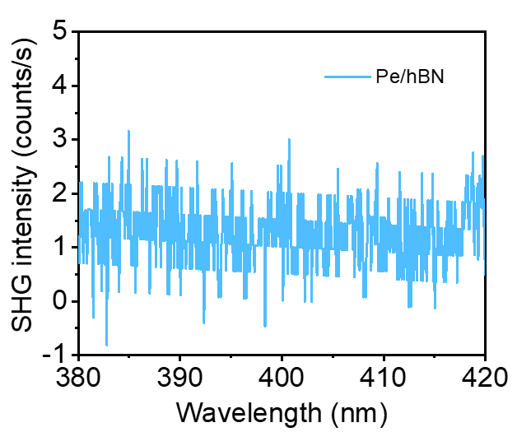
Fig. S9 | Control experiments excluding hexagonal boron nitride (hBN)-induced SHG in the α-Pe/hBN/WS₂ stack. Under 800 nm excitation, the α-Pe/hBN control (without WS₂) shows no discernible second-harmonic peak at 400 nm and remains at the noise floor, and pristine hBN on the same substrate is likewise SHG-inactive under identical power and collection conditions.

Fig. S10 | Polarization-dependent SHG response of WS₂ and α-Pe/ WS₂ heterostructure. Polar plots of the SHG intensity for pristine WS₂ (light blue) and the α-Pe/WS₂ heterostructure (red) under 800 nm excitation. The pristine WS₂ exhibits a six-lobed pattern corresponding to its intrinsic threefold crystal symmetry, while the α-Pe/WS₂ heterostructure shows a two-lobed distribution. The reduction of symmetry from sixfold to twofold reveals that the optical anisotropy of the α-Pe crystal significantly modifies the nonlinear optical response of WS₂ through interfacial coupling.

Fig. S11 | Polarization-dependent SHG response of the α-Pe/hBN/WS₂ heterostructure. Polar plot of the SHG intensity from the α-Pe/hBN/ WS₂ heterostructure under 800 nm excitation. The SHG signal exhibits a pronounced two-lobed pattern, indicating a strong polarization dependence. The reduction from the intrinsic sixfold symmetry of WS₂ to a twofold symmetry in the heterostructure suggests that the optical anisotropy of the Pe crystal is effectively transferred through the hBN spacer, reorienting interfacial dipole and breaking the in-plane symmetry of WS₂.

Fig. S12 | PL and two-photon luminescence (TPL) of a α-Pe single crystal. The emission spectrum obtained under 800 nm excitation (red) coincides with the PL spectrum recorded at 405 nm excitation (blue), verifying that the observed signal originates from the TPL of the α-Pe crystal.

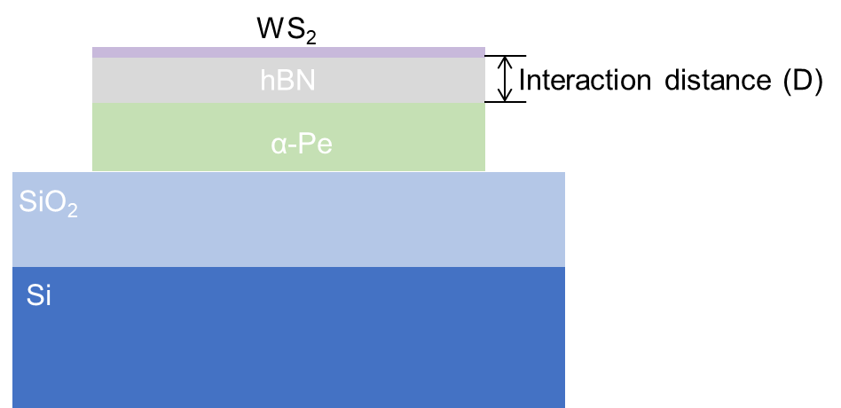
Fig. S13 | Schematic of the α-Pe/hBN/WS₂ heterostructure and definition of interaction distance. A 1L WS₂ is stacked on a crystalline α-Pe crystal with hBN inserted as a spacer. The vertical separation D (interaction distance) denotes the donor–acceptor distance between α-Pe and WS₂, which is tuned by the hBN thickness to modulate interfacial coupling and the resulting SHG response. The stack is supported on a SiO₂/Si substrate.

Fig. S14 | Polarization-dependent optical absorption spectra of α-Pe single crystal. Polarization-resolved absorption spectra of α-Pe measured with incident light polarized along the b-axis (0°), at 45° between the a and b axis, and along the a-axis (90°). The absorption feature near 477 nm strengthens when the polarization is parallel to the b-axis, corresponding to the low-energy excitonic transition dominated by the dimers are alternately oriented. The pronounced anisotropy reflects the distinct transition dipole strengths associated with the a and b crystallographic axis, consistent with the “sandwich–herringbone” molecular packing of α-Pe.

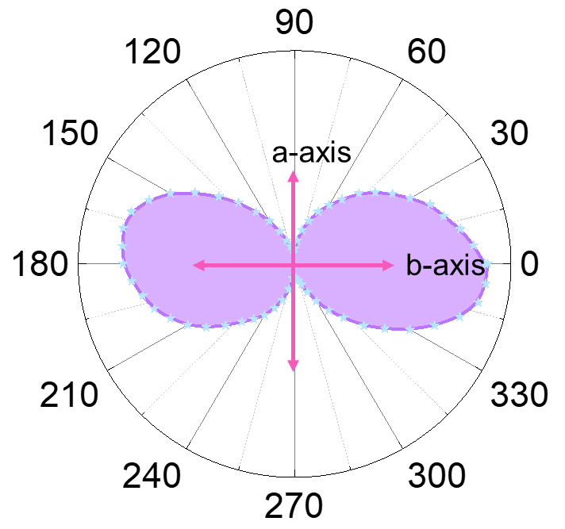
Fig. S15 | Polarization-dependent PL of the α-Pe crystal. Polar plot of PL intensity from the α-Pe single crystal under linearly polarized excitation. The emission shows a two-lobed anisotropic pattern following the molecular stacking. Along the axis, parallel dipoles are poorly coupled to the far field, leading to weak emission, whereas along the b axis, partially opposing dipoles interfere constructively, enabling efficient radiative coupling and bright PL output.

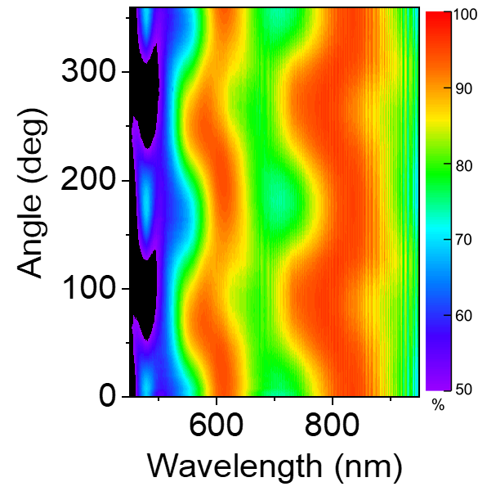
Fig. S16 | Polarization-dependent absorption mapping of the α-Pe crystal. Angle-resolved absorption mapping of the α-Pe crystal measured under variable polarization excitation. The overall optical response exhibits a clear twofold symmetry as the polarization angle is rotated, showing maximum absorption near 800 nm when the incident polarization aligns with the a-axis (90° and 270°) and minimum absorption along the b-axis (0° and 180°).

Fig. S17 | Raman characterization confirming the bilayer nature of WS₂ in the α-Pe/2L WS₂ heterostructure. Raman spectra of 2L WS₂ on a Si/SiO₂ substrate (blue) and the α-Pe/2L WS₂ heterostructure (red). For 2L WS₂ on Si/SiO₂, the in-plane $E_{2g}^{1}$ and out-of-plane $A_{1g}$ phonon modes appear at 356.27 cm⁻¹ and 422.07 cm⁻¹, respectively, giving a frequency separation of 65.80 cm⁻¹. In the α-Pe/2L WS₂ heterostructure, these modes are located at 356.47 cm⁻¹ and 421.96 cm⁻¹, with a separation of 65.49 cm⁻¹. The nearly identical mode spacing confirms that the transferred WS₂ retains its bilayer configuration after integration with the α-Pe crystal.

Supplementary Note 1. Extraction of the effective second-order susceptibility.

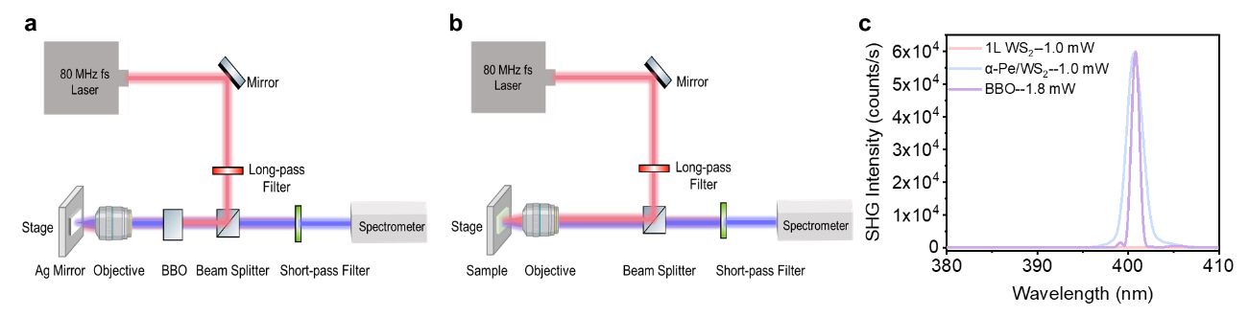
Fig. S18 | Optical setup and SHG response of BBO, WS₂, and α-Pe/WS₂. a, Setup for the SHG measurement of the BBO reference crystal. b, Setup for the SHG measurement of monolayer WS₂ and the α-Pe/WS₂ heterostructure under 800-nm excitation. c, SHG signals from monolayer BBO, WS₂ and α-Pe/WS₂ under 800-nm excitation.

To quantitatively determine the effective bulk second-order nonlinear susceptibility $χ_{eff}^{(2)}$​ of monolayer WS₂ and the α-Pe/WS₂ heterostructure, we benchmark their SHG response against a BBO crystal measured under well-defined reference conditions, which serves as a calibrated nonlinear standard following the procedure established in previous reports on SHG in two-dimensional TMDs.³ The SHG power generated from a nonlinear medium of thickness L under 800-nm excitation can be expressed as:
$P_{2ω}=\frac{2π{(χ_{eff}^{(2)})}^{2}L^{2}P_{ω}^{2}}{ε_{0}cn_{ω}^{2}n_{2ω}^{2}A}∙\frac{\sin^{2}({ΔkL}/2)}{{ΔkL}/2}$ (S1)
where $L$ is the thickness of the sample, $ε_{0}$ is the vacuum dielectric constant, c is the speed of light in vacuum and $A$ is the laser beam illuminance areas. $n_{ω}$ and $n_{2ω}$ denote the refractive indices at the fundamental and SH frequencies. For atomically thin WS₂, the interaction length is far smaller than the coherence length, and refractive-index variations across the interface are negligible. Equation (S1) therefore reduces to a simple intensity-ratio form when the SH signal is normalized to that of the BBO reference crystal:
${(\frac{χ_{eff(s)}^{(2)}}{χ_{eff(BBO)}^{(2)}})}^{2}= \frac{I_{2ω, S}}{I_{2ω, BBO}}∙{\left(\frac{L_{BBO}}{L_{S}}\right)}^{2}∙{\left(\frac{P_{ω, BBO}}{P_{ω, S}}\right)}^{2}∙(\frac{A_{S}}{A_{BBO}})$ (S2)
where $S$ is the sample (monolayer WS₂ or α-Pe/WS₂), $I_{2ω}$ is the measured SHG intensity (counts/s), $P_{ω}$ is the incident power. As for the monolayer WS₂, it possesses a thickness of 0.82 nm, as determined by atomic force microscopy. Under an incident average power of 1.0 mW at 800 nm and a tightly focused beam with an approximate 2 µm diameter, the detected second-harmonic intensity ($I_{2ω, {ws}_{2}}$) reaches about 90 counts/s. For comparison, a BBO crystal with a thickness of 2 mm yields an SHG intensity of $I_{2ω, BBO}$ = 59000 counts/s when excited under identical detection conditions but with an incident power of 1.8 mW and a ~1mm focal spot. Taking the accepted value $χ_{eff(BBO)}^{(2)}$= 2.3 pm V⁻¹ and inserting the corresponding parameters into Eq. (S2), the effective second-order susceptibility of monolayer WS₂ is obtained as
$χ_{eff({WS}_{2})}^{(2)}≈0.8 nm V^{-1}$.
Under identical focusing and excitation conditions, the α-Pe/WS₂ heterostructure exhibits a significantly stronger SH response, yielding $I_{2ω, α-Pe/{WS}_{2}}$ = 59000 counts/s, nearly three orders of magnitude higher than monolayer WS₂. Applying the same calibration procedure, the effective susceptibility of the heterostructure is determined to be
$χ_{eff(α-Pe/{WS}_{2})}^{(2)}≈20 nm V^{-1}$.
The extracted values do not include corrections for local-field factors or multiple-reflection effects in the substrate; thus $χ_{\text{eff}}^{(2)}$ should be regarded as an effective parameter specific to our sample configuration. The marked enhancement in $χ_{eff}^{(2)}$reflects the strong interfacial nonlinear coupling introduced by the α-Pe overlayer, which substantially amplifies the SHG response relative to pristine monolayer WS₂.

Supplementary Note 2. Fitting of thickness-dependent SHG and TPL intensity in α-Pe/hBN/WS₂ heterostructures.

Fitting of thickness-dependent SHG
The integrated SHG (blue dots) intensities in α-Pe/hBN/WS₂ heterostructures are plotted as a function of the hBN spacer thickness. The data were fitted using an allometric power-law function:
$I_{SHG}=a*x^{b} (S3)$
where $a$ is a prefactor representing the amplitude scaling factor, and $b$ is the power-law exponent characterizing the dependence of SHG intensity on spacer thickness. The fitted curve (solid line) reproduces the continuous decrease of SHG intensity with increasing hBN thickness. The negative exponent reveals a strong power law decay, consistent with the attenuation of interfacial nonlinear polarization as the optical coupling between α-Pe and WS₂ is suppressed by the increasing spacer thickness. The fitting parameters are summarized in Table S1
Table S1
Parameter | Value
a | (2.23±1.34)×10⁷
b | −2.93±0.27

Fitting of thickness-dependent TPL
The integrated TPL (green dots) intensities in α-Pe/hBN/WS₂ heterostructures are plotted as a function of the hBN spacer thickness. The data were fitted using a sigmoidal saturation function:
$I_{TPL}=A_{2}+\frac{A_{1}-A_{2}}{1+{(x/{x_{0}})}^{p}} (S4)$
where $A_{1}$ and $A_{2}$ represent the lower and upper asymptotic limits of the TPL intensity, $x_{0}$ is the characteristic spacer thickness corresponding to half of the saturation value, and $p$ defines the steepness of the transition. The fitted curve (solid line) reproduces the rapid rise in TPL intensity at small hBN thicknesses and the subsequent saturation at larger thicknesses. This sigmoidal behavior reflects the distance-dependent near-field coupling between α-Pe and WS₂, where the TPL enhancement becomes saturated once the energy transfer through the hBN spacer is effectively suppressed beyond ~12 nm. The extracted fitting parameters are summarized in Table S2

Table S2
Parameter | Value
A₁ | −65.44±5.37
A₂ | 730.31±3.11
x₀ | 12.04±0.06
p | 2.92±0.27

Supplementary Note 3. Derivation of the dipole-dipole interaction model for α-Pe/WS₂ heterostructures.
Under excitation by a strong pulsed laser at frequency $ω$, monolayer WS₂ alone produces only weak SHG, whereas the α-Pe crystal undergoes efficient two-photon absorption. Owing to its pronounced birefringence and well-defined crystallographic (a) and (b) axes, the α-Pe crystal exhibits a competition between PL and energy transfer pathways. When the incident light polarization is aligned with the (a)-axis (H-aggregate–like behavior), the lowest-excited–state to ground-state transition in α-Pe crystal becomes optically forbidden, suppressing radiative decay. Then the α-Pe crystal forms an electric field (polarization intensity) with a frequency of $2ω$, and the corresponding energy is transferred to WS₂ through near-field dipole-dipole interaction. The corresponding radiation energy is a first-order effect for WS₂, further enhancing the $2ω$ frequency intensity of WS₂, which is indistinguishable from the intrinsic SHG of WS₂ itself. In contrast, when the incident polarization is aligned with the (b)-axis (J-aggregate–like behavior), the same transition becomes optically allowed, and the stored energy is rapidly released through TPL, thereby suppressing the energy transfer to WS₂. In the following section, we provide a toy model derivation of this process.

Polarization intensity with a frequency of $2ω$ generated by two-photon absorption in α-Pe crystal.
The fundamental electric field is $E\left(ω,t\right)=E\left(ω\right)e^{-iωt}+\text{c.c.}$, where $ω$ is the frequency of the incident light field, the α-Pe crystal will absorb two photons and induce a polarization intensity with a frequency of $2ω$. In the process of two-photon absorption, the macroscopic nonlinear polarization intensity $P\left(2ω\right)$, is determined by the incident optical field components $E_{j}\left(ω\right)$ and $E_{k}\left(ω\right)$ through the second-order nonlinear optical coefficients $β_{i,jk}$. The relationship is given by a book about nonlinear optics⁴:
$$P_{o,i}\left(2ω\right)=ε_{0}\sum_{jk}{β_{i,jk}\left(2ω;ω,ω\right)E_{j}\left(ω\right)E_{k}\left(ω\right)} (S5)$$
where the tensor index i​ corresponds to the direction of the generated second-harmonic polarization, while j​ and ​k denote the polarization directions of the two incident optical fields at frequency $ω$​. The coefficient $β_{i,jk}\left(2ω;ω,ω\right)$ describes the nonlinear response of the system under second-order perturbation theory and is expressed as:
$$β_{i,jk}\left(2ω;ω,ω\right)=\frac{1}{ℏ^{2}}\sum_{v}{\frac{μ_{ie}μ_{ev,j}μ_{vg,k}}{\left(ω_{vg}-ω\right)\left(ω_{eg}-2ω-iγ_{e}\right)}} (S6)$$
where ​$μ_{ie}$, $μ_{ev,j}$ and $μ_{vg,k}$​ represent the transition dipole moments associated with the quantum path involving the system’s states. Specifically, the system first absorbs a photon of frequency $ω$​, transitioning from the ground state $\left|g\right\rangle$​ to an intermediate state $\left|v\right\rangle$ (with corresponding matrix elements $μ_{vg,k}$​), followed by the absorption of a second $ω$​​-frequency photon to reach the excited state ​$|e⟩$ (with matrix elements $μ_{ev,j}$​), and finally radiates a photon at frequency $2ω$​ upon relaxation to the ground state (corresponding to $μ_{ie}$​).
The denominator terms quantify the detuning of the transition path from resonance: (​$ω_{vg}- ω$) represents the detuning of the first photon absorption process, while ($ω_{eg}-2ω-iγ_{e}$) describes the detuning of the two-photon process relative to the final excited state $|e⟩$​, with the imaginary term $iγ_{e}$​ accounting for the finite lifetime (or spectral broadening) of the excited state.
Summing over all possible intermediate states ​$\left|v\right\rangle$, the overall second-order nonlinear response arises from the coherent superposition of all quantum transition paths. This expression fully encapsulates the fundamental physical mechanisms governing second-order nonlinear optical processes, such as second-harmonic generation, at the microscopic level.
From our analysis, the enhancement of SHG intensity is only related to the p//a axis (H-aggregation behavior), so we define the angle between the incident electric field ​$E$ and the a-axis of the α-Pe crystal as $θ$​. Thus, the effective polarization intensity induced in the α-Pe crystal—serving as the channel for energy transfer—can be expressed as:
$$P_{O}\left(2ω\right)=ε_{0}\left({\hat{μ}}_{o,i}β_{i,jk}{\hat{μ}}_{o,j}{\hat{μ}}_{o,k}\right)E^{2}=ε_{0}χ_{\text{eff}}^{\left(2\right)}\left(2ω\right)E^{2}cos^{2}θ (S7)$$
where $χ_{\text{eff}}^{\left(2\right)}\left(2ω\right)≡{\hat{μ}}_{o,i}β_{i,jk}\left(2ω\right){\hat{μ}}_{o,j}{\hat{μ}}_{o,k}$​ is the effective two-photon polarizability.

Near-field dipole-dipole interaction from α-Pe crystal to WS₂.
In the near-field ($R ≪ λ$), the nonlinear polarization $P_{O}\left(2ω\right)$ of the crystal couples with WS₂ ($P_{S}$) through near-field dipole-dipole interaction. We first investigate the near-field dipole-dipole interaction between point dipoles (0D-0D), which refers to the interaction between a dipole in the α-Pe crystal and a dipole in the WS₂. The interaction energy is:
$$V=\frac{1}{4πϵ_{0}}\frac{\vec{P_{O}}⋅\vec{P_{S}}-3\left(\vec{P_{O}}⋅\hat{R}\right)\left(\vec{P_{S}}⋅\hat{R}\right)}{R^{3}}=\frac{1}{4π}\frac{χ_{\text{eff}}^{\left(2\right)}\left(2ω\right)E^{2}cos^{2}θ⋅P_{S}}{R^{3}} (S8)$$
Where ​$\hat{R}$ is the unit vector in the direction of the interaction distance between the ​​$P_{0}$ and $P_{S}$​, therefore ​$\vec{P_{O}}⊥\hat{D},\vec{P_{S}}⊥\hat{D}$. And the response of WS₂ is isotropic, so $\vec{P_{O}}⋅\vec{P_{S}}=P_{O}P_{S}$.
According to the Fermi Gold Rule, the corresponding energy transfer rate is:
$$Γ∝{\left|V\right|}^{2}×ρ_{d}∝\frac{cos^{4}θ}{R^{6}}×ρ_{d} (S9)$$
where $ρ_{d}$ is the density of states of the receptor. Starting from the 0D-0D system, we can extend the dimensions of the donor and acceptor, resulting in different scale dependencies of energy transfer rate on distance:
$$Γ_{\text{total}}∝cos^{4}θ⋅\iint{\frac{1}{R^{6}}}d^{d_{D}}r_{D}d^{d_{A}}r_{A} (S10)$$
where $d^{d_{D}}r_{D}$ is the volume element of the donor, $d^{d_{A}}r_{A}$ is the volume element of the acceptor, the corresponding dimension is $d_{D}$ and $d_{A}$, respectively. For different dimensions of donors and acceptors, we can extend the case of 0D-0D to obtain the corresponding scaling relationship between energy transfer rate and distance.
In our Pe/1L-WS₂ Organic-2D heterostructure, the excitons in the α-Pe crystal are spatially localized (Frenkel-like excitons) and can be regarded as an array of discrete, fixed dipoles. These dipoles share nearly identical transition energies and oscillate coherently, so it can be seen as a line of dipoles (1D). In contrast, WS₂ hosts delocalized excitons, so in our structure, it can be considered as the case of 1D-2D.
We assume that the line of dipoles is located along the x-direction of the Cartesian coordinate system at z=0 and y=R. The acceptor’s surface is $\left(x_{A},0,z_{A}\right)$, the donor’s chain is $\left(x_{D},R,0\right)$, and the square of the distance is $R^{2}={\left(x_{D}-x_{A}\right)}^{2}+R^{2}+z_{A}^{2}$. Therefore, the overall energy transfer rate is:
$$Γ∝cos^{4}θ\int{dx_{D}\iint{dx_{A}}}dz_{A}\frac{1}{{{[\left(x_{D}-x_{A}\right)}^{2}+R^{2}+z_{A}^{2}]}^{3}}∝cos^{4}θ⋅\frac{1}{R^{3}} (S11)$$
This is consistent with what we observed in our experiment, that is, the energy transfer rate is proportional to $R^{-2.92}$ and dependent on $cos^{4}θ$, which is consistent with the two-lobe pattern observed experimentally (see Supplementary Fig.10), reflecting the intrinsic anisotropy of the α-Pe crystal.

References:
1. Graf, L., Knupfer, M., Wang, Q., Fahlman, M. & Liu, X. Exciton dispersion in two-dimensional organic perylene crystal indicates substantial charge-transfer exciton coupling. Phys. Rev. B 107, 115201 (2023).
2. Hong, H. et al. Giant enhancement of optical nonlinearity in two-dimensional materials by multiphoton-excitation resonance energy transfer from quantum dots. Nat. Photonics 15, 510–515 (2021).
3. Shi, J. et al. Giant Enhancement and Directional Second Harmonic Emission from Monolayer WS₂ on Silicon Substrate via Fabry-Pérot Micro-Cavity. ACS Nano 16, 13933–13941 (2022).
4. Boyd, R. W., Gaeta, A. L. & Giese, E. Nonlinear Optics. in Springer Handbook of Atomic, Molecular, and Optical Physics (ed. Drake, G. W. F.) 1097–1110 (Springer International Publishing, Cham, 2023). doi:10.1007/978-3-030-73893-8_76.

