Supplemental Online Materials for
A Scalable, Theory-Based Intervention to Influence
Teachers’ Student Engagement Practices
Improves Academic Performance in a State-Wide Sample
December 1, 2025
Table of Contents
Pre-Registered Questions, Hypotheses, and Answers 3
Comparison of Achieved Sample to Sampling Frame 6
Supplemental Table 1. Generalizability of Achieved Sample Relative to Statewide Data. 6
Randomization and Balance Tests 8
Supplemental Table 2: Pre-Random-Assignment Characteristics of Classrooms and Teachers, by Condition. 8
Response Rates, Attrition, Missing Data, and Weighting 10
Supplemental Table 3: Teacher Responses for Teacher-Report Measures. 10
Supplemental Table 4: Classroom Responses for Student Measures. 10
Supplemental Table 5: Synchronous Participation in Professional Learning Institutes (PLIs). 10
Supplemental Table 6: Participation in Virtual Conferences (VCs). 11
Missing Data Approach 11
Treatment (Culture-of-Learning) Program Content 12
Supplemental Table 7: Summaries of Treatment (Culture-of-Learning) Program Content. 12
Supplemental Figure 1: Screen Captures from Pre-PLI (Values-Alignment) Module 14
Supplemental Figure 2: Screen Captures from Retesting and Revision Module 17
Supplemental Figure 3: Screen Captures from Mining Mistakes Module 19
Supplemental Figure 4: Screen Captures from Culture of Learning Speech Module 22
Supplemental Figure 5: Screen Captures from Collaborative Troubleshooting Module 23
Supplemental Figure 6: Screen Captures from Exam Speeches Module 24
Control (Cognitive-Science-of-Learning) Program Content 25
Baseline Measures Used as Covariates 31
Culture of Learning Teaching Practices 34
Measures for RAND American Educator Panel Pilot Study (ED Table 1) 34

Pre-Registered Questions, Hypotheses, and Answers
Explanation of Pre-Registrations
As noted in the main paper, the comprehensive pre-registration, covering all of the primary outcomes was posted and frozen prior to the accessing or analysis of any data on the secure server (https://osf.io/6nwuq). A preliminary pre-registration for the immediate post-test (summer PLI) outcomes was posted and frozen prior to the collection of any outcome data (https://osf.io/vwsry), and this was later updated by the comprehensive pre-registration.
RQ1. Does the culture of learning FUSE program change teachers’ mindsets and practices?
Primary H1. (a) Treated teachers will show reduced fixed mindsets, especially those who reported more of a fixed mindset at baseline. (b) Treated teachers will be more likely to report having used the treatment practices (on the spring survey) and less likely to report having used the control practices.
- Answers: (a) Treated teachers showed reduced fixed mindsets (Extended Data Table 3); (b) Treated teachers were more likely to report having used treatment practices and less likely to report control practices (rows 5 and 9, Extended Data Table 3).
Secondary H1. (a) Treated teachers will report more of a mentor mindset and less of an enforcer mindset over time. (b) Treated teachers will endorse more growth mindset language on a speech rating task and on a hypothetical mistake response task.
- Answers: (a) Treated teachers reported more of a mentor mindset and less of an enforcer mindset (rows 3 and 2 in Extended Data Table 3, respectively); (b) Treated teachers endorsed less fixed mindset language and provided more culture-of-learning-oriented responses to the mistake response task (rows 6 and 7 in Extended Data Table 3, respectively).

RQ2. Does the culture of learning FUSE program change teachers’ burnout, well-being, and attrition?
Primary H2. (a) Treated teachers will show reduced rates of burnout on the two-item primary measure. (b) Treated teachers will show a reduced rate of saying that they will not be teaching math at their current school in the subsequent school year. Both findings should be especially strong among teachers who reported more of a fixed mindset at baseline.
- Answers: (a) Treated teachers showed reduced rates of burnout on the fall post-PLI survey (Figure 6), and on the spring post-PLI survey this was true among teachers who started with more of a fixed mindset (Figure 9 and Extended Data Figure 4); (b) we did not find reductions in attrition intentions among teachers regardless of their prior mindset.
Secondary H2. We do not have a strong hypothesis about whether the benefits of FUSE will extend to other burnout/mental health indicators or operationalizations, but we do not believe that FUSE will make burnout/mental health worse.
- Answer: For the secondary measures, we found treatment impacts on the satisfaction with life scale (SWLS) (Figure 6 and Extended Data Table 3c). We did not find reliable treatment impacts on any other measures of well-being.

RQ3. Does the culture of learning FUSE program change students’ experiences and math performance, especially for students from under-represented groups?
Primary H3. (a) Students in the classrooms of treated teachers will report greater feelings of respect and (b) will earn higher scores on the math assessment. Both findings should be especially strong among teachers who reported more of a fixed mindset at baseline.
- Answers: (a) Students rated the treated teachers as treating them with more respect compared to students of control teachers (Figure 5 and Extended Data Table 3b) and this was especially true among teachers with more of a fixed mindset (Extended Data Figure 3); (b) students of treated teachers earned higher scores on the math assessment (Extended Data Table 4), and impacts were twice as large among teachers with more of a fixed mindset at baseline.
Secondary H3. Students in the classrooms of treated teachers should notice at least some differences in teachers’ culture of learning (growth mindset) practices, but we do not have strong hypotheses about the specific classroom culture items that will differ.
- Answers: Students rated treated teachers as having more of an overall culture of learning on the longer, comprehensive, pre-registered secondary index of classroom culture, and an exploratory analysis found that this as more true for the subset of items that focused on students’ perceptions of teachers’ attitudes toward mistakes (Extended Data Table 3b).

RQ4. Are there any features of schools or districts that might make the FUSE program more or less effective at influencing teachers and students?
Secondary H4. We hypothesize that at least one moderator listed below (e.g. assets/barriers, trust in admin/districts, sense of purpose) will show suggestive evidence of moderation of impact of the FUSE treatment on teachers’ practices, student culture ratings, and/or student performance. Note that this question is designed to generate stronger hypotheses that could be confirmed or not in future, larger studies.
- Answers: We fit a more expansive model of moderators of the treatment impacts on math test performance, and found three suggestive moderators that indicate the importance of school context: trust in admin/districts, school achievement level (taken from the state of Texas annual school ratings), and teachers’ adherence with the virtual conferences (i.e., the more that teachers attended the virtual conferences, the greater the impact). There were larger treatment effects among teachers with lower levels of trust at baseline, suggesting that the treatment improved outcomes most for the most vulnerable teachers.

Comparison of Achieved Sample to Sampling Frame
As noted in the paper, the sample was constructed through a combination of (1) random selection of high schools and their feeder middle schools and (2) “snowball” sampling, in which randomly-selected schools could refer the recruitment team to potentially-interested partner schools. Although we do not make strong claims of representativeness for this sample, we nevertheless present below in Supplemental Table 1 a comparison between the achieved sample and the sampling frame (i.e., regular Texas public and charter high schools and their feeder schools) in order to better facilitate data-based arguments about the generalizability of our results. In general, Table 1 shows rather small differences between the achieved sample of schools and the sampling frame of Texas public and charter high schools (M_{absolute value of differences} =.19 s.d.), with differences generally showing more diversity with respect to school achievement level (i.e. more schools in the lower-achieving “D” or “F” range, which are relatively rare in the sampling frame). This greater diversity in our sample generally improved the sample’s potential to detect moderation across schools in terms of school achievement level.
Supplemental Table 1. Generalizability of Achieved Sample Relative to Statewide Data. Note: All benchmark data were obtained from publicly-available administrative sources (the National Center for Education Statistics [NCES] and the Texas Education Agency [TEA]) and describe the year when our sample was pulled (the 2022-2023 school year).
 |  | Sampling Frame (Texas High Schools + Feeder Middle Schools) | Achieved Sample | Standardized Difference  (in sampling frame s.d. units)
Total Enrollment | M = | 869.27 | 896.99 | 0.04
 | SD = | 788.67 | 619.06
Female | M = | 0.48 | 0.49 | 0.04
 | SD = | 0.05 | 0.04
Race
Asian/Asian Pacific Islander | M = | 0.03 | 0.02 | 0.23
 | SD = | 0.07 | 0.02
Hispanic | M = | 0.50 | 0.63 | 0.47
 | SD = | 0.28 | 0.26
Black | M = | 0.09 | 0.06 | 0.26
 | SD = | 0.11 | 0.08
White | M = | 0.34 | 0.26 | 0.31
 | SD = | 0.26 | 0.22
Other | M = | 0.03 | 0.03 | 0.18
 | SD = | 0.03 | 0.02
Free/Reduced Lunch Eligible | M = | 0.60 | 0.65 | 0.20
 | SD = | 0.22 | 0.19
Emergent Bilingual/English Learner | M = | 0.16 | 0.15 | 0.06
 | SD = | 0.16 | 0.14
Locale
City | M = | 0.29 | 0.39 | 0.22
 | SD = | 0.45 | 0.49
Rural | M = | 0.35 | 0.26 | 0.19
 | SD = | 0.48 | 0.44
Suburb | M = | 0.24 | 0.14 | 0.23
 | SD = | 0.42 | 0.35
Town | M = | 0.12 | 0.21 | 0.28
 | SD = | 0.33 | 0.41
TX Standardized Test Score (100 pt scale) | M = | 81.76 | 78.63 | 0.31
 | SD = | 10.12 | 11.08
TX Math "Distinction" Earned | M = | 0.31 | 0.23 | 0.18
 | SD = | 0.46 | 0.42
TX Standardize Letter Rating
A | M = | 0.27 | 0.18 | 0.21
 | SD = | 0.44 | 0.38
B | M = | 0.35 | 0.36 | 0.02
 | SD = | 0.48 | 0.48
C | M = | 0.23 | 0.23 | 0.02
 | SD = | 0.42 | 0.42
D | M = | 0.11 | 0.16 | 0.16
 | SD = | 0.32 | 0.37
F | M = | 0.03 | 0.08 | 0.29
 | SD = | 0.16 | 0.27
N= |  | 468 | 80

Randomization and Balance Tests
Teachers’ randomization to condition was ignorable with respect to the characteristics of students and teachers that we measured. All standardized mean differences were lower than .30s.d. Note that the characteristics in Supplemental Table 2 were entered into the BCF model as potential covariates to be considered for inclusion by the machine-learning algorithm; thus all treatment impact estimates account for any chance imbalances on the characteristics below.

Supplemental Table 2: Pre-Random-Assignment Characteristics of Classrooms and Teachers, by Condition.
Pre-Random-Assignment Variables |  | Control Group | Treatment Group | Diff  (in s.d. units)
Classroom-level: Aggregates of student variables
Proportion girls | M = | 0.48 | 0.45 | -0.22
 | SD = | 0.18 | 0.16
Parental education | M = | 1.89 | 2.18 | 0.26
 | SD = | 0.98 | 1.08
Math course level | M = | 3.44 | 3.62 | 0.09
 | SD = | 1.41 | 2.01
Proportion Black students | M = | 0.12 | 0.11 | -0.08
 | SD = | 0.14 | 0.10
Proportion White students | M = | 0.37 | 0.35 | -0.11
 | SD = | 0.25 | 0.23
Proportion Asian students | M = | 0.03 | 0.04 | 0.14
 | SD = | 0.04 | 0.04
Proportion Latinx/Hispanic students | M = | 0.59 | 0.55 | -0.18
 | SD = | 0.27 | 0.28
Teacher-level variables
Self-transcendent purpose for teaching | M = | 4.57 | 4.49 | -0.13
 | SD = | 0.55 | 0.58
Perceived school/district assets to support FUSE implementation | M = | 5.85 | 6.59 | 0.22
 | SD = | 3.43 | 3.44
Perceived school/district barriers to support FUSE implementation | M = | 1.57 | 1.73 | 0.12
 | SD = | 1.20 | 1.35
Teacher race/ethnicity: White | M = | 0.85 | 0.87 | 0.05
 | SD = | 0.36 | 0.34
Teacher race/ethnicity: Black | M = | 0.05 | 0.04 | -0.06
 | SD = | 0.22 | 0.19
Teacher years of experience | M = | 9.01 | 11.78 | 0.30
 | SD = | 7.33 | 9.23
Teacher type of certification | M = | 1.40 | 1.43 | 0.06
 | SD = | 0.55 | 0.56
Teacher score on Raven's IQ test | M = | 3.74 | 3.31 | -0.26
 | SD = | 1.21 | 1.63
Teacher enjoyment of Raven's IQ puzzles | M = | 2.61 | 2.82 | 0.17
 | SD = | 1.20 | 1.23
Proportion women | M = | 0.71 | 0.82 | 0.25
 | SD = | 0.45 | 0.43
Proportion teaching 6th graders | M = | 0.30 | 0.30 | 0.02
 | SD = | 0.46 | 0.46
Proportion teaching 7th graders | M = | 0.34 | 0.40 | 0.12
 | SD = | 0.47 | 0.49
Proportion teaching 8th graders | M = | 0.36 | 0.37 | 0.03
 | SD = | 0.48 | 0.48
Proportion teaching 9th graders | M = | 0.24 | 0.26 | 0.03
 | SD = | 0.43 | 0.44
Trust in administrators | M = | 3.67 | 3.55 | -0.12
 | SD = | 0.78 | 0.96
Trust in other teachers | M = | 3.70 | 3.75 | 0.07
 | SD = | 0.77 | 0.74
Depression symptoms | M = | 1.42 | 1.47 | 0.08
 | SD = | 0.59 | 0.63
Fixed mindset | M = | 1.98 | 2.13 | 0.20
 | SD = | 0.76 | 0.78
Intentions to use culture of learning practices | M = | 4.00 | 3.93 | -0.09
 | SD = | 0.51 | 0.77
Fixed mindset language | M = | 2.07 | 2.27 | 0.19
 | SD = | 1.03 | 1.02

Response Rates, Attrition, Missing Data, and Weighting

Supplemental Table 3: Teacher Responses for Teacher-Report Measures. Note: Every teacher who completed a post-PLI survey also participated at some level in a given PLI, but some teachers who participated in the PLI did not complete the post-PLI survey.
Measurement Occasion | Overall response N | Control response N | Treatment response N
Pre-test  (Pre-summer-PLI) | 153 | 74 | 79
Immediate post-test  (Post-summer-PLI) | 145 | 71 | 74
Fall survey  (Post-fall-PLI) | 133 | 65 | 68
Spring  (Post-spring-PLI) | 124 | 59 | 65

Supplemental Table 4: Classroom Responses for Student Measures. Note: A response is counted if a student logged on and saw the first question on the survey; therefore these are the maximum possible sample sizes for a given measurement occasion (due to item non-response).
Measurement Occasion | Overall response N | Treatment response N | Control response N
Survey #1  (August/September) | 11083 | 5360 | 5226
Survey #2  (October) | 10671 | 4980 | 5192
Survey #3  (March) | 10368 | 4995 | 4861

Supplemental Table 5: Synchronous Participation in Professional Learning Institutes (PLIs). Note: Teachers not participating synchronously either participated asynchronously (e.g. consuming the video content and completing exercises independently) or did not participate.
Occasion | Overall N | Control N | Treatment N
Summer PLI | 105 | 55 | 50
Fall PLI (Virtual) | 124 | 59 | 65
Spring PLI (Virtual) | 110 | 54 | 56

Supplemental Table 6: Participation in Virtual Conferences (VCs).
Occasion | Overall N | Control N | Treatment N
VC#1 | 108 | 53 | 55
VC#2 | 71 | 41 | 30
VC#3 | 49 | 28 | 21
VC#4 | 54 | 28 | 26

Missing Data Approach
Missing data for covariates
Missing data for covariates was under 5% on average. To avoid excluding participants due to missing covariate data (and therefore potentially biasing treatment effect estimates), we imputed missing data using the dummy variable technique. In this technique, which is the standard method for our research laboratory, we imputed a value of 0 for each participant who was missing data and we separately computed a dummy variable indicating missing data (1 = missing, 0 = not) and then we included in the analysis both the original variable and the dummy variable.
Missing data for outcomes
We did not impute missing data for outcome variables. Instead we computed inverse probability weights and included them in the analysis, as described next.
Inverse probability weighting
To conduct inverse probability weighting (IPW) to adjust for missing data, we estimated, for each participant, a propensity score for their likelihood of missing data for a given outcome. This was estimated using the randomForest package in R. The models included every measured covariate that was later included in the full BCF regression model (50 in total, including missing data dummies; see Supplemental Table 1). We next took the inverse of this propensity score and used the resulting IPW score as a covariate in the full models. Finally, when calculating estimated treatment effects we used the IPW as a weight so that the results corresponded to what the model estimated would have been obtained if there had been no missing data (i.e., down-weighting cases whose IPW suggested they were over-represented in the realized dataset and up-weighting cases that were under-represented).

Treatment (Culture-of-Learning) Program Content

Supplemental Table 7: Summaries of Treatment (Culture-of-Learning) Program Content.
Program Activity | Summary | Example Quotations
1. Pre-PLI Module: Developmental Science and Student Engagement | Teachers read about the underlying causes of student disengagement; They learn that adolescents’ hormones and pubertal developments make them sensitive to status and respect; They learn that it’s possible to address disengagement through different practices that grant adolescents status and respect; And finally that practices which promote growth are respectful and therefore engage students. | Insights from new research have helped experts on adolescence to understand that such disengagement has much more to do with how adolescents experience relationships in the classroom: with their peers and, critically, with their teachers. This is great news because it means that we can help disengaged students become engaged in their learning again.
2. Retesting and Revision Policies | Teachers read about how students are typically unmotivated to revisit and fix their mistakes, in part because they do not see incentives for learning from mistakes, in the form of points that can be regained from correcting mistakes. Teachers learn that flexible grading policies (and advertising those policies) can encourage students to correct their mistakes. | Students tend to think that the purpose of an exam is to judge them. Looking back at their mistakes only reminds them of how they were evaluated. So, they avoid revisiting mistakes … But just saying that missed exam questions are learning opportunities isn’t enough to make students believe it. Puberty makes adolescents attuned to hypocrisy—that is, when we say one thing and do another. … We need to back up our words through our policies. When teachers say that they value mistakes and provide real opportunities to earn points back through revisions, students feel valued and supported. This is because students have proof that their teachers meant it when they said that a mistake on an exam was a learning opportunity.
3. Reframing Mistakes | Teachers read about how a common frustration is that students don’t even want to try hard in math. But this is reframed as the result of students’ deep fear of appearing “stupid” in front of their teachers and fellow students. Then teachers are encouraged to reframe mistakes as a learning opportunity, so that students do not experience a “culture of fearing mistakes” but instead experience a “culture of learning.” | By the time they come to us in middle and high school, many students already carry this baggage with them, even if we don’t buy into this culture. Perhaps they were shamed for making mistakes. Perhaps they were told that mistakes result from carelessness or a lack of ability. In this dominant culture, making mistakes leads to embarrassment and a questioning of ability and effort… The debilitating fear of mistakes that plagues many adolescent students is closely related to adolescent hypersensitivity to disrespect… Luckily, teachers can change this narrative. Teachers have the power to instill new beliefs about mistakes in students. This power comes from their authority to reframe mistakes as a valuable contribution to the whole class's learning—something to be respected and even admired.
4. Culture of Learning Speech | A critical step early in the year is to “reset” the culture that students expert by delivering a “culture of learning speech” that clearly and transparently conveys your belief that all students can learn, and shows how your classroom policy is set up to help all students learn and succeed. | When students start the school year, they don’t know what your classroom culture will be like yet. Without knowing that your class is different, they will be likely to assume your classroom culture will be the same as what they have experienced in past classes. That could be a culture that makes students ashamed of their mistakes and seems to value getting the right answer quickly above all else. But if, instead, you share your philosophy and explain how the class operates differently, then students won’t default to those expectations.
5. Collaborative Troubleshooting Routine | The primary way that students learn about a culture of learning is through teachers’ actions when students actually make mistakes; how do teachers respond? With fear/disappointment? Or with curiosity and confidence? Teachers learn that the latter can communicate a culture of learning. Therefore teachers need a habit or routine for troubleshooting mistakes collaboratively. | Everyone knows that it’s not enough for students to just embrace their mistakes. Students need to learn from mistakes to do better on the final exam and beyond. That’s why in today’s module, we’ll share a routine for turning mistakes in math into learning moments. We will do that by expanding upon the culture-building practices you developed over the summer and have been implementing so far this school year. Why does the way we talk about mistakes matter? Because conversations about mistakes are powerful drivers of classroom culture. When students make mistakes, they feel vulnerable and embarrassed. Nobody likes admitting that they failed at something. Teenagers who are going through puberty like it even less. Therefore, one of the most important things a teacher can do to create a culture of learning is to have routines for mining mistakes that turn them into learning moments.
6. Exam Speeches | A critical moment for communicating a culture of learning is before and after exams, because these are highly evaluative moments in which students feel judged or evaluated. | Understandably, students feel a lot of pressure around exams. Some of them feel really stressed just by the idea of a test, and this stress can impact their performance. Some students may put off preparation, hoping that they can recoup their grades later. Others may prepare, but worry they won’t see that preparation reflected in their grades. Students might even worry that their performance on a test will impact your respect for them and the way that you  view them. But the good news is you can actually ease this pressure by effectively communicating and cultivating your culture of learning. As we know, teachers often feel like their beliefs are clear to students, but students may miss or misinterpret them. Being clear and transparent helps realign students so they understand their teacher’s intentions and are more likely to take advantage of classroom opportunities that will benefit their learning.

Supplemental Figure 1: Screen Captures from Pre-PLI (Values-Alignment) Module
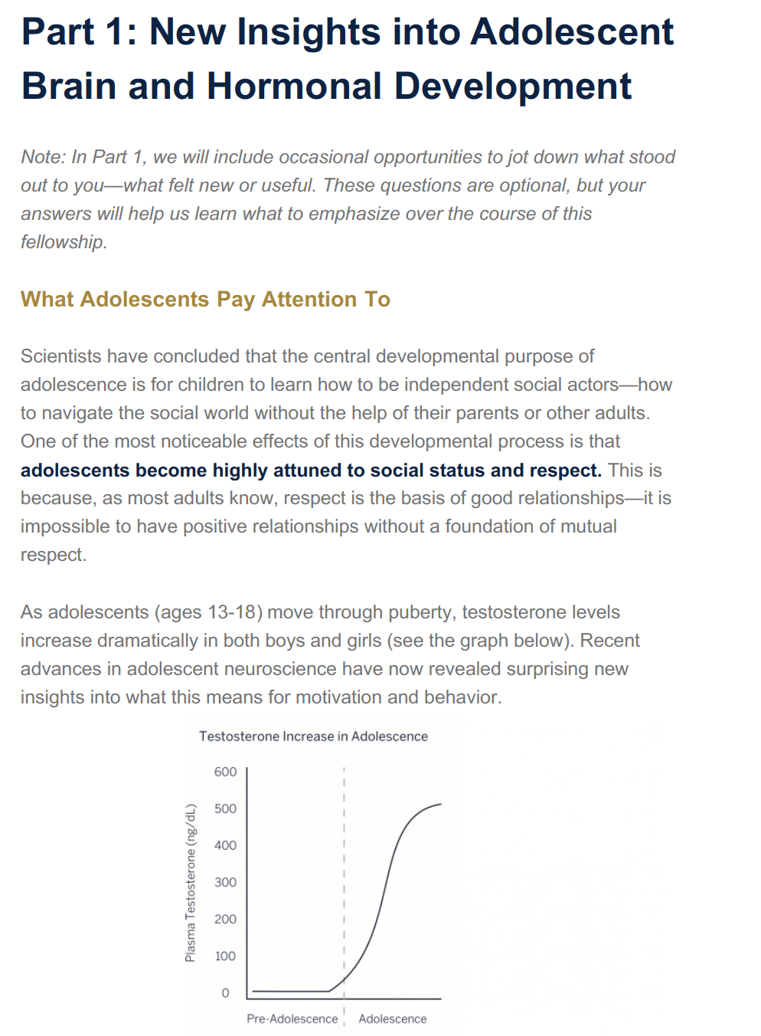
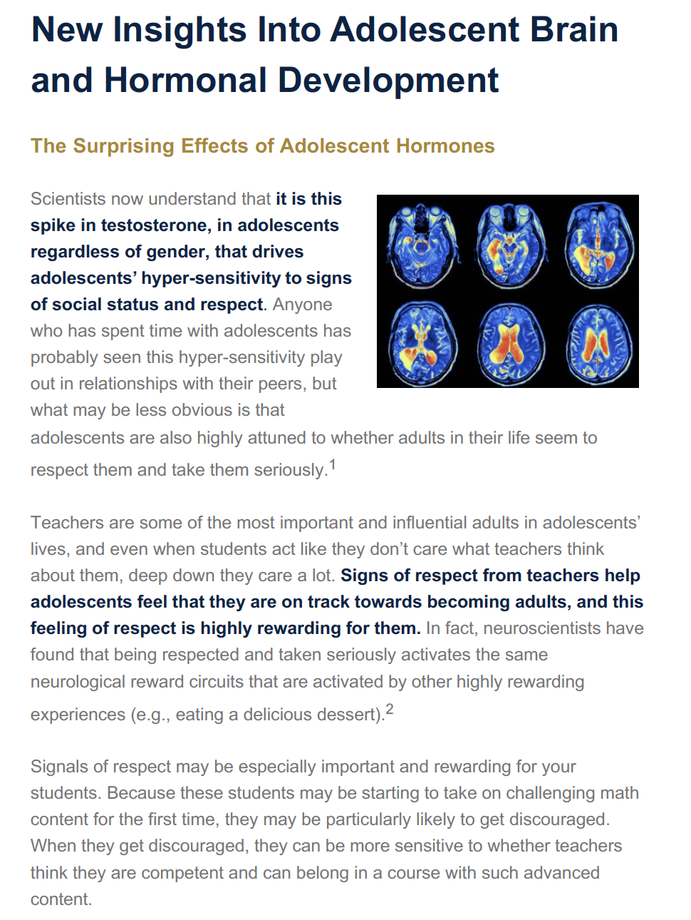

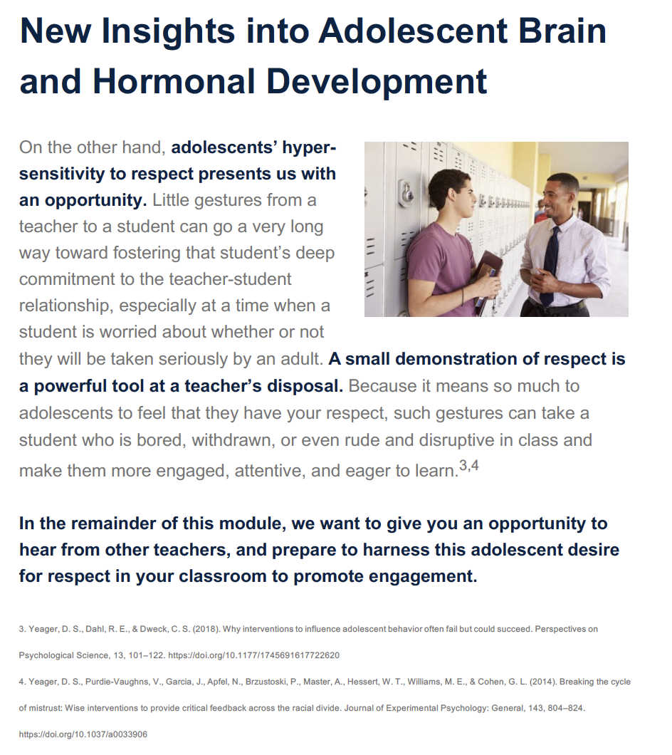

Supplemental Figure 2: Screen Captures from Retesting and Revision Module
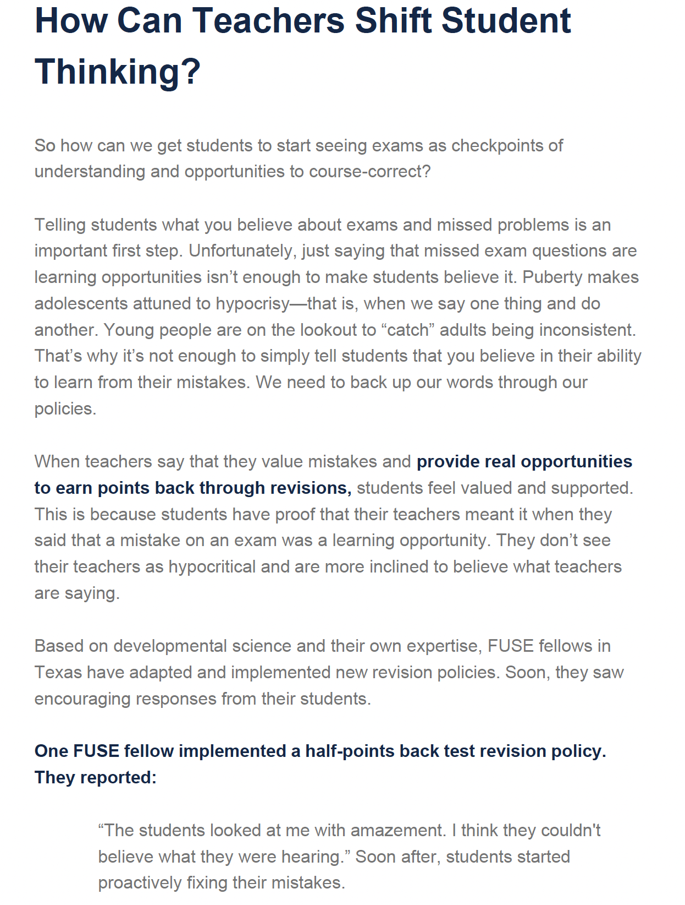


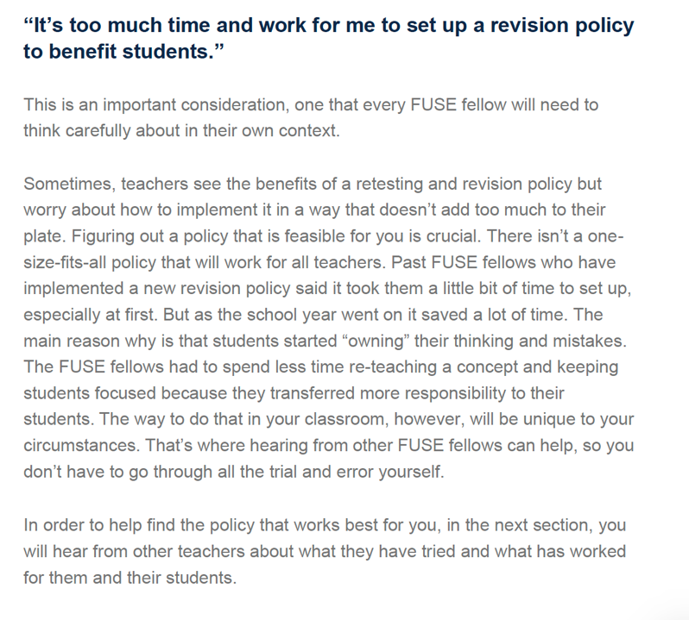

Supplemental Figure 3: Screen Captures from Mining Mistakes Module
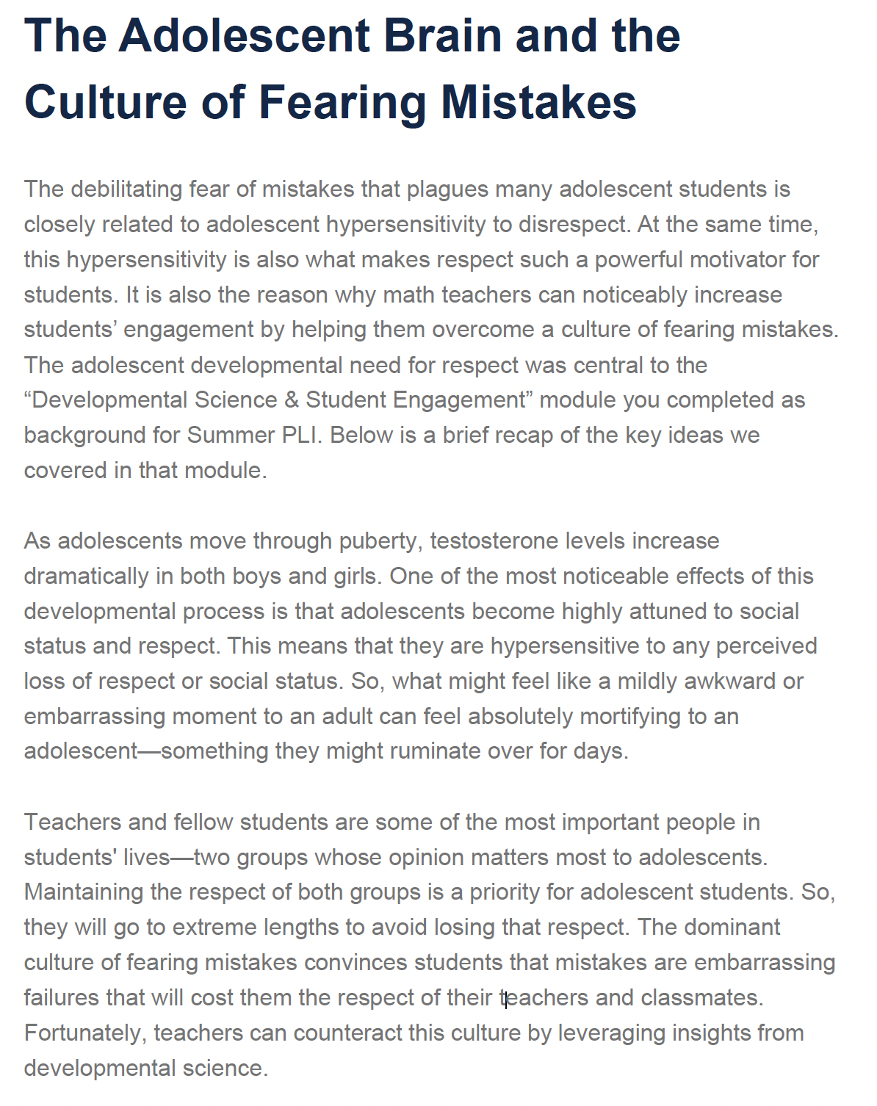
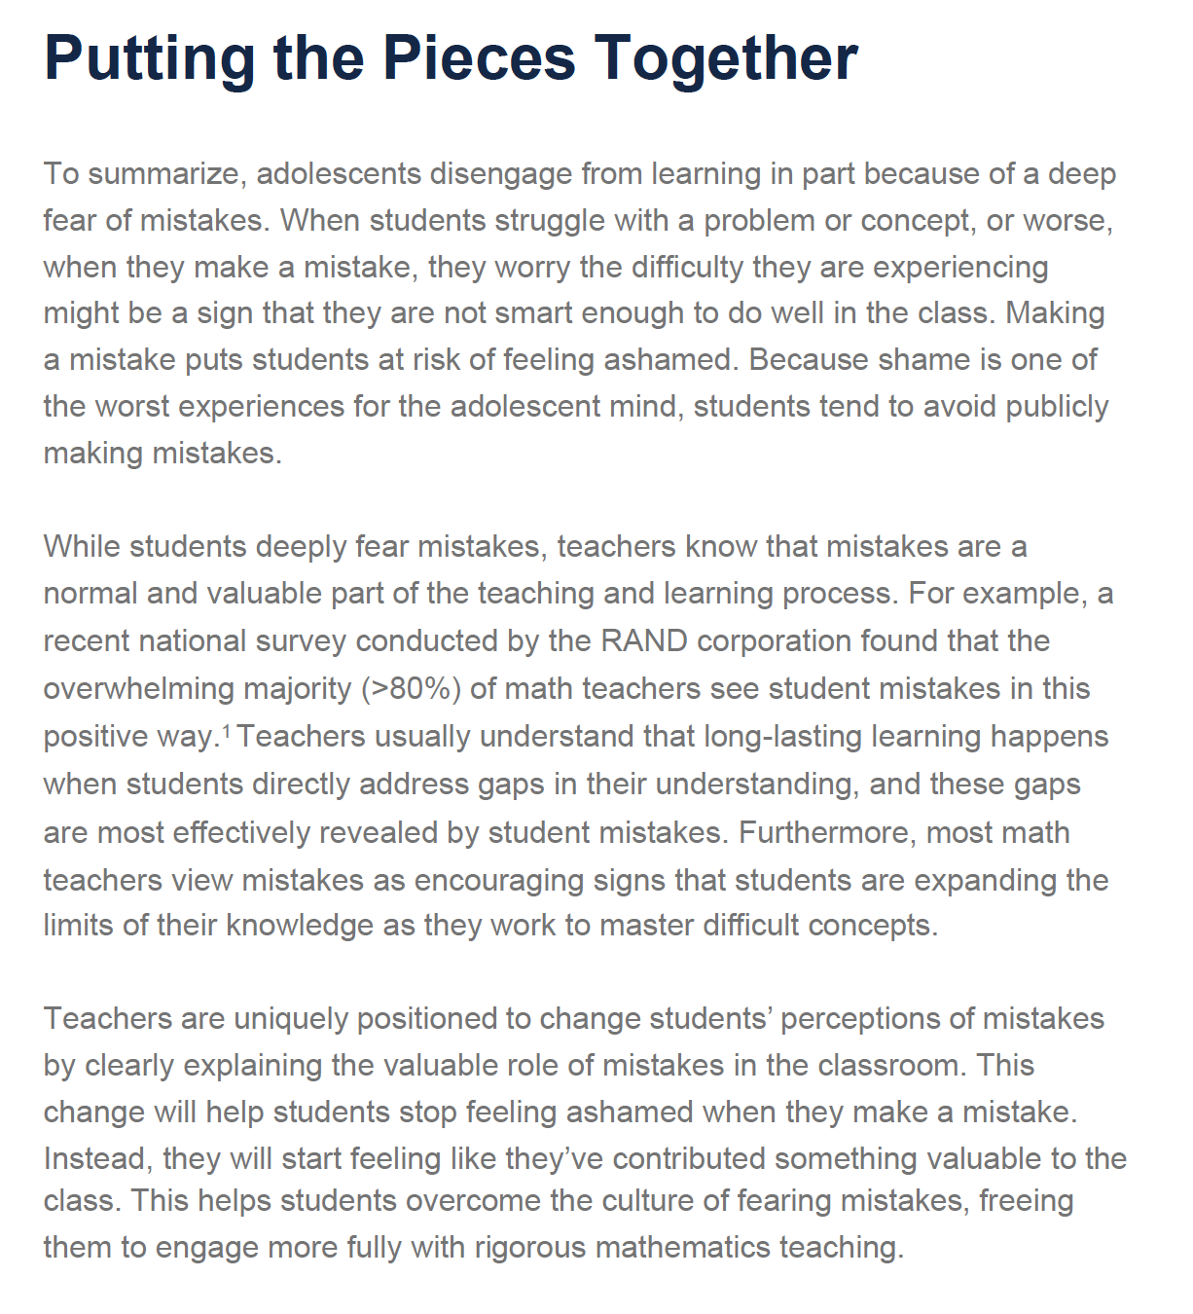
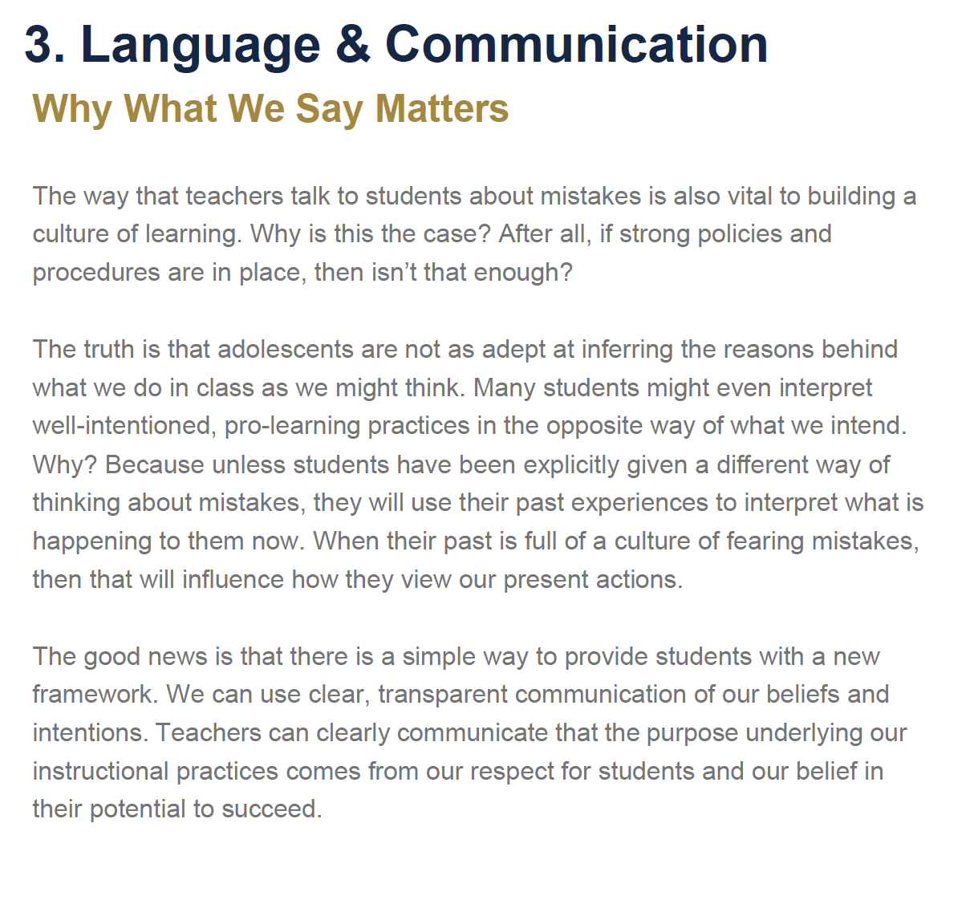
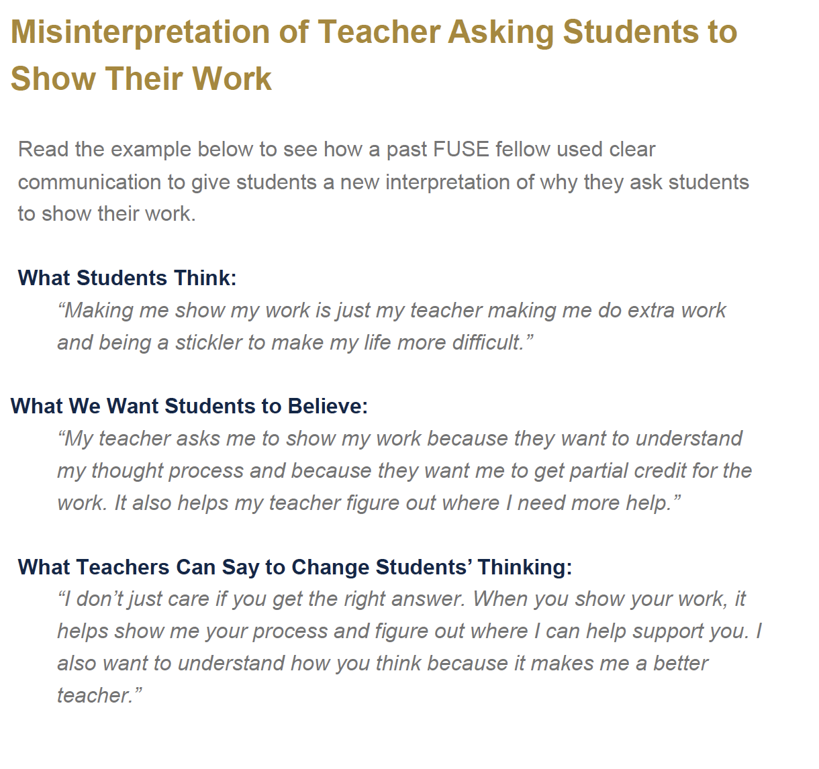

Supplemental Figure 4: Screen Captures from Culture of Learning Speech Module


Supplemental Figure 5: Screen Captures from Collaborative Troubleshooting Module
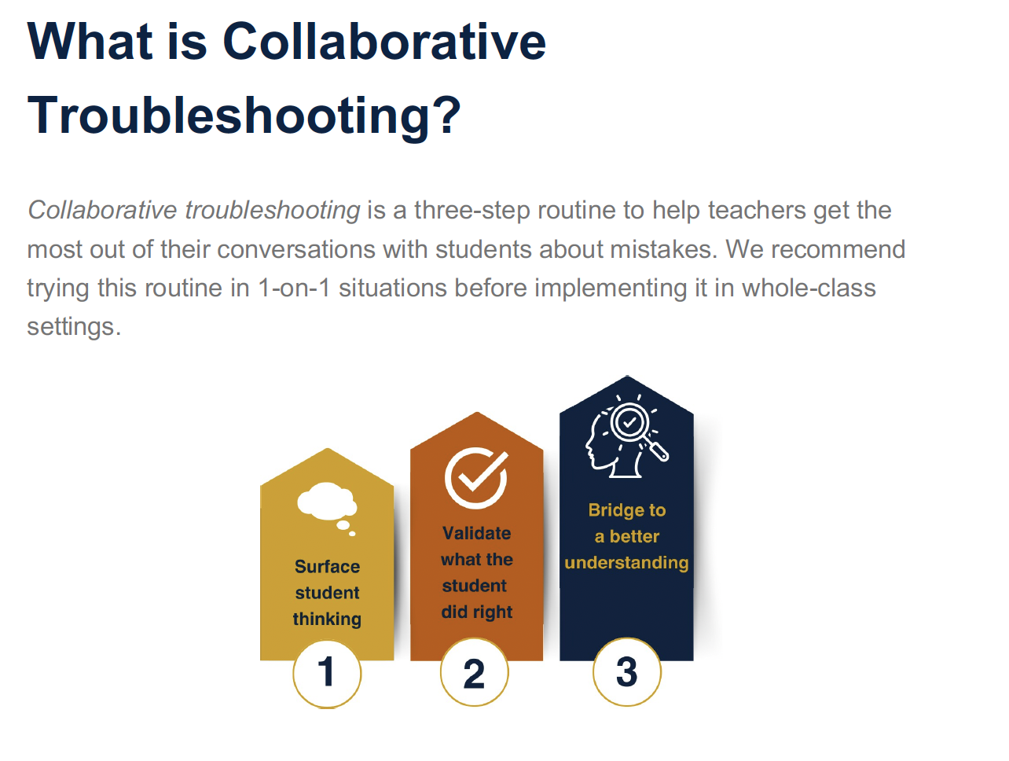
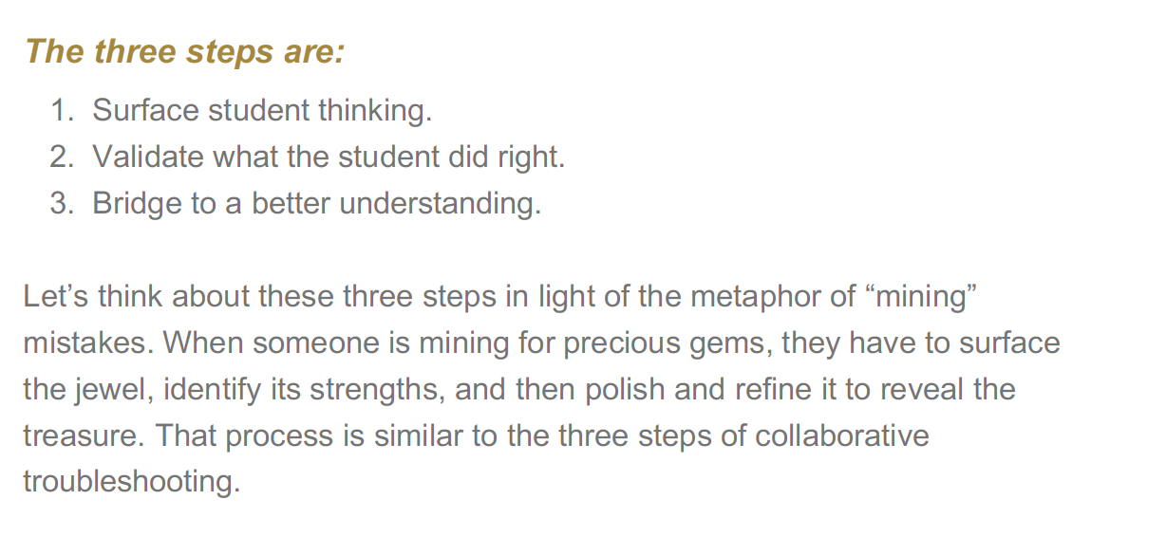

Supplemental Figure 6: Screen Captures from Exam Speeches Module


Control (Cognitive-Science-of-Learning) Program Content


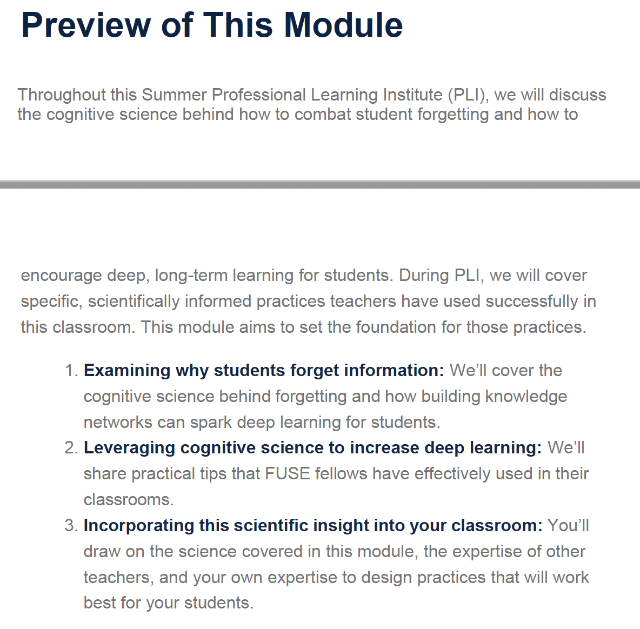

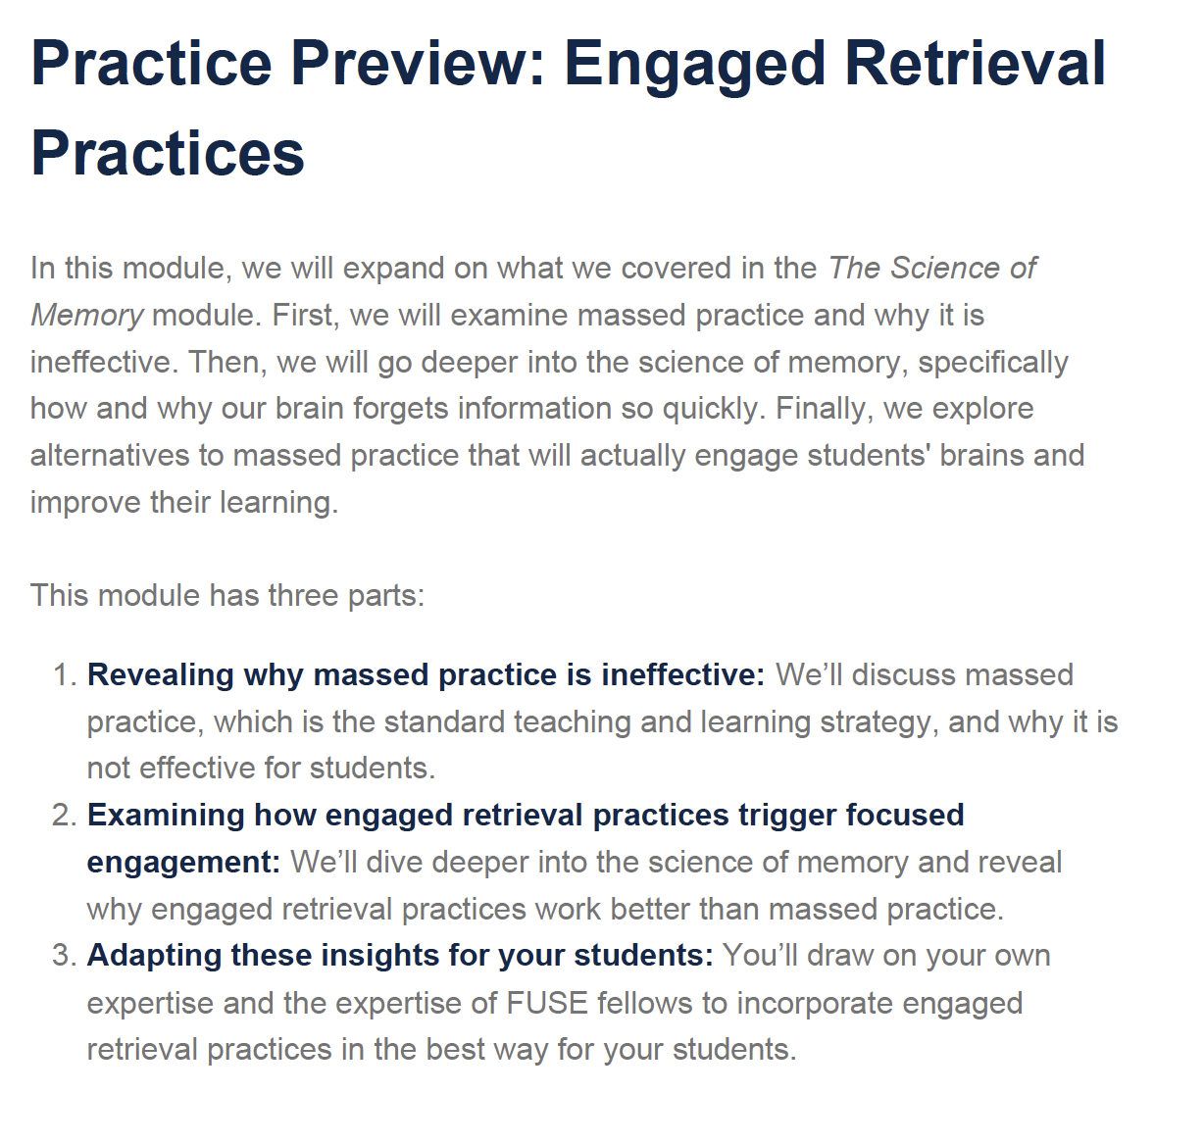
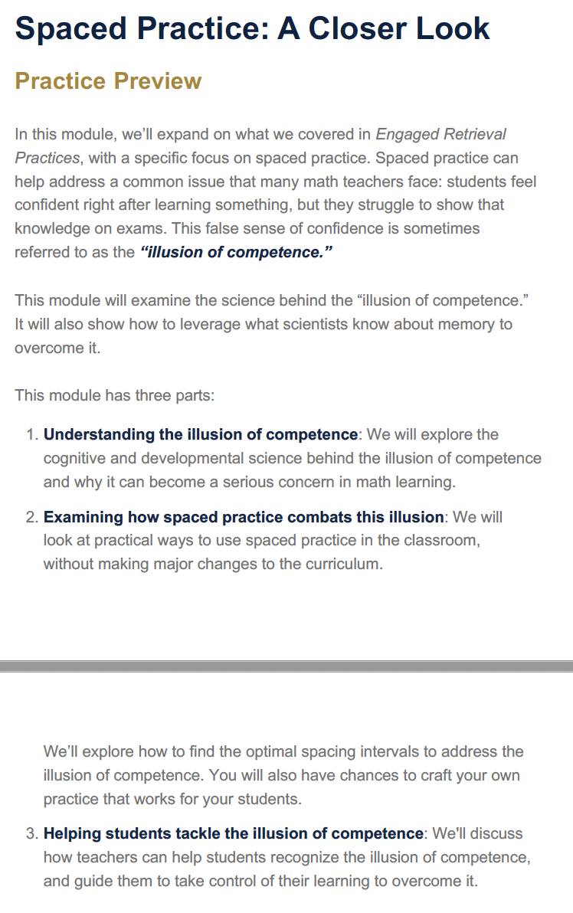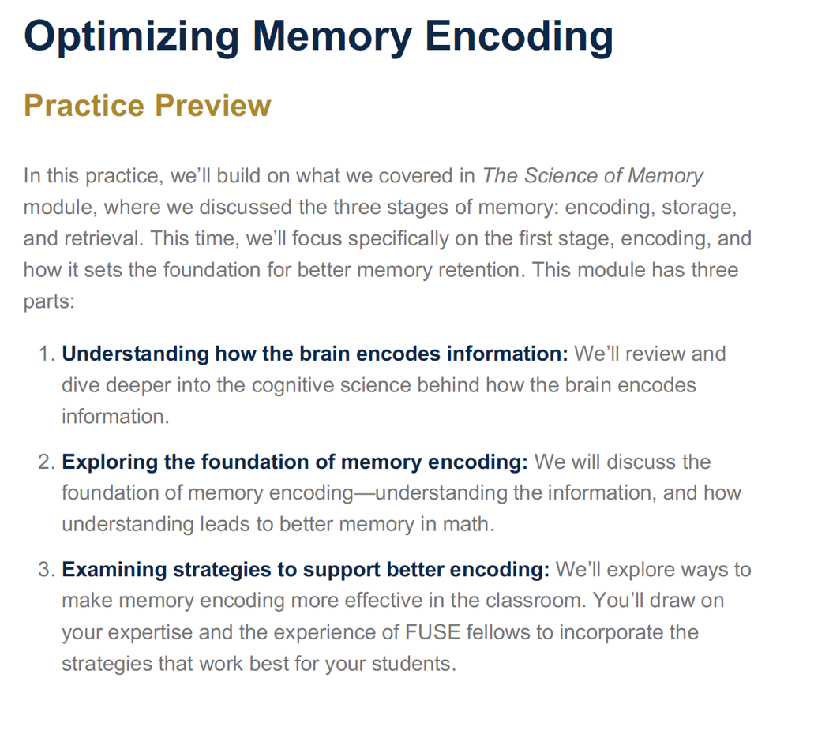
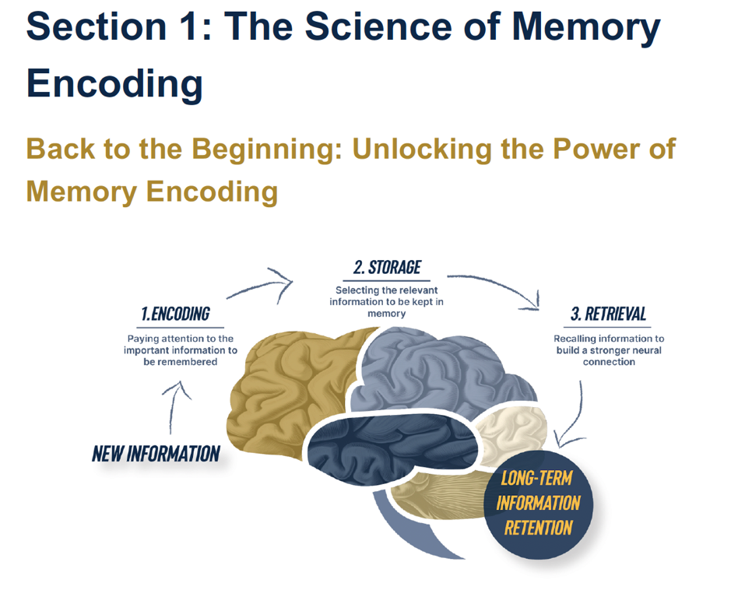
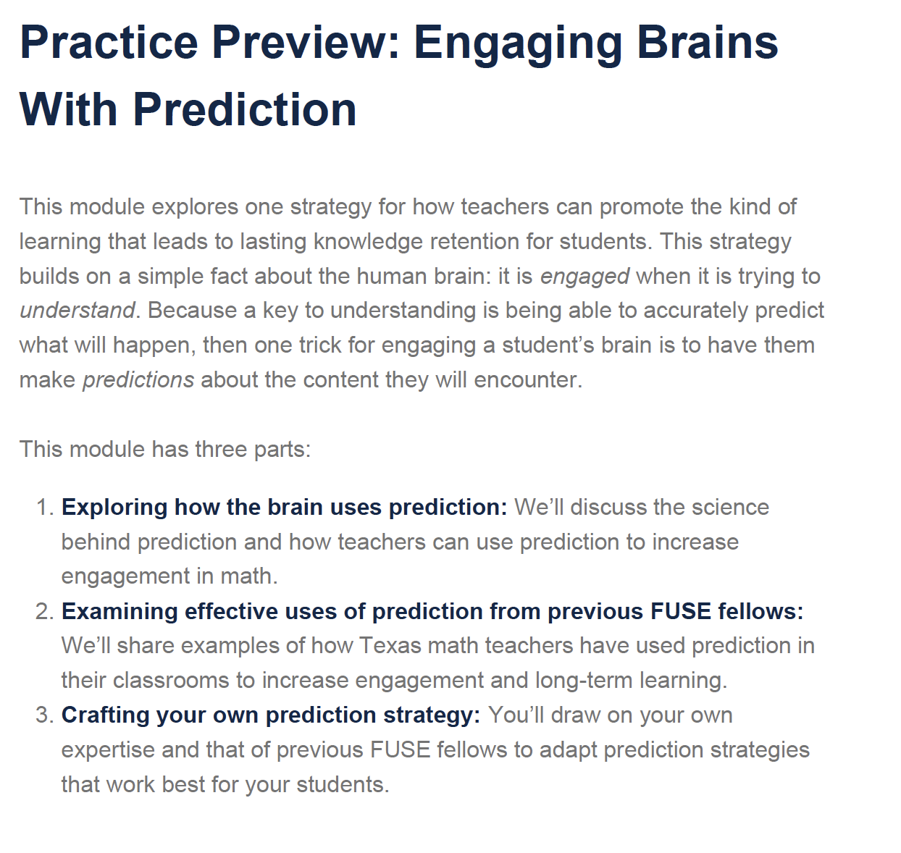

Baseline Measures Used as Covariates
The variables described below were measured prior to randomization and entered into the BCF model as covariates to address any chance differences between conditions. For means by condition, see Supplemental Table 1 above.

Student Covariates

Student race. Choose one or more races that you consider yourself to be. American Indian / Native American or Alaska Native; Asian; Black or African American; Native Hawaiian or Other Pacific Islander; White or Caucasian; Other (please specify); Prefer not to say.

Student ethnicity. Are you Hispanic or Latino/a? Yes; No.

Student gender. How would you describe your gender? Male / Man / Boy; Female / Woman / Girl; Other [blank].

Student maternal education. To the best of your knowledge, what is the HIGHEST level of education earned by your mother? If your mother was not the person who raised you, then answer this question thinking about the adult who you spent the most time with growing up (such as your grandmother, father, or legal guardian). My mother or guardian’s highest level of education is: Doctorate: Lawyer, Doctor or PhD; MA, MS, or MBA: Master’s degree; BA or BS: Bachelor’s degree (four-year college or university); AA or AS: Associate’s degree (i.e., community college or junior college); Took some college courses, no college degree; Finished high school, no college degree; Did not finish high school; Do not know.

Teacher Covariates

Grade level(s) taught. For which grade levels are you teaching a math course for this 2024-25 school year? Please select all that apply. (options: 6th to 12th).

Teacher race. Choose one of more races that you consider yourself to be: White or Caucasian; Black or African American; American Indian/Native American; Asian; Native Hawaiian or other Pacific Islander; Other (please specify).

Teacher ethnicity. Are you of Hispanic or Latino origin? Yes; No.

Teacher gender. How would you describe your gender? Male/Man; Female/Woman; Other.

Teacher years teaching. What is the total number of years you have been a classroom instructor of record?

Teacher certification. Which TEA-approved Educator Preparation Program (EPP) did you complete to become a certified teacher in Texas? A university or college-based program. Please specify institution; An Alternative Certification Program (ACP). Please specify name of ACP; Another way. Please describe.

Teacher fluid intelligence score. On the next page, please share your opinion about puzzles in general. Then we’d like you to try out some novel puzzles. To solve each puzzle, you look along each row and column and decide how the patterns are changing and what the missing figure in the lower right might be like. Then look for the answer that is correct, among the eight choices available. [Puzzles are three items from the Raven’s progressive matrices, selected using IRT analysis to cover the range of ability scores with minimal time].

Teacher challenge preference. Thanks for trying these puzzles. Now that you've tried them, we'd like to know your honest opinion of them. How much did you enjoy doing the puzzles on the previous pages? 1 = Not at all; 5 = An extreme amount.

Teacher self-transcendent purpose for teaching. One of my main reasons for being a teacher is because I care about helping people and contributing to my community or society; One of my main reasons for being a teacher is because I want to be a positive influence on youth in my community or society. 5 = Extremely true; 1 = Not at all true.

Teacher trust in administrators. To what extent do you feel comfortable discussing your feelings, worries, or frustrations with the principal in your school?; To what extent do you feel the principal in your school looks out for the personal welfare of the math teachers? To what extent do you feel respected by the principal in your school? 5 = A great deal; 1 = Not at all.

Teacher trust in other teachers. To what extent do you feel comfortable discussing your feelings, worries, and frustrations with other teachers in your school? To what extent do teachers in your school really care about each other? To what extent do teachers at your school respect other teachers who take the lead on efforts to improve the school’s instruction? 5 = A great deal; 1 = Not at all.

Teacher burnout. These measures were the same as reported in the main text.

Teacher depression. Over the last 2 weeks, how often have you been bothered by any of the following problems? Little interest or pleasure in doing things; Feeling down, depressed, or hopeless. 4 = Nearly every day; 1 = Not at all
.
Teacher fixed mindset. These measures were the same as reported in the main text.

Teacher enforcer mindset. These measures were the same as reported in the main text.

Teacher protector mindset. Most adolescents can’t handle the stress or frustration of trying to understand challenging assignments in school; Most adolescents are so fragile that they would lose their confidence and give up if they struggled in math class; When adolescents experience failure or difficulty, it seriously harms their confidence and performance. 1 = Strongly disagree; 6 = Strongly agree.

Teacher mentor mindset. These measures were the same as reported in the main text.

Teacher fixed mindset language (speech ratings). For the next few questions, you will imagine that you are giving feedback to a novice instructor who has shared a draft of a first day speech.
Imagine a first-year teacher is preparing for their first day of class. They are preparing a speech for their students to communicate their expectations for the year. The teacher is asking for your input on how effective their speech is. The teacher begins by saying:
“Hi class. I’m looking forward to teaching you this year. I want to give you an idea of what this class will be like, so l will tell you about my approach to teaching math and introduce you to some of my class policies.”
Please read the rest of the speech on the next few pages and answer the questions that follow. How effective is this teacher's statement at creating a classroom that supports student learning?
“Math is challenging for a lot of people, and this is going to be a hard class. Math is basically a set of facts and techniques that you need to learn to solve problems. I will tell you the right facts and techniques for solving each kind of problem. It will be up to you to remember them.”
“If you struggle in this class, remember that not everybody is a 'math person' who can easily learn and apply the right facts and techniques for problems. And that’s okay. You shouldn’t feel bad if you’re one of the struggling students.”
“If you don’t understand something I’ve already taught you, please don’t ask questions until after class. I’ve found that these questions can slow down the students that are staying on track.”
“When you turn in assignments, whatever grade you get will be final. So, in my class, you should pay attention to the assignments you turn in so that you don’t make mistakes.”
“In my class, I will give you three tests (one for each major unit) and a final exam that covers all of the units. You cannot make up for problems missed on previous tests, so make sure you’re prepared for each test.”
“Students usually know where they stand in this class after the first one or two exams. Students who do the best at the beginning of the year are typically the same ones who do well at the end.”
1 = Extremely ineffective; 7 = Extremely effective.

Teacher intent to use culture-of-learning practices. Here is a practice that some teachers might use: [practice]. Answer the questions below while thinking about this teaching practice. How likely are you to use this teaching practice at least once during this 2024-2025 school year? [See list of practices below]. 1 = Not at all likely; 5 = Extremely likely.

Teacher perceived barriers to use of culture-of-learning practices. There are many things that happen in schools that could stand in the way of teachers implementing practices they care about. Examples include lack of student motivation, teachers’ concern about being evaluated by administrators, or limitations on teachers’ time. How often, if ever, will something get in the way of you making this practice one of your top priorities during this 2024-25 school year? 1 = Never; 5 = Always. [Asked after each of the practices listed below].

Culture of Learning Teaching Practices
Spend class time encouraging students to reveal and discuss their mistakes with the teacher or classmates.
From the start of the year, spend time explaining to students how your class is designed to help them be successful when they are struggling.
Assign math problems that many students may get wrong and may cause them stress but will allow you to understand how to correct their thinking.
Encourage every eligible student to earn points back on an exam or quiz by correcting missed questions or retaking the exam.
Spend in-class or out-of-class time reviewing or re-teaching concepts students missed after each summative exam.

Measures for RAND American Educator Panel Pilot Study (ED Table 1)
“Ability” Attributions. How likely would you be to think this thought or something like it? The student is always going to struggle because they just don't have enough math ability. 1 = Not at all likely; 5 = Extremely likely.

“Support” attributions. How likely would you be to think this thought or something like it? With the right support, the student can learn better ways to study and do well in the class. 1 = Not at all likely; 5 = Extremely likely.

Effort beliefs. If a student has to try really hard in math, it means they can't be good at that subject. 1 = Strongly disagree; 6 = Strongly agree.

Self-efficacy. I can't make my students learn the material if they're not intrinsically motivated to work hard and learn; I probably can't motivate every one of my students to work hard and learn all the material in my class. 1 = Strongly disagree; 6 = Strongly agree.

Fixed mindset speeches. See above.

Intention to enact culture-of-learning practices. See above.

Perceived barriers to enacting culture-of-learning. See above.
Misunderstanding of growth mindset. We are interested in your professional opinions about the popular educational trend, in recent years, of supporting students' growth mindset. How much do you believe that when teachers regularly and strongly emphasize their support for students' growth mindsets, it causes teachers to lower their standards of academic rigor or hard work? 1 = Not at all; 5 = A great deal. (Data only analyzed among teachers who have ever heard of a growth mindset).

Skepticism of growth mindset. Are you generally more skeptical or more enthusiastic about the idea of regularly and strongly emphasizing your support for students' growth mindsets in your own teaching? 1 = Very skeptical; 7 = Very enthusiastic. (Data only analyzed among teachers who have ever heard of a growth mindset).

https://cran.r-project.org/web/packages/randomForest/index.html

