Table 2 Changes in the dominant coral species (Top 5) of the Wenchang coral community before and after the typhoon
 | Ecological photo | Species | Frequency of occurrence | Dominance | Rank
Pre-typhoon | 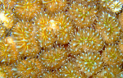 | Galaxea fascicularis | 1 | 0.128 | 1
Pre-typhoon | 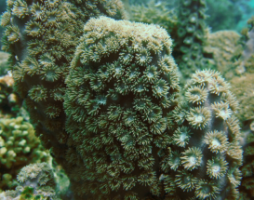 | Duncanopsammia peltata | 1 | 0.090 | 2
Pre-typhoon | 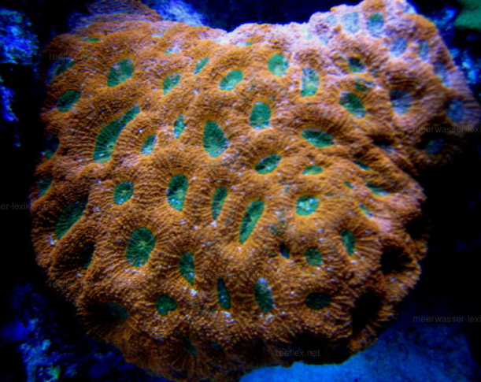 | Favites complanata | 1 | 0.082 | 3
Pre-typhoon | 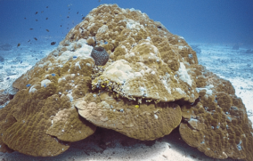 | Porites lutea | 0.5 | 0.081 | 4
Pre-typhoon | 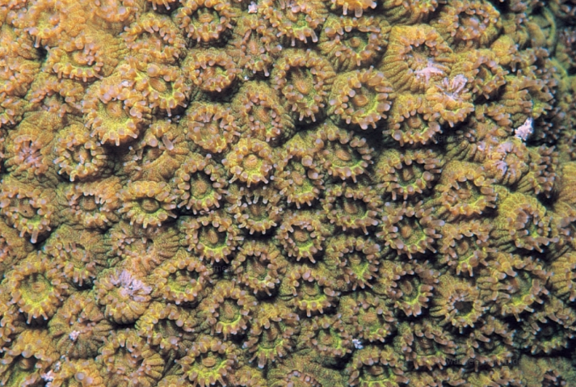 | Plesiastrea versipora | 1 | 0.071 | 5
Post-typhoon |  | Galaxea fascicularis | 1 | 0.173 | 1
Post-typhoon | 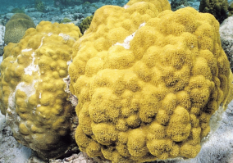 | Porites sp. | 1 | 0.103 | 2
Post-typhoon | 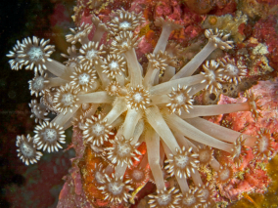 | Goniopora sp. | 1 | 0.095 | 3
Post-typhoon |  | Favites complanata | 1 | 0.076 | 4
Post-typhoon |  | Plesiastrea versipora | 1 | 0.044 | 5

Table 3 Changes in the dominant reef fish species of the Wenchang coral community before and after the typhoon
 | Ecological photo | Species | Frequency of occurrence | Dominance | Rank
Pre-typhoon | 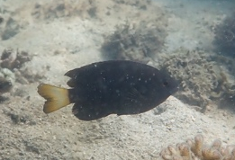 | Pomacentrus chrysurus | 0.6 | 0.118 | 1
Pre-typhoon | 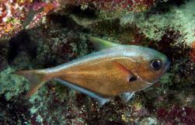 | Pempheris oualensis | 0.6 | 0.116 | 2
Pre-typhoon | 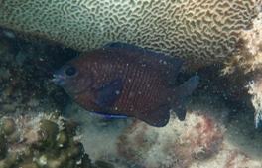 | Plectroglyphidodon fasciolatus | 0.4 | 0.066 | 3
Pre-typhoon | 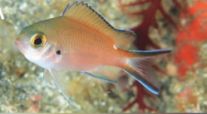 | Chromis fumea | 0.6 | 0.039 | 4
Post-typhoon |  | Pomacentrus chrysurus | 0.8 | 0.274 | 1
Post-typhoon |  | Plectroglyphidodon fasciolatus | 1 | 0.166 | 2
Post-typhoon | 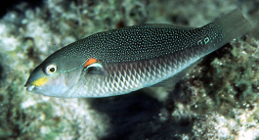 | Stethojulis bandanensis | 0.6 | 0.035 | 3
Post-typhoon | 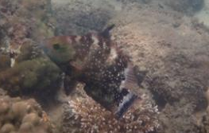 | Labridae sp. | 0.6 | 0.021 | 5

