Supplementary Figure 1

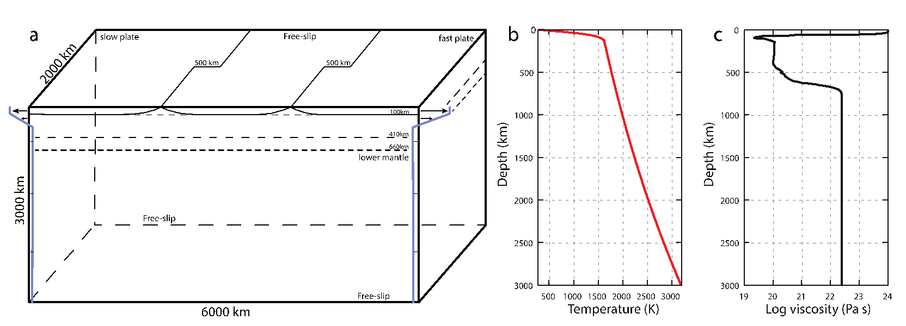

a) Cartoon of the model set up showing the extent of the domain and the initial location of the mid-oceanic ridges and transform faults. The blue lines represent the boundary velocity profile (not to scale) that is imposed on the entire left and right sides. b) Initial temperature profile and c) initial viscosity profile obtained away from a ridge.

