Heterogeneous van der Waals integration of single-crystalline photonic nanomembranes –- Supplementary Information
Yuan Meng^{1†}, Wenbo Mao^{2†}, Zhihao Xu^{3†}, Di Jia^{2†}, Mengxin Lin^{4,5}, Jisung Seo^{6,7}, Bora Kim^{7,8}, Xinyuan Zhang⁹, Eugene Park⁹, Seokje Lee^{10,11}, Jekyung Kim^{10,11}, Sangmoon Han¹, Ji-Yun Moon¹, Weijie Xu², Qian Zhang², Xiaoqing He³, Mingfeng Chen¹², Sang Hyun Nam¹³, Jianqi Hu^{4,5}, Justin S. Kim³, Sejin Lee³, Sanggeun Bae³, Soo Ho Choi^{7,8}, Tae Hyung Kim^{1,13}, Yunseok Choi¹, Seung-Il Kim¹, Kyubeen Kim¹, Minho Jin¹, Chen Jiang¹, Yiheng Zhang², Young-Hoon Kim¹³, Jae-Hyun Lee¹⁴, Hobeom Kim¹⁵, Sheng Ran¹², Xi Wang¹², Cheng-Wei Qiu¹⁶, Frances M. Ross⁹, Jeehwan Kim^{9,10,11}, Minjoo Larry Lee^{6,7,8}, Hyunseok Kim^{6,7,8,17}, Tobias J. Kippenberg^{4,5}, Lan Yang^{2,3}*, and Sang-Hoon Bae^{1,3,12}*
¹Department of Mechanical Engineering and Materials Science, Washington University in St. Louis, St. Louis, MO, USA.
²Department of Electrical and Systems Engineering, Washington University in St Louis, St. Louis, MO USA.
³Institute of Materials Science and Engineering, Washington University in St Louis, St. Louis, MO, USA.
⁴Institute of Physics, Swiss Federal Institute of Technology Lausanne (EPFL), Lausanne, Switzerland.
⁵Institute of Electrical and Micro Engineering (IEM), Swiss Federal Institute of Technology (EPFL), Lausanne, Switzerland.
⁶Department of Materials Science and Engineering, University of Illinois Urbana-Champaign, Urbana, IL, USA.
⁷Holonyak Micro and Nanotechnology Laboratory, University of Illinois Urbana-Champaign, Urbana, IL, USA.
⁸Department of Electrical and Computer Engineering, University of Illinois Urbana-Champaign, Urbana, IL, USA.
⁹Department of Materials Science and Engineering, Massachusetts Institute of Technology, Cambridge, MA, USA.
¹⁰Department of Mechanical Engineering, Massachusetts Institute of Technology, Cambridge, MA, USA.
¹¹Research Laboratory of Electronics, Massachusetts Institute of Technology, Cambridge, MA, USA.
¹²Department of Physics, Washington University in St Louis, St Louis, MO, USA.
¹³Department of Energy Engineering, Hanyang University, Seoul, Republic of Korea.
¹⁴Department of Electrical and Computer Engineering, Sungkyunkwan University, Suwon, Republic of Korea.
¹⁵Department of Materials Science & Engineering, Gwangju Institute of Science and Technology, Gwangju, Republic of Korea.
¹⁶Department of Electrical and Computer Engineering, National University of Singapore, Singapore, Singapore.
¹⁷Materials Research Laboratory, University of Illinois Urbana-Champaign, Urbana, IL, USA.
† Equal contribution.
Correspondence: sbae22@wustl.edu; lyang25@wustl.edu;

Table of Contents for Supplementary Notes
S1. Freestanding nanomembranes lift-off and transfer details 3
S2. Additional material characterization data 7
S3. Artificial 3D heterostructures of GaAs/BTO/GaN/STO 8
S4. BTO crystallographic axis control 9
S5. Comparisons of ELO and 2DLT 11
S6. BTO effective Pockels coefficient estimation details 12
S7. Multi-domain BTO $reff$ Derivation 13
S8. RSM measurement details 18
S9. Si and SiN photonics fabrication details 19
S10. High-speed BTO MZMs design 20
S11. Rigorous BTO Pockels tensor simulations 21
S12. Benchmarks for BTO $reff$ details 23
S13. Additional HR-TEM data for BTO MZMs 26
S14. Additional high-speed BTO MZMs measurement data 27
S15. Transfer details for remote epitaxial GaN 29
S16. Additional TEM data for GaAs and GaN photodetectors 29
S17. III-V-SiN photodetector samples details 29
S18. Benchmarks for waveguide-coupled III-V photodetectors 30
S19. Device details for CFO/BTO hybrid microring 31
S20. Magnet-free CFO optical isolators 32
S21. Faraday rotation coefficient estimation details 32
S22. Ferromagnetic loop measurements 33
S23. Benchmarks of MO material CFO 34
S24. Fully integrated MO devices prospects 35
S25. Wafer-scale BTO nanomembrane vdW integration 36
S26. Robustness of photonic vdW integration 37
Supplementary References 38

S1. Freestanding nanomembranes lift-off and transfer details
Different functional single-crystalline nanomembranes are prepared by either 2D materials-assisted layer transfer (2DLT)¹⁻⁵ or epitaxial lift-off (ELO)⁶⁻⁸ with film growth details discussed in Methods.
For 2DLT (Fig. S1), 2D-covered single-crystalline substrates are prepared as growth templates^{3,4,9}, typically monolayer layer graphene or boron nitride (BN) depending on the polarity of substrate mateials¹⁰. Afterwards, remote epitaxy is performed at varying optimized conditions for GaN¹¹, GaAs^{9,12,13}, and YIG^{2,14} (Y₃Fe₅O₁₂), to name a few^{1,15}. The semi-transparent 2D layers facilitate remote adatom interaction with the substrate for single-crystalline epilayers³, and the subsequent release of the nanomembranes precisely along the 2D layer interface. These 2D interlayers can be realized by either transfer^{9,16} or direct growth atop the substrate¹¹, the proper implementation of which is crucial for realizing successful and scalable 2DLT with guidelines discussed elsewhere^{3,17}.
For BTO (BaTiO₃) and CFO (CoFe₂O₄) nanomembranes, ELO and wet transfer processes are applied (see Methods). Different polymer handlers, including polypropylene carbonate (PPC), polymethylmethacrylate (PMMA), polydimethylsiloxane (PDMS), and ethylene-vinyl acetate (EVA) with varying Young's modulus, can be applied for optimal layer transfer yield⁸. For BTO (Fig. S2a), the Sr₃Al₂O₆ (SAO)¹⁸⁻²⁰ sacrificial layer can be etched in deionized (DI) water, followed by scooping of the freestanding PPC/BTO nanomembranes floating on wafer surface to the target photonic chip. For CFO (Fig. S2b), the MgO interlayer can be etched in ammonium sulfate ((NH₄)₂SO₄) aquatic solution with slow speed, or heated weak acetic acid solution with faster layer lift-off speed^{21,22} without damaging single-crystalline CFO epilayer.
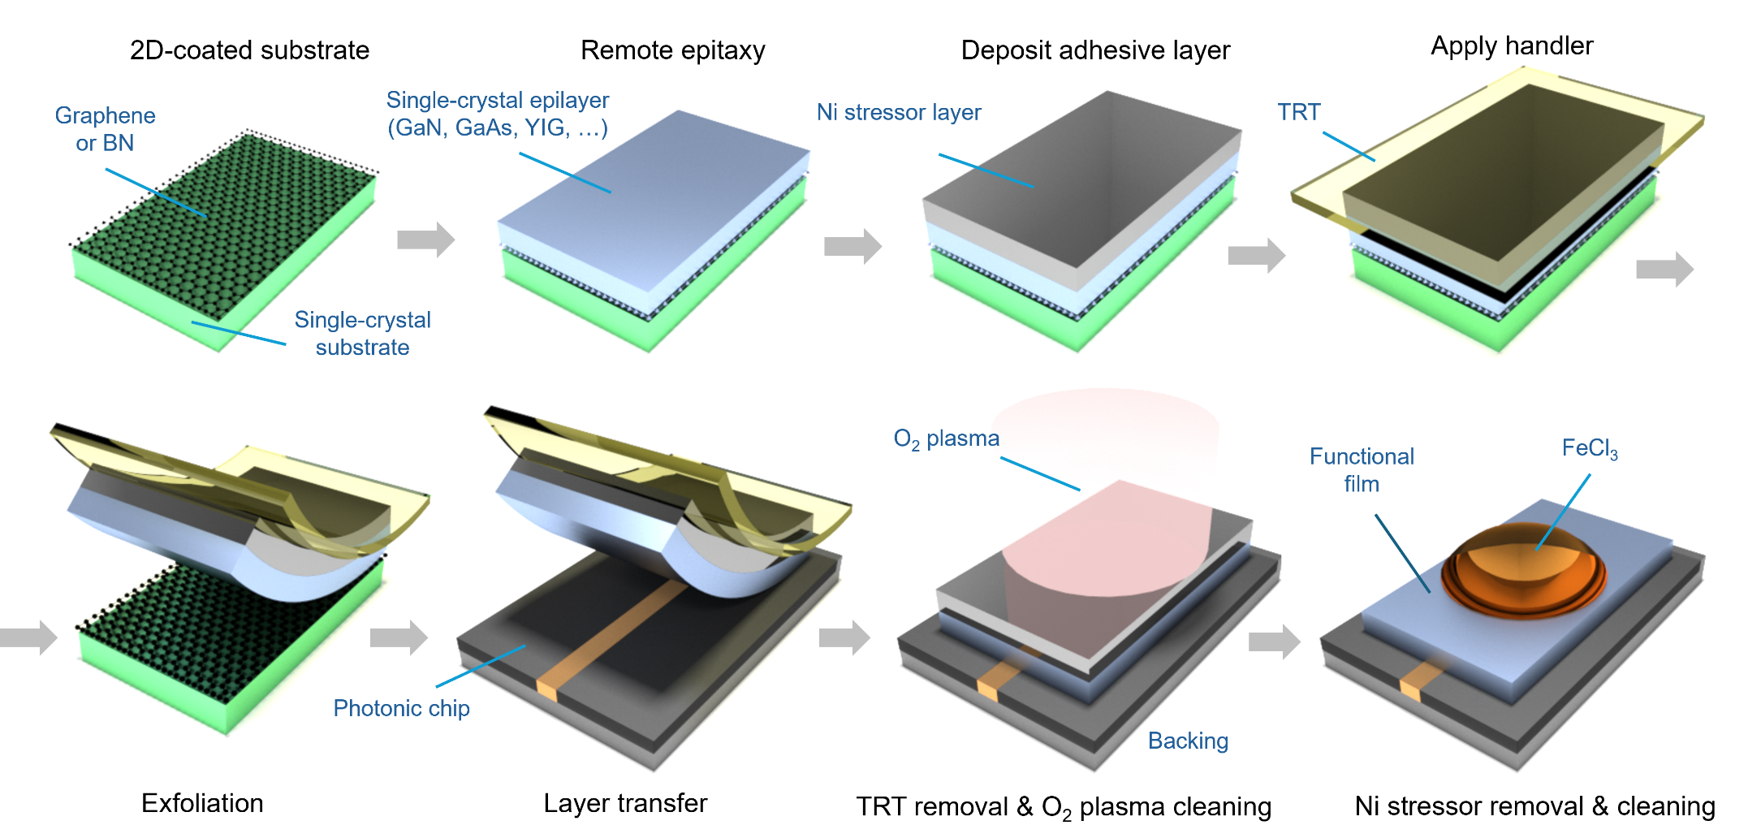

Figure S1. Remote epitaxy through 2D materials and 2DLT process for producing various functional single-crystalline nanomembranes. TRT: thermal release tape.

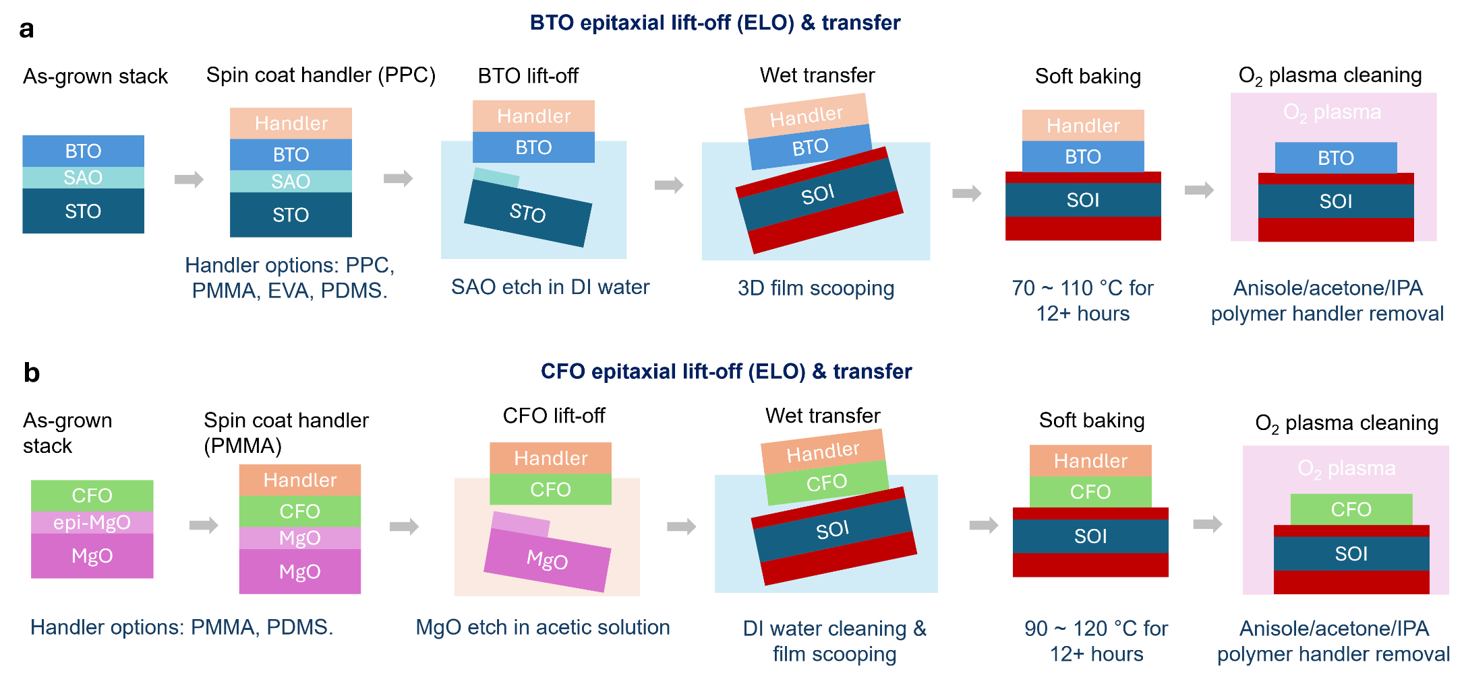

Figure S2. ELO and film transfer processes for BTO (a) and CFO (b) nanomembranes to arbitrary photonic substrates.
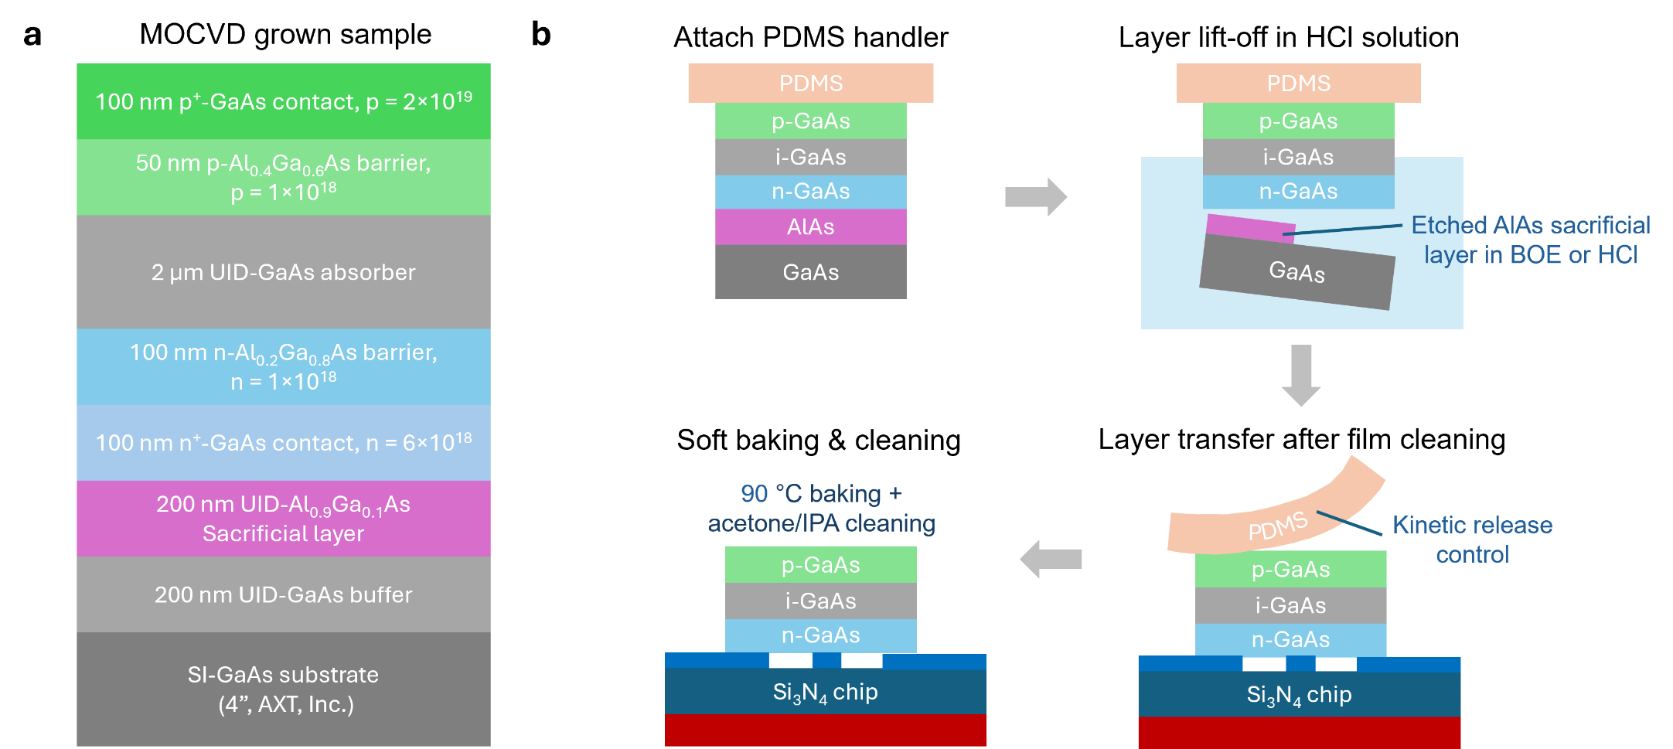

Figure S3. Epitaxial structure (a) and layer transfer process (b) for freestanding GaAs films. SI: semi-insulating. UID: unintentionally doped. BOE: Buffered oxide etchant. PDMS: polydimethylsiloxane.
For ELO GaAs nanomembranes for integrated photodetectors, the epitaxial structure is shown as Fig. S3a, where the unintentionally doped (UID) Al_{0.9}Ga_{0.1}As layer can be etched in diluted hydrochloric acid (HCl) or buffered oxide etchant (BOE) for subsequent layer transfer via PDMS handler^{23,24} (Fig. 3b). For 2DLT GaN nanomembranes^{4,11}, due to high-stress-level adhesive layers (Ti/Ni) required for epilayer exfoliation³ (Methods), its layer transfer process is slightly different (Fig. S4) with additional steps. Details are discussed later in Supplementary Note 15.
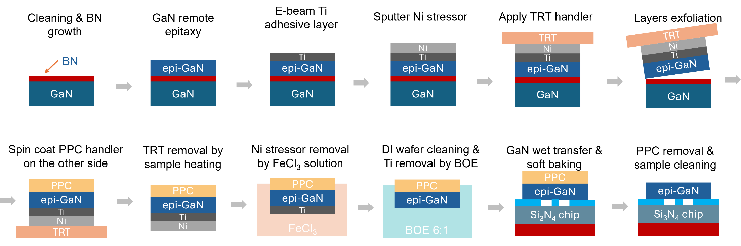

Figure S4. Remote epitaxy and transfer process for freestanding GaN nanomembranes.
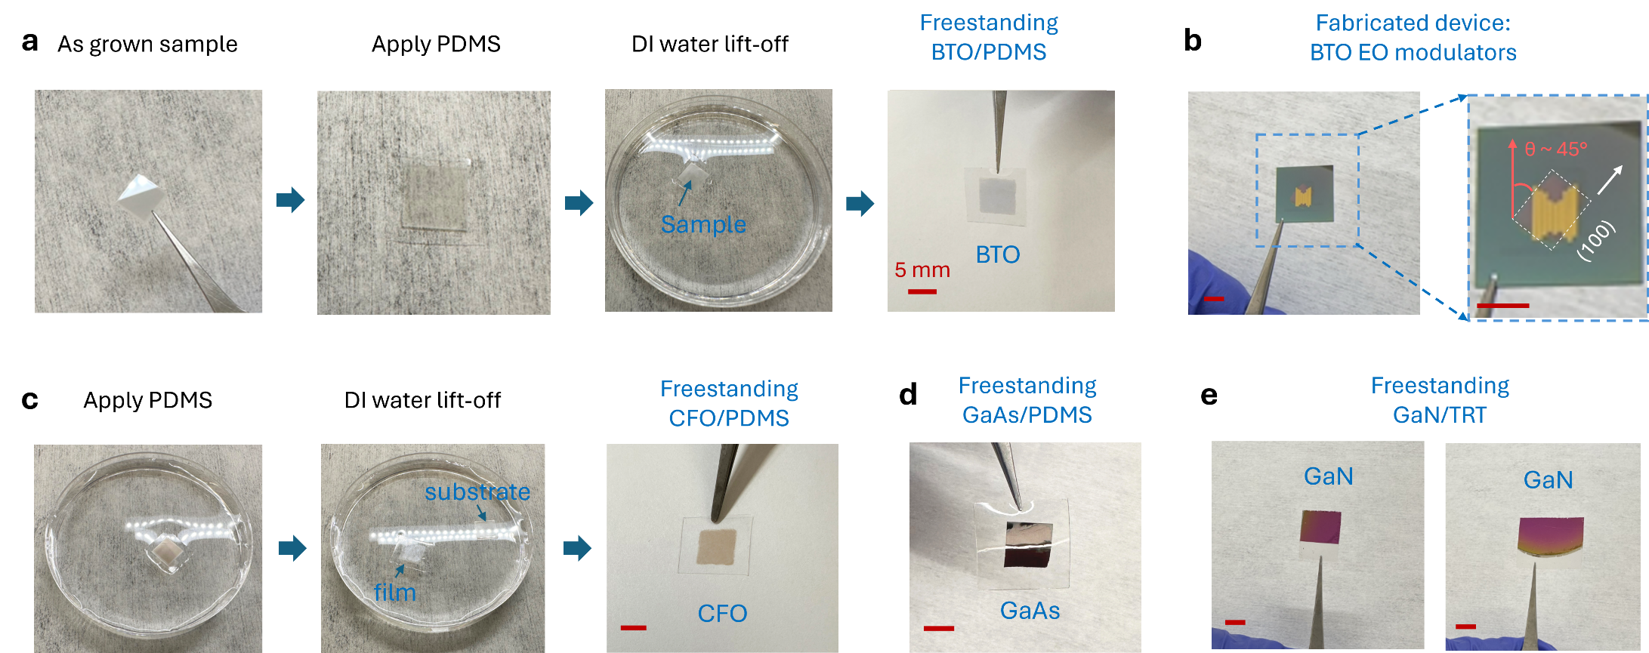

Figure S5. Photographs of BTO transfer process (a) and BTO vdW integrated chip (b) with designed 45° film rotation angle θ. (c) Photographs of ELO process for freestanding CFO. (d) and (e) Photographs of freestanding GaAs and GaN nanomembranes. Scale bars: 5 mm.
The vdW integration of diverse functional nanomembranes are experimentally verified (Fig. S6) with clean and uniform film surface morphology, atomically sharp interfaces (see Figs. 2i, 3a, 3h, and 4f in main text, and Figs. S10 and S31 discussed later in Supplementary Notes), and high robustness (detailed in Supplementary Note 26). The photonic vdW integration approach²⁵ has proven with high versatility to infuse arbitrary desired optical functionalities to arbitrary prefabricated photonic templates by selecting proper functional 3D nanomembranes building blocks.
Photonic chips with prefabricated waveguides, microring resonators, and Mach-Zehnder interferometers (MZIs) patterns etc. are experimentally proven feasible for high-quality nanomembranes vdW integration (Fig. S6), as long as this substrate is overall flat. For example, the etching trenches (due to positive electron beam lithography/EBL resists used) for waveguides and other patterns (Figs. S6a and S6b), and thin electrodes (around 30 nm-thick, shown as Fig. S6c) have been verified for robust 3D film transfer without issues, because the majority of the chip surface is flat to secure uniform film adhesion. However, for photonic chips with dense and significant height distinctions, such as the 500 nm-thick travelling wave electrodes (in Fig. 2f of main text), uniform nanomembrane vdW integration to the substrate will be perturbed. Therefore, thick electrodes are either fabricated atop/after the transferred 3D nanomembranes (such as the devices shown in Fig. 2), or applying buried electrode structures (like the device shown in Fig. 4g, detailed later in Supplementary Note 19). This vdW heterogeneous integration strategy well fits the planar processing applied in current complementary metal-oxide-semiconductor (CMOS) foundries for potential scalable manufacturing similar to wafer bonding^{7,26,27}. Scanning electron microscopy (SEM) also confirmed the uniform and high-quality nanomembranes bonding to various prefabricated photonic chips without any lossy adhesive interlayers (Fig. S7).
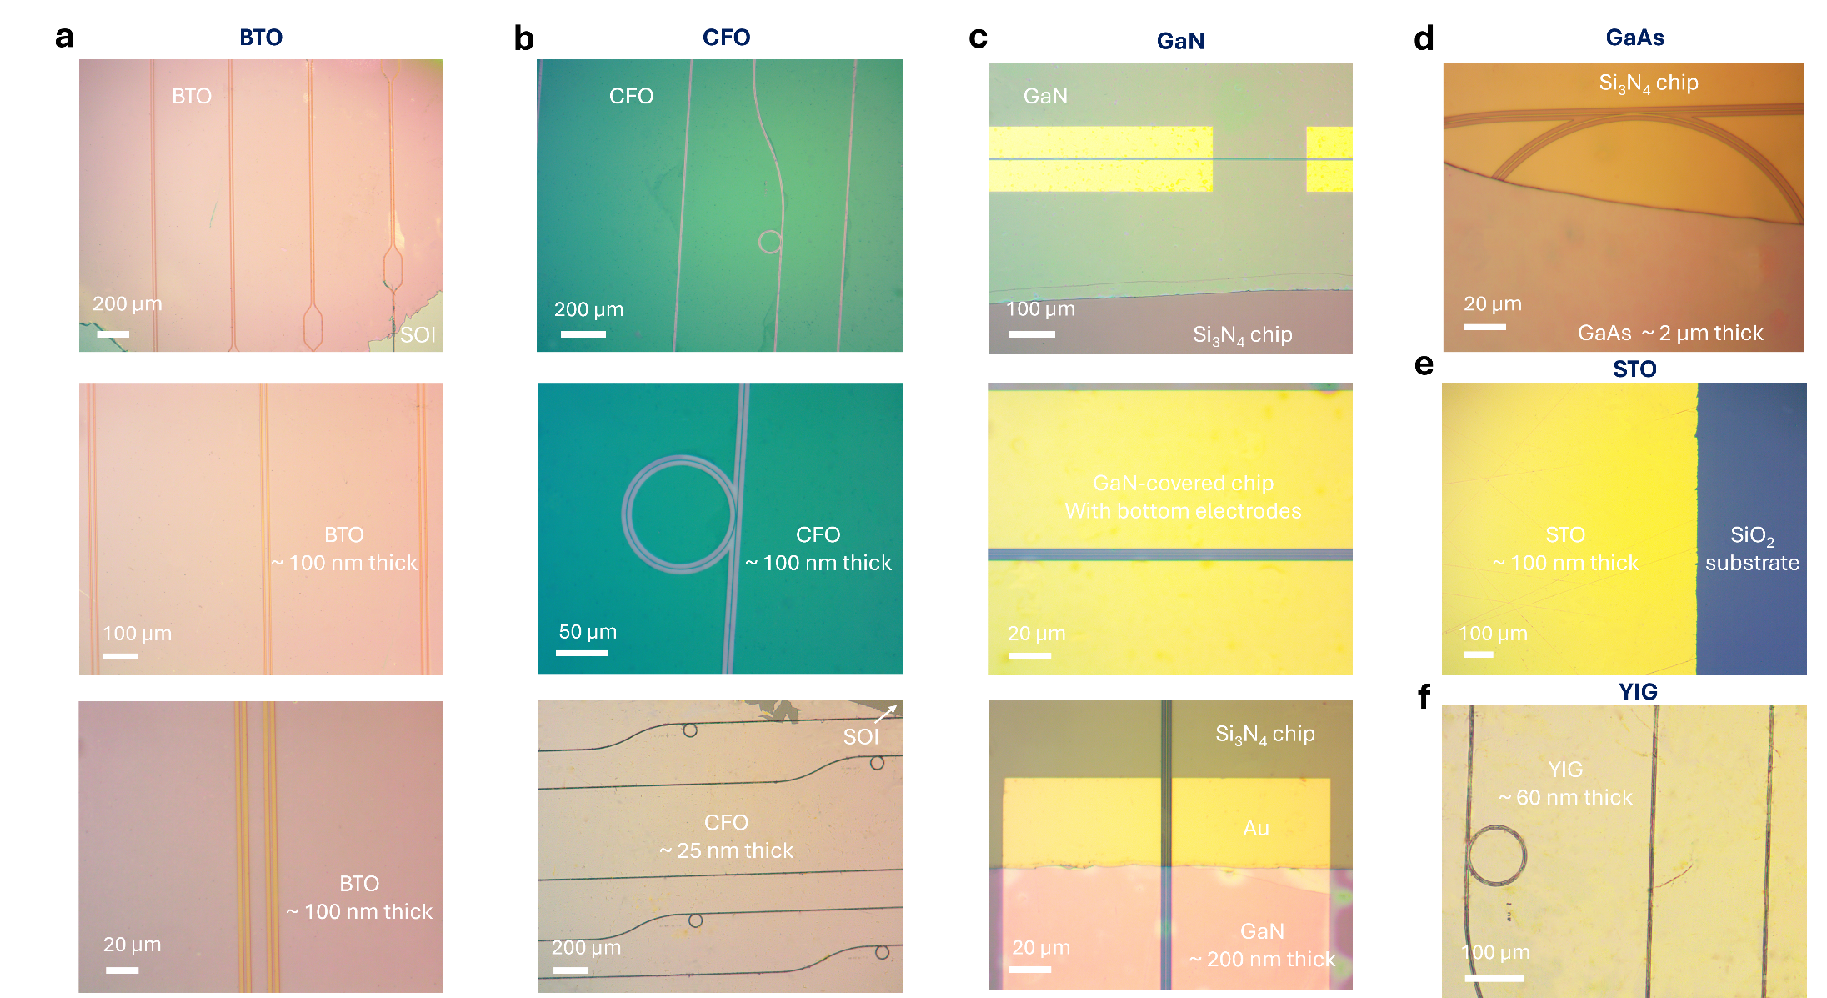

Figure S6. Optical micrographs of vdW integrating various functional nanomembranes to photonic substrates: (a) BTO, (b) CFO, (c) GaN, (d) GaAs, (e) STO, (f) YIG, showing uniform film integration.
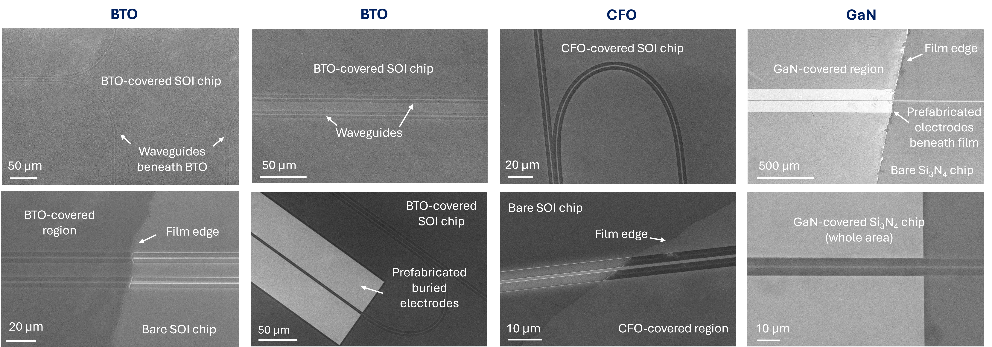

Figure S7. SEM on various vdW hetero-integrated nanomembranes on Si and SiN photonic chips showing uniform and clean surface morphology.

S2. Additional material characterization data
Besides the φ-scan X-ray diffraction (XRD) and electron backscatter diffraction (EBSD) characterizations shown in Fig. 1 (main text), the 2θ-ω-scan XRD of the as grown BTO (BTO/SAO/STO), CFO (CFO/MgO/STO), and YIG (YIG/2D/GGG) samples are shown as Figs. S8a-S8c respectively. For CFO, given that the 2θ-ω-scan XRD peaks of CFO and MgO are very approaching^{22,28}, the XRD data for CFO/MgO/STO is shown here (Fig. S8b) instead of the CFO/MgO/MgO (Methods) with very strong MgO peak contributed by the substrate, for a clear and better data visualization. As the MgO interlayer here only has a thin thickness around 20 nm, the XRD peak is majorly contributed by the ~200 nm-thick CFO. Despite that single-crystalline MgO can be also realized by pulsed laser deposition (PLD) on STO substrates^{29,30}, we have found the direct homoepitaxial MgO buffer layers (atop MgO substrate) yield better CFO quality. By altering growth conditions with lower O₂ pressure, the resultant MgO buffer layer showed faster etching speed than the substrate to facilitate ELO of freestanding CFO nanomembranes (see Methods). The 2θ-ω-scan XRD data for exfoliated freestanding GaN (2DLT) and GaAs (ELO) nanomembranes resting on TRT support layers are shown as Figs. S8d and S8e respectively.
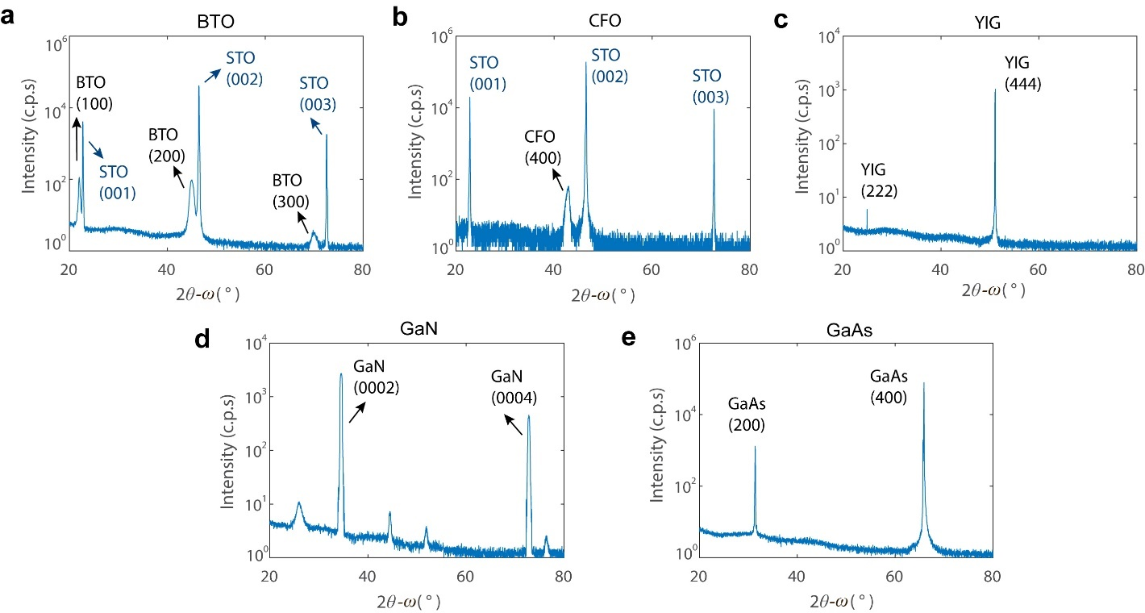

Figure S8. Additional 2θ-ω-scan XRD data for grown samples of (a) BTO, (b) CFO, (c) YIG, (d) GaN, and (e) GaAs nanomembranes.
For electro-optical (EO) material BTO, it has tetragonal crystal unit cells belonging to the 4$mm$ point group under room temperature^{31,32}. It has a longer crystallographic $c$-axis and two identical shorter axes $a = b<c$. The orientation of the $c$-axis is crucial for the Pockels response and EO applications of BTO³²⁻³⁷ (discussed in Supplementary Note S7). Besides the $a$-axis-domain BTO (i.e. the crystallographic $c$-axis of BTO is parallel to the film plane) shown in Figs. 1h and 1i (main text) for on-chip EO modulations, by altering the growth condition, $c$-axis-domain BTO (i.e. the crystallographic $c$-axis of BTO is perpendicular to the film plane) can be realized as well. Details are discussed later in Supplementary Note S4. The EBSD map and corresponding Kikuchi pattern of a 60 nm-thick $c$-axis-domain BTO are shown in Figs. S9a and S9b respectively. The EBSD polar maps of different hybrid-domain BTO samples are given as Figs. S9c and S9d.
The experimentally measured permittivity of this (001) BTO nanomembrane is shown as Fig. S9e by constructing a vertical capacitor structure, showing signature butterfly-shaped ferromagnetic loop. We note that the exact shape of this hysteresis loop depends on the crystallographic orientation of BTO: for $a$-axis-domain BTO the vertical ferroelectric hysteresis loops are found to be comparatively much smaller or vanishing³⁸, as in this case the applied voltage is perpendicular to the spontaneous polarizations impacted by BTO’s crystallographic $c$-axis orientation.
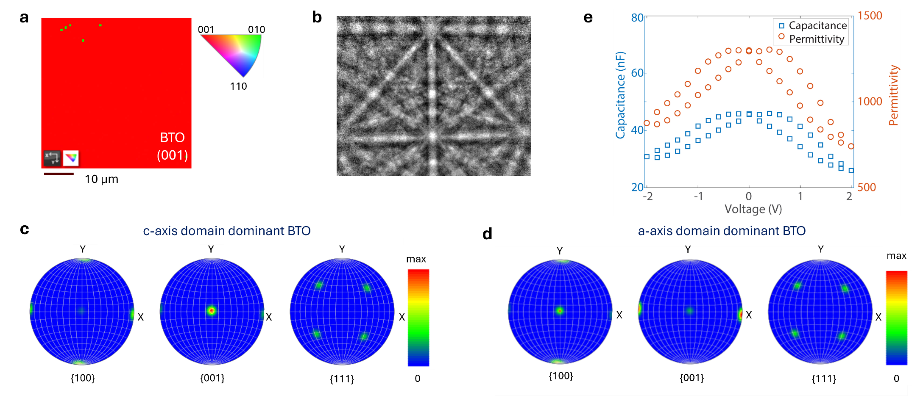

Figure S9. (a) EBSD map of $c$-axis-domain BTO. (b) Corresponding Kikuchi pattern. (c) Experimentally measured capacitance and permittivity data using a vertical capacitor structure for a $c$-axis-domain (001) BTO. (c) and (d) EBSD polar maps for hybrid-domain BTO cases: with $c$-axis-domain dominance (c), or $a$-axis-domain dominance (d).

S3. Artificial 3D heterostructures of GaAs/BTO/GaN/STO
Photonic vdW integration offers a powerful platform for heterogeneous integration²⁵, enabling the combination of disparate, high-quality optical materials onto arbitrary photonic templates for developing advanced optoelectronic devices. This unique strategy enables the creation of exotic heterogeneous photonic configurations with single-crystalline functional layers of unparalleled performance but with drastically mismatched crystal structures, which are hardly accessible via direct heteroepitaxial approaches.
To embody this concept, Figs. S10a and S10b illustrate the vertical stack and lateral stitch, respectively, of freestanding GaAs, BTO, GaN, and STO films atop SiO₂ substrate via photonic vdW integration, further extending the prior concepts of vdW heterostructures^{39,40} into 3D thin-films-based materials²⁵. Specifically, all these functional nanomembranes are prepared in optimal single-crystallinity, despite with distinct lattice constants (Fig. 10c). The energy-dispersive X-ray spectroscopy (EDS) of the GaAs/BTO/GaN/STO artificial heterostructure stacked on SiO₂ substrate is shown in Fig. 10d: in the first panel, GaAs, BTO, GaN, and STO are colored as yellow, green, red, and blue, respectively. A versatile platform is thus created for advancing nanomembranes technology^{18,41-43}, studying physical coupling^{2,44,45}, and prototyping exotic heterogeneous integrated photonic applications^{15,25,46-48}.
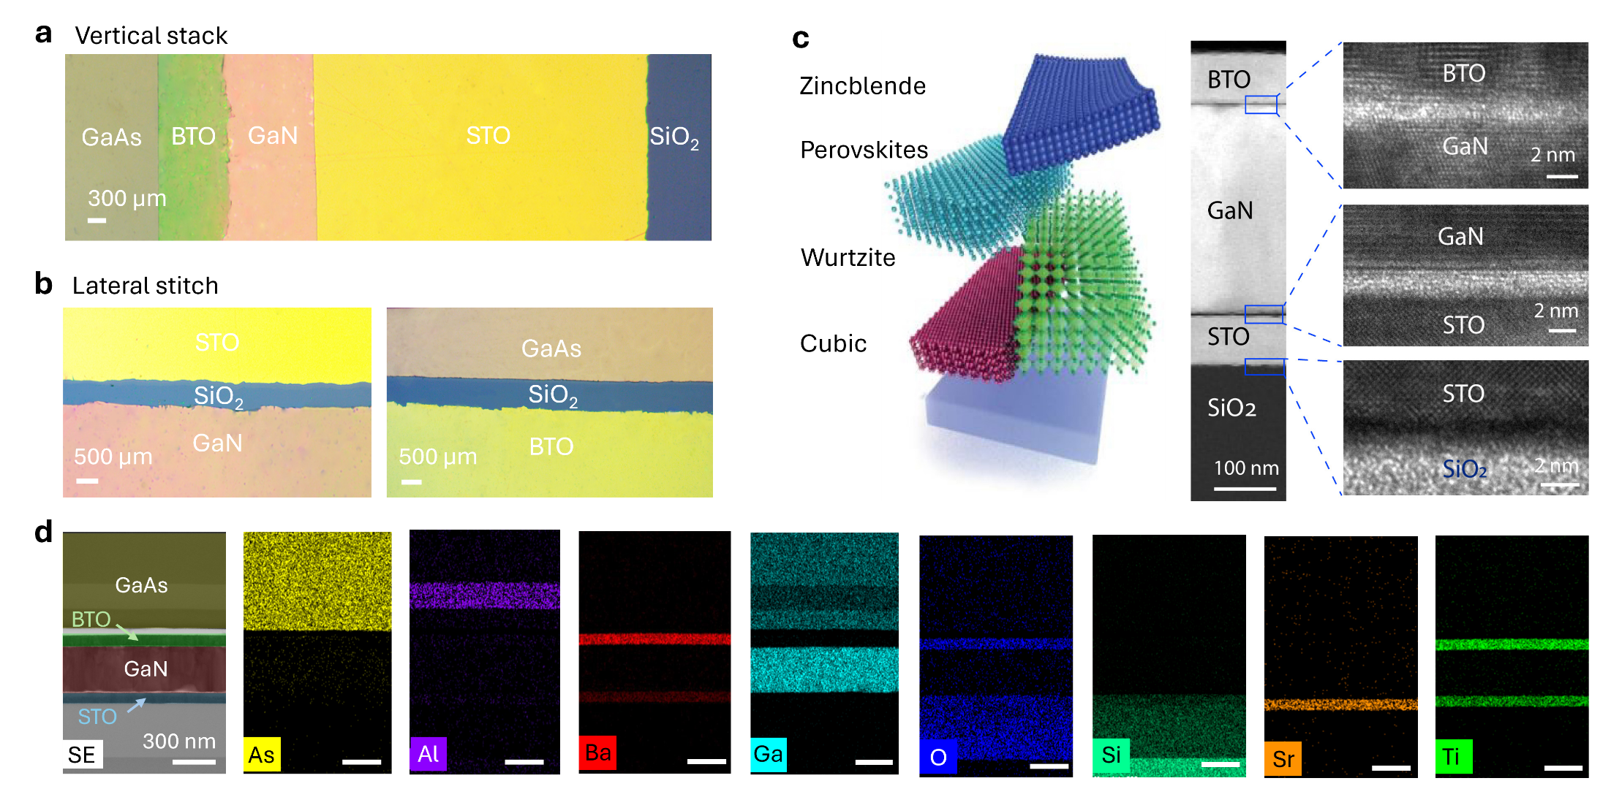

Figure S10. vdW integration of distinct single-crystalline freestanding nanomembranes. (a) and (b) vdW integration modes: Optical microscope photos of vertical stacking (a) and lateral stitching (b) of 3D nanomembranes. (c) Artificial 3D heterostructures constructed by vdW integrating STO, GaN, BTO to SiO₂ substrate, where all the stacked 3D layers are single-crystalline as verified by HR-TEM. (d) EDS data of a GaAs/BTO/GaN/STO heterostructure atop SiO₂ substrate. SE: second electron.

S4. BTO crystallographic axis orientation control
For tetragonal BTO nanomembranes, the orientation of the crystallographic $c$-axis can be controlled by altering growth conditions, which largely impacts BTO’s in-plane Pockels response^{33,35,49}. Besides the ultrathin MgO layer deposited between SAO and BTO layers to promote tensile BTO epitaxial strain relaxation^{34,38} (Methods), the growth temperature, annealing, and cooling rates also play vital role. Figure S11 (a) shows the 2θ-ω-scan XRD details of different hybrid-domain BTO nanomembranes transferred to silicon-on-insulator (SOI) substrates during growth condition optimization.
For a brief empirical summary, at lower growth temperatures (around 700~ 800 °C) without film annealing, the grown BTO samples tend to be $c$-axis-domain dominant. This can be tested by the reciprocal space mapping (RSM) measurements (discussed in Supplementary Note 8), or the peak positions in the 2θ-ω-scan XRD^{35,49}. Given the BTO crystal axes $a=b<c$, for $c$-axis-domain BTO, the longer BTO crystallographic $c$-axis is perpendicular to film plane³¹, thus leading to smaller BTO (002) XRD peak angle than $a$-axis-domain (200) or (020) BTO³⁵, where the longer BTO $c$-axis is parallel to film plane. An example of $c$-axis-domain dominant BTO is shown for the top panel of Fig. S11a, while the XRD of $a$-axis-domain dominant BTO is shown at the bottom panel of Fig. S11a. In Figs. 1h and 2c (main text), excellent phase pure $a$-axis-domain BTO is observed, with clean (200) or (020) BTO XRD peaks. For the case of hybrid domain BTO (Fig. S11b), a split in the BTO XRD peak takes place (Fig. S11c) around 45°. In contrast to the clean φ-scan XRD shown in Fig. 1h, split XRD peaks will be observed for hybrid-domain BTO (Fig. S11d). When growing at elevated temperatures (800~850 °C) with post-growth annealing (detailed in Methods), $a$-axis-domain dominant BTO can be achieved⁵⁰. Nevertheless, in this work post-growth annealing (excluding the slow cooling time) was performed no longer than 4 hours, given that under high O₂ pressure and high temperature environments, the SAO interlayer can be degraded²⁰. More detailed research can be also performed on the SAO sacrificial layer in future, such as the tetragonal-phased Sr₄Al₂O₇ for promoted BTO epitaxy with tunable lattice constants¹⁹, which has, however, passed beyond the scope of this paper. We have also experimentally found that the XRD and RSM measurements are the more reliable and precise tools to evaluate the $c$-axis orientation of BTO if compared to EBSD, as the Kikuchi patterns (such as the one in Fig. S9b) between different BTO domains can be very approaching³¹. For hybrid-domain BTO nanomembranes, the EBSD maps of the representative $c$-axis-domain dominant and $a$-axis-domain dominant BTO samples are shown as Fig. S11f and S11g respectively for reference.
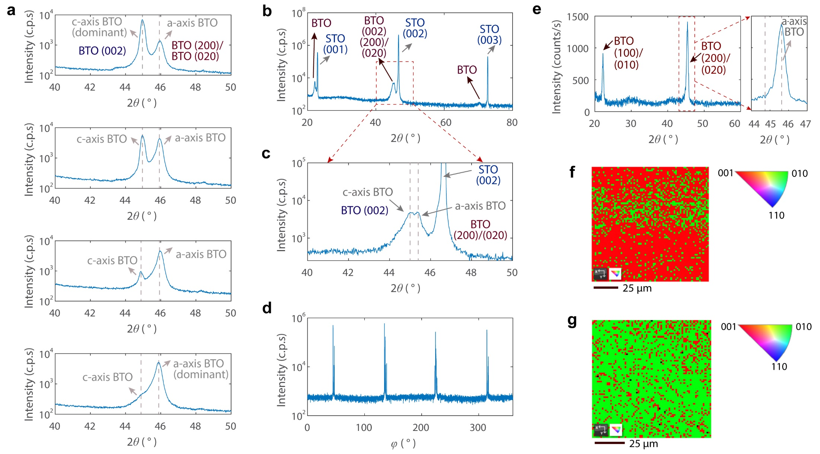

Figure S11. (a) 2θ-ω-scan XRD of hybrid-domain BTO nanomembranes transferred to SOI substrates. By altering growth conditions, the resultant BTO samples migrate from $c$-axis-domain dominant to $a$-axis-domain dominant BTO. (b) and (c) 2θ-ω-scan XRD (b) and the zoom in (c) of an as-grown BTO/SAO/STO sample with hybrid $c$-axis orientation. (d) Corresponding φ-scan XRD of the BTO sample shown in (b). (e) 2θ-ω-scan XRD of freestanding $a$-axis-domain BTO resting on PDMS, showing narrow BTO (200) or (020) peak. (f) and (g) EBSD maps of BTO samples with hybrid $c$-axis-orientations for $c$-axis-domain dominant (f) and $a$-axis-domain dominant (g) cases.

S5. Comparisons of ELO and 2DLT
We adopt 2DLT and ELO for the heterogeneous integration of freestanding nanomembranes due to their eminent advantages in fast layer transfer¹¹, precise film thickness control^{6,7}, scalable cost reduction^{9,25}, and high robustness² (Fig. S12). For other approaches also permitting the single-crystallinity quality of the hetero-integrated layer, wafer bonding has showcased fruitful results recently^{48,51-54}. Nevertheless, sophisticated and lengthy substrate grinding, etching, and polishing procedures are required^{35,55}. For mechanical spalling, despite that it can inherit the single-crystallinity from the bulk crystal (given that effective BTO ion slicing is still elusive so far), current demonstrations exhibit highly un-uniform spalled BTO films with vastly compromised film morphology and yield with uncontrollable spalled film thickness⁵⁶.
In addition, both 2DLT and ELO enable the recycling of costly substrates^{3,11} (discussed in Supplementary Note 26), which contributes significantly to the manufacturing cost of functional materials (such as group III-V semiconductors and complex oxides like STO, BTO, YIG): Only the top thin films are used for devices, while the expensive bulk substrates primarily only provide mechanical support. The recycled substrates can thus furnish multiple rounds of nanomembranes epitaxy and exfoliation after simple cleaning procedures^{7,11,12} towards cost reduction.
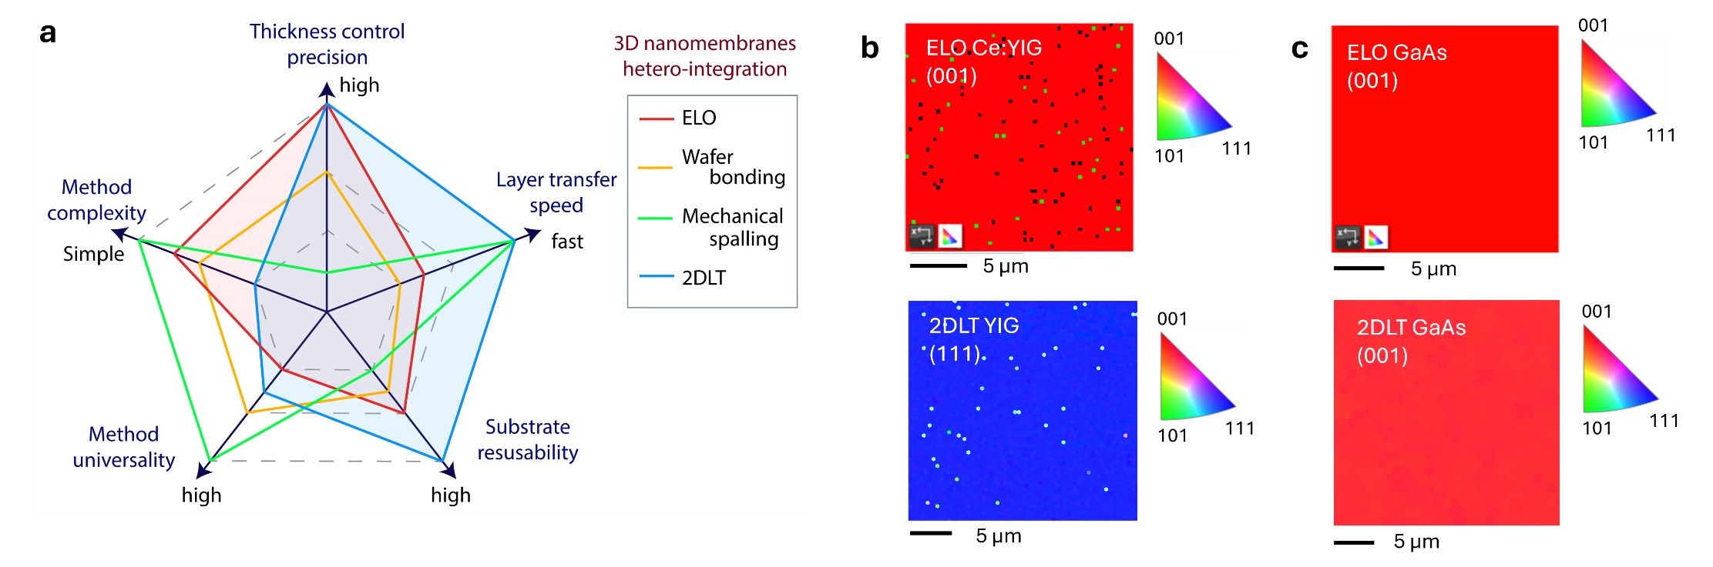

Figure S12. (a) Comparisons of different heterogeneous photonic integration approaches. The ELO and 2DLT methods used in this work are shaded in red and blue colors respectively. (b) and (c) EBSD maps of the resultant YIG (b) and GaAs (c) nanomembranes under different growth approaches.
For experimental complexity, 2DLT has stringent requirements on 2D-covered substrate to ensure high-quality remote epitaxy and efficient layer release^{3,14,17}. For ELO nanomembranes, simpler substrate preparation and epitaxy optimizations are involved. However, the judiciously selection sacrificial layers are mandatory^{19,20,57,58}, limiting the method universality¹⁰ of ELO compared to 2DLT³. For example, despite domain-epitaxy performed^{28,59,60}, 2DLT YIG showed better XRD (Fig. S13) than domain-epitaxial Ce: YIG (see Methods) with cleaner and stronger peaks. Nevertheless, the layer lift-off of 2DLT YIG is found to be more challenging than ELO Ce: YIG, due to the very stringent requirements on 2D interlayer quality and meticulous epitaxy optimizations^{2,14}. Figure S12b shows the EBSD maps of ELO Ce: YIG and 2DLT YIG, where the crystal orientation is primarily determined by the crystalline registry of the substrates used (Methods). For group III-V semiconductors (Fig. S12c), both approaches can provide scalable and robust single-crystalline nanomembranes after careful optimizations discussed in our previous works^{6,11,13,45}. In brief conclusion, both EBL and 2DLT can offer single-crystalline freestanding nanomembranes after careful optimizations, while 2DLT can become a more competitive option at the cost of increased method complexity, when lacking appropriate sacrificial material to facilitate ELO.
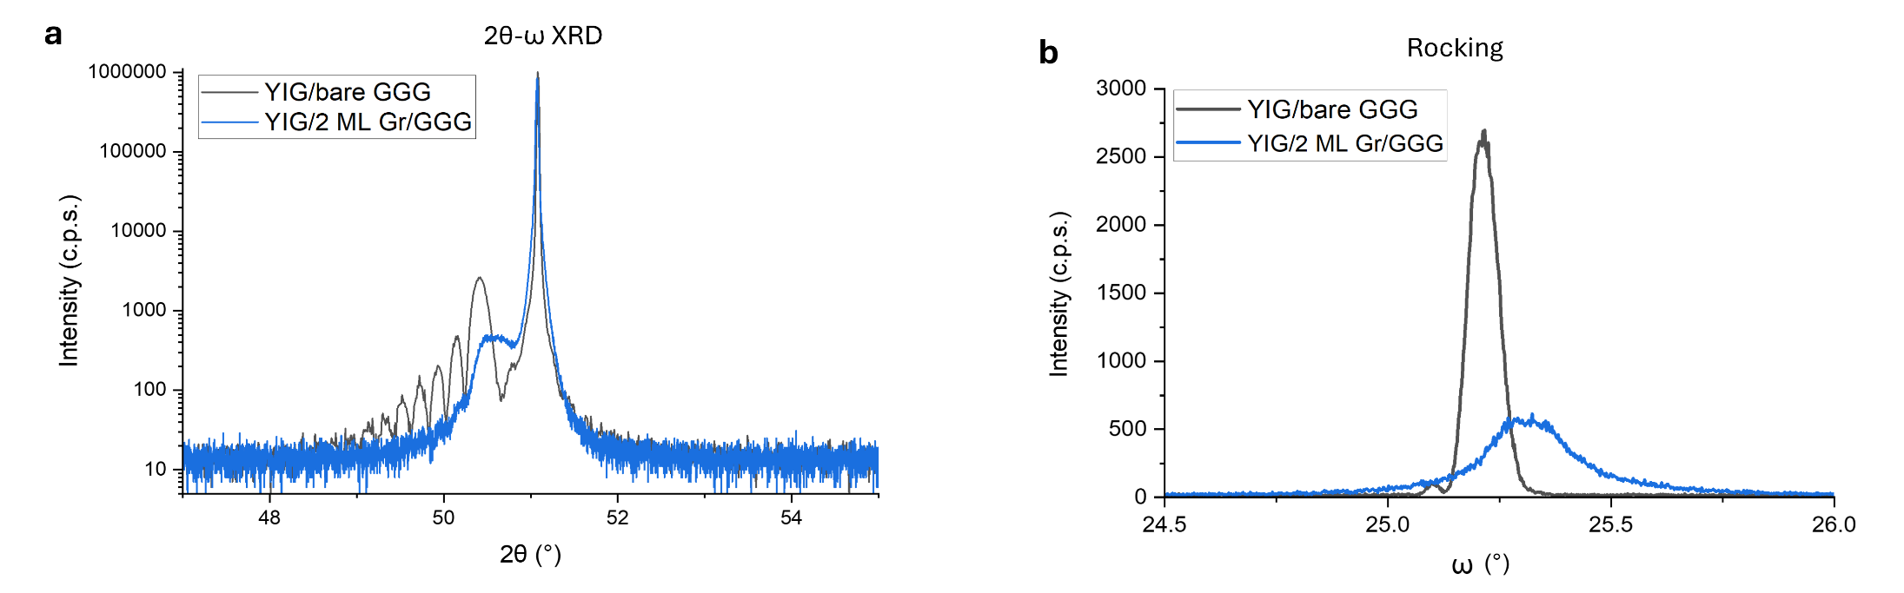

Figure S13. Supplementary 2θ-ω-scan (a) and rocking (b) XRD measurements for 2DLT YIG atop of two monolayer graphene (2ML Gr)-covered GGG (Gd₃Ga₅O₁₂) substrates.

S6. BTO effective Pockels coefficient estimation details
As discussed in Methods, linear electro-optical (EO) effect (namely Pockels effect) can be formulated by a scalar equation³³ to describe refractive index change of the EO material $∆n_{BTO}$ as
$∆n_{BTO}=-\frac{1}{2}n_{(0)}^{3}r_{eff}E_{EF}$, (S6-1)
where $n_{(0)}$ is the unperturbed refractive index of the EO material³⁷, $r_{eff}$ is the effective Pockels coefficient. The applied electric field can be estimated by $E_{EF}=\frac{V}{g}$, where $V$ is the applied voltage and $g$ is the gap between electrodes.
We have the relation^{49,61} between $∆n_{BTO}$ and the mode refractive index change as $∆n_{eff}=∆n_{BTO}∙Γ$, where $Γ=\frac{\int_{EO }{\frac{1}{2}}R(E×H^{*})∙\hat{x}dS}{\int_{All }{\frac{1}{2}}R(E×H^{*})∙\hat{x}dS}$ is the overlap between the optical mode and the EO film. Given the modulated phase at one MZI arm is $Φ=\frac{2πL}{λ}∆n_{eff}$, where $L$ is the length of the MZI arm, at half-wave voltage $V_{π}$ we have $Φ_{π}=-π=\frac{2πLΓ}{λ}∆n_{BTO}=-\frac{πV_{π}LΓ}{λg}n_{(0)}^{3}r_{eff}$.
Therefore, we can roughly estimate the effective Pockels coefficient as below.
$r_{eff}=\frac{λg}{n_{(0)}^{3}ΓV_{π}L}$ (S6-2)
Based on Eq. (S6-2), BTO $r_{eff}$ is estimated based on experimentally measured data $V_{π}L$, numerically simulated $Γ$ via actual device structure parameters, and literature $n_{(0)}$ values.
(1) For a conservative estimation, taking BTO $n_{(0)}=$ 2.27 (Ref.^{35,61}):
(a) For low-frequency BTO-Si Mach Zehnder modulator (MZM): Si waveguide dimension: 1 µm × 120 nm, BTO thickness: 100 nm, Au electrodes (100 nm) directly deposited on BTO. COMSOL calculated field overlap $Γ≈$19.5%. For experimental $V_{π}=0.65$ V, $L$ ~ 0.45 cm (measured at 1 kHz frequency), electrodes gap $g=4$ µm, at wavelength $λ=1.55$ µm, we have estimated $r_{eff}≈$ 928 pm/V.
Given that when performing vdW integration of BTO nanomembranes, the rotation angle between BTO (100) axes and the waveguide are set as $θ\sim 45°$, the effective Pockels coefficient is thus taken as (detailed in Supplementary Note 7) below.
$r_{eff}=\frac{\sqrt{2}}{4}\left(2r_{42}+r_{33}+r_{13}\right)$ (S6-3)
Assuming Pockels tensor elements as $r_{33}=$ 100 pm/V, $r_{13}=$ 10 pm/V (same assumption applied henceforth to all estimations in Supplementary Note 6), this $r_{eff}$ corresponds to a Pockels tensor component $r_{42}$ ~1250 pm/V. Currently applied values of $r_{33}$ and $r_{13}$ can be overestimated, while lower $r_{33}$ and $r_{13}$ values taken will lead to further bigger $r_{eff}$ than current estimation (see Supplementary Note 12).
(b) For high-frequency BTO-Si MZM, Si waveguide dimension: 1.5 µm × 150 nm, BTO thickness: 45 nm, Au electrodes thickness ~500 nm, 250 nm-thick PECVD SiO₂ layer between BTO and electrodes (see Fig. S17 for details), COMSOL calculated field overlap $Γ≈8.50$%.
For experimental $V_{π}=14.4$ V, $L\sim$ 0.1 cm (measured at 2 MHz frequency), electrodes gap $g=8$ µm, at wavelength $λ=1.55$ µm, we have estimated $r_{eff}≈$ 867 pm/V, corresponding to $r_{42}$ ~1160 pm/V.

(2) For a less conservative estimation, taking $n_{(0)}=$ 2.26 (Ref.³⁷):
(a) For low-frequency BTO-Si MZM, calculated $Γ≈$ 19.3%. Updating $n_{(0)}$, we have an estimated $r_{eff}≈$ 950 pm/V, corresponding to $r_{42}$ ~1290 pm/V.
(b) For high-frequency BTO-Si MZM, calculated $Γ≈$ 8.47%. Updated estimation $r_{eff}≈$ 880 pm/V, corresponding to $r_{42}$ ~1190 pm/V.

S7. Multi-domain BTO $r_{eff}$ Derivation
At crystal principal axes coordinates, we have the impermeability tensor as $η(0)=diag\left(η_{1}, η_{2},η_{3}\right)=diag(\frac{1}{n_{1}^{2}},\frac{1}{n_{2}^{2}},\frac{1}{n_{3}^{2}})$, where $n_{1},n_{2},n_{3}$ are the corresponding refractive indices and the semi-axes lengths of the (un-rotated) index ellipsoid³². Under external electric field ($E_{RF}$), the EO material’s impermeability tensor will be impacted and changed into $η\left(E_{RF}\right)=η\left(0\right)+∆η\left(E_{RF}\right)$. The perturbed impermeability tensor $η\left(E_{RF}\right)$ will still be a 3 × 3 symmetric and positive definite matrix (with matrix elements written as $η_{ij}$), corresponding to a rotated and semi-axes-changed ellipsoid.
$η_{11}x^{2}+η_{22}y^{2}+η_{33}z^{2}+2η_{12}xy+2η_{23}yz+2η_{31}zx=1$ (S7-1)
Below the Curie temperature (~120 °C), BTO is in tetragonal phase with the point group of $4mm$ possessing linear EO (Pockels) effect (with crystallographic axes $a =b<c$). Under the Voigt notation we have the EO material’s impermeability change written as^{33,62}
$\left[\begin{matrix}\begin{matrix}∆η_{1} \\ ∆η_{2} \\ ∆η_{3}\end{matrix} \\ \begin{matrix}∆η_{4} \\ ∆η_{5} \\ ∆η_{6}\end{matrix}\end{matrix}\right]=\left[\begin{matrix}\begin{matrix}∆η_{11} \\ ∆η_{22} \\ ∆η_{33}\end{matrix} \\ \begin{matrix}∆η_{23} \\ ∆η_{31} \\ ∆η_{12}\end{matrix}\end{matrix}\right]=\left[\begin{matrix}\begin{matrix}η_{11}\left(E_{RF}\right)-\frac{1}{n_{1}^{2}} \\ η_{22}\left(E_{RF}\right)-\frac{1}{n_{2}^{2}} \\ η_{33}\left(E_{RF}\right)-\frac{1}{n_{3}^{2}}\end{matrix} \\ \begin{matrix}η_{23}\left(E_{RF}\right) \\ η_{31}\left(E_{RF}\right) \\ η_{12}\left(E_{RF}\right)\end{matrix}\end{matrix}\right]=r_{BTO}∙E_{RF}=\left[\begin{matrix}\begin{matrix}\begin{matrix}0 \\ 0 \\ 0\end{matrix} \\ \begin{matrix}0 \\ r_{51} \\ 0\end{matrix}\end{matrix} & \begin{matrix}\begin{matrix}0 \\ 0 \\ 0\end{matrix} \\ \begin{matrix}r_{42} \\ 0 \\ 0\end{matrix}\end{matrix} & \begin{matrix}\begin{matrix}r_{13} \\ r_{23} \\ r_{33}\end{matrix} \\ \begin{matrix}0 \\ 0 \\ 0\end{matrix}\end{matrix}\end{matrix}\right]\left[\begin{matrix}E_{x}^{RF} \\ E_{y}^{RF} \\ E_{z}^{RF}\end{matrix}\right]$ (S7-2)
where $r_{BTO}$ is the Pockels tensor of BTO (with its elements written as $r_{ij}$), and we have its elements $r_{23}=r_{13}$ and $r_{51}=r_{42}$ due to symmetry constraints. The EO modulation and Pockels effect is thus not only dependent on the applied electric field $E_{RF}$, but also on the light polarization direction and the crystal orientation of the BTO material. The optical indicatrix change $∆η_{i}=∆{\left(\frac{1}{n^{2}}\right)}_{i}=\sum_{j=1}^{3}{r_{ij}E_{j}^{RF}}$, where $E_{RF}={\left[E_{1}^{RF}, E_{2}^{RF},E_{3}^{RF}\right]}^{T}={\left[E_{x}^{RF}, E_{y}^{RF},E_{z}^{RF}\right]}^{T}$.
The Pockels coefficient matrix $r_{BTO}$ above has assumed that the $z$ axis parallel to the crystallographic $c$-axis of BTO. If the c-axis of BTO is rotated, the explicit expression of $r_{BTO}$ will be modified. Set $R$ as a 3 × 3 rotation matrix, and $B(R)$ as the corresponding (6 × 6) Mandel-Voigt rotation matrix^{32,33} that rotates second-rank symmetric tensors in Voigt notation (equivalently rotates the original 3rd-rank Pockels elements $r_{i,j,k}$ with minor symmetry $j↔k$ and then re-contract). The rotated Pockels matrix ${r_{BTO}}^{(Q)}$ will be ${r_{BTO}}^{(Q)}=B(R)r_{BTO}R^{T}$. For example, when BTO c-axis is in plane and parallel to lab axis $x$, we have its Pockels tensor ${r_{BTO}}^{(x∥c)}$ (with symmetrical constraints implemented) as below.
${r_{BTO}}^{(x∥c)}=\left[\begin{matrix}\begin{matrix}\begin{matrix}r_{33} \\ r_{13} \\ r_{13}\end{matrix} \\ \begin{matrix}0 \\ 0 \\ 0\end{matrix}\end{matrix} & \begin{matrix}\begin{matrix}0 \\ 0 \\ 0\end{matrix} \\ \begin{matrix}0 \\ 0 \\ r_{42}\end{matrix}\end{matrix} & \begin{matrix}\begin{matrix}0 \\ 0 \\ 0\end{matrix} \\ \begin{matrix}0 \\ r_{42} \\ 0\end{matrix}\end{matrix}\end{matrix}\right]$ (S7-3)
Now consider the following coordinates: under principal axes coordinates $(x’, y’, z’)$, BTO $c$-axis is parallel to $z'$ axis, the other two crystallographic axes $(a=b)$ are parallel to $x'$ and $y'$ axes respectively. Set the lab coordinates as $(x, y, z)$, considering only the $c$-axis in-plane BTO case, assume the angle between BTO $c$-axis $(\hat{x}')$ and $x$-axis ($\hat{x}$) as $θ=acos⁡(\hat{x}'∙\hat{x})$. The dominant light polarization $E_{opt}$ (for TE₀₀ mode) and applied electric field $E_{RF}$ are both parallel to $x$ axis.
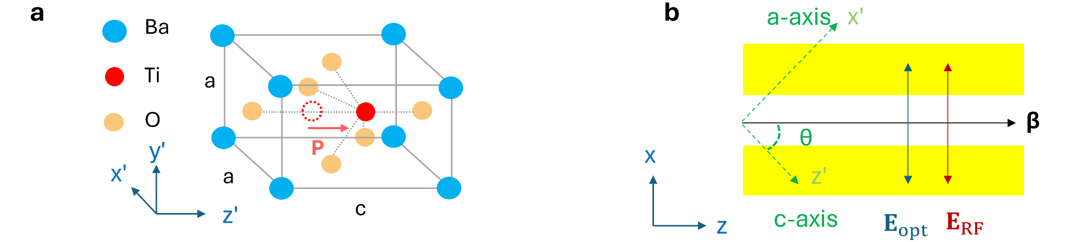

Figure S14. (a) Crystallographic structure of BTO and the principal coordinates. (b) Device lab coordinates and the orientations of vectors. $θ$: rotation angle between BTO $c$-axis ($z’$ axis) and $z$ axis. $β$: optical mode propagation constant, showing light propagation and waveguide direction.
(1) BTO crystal axis un-rotated
When $θ=0$, the crystallographic coordinates overlap with lab coordinates ($a∥x$, $b∥y$, $c∥z$), applying $E_{RF}={\left[E_{x}^{RF}, 0, 0\right]}^{T}$ and light propagation direction $β∥z$, only the $i=5$ (i.e. $xz$) row contributes to impermeability change $∆η=r_{BTO}∙E_{RF}$ in Eq. (S7-1).
$∆η_{xz}=∆η_{zx}=r_{51}E_{x}^{RF}$, $∆η_{ij}=0$ otherwise. (S7-4)
Set BTO ordinary and extraordinary light refractive indices as $n_{o}$ and $n_{e}$ respectively, we have BTO unperturbed impermeability tensor (in principal axes) $η\left(0\right)=diag\left(η_{o}, η_{o},η_{e}\right)=diag\left(\frac{1}{ ε_{o}}, \frac{1}{ ε_{o}},\frac{1}{ ε_{e}}\right)=diag(\frac{1}{n_{o}^{2}},\frac{1}{n_{o}^{2}},\frac{1}{n_{e}^{2}})$, the index-ellipsoid (optic indicatrix) from Eq. (S7-1) becomes
$η_{o}x^{2}+η_{o}y^{2}+η_{e}z^{2}+2r_{51}zx=1$. (S7-5)
We have the explicit Impermeability tensor as $η\left(E_{RF}\right)=η(E_{x}^{RF})$ as
$η\left(E_{x}^{RF}\right)=\left[\begin{matrix}η_{o} & 0 & r_{51}E_{x}^{RF} \\ 0 & η_{o} & 0 \\ r_{51}E_{x}^{RF} & 0 & η_{e}\end{matrix}\right]$. (S7-6)
The relative permittivity tensor $ϵ=η^{-1}$ can be also explicitly calculated as below.
$ϵ\left(E_{x}^{RF}\right)=\left[\begin{matrix}\frac{ε_{o}}{1-ε_{o}ε_{e}Δ^{2}} & 0 & -\frac{ε_{o}ε_{e}Δ}{1-ε_{o}ε_{e}Δ^{2}} \\ 0 & ε_{o} & 0 \\ -\frac{ε_{o}ε_{e}Δ}{1-ε_{o}ε_{e}Δ^{2}} & 0 & \frac{ε_{e}}{1-ε_{o}ε_{e}Δ^{2}}\end{matrix}\right]$, with $Δ≡r_{51}E_{x}^{RF}$ (S7-7)
When $Δ$ is very small, the permittivity tensor can be simplified as first-order small signal form (for BTO $r_{51}=r_{42}$):
$ϵ\left(E_{x}^{RF}\right)\sim$ $\left[\begin{matrix}ε_{o} & 0 & -ε_{o}ε_{e}r_{51}E_{x}^{RF} \\ 0 & ε_{o} & 0 \\ -ε_{o}ε_{e}r_{51}E_{x}^{RF} & 0 & ε_{e}\end{matrix}\right]$ (S7-8)
(2) BTO crystal axis rotated
When $θ≠0$, set the rotation matrix $R(θ)$ (from crystal coordinates to lab coordinates) about $y$ axis by $θ$:
$R\left(θ\right)=\left[\begin{matrix}cosθ & 0 & sinθ \\ 0 & 1 & 0 \\ -sinθ & 0 & cosθ\end{matrix}\right]$ (S7-9)
We have ${\left[x, y,z\right]}^{T}={R\left(θ\right)}^{T}{\left[x', y',z'\right]}^{T}$, and applied electric field in crystal axes ${E_{RF}}^{(c)}={R\left(θ\right)}^{T}{\left[E_{x}^{RF}, 0, 0\right]}^{T}={\left[E_{x}^{RF}cosθ, 0, E_{x}^{RF}sinθ\right]}^{T}$. The change of impermeability in crystal axes $∆η^{(c)}\left(E_{x}^{RF}\right)$ can thus be given by:
$∆η^{(c)}\left(E_{x}^{RF}\right)=\left[\begin{matrix}r_{13}E_{x}^{RF}sinθ & 0 & r_{51}E_{x}^{RF}cosθ \\ 0 & r_{13}E_{x}^{RF}sinθ & 0 \\ r_{51}E_{x}^{RF}cosθ & 0 & r_{33}E_{x}^{RF}sinθ\end{matrix}\right]$ (S7-10)
By applying $η^{(c)}\left(E_{x}^{RF}\right)=η\left(0\right)+∆η^{(c)}\left(E_{x}^{RF}\right)$ and the rotation of crystal axes to lab axes $η^{(lab)}\left(E_{x}^{RF}\right)=R\left(θ\right)η^{(c)}\left(E_{x}^{RF}\right){R\left(θ\right)}^{T}$, we have the BTO’s impermeability tensor under lab axis $(x, y, z)$ as $η(θ,E_{x}^{RF})$:
$η\left(θ,E_{x}^{RF}\right)=\left[\begin{matrix}A & 0 & C \\ 0 & B & 0 \\ C & 0 & D\end{matrix}\right]$ (S7-11)
with entries:
$A=\underset{Zero-field}{\underbrace{\left(η_{o}\cos^{2}θ+η_{e}\sin^{2}θ\right)}}+\underset{EO modulation}{\underbrace{E_{x}^{RF}sinθ\left[\left(2r_{51}+r_{13}\right)\cos^{2}θ+r_{33}\sin^{2}θ\right]}}$
$B=\underset{Zero-field}{\underbrace{η_{o}}}+\underset{EO modulation}{\underbrace{E_{x}^{RF}r_{13}sinθ}}$
$C=\underset{Zero-field}{\underbrace{(η_{e}-η_{o})sinθcosθ}}+\underset{EO modulation}{\underbrace{E_{x}^{RF}cosθ\left[r_{51}\left(\cos^{2}θ-\sin^{2}θ\right)+(r_{33}-r_{13})\sin^{2}θ\right]}}$
$D=\underset{Zero-field}{\underbrace{(η_{e}\cos^{2}θ+η_{o}\sin^{2}θ)}}+\underset{EO modulation}{\underbrace{E_{x}^{RF}sinθ\left[\left(r_{33}-2r_{51}\right)\cos^{2}θ+r_{13}\sin^{2}θ\right]}}$.
The relative permittivity tensor $ϵ$ can thus be solved in an analytic expression (with $Ψ≡AD-C^{2}$) as below.
$ϵ\left(θ,E_{x}^{RF}\right)=η^{-1}\left(θ,E_{x}^{RF}\right)=\left[\begin{matrix}\frac{D}{Ψ} & 0 & -\frac{C}{Ψ} \\ 0 & \frac{1}{B} & 0 \\ -\frac{C}{Ψ} & 0 & \frac{A}{Ψ}\end{matrix}\right]$ (S7-12)
The anisotropic refractive index tensor can thus be derived as $n=ϵ^{1/2}$, assuming relative permeability $μ_{r}=1$ for non-magnetic material BTO.
Given that the crystallographic coordinates are rotated by $y$ axis, we have the refractive index component $n_{yy}=1/\sqrt{B}$. Using the identity $\sqrt{M}=\frac{M+\sqrt{det⁡(M)}∙I}{\sqrt{tr\left(M\right)+2det⁡(M)}}$ (where $I$ is the identity matrix) for any given 2 × 2 symmetric positive definite (SPD) matrix $M$ (where $η$ and $ϵ$ are also SPD matrices due to physical constraints), the $x-z$ block of the refractive index tensor $n_{xz}$ (2 × 2) can thus be calculated $n_{xz}=\sqrt{ϵ_{xz}}$, yielding the full anisotropic refractive index tensor $n(θ,E_{x}^{RF})$ at lab coordinates $(x,y,z)$:
$n\left(θ,E_{x}^{RF}\right)=\left[\begin{matrix}\frac{D/\sqrt{Ψ}+1}{\sqrt{A+D+2\sqrt{Ψ}}} & 0 & -\frac{C/\sqrt{Ψ}}{\sqrt{A+D+2\sqrt{Ψ}}} \\ 0 & \frac{1}{\sqrt{B}} & 0 \\ -\frac{C/\sqrt{Ψ}}{\sqrt{A+D+2\sqrt{Ψ}}} & 0 & \frac{A/\sqrt{Ψ}+1}{\sqrt{A+D+2\sqrt{Ψ}}}\end{matrix}\right]$ (S7-13)
The above Eqs. (S7-11) ~ (S7-13) can be implemented into commercial numerical simulation tools such as Lumerical FDTD Solutions or COMSOL Multiphysics for full Pockels electromagnetic simulations (input Pockels components $r_{13}, r_{33}, r_{42}=r_{51}$) for light propagating in single-domain BTO under external electric field (discussed later in Supplementary Note 11).
(3) Multi-domain BTO
Set $θ$ as the angle between waveguide direction and BTO $c$-axis, applying the coordinates transform from crystal axes to lab axes ${\left[x, y,z\right]}^{T}={R\left(θ\right)}^{T}{\left[x', y',z'\right]}^{T}$, the refractive index change at $\hat{x}$ direction can be written from Eqs. (S7-1) and (S7-2) as
$Ax^{2}+…=\left\{\left(η_{o}\cos^{2}θ+η_{e}\sin^{2}θ\right)+E_{x}^{RF}\left[\left(2r_{42}+r_{13}\right)sinθ\cos^{2}θ+r_{33}\sin^{3}θ\right]\right\} x^{2}+…=1$,
(S7-14)
where symmetry relation $r_{51}=r_{42}$ has been applied. Given that in this case both light polarization $E_{opt}$ and applied electric field $E_{RF}={\left[E_{x}^{RF}, 0, 0\right]}^{T}$ are parallel to $y$ axis, the other terms in Eq. (1) except $η_{11}x^{2}$ can be omitted. We thus have the impermeability change as $∆η_{11}=E_{x}^{RF}sinθ\left[\left(2r_{42}+r_{13}\right)\cos^{2}θ+r_{33}\sin^{2}θ\right]$ in lab coordinates. By combining it with the Pockels equation, we have the effective Pockels coefficient for single-domain BTO as
$r_{eff}\left(θ\right)=\left[\left(2r_{42}+r_{13}\right)sinθ\cos^{2}θ+r_{33}\sin^{3}θ\right]$. (S7-15)
For $c$-axis in-plane BTO (i.e. $a$-axis-domain BTO), 4 potential domain orientations exist. Set 𝜑 as the BTO domain orientation (for not poling a-domain/ c-axis parallel to film BTO grown in our case, possible 𝜑 values are 0°, 90°, 180°, 270°) respective to the film edge (100), and $γ_{φ}$ as the portion of the 𝜑 orientated domains (satisfying $\sum_{ φ}{γ_{φ}}=1$), the effective Pockels coefficient of the BTO film is the weighted average of all the possible domains³⁷.
$r_{eff}\left(θ,φ\right)=\sum_{ φ}{γ_{φ}[\sin\left(θ+φ\right)\cos^{2}\left(θ+φ\right)\left(2r_{42}+r_{13}\right)+\sin^{3}\left(θ+φ\right)r_{33}]}$ (S7-16)
After poling (i.e. either $φ∈\left\{0°, 90°\right\}$ or $φ∈\left\{180°, 270°\right\}$) assuming the portion of perpendicularly orientated domains are same, we have $r_{eff}\left(θ\right)=\frac{1}{2}\left[\cos^{2}θ\sin{θ}\left(2r_{42}+r_{13}\right)+\sin^{3}θr_{33}\right]+\frac{1}{2}\left[\cos^{2}\left(θ+\frac{π}{2}\right)\sin\left(θ+\frac{π}{2}\right)\left(2r_{42}+r_{13}\right)+\sin^{3}\left(θ+\frac{π}{2}\right)r_{33}\right]$. Thus, we have
$$r_{eff}\left(θ\right)=\frac{1}{2}\left(2r_{42}+r_{13}\right)\left(\cos^{2}θ\sin{θ}+\sin^{2}θ\cos{θ}\right)+\frac{1}{2}r_{33}\left(\cos^{3}θ+\sin^{3}θ\right)$$$=\frac{\sqrt{2}}{2}\cos\left(θ-\frac{π}{4}​\right)\left[\left(\frac{3}{2}r_{33}-r_{42}-\frac{1}{2}r_{13}\right)+(2r_{42}+r_{13}-r_{33})\cos^{2}(θ-\frac{π}{4})\right]$, (S7-17)
with trigonometric identities transform applied. Therefore, given that $\cos\left(θ-\frac{π}{4}​\right)∈[-1,1]$, thus at $θ=\frac{π}{4}$ , the effective Pockels coefficient reaches its maxim as below^{37,49}.
$r_{eff}=\frac{\sqrt{2}}{4}\left(2r_{42}+r_{33}+r_{13}\right)$. (S7-18)

S8. RSM measurement details
Reciprocal space mapping (RSM) XRD is a powerful tool to quantify the crystallographic orientations of hybrid-domain BTO^{35,50,63,64}. Detailed RSM analyses are performed for as grown BTO/SAO/STO samples (Fig. S15a), the positions of lattice planes are calibrated based on the (103) lattice plane of the STO substrate (Methods). To evaluate the crystal orientation of the freestanding BTO nanomembranes, a think $a$-axis-domain BTO was transferred to fused glass substrate (Fig. S15b), where scaling calibrations were made similarly to Fig. S15a. The original data shown in Fig. S15b was then scaled by a factor around 10, yielding a clearer color visualization of the crystal planes shown in Fig. 2c (main text). For a lattice plane $(h, k,l)$, the reciprocal space lattice units can be calculated as below.
$\left(q_{x},q_{z}\right)=\left(\sqrt{{\left(\frac{k}{a}\right)}^{2}+{\left(\frac{l}{c}\right)}^{2}},\frac{h}{a}\right)$ (S8-1)
Given the lattice parameters for tetragonal BTO as $a=b=3.994$ Å and $c=4.038$ Å, the theoretical positions for single $a$-axis-domain BTO crystal planes (301) and (310) are thus estimated as (2.47, 7.51) and (2.50, 7.51) respectively (in the unit of nm⁻¹). The two approaching intensities of (301) and (310) planes indicate two equivalent domain orientations for $a$-axis BTO domains (with identical proportions)³⁴, where the BTO $c$-axes are parallel to film plane but can have two orientations perpendicular to each other^{35,37,49} (as shown in Fig. S15a inset panel). The theoretical $\left(q_{x},q_{z}\right)$ position for single $c$-axis-domain BTO (103) crystal plane (interchanging the formula of $q_{x}$ and $q_{z}$in Eq. S8-1) is estimated as (2.50, 7.43). From Fig. S15b, a significant (over 2 orders of magnitude) intensity contrast can be observed between (301) or (310) planes and (103) planes, verifying our resultant BTO nanomembranes are pure single-crystalline and $a$-axis-domain dominant, which is crucial to realize giant in-plane Pockels response and on-chip EO applications³⁵.
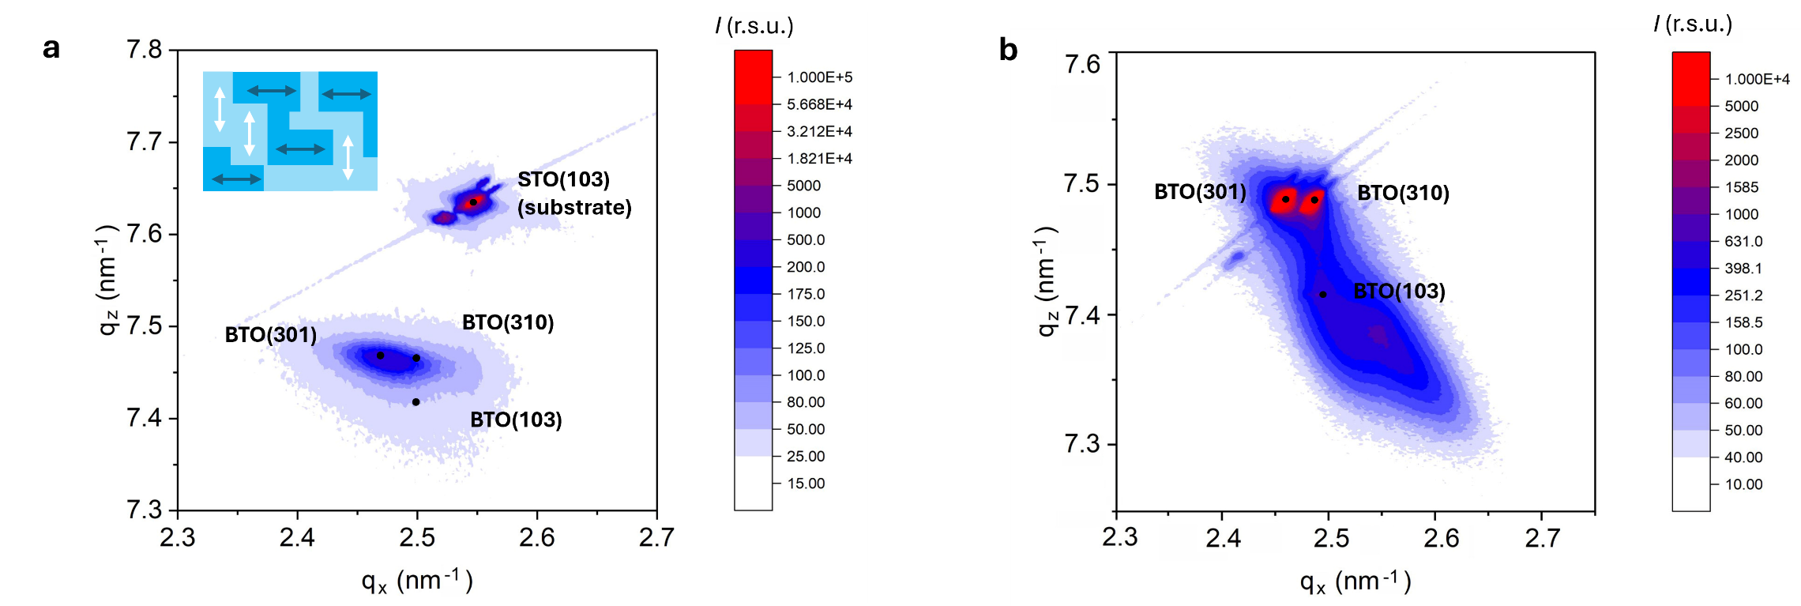

Figure S15. RSM XRD for (a) as grown BTO/SAO/STO sample with an around 80 nm-thick $a$-axis-domain BTO, and (b) RSM for an over 300 nm-thick $a$-axis-domain BTO transferred to amorphous glass substrate. Inset panel: top view schematics of $a$-axis-domain BTO with two possible $c$-axis orientations in multiple ferroelectric domains, where the arrows indicate the direction of spontaneous ferroelectric polarization (parallel to $c$-axis orientation).

S9. Si and SiN photonics fabrication details
The Si and Si₃N₄ (SiN) photonic chips are fabricated at university cleanrooms based on commercial SOI or stoichiometric Si₃N₄-on-insulator (SiNOI) wafers via electron-beam lithography (EBL) and inductively coupled plasma reactive ion etching (ICP-RIE) processes (Methods, Figs. S16a and 16b). Optical measurements (Fig. S16c) and SEM characterizations (Fig. S16d) confirmed the good quality of these lab-fabricated chips, through foundry-based professional photonic chips are expected to further enhance the performance of devices discussed in this work (see Supplementary Note 14). Despite photolithography is more favorable to realize electrodes patterning, aligned EBL was adopted instead primarily due to the practical cleanroom facilities constraints here. To facilitate ideal vdW integration and layer bonding of the freestanding functional nanomembranes, buried electrode structures are applied for certain devices (such as the device in Fig. 4g in main text) to eliminate big height variations of the chip surface. In this case, the area for placing electrodes needs to be patterned and etched together with the waveguides (Figs. S16b, S16e). Therefore, after metal deposition and lift-off, thick electrodes can have the same height as the photonic waveguides to enable good vdW heterogeneous integration. Very thin electrodes are proven feasible for good vdW integration, such as the ones (~30 nm thick Ti/Au) used in SiN photonic chips (Fig. S16f) for III-V nanomembranes vdW integration, with uniform layer bonding (Figs. S6, S7) and high robustness after proper thermal treatments (Supplementary Note 26).
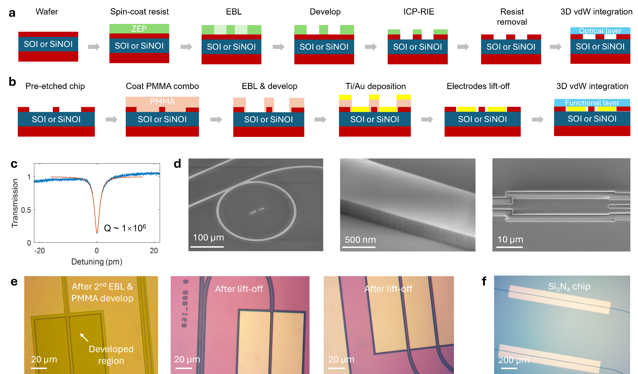

Figure S16. (a) Device fabrication flow of SOI or SiNOI photonic chips. (b) Additional nanofabrication steps when photonic chips with buried electrodes are needed. (c) Normalized optical transmission curve for a SOI microring resonator. (d) SEM images of fabricated SOI and SiNOI photonic structures. (e) Optical micrographs of a SOI chip after aligned EBL and development of thick double-layered PMMA for buried electrodes (left panel), and the fabricated devices after metal lift-off (right panels). (f) Optical micrograph of fabricated SiNOI chip before performing vdW integration.

S10. High-speed BTO MZMs design
The BTO Mach Zehnder modulator (MZM) device structures for Figs. 2h and 2k (main text) are illustrated as Figs. 17a and 17b respectively. To enable high-speed EO applications, travelling wave electrodes design are required^{52,65-67} to simultaneously catch the following goals: (1) matched group velocities⁶⁸ between the high-speed microwave (RF) electrical signal $n_{g}^{RF}$ and optical signal $n_{g}^{Opt}$, (2) about $Z_{0}=50$ Ω device characteristic impedance, and (3) low RF signal propagation loss along the electrodes. Nevertheless, the big relative permittivity of BTO at low frequencies makes it challenging to perfectly match $n_{g}^{RF}$ and $n_{g}^{Opt}$. Therefore, a trade-off emerged when designing BTO-based MZMs.
To best exploit the large in-plane Pockels response of $a$-axis-domain BTO, thicker BTO nanomembranes can be selected for higher overlap between the light field and EO material. Directly depositing electrodes atop BTO layer with narrow gap distance $g$ between the signal (S) and ground (G) electrodes also enable strongest electric field intensity within the BTO material under given bias voltage. However, in this case, the group velocities are largely mismatched between $n_{g}^{RF}$ and $n_{g}^{Opt}$, and the device characteristic impedance $Z_{0}$ is also typically found far away from the 50 Ω target, leading to narrow EO 3 dB bandwidths (benchmarked in Supplementary Note 12) and faltering the requirements for high-speed integrated EO applications.
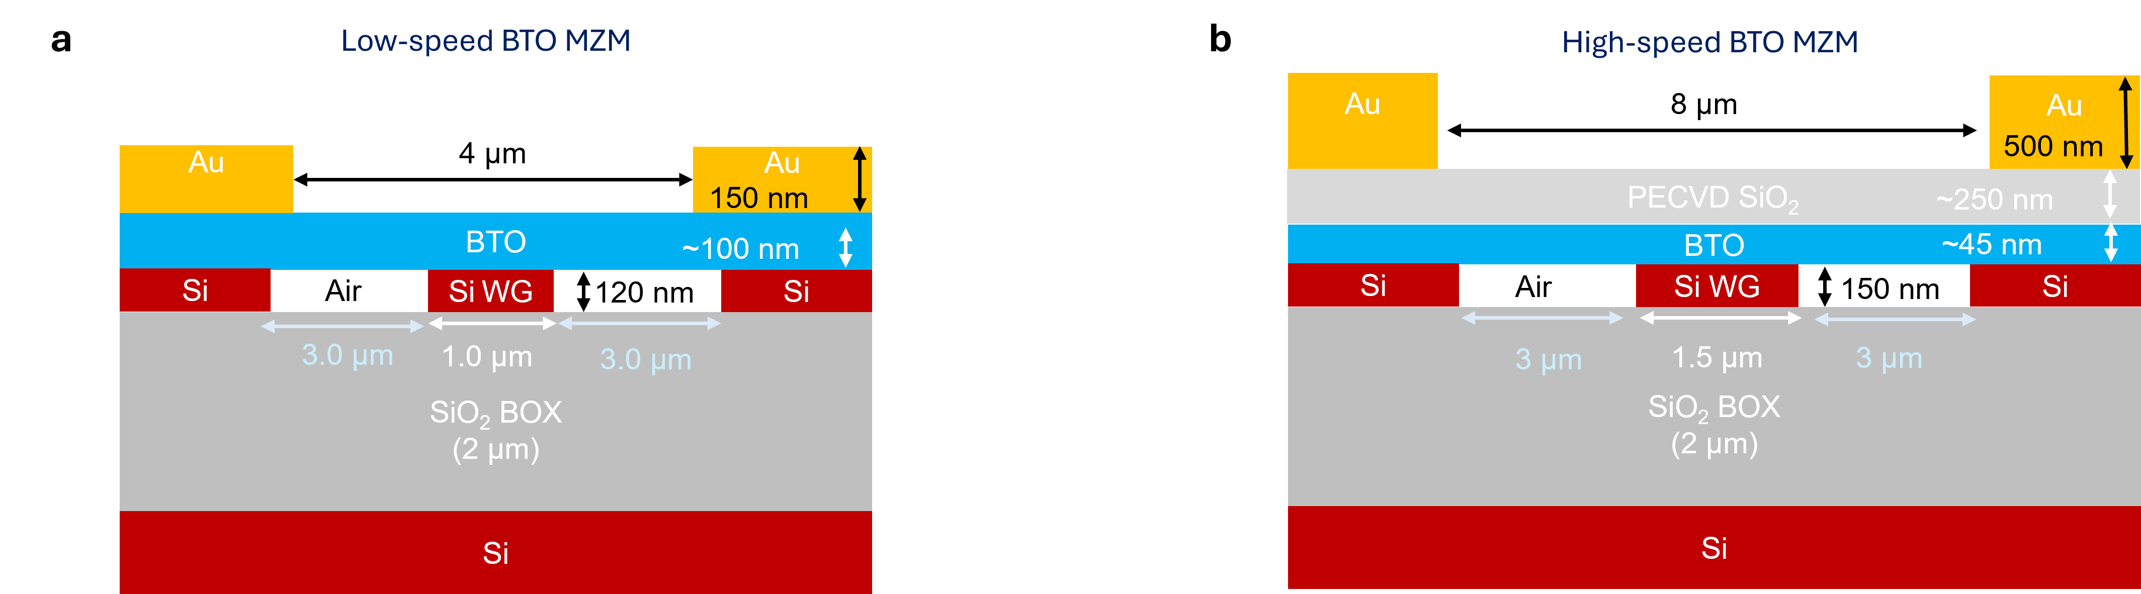

Figure S17. (a) and (b) Device structure schematics for the BTO nanomembranes vdW integrated MZMs shown in Fig. 2h (namely low-speed BTO MZM) and Fig. 2k (namely high-speed BTO MZM) respectively. PECVD: plasma-enhanced chemical vapor deposition. WG: waveguide. BOX: buried oxide.
To further enhance EO bandwidth, we moderately sacrificed device driving voltage ($V_{π}L$) by increasing the gap distance $g$ between the signal (S) and ground (G) electrodes; a SiO₂ layer (with thickness of $t_{SiO2}$) is also inserted between BTO and electrodes, for a better match of $n_{g}^{RF}$ and $n_{g}^{Opt}$, as well as catching the $50$ Ω target of device characteristic impedance $Z_{0}$, at the cost of slightly reduced electric field intensity $E^{RF}$ delivered to BTO layer. Group velocity matching is a non-trivial step due to the large discrepancy between the relative permittivity of BTO at microwave (ε_{RF} ~ 1000, with varying values over frequencies^{35,37}) and optical (ε_{opt}~ 5.2) frequencies. The mismatched group velocities and $Z_{0}$ contribute the major reasons limiting the operation speed of prior BTO-based EO modulators³¹. The simulated (COMSOL Multiphysics) electric field distribution of the high-speed BTO MZM device (with structure illustrated as Fig. S17b) are shown as Fig. S18a. By running parametric sweep optimizations (Fig. S18b, Fig. S18c), the SiO₂ layer thickness is selected as $t_{SiO2}=$250 nm, and the signal electrodes width $w_{s}$ and height $h_{s}$ are chosen as 10 µm and 500 nm respectively. Figures S18d-18e show the simulated microwave (RF) signal loss, device characteristic impedance $Z_{0}$, microwave signal group index $N_{m}$, and device 3 dB bandwidth $S_{21}$, respectively. Thicker electrodes may further reduce RF signal propagation loss, while current electrodes thickness $h_{s}$~500 nm is limited by our university cleanroom facilities. We also note that current performances of these proof-of-concept devices shown in Fig. 2 (main text) are primarily limited by device fabrication with further room of improvement (discussed in Supplementary Note 14).
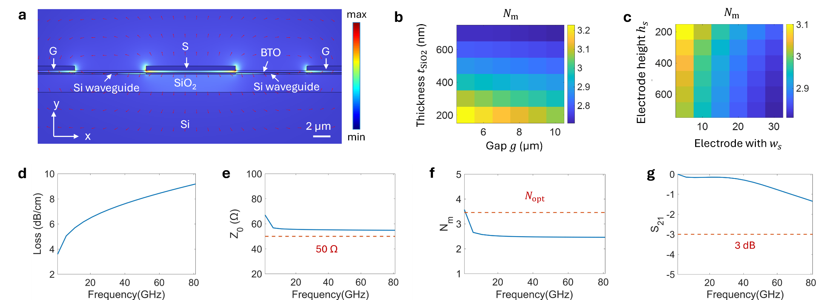

Figure S18. (a) Simulated RF electric field $E^{RF}$ distribution of the BTO MZM cross-section. S: signal electrode. G: ground electrode. $t_{SiO2}$: thickness of PECVD SiO₂ between BTO layer and electrodes (structure shown in Fig. S17b). (b) Simulated microwave group index $N_{m}$ as a function of $t_{SiO2}$ and G-S electrodes gap $g$. (c) Simulated $N_{m}$ as a function of signal electrode width $w_{s}$ and height $h_{s}$. (d)-(g) Simulated microwave loss, characteristic impedance $Z_{0}$, microwave signal group index $N_{m}$, and EO 3 dB bandwidth (scatter parameter $S_{21}$ as the ratio of power) as a function of electrical signal frequency, respectively.

S11. Rigorous BTO Pockels tensor simulations
Electromagnetic finite-element method (FEM) numerical simulations are performed via COMSOL Multiphysics to probe the impact of BTO effective Pockels coefficient $r_{eff}$ on device EO modulation. Real device structure parameters are implemented. Coupled FEM simulations are conducted via the following steps.
Step 1: Static electric field simulation first calculating the applied electric field distribution $E_{RF}(x,y,z)$ via applying bias voltage to signal (S) and ground (G) electrodes.
In this step, BTO is set as constant and isotropic relative permittivity^{35,37} $ε_{RF}=1000$ (Supplementary Note 2). Then the external electric field (‘es.Ex’ in COMSOL and other field components) are obtained, where the applied voltage is fixed as $V_{0}=1$ V.
Step 2: Electromagnetic (optical) simulation for mode analysis around $λ=1.55$ µm, implementing $E_{RF}$ and BTO $r_{eff}$.
In this step, effective Pockels coefficient is implemented to the refractive index of BTO as $n_{EO}=n_{(0)}-∆n_{BTO}=n_{(0)}-\frac{1}{2}n_{(0)}^{3}r_{eff}E_{RF}$, where $E_{RF}$ is fed by the ‘es.Ex’ distribution calculated from Step 1. Optical field distribution $E_{opt}$ and effective mode indices (after EO modulation) ${n_{eff}}^{1V}$, are thus obtained. Only fundamental TE₀ mode is considered here. Other guided modes (such as TM₀ and TE₁) also theoretically exist but have significantly smaller mode index and higher loss compared to TE₀ mode.
Step 3: Same electromagnetic simulation for mode analysis, but at zero applied electric field $E_{RF}(x,y,z)≡0$. In this step, BTO refractive index is set as a constant for $n_{(0)}$ at $λ=1.55$ µm. The simulation yields TE₀ mode effective mode index (zero-field) ${n_{eff}}^{0V}$.
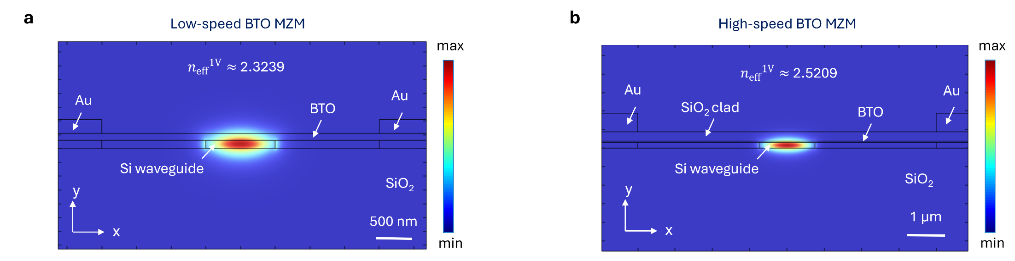

Figure S19. Coupled electromagnetic simulations implementing both RF electric field and BTO Pockels coefficients for optical fields (at wavelength $λ=$ 1550 nm) for the low-speed (a) and high-speed (b) BTO MZMs. The explicit device structures for panels (a) and (b) are shown in Fig. S17a and S17b respectively.
Results:
At half-wave voltage $V_{π}$, the phase modulation at one MZM arm is $Φ=\frac{2πL}{λ}∆n_{eff}=-π$. Given that $∆n_{eff}=\frac{V_{π}}{V_{0}}\left({n_{eff}}^{1V}-{n_{eff}}^{0V}\right)$, where $V_{0}=1$ V used in simulation, we have the theoretical half-wave voltage product:
$V_{π}L=\frac{λ}{2\left({n_{eff}}^{0V}-{n_{eff}}^{1V}\right)}$ (S11-1)
Taking BTO $n_{(0)}=$ 2.27 as an example^{35,61}:
(1) For low-speed BTO EOM (device structure shown as Fig. S17a), by setting BTO effective Pockels coefficient as $r_{eff}=$ 928 pm/V (estimated in Supplementary Note 6), we have the simulated ${n_{eff}}^{0V}≈$ 2.324199, ${n_{eff}}^{1V}≈$ 2.323911. It corresponds to a calculated $V_{π}L≈$ 0.27 V·cm, roughly agreeing with the experimental value $V_{π}L≈$ 0.29 V·cm.

(2) For high-speed BTO EOM (device structure shown as Fig. S17b), by setting BTO $r_{eff}=$ 867 pm/V (estimated in Supplementary Note 6), we have the simulated ${n_{eff}}^{0V}≈$ 2.521025, ${n_{eff}}^{1V}≈$ 2.520983. It corresponds to a calculated $V_{π}L≈$ 1.8 V·cm (via Eq. S11-1), which is much higher than the experimental $V_{π}L≈$ 1.4 V·cm, indicating an underestimated BTO actual $r_{eff}$ in this case.
A closer estimation can be reached if we assume BTO $r_{eff}=$ 900 pm/V, yielding a simulated ${n_{eff}}^{0V}-{n_{eff}}^{1V}≈$ 2.521023-2.52097, and a calculated $V_{π}L≈$ 1.5 V·cm agreeing well with the experimentally measured value.
The simulated optical field distributions of one BTO MZM arm are shown as Fig. S19.

(3) Discussions: This estimation method eliminates the disadvantage of high sensitivity of predicted $r_{eff}$ on the value of modal overlap factor $Γ$ manifested in Supplementary Note 6. Nevertheless, the results of this approach still depend on the selected value of $n_{(0)}$.
If taking $n_{(0)}=$ 2.26 into simulation³⁷, for the low-speed BTO MZM structure, setting $r_{eff}=$ 950 pm/V, we have the simulated ${n_{eff}}^{0V}≈$ 2.321985, ${n_{eff}}^{1V}≈$ 2.321696, and calculated $V_{π}L≈$ 0.27 V·cm.
For low-speed BTO MZM structure, setting $r_{eff}=$ 900 pm/V, we have the simulated ${n_{eff}}^{0V}≈$ 2.524113, ${n_{eff}}^{1V}≈$ 2.524069, corresponding to a calculated $V_{π}L≈$ 1.7 V·cm.

S12. Benchmarks for BTO $r_{eff}$ details
Photonic vdW integration²⁵ permits optimal single-crystalline functional nanomembranes available for heterogeneous integration to arbitrary photonic substrates with precisely controlled film thickness and well-defined crystallographic orientations. This feature becomes critical, especially when crystal quality and orientation drastically impact material and device performance, such as the EO Pockels material BTO. Supplementary Fig. S20 gives the benchmark details for Figs. 5a and 5b (in main text), with corresponding references marked near the scattered plots.
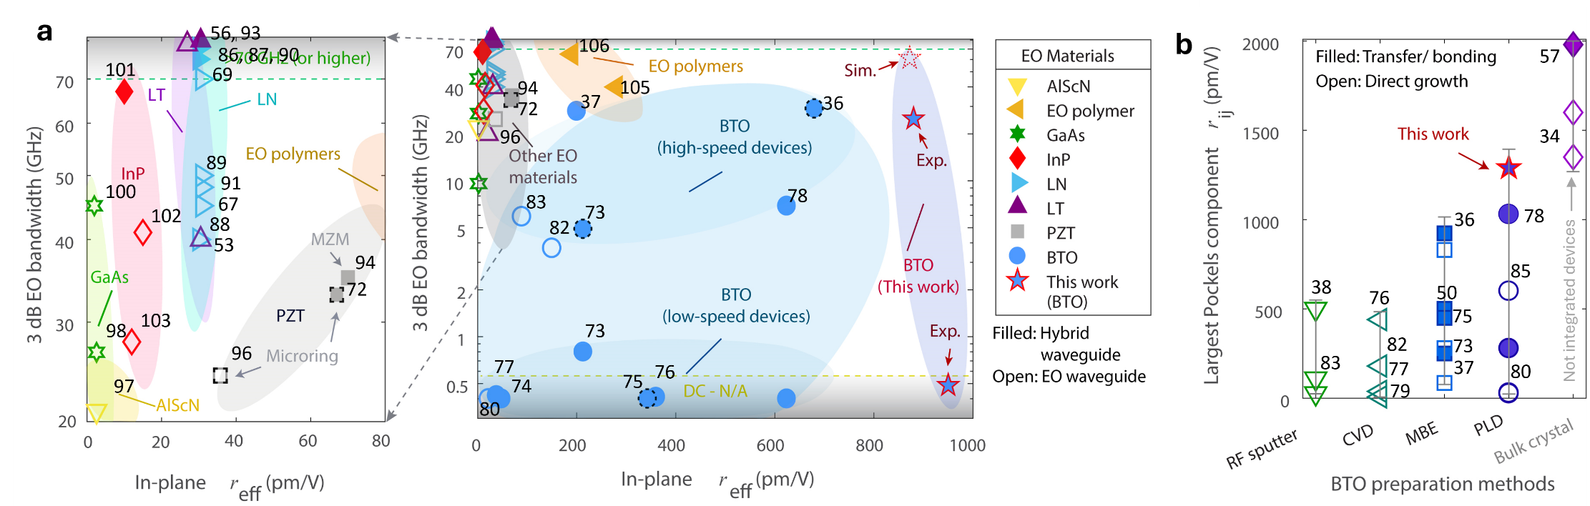

Figure S20. (a) Benchmark details for BTO-based EO modulators. Hybrid waveguides are marked with filled symbols (defined in the notes after Table S1), otherwise open symbols are applied. Symbols with dashed outlines represent microring structures-based EO modulators, while solid-outlined symbols denote MZI-based EO modulators. (b) Benchmarks on the reported largest Pockels tensor component $r_{ij}$ made by different BTO growth methods. Open symbols represent directly grown BTO on various substrates or structures, while filled symbols denote transferred or bonded BTO layers.
Leveraging vdW integrated single-crystalline $a$-axis-domain BTO nanomembranes, desired EO functionality is infused to well-established Si photonics. We experimentally demonstrated giant in-plane effective Pockels coefficient ${r_{eff}}^{∥}$ approaching 950 pm/V, corresponding to an estimated largest Pockels tensor component $r_{42}$~1290 pm/V (Supplementary Note 6), with measured half-wave voltage and device length product $V_{π}L$ around 0.29 V·cm. Another modified high-speed BTO MZM showcased strong ${r_{eff}}^{∥}$ around 880 pm/V (corresponding to an estimated $r_{42}$~1190 pm/V) and a decent proof-of-principle EO 3 dB bandwidth of 23 GHz (Supplementary Note 14). Detailed electromagnetic simulations agree with our Pockels coefficient estimation (Supplementary Note 11). The resultant Pockels coefficient is over 40 times higher than current mainstream EO material lithium niobate (LN)^{62,66-68}, and around 5~20 times higher than PZT⁶⁹⁻⁷¹.

Table S1 – Benchmarks of reported EO materials and devices.
EO  Material | Hybrid waveguide | Structure | ${r_{eff}}^{∥}$ (pm/V) | Largest $r_{ij}$(pm/V) | $V_{π}$·$L$ (V·cm) | EO 3dB  BW (GHz) | Notes on material preparations | Ref
BTO | Yes (Si–BTO) | Microring | 680* | 923 | — | 30 | MBE BTO on Si with engineered STO buffer. | ³⁵
BTO | Yes (Si–BTO) | MZI | 213 | — | 1.5 | 0.8 | MBE BTO on SOI with engineered STO buffer layer. Top Si hybrid slab WG. | ⁷²
BTO | Yes (Si–BTO) | Microring | — | — | — | 4.9 |  | ⁷²
BTO | Yes (Si–BTO) | MZI | 380 | — | 0.23 | >2 | Molecular wafer bonding. | ⁴⁹
BTO | Yes (Si–BTO) | Microring | 380 | — | — | 12* | Molecular wafer bonding. | ⁴⁹
BTO | Yes (Si–BTO) | MZI | 48 | — | 1.67 | — | Transferred freestanding c-axis BTO. | ⁷³
BTO | Yes (Si–BTO  & SiN-BTO) | MZI | 200 | — | 5 | > 30 | MBE BTO on Si with engineered STO buffer. | ³⁶
BTO | Yes (SiN–BTO) | Microring | 343 | — | 0.3 | DC/NA | MBE BTO on Si with engineered STO buffer. | ⁷⁴
BTO | Yes (SiN–BTO) | MZI | 360 | — | 0.5 | DC/NA | MOCVD BTO on MgO. | ⁷⁵
BTO | Yes (SiN–BTO) | MZI | 38 | — | 4.5 | DC/NA | MOCVD BTO on MgO. | ⁷⁶
BTO | Yes (SiN–BTO) | MZI | 624* | > 1000⟂ | 0.62 | 6.9 | BTO growth with engineered STO buffer. | ⁷⁷
BTO | N/A | N/A | 388* | <500* | — | — | RF sputtered BTO on SiO₂ with buffer. | ³⁷
BTO | N/A | N/A | 55~160* | 1980⟂ | — | 5.92$×$10⁻⁴ | Mechanical spalling from bulk BTO. | ⁵⁶
BTO | N/A | N/A | 7 | 6.2 ($r_{33}$) | — | — | CVD BTO film microstructures. | ⁷⁸
BTO | No | MZI | 22 | — | 5.7 | — | Poly-crystal BTO grown on glass. | ⁷⁹
BTO | No | MZI | 162 | — | 0.54 | — | RF sputtered BTO with STO buffer layer. | ⁸⁰
BTO | No | MZI | 150 | — | 1.248 | 3.7 | MOCVD BTO on MgO. | ⁸¹
BTO | No | MZI | 89 | — | 2.32 | 5.9~ 21* | RF sputter BTO on SOI. | ⁸²
BTO | No | MZI | — | 390 ~1030* | — | — | PLD BTO on MgO. | ⁸³
BTO | No | N/A | — | 600* | — | — | PLD BTO on DSO for polarization rotator. | ⁸⁴
BTO  (This work) | Yes (Si–BTO) | MZI | 928~950 | 1250~1290 | 0.29 | DC/NA | Measured at 1 kHz. Limited by TWE. | /
BTO  (This work) | Yes (Si–BTO) | MZI | 867~880 | 1160~1190 | 1.44 | 23 | Limited by device TWE fabrication. | /
BTO  (This work) | Yes (Si–BTO) | MZI | 880 | 1190* | — | >60* | Simulated EO 3 dB BW for 1-mm device. | /
LN | Yes (SiN–LN) | MZI | — | 30.9 | 8.2~8.8 | — | Wafer bonding LNOI with SiNOI. | ⁵⁵
LN | Yes (SiN–LN) | MZI | — | 30.9 | — | ≈100 | Wafer bonding LNOI with SiNOI. | ⁸⁵
LN | Yes (Si–LN) | MZI | — | 30.9 | 6.7 | >100 | Wafer bonding LNOI with SOI. | ⁸⁶
LN | No | MZI | — | 30.9 | 1.29 | >40 | LN WG based on LNOI. | ⁸⁷
LN | No | MZI | — | 30.9 | 2.16 | >50 | LN WG based on LNOI. | ⁸⁸
LN | No | MZI | — | 30.9 | 2.8 | >45 | LN WG based on LNOI. | ⁶⁶
LN | No | MZI | — | 30.9 | — | >110 | LN WG based on LNOI. | ⁸⁹
LN | No | MZI | — | 30.9 | 2.5 | >70 | LN WG based on LNOI. | ⁶⁸
LN | No | MZI | — | 30.9 | 2.47 | ~48 | LN WG based on LNOI. | ⁹⁰
LT | Yes (SiN–LT) | MZI | — | 30* | 4.08 | ~100* | Wafer bonding LTOI with SiNOI. | ⁵⁵
LT | Yes (SiN–LT) | MZI | — | 30* | 4.08 | >100 | Wafer bonding LTOI with SiNOI. | ⁵⁵
LT | No | MZI | — | 16.9 | 0.0351 | > 20 | LT WG based on LTOI. | ⁹¹
LT | No | MZI | — | 16.9 | — | 110 | LT WG based on LTOI. | ⁹²
LT | No | MZI | — | 30* | 1.9 | 40 | LT WG based on LTOI. | ⁵²
PZT | Yes (SiN–PZT) | ring | 67 | 100* | 3.2 | 33 | CSD grown PZT on SiN with seed layers. | ⁷¹
PZT | Yes (Si–PZT) | MZI | 70* | 67 | 3.2 | ~30 | CSD grown PZT on SiN with seed layers. | ⁹³
PZT | No | Microring | 35.8 | 100* | 1.17 | 24.9 | Wafer bonding of PZT. | ⁹⁴
Si* | No | MZI | 10~80* | — | — | 10 | Strained Si with SiN. (Normal Si has no EO) | ⁹⁵
AlScN | No | MZI | 1~2.86* | — | 3.12 | 22 | Direct growth of AlScN. | ⁹⁶
GaAs | No | MZI | 2* | — | 9 | 27 | Monolithic GaAs modulator. | ⁹⁷
GaAs | No | MZI | 2* | — | — | 9.6 | Epitaxial GaAs structures and design. | ⁹⁸
GaAs | No | MZI | — | — | — | >40* | Epitaxial GaAs. | ⁹⁹
InP | Yes (Si–InP) | MZI | — | — | — | >67 | Direct MOVPE InP with deposited Si layer. | ¹⁰⁰
InP | No | MZI | — | <30 | 0.68 | 41 | Epitaxial InP. | ¹⁰¹
InP | No | MZI | — | — | — | 28 | Epitaxial InP. | ¹⁰²
EOP | Yes  (plasmonic) | MZI | — | 1000 | 0.01 | >500 | EO polymers in plasmonic structure. | ¹⁰³
EOP  (JRD1) | Yes | MZI | — | 200~390* | 0.26  ~0.41 | 40 | EO polymer (JRD1) on Si. | ¹⁰⁴
EOP  (YID124) | Yes | MZI | — | 180~300* | 1.3 | >67 | EO polymer (YID 124) on Si. | ¹⁰⁵
Notes: (1) Abbreviations: Barium titanate (BTO), lithium niobate (LN), lithium tantalate (LiTaO₃), lead zirconate titanate (PZT), aluminum scandium nitride (AlScN), gallium arsenide (GaAs), indium phosphide (InP), dysprosium scandate (DSO or DyScO₃), electro-optical (EO) polymers (EOP) such as JRD1, and YID124 (Ref.¹⁰⁶), Mach-Zehnder interferometer (MZI), bandwidth (BW), waveguide (WG), Metalorganic vapor-phase deposition (MOCVD); metal-organic vapor-phase epitaxy (MOVPE); pulsed laser deposition (PLD); chemical solution deposition (CSD); travelling wave electrode (TWE); effective in-plane Pockels coefficient (${r_{eff}}^{∥}$), half-wave voltage length product ($V_{π}$·$L$). (2) For hybrid waveguide classification, if the waveguide is made solely by EO material, such as LNOI (LN-on-insulator) and LTOI (LT-on-insulator), it is classified as not hybrid waveguide. Otherwise, it is ascribed as a hybrid waveguide structure (marked as high-index waveguide material–coupled to functional EO material, such as Si-LN). (3) Superscripts: only in-plane Pockels coefficients ${r_{eff}}^{∥}$ (crucial for chip-integrated EO applications) are benchmarked in the Table. Superscript ⟂ denotes out-of-plane (perpendicular to film) Pockels coefficients $r_{ij}$. Superscript * denotes estimated value. (4) For the largest reported Pockels components $r_{ij}$, by default $r_{42}=r_{51}$ is reported, otherwise the exact Pockels tensor component is marked out beneath the number (such as $r_{33}$). ‘—’ denotes no explicit values were reported by the reference. (5) For EO bandwidth, DC/NA denotes low-frequency (like direct-current to kHz-level) measurements are performed or reported. Experimental setup (such as photodetector or vector network analyzer/VNA) limited EO 3dB bandwidth measurements are marked out, for example > 67 GHz.
Table S1 manifests the benchmarks details shown in Fig. S20, showcasing a clear supremacy of BTO over other EO materials in terms of the Pockels coefficient value³³. Given the integrated photonics background, we note that only in-plane Pockels coefficients ${r_{eff}}^{∥}$ are focused here on Table S1, as out-of-plane effective Pockels coefficients generally cannot be effectively probed in integrated photonic chips with planner electrodes structures^{34,35,49,65}. For references with reported device structures and $V_{π}L$, the ${r_{eff}}^{∥}$ can be estimated via Eq. (S6-2). For instance, in Ref.⁷⁷, the reported $r_{eff}$ are measured via free-space optics and perpendicular to film plane. Taking the device structure parameters (extracted from Fig. 5e in Ref⁷⁷ with scale bar and related discussions) as: Si₃N₄ (SiN) waveguide width × height as 1 µm × 260 nm (estimated), reported electrodes gap $g$ as 10 µm, BTO thickness as 135 nm, SiO₂ thickness between SiN waveguide and BTO around 150 nm, and ($>1$ µm) SiO₂ cladding atop BTO, the modal overlap factor can be calculated as $Γ≈$ 34.7%, by setting Si₃N₄ refractive index as 2.0 and BTO refractive index^{33,37} as $n_{(0)}=$ 2.26. By further feeding the reported experimental $V_{π}L=$ 0.62 V⋅cm to Eq. (S6-2), the in-plane effective Pockels efficient can thus be estimated⁷⁷ as ${r_{eff}}^{∥} =\frac{λg}{n_{(0)}^{3}ΓV_{π}L}≈$ 624 pm/V.

S13. Additional HR-TEM data for BTO MZMs
Selected area electron diffraction (SAED) pattern was taken from the BTO film via JEOL 2100F transmission electron microscope (TEM) and calibrated against the SAED pattern taken from the Si wafer substrate at the same TEM condition to ensure the accuracy of $d$ spacing measurements for the right panel of Fig. 2j (in main text). The relative orientation of the diffraction vector [100] and the film is confirmed via the shadow image in a defocused convergent beam electron diffraction pattern that confirms the [100] diffraction points perpendicular to the film in the out of plane direction. This further confirms the $a$-axis-domain BTO besides the XRD and RSM measurements.
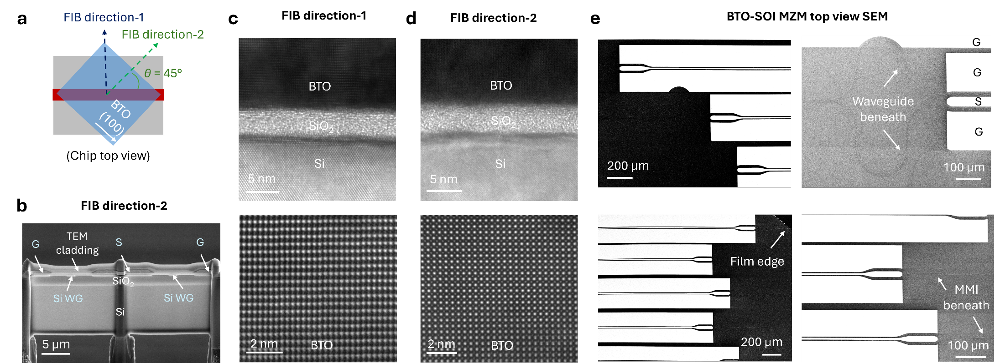

Figure S21. (a) Illustration on the two FIB directions along the photonic chip sample. (b) SEM of the cross-sectional sample (along FIB direction-2) for HR-TEM showing two MZM waveguide arms, BTO layer, and electrodes. S: signal. G: ground. (c) and (d) HR-TEM (top panels) and HAADF-STEM images (bottom panels) for the BTO-Si waveguide interface along FIB direction-1 (c) and direction-2 (d) respectively. (e) Top view SEM images of the fabricated BTO MZMs chip.
The high-resolution (HR)-TEM photos also depend on the focused ion beam (FIB) direction. Figure S21a illustrates the two FIB directions used to prepare the TEM samples: one is perpendicular to the waveguide, while the other has an angle around $θ≈45°$ with respect to the waveguide (i.e. parallel to the epitaxial edge of BTO film). An exemplary TEM sample (cleaved along FIB direction-2) is illustrated as Fig. S21b, showing the two waveguide arms of the MZM and the signal (S) and ground (G) electrodes (with device structure detailed in Fig. S17b). The HR-TEM images along the BTO-Si waveguide interfaces along FIB direction-1 and direction-2 are shown as the top panels of Fig. S21c and S21d respectively with clear BTO lattice fringes. The corresponding high-angle annular dark-field scanning transmission electron microscopy (HAADF STEM) images of the BTO layers are shown as lower panels.
The top-view SEM images of the BTO vdW-integrated EO MZMs are shown in Fig. S21e, where the Si waveguide patterns can be seen beneath the heterogeneous integrated BTO layer. The EDS SEM images of the two TEM samples with different FIB cleavage directions are shown in Fig. S22.
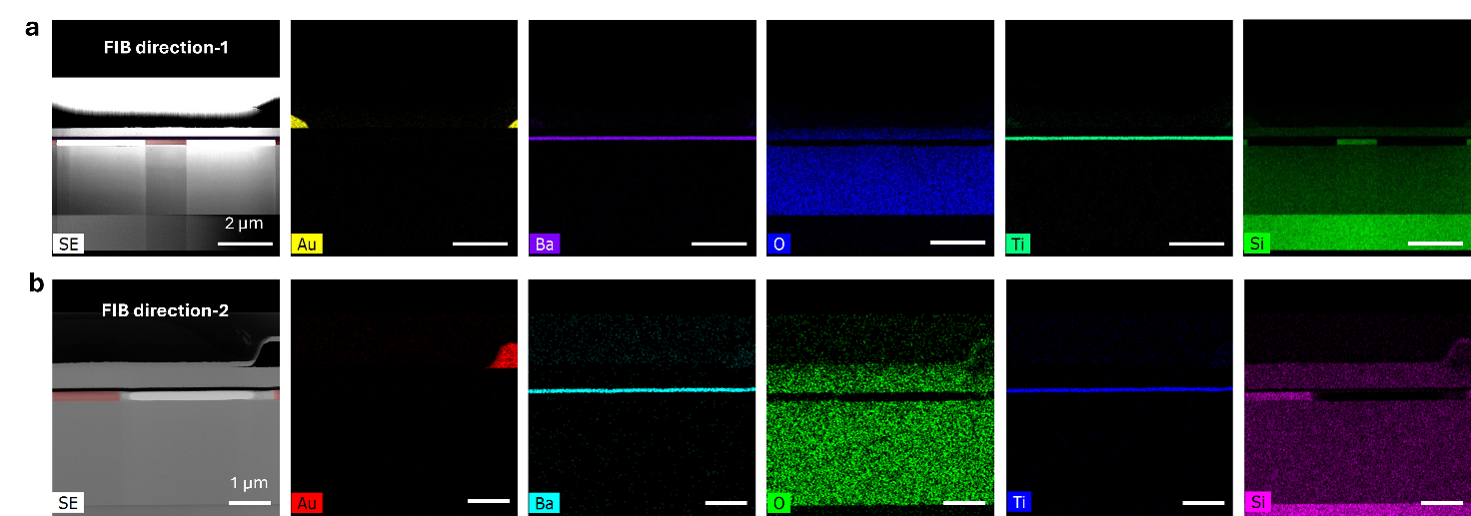

Figure S22. (a) and (b) EDS SEM images for the two TEM samples along FIB direction-1 (a) and direction-2 (b) respectively. The left-most panels are the corresponding second-electron (SE) SEM images, where the Si waveguides are manually colored in red.

S14. Additional high-speed BTO MZMs measurement data
The experimental setup for high-speed EO MZMs is shown in Fig. S23a (and in Methods), where the EO scattering parameter $S_{21}$ (as ratio of powers) was characterized by a 67 GHz vector network analyzer (VNA, R&S ZNA67).
The microwave measurements of the high-speed BTO MZMs are shown as Figs. S23b-S23e. The discrepancy between measured and designed device impedance $Z_{0}$ is mainly ascribed to the imperfect travelling-wave electrodes fabrication due to cleanroom facility constraints (Supplementary Note 9), which can be also evidenced by the partially collapsed non-ideal electrode edges shown in the SEM images of Fig. 2i (in main text), Fig. S21b and Fig. S22a. Nevertheless, an over 23 GHz EO 3 dB bandwidth is still experimentally confirmed despite nanofabrication imperfections (Fig. S24). The estimated edge coupling loss (without chip facet polishing limited by facility) is about 6~8 dB per facet, and the measured total fiber-to-fiber loss is around 18~22 dB depending on chip dicing, where these proof-of-concept results can be further enhanced in optical coupling by applying professional foundry-based photonic chips. Asymmetric optical phase modulation is also observed (Figs. S24c) due to ferroelectric material BTO, which could be further exploit to develop photonic memories¹⁰⁷ but beyond the scope of this paper. Detailed device EO bandwidth characterization data (supplementary for Fig. 2k in main text) are shown in Figs. S24d and S24e, where increasing microwave signal reflection was observed at high frequencies due to the mismatched target device characteristic impedance $Z_{0}$ to the 50 Ω target, leaving further room of improvements in future works.
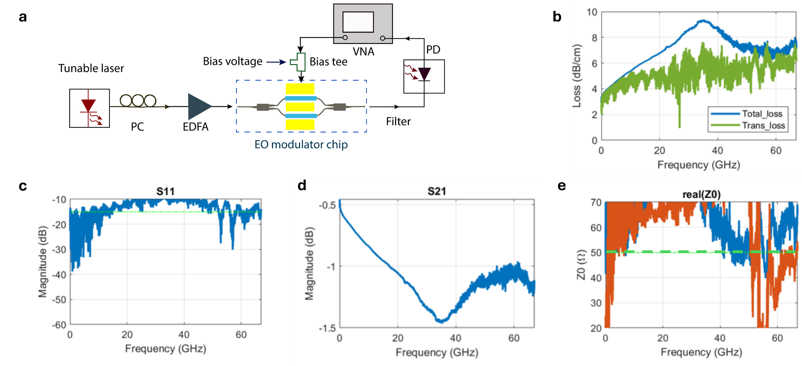

Figure S23. (a) High-speed EO modulator measurement setup. (b) Measured electrodes microwave transmission (trans) and total loss. (c) and (d) Measured microwave reflection ($S_{11}$) (c) and transmission ($S_{21}$) (d) ratio of the fabricated electrodes, respectively. (e) Measured device characteristic impedance $Z_{0}$.
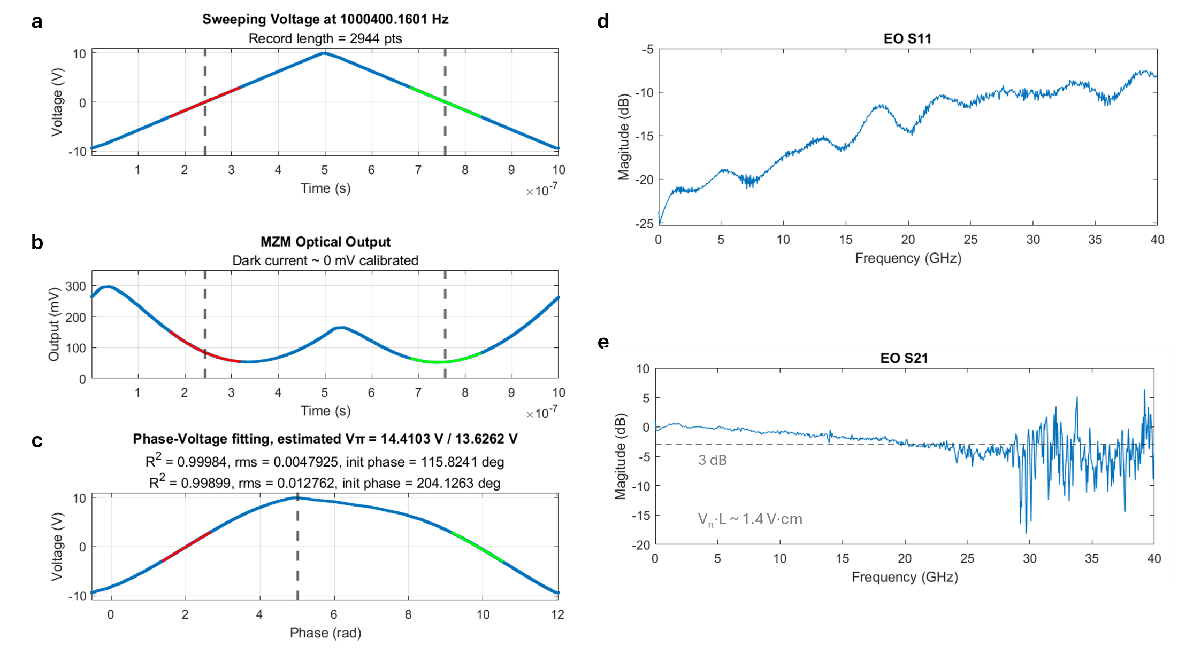

Figure S24. (a) Sweeping triangular voltage signal. (b) and (c) Corresponding optical output of the BTO MZM by the photodetector (b), and device phase voltage fitting (c), respectively. (d) and (e) Measured EO refection ($S_{11}$) (d) and transmission ($S_{21}$) (e) as a function of signal frequency, respectively. Device modulation length $L$ is 1 mm.

S15. Transfer details for remote epitaxial GaN
Besides conventional layer transfer steps discussed in Fig. S1 and Supplementary Note 1, additional attention is required when high-stress-level metal adhesive layers are used. For the single-crystalline unintentionally-doped (UID) GaN film grown by remote epitaxy via molecular beam epitaxy (MBE, detailed in Methods)^{3,11}, high-stress-level Ti/Ni adhesive layers are needed to overcome the strong adhesive energy between the in-situ grown BN and substrate to facilitate efficient nanomembrane exfoliation (Fig. S4). The strong strain in the Ti/Ni layer prohibits uniform vdW integration, leading to detached or rolled up nanomembranes after retrieving the thermal release tape (TRT) supporting layer.
To address this issue, another polymer handler such as PPC or PMMA was spin coated to the exfoliated GaN nanomembranes, followed by the TRT removal by soft baking and Ti/Ni stressor layer etching (Fig. S4). Upon the removal of the high-stress-level Ti/Ni adhesive layers, the freestanding GaN nanomembranes are cleaned and subsequently transferred to target photonic chips with uniform and robust layer bonding to the photonic chips to develop heterogeneous integrated photodetectors.

S16. Additional TEM data for GaAs and GaN photodetectors
Besides the TEM images in Fig. 3b and 3h (in main text), the zoom-in HR-TEM details of the GaN and GaAs nanomembranes are shown in Fig. S25a, verifying excellent single-crystalline quality. The EDS SEM composite maps of the constituent elements for the vdW-integrated GaAs (with p-i-n doping structures shown in Fig.S3a) are given in Fig. S25b.
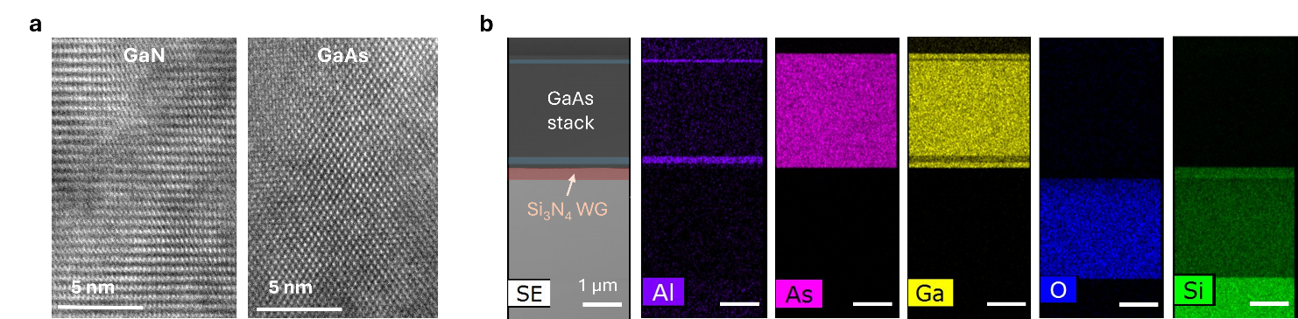

Figure S25. (a) HR-TEM images for the vdW-integrated GaN (left) and GaAs (right) nanomembranes. (b) EDS SEM of vdW-integrated freestanding GaAs atop SiN waveguide. In the left-most second electron (SE) SEM panel, the SiN and AlGaAs layers are colored as red and blue colors respectively.

S17. III-V-SiN photodetector samples details
The device structures are illustrated in Fig. S26a, where the etching trenches $d_{t}$ for the SiN waveguide are 2.5 µm, waveguide width × height as 1 µm × 220 nm. Bottom electrodes spacing $g_{b}$ and thickness $h$ are 6 µm and 30 nm respectively, and top electrodes spacing as $g_{t}$ varying from 2~5 µm between different devices. Limited by current cleanroom facilities, only GaAs films were patterned by combining EBL and piranha solution wet etch (Methods). Adopting further ICP-RIE patterning with reduced device footprint (applying buried electrodes structures like the steps shown in Fig. S16b with eliminated air gap $h$) can further enhance performance of the vdW integrated III-V-SiN photodetectors.
Despite stronger photoresponsivity expected from GaN nanomembranes at shorter ultraviolet (UV) wavelengths such as 365 nm, the largely increasing optical loss from our lab-made SiN waveguide chips prohibits on-chip photodetector measurements at shorter wavelengths. For the photoresponsivity measurements for GaN-based integrated detectors, calibrations on delivered optical power intensity to the GaN-photodetectors were performed. Bare SiN chips (without GaN photonic vdW integration) of identical patterns are measured first. Then the optical power reached to the GaN-photodetectors are estimated by considering the output laser source power after fiber lens, chip edge coupling loss, and waveguide propagation loss (over 25 dB/cm around $λ=$ 405 nm wavelength). Negligible photoresponsivity was experimentally confirmed for GaN-SiN photodetectors around 520 nm wavelength (Fig. S26b), as the small photon energy far below the GaN bandgap cannot enable efficacious sideband photodetection^{11,108}. This calibration was found necessary due to the increasing SiN chip loss at short light wavelengths.
In contrast, for GaAs-based photodetectors only edge coupling loss was considered, given the acceptable optical loss at longer wavelengths (around 1.5 dB/cm at $λ=$ 780 nm wavelength for our lab-made chips). To facilitate further advanced waveguide-integrated UV photodetectors, additional attentions on optimizing SiN photonic chips fabrication or adopting foundry-based chips are required⁴⁶ for future works. For the measurement of current-voltage ($I$-$V$) curves and photoresponsivity (detailed in Methods), either bottom contact (BC1) and top contact (TC1), or BC2 and TC2 are probed at the same time. Otherwise, different $I$-$V$ curves can be observed (such as Fig. S26c, when both TC1 and TC2 are probed) for some devices.
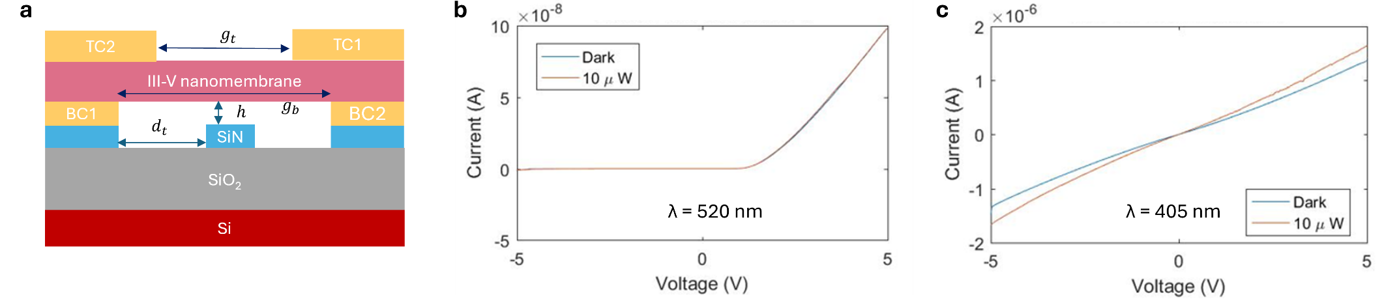

Figure S26. (a) Device structure schematics. (b) Supplementary GaN-SiN photodetectors $I$-$V$ curves from a different device under different pumping light powers at 520 nm wavelengths. (c) Additional device $I$-$V$ curves when probing from both top electrode contacts (TC1 and TC2). BC: bottom contact. TC: top contact.

S18. Benchmarks for waveguide-coupled III-V photodetectors
By lateral stitching of GaAs and GaN freestanding single-crystalline nanomembranes atop the same SiN photonic chip, extended wide-spectrum photodetection can be enabled. The benchmarks for waveguide-coupled on-chip photodetectors based on group III-V (including III-N) semiconductors supporting the scattering plot shown in Fig. 5d (in main text) are shown in Table S2. Waveguide-coupled structures are mainly focused here (some free-space photodetectors for comparison are also marked out in the Table).

Table S2 – Benchmarks of waveguide-integrated III-V photodetectors.
Materials | Waveguide-based? | Wavelength (nm) | Responsivity (A/W) | Integration approach notes | Ref.
InGaAs | Yes (Si) | 1320 | 0.2 | (Growth) Monolithic selective epitaxy on SOI chip. | ¹⁰⁹
InGaAs | Yes (SiN) | 1064 | 0.31 | (Transfer) Heterogeneous low-temperature die bonding to SiN chip. | ¹¹⁰
InGaAs | Yes (SiN) | 1550 | 0.3 | (Transfer) Heterogeneous bonding to SiN chip. | ¹¹¹
InGaAs | Yes (LN) | 1550 | 0.4 | (Transfer) Heterogeneous III-V bonding onto LNOI chips. | ¹¹²
InGaAs | Yes (Si) | 1550 | 0.17 | (Growth) Direct epitaxial III-V growth on Si. | ¹¹³
InP | Yes (Si) | 1575 | 0.45 | (Transfer) Heterogeneous bonding of InP membrane to Si photonics. | ¹¹⁴
GaAs | Yes (SiN) | 850 | 0.11 | (Transfer) Micro-transfer printing of GaAs. | ¹¹⁵
GaAs | Yes (GaAs) | 800 | 0.052 | (Growth) Monolithic epitaxial GaAs/AlGaAs. | ¹¹⁶
GaAs | Yes (PI) | 850 | 0.4 | (Growth) Epitaxial GaAs combined with polyimide (PI) waveguide. | ¹¹⁷
GaAs | Yes (Ta₂O₅) | 635 | 0.3 | (Transfer) Adhesive die-to-wafer bonding onto Ta₂O₅ waveguides. | ¹¹⁸
GaAs | Yes (Ta₂O₅) | 780 | 0.36 |  | ¹¹⁸
GaAs | No | 620 | 0.04 | (Transfer) ELO GaAs and bonding to form integrated photodetectors. | ¹¹⁹
AlGaAs | No | 440 | 0.137 | (Growth) Epitaxial free-space device on GaAs substrate. | ¹²⁰
AlGaAs | No | 540 | 0.19 | (Growth) Epitaxial free-space device on GaAs substrate. | ¹²⁰
GaN | No | 370 | 0.14 | (Growth) Monolithic epitaxial GaN photodetector. | ¹²¹
GaN | No | 240 | 0.005 | (Growth) Monolithic epitaxial GaN photodetector. | ¹²²
AlGaN | No | 305 | 0.004 | (Growth) Monolithic epitaxial AlGaN photodetector. | ¹²³
GaAs | Yes (SiN)  (This work) | 780 | 0.23 | (Transfer) Lateral stitching of vdW-integrated single-crystalline GaAs and GaN nanomembranes on SiN photonic chip. | \
GaAs | Yes (SiN)  (This work) | 520 | 0.17 |  | \
GaN | Yes (SiN)  (This work) | 405 | 0.0166 |  | \
Note: The primary photodetection material is marked out. For waveguide-coupled photodetectors, the waveguide materials are manifested, such as: Yes (SiN). Silicon nitride (Si₃N₄): SiN. Epitaxial lift-off (ELO). For integration approach, if the operating III-V (or III-N) semiconductors are directly grown on the photonic structures or substrates, it is classified as ‘Growth’-based approach. Otherwise, it is denoted as ‘Transfer’-based approach.

S19. Device details for CFO/BTO hybrid microring
For the CFO-SOI microring-based on-chip optical isolators shown in Fig. 4c (in main text), an 80 nm-thick SiO₂ is deposited via PECVD on prefabricated SOI chip to engineer the desired spatial modal overlap between CFO layer and the operating transverse magnetic (TM) mode⁷⁵. The CFO films were latter patterned via combined EBL and wet etching processes (Methods). For the multifunctional EO and magneto-optical (MO) modulation devices shown in Fig. 4g (main text), PECVD SiO₂ (around 80 nm-thick) was also applied to BTO nanomembrane-transferred SOI photonic chip. To ensure the high uniformity and yield of BTO vdW integration²⁵, buried electrodes structures (Fig. S16b) are applied.
Compared with other metallic ferromagnets, such as the permalloys of Fe, Co, Ni, etc., CFO is an insulator oxide with comparatively much lower optical absorptions and microwave loss, as well as much higher chemical and thermal stability¹²⁴⁻¹²⁶. The optical loss for CFO-covered waveguides is estimated by comparing the quality (Q) factors of the microrings of identical structure after CFO vdW-integration. For a radius $R=$ 50 µm microring with experimentally measured free-spectrum range $FSR≈$ 1.82 nm, the group index can be calculated as $n_{g}=λ^{2}/(FSR∙2πR)≈$ 4.23, for 1.555 µm light wavelength $λ$. Near critical coupling, we have the intrinsic $Q_{int}≈{2Q}_{load}$, where the loaded Q factor can be estimated as $Q_{load}=λ/{∆λ}_{FWHM}$. Applying the measured full-width half-maximum (FWHM) linewidth ${∆λ}_{FWHM}$ (based on not normalized transmission curves) around 37 pm, the estimated overall loss is $α_{avg}=2πn_{g}/(Q_{int}λ)≈9$ dB/cm. Given the modal overlap factor $Γ≈$ 3.98 %, and the CFO cover ratio $τ=L_{CFO}/(2πR)≈$ 8%, where $L_{CFO}$ is the CFO-covered length, we have the estimated CFO material loss $α_{CFO}=α_{avg}/(Γτ)≈$ 2900 dB/cm. For the CFO/BTO hybrid microring shown in Fig. 4g (main text), taking updated $L_{CFO}=$ 160 µm, $Γ≈$ 1.21%, $FSR≈$ 0.31 nm, ${∆λ}_{FWHM}≈$ 24 pm, the estimated CFO loss $α_{CFO}$is around 5400 dB/cm. Based on the material and device characterization results from previous literature¹²⁷⁻¹²⁹, the optical scattering from the defects and morphology uniformity of the CFO nanomembranes is a crucial factor contributing to total optical loss of the MO materials.

S20. Magnet-free CFO optical isolators
Distinctive from ferrimagnetic garnets such as YIG^{51,75}, CFO is a hard ferromagnetic material with strong coercivity, where the magnetic field can persist even after the retrieval of external magnets^{127,129}. Therefore, magnet-less on-chip optical isolation can be realized by CFO nanomembranes. Besides the conventional nonreciprocal optical applications with external permanent magnets shown in Fig. 4 (main text), the vdW-integrated CFO nanomembranes permits optical isolation without external magnets after CFO magnetization.
Figure S27a shows the normalized optical transmission of the CFO-integrated SOI microring after removing the permanent magnet for 30 minutes. The single-crystallinity film quality enables stronger magnetic responses than those based on poly-crystal CFO films^{127,129,130}, persisting over hours (Fig. S27b). The fabricated device was magnetized at room temperature by a pair of neodymium magnets overnight with over 300 mT magnetic field intensity limited by experimental setup. Enhanced magnetization process such as stronger magnetic field at engineered temperatures can further enhance device performance⁷⁵.
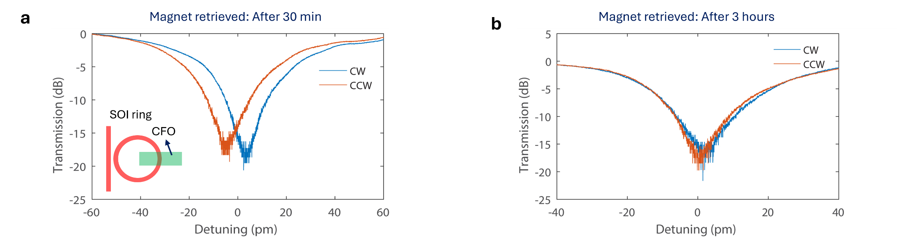

Figure S27. Normalized optical transmission between clockwise (CW) and counterclockwise (CCW) light after retrieving external permanent magnet for (a) 30 min, and (b) 3 hours.

S21. Faraday rotation coefficient estimation details
Through magneto-optical (MO) effect, time reversal symmetry can be broken to facilitate optical isolators and circulators⁷⁵. The dielectric matrix $ϵ$ of the MO material is no longer symmetric¹³¹
$ϵ=\left[\begin{matrix}ϵ_{xx} & 0 & iϵ_{xz} \\ 0 & ϵ_{yy} & 0 \\ -iϵ_{xz} & 0 & ϵ_{zz}\end{matrix}\right]$, (S21-1)
where the non-zero off-diagonal component $ϵ_{xz}≈nλθ_{F}/π$ is related to the Faraday rotation $θ_{F}$ as a consequence of Zeeman splitting, with $n$ as refractive index and $λ$ as light wavelength^{75,131,132}.
For a resonant microring resonator $mλ=n_{eff}∙L$, where $L$ is the ring perimeter and $m$ is an integer, in small effective-index perturbation, $∆n_{eff}$ shifts the resonance by $∆λ=​λ​∆n_{eff}/n_{g}$​, with $n_{g}​$ as the group index. The difference in effective index between CW and CCW light⁷⁵ can be given below.
$2λ_{MO}=∆λ=λ\frac{∆n_{eff}}{n_{g}}$ (S21-2)
Given the experimentally measured free spectrum range as $FSR=1.82$ µm for the approximate $R=50$ µm radius SOI micro-ring ($L=2πR$), the group index is calculated as $n_{g}=\frac{λ^{2}}{FSR∙L}≈4.23$ for TM₀ mode around $λ=1555$ nm. With the experimentally measured $∆λ=$ 36 pm, the non-reciprocal phase shift (NRPS)¹³³ is calculated as $∆Φ_{NRPS}=2π\frac{∆λ}{FSR}=0.124$ rad. We have
$∆Φ_{NRPS}=\left(β_{CW}-β_{CCW}\right)L_{MO}=2∆βL_{MO}=2θ_{F}L_{MO}$, (S21-3)
where $β$ is TM₀ mode propagation constant, $L_{MO}$ is the length of the magneto-optical (MO) material CFO, and $θ_{F}$ is the Faraday rotation coefficient.
Therefore, for $L_{MO}≈26.5$ µm, the mode-effective Faraday rotation coefficient ${θ_{F}}^{eff}=\frac{∆Φ_{NRPS}}{2L_{MO}}≈2344$ rad/m. To derive the intrinsic CFO film Faraday rotation coefficient ${θ_{F}}^{film}$, the modal overlap factor $Γ$ between the TM₀ mode and CFO is numerically calculated via FEM method $Γ=\frac{\int_{MO }{\frac{1}{2}}R(E×H^{*})∙\hat{x}dS}{\int_{All }{\frac{1}{2}}R(E×H^{*})∙\hat{x}dS}≈3.98\%$. We have ${θ_{F}}^{film}={θ_{F}}^{eff}/Γ≈33800°$/cm.
For the CFO/BTO hybrid microring, the device structure parameters: Si waveguide dimension: 750 nm × 220 nm, BTO thickness: 60 nm, SiO₂ thickness: 80 nm, CFO thickness: 40 nm. Given the FSR ~ 0.31 nm for the racetrack microring resonator, the experimentally measured CW and CCW wavelength split $∆λ$ ~ 10.1 pm, and CFO length $L_{MO}$ ~ 160 µm, NRPS is calculated as $∆Φ_{NRPS}=2π\frac{∆λ}{FSR}≈0.204$ rad. Mode effective Faraday rotation yields ${θ_{F}}^{eff}=\frac{∆Φ_{NRPS}}{2L_{MO}}≈640$ rad/m. Given the numerically simulated field overlap $Γ \sim 1.21\%$, the intrinsic CFO film Faraday rotation coefficient for this device is estimated as ${θ_{F}}^{film}={θ_{F}}^{eff}/Γ≈30100°$/cm.

S22. Ferromagnetic loop measurements
The magnetic properties of grown CFO and YIG nanomembranes were evaluated at room temperature using vibrating sample magnetometer (VSM 7410 Series, Lake Shore). For instance, the as-grown CFO/MgO sample (Fig. S28a) and bare MgO substrate of identical size (Fig. S28b) were measured first. The CFO ferromagnetic loop was then obtained by subtracting the substrate response from as grown samples (Fig. S28c, Methods)^{134,135}. The measured Ce: YIG magnetic hysteresis is shown as Fig. S28d.
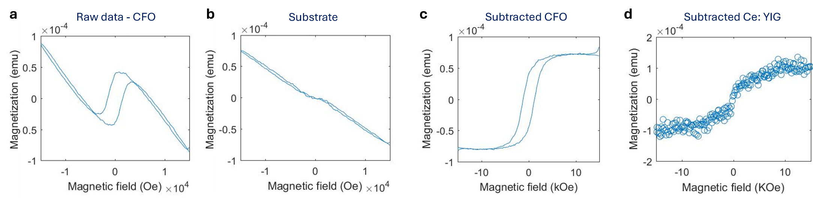

Figure S28. (a) and (b) Representative original ferromagnetic loop measurements raw data of the CFO/MgO sample (a) and bare MgO substrate (b). (c) Resultant CFO ferromagnetic loop of an approximate 6 × 6 mm sample. (d) Measured ferromagnetic loop of the thick Ce: YIG film.

S23. Benchmarks of MO material CFO
The benchmark details for different MO materials are shown in Fig. S29 and Table S3. CFO exhibits giant Faraday rotation coefficients and magnet-less operation capability compared to other magnetic materials. The optimal single-crystalline nanomembrane quality also enhances magnetic response and reduces optical losses from defects scattering or imperfect CFO crystal quality found in previous works^{21,127,129}, circumventing the prior obstacles of lattice mismatching of defective heteroepitaxial CFO layer by applying photonic vdW integration²⁵.
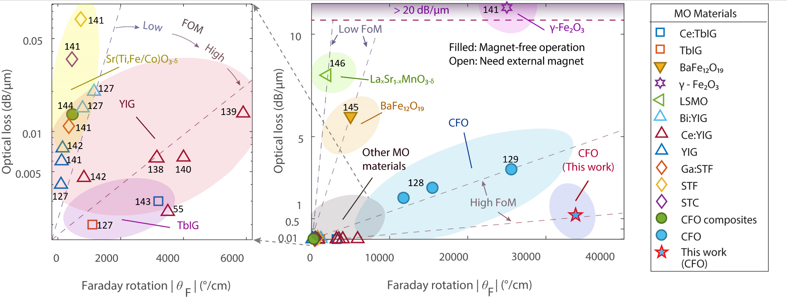

Figure S29. Benchmark details on the key parameters of different MO materials. Detailed symbol explanations are made below Table S3.

Table S3 – Benchmarks of reported MO materials and devices.
Material | Faraday rotation (°/cm) | Material absorption (dB/cm) | Waveguide propagation loss (dB/cm) | Operation λ (nm) | FOM  (°/dB) | Notes on material preparations | Ref
Ce:YIG | -1500 | — | — | 1550 | — | Sputtered Ce: YIG film on Si with YIG buffer. | ¹³⁶
Ce:YIG | -3000 | — | 31.9 | ~1550 | — | Wafer bonding of Ce:YIG film to SOI microring. | ¹³⁷
Ce:YIG | -3200 | 60* | 6.3* | 1550 | 53 | Wafer bonding of Ce:YIG film to SOI. | ¹³⁸
Ce:YIG | −5900 | 137* | 31.7 | 1550–1570 | 43 | PLD Ce: YIG on SiN with YIG buffer later. | ¹³⁹
Ce:YIG | -4000 | — | 14.5 | 1550 | — | Wafer bonding of Ce: YIG dies. | ¹⁴⁰
Ce:YIG | -830 | 45 | — | 1550 | 21 | Poly-crystal YIG growth. | ¹⁴¹
Ce:YIG | −1263 | — | — | 1540–1550 | — | PLD poly-crystal Ce: YIG on Si. | ¹⁴²
Ce:YIG | -3500 | — | 13 | 1550 | — | Wafer bonding of Ce: YIG/GGG to Si photonics. | ⁵⁴
YIG | 100 | 50* | — | 1550 | 2 | Direct grown poly-crystal YIG. | ¹⁴¹
YIG | 120 | 60* | — | 1550 | 2 | RF sputtered poly-crystal YIG. | ¹²⁶
Bi:YIG | −1200 | 200 | 50* | 1550 | 6 | RF sputtered poly-crystal Bi: YIG on Si. | ¹²⁶
Bi:YIG | -838 | 150 | — | 1550 | 5.6 | liquid phase epitaxy on GGG. | ¹²⁶
Ce:TbIG | −3200 | — | 15* | 1550 | — | Sputtered Ce:TbIG on Si. | ¹⁴³
TbIG | -1100 | — | 20* | 1550 | — | Sputtered Ce:TbIG. | ¹²⁶
CAFO | 12000 | 8300 | 3700 | ~1550 | 1.5 | RF sputtered CAFO with different buffer layers. | ¹³⁰
CFO NPs | 310 | 130* | — | 820, 1550 | 2.4 | CFO nanoparticle composites. | ¹²⁸
CFO | 25600 | 34000 | — | 1550 | 0.8 | Sputtered CFO on Si. | ¹²⁹
CFO | 15500 | — | 210 | 1545–1550 | — | Sputtered CFO on Si. | ¹²⁷
BaFe₁₂O₁₉ | 5000* | 60000* | — | ~1550 | 0.08 | PLD growth. Magnet-less operation. | ¹⁴⁴
γ-Fe₂O₃ | 25000 | 350000* | — | 1550 | 0.07 | — | ¹⁴¹
LSMO | 2000 | 80000* | — | 460, ~1550 | 0.025 | Ion‑plasma evaporation on STO substrates. | ¹⁴⁵
Ga:STF | -400 | 110* | — | 1550 | 3.6 | — | ¹⁴¹
STC | -500 | 350* | — | 1550 | 1.4 | — | ¹⁴¹
STF | -780 | 700* | — | 1550 | 1.1 | — | ¹⁴¹
This work  (CFO) | 33800 | 5400* | 9* | 1550 | 6 | Giant $θ_{F}$ and single-crystalline CFO film with low defects. Magnet-less optical isolation. | \
Notes: YIG: yttrium iron garnet (Y₃Fe₅O₁₂), TbIG: terbium iron garnet (Tb₃Fe₅O₁₂), CFO: cobalt ferrite (CoFe₂O₄), CAFO: aluminum-substituted cobalt ferrite (CoAl_{x}Fe_{2-x}O₄), GGG: gadolinium gallium garnet (Gd₃Ga₅O₁₂), STO: strontium titanate (SrTiO₃). NPs: nanoparticles, LSMO: lanthanum strontium manganite (La_{0.7}Sr_{0.3}MnO_{3‑δ}), STF: strontium titanate-ferrite oxide (Sr(Ti,Fe)O_{3‑δ}), STC: strontium titanium cobalt oxide (Sr(Ti,Co)O_{3‑δ}), FOM: figure of merit, defined as $|θ_{F}|/α$, where $θ_{F}$ and $α$ are the Faraday rotation coefficient and material optical loss respectively. Estimated Faraday rotation values are marked with * superscript. Not reported values are marked by — symbol. Approximate operation wavelengths are marked with ~ symbol. Most directly grown MO films are polycrystalline.

S24. Fully integrated MO devices prospects
In the proof-of-concept demonstrations shown in Fig. 4 (main text), permanent magnets are applied to verify the non-reciprocal optical transmissions. Nevertheless, the bulk external magnets do not fit integrated photonic applications. To facilitate fully chip-integrated MO devices, electromagnets via metal coil structures can be applied^{51,54} (Fig. S30a), where the vdW-integrated CFO nanomembrane can be optionally patterned for desired spatial modal overlap (Methods). Through injecting electrical current (as white arrows in Fig. S30a), magnetic fields can be locally induced around the microring waveguide (Fig. S30b) operating at transverse magnetic (TM) optical mode (Fig. S30c). The metal electromagnet design was not applied in current work limited by experimental setup, because in this case precise temperature control is needed to exclude the current-induced thermal tuning effect on the microring resonators. Current external magnet fully confirmed the feasibility of CFO-based MO applications excluding any thermal-related tuning effects. Nevertheless, fully integrated MO nonreciprocal devices can be envisaged in future work.
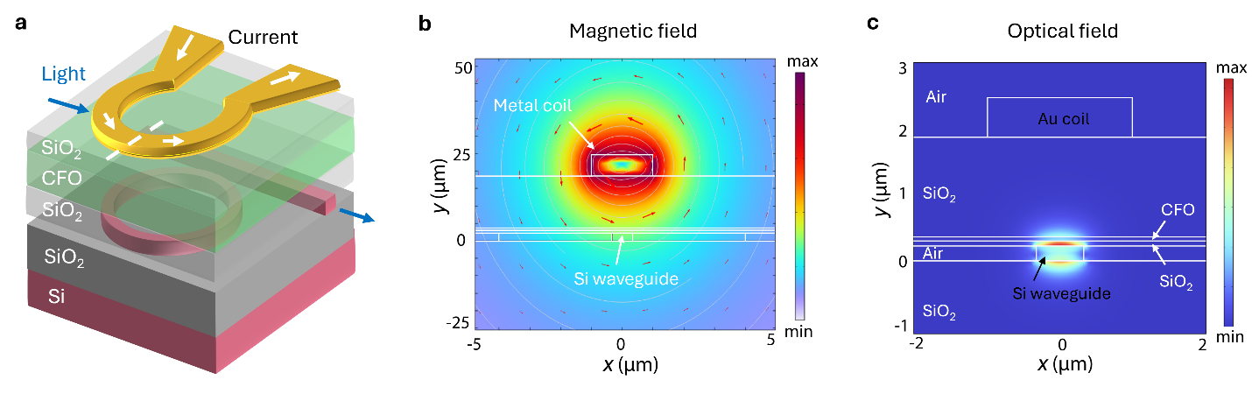

Figure S30. (a) Structure schematics of fully integrated CFO-SOI nonreciprocal microring with electromagnet. Light propagation directions are marked in blue arrows. (b) and (c) Simulated cross-sectional magnetic field (b) and fundamental TM mode optical field (c) distributions of the microring waveguide.

S25. Wafer-scale BTO nanomembrane vdW integration
Photonic vdW integration of functional freestanding nanomembranes^{2,25} can be performed at varying scales from millimeter-sized film (Fig. 1g in main text) to wafer-scale (Fig. S31a). After soft hotplate baking (~100 °C) and cleaning processes (Methods), smooth surface morphologies were confirmed by AFM at 16 representative areas for the transferred 1-inch-diameter BTO film with a spacing around 5 mm between different measurement areas (Fig. S31b). An average root mean square (RMS) roughness below 1 nm was experimentally confirmed, which can be further reduced by applying chemical mechanical planarization (CMP) polishing³⁵. Cross-sectional HAADF STEM images confirm the atomically clean and electronically sharp interface between the vdW-integrated single-crystalline BTO layer and the oxide substrate (Fig. S31c) with high robustness (Supplementary Note 26). Corresponding EDS STEM composition maps are shown in Fig. S31d.
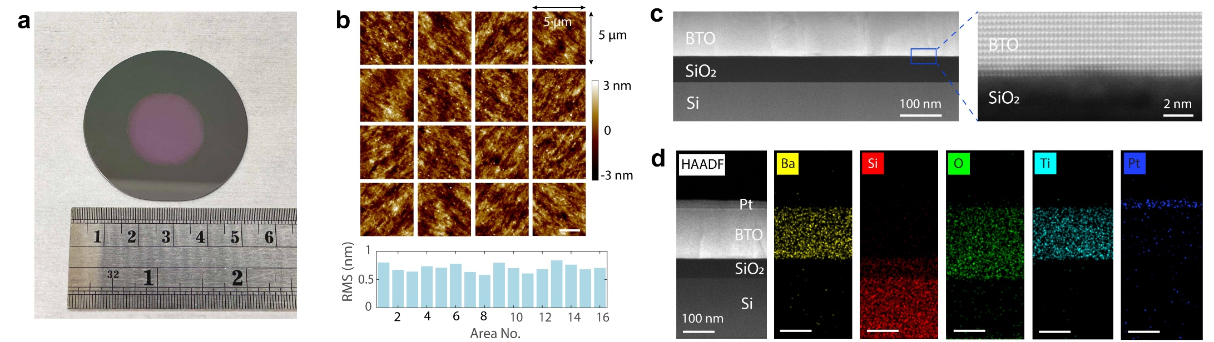

Figure S31. (a) Photograph of 1-inch diameter BTO vdW integrated onto SiO₂ substrate. (b) AFM images from 16 representative areas over the transferred BTO film, with measured RMS roughness shown below. (c) and (d) Cross-sectional HAADF STEM image (c) and EDS maps of vdW-integrated single-crystalline BTO nanomembrane.
The layer transfer processes of wafer-scale nanomembranes are similar (Methods), while additional layer lift-off time and attention in layer handling are needed for large-sized samples¹¹. For example, polymer handers such as PPC or PMMA can be applied. Despite trivial details, the sample edge needs to be exposed to the etchant, otherwise the polymer-encapsulated sacrificial layer will largely increase layer lift-off time (Fig. S32a). Supporting layers such as thermal release tape (TRT) are also found necessary for large-scale nanomembrane lift-off. Otherwise, the heavy wafer substrate tends to get detached from the film stacks and sank down into the etchant before the full completion of sacrificial layer etching, leading to compromised film lift-off yield. Shallow etchant or bottom supporting pieces (second left panel in Fig. S32b) can address this issue. After nanomembrane vdW integration, overnight drying and subsequent thermal treatments (Supplementary Note 26) were applied to enhance layer bonding to the substrate. Compared to TRT-based transfer, where wrinkles are more easily generated during the thermal release and cooling process with layer thermal deformation, mixed PPC- or PMMA-handlers-based layer transfer with engineered polymer Young's modulus⁸ can yield better vdW-integration uniformity of the freestanding films (Fig. S32b). Despite that practical details and tentative handlings are needed here to facilitate ideal vdW integration of functional nanomembranes²⁵, the proof-of-concept demonstrations here primarily aim to verify the feasibility of large wafer-scale vdW integration perspectives. Automatic transfer^{146,147} or bonding tools¹⁴⁸ can be applied in future for larger scale manufacturing. Compared with conventional wafer bonding (discussed in Fig. S12a), the proposed 2DLT and ELO schemes features fast layer release speed (almost instant for 2DLT^{1,3} and around 10 min for a 1 × 1 cm BTO²) without necessitating sophisticated substrate grinding or CMP procedures²⁵, precise film thickness control, and reduced film manufacture cost by substrates recycling^{9,11} (Fig. S33).
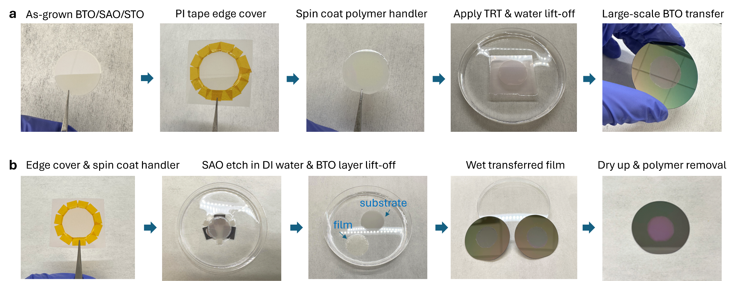

Figure S32. (a) and (b) Layer lift-off and transfer process of BTO nanomembranes via TRT (a) and PPC polymer (b) handlers respectively.

S26. Robustness of photonic vdW integration
After nanomembranes transfer and fully dry up in wet transfer, the samples are put under soft hotplate baking (80~150 °C depending on samples) for overnight to a day (Methods) to enhance nanomembranes adhesion before removing polymer handlers. After proper thermal treatment, very robust nanomembranes bonding to the substrate was experimentally verified. Mild ultrasonic for minutes will not delaminate the transferred films. Nevertheless, for prefabricated photonic substrates with varying structures, such as the bottom electrodes (discussed in Supplementary Notes 9), the film attachments are found comparatively weaker than full-dielectric or bare substrates. Highly reliable photonic vdW integration are found feasible for arbitrary substrates, as long as the substrates are in general flat and smooth¹⁴⁹ without big and dense height steps variations (Supplementary Notes 1, 19). As evidenced by Figs. 2i, 3a, 4f (in main text) and supplementary Figs. S7, S21, S31, the narrow vdW gaps observed before⁸ between layers can vanish after applying soft baking procedures, where solid bonding are experimentally confirmed instead, mediated by the abundant dangling bonds-decorated 3D nanomembrane surfaces^{1,2,25}. Currently all nanomembrane transfers are made at ambient pressure in lab, further professional bonding tools with vacuum and heating in cleanroom can further enhance the outcomes. An intriguing playground thus unfolds to coalesce various functional optical layers with optimal single-crystallinity but distinct crystal structures that are hardly accessible via direct heteroepitaxial approaches, permitting emerging opportunities for heterogeneous photonic integration^{1,2,15,25} and nanomembranes-related physics and technologies^{7,18,19,41-44,150}.
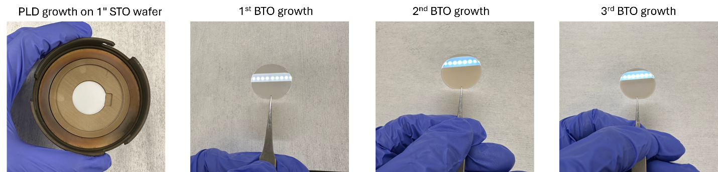

Figure S33. Manufacture cost reduction through recycling of costly substrates in the heterogeneous integration of functional nanomembranes. Repeated acetone/IPA ultrasonic bath and BOE cleaning were applied to substrate after each time of nanomembranes growth and lift-off.

Supplementary References
1 Shin, J. et al. Vertical full-colour micro-LEDs via 2D materials-based layer transfer. Nature 614, 81-87 (2023).
2 Kum, H. S. et al. Heterogeneous integration of single-crystalline complex-oxide membranes. Nature 578, 75-81 (2020).
3 Kim, H. et al. Remote epitaxy. Nature Reviews Methods Primers 2, 1-21 (2022).
4 Chang, C. S. et al. Remote epitaxial interaction through graphene. Science Advances 9, eadj5379 (2023).
5 Jia, R. et al. Long-distance remote epitaxy. Nature 646, 584-591 (2025).
6 Kum, H. et al. Epitaxial growth and layer-transfer techniques for heterogeneous integration of materials for electronic and photonic devices. Nature Electronics 2, 439-450 (2019).
7 Rogers, J. A., Lagally, M. G. & Nuzzo, R. G. Synthesis, assembly and applications of semiconductor nanomembranes. Nature 477, 45-53 (2011).
8 Moon, J.-Y. et al. Crack-Free Transfer of Wafer-Scale Freestanding Single-Crystalline Nanomembranes Enabled by Elastically Graded Polymer. Advanced Materials, e13080 (2025).
9 Kim, Y. et al. Remote epitaxy through graphene enables two-dimensional material-based layer transfer. Nature 544, 340-343 (2017).
10 Kong, W. et al. Polarity governs atomic interaction through two-dimensional materials. Nature Materials 17, 999-1004 (2018).
11 Kim, H. et al. High-throughput manufacturing of epitaxial membranes from a single wafer by 2D materials-based layer transfer process. Nature Nanotechnology 18, 464-470 (2023).
12 Kim, H. et al. Graphene nanopattern as a universal epitaxy platform for single-crystal membrane production and defect reduction. Nature Nanotechnology 17, 1054-1059 (2022).
13 Bae, S.-H. et al. Graphene-assisted spontaneous relaxation towards dislocation-free heteroepitaxy. Nature Nanotechnology 15, 272-276 (2020).
14 Lee, S. et al. Route to Enhancing Remote Epitaxy of Perovskite Complex Oxide Thin Films. ACS Nano 18, 31225-31233 (2024).
15 Choi, C. et al. Reconfigurable heterogeneous integration using stackable chips with embedded artificial intelligence. Nature Electronics 5, 386-393 (2022).
16 Shim, J. et al. Controlled crack propagation for atomic precision handling of wafer-scale two-dimensional materials. Science 362, 665-670 (2018).
17 Kim, H. et al. Role of transferred graphene on atomic interaction of GaAs for remote epitaxy. Journal of Applied Physics 130, 174901 (2021).
18 Huang, J.-K. et al. High-κ perovskite membranes as insulators for two-dimensional transistors. Nature 605, 262-267 (2022).
19 Zhang, J. et al. Super-tetragonal Sr4Al2O7 as a sacrificial layer for high-integrity freestanding oxide membranes. Science 383, 388-394 (2024).
20 Chiabrera, F. M. et al. Freestanding Perovskite Oxide Films: Synthesis, Challenges, and Properties. Annalen der Physik 534, 2200084 (2022).
21 Lisfi, A. et al. Reorientation of magnetic anisotropy in epitaxial cobalt ferrite thin films. Physical Review B 76, 054405 (2007).
22 Yanagihara, H., Uwabo, K., Minagawa, M., Kita, E. & Hirota, N. Perpendicular magnetic anisotropy in CoFe2O4(001) films epitaxially grown on MgO(001). Journal of Applied Physics 109, 07C122 (2011).
23 Kim, B., Kim, M., Li, B. D., Hool, R. D. & Lee, M. L. Cryogenic GaAs laser power converters. Solar Energy Materials and Solar Cells 281, 113321 (2025).
24 Szymanski, N. J. et al. An autonomous laboratory for the accelerated synthesis of novel materials. Nature 624, 86-91 (2023).
25 Meng, Y. et al. Photonic van der Waals integration from 2D materials to 3D nanomembranes. Nature Reviews Materials 8, 498–517 (2023).
26 Shekhar, S. et al. Roadmapping the next generation of silicon photonics. Nature Communications 15, 751 (2024).
27 Snigirev, V. et al. Ultrafast tunable lasers using lithium niobate integrated photonics. Nature 615, 411-417 (2023).
28 Chambers, S. A. et al. Molecular beam epitaxial growth and properties of CoFe2O4 on MgO(001). Journal of Magnetism and Magnetic Materials 246, 124-139 (2002).
29 Matsuzaki, K., Takagi, H., Hosono, H. & Susaki, T. Structural study of polar MgO(111) epitaxial thin films grown on SrTiO${}_{3}$(111). Physical Review B 84, 235448 (2011).
30 Niu, F., Meier, A. L. & Wessels, B. W. Epitaxial growth and strain relaxation of MgO thin films on Si grown by molecular beam epitaxy. Journal of Vacuum Science & Technology B: Microelectronics and Nanometer Structures Processing, Measurement, and Phenomena 24, 2586-2591 (2006).
31 Karvounis, A., Timpu, F., Vogler‐Neuling, V. V., Savo, R. & Grange, R. BaTiO3: Barium Titanate Nanostructures and Thin Films for Photonics Advanced Optical Materials 8, 2070094 (2020).
32 Steglich, P. & Kehrein, A. Light propagation in anisotropic materials and electro-optical effects: tutorial on the use of eigenvalue problems, tensors, and symmetries. J. Opt. Soc. Am. B 41, 2191-2210 (2024).
33 Boyd, R. W. in Nonlinear Optics 511-523 (Springer, 2008).
34 Abel, S. et al. A strong electro-optically active lead-free ferroelectric integrated on silicon. Nature Communications 4, 1671 (2013).
35 Abel, S. et al. Large Pockels effect in micro-and nanostructured barium titanate integrated on silicon. Nature Materials 18, 42-47 (2019).
36 Eltes, F. et al. An integrated optical modulator operating at cryogenic temperatures. Nature Materials 19, 1164-1168 (2020).
37 Chelladurai, D. et al. Barium titanate and lithium niobate permittivity and Pockels coefficients from megahertz to sub-terahertz frequencies. Nature Materials 24, 868-875 (2025).
38 Lee, J. W. et al. In-plane quasi-single-domain BaTiO3 via interfacial symmetry engineering. Nature Communications 12, 6784 (2021).
39 Castellanos-Gomez, A. et al. Van der Waals heterostructures. Nature Reviews Methods Primers 2, 58 (2022).
40 Geim, A. K. & Grigorieva, I. V. Van der Waals heterostructures. Nature 499, 419-425 (2013).
41 Sun, H. et al. Ferroelectric topologies in BaTiO3 nanomembranes for light field manipulation. Nature Nanotechnology 20, 881-888 (2025).
42 Yoon, H. et al. Freestanding epitaxial SrTiO3 nanomembranes via remote epitaxy using hybrid molecular beam epitaxy. Science Advances 8, eadd5328 (2022).
43 Zhang, X. et al. Atomic lift-off of epitaxial membranes for cooling-free infrared detection. Nature 641, 98-105 (2025).
44 Sánchez-Santolino, G. et al. A 2D ferroelectric vortex pattern in twisted BaTiO3 freestanding layers. Nature 626, 529-534 (2024).
45 Bae, S.-H. et al. Integration of bulk materials with two-dimensional materials for physical coupling and applications. Nature Materials 18, 550-560 (2019).
46 Tran, M. et al. Extending the spectrum of fully integrated photonics. Nature 610, 54–60 (2022).
47 De Koninck, Y. et al. GaAs nano-ridge laser diodes fully fabricated in a 300-mm CMOS pilot line. Nature 637, 63-69 (2025).
48 Riemensberger, J. et al. A photonic integrated continuous-travelling-wave parametric amplifier. Nature 612, 56-61 (2022).
49 Eltes, F. et al. A BaTiO3-Based Electro-Optic Pockels Modulator Monolithically Integrated on an Advanced Silicon Photonics Platform. J. Lightwave Technol. 37, 1456-1462 (2019).
50 Kim, B. et al. Controlling of lattice strains for crack-free and strong ferroelectric barium titanate films by post-thermal treatment. Scientific Reports 12, 5363 (2022).
51 Pintus, P. et al. Integrated non-reciprocal magneto-optics with ultra-high endurance for photonic in-memory computing. Nature Photonics 19, 54-62 (2025).
52 Wang, C. et al. Lithium tantalate photonic integrated circuits for volume manufacturing. Nature 629, 784-790 (2024).
53 Zhang, J. et al. Ultrabroadband integrated electro-optic frequency comb in lithium tantalate. Nature 637, 1096-1103 (2025).
54 Pintus, P. et al. An integrated magneto-optic modulator for cryogenic applications. Nature Electronics 5, 604-610 (2022).
55 Cai, J. et al. Heterogeneously integrated lithium tantalate-on-silicon nitride modulators for high-speed communications. (2025).
56 Thureja, P. et al. Spalled Barium Titanate Single Crystal Thin Films for Functional Device Applications. Nano Letters 25, 11089-11096 (2025).
57 Ji, D. et al. Freestanding crystalline oxide perovskites down to the monolayer limit. Nature 570, 87-90 (2019).
58 Varshney, S. et al. Hybrid Molecular Beam Epitaxy for Single-Crystalline Oxide Membranes with Binary Oxide Sacrificial Layers. ACS Nano 18, 6348-6358 (2024).
59 Narayan, J. & Larson, B. C. Domain epitaxy: A unified paradigm for thin film growth. Journal of Applied Physics 93, 278-285 (2003).
60 Sung, S.-Y., Qi, X. & Stadler, B. J. H. Integrating yttrium iron garnet onto nongarnet substrates with faster deposition rates and high reliability. Applied Physics Letters 87, 121111 (2005).
61 Messner, A. et al. Plasmonic Ferroelectric Modulators. J. Lightwave Technol. 37, 281-290 (2019).
62 Hu, Y. et al. Integrated electro-optics on thin-film lithium niobate. Nature Reviews Physics 7, 237-254 (2025).
63 Cho, S. et al. Strongly enhanced dielectric and energy storage properties in lead-free perovskite titanate thin films by alloying. Nano Energy 45, 398-406 (2018).
64 Surampalli, A. & Reddy, V. R. X-ray reciprocal space mapping study of domain evolution with electrical poling in BaTiO3 single crystal. AIP Conference Proceedings 2265, 030015 (2020).
65 Marpaung, D., Yao, J. & Capmany, J. Integrated microwave photonics. Nature Photonics 13, 80-90 (2019).
66 Wang, C. et al. Integrated lithium niobate electro-optic modulators operating at CMOS-compatible voltages. Nature 562, 101-104 (2018).
67 Zhu, D. et al. Integrated photonics on thin-film lithium niobate. Advances in Optics and Photonics 13, 242-352 (2021).
68 He, M. et al. High-performance hybrid silicon and lithium niobate Mach–Zehnder modulators for 100 Gbit s− 1 and beyond. Nature Photonics 13, 359-364 (2019).
69 Zhu, M., Du, Z., Jing, L., Yoong Tok, A. I. & Tong Teo, E. H. Optical and electro-optic anisotropy of epitaxial PZT thin films. Applied Physics Letters 107, 031907 (2015).
70 Mao, J. et al. Ultra-fast perovskite electro-optic modulator and multi-band transmission up to 300 Gbit s−1. Communications Materials 5, 114 (2024).
71 Alexander, K. et al. Nanophotonic Pockels modulators on a silicon nitride platform. Nature Communications 9, 3444 (2018).
72 Xiong, C. et al. Active Silicon Integrated Nanophotonics: Ferroelectric BaTiO3 Devices. Nano Letters 14, 1419-1425 (2014).
73 Mengxue, T. et al. Towards high quality transferred barium titanate ferroelectric hybrid integrated modulator on silicon. Light: Advanced Manufacturing 5, 479-489 (2025).
74 Ortmann, J. E. et al. Ultra-Low-Power Tuning in Hybrid Barium Titanate–Silicon Nitride Electro-optic Devices on Silicon. ACS Photonics 6, 2677-2684 (2019).
75 Dötsch, H. et al. Applications of magneto-optical waveguides in integrated optics: review. J. Opt. Soc. Am. B 22, 240-253 (2005).
76 Pingsheng, T., Towner, D. J., Meier, A. L. & Wessels, B. W. Low-loss electrooptic BaTiO/sub 3/ thin film waveguide modulator. IEEE Photonics Technology Letters 16, 1837-1839 (2004).
77 Alexander, K. et al. A manufacturable platform for photonic quantum computing. Nature 641, 876-883 (2025).
78 Kormondy, K. J. et al. Microstructure and ferroelectricity of BaTiO3 thin films on Si for integrated photonics. Nanotechnology 28, 075706 (2017).
79 Petraru, A., Schubert, J., Schmid, M., Trithaveesak, O. & Buchal, C. Integrated optical Mach Zehnder modulator based on polycrystalline BaTiO3. Opt. Lett. 28, 2527-2529 (2003).
80 In Kim, G., Yim, J. & Bahl, G. Low loss monolithic barium titanate on insulator integrated photonics with intrinsic quality factor >1 million. arXiv e-prints, arXiv:2507.17150 (2025).
81 Tang, P., Towner, D. J., Hamano, T., Meier, A. L. & Wessels, B. W. Electrooptic modulation up to 40 GHz in a barium titanate thin film waveguide modulator. Opt. Express 12, 5962-5967 (2004).
82 Dong, Z. et al. Monolithic Barium Titanate Modulators on Silicon-on-Insulator Substrates. ACS Photonics 10, 4367-4376 (2023).
83 Winiger, J. et al. PLD Epitaxial Thin-Film BaTiO3 on MgO − Dielectric and Electro-Optic Properties. Advanced Materials Interfaces 11, 2300665 (2024).
84 Cao, Y., Ng, J. D., Lin, H.-L., Tan, S. L. & Danner, A. An active straight waveguide polarization rotator in single crystal thin film barium titanate-on-insulator. Applied Physics Letters 122, 031106 (2023).
85 Valdez, F., Mere, V. & Mookherjea, S. 100 GHz bandwidth, 1 volt integrated electro-optic Mach–Zehnder modulator at near-IR wavelengths. Optica 10, 578-584 (2023).
86 Weigel, P. O. et al. Bonded thin film lithium niobate modulator on a silicon photonics platform exceeding 100 GHz 3-dB electrical modulation bandwidth. Opt. Express 26, 23728-23739 (2018).
87 Li, Y. et al. High-Performance Mach–Zehnder Modulator Based on Thin-Film Lithium Niobate with Low Voltage-Length Product. ACS Omega 8, 9644-9651 (2023).
88 Hassanien, A. E., Ghoname, A. O., Chow, E., Goddard, L. L. & Gong, S. Compact MZI modulators on thin film Z-cut lithium niobate. Opt. Express 30, 4543-4552 (2022).
89 Yang, L. et al. Volume manufacturing of thin-film lithium niobate modulators with bandwidth 110 GHz based on 4-inch wafer with a quartz handle. Light: Advanced Manufacturing 6, 575-581 (2025).
90 Xu, M. et al. High-performance coherent optical modulators based on thin-film lithium niobate platform. Nature Communications 11, 3911 (2020).
91 Powell, K. et al. A sub-volt near-IR lithium tantalate electro-optic modulator. APL Photonics 10, 091303 (2025).
92 Wang, C. et al. Ultrabroadband thin-film lithium tantalate modulator for high-speed communications. Optica 11, 1614-1620 (2024).
93 Feutmba, G. F. et al. High frequency characterization of PZT thin-films deposited by chemical solution deposition on SOI for integrated high speed electro-optic modulators. Opt. Mater. Express 13, 2120-2134 (2023).
94 Liu, G. et al. Highly efficient lead zirconate titanate ring modulator. APL Photonics 9, 066111 (2024).
95 Chmielak, B. et al. Pockels effect based fully integrated, strained silicon electro-optic modulator. Opt. Express 19, 17212-17219 (2011).
96 Xu, T. et al. Silicon-integrated scandium-doped aluminum nitride electro-optic modulator. Photon. Res. 13, 477-487 (2025).
97 Schindler, P. C. et al. Monolithic GaAs Electro-Optic IQ Modulator Demonstrated at 150 Gbit/s With 64QAM. J. Lightwave Technol. 32, 760-765 (2014).
98 Lin, S. H. & Wang, S.-Y. High-throughput GaAs PIN electrooptic modulator with a 3-dB bandwidth of 9.6 GHz at 1.3 μm. Appl. Opt. 26, 1696-1700 (1987).
99 Spickermann, R., Dagli, N. & Peters, M. in Optical Fiber Communications Conference. ThK6 (Optica Publishing Group).
100 Ogiso, Y. et al. Over 67 GHz Bandwidth and 1.5 V Vπ InP-Based Optical IQ Modulator With n-i-p-n Heterostructure. J. Lightwave Technol. 35, 1450-1455 (2017).
101 Lange, S. et al. Low Power InP-Based Monolithic DFB-Laser IQ Modulator With SiGe Differential Driver for 32-GBd QPSK Modulation. J. Lightwave Technol. 34, 1678-1682 (2016).
102 Akiyama, S. et al. in 16th IPRM. 2004 International Conference on Indium Phosphide and Related Materials, 2004. 581-584.
103 Burla, M. et al. 500 GHz plasmonic Mach-Zehnder modulator enabling sub-THz microwave photonics. APL Photonics 4, 056106 (2019).
104 Kieninger, C. et al. Silicon-organic hybrid (SOH) Mach-Zehnder modulators for 100 GBd PAM4 signaling with sub-1 dB phase-shifter loss. Opt. Express 28, 24693-24707 (2020).
105 Ummethala, S. et al. in Conference on Lasers and Electro-Optics. JTh5B.2 (Optica Publishing Group).
106 Liu, J. et al. Recent advances in polymer electro-optic modulators. RSC Advances 5, 15784-15794 (2015).
107 Geler-Kremer, J. et al. A ferroelectric multilevel non-volatile photonic phase shifter. Nature Photonics 16, 491-497 (2022).
108 Tomasulo, S. & Lee, M. L. Advances in wide-bandgap III-V solar cells. Applied Physics Reviews 12, 031309 (2025).
109 Wen, P. et al. Waveguide coupled III-V photodiodes monolithically integrated on Si. Nature Communications 13, 909 (2022).
110 Yu, Q. et al. Heterogeneous photodiodes on silicon nitride waveguides. Optics Express 28, 14824-14830 (2020).
111 Maes, D. et al. High-speed uni-traveling-carrier photodiodes on silicon nitride. APL Photonics 8, 016104 (2023).
112 Wei, C. et al. Ultra-wideband waveguide-coupled photodiodes heterogeneously integrated on a thin-film lithium niobate platform. Light: Advanced Manufacturing 4, 30 (2023).
113 Feng, S., Geng, Y., Lau, K. M. & Poon, A. W. Epitaxial III-V-on-silicon waveguide butt-coupled photodetectors. Optics Letters 37, 4035-4037 (2012).
114 Binetti, P. R. A. et al. InP/InGaAs Photodetector on SOI Photonic Circuitry. IEEE Photonics Journal 2, 299-305 (2010).
115 Chen, G. et al. Integration of high-speed GaAs metal-semiconductor-metal photodetectors by means of transfer printing for 850 nm wavelength photonic interposers. Optics Express 26, 6351-6359 (2018).
116 Lasaosa, D. et al. Traveling-wave photodetectors with high power-bandwidth and gain-bandwidth product performance. IEEE Journal of Selected Topics in Quantum Electronics 10, 728-741 (2004).
117 Lei, L., Yujie, L., Chulchae, C., Bipin, B. & Ray, T. C. in Proc.SPIE. 10-16.
118 Jafari, M., Fatema, T., Carlson, D. R., Papp, S. B. & Beling, A. Heterogeneously Integrated AlGaAs/GaAs Photodiodes on Tantala Waveguides. J. Lightwave Technol. 42, 8302-8307 (2024).
119 Geum, D.-M. et al. Monolithic integration of visible GaAs and near-infrared InGaAs for multicolor photodetectors by using high-throughput epitaxial lift-off toward high-resolution imaging systems. Scientific Reports 9, 18661 (2019).
120 Wang, J. et al. InGaP/AlGaAs Near-UV and Visible Avalanche Photodiodes for Li-Fi Application. IEEE Photonics Technology Letters 36, 293-296 (2024).
121 Park, T.-Y. et al. 2-Gb/s ultraviolet-light optical wireless communication by InGaN/GaN multi-quantum well dual-function micro-photodetector. Applied Physics Letters 124, 061110 (2024).
122 Wang, J. et al. Polarization assisted self-powered GaN-based UV photodetector with high responsivity. Photon. Res. 9, 734-740 (2021).
123 Chang, S.-J. et al. AlGaN Ultraviolet Metal–Semiconductor–Metal Photodetectors with Low-Temperature-Grown Cap Layers. Japanese Journal of Applied Physics 46, 2471 (2007).
124 Yan, W. et al. On-Chip Nonreciprocal Photonic Devices Based on Hybrid Integration of Magneto-Optical Garnet Thin Films on Silicon. IEEE Journal of Selected Topics in Quantum Electronics 28, 1-15 (2022).
125 Armelles, G., Cebollada, A. & Alvaro, R. Plasmon-phonon interaction effects on the magneto refractive response of spintronic-plasmonic/dielectric structures. Optical Materials Express 12, 1092-1101 (2022).
126 Wei, Z. et al. Recent development of magneto-optical thin films and integrated photonic devices. Journal of Materials Chemistry C 13, 12628-12649 (2025).
127 Serrano-Núñez, M. A., Shoji, Y. & Mizumoto, T. Small magnetless integrated optical isolator using a magnetized cobalt ferrite film. IEICE Electronics Express 19, 20210500-20210500 (2022).
128 Choueikani, F. et al. Magneto-optical waveguides made of cobalt ferrite nanoparticles embedded in silica/zirconia organic-inorganic matrix. 94 (2009).
129 Serrano-Núñez, M. A., Shoji, Y. & Mizumoto, T. J. A. P. E. Giant Faraday rotation of cobalt ferrite thin films deposited on silicon substrates for silicon photonic nonreciprocal device applications. Applied Physics Express 13, 062002 (2020).
130 Sato, K., Okano, M. & Shoji, Y. Ultra-compact microring optical isolator using an aluminum-substituted cobalt ferrite thin film. Optica 11, 889-895 (2024).
131 Srinivasan, K. & Stadler, B. J. Magneto-optical materials and designs for integrated TE-and TM-mode planar waveguide isolators: a review. Optical Materials Express 8, 3307-3318 (2018).
132 Dillon, J. F., Jr. Origin and Uses of the Faraday Rotation in Magnetic Crystals. Journal of Applied Physics 39, 922-929 (1968).
133 Yan, W. et al. Ultra-broadband magneto-optical isolators and circulators on a silicon nitride photonics platform. Optica 11, 376-384 (2024).
134 Zhu, X. D. Magnetic domains and unusual hysteresis loops of yttrium iron garnet crystals revealed by magneto-optic effects. AIP Advances 11, 085214 (2021).
135 Li, G. et al. Tunable perpendicular magnetic anisotropy in epitaxial Y3Fe5O12 films. APL Materials 7, 041104 (2019).
136 Zhang, Y. et al. Monolithic integration of broadband optical isolators for polarization-diverse silicon photonics. Optica 6, 473-478 (2019).
137 Tien, M.-C., Mizumoto, T., Pintus, P., Kromer, H. & Bowers, J. E. J. O. e. Silicon ring isolators with bonded nonreciprocal magneto-optic garnets. 19, 11740-11745 (2011).
138 Shoji, Y., Mizumoto, T., Yokoi, H., Hsieh, I.-W. & Osgood, R. M. J. A. p. l. Magneto-optical isolator with silicon waveguides fabricated by direct bonding. 92 (2008).
139 Yan, W. et al. Waveguide-integrated high-performance magneto-optical isolators and circulators on silicon nitride platforms. 7, 1555-1562 (2020).
140 Ghosh, S. et al. Ce: YIG/Silicon-on-Insulator waveguide optical isolator realized by adhesive bonding. 20, 1839-1848 (2012).
141 Bi, L. et al. Magneto-optical thin films for on-chip monolithic integration of non-reciprocal photonic devices. 6, 5094-5117 (2013).
142 Bi, L. et al. On-chip optical isolation in monolithically integrated non-reciprocal optical resonators. Nature Photonics 5, 758-762 (2011).
143 Srinivasan, K. et al. High-gyrotropy seedlayer-free Ce: TbIG for monolithic laser-matched SOI optical isolators. 6, 2455-2461 (2019).
144 Šimša, Z. et al. Optical absorption and faraday rotation of barium hexaferrite films prepared by laser ablation deposition. 59, 111-119 (1998).
145 Sukhorukov, Y. P. et al. Magnetooptical Faraday effect in La0. 7Sr0. 3MnO3− δ films. 46, 778-781 (2001).
146 Park, S. H. et al. Universal selective transfer printing via micro-vacuum force. Nature Communications 14, 7744 (2023).
147 Masubuchi, S. et al. Autonomous robotic searching and assembly of two-dimensional crystals to build van der Waals superlattices. Nature Communications 9, 1413 (2018).
148 Niklaus, F., Stemme, G., Lu, J. Q. & Gutmann, R. J. Adhesive wafer bonding. Journal of Applied Physics 99, 031101 (2006).
149 Han, S. et al. High energy density in artificial heterostructures through relaxation time modulation. Science 384, 312-317 (2024).
150 Xu, R. et al. Strain-induced room-temperature ferroelectricity in SrTiO3 membranes. Nature Communications 11, 3141 (2020).

