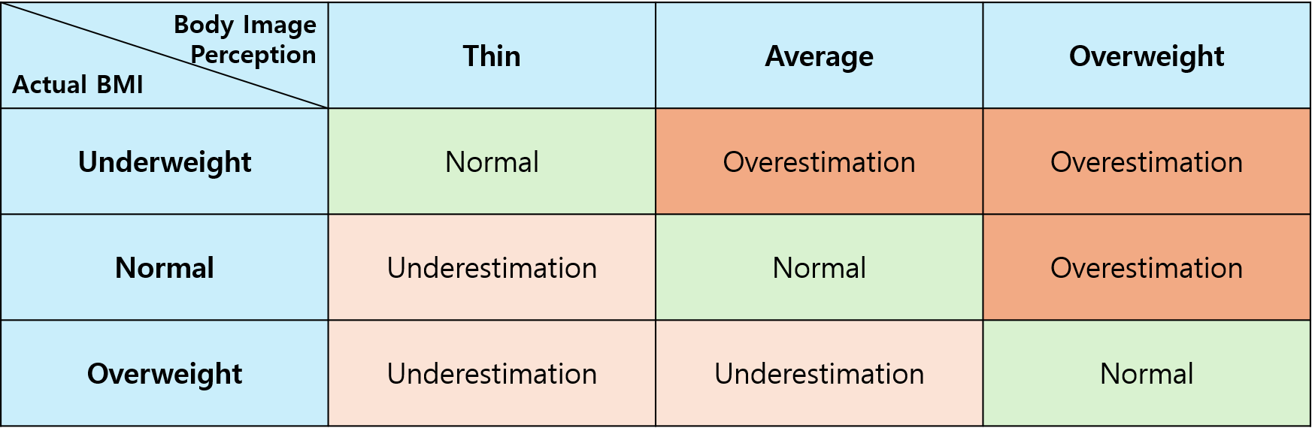
Adolescent BMI and Body Image Perception
Actual BMI vs. Perceived Body Image: Normal, Underestimation, and Overestimation

