Table of Contents
Supplementary Fig. 1-10 2-10

Supplementary Table. 1 13

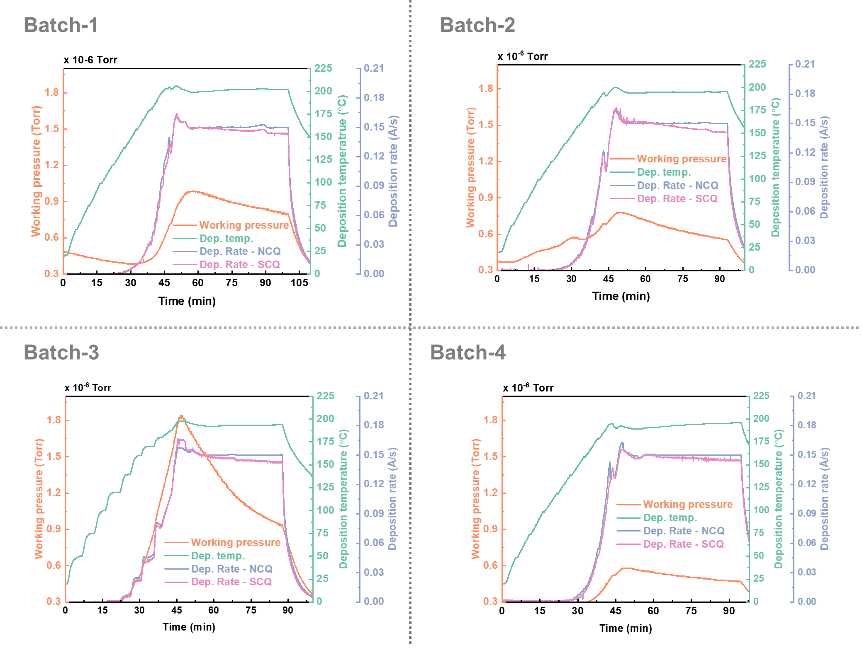
Supplementary Fig. 1 | FAI evaporation characteristics across four independent batches under identical conditions. All batches exhibited nearly identical profiles, where the SCQ rate overlapped with the NCQ during the ramp and early steady-state stages and subsequently decreased by 3~5% while the NCQ remained constant.

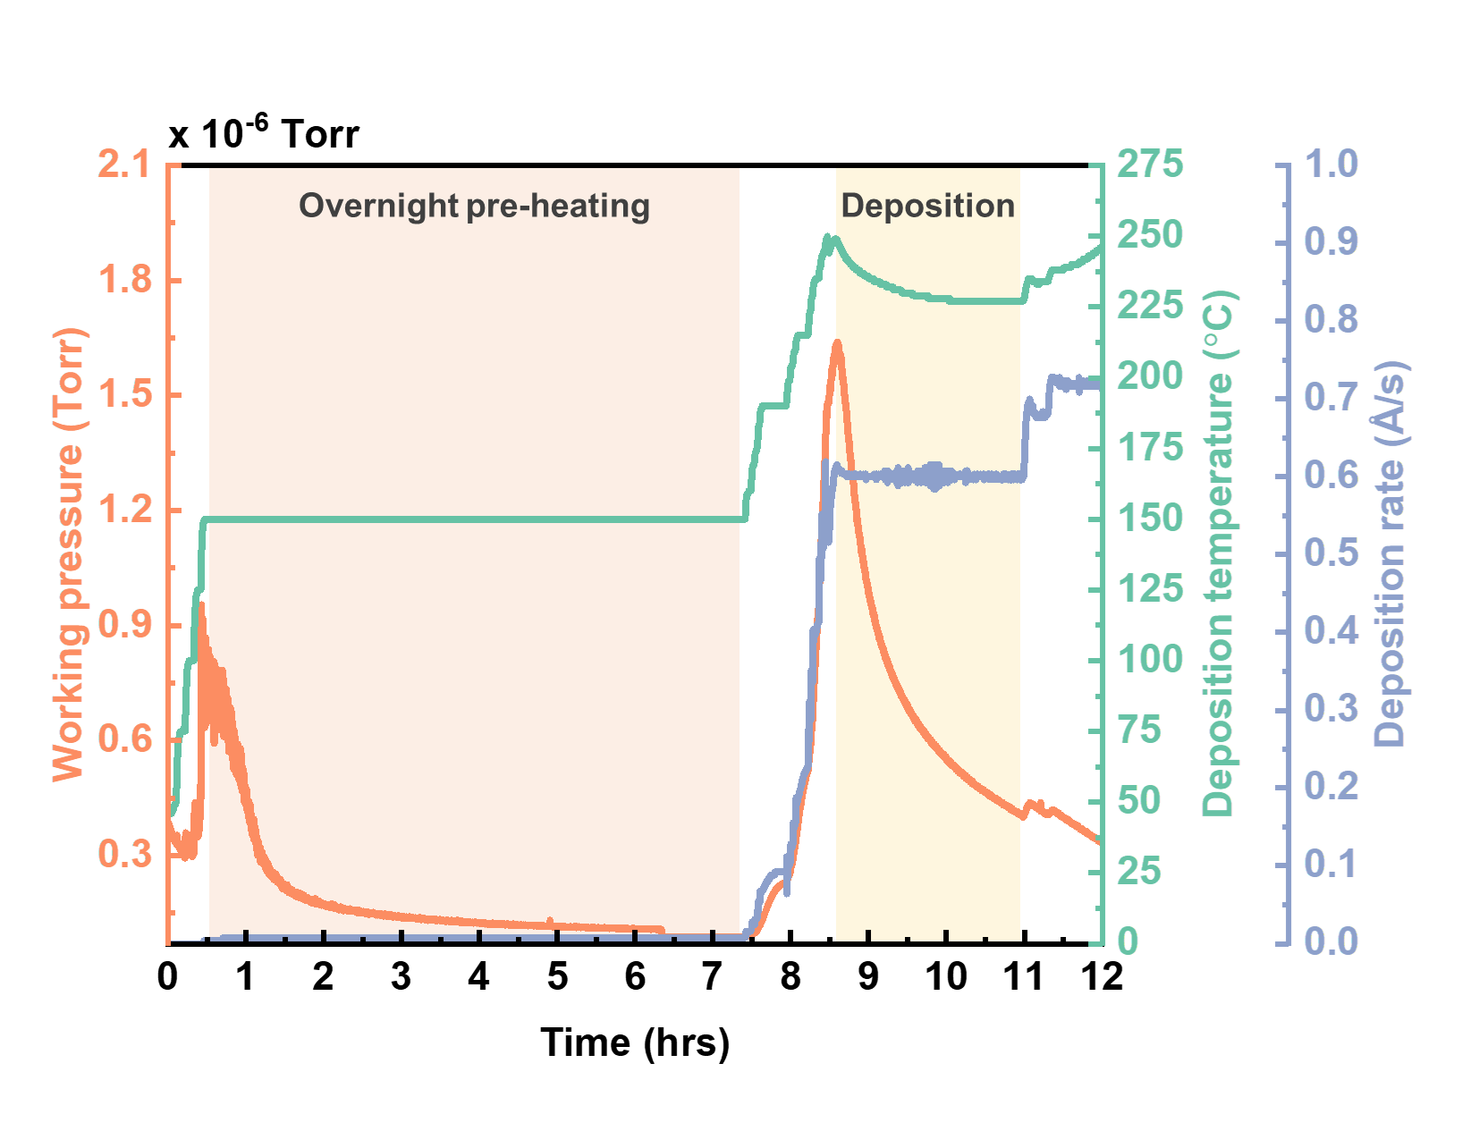
Supplementary Fig. 2 | FAI evaporation characteristics maintained after overnight pre-heating. The FAI-loaded crucible was pre-heated at 150 °C for ~7 h prior to deposition. After pre-heating, the FAI source exhibited its characteristic evaporation behavior, including the pressure rise and subsequent decay profile, indicating that pre-heating does not alter the intrinsic sublimation behavior of FAI.

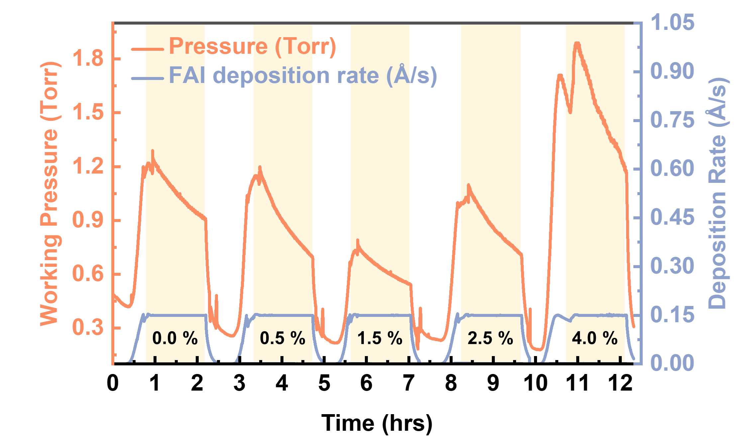
Supplementary Fig. 3 | Real-time monitoring of FAI evaporation behavior during perovskite film fabrication. Working pressure and FAI deposition rate recorded during consecutive perovskite deposition steps with varying MACl additive molar ratios (0.0%, 0.5%, 1.5%, 2.5%, and 4.0%). Consistent with the standalone FAI sublimation tests, the working pressure decreased at 0.5% and 1.5% MACl, whereas it increased at 2.5% and 4.0%, confirming that the MACl-dependent pressure response of FAI is preserved during actual perovskite film fabrication.

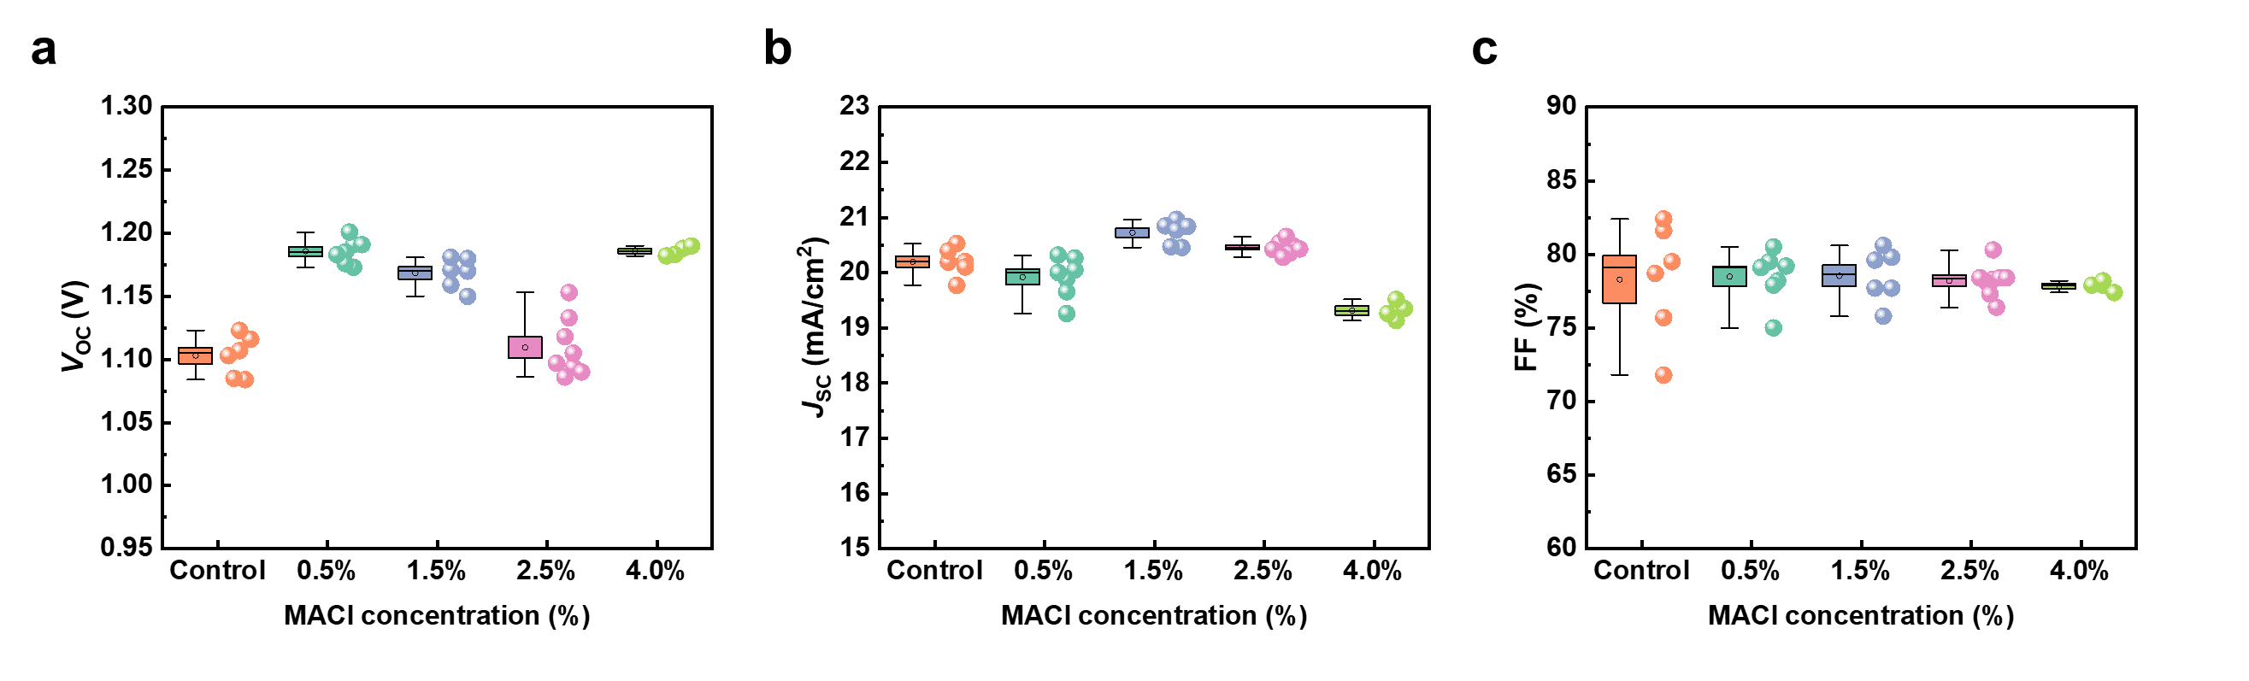
Supplementary Fig. 4 | Detailed distributions of photovoltaic parameters for each MACl concentration. Device-to-device distributions of (a) open-circuit voltage (V_{OC}), (b) short-circuit current density (J_{SC}), and (c) fill factor (FF) for perovskite solar cells prepared with varying MACl concentrations (Control, 0.5, 1.5, 2.5, and 4.0%). These data provide the detailed statistical spread corresponding to the performance trends summarized in Fig. 3f.

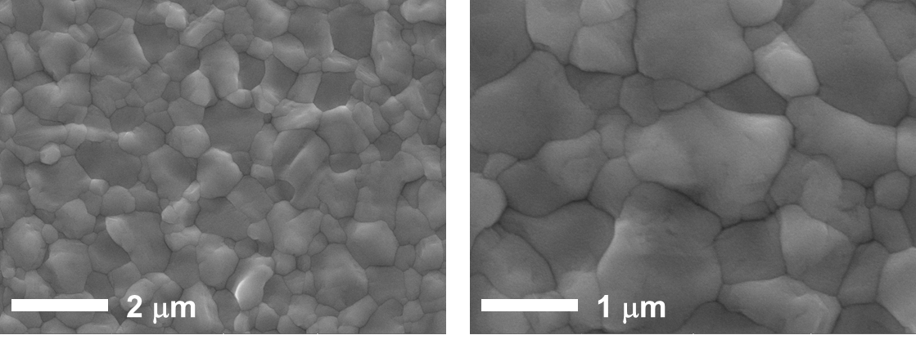
Supplementary Fig. 5 | SEM morphology of perovskite films prepared using FAI containing 1.5% MACl. Top-view SEM images of perovskite films deposited with FAI containing 1.5% MACl, showing compact and uniformly packed grains characteristic of this optimized additive condition.

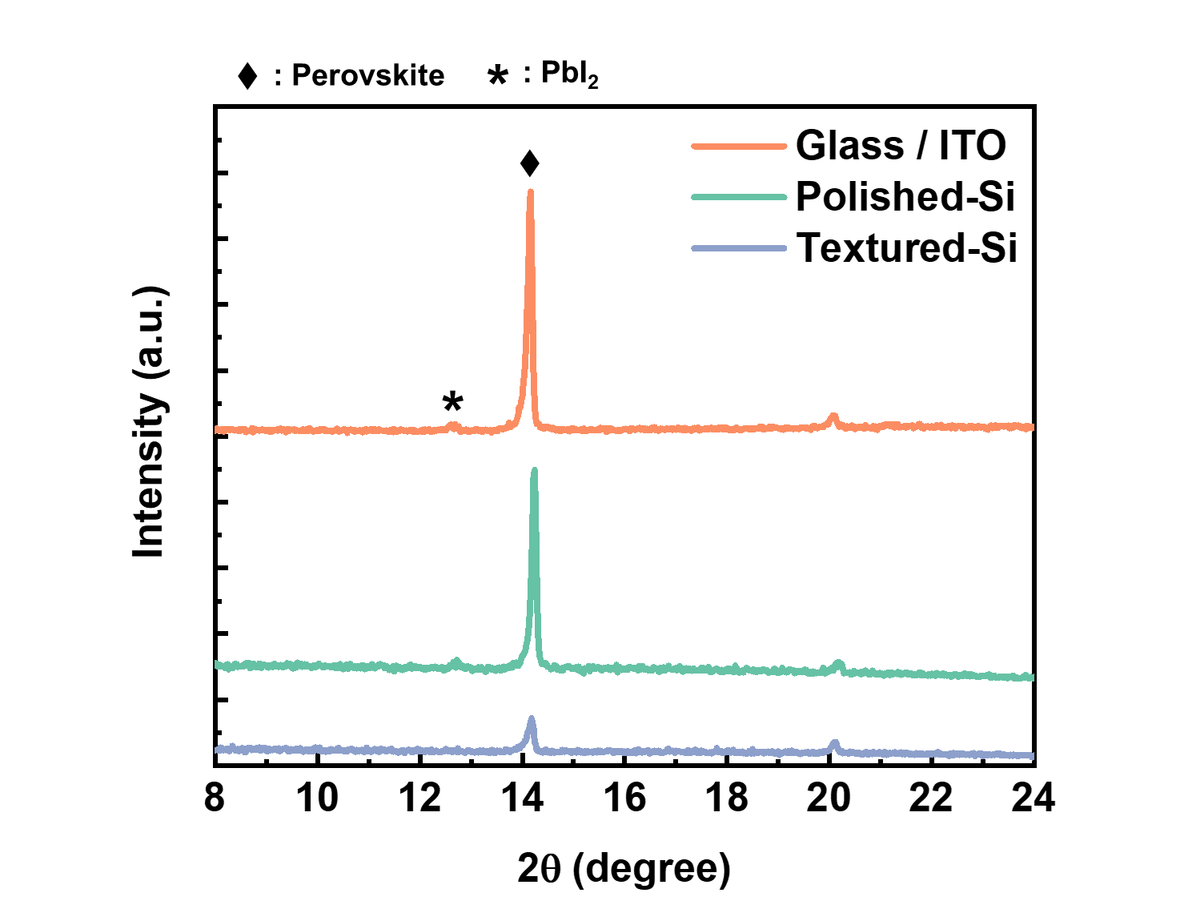
Supplementary Fig. 6 | XRD patterns of perovskite films deposited on different substrate. X-ray diffraction (XRD) patterns of perovskite films deposited on Glass/ITO, polished-silicon, and textured-silicon bottom cells. The perovskite diffraction peak is significantly weaker on the textured-Si bottom cells than on Glass/ITO and polished-Si, indicating reduced perovskite crystallinity on the tilted pyramidal facets, in line with the growth-mode change discussed in the main text.

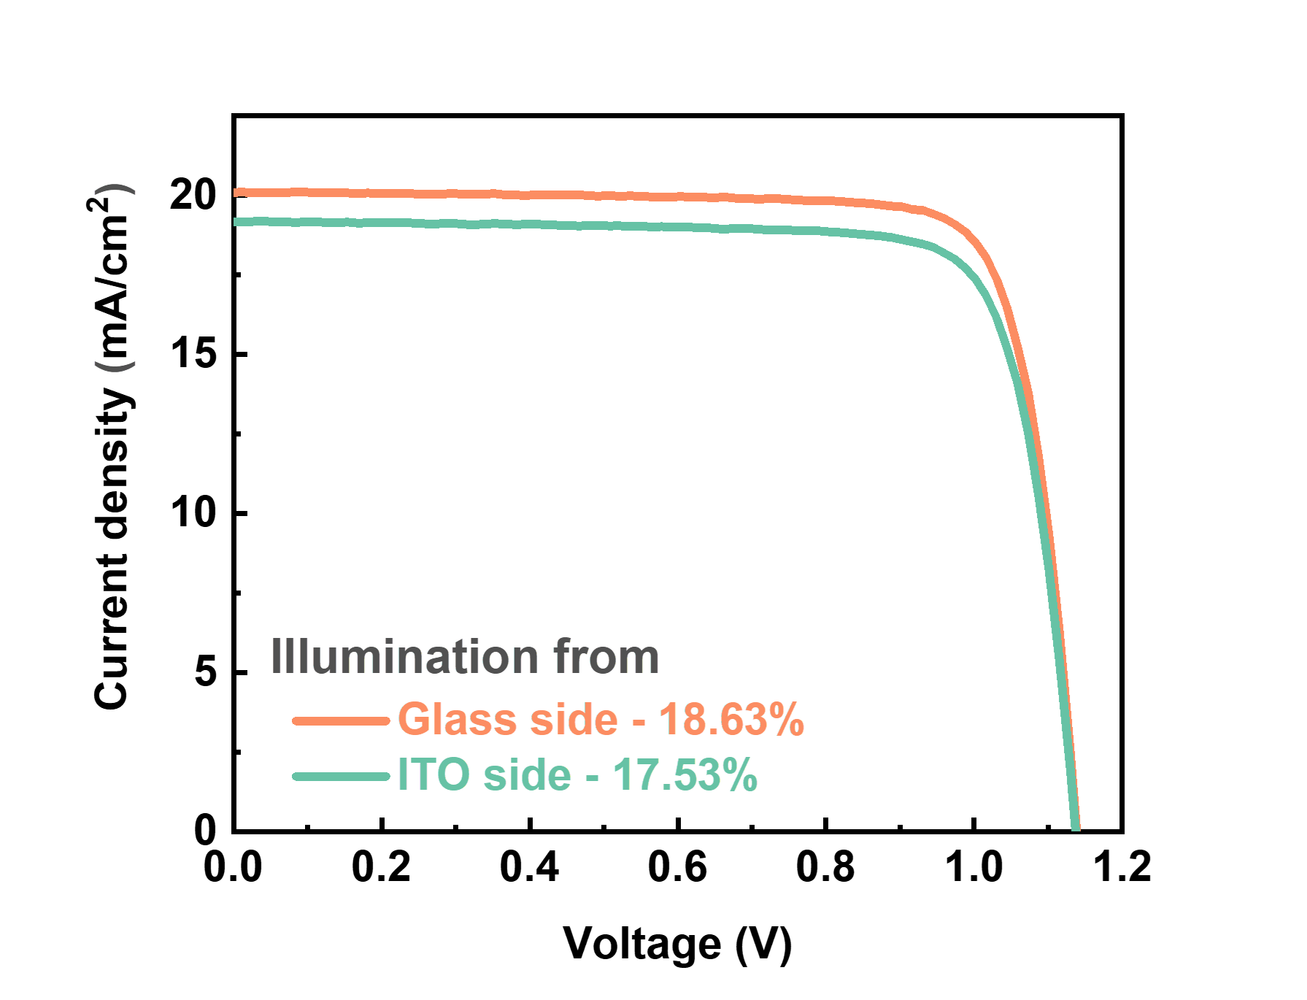
Supplementary Fig. 7 | J-V characteristics of semi-transparent single-junction PSCs fabricated from the same batch as the tandem devices. J-V curves of the semi-transparent single-junction perovskite solar cells measured under glass-side and ITO-side illumination. The device, fabricated from the same deposition batch as the tandem cells (Fig. 4), shows consistent photovoltaic performance with PCEs of 18.63% (glass side) and 17.53% (ITO side).

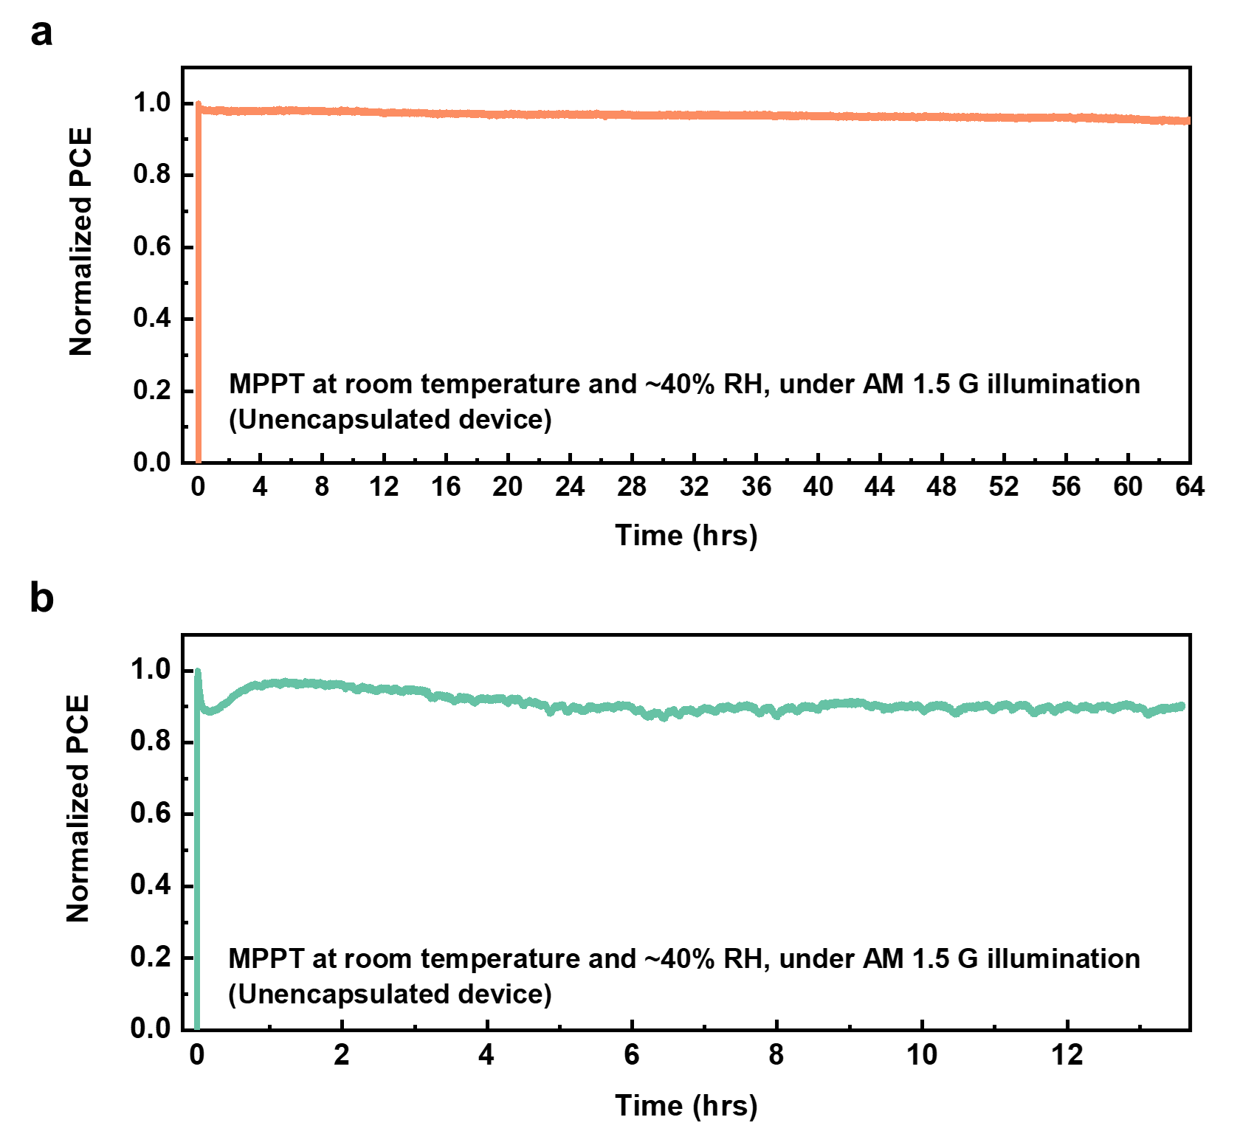
Supplementary Fig. 8 | MPPT stability of tandem devices on polished and textured silicon bottom cells. Maximum power point tracking (MPPT) measurements performed on unencapsulated tandem devices fabricated on (a) polished-Si and (b) textured-Si bottom cells. Under continuous AM 1.5 G illumination at ~40% RH, the polished-Si device retains ~95% of its initial efficiency for 64 h, whereas the textured-Si device maintains ~90% over 13 h.

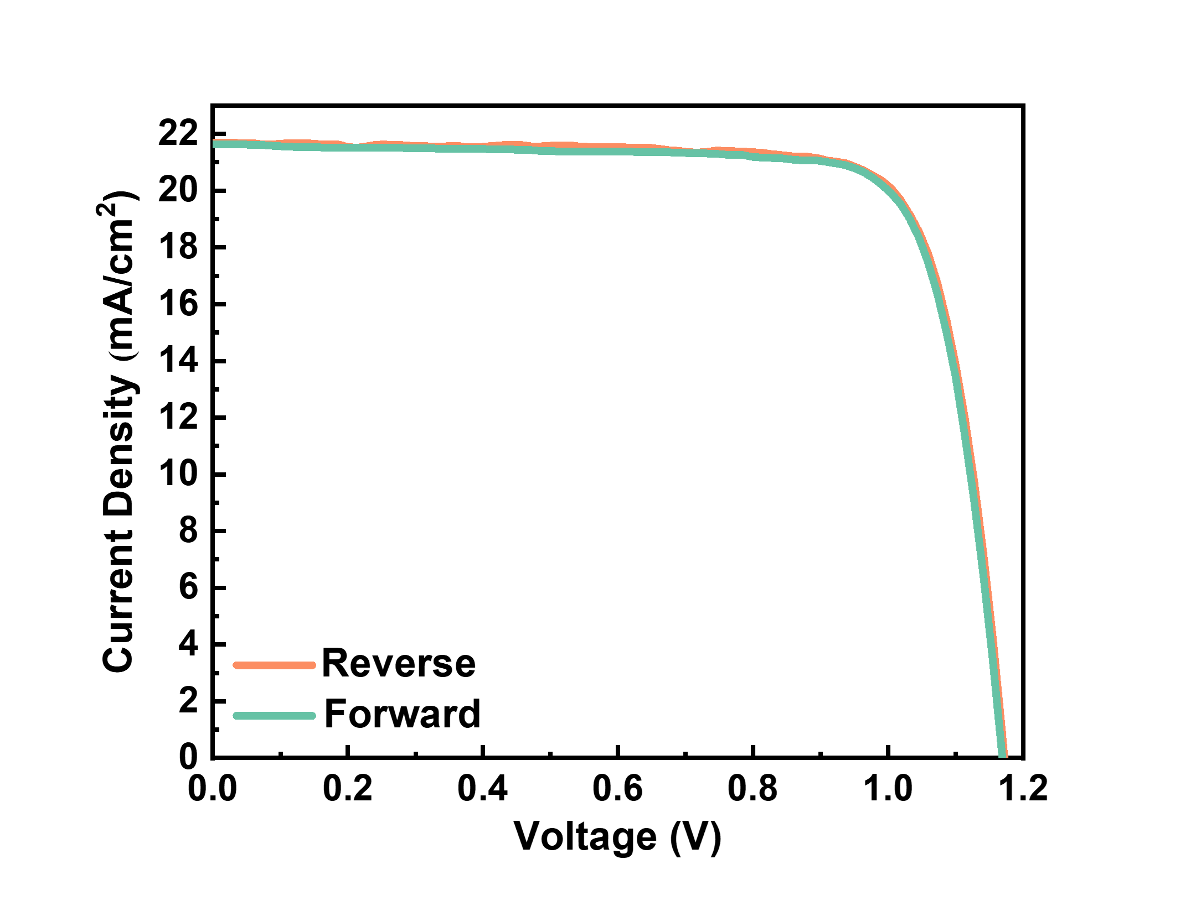
Supplementary Fig. 9 | Certified J-V characteristics of the champion perovskite solar cell. Reverse and forward J–V scans of the champion wide-bandgap perovskite solar cell corresponding to the certified efficiency reported in Fig. 3g. The device achieves certified PCEs of 20.2% (reverse) and 20.0% (forward), as issued by Chungbuk Technopark, Korea (http://www.cbtp.co.kr). Both scan directions show nearly overlapping curves, indicating negligible hysteresis and confirming the reliability of the certified performance.

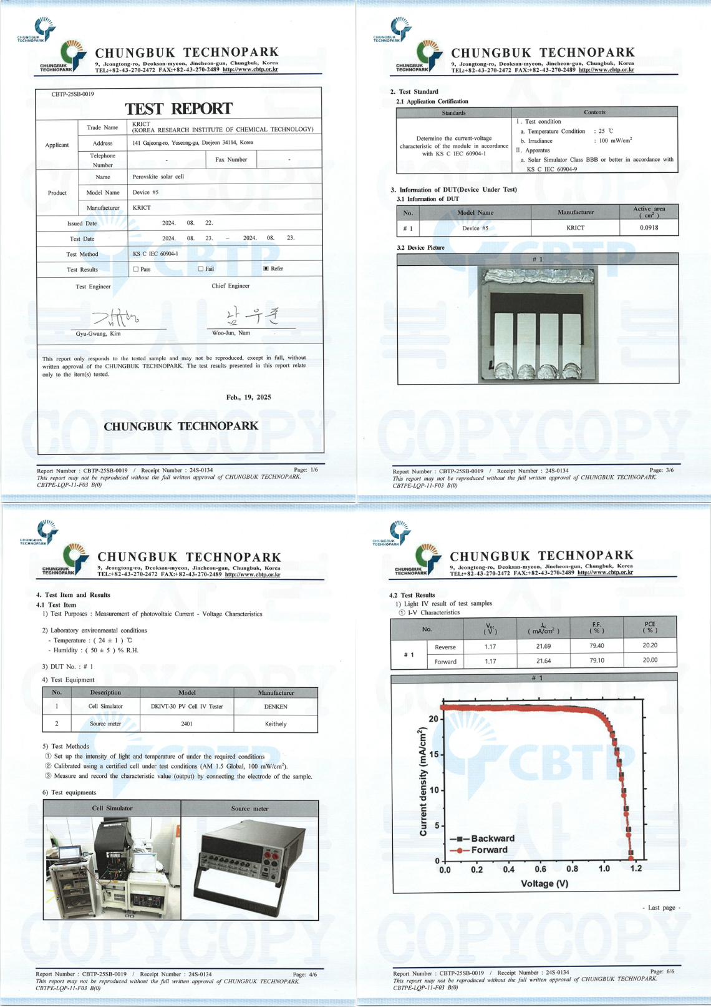
Supplementary Fig. 10 | Certified test report issued by Chungbuk Technopark. Official certification documents for the champion perovskite solar cell reported in Fig. 3g, issued by Chungbuk Technopark, Korea (http://www.cbtp.co.kr). The report includes the measured J–V characteristics and certified PCEs of 20.2% (reverse) and 20.0% (forward).

 | V_{OC}  (V) | J_{SC} (mA/cm²) | FF  (%) | PCE  (%)
Reverse | 1.17 | 21.69 | 79.40 | 20.20
Forward | 1.17 | 21.64 | 79.10 | 20.00

Supplementary Table 1 | Detailed photovoltaic parameters of the certified champion device. Photovoltaic parameters (V_{OC}, J_{SC}, FF, and PCE) of the champion wide-bandgap perovskite solar cell corresponding to the certified J–V measurements shown in Supplementary Fig. 9, including reverse and forward scan values issued by Chungbuk Technopark.

