Supplementary Information

High wellbeing with lower energy consumption: scenarios for India’s residential sector

Alessio Mastrucci¹, Souran Chatterjee², Kaveri Ashok³, Vassilis Daioglou^{4,5}, Srihari Dukkipati⁶, Ashok Sreenivas⁶, Oreane Edelenbosch⁵, Poornima Kumar⁷, Diana Ürge-Vorsatz⁸, Sarah Khan³, Ramya Natarajan³, Victhalia Zapata⁵, Shonali Pachauri¹

¹Energy, Climate, and Environment (ECE) Program, International Institute for Applied Systems Analysis (IIASA), Laxenburg, Austria
²School of Geography, Earth and Environmental Sciences, University of Plymouth, Plymouth, United Kingdom
³Center for Study of Science, Technology and Policy (CSTEP), Bangalore, India
⁴PBL Netherlands Environmental Assessment Agency, The Hague, the Netherlands
⁵Copernicus Institute of Sustainable Development, Utrecht University, Utrecht, the Netherlands
⁶Prayas (Energy Group), Pune, India
⁷Environmental Change Institute (ECI), Oxford University, Oxford, United Kingdom
⁸Department of Environmental Sciences and Policy, Central European University, Vienna, Austria

Contents

Supplementary Methods 2
Models documentation 2
Modelling protocol 6
Research goals 6
Scenario runs 6
Scenario setup 6
Variable template 7
Supplementary Note 9
References 12

Supplementary Methods

Models documentation
This section provides additional documentation on the models in this study and scenarios implementation. Supplementary Table 1 reports detailed information on the model identity, scope, and modelling approaches. Supplementary Table 2 describes the model granularity in geographical context, socio-economics, and housing characteristics. Supplementary Table 3 provides description of the implementation of aspects related to DLS provision, including model dynamics and relevant model parameters and units defining service levels. We provide an overview of the five models here below.
HEB¹ is a global model to analyse building energy use and CO₂ emissions. This model calculates with the overall energy performance levels of buildings regardless of the measures applied to achieve it. Moreover, this model also captures the diversity of solutions required in each region by having region-specific assumptions about advanced and sub-optimal technology mixes. The elaborated model is in the framework of the bottom-up approach, as it includes rather detailed technological information for one sector of economy, however, it also benefits from certain macroeconomic (GDP) and sociodemographic data (population, urbanization rate, floor area per capita, etc.).
IMAGE^{2,3} is an integrated assessment model (IAM) describing the relationships between humans and natural systems, including energy use, land use, and greenhouse gas emissions. The energy module of IMAGE uses recursive dynamics to project supply and demand of primary and secondary energy carriers needed to provide energy services for different end-use sectors. The model represents the global energy system disaggregated across 26 global regions. Residential energy demand is projected as a result building stock turnover, insulation and efficiency levels, renovation rates, investment in rooftop PV, end use demand and shifts, technological progress, technology, fuel choices, and emergence of prosumers. The model makes a distinction between urban and rural energy demand and across income quintiles.
MESSAGEix-Buildings⁴ is a building sector modelling framework to assess the stock turnover, energy and material demands, and greenhouse gas (GHG) emissions of buildings at national, regional, and global scales. Specific modules within this framework use different bottom-up methods to estimate heating and cooling demands (CHILLED module) and building stock turnover and energy efficiency investment decisions (STURM module) in future scenarios. The framework is linked to the MESSAGEix-GLOBIOM IAM (Huppmann et al. 2019) to account for linkages between the demand- and supply-side systems under different policy scenarios. The model is highly granular, including detailed representation of geographical, socio-economics, and building heterogeneities.
PIER^{5,6} is an open-data, demand-oriented model built upon Rumi, an open-source energy systems modelling platform. This national model is used to understand future trajectories of the Indian energy sector through bottom up estimation of energy service demand and technologies and optimising the energy supply technologies to meet the estimated demand. PIER models the residential energy demand, based on bottom-up modelling of different energy services at state-level by urban and rural areas, based on drivers such as appliance penetrations, per-capita GDP growth and temperature.
SAFARI⁷ is a national system dynamics model designed to explore pathways for India to reduce emissions while maintaining developmental progress. The model specifically aims to assess how to provide a basic quality of life for all citizens, especially those who currently lack access to essential needs such as food, shelter, and inclusive mobility. By having development goals drive demand growth across various sectors, SAFARI evaluates alternative, low-carbon strategies to achieve these objectives. This approach balances developmental and environmental priorities, examining trade-offs related to resource constraints and identifying potential synergies to capitalise on.

Supplementary Table 1 Detailed models documentation.

 | HEB | IMAGE | MESSAGEix-Buildings | PIER | SAFARI
Identity
Full name and version | High-efficiency Building model (HEB)-2.0 | IMAGE 3.4 – Integrated Assessment Model | MESSAGEix-Buildings  (CHILLED and STURM modules) | Perspectives on Indian Energy based on Rumi. Residential demand estimation from PIER 1.5 used for this paper | Sustainable Alternative Futures for India
Abbreviation | HEB | IMAGE | MESSAGEix-Buildings | PIER | SAFARI
Institution | Central European University (CEU), University of Plymouth | PBL, The Netherlands Environmental Assessment Agency | IIASA | Prayas (Energy Group) | Center for Study of Science, Technology, and Policy, India
Model documentation | ¹ | ^{2,3} | ⁴ | ^{5,6} | ⁷
Scope
Sector | Buildings | Buildings | Buildings | Multi-Sectoral | Buildings
Subsector | Residential/Commercial | Residential/Commercial | Residential/Commercial | Residential | Residential/Commercial
Geographical scope | Global | Global | Global | India | India
Geographical resolution | 12 Regions | 26 regions | 60 regions | National, Sub-national or local | National
Temporal resolution | Annual/hourly | Annual | Five-year | Annual | Annual
Base year | 2022 | 2025 | 2015 | 2020-21 | 2011
End year | 2060 | 2100 | 2100 | 2040-41 | 2051
Modelling approach
Overall approach | Bottom-up (engineering approach) | Hybrid | Bottom-up (engineering approach) | Bottom-up (engineering approach) | Hybrid
Methods | Accounting | Simulation | Simulation | Accounting | Simulation, System dynamics
Linkages to other models | BISE model (energy supply-side model) | Runs within the energy model of the IMAGE framework (TIMER), links to energy prices calculated by the supply modules, which are affected by demand choices | MESSAGEix-GLOBIOM (Integrated Assessment Model - energy supply) | Stand-alone model | Soft-linked with a CGE model
Methods: energy demand calculation for space cooling and heating | Engineering energy demand model based on floor area, socio-economic data, energy intensity, variable degree days | Floorspace, HDD, CDD, GDP, Population, technology choice, energy price, technology development, household size, electrification | Engineering energy demand model based on variable degree days | Engineering energy demand model projecting penetration of cooling appliances and cooling degree hours based on temperature projections | Based on fan and AC penetration rates and weighted usage hours and wattage. Cooling demand estimation via building envelope charateristics also included.
Methods: energy demand calculation for cooking and appliances | Not available | GDP, Population, technology choice, energy price, technology development | Engineering energy demand model based on projected appliances penetration and energy intensity coefficients | Engineering energy demand model projecting penetration of different cooking fuels and appliances | Based on urban and rural penetration rates of different cooking fuels and average cooking useful energy requirement for an Indian household
Methods: building stock turnover | Not available | stock turnover model | Dynamic material flow analysis (MFA) | Not available | Stock turn-over based on ageing chain and building condition
Methods: building efficiency improvements | Mostly assumption based socio-economic data were used (linear projection) | Market shares of different insulation levels based on logit function. Choice depends on life cycle cost calculation accounting for investments and potential savings. Improvements can be made during construction or as "renovation" in existing stocks. | Discrete choice models based on life cycle cost calculation for energy efficiency decisions of households. Exogenous assumptions on energy efficiency improvements of heating, cooling systems, and appliances. | Can be modelled with suitable assumptions/inputs

Supplementary Table 2 Models granularity.
Model | Geographical context |  |  | Socio-economics |  | Housing characteristics
 | States | Urban/  Rural | Climatic zones | Household size | Income groups | Housing types | Energy efficiency cohorts | Informal housing
HEB |  | X | X |  |  | X | X | X
IMAGE |  | X | X | X | X | X | X
MESSAGEix-Buildings |  | X | X |  | X | X | X | X
PIER | X | X | X | X
SAFARI |  | X |  | X | X | X | X | X

Supplementary Table 3 Model representation of aspects related to Decent Living Standard (DLS) provision: model dynamics (EN = endogenous, EX = exogenous) and relevant model parameters and units defining service levels.
Model | Durable housing | Sufficient housing size | Thermal comfort – cooling | Clean cooking | Appliances
HEB | EX: Floorspace informal buildings (m2) | EX: Floorspace (m2/cap) | - | - | -
IMAGE | - | EN: Floorspace (m2/cap) | EN: access to AC, air coolers, and fans (%households) | EN: Access to clean cooking (%households) | EN: access to appliances (%households, 8 appliance groups)
MESSAGEix-Buildings | EN-EX: Access to formal housing in urban (%households) | EX: Floorspace (m2/cap) | EN-EX: access to AC and fans (%households) | EX: Access to clean cooking (%households) | EX: access to appliances (%households)
PIER | - | - | EN-EX: penetrations of AC, air coolers, and fans (%households) | EN-EX: Access to clean cooking (%households) | EN-EX: access to appliances (%households)
SAFARI | EX: Access to durable housing (%households) | EX: Average built-up area per housing category (m2) | EN-EX: penetration of AC and fans (%households) | EN-EX: Access to clean cooking (%households) | EN-EX: access to appliances (%households)

Modelling protocol

Research goals
The goal of this study is to analyse the energy and CO₂ emission implications of decent living standards (DLS) provision and implementation of demand-side measures via supportive policies and widely available technologies for the residential sector in India under different climate policies. The investigated energy end-uses include space cooling, cooking and appliances. We focus on five key dimensions of DLS: durable housing, sufficient floorspace, basic cooling thermal comfort, access to clean fuels for cooking, and basic appliances, including refrigerators and televisions. The scenarios cover the time period 2020-2050.

Scenario runs
Supplementary Table 4 provides an overview of the model runs, including three main scenarios (Reference, Decent Living, and Decent living – Demand measures) and two sets of climate policies (Current Policies, and Mitigation Policies).

Supplementary Table 4 Scenario runs.
Run | Scenario | Climate Policy
1 | Reference (REF) | Current Policies
2 | Decent Living (DL) | Current Policies
3 | Decent living – Demand measures (DL-DEM) | Current Policies
4 | Reference (REF) | Mitigation Policies
5 | Decent Living (DL) | Mitigation Policies
6 | Decent living – Demand measures (DL-DEM) | Mitigation Policies

Scenario setup
The demographics and socio-economics underlying all scenarios, including population, gross domestic product (GDP), and urbanization should be well aligned with the Shared Socioeconomic Pathway SSP2 “Middle of the road” with medium challenges to both mitigation and adaptation⁸.

The Reference scenario represents a baseline with continuation of current policies and is in line with the Shared Socioeconomic Pathway SSP2 “Middle of the road” ⁸. Access to DLS and energy efficiency improvements follow current trends.

The Decent Living scenarios assumes an improvement in access to basic services and amenities to provide near universal access to DLS by 2050 (target year). The minimum requirements for DLS, consistent with previous literature^{9,10}, should be achieved by the target year:
- Floorspace: at least 10m²/cap with a minimum of 30m² per household
- Durable homes: eradication of informal housing in urban settlements
- Cooling: access to fans and/or air-conditioners where needed to shelter from heat.
- Clean cooking: access to clean cooking stoves
- Appliances: access to basic appliances, including to refrigerators and televisions

The Decent Living – Demand-side measures scenario combines improved access to wellbeing in line with the Decent Living scenario and additional demand-side measures achievable with currently available technologies, representing the best case scenario for technological improvements and behavioural change. Energy efficiency improvements include the following measures:
- Energy-efficient building shell interventions in new buildings, such as improved building insulation, windows, and shading.
- Energy efficient heating and cooling systems.
- Energy-efficient cooking stoves and appliances.
- Electrification
- Behavioural change limiting energy demand.
We consider two sets of climate policies strategies. The Current Policies strategies assume continuation of current policies but no stringent climate policies. The Mitigation Policies strategies assume stringent climate policies aligned with the 1.5°C target. The end-of-century carbon budget associated with this scenario (2020-2100) is 600 GtCO₂.

Variable template
Supplementary Table 2 reports the variable template for this study, based on the IAMC time-series data template¹². Additional variables were defined at more granular level, depending on the output of specific models.

Supplementary Table 5 Time-series data variable template.
Category | Variable | Unit | Definition
demography | Population | million | Total population
DLS | Population|Air Conditioning Access | million | Population with access to air conditioning.
DLS | Population|Fan Access | million | Population with access to fans.
DLS | Population|Informal Settlements | million | Population living in informal settlements
DLS | Population|Electricity Access | million | Population with access to electricity
DLS | Population|Clean Cooking Access | million | Population with access to clean cooking (e.g. non-solid fuels)
DLS | Population|Refrigerator Access | million | Population with access to refrigerators.
DLS | Population|Television Access | million | Population with access to televisions.
energy service | Energy Service|Residential|Floor Space | billion m2 | Energy service demand for conditioned floor space in residential
final energy | Final Energy|Residential | EJ/yr | Final energy consumed in the residential sector
final energy | Final Energy|Residential|Appliances | EJ/yr | Final energy consumption by the residential sector for appliances
final energy | Final Energy|Residential|Cooling | EJ/yr | Final energy consumption by the residential sector for cooling
final energy | Final Energy|Residential|Heating|Cooking | EJ/yr | Final energy consumption by the residential sector for heating|cooking
final energy | Final Energy|Residential|Electricity | EJ/yr | Final energy consumption by the residential sector of electricity, excluding transmission/distribution losses
final energy | Final Energy|Residential|Gases | EJ/yr | Final energy consumption by the residential sector of gases (natural gas, biogas, coal-gas), excluding transmission/distribution losses
final energy | Final Energy|Residential|Liquids | EJ/yr | Final energy consumption by the residential sector of refined liquids (conventional & unconventional oil, biofuels, coal-to-liquids, gas-to-liquids)
final energy | Final Energy|Residential|Other | EJ/yr | Final energy consumption by the residential sector of other sources that do not fit to any other category
final energy | Final Energy|Residential|Solids|Biomass | EJ/yr | Final energy solid biomass consumption by the residential sector
final energy | Final Energy|Residential|Solids|Biomass|Traditional | EJ/yr | Final energy traditional biomass consumption by the residential sector
final energy | Final Energy|Residential|Solids|Fossil | EJ/yr | Final energy consumption of fossil solids by the residential sector
emissions | Emissions|CO2|Energy|Demand|Residential | Mt CO2/yr | CO₂ emissions from fuel combustion in residential (IPCC category 1A4b)
emissions | Emissions|CO2|Energy|Supply|Electricity|Residential | Mt CO2/yr | CO₂ emissions from electricity and CHP production and distribution (IPCC category 1A1ai and 1A1aii) for the residential sector

Supplementary Note

This section reports additional data and results of the scenario analysis based on the five models in this study (HEB, IMAGE, MESSAGEix-Buildings, PIER, and SAFARI). Population projections for India are reported in Supplementary Figure 1. Supplementary Figure 2 shows the projections of total residential floorspace available from four of the models (HEB, IMAGE, MESSAGEix-Buildings, and SAFARI). Apparent final energy intensity projections in per-capita terms for cooling, appliances and cooking are reported in Supplementary Figure 3. Supplementary Figure 4 shows the CO₂ emission projections using electricity emission factors from the MESSAGEix-GLOBIOM IAM.

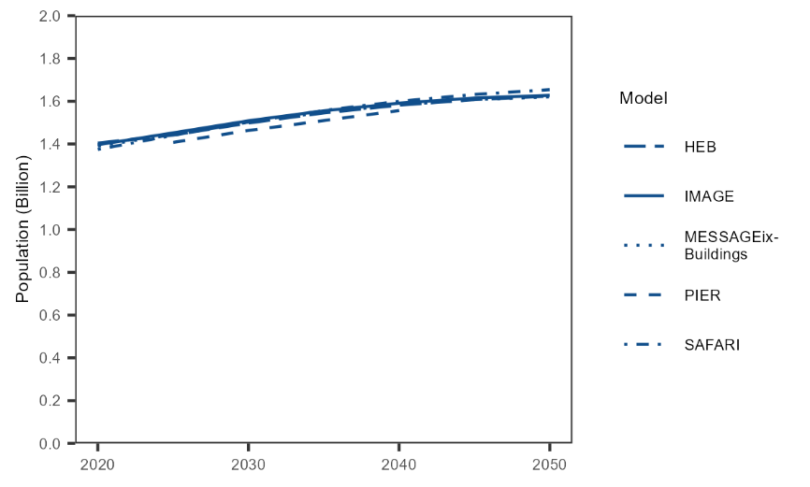
Supplementary Figure 1 Population projections for India.

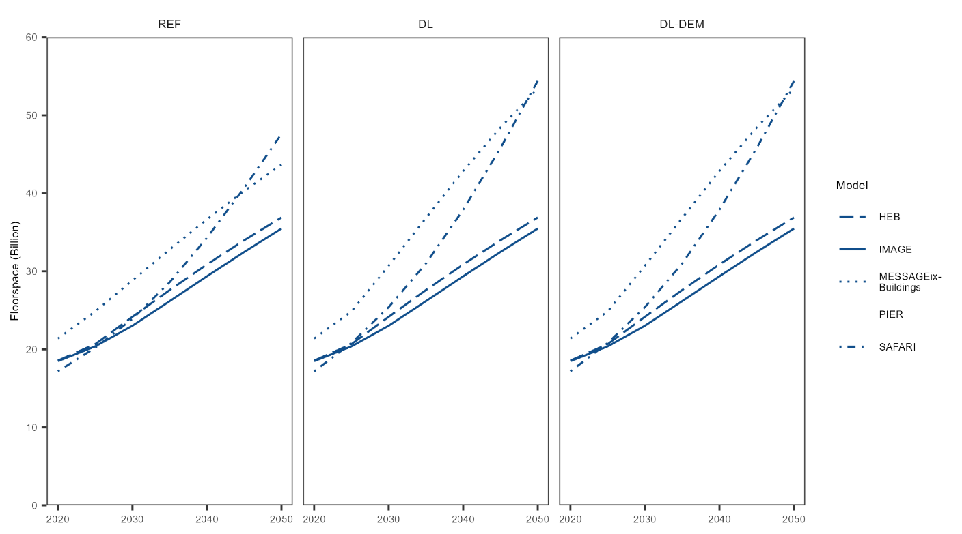
Supplementary Figure 2 Residential floorspace projections for India in different scenarios.
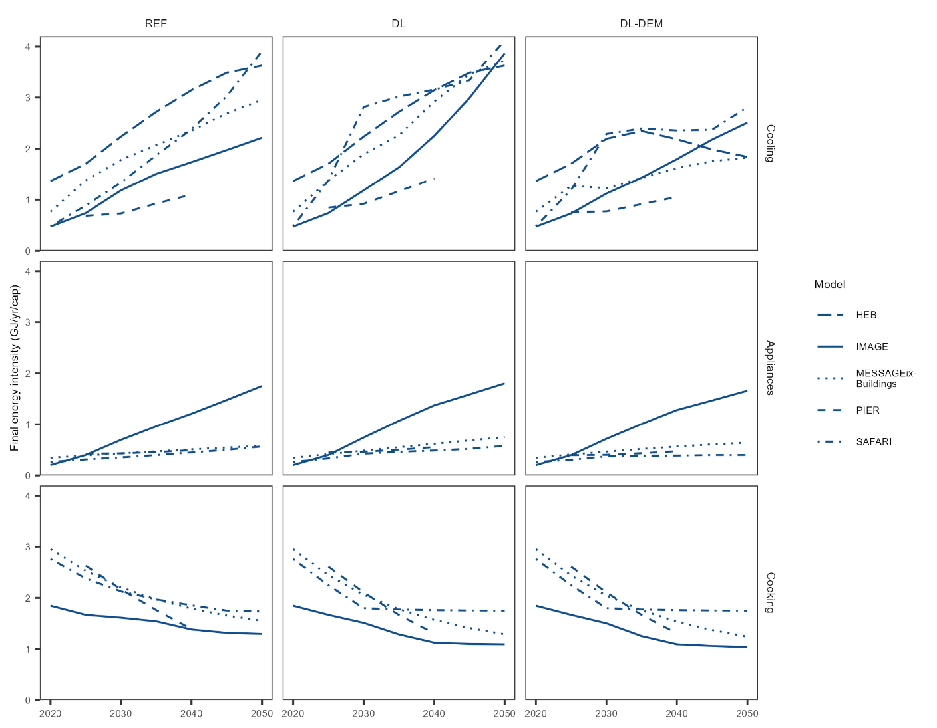
Supplementary Figure 3 Projections of apparent final energy demand intensity per-capita for different end-uses in different scenarios.
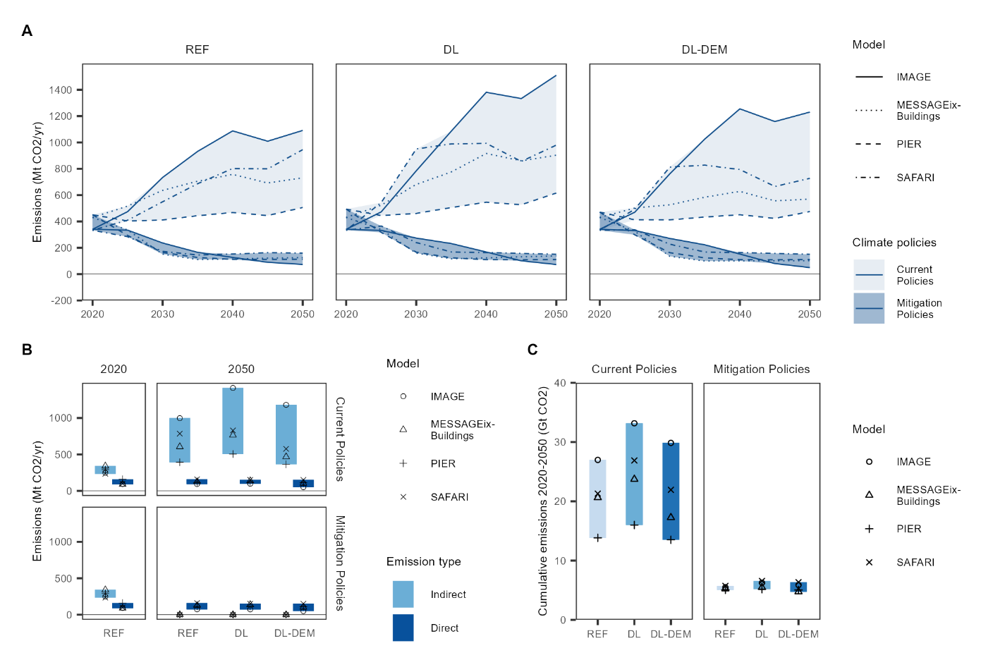
Supplementary Figure 4 Projections of CO₂ emissions for the residential sector in India in the Reference (REF), Decent Living (DL), and Decent living – Demand measures (DL-DEM) scenarios under different climate policy strategies (Current Policies and Mitigation Policies). Results are from four building sector models, IMAGE, MESSAGEix-Buildings, PIER, and SAFARI, with indirect emission calculated based on electricity emission factors from the MESSAGEix-GLOBIOM integrated assessment model.

References

1. Chatterjee, S., Kiss, B., Ürge-Vorsatz, D. & Teske, S. Decarbonisation Pathways for Buildings. in Achieving the Paris Climate Agreement Goals (ed. Teske, S.) 161–185 (Springer International Publishing, Cham, 2022). doi:10.1007/978-3-030-99177-7_7.
2. Daioglou, V., Van Ruijven, B. J. & Van Vuuren, D. P. Model projections for household energy use in developing countries. Energy 37, 601–615 (2012).
3. Daioglou, V., Mikropoulos, E., Gernaat, D. & van Vuuren, D. P. Efficiency improvement and technology choice for energy and emission reductions of the residential sector. Energy 243, 122994 (2022).
4. Mastrucci, A., van Ruijven, B., Byers, E., Poblete-Cazenave, M. & Pachauri, S. Global scenarios of residential heating and cooling energy demand and CO2 emissions. Climatic Change 168, 14 (2021).
5. Prayas (Energy Group). PIER: Modelling the Indian energy system through the 2020s. (2021).
6. Prayas (Energy Group). More with Less: Insights from Residential Energy Demand Assessment Using PIER. https://energy.prayaspune.org/our-work/research-report/more-with-less (2023).
7. Kumar, P., Natarajan, R. & Ashok, K. Sustainable alternative futures for urban India: the resource, energy, and emissions implications of urban form scenarios. Environ. Res.: Infrastruct. Sustain. 1, 011004 (2021).
8. O’Neill, B. C. et al. The roads ahead: Narratives for shared socioeconomic pathways describing world futures in the 21st century. Global Environmental Change 42, 169–180 (2017).
9. Rao, N. D. & Min, J. Decent Living Standards: Material Prerequisites for Human Wellbeing. Soc Indic Res 138, 225–244 (2018).
10. Rao, N. D., Min, J. & Mastrucci, A. Energy requirements for decent living in India, Brazil and South Africa. Nat Energy 4, 1025–1032 (2019).
11. Grubler, A. et al. A low energy demand scenario for meeting the 1.5 °C target and sustainable development goals without negative emission technologies. Nat Energy 3, 515–527 (2018).
12. IAMC. IAMC time-series data template.

