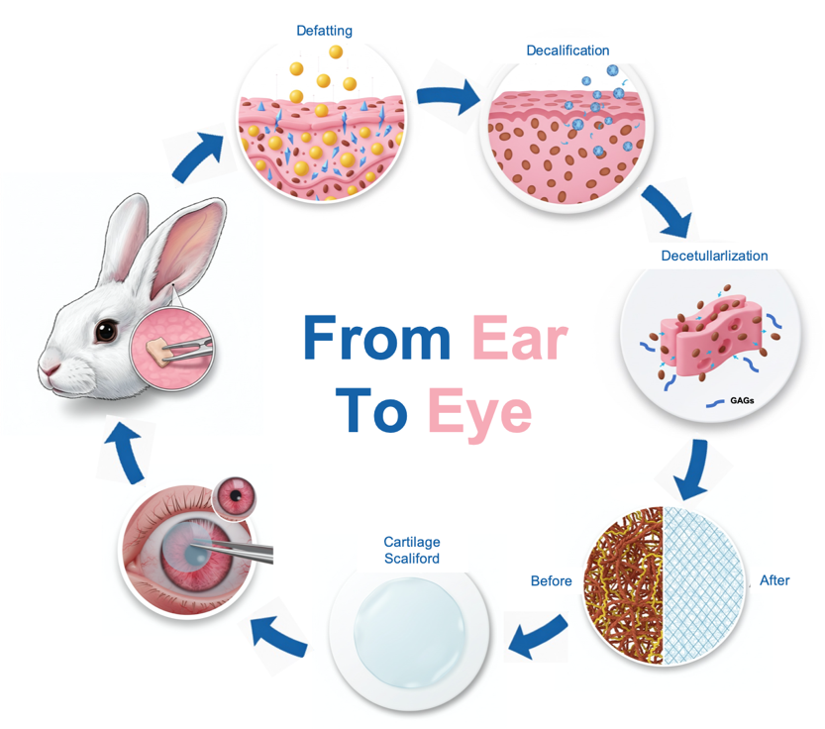
Scheme 1. Schematic illustration of rabbit auricular cartilage harvesting, modification, and application in corneal repair.

