Supplementary Material to
A cost-effective and video-based method for continuous cardiac output monitoring: design and clinical validation

Table of Contents
S1. | The transformation of blood pressure data extracted from real-time video into real-time cardiac output data.
S2. | Video waveform extraction and the design of Video-based method
S3. | Hemodynamic monitoring algorithm and the design of “Direct” system
S4. | Patient characteristics
S5. | Hemodynamic data
S6. | The time-varying trend and trend line of CO values measured by three methods
S7. | The cost of the video-based cardiac output monitoring

S1. The transformation of blood pressure data extracted from real-time video into real-time cardiac output data
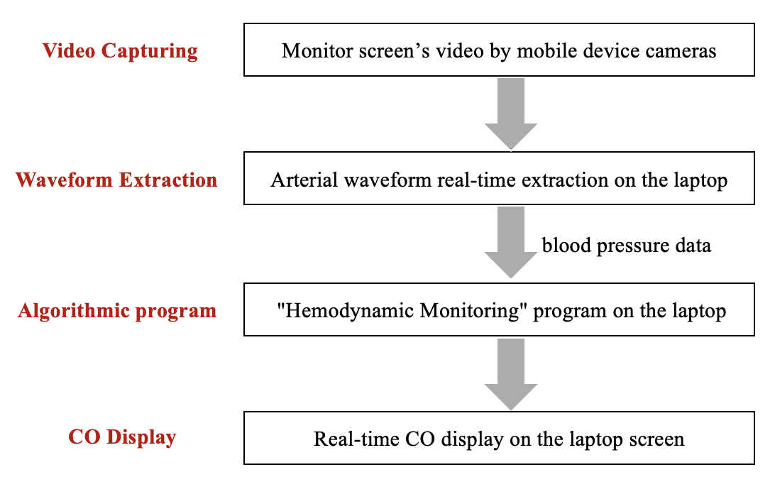
Fig. S1. The transformation of blood pressure data extracted from real-time video into real-time cardiac output data.
S2. Video waveform extraction and the design of Video-based method

S2.1 Video waveform extraction
The specific technical process is as follows (Fig. S2):
- Real-time image recording: The smartphone camera is fixed in front of the monitor to accurately capture the screen area displaying the invasive arterial waveforms, ensuring the initial collection of image data. Additionally, real-time images of the monitor screen are recorded, with sampling performed every 8 seconds to capture continuous waveform data.
- Image correction: The Hough Transform method is utilized to identify and correct any skew in the image by detecting horizontal lines in the monitor, calculating the average angle of these lines with the horizontal, and rotating the image accordingly to correct any tilt, ensuring the accuracy of waveform data.
- Scale identification: Image processing technology is used to identify the scale markings on the monitor screen, which is crucial for accurately calculating actual arterial blood pressure values.
- Region exclusion: During the image processing phase, non-waveform regions are excluded, removing small areas, retaining only the largest waveform area to enable more precise waveform analysis.
- Digitization of the waveform: The identified waveform region is converted into digital data, where the x-axis represents the time series and the y-axis represents arterial blood pressure values.
- Waveform denoising: Median filtering technology is applied for waveform denoising to enhance the accuracy and reliability of the data.
- Data transmission: The processed arterial blood pressure data is transmitted in real-time to hemodynamic analysis software for further analysis, obtaining relevant parameters, such as cardiac output (CO).

Fig. S2 Video waveform extraction

S2.2 The design of Video-based method
Real-time extraction of CO is performed on a laptop currently. Notably, the customized program in laptop is developed using Python, which could be migrated to mobile platform (Android or iOS) through the implementation of frameworks such as Kivy and BeeWare. Therefore, the video-based CO monitoring will be universally applicable, rather than limited to specific smartphones or operating systems.
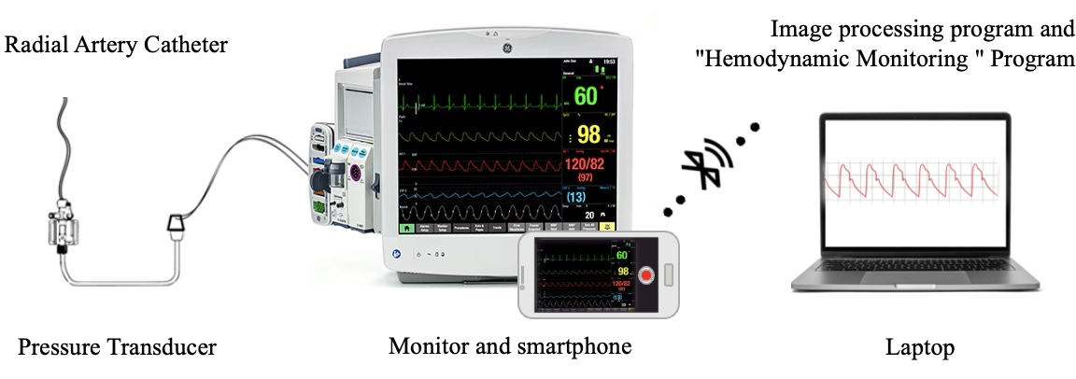
Fig. S3 The design of Video-based method

S3 Hemodynamic monitoring algorithm and “Direct” system

S3.1 “Hemodynamic monitoring” algorithm
- Cardiovascular system model

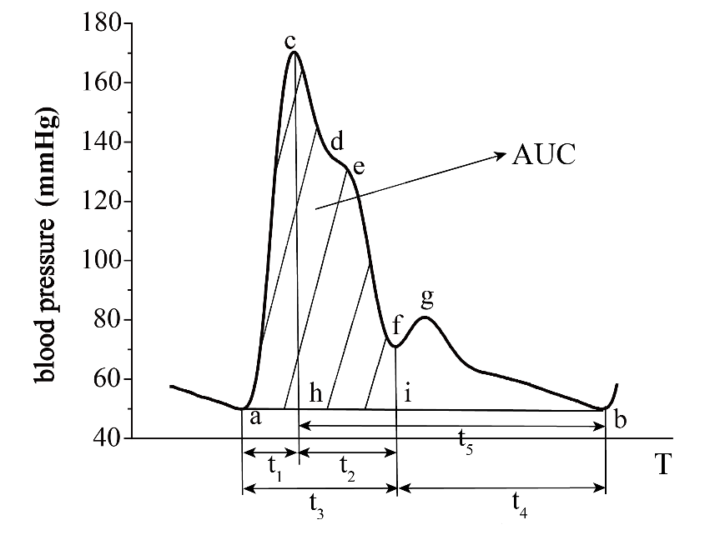
Fig. S4 Pulse waveform
The characteristics of the pulse waveform are closely related to the physiological and pathological features of the human cardiovascular system. Under the influence of various physiological factors, the pulse wave can present different waveform morphologies. The pulse wave obtained through radial artery puncture consists of two peaks, as shown in Fig. S4 The main wave of the pulse wave is primarily composed of the ascending and descending limbs, with a dicrotic wave appearing on the descending limb. A complete pulse wave starts at point ‘a’, where the left ventricle contracts sharply, forcing the aortic valve open, and a large volume of blood rushes into the arteries, rapidly increasing the pressure within the artery until it reaches its peak at point ‘c’. As the ventricle continues to eject blood, and when the aortic pressure exceeds the intraventricular pressure, the blood still with high kinetic energy within the ventricle continues to enter the aorta against the pressure gradient, but the speed of ejection weakens. When the left ventricle stops ejecting, the arteries relax, forming the tidal wave segment d-e. After ejection is complete, the ventricle begins to relax, and at this time, the aortic pressure is higher than the intraventricular pressure. The aortic valve closes (point 'f') when the intraventricular pressure falls below the aortic pressure. The closure of the aortic valve generates a dicrotic wave segment (f-g) due to the elastic recoil of the aorta, which creates a transient increase in aortic pressure. The blood pressure continues to decline to point ‘b’ until the next cardiac cycle begins. The heart cyclically pumps blood into the arteries, ultimately forming a regular pulse wave. The cardiovascular system continuously supplies blood and oxygen to the body to meet the needs of bodily activities. At the same time, it removes the “waste” produced by the body through cardiopulmonary exchange. Therefore, as a complex physiological system, the cardiovascular system has many models that attempt to explain and describe the relationship between arterial blood pressure (ABP) and cardiac output (CO).[1-4] Among them, the two-element Windkessel model proposed by Frank is commonly used as a basic model to describe the relationship between blood pressure, vascular elasticity, and peripheral resistance.[2] Subsequent improvements to the three-element and four-element Windkessel models are based on the two-element model, adding resistance units or inertial quantities to better describe the cardiovascular model.
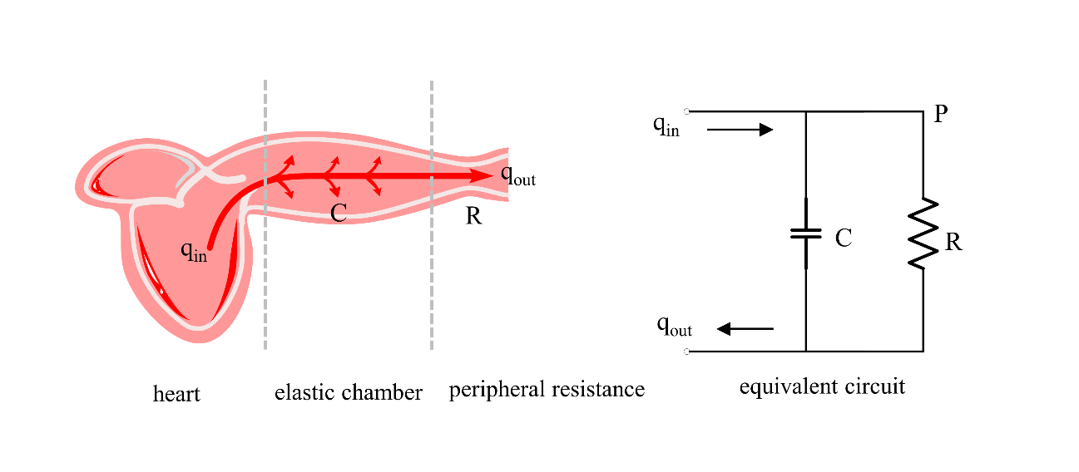
Fig. S5 Two-element windkessel model and its equivalent circuit
The Windkessel model, as shown in Fig. S5, considers all arteries as an elastic chamber, sets the total peripheral resistance as R, and denotes the vascular compliance as C, with the following equations:
$$\begin{aligned}R=\frac{P_{m}}{CO}，C=\frac{ΔV}{ΔP}\#（2.1）\end{aligned}$$
Here,$P_{m}$ represents the mean arterial pressure, and vascular compliance is described as the ratio of the change in vascular volume$ΔV$ to the change in blood pressure $ΔP$. If the elastic chamber model is transformed into an RC equivalent circuit, with the cardiac pumping volume qin considered as the input volume, then the state equation of the equivalent circuit can be expressed as Equation 2.2:
$$\begin{aligned}q（t）=\frac{p（t）}{R}+C\frac{dp（t）}{dt}\#（2.2）\end{aligned}$$
The above equation provides a rough simulation of the cardiovascular model through the circuit model. The proposal of the two-element Windkessel model has provided a powerful analytical tool for studying the structure of arteries in the cardiovascular system. However, for the complex human cardiovascular system, it still cannot interpret the blood flow situation under real conditions. It is a very basic model, but due to its simplicity and intuitiveness, it has now been widely used in various cardiovascular algorithms.
2. Calculation of hemodynamic parameters
I. Derivation of cardiac output calculation
The basic formula for cardiac output (CO) is as follows:
$$\begin{aligned}CO=SV×HR\#（2.3）\end{aligned}$$
where HR represents heart rate, and SV is the stroke volume, defined as the product of the two. Additionally:
$$\begin{aligned}SV=\int_{0}^{T_{S}}{q_{in}（t）}dt=C\int_{0}^{T}{\frac{dp}{dt}}dt+\frac{1}{R}\int_{0}^{T}{p}dt\#（2.4）\end{aligned}$$
$$\begin{aligned}p_{m}=\frac{1}{T}\int_{0}^{T}{P}dt\#（2.5）\end{aligned}$$
where T is the duration of a cardiac cycle, Ts is the ejection period, C is arterial compliance, and P is blood pressure. During diastole, we have:
$$\begin{aligned}q_{m}=\int_{0}^{T}{\frac{dp}{dt}}dt=0\#（2.6）\end{aligned}$$
Substituting into the formula, we get:
$$\begin{aligned}SV=\frac{1}{R}\int_{0}^{T}{P}dt=\frac{P_{m}}{R}*T\#（2.7）\end{aligned}$$
From the above equation, it is evident that the stroke volume (SV) is related to peripheral resistance R and mean pressure Pm. Therefore, obtaining the peripheral resistance R and mean pressure Pm, and then multiplying by the heart rate, we can determine the cardiac output. Based on the above theoretical derivation, the formula for cardiac output (CO) can ultimately be expressed as:
$$\begin{aligned}CO=\frac{1}{R}\int_{0}^{T}{P}dt×HR\#（2.8）\end{aligned}$$
From the above theoretical derivation, it is clear that cardiac output can be obtained by multiplying the stroke volume by the heart rate, where the stroke volume can be obtained from peripheral resistance and blood pressure, with $SV=\frac{1}{R}\int_{0}^{T}{P}dt$. From Equation 2.8, it can be seen that the main influencing factors of cardiac output are as follows: the blood ejected by the heart with each beat, i.e., the stroke volume, forms blood pressure by working against the vessel walls after entering the large vessels. The viscosity of the blood and the size of the vessel lumen determine the peripheral resistance R, and arterial compliance reflects the buffering capacity of the vessel walls, both of which change the pulse wave waveform to some extent. Therefore, based on the area under a single pulse wave waveform, the stroke volume can be determined, and further, combined with the heart rate, the continuous cardiac output can be calculated. The resistance R is calculated based on the decay time constant RC of the pulse wave descending limb and arterial compliance C, thereby calibrating the value of cardiac output.
II. Peripheral Resistance and Arterial Compliance
Blood has viscosity, and as it propagates forward through the vessels, it encounters a certain resistance, leading to a drop in blood pressure. This resistance is known as peripheral resistance. Peripheral resistance is generally difficult to measure directly. Since the decay time constant RC of the pulse wave descending limb is the product of peripheral resistance R and arterial compliance C, R can be obtained by dividing RC by C. According to the single-chamber elastic model, when in a diastolic state, i.e., when qin=0, we have:
$$\begin{aligned}0=\frac{p（t）}{R}+C\frac{dp（t）}{dt}\#（2.9）\end{aligned}$$
Solving the equation, we get:
$$\begin{aligned}P=p_{s}e^{\frac{t-T_{S}}{RC}}\#（2.10）\end{aligned}$$
where $p_{s}$ is the systolic pressure, $T_{s}$ is the systolic interval, and P is blood pressure. From the above equation, the decay time constant RC can be estimated based on the elastic chamber model. Arterial compliance C is used to measure the ability of arterial vessels to accumulate energy from blood. The greater the arterial compliance, the better the elasticity of the arteries; the smaller the arterial compliance, the worse the elasticity. Arterial compliance C can be calculated from the pulse pressure. In 1984, Dr. Langewouters obtained the compliance of large vessels under physiological conditions in humans through methods such as autopsy.[5]
$$\begin{aligned}C\left(P\right)=\frac{C_{m}}{1+{\left(\frac{P-P_{0}}{P_{1}}\right)}^{2}}\#（2.11）\end{aligned}$$
where，$C_{m}=\frac{A_{max}}{πP_{1}}$，$A_{max}$ is the maximum cross-sectional area of the aorta when blood pressure is high, and P0、P1 can be determined by the subject’s age and gender, as shown in Table S1 below.
Table S1 Parameters of Large Vessel Compliance for Subjects
 | female | male
Amax | 4.12 | 5.62
P0 | 72-0.89*age | 76-0.89*age
P1 | 57-0.44*age | 57-0.44*age
From the above, the value of cardiac output (or stroke volume) can be estimated. Additionally, under mechanical ventilation, the action of the ventilator will cause regular fluctuations in the blood volume within the pulmonary vessels, leading to corresponding fluctuations in the stroke volume of the left ventricle. The larger the percentage difference in stroke volume variation (i.e., SVV), the more insufficient the blood volume, and fluid replenishment can significantly increase cardiac output. The smaller the percentage difference in stroke volume variation (SVV), the more sufficient the blood volume, and fluid replenishment cannot significantly increase stroke volume; inotropic drugs or other methods are needed to improve stroke volume. Therefore, combining respiratory and other waveform values, other hemodynamic parameters such as stroke volume variability can be calculated.

S3.2 The “Direct” system
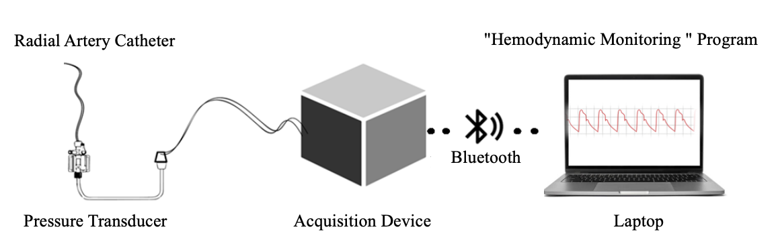Fig. S6 The design of “Direct” Hemodynamic System

S4. Patient characteristics
Results are expressed as median (range) or number (percentage). BMI, body mass index; SD, standard deviation. ASA, American Society of Anesthesiologists.
Table S2 Patient characteristics.
Variables | N = 11
Demographic and biometric data
Male sex | 7 (63%)
Age, yr. | 56 (32 - 64)
BMI, kg·m⁻² | 23 (18 - 28)
ASA physical status
1 | 3 (27%)
2 | 7 (63%)
3 | 1 (9%)
Type of surgery
Curative resection of colorectal cancer | 3 (27%)
Neurosurgery | 3 (27%)
Total gastrectomy | 2 (18%)
Partial hepatectomy | 2 (18%)
Pancreaticoduodenectomy | 1 (9%)

S5. Hemodynamic data
Table S3 Hemodynamic data.
 | COvigileo | COdirect | COvideo
n | 3892 | 3892 | 3892
Mean ± SD | 5.21 ± 1.40 | 5.15 ± 1.36 | 5.2 ± 1.44
Minimum | 2.3 | 2.9 | 2.2
Maximum | 13.7 | 13.9 | 13.4

S6. The time-varying trend and trend line of CO values measured by three methods
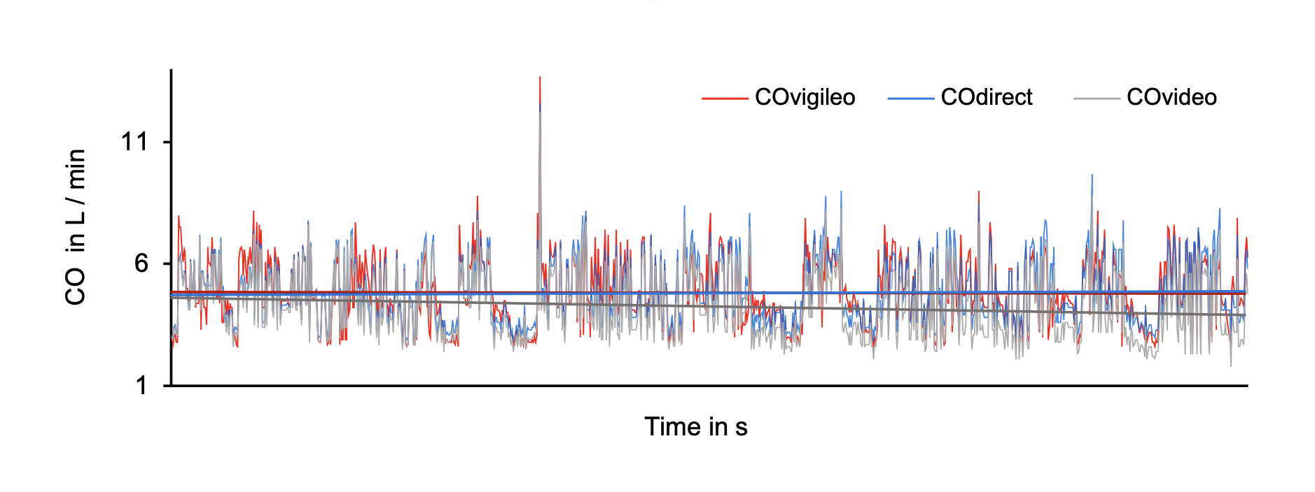 Fig. S7 The time-varying trend and trend line of CO values measured by three methods.CO Vigileo, red curve; CO direct, bule curve; COvideo, gray curve.

S7. The cost of the video-based cardiac output monitoring
As shown in Table S4, a cost of 20 USD is consisted of disposable consumables, including an arterial catheterization and a standard pressure transducer. As a comparison, an arterial catheterization, a specific disposable transducer, and an expensive stand-alone monitor are required for commercially available invasive CO monitoring, such as the FloTrac/Vigileo system, which cost much more than 20 USD.

Table S4 The cost of the video-based cardiac output monitoring
Item | Cost
An arterial catheterization | 2 USD
A standard pressure transducer | 16 USD
Total | 18 USD

References
[1] O'Rourke MF. Pressure and flow waves in systemic arteries and the anatomical design of the arterial system. J Appl Physiol. 1967;23:139-49.
[2] Frank O. Die grundform des arteriellen pulses: mathematische analyse. erste abhandlung1899.
[3] Westerhof N, Elzinga G, Sipkema P. An artificial arterial system for pumping hearts. J Appl Physiol. 1971;31:776-81.
[4] Burattini R, Knowlen GG, Campbell KB. Two arterial effective reflecting sites may appear as one to the heart. Circ Res. 1991;68:85-99.
[5] Langewouters G, Wesseling K, Goedhard W. The static elastic properties of 45 human thoracic and 20 abdominal aortas in vitro and the parameters of a new model. J Biomech. 1984;17:425-35.

