Supplementary Materials

Coupled Effects of Acid Mine Drainage and Domestic Wastewater Reshape Sediment Microbial Communities
Shihong Zhang¹ · Pan Wu^{1,2,3} * · Jian Zhang² · Yisheng Mu¹ · Jiarui Zhu¹
¹ College of Resources and Environmental Engineering, Guizhou University, Guiyang 550025, China;
² Key Laboratory of Karst Georesources and Environment (Guizhou University), Ministry of Education, Guiyang 550025, China;
³ Guizhou Karst Environmental Ecosystems Observation and Research Station, Ministry of Education.
*Correspondence Author
e-mail: pwu@gzu.edu.cn
Phone: +86-136-0857-2205

List of the supporting information:
Fig. S1 Schematic diagram of the stratigraphic structure and the aquifer of the top and bottom plates of the Liangshan Formation.
Fig. S2 pH and Redox characteristics of water samples.
Fig. S3 Results of a PCoA analysis of the differences in the bacterial distribution among samples.
Fig. S4 RDA analysis of microbial communities and environmental factors.
Fig. S1 Schematic diagram of the stratigraphic structure and the aquifer of the top and bottom plates of the Liangshan Formation

Fig. S2 pH and Redox characteristics of water samples.

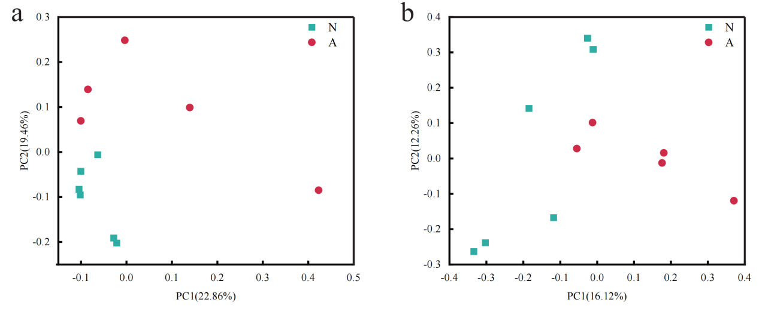
Fig. S3 Results of a PCoA analysis of the differences in the bacterial
distribution among samples.
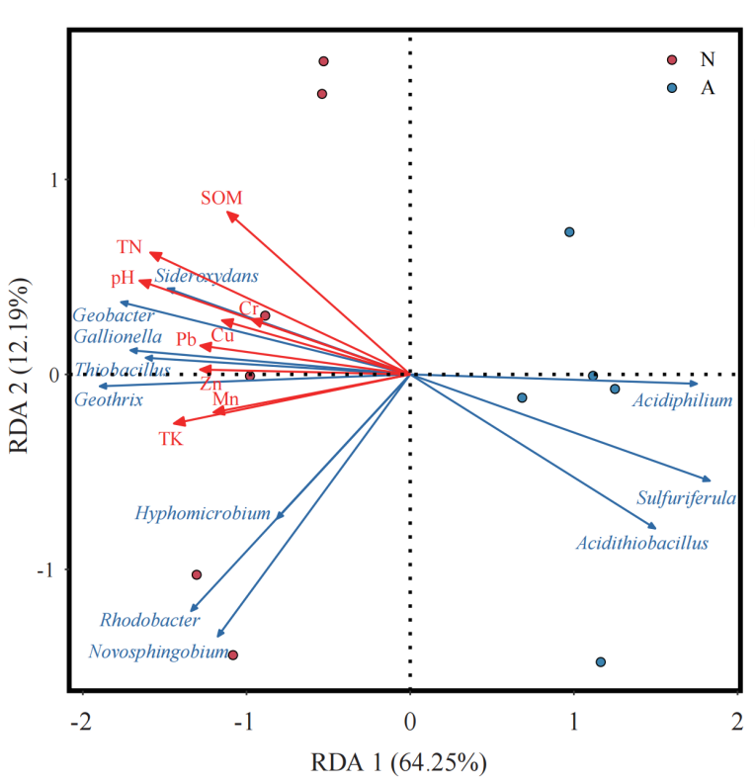
Fig. S4 RDA analysis of microbial communities and environmental factors.

