Translational Psychiatry
Neuronal versus Glial CB2 Receptors: Insights from a Novel CB2-KO-eGFP Reporter Mouse Line
Zheng-Xiong Xi^{1,*}, Emily Linz¹, Hai-Ying Zhang², Christopher Dunn³, Guo-Hua Bi¹, Ewa Galaj⁴, Maia Maras¹, Bruce Hope⁶, F. Javier Rubio6⁶, Qing-Rong Liu⁵

Supplementary Information - Part 2

Suppl. Figures: 13
Suppl. Tables: 2
Supplementary Figure 1:
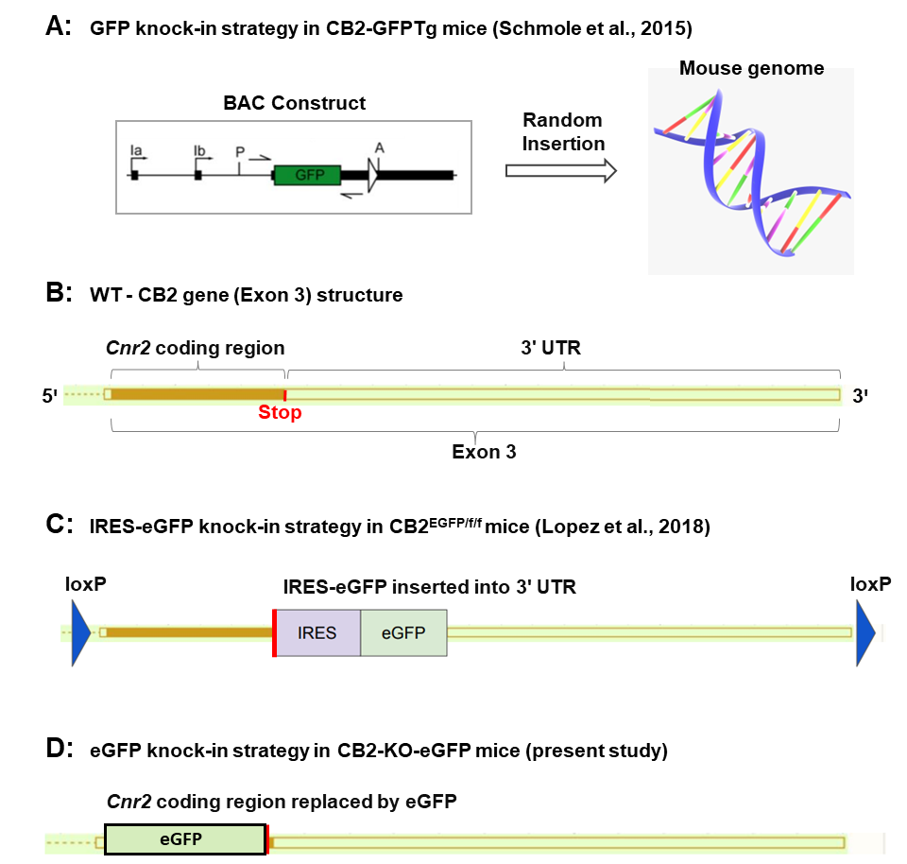

Figure S1. Schematics of GFP knock-in (KI) strategies used to generate three CB2-GFP reporter mouse strains. (A) CB2-GFPTg line (Schmole et al., 2015)¹: A GFP reporter cassette replaces the Cnr2 coding sequence within a bacterial artificial chromosome (BAC) containing the CB2 promoter and regulatory elements. The BAC construct is microinjected into mouse embryos and randomly integrated into the genome, enabling GFP expression under CB2 promoter control within the transgene. The endogenous Cnr2 gene remains intact. (B) Mouse Cnr2 gene structure (Exon 3 only), illustrating Cnr2 coding region (open read frame, ORF) and 3ꞌ untranslated region (3ꞌ UTR) on Exon 3 of the Cnr2 locus. (C) CB2^{EGFP/f/f} mice (Lopez et al., 2018)²: An IRES-EGFP cassette is inserted downstream of the Cnr2 coding sequence in the 3′ UTR, flanked by two loxP sites. This dual-function KI mouse can be used for both conditional CB2R deletion and GFP reporter studies. While the IRES-EGFP transcription is driven by the Cnr2 promoter, translation is initiated via a viral-derived IRES, decoupling it from native CB2R translational regulation due to a stop codon located upstream of the IRES-EGFP cassette. (D) CB2-KO-eGFP line: The entire Cnr2 ORF is replaced by eGFP via homologous recombination, producing a CB2 knockout and GFP reporter mouse in which GFP is expressed under the control of the native Cnr2 promoter and translation regulatory elements.

Supplementary Figure 2:
Figure S2 (related to Figure 1): More detailed structure of mouse Cnr2 gene, the CB2-KO-eGFP construct and modified Cnr2 structure (Exon 3) in CB2-KO-eGFP mice. (A) Mouse Cnr2 gene structure. Open boxes represent 3 Exons, and solid lines represent introns with their sizes in base pair (bp) labeled on the top and bottom of the schema, respectively. ORF represents Cnr2 open reading frame (CB2R coding sequency). Blue represents 5'-UTR and yellow 3'-UTR. The alternative promoters are labeled as P1 and P2 in front of the exon-1 and exon-2, respectively. (B) The CB2-KO-eGFP construct, which is used to replace the Cnr2 ORF. The Neo cassette is flanked by flippase recognition target (FRT) sites. Red F represents FRT sequence for flippase (FLP) recombination in deleter ES cells. The construct cassettes and sizes are labeled. (C) The modified gene structure of Exon 3 in the CB2-KO-eGFP mice, in which the eGFP reporter gene and Neo-footprint replace the Cnr2 ORF. After FLP recombination, 79 bp Neo-footprint (including a FRT site) remains in the CB2-KO-eGFP mouse genome and can be targeted by TaqMan probe (red bar) for genotyping.

Supplementary Figure 3:
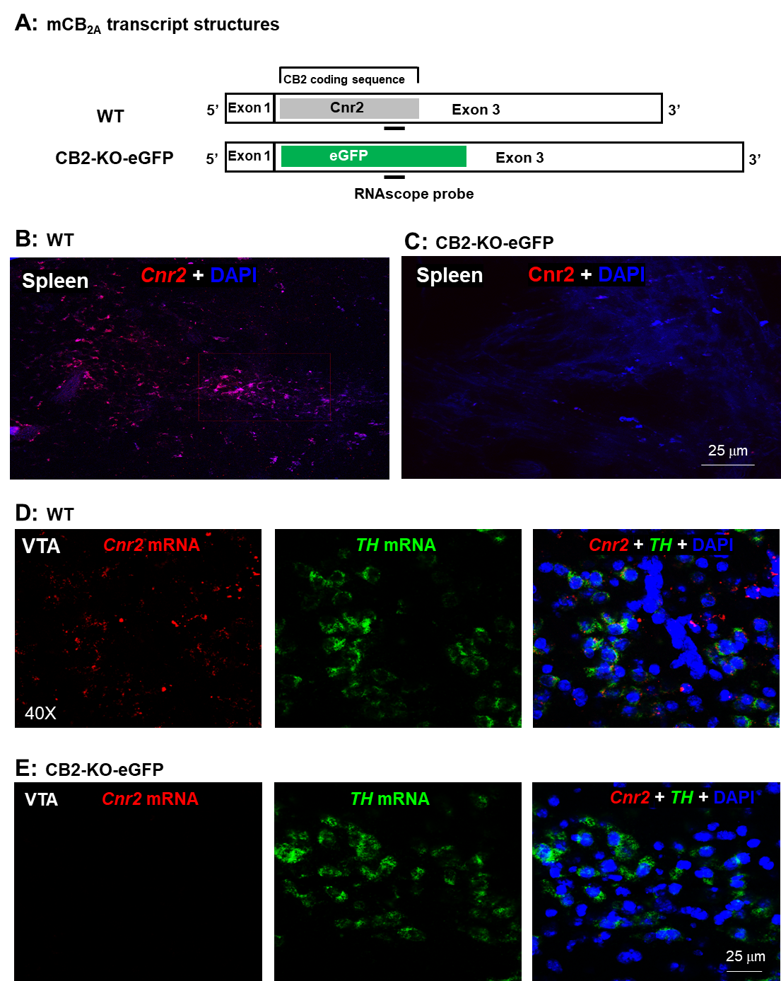
Figure S3. Verification of CB2R knockout in CB2-KO-eGFP mice by RNAscope in situ hybridization. (A) Diagram of mCB_{2A} transcript and the RNAscope probe targeting the deleted Cnr2 coding region in Exon 3. (B, C) Cnr2 mRNA is detected in WT spleen (B) but absent in CB2-KO-eGFP spleen (C). (D, E) Low-level Cnr2 mRNA is also detected in tyrosine hydroxylase-positive (TH⁺) dopaminergic neurons of the ventral tegmental area (VTA) in WT mice (D) but absent in CB2-KO-eGFP mice (E).

Figure S4:
Figure S4 (related to Fig. 2). Open field locomotor responses to Δ⁹-THC in wild-type (WT) and CB2-KO-eGFP mice. (A) Time courses of open-field locomotion before and after Δ⁹-THC administration in WT mice. (B) The area under the curve (AUC) data for the time window highlighted by the gray box in A, demonstrating that Δ⁹-THC dose-dependently reduced locomotor activity in WT mice. (C, D) Δ⁹-THC also dose-dependently decreased locomotor activity in CB2-KO-eGFP mice. *p < 0.05; **p < 0.01, compared to vehicle.
Supplementary Figure 5:
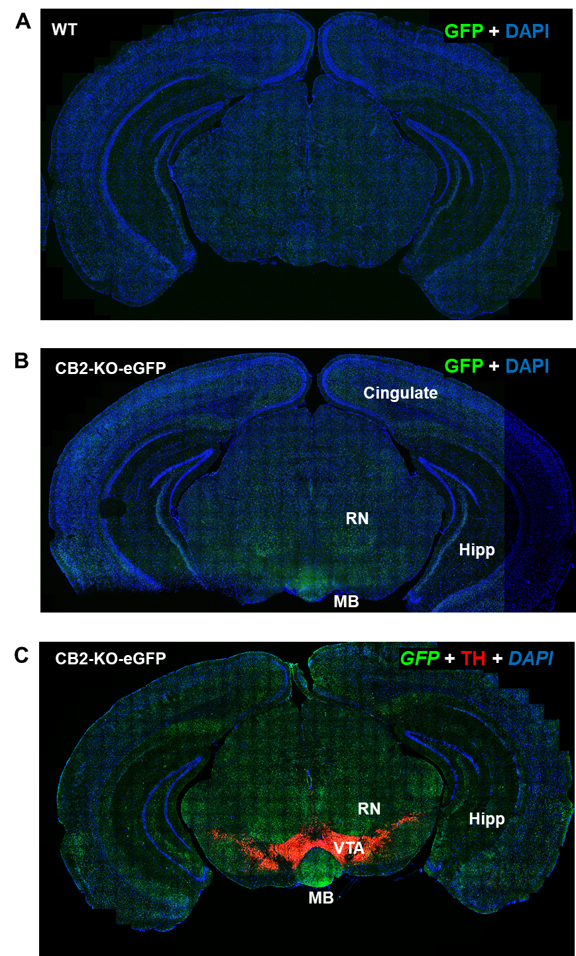
Figure S5 (related to Fig. 3): Whole coronal section images generated by stitched imaging techniques using the Leica THUNDER microscope at 40× and large volume computational clearing (LVCC) software, illustrating the distinct regional distributions of CB2-driven GFP expression in the brains of WT (A) and CB2-KO-eGFP (B) mice in the presence (C) or absence (A, B) of tyrosine hydroxylase (TH) antibody. GFP-immunostaining is detected in cortex, hippocampus, midbrain red nucleus (RN) and mammillary body (MB) in CB2-KO-eGFP mice, not in WT mice.
Supplementary Figure 6:
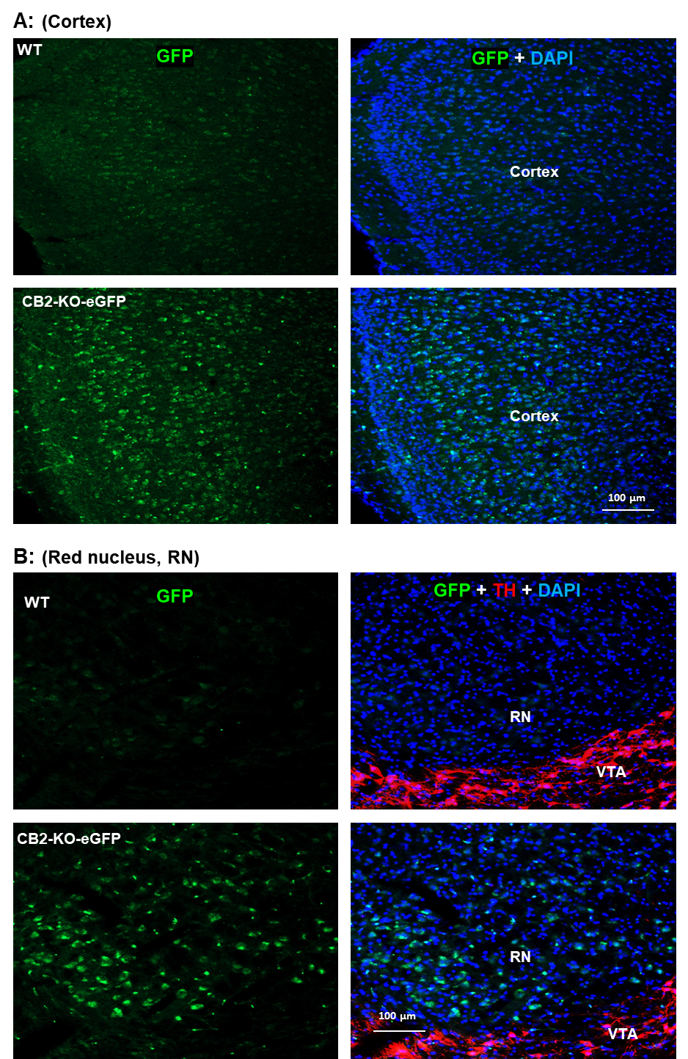
Figure S6 (related to Fig. 3): Confocal images taken under 20× magnification, showing GFP expression in the cortex (A) and midbrain red nucleus (B) of CB2-KO-eGFP mice, compared to WT mice.
Supplementary Figure 7:
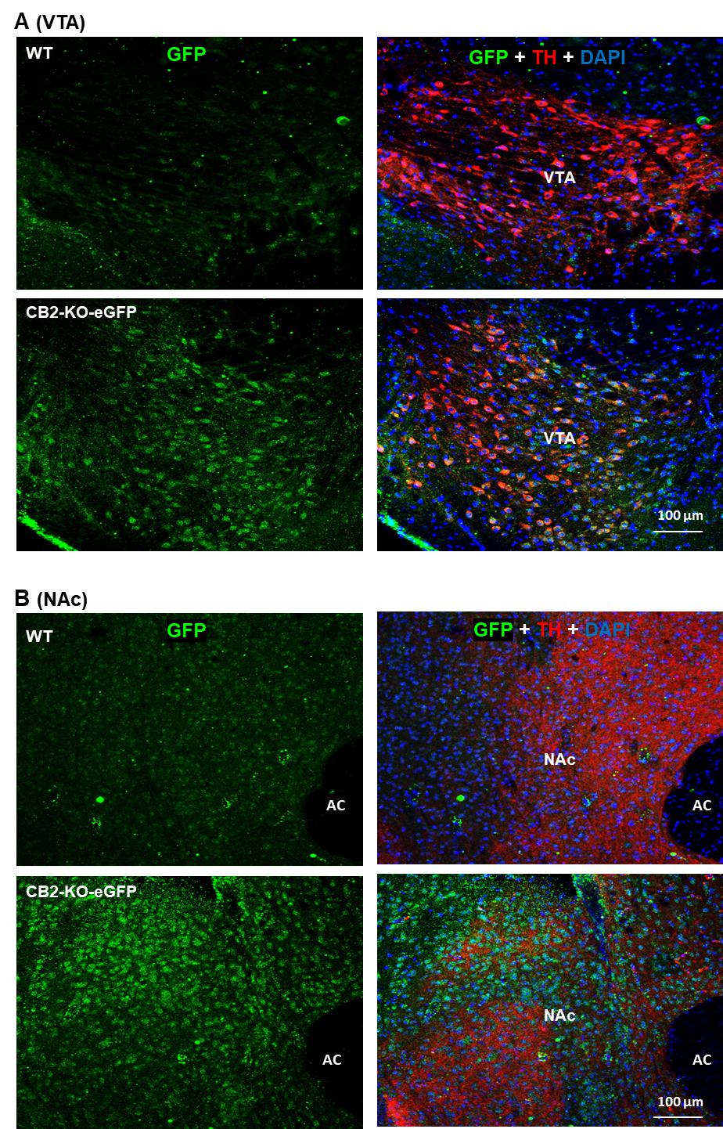
Figure S7 (related to Fig. 3): Confocal images taken under 20× magnification, showing GFP expression in the VTA (A) and NAc (B) of CB2-KO-eGFP mice, compared to WT mice.
Supplementary Figure 8:
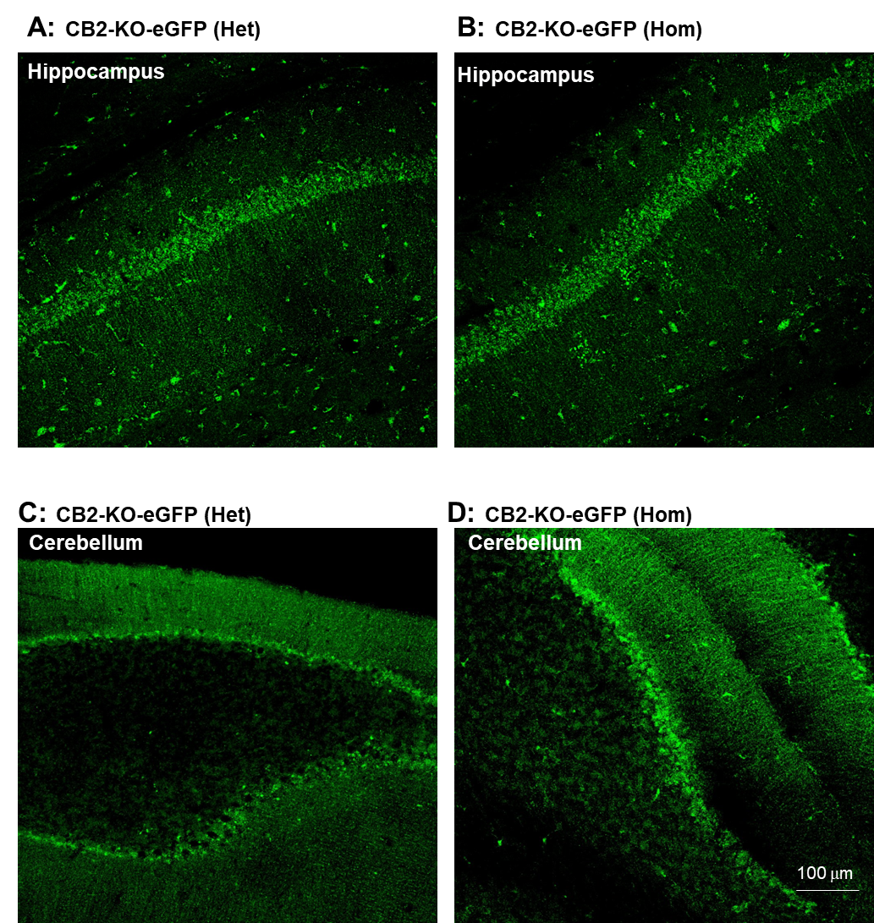
Figure S8 (related to Fig. 3): Comparison of GFP signaling in the hippocampus (A, B) and cerebellum (C, B) between heterozygous (Het) (A, C) and Homozygous (Hom) (B, D) CB2-KO-eGFP mice.

Supplementary Figure 9:
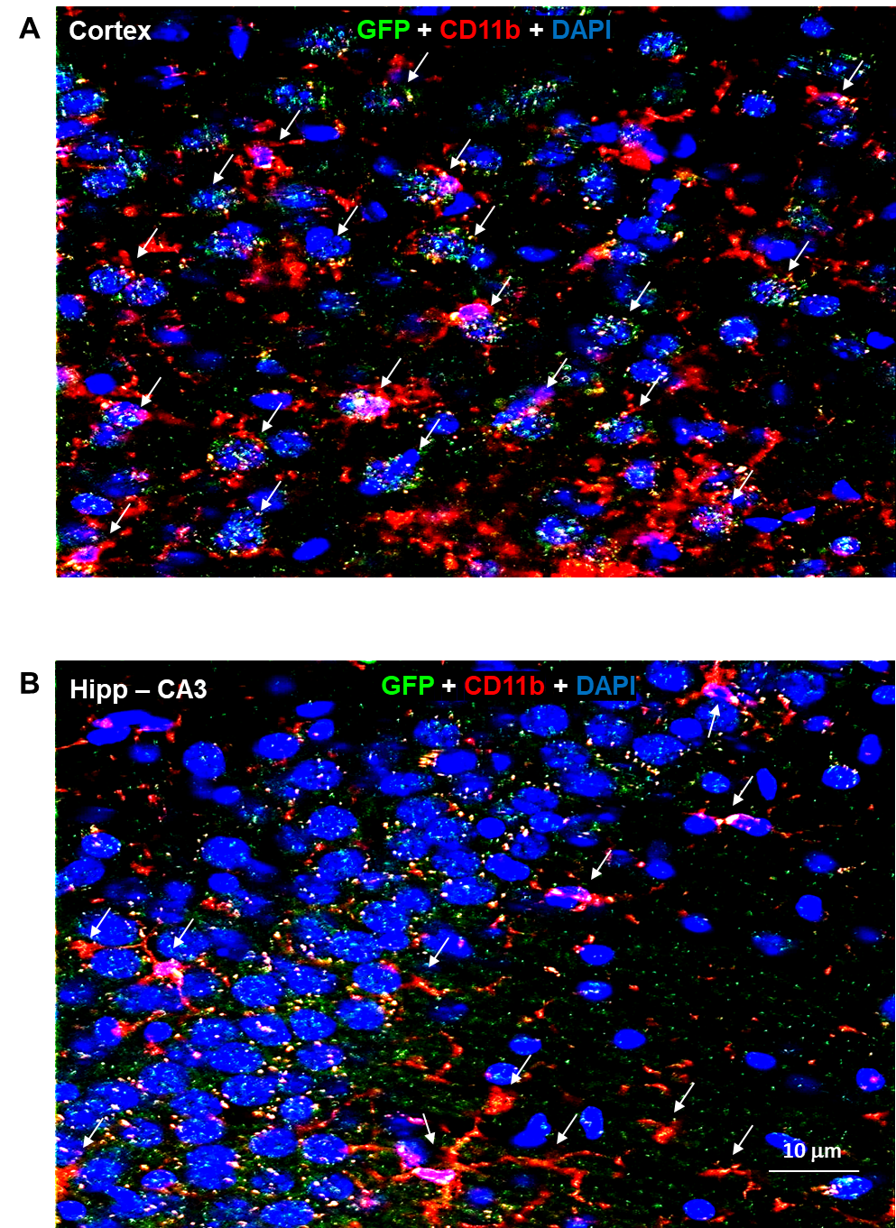
Figure S9 (related to Fig. 4): Magnified images in Fig. 4-A, B (right panels), showing colocalization of GFP and CD11b in microglia of CB2-KO-eGFP mice.
Supplementary Figure 10:
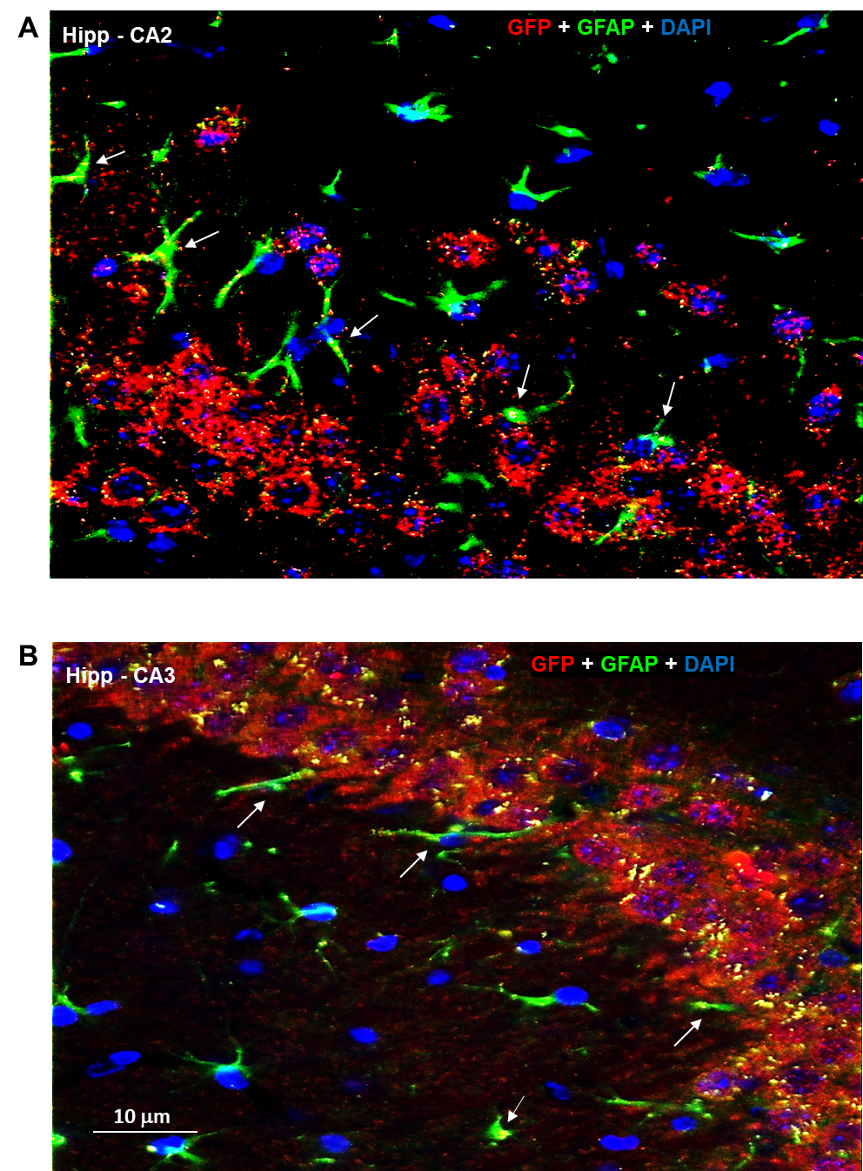
Figure S10 (related to Fig. 4): Magnified images in Fig. 4C, D (right panels), showing colocalization of GFP and GFAP in astrocytes of CB2-KO-eGFP mice.
Supplentary Figure 11:
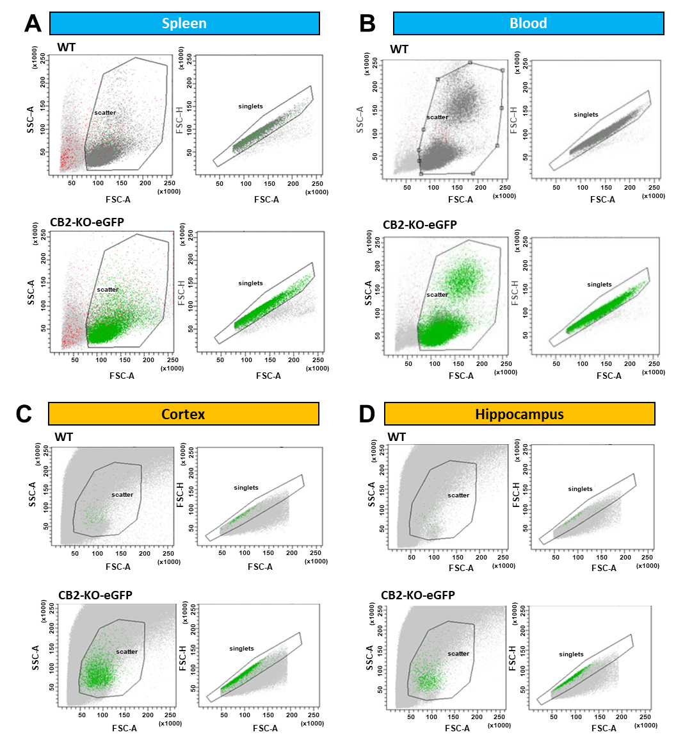
Figure S11 (related to Fig. 5). Additional gating strategy for flow cytometric analysis of single-cell suspensions from peripheral and brain tissues. Alternative flow cytometry plots, showing the sequential gating strategy used to identify GFP⁺ single-cell populations from (A) spleen, (B) blood, (C) cortex, and (D) hippocampus samples. The first gate (“scatter”) was applied on a forward scatter–area (FSC-A) vs. side scatter–area (SSC-A) plot to exclude debris and select intact cells based on size and granularity. The second gate (“singlets”) was applied on a forward scatter–height (FSC-H) vs. forward scatter–area (FSC-A) plot to discriminate single cells from doublets and aggregates. Green events represent gated single-cell populations used for downstream fluorescence analysis. This gating approach ensures consistent isolation of viable, single cells across peripheral (spleen, blood) and brain (cortex, hippocampus) tissues for subsequent FITC-A measurements. FITC: Fluorescein isothiocyanate, a fluorescent dye used to label gated GFP⁺ cells in singlets.

Supplementary Figure 12
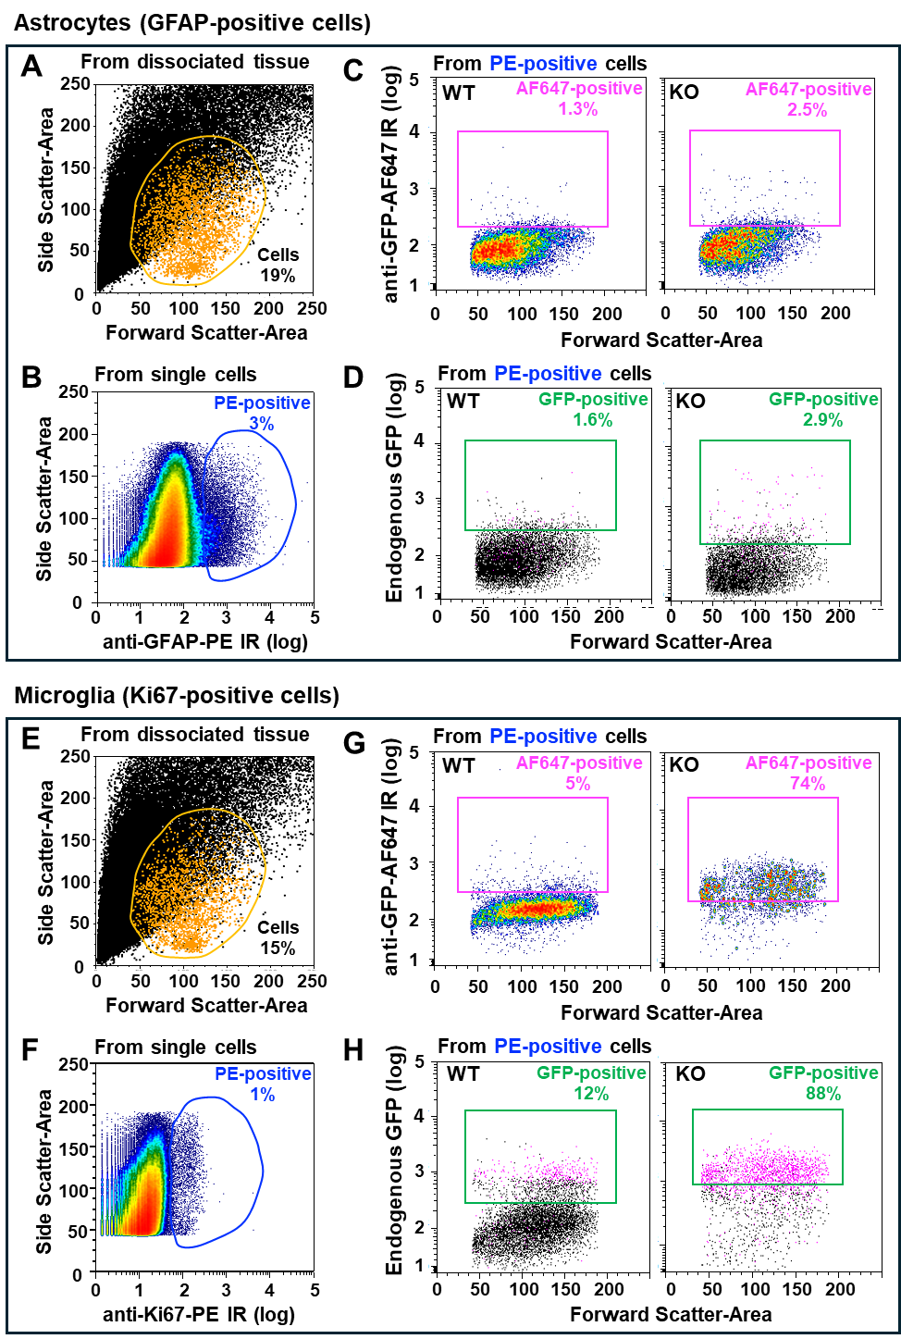
Figure S12 (related to Fig. 6). Flow cytometry of hippocampal cells from wild type and CB2-KO-GFP (KO) mice. (A-D) Gate strategy for astrocytes (GFAP-positive cells). (A) Representative linear plot of forward scatter-area (X-axis, cell size) and side scatter-area (Y-axis, granularity). Sample was stained with DAPI for nuclear identification. Orange gate shows 19% of all events that contains 80-90% of DAPI-positive events (orange dots) that we called ‘Cells’. (B) Representative density plot of fluorescence for PE (X-axis, logarithmic scale) after immunolabeling with anti-GFAP antibody (astrocytic marker). Blue gate shows 3% of PE-positive events (astrocyte cells) from single cells (95% from ‘Cells’ gate, not shown). (C) Representative density plot of fluorescence for AF647 (Y-axis, logarithmic scale) after immunolabeling with anti-GFP antibody. Pink gate shows the percentage of AF647-positive events from PE-positive cells (blue gate in B) from WT or KO mouse hippocampal tissue. (D) Representative scatter plot of endogenous GFP fluorescence (Y-axis, logarithmic scale) from the same mice shown in C. Most of the GFP-positive events are also found immunolabeled with antibody anti-GFP-AF647 (shown as pink dots in D). (E-H) Gate strategy for microglia (Ki67-positive cells). (E) Representative linear plot of forward scatter-area (X-axis, cell size) and side scatter-area (Y-axis, granularity). Sample was stained with DAPI for nuclear identification. Orange gate shows 15% of all events that contains 80-90% of DAPI-positive events (orange dots) that we called ‘Cells’. (F) Representative density plot of fluorescence for PE (X-axis, logarithmic scale) after immunolabeling with anti-Ki67 antibody (microglia marker). Blue gate shows 1% of PE-positive events (microglia cells) from single cells (95% from ‘Cells’ gate, not shown). (G) Representative density plot of fluorescence for AF647 (Y-axis, logarithmic scale) after immunolabeling with anti-GFP antibody. Pink gate shows the percentage of AF647-positive events from PE-positive cells (blue gate in B) from a WT or a KO mouse hippocampal tissue. (H) Representative scatter plot of endogenous GFP fluorescence (Y-axis, logarithmic scale) from the same mice shown in C. Most of the GFP-positive events are also found immunolabeled with antibody anti-GFP-AF647 (shown as pink dots in D).

Supplementary Figure 13:
Figure S13. Behavioral phenotypes in WT and CB2-KO-eGFP mice. (A, B) Open-field locomotor activity showing that CB2-KO-eGFP mice display higher basal locomotor activity compared to WT littermates in both males (A) and females (B). (C, D) Body weight measurements across ages 25–400 days indicate that CB2-KO-eGFP mice have greater body weight than WT littermates in both males (C) and females (D). (E) Feeding behavior, assessed by oral food pellet self-administration, did not differ between WT and CB2-KO-eGFP mice. (F) Nociceptive responses, evaluated using the hot-plate test, showed no significant difference between the two genotypes.

References:
1. Schmole, A.C., et al. Expression Analysis of CB2-GFP BAC Transgenic Mice. PLoS One 10, e0138986 (2015).
2. Lopez, A., et al. Cannabinoid CB(2) receptors in the mouse brain: relevance for Alzheimer's disease. J Neuroinflammation 15, 158 (2018).

Supplementary Table 1. MGB TaqMan probes and primers used for qRT-PCR assays (related to Fig. 1)
Probe | MGB TaqMan probe | Forward primer | Reverse primer
mCB2A | CTGACAAATGACACCCAGTC | CAGGACAAGGCTCCACAAGAC | GATGGGCTTTGGCTTCTTCTAC
CB2-KO | ATGCTGGTTCCCTGCAC | AGCTCGGATGCGGCTAGAC | AGGCTGTGGCCCATGAGA
Gapdh | ATGAAGATCAAGATCATTGCT | GATTACTGCTCTGGCTCCTAGCA | CCACCGATCCACACAGAGTACTT

Supplementary Table 2. Statical analysis results with two-way RM ANOVA for the behavioral data in Figure 2.
Genotype | Figure 2 | THC main effect | Time main effect | Interaction
WT | A (Analgesia) | F_{2, 12} = 21.05, p<0.001 | F_{4, 24} = 6.53, p=0.001 | F_{8, 48} = 5.66, p<0.001
WT | B (Hypothermia) | F_{2, 12} = 61.55, p<0.001 | F_{4, 24} = 68.12, p<0.001 | F_{8, 48} = 39.14, p<0.001
WT | C (Catalepsy) | F_{2, 12} = 4.44, p=0.036 | F_{4, 24} = 5.89, p=0.002 | F_{8, 48} = 0.74, p=0.655
CB2-KO-eGFP | D (Analgesia) | F_{2, 12} = 70.20, p<0.001 | F_{4, 24} = 16.17, p<0.001 | F_{8, 48} = 15.94, p<0.001
CB2-KO-eGFP | E (Hypothermia) | F_{2, 12} = 229.97, p<0.001 | F_{4, 24} = 103.87, p<0.001 | F_{8, 48} = 75.80, p<0.001
CB2-KO-eGFP | F (Catalepsy) | F_{2, 12} = 7.08, p=0.009 | F_{4, 24} = 2.00, p=0.127 | F_{8, 48} = 1.65, p=0.136
Genotype | Figure 2 | Genotype main effect | Time main effect | Interaction
WT vs. KO | G (Analgesia) | F_{1, 12} = 3.00, p=0.109 | F_{4, 48} = 16.87, p<0.001 | F_{4, 48} = 1.87, p=0.131
WT vs. KO | H (Hypothermia) | F_{1, 12} = 14.05, p=0.003 | F_{4, 48} = 321.17, p<0.001 | F_{4, 48} =11.13, p<0.001
WT vs. KO | I (Catalepsy) | F_{1, 12} = 6.36, p=0.027 | F_{4, 48} = 8.74, p<0.001 | F_{4, 48} = 2.83, p=0.035

