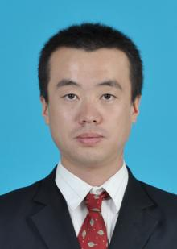
Yunfei Wang received the M.S. degrees in materials from Henan University of Science and Technology, Luoyang, China in 2009, and the Ph. D. degrees in materials from Beijing Institute of Technology, Beijing, China in 2015.
He is currently a associate professor with Henan Mechanical & Electrical Vocational College, Zhengzhou, Henan, China. His research interests include machine vision and artificial intelligence.


Yaping Li received the M.S. degrees in detection technology and automation devices from Zhengzhou University, Zhengzhou, China in 2015.
She is currently a lecturer with Henan Mechanical & Electrical Vocational College, Zhengzhou, Henan, China. Her research interests include artificial intelligence and automation.

