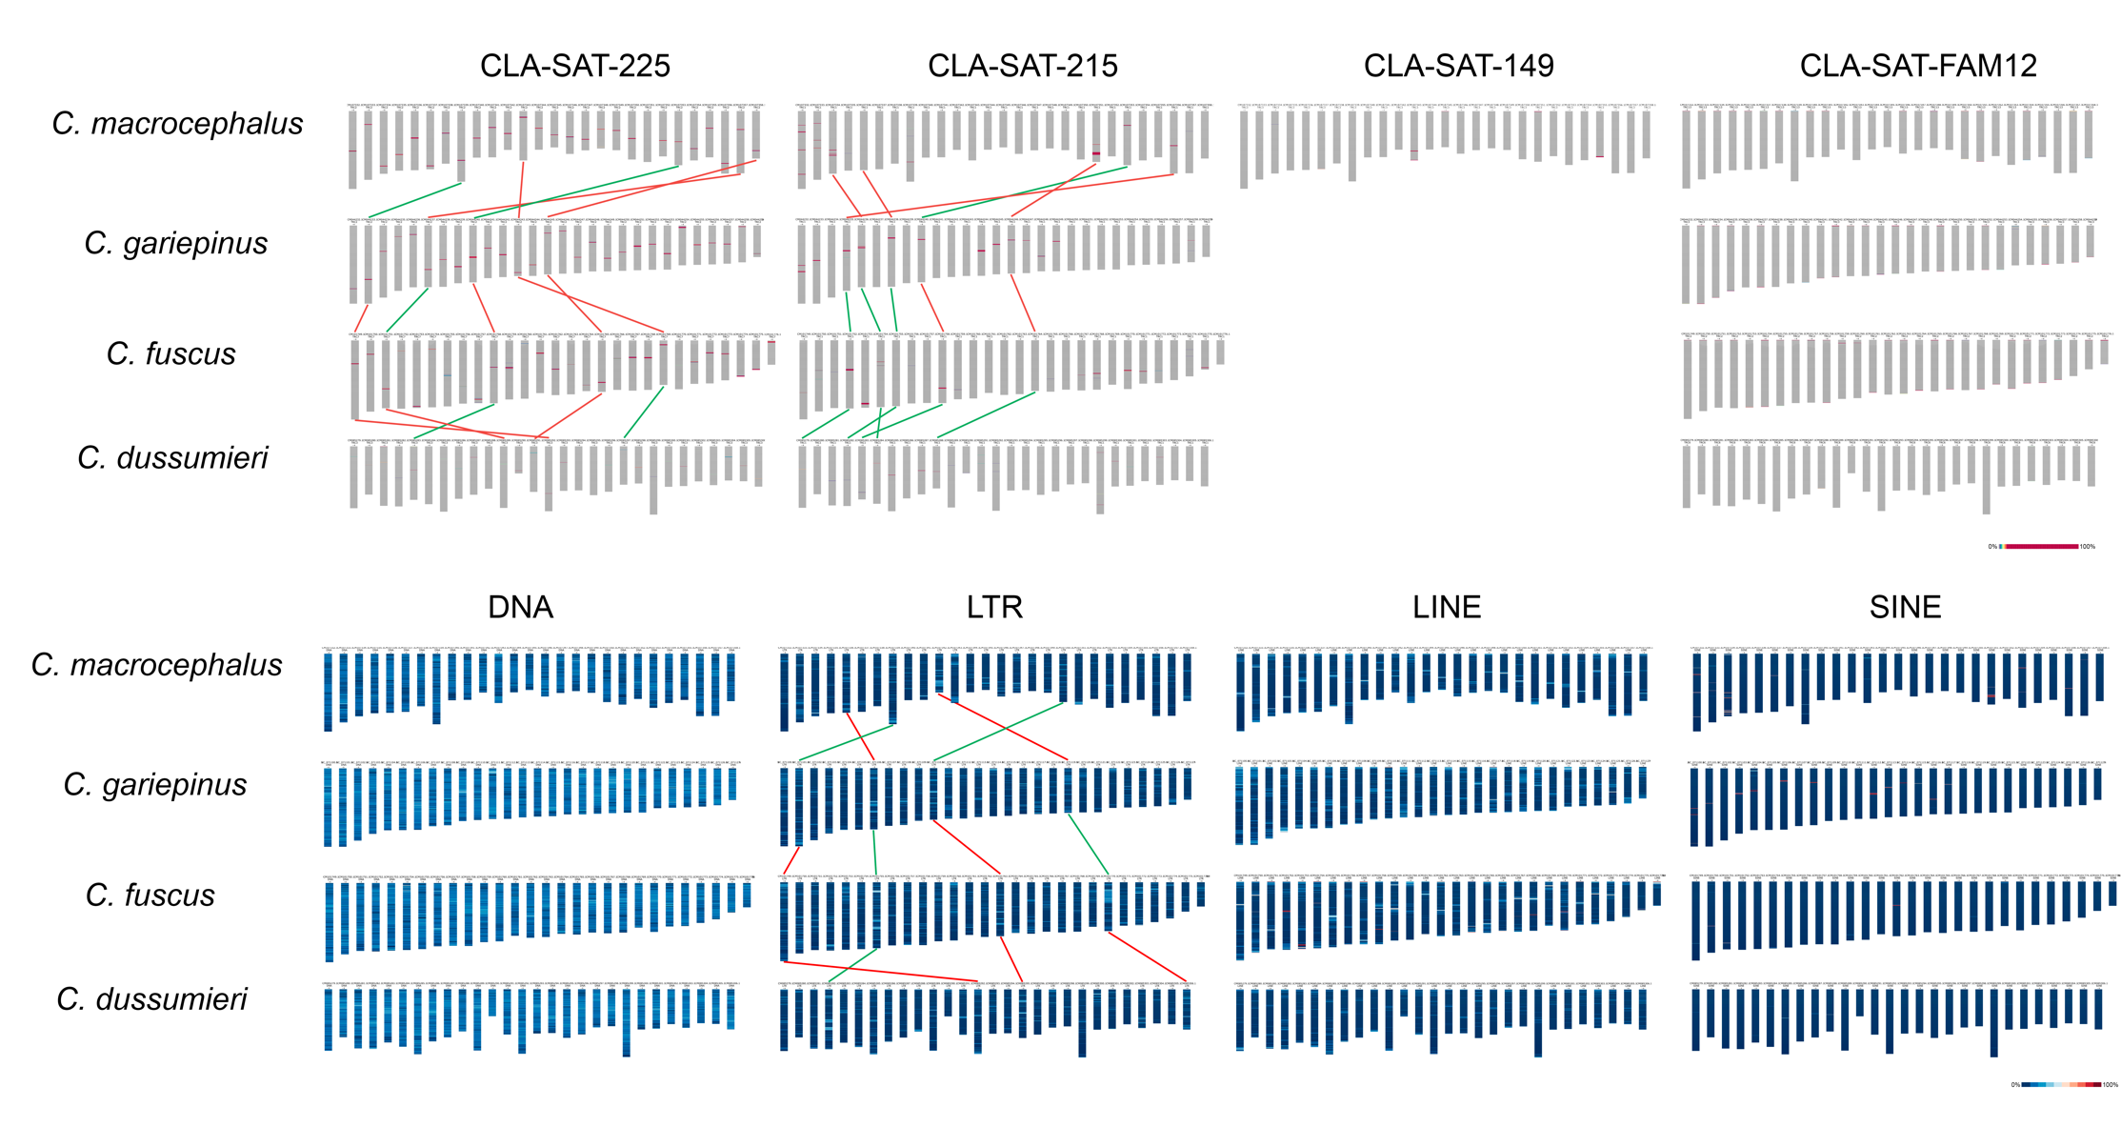
Supplementary Figure 1. Lisachov et al.

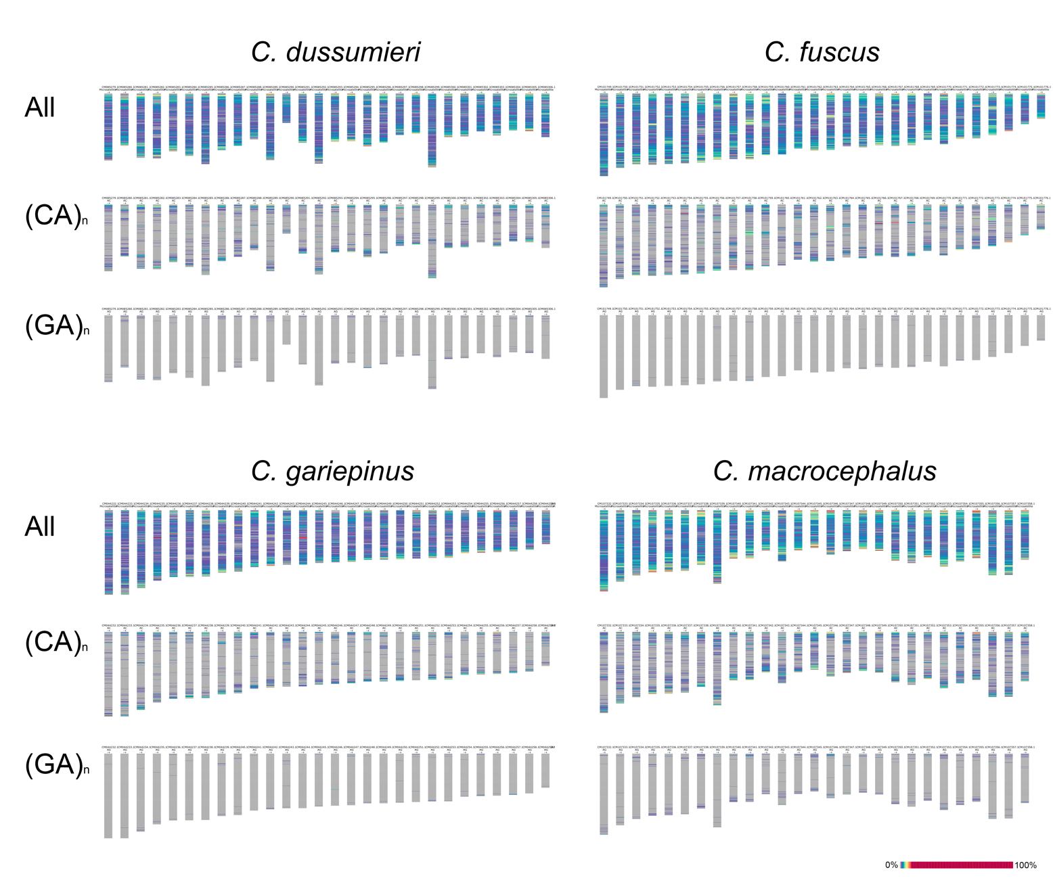
Supplementary Figure 2. Lisachov et al.

