Supplementary information

Oxygen Delivery Reprograms Hypoxic Tumor Niche to Rejuvenate CAR-NKT Cells for Improved Cancer Immunotherapy

Parvaiz Ahmad Shiekh^{1,2 #}, Yan-Ruide Li^{1,3 #}, Haochen Nan¹, Karina Mitchell¹, Youcheng Yang¹, Yichen Zhu^{1,3}, Lili Yang^{1,3,4,5,6,7,8}*, Song Li^{1,4,5}*
1 Department of Bioengineering, University of California, Los Angeles, Los Angeles, CA, USA.
2 Centre for Biomedical Engineering, Indian Institute of Technology Delhi, New Delhi, India
3 Department of Microbiology, Immunology & Molecular Genetics, University of California, Los Angeles, Los Angeles, CA, USA.
4 Eli and Edythe Broad Center of Regenerative Medicine and Stem Cell Research, University of California, Los Angeles, Los Angeles, CA, USA
5 Jonsson Comprehensive Cancer Center, David Geffen School of Medicine, University of California, Los Angeles, Los Angeles, CA, USA
6 Molecular Biology Institute, University of California, Los Angeles, CA, USA
7 Parker Institute for Cancer Immunotherapy, University of California, Los Angeles, Los Angeles, CA, USA
8 Goodman-Luskin Microbiome Center, University of California, Los Angeles, Los Angeles, CA, USA
#These authors contributed equally
* Corresponding to: songli@ucla.edu; liliyang@ucla.edu

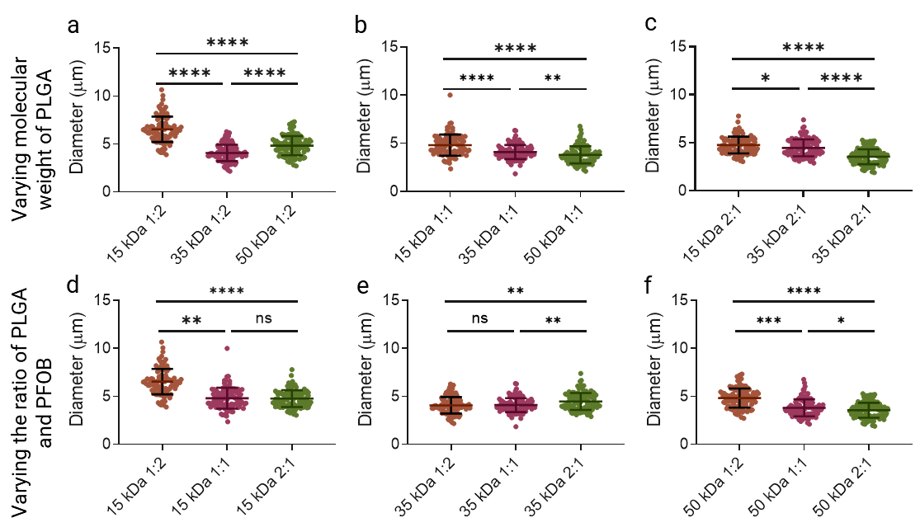

Supplementary Fig. S1 | Particle size distributions of HOPE microsacs across PLGA molecular weights and PLGA:PFOB ratios.
a–c, Diameter distributions for HOPE microsacs formulated with PLGA of three molecular weights (15, 35, 50 kDa) at fixed PLGA:PFOB ratios of 1:2 (a), 1:1 (b), and 2:1 (c).
d–f, Diameter distributions for HOPE microsacs formulated with PLGA:PFOB ratios of 1:2, 1:1, and 2:1 for PLGA molecular weights of 15 kDa (d), 35 kDa (e), and 50 kDa (f).
In all panels, each dot represents one microparticle (n ≥ 100 per formulation). Significance was determined by one way ANOVA test followed by Tukey’s post-hoc multiple comparisons test. **P < 0.01, ***P < 0.001, ****P < 0.0001; ns, not significant.

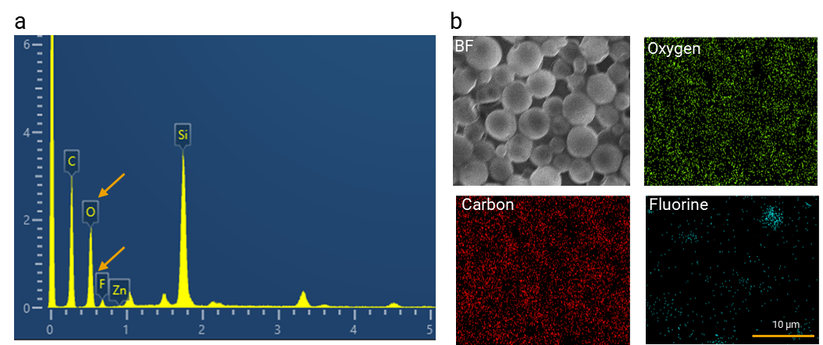

Supplementary Fig. S2 | Elemental characterization of HOPE microsacs by EDS and elemental mapping.
a. Energy-dispersive X-ray spectroscopy (EDS) spectrum of HOPE microsacs showing major peaks for carbon (C), oxygen (O), fluorine (F), zinc (Zn, from stub), and silicon (Si, from wafer). Arrows highlight the O and F peak at ~0.5 keV and ~0.7 keV, respectively.
b. Scanning electron microscopy (SEM)–based elemental mapping of HOPE microsacs showing spatial distribution of (b) oxygen, (c) carbon, and (d) fluorine. Bright-field SEM image is shown in (b) as “BF.” Scale bar, 10 µm.

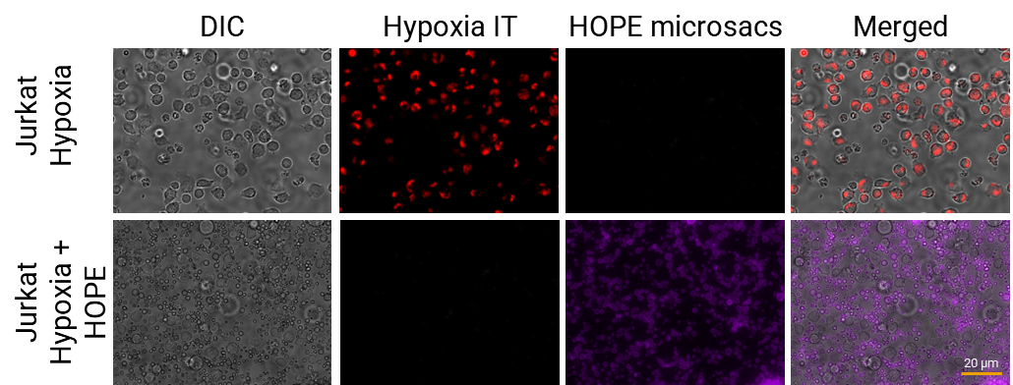

Supplementary Fig. S3 | HOPE microsac coculture alleviates hypoxia in Jurkat T cells in vitro. Jurkat cells incubated under hypoxia with and without HOPE reveal markedly diminished Hypoxia Red signal upon HOPE treatment. Particles are false colored as purple for better visualization. (n=3). Scale bar, 20 µm.

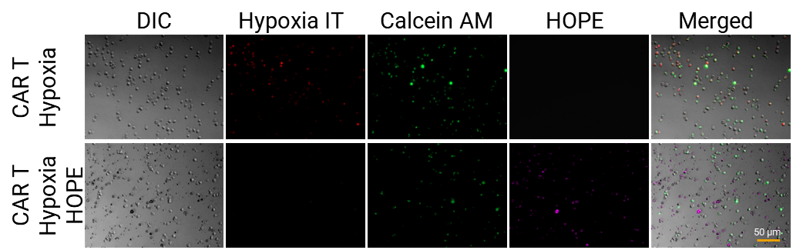

Supplementary Fig. S4 | HOPE microsac coculture alleviates hypoxia in CAR T cells in vitro. CAR T cells incubated under hypoxia with and without HOPE reveal markedly diminished Hypoxia Red signal upon HOPE treatment. Calcein AM staining demonstrates cells viable upon HOPE treatment. Particles are false colored as purple for better visualization. (n=3). Scale bar, 50 µm.

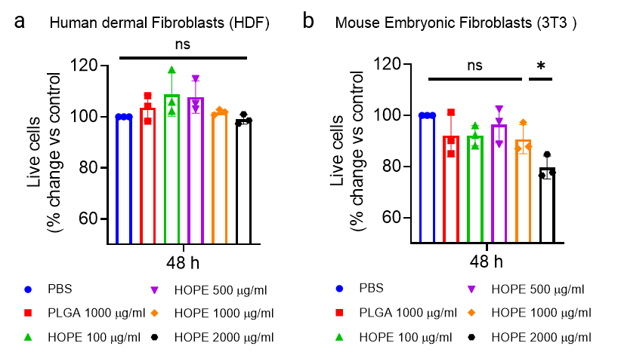

Supplementary Fig. S5 | Cytocompatibility of HOPE microsacs in the culture of dermal and embryonic fibroblasts. Evaluation of HOPE microsac cytotoxicity against non-tumor cells at 48 h. (a) Human Dermal Fibroblast (HDF) and (b) Mouse Embryonic Fibroblast (3T3) cells were cocultured with different concentrations of HOPE microsacs for 24 h. (n=3). No significant cytotoxicity was observed.

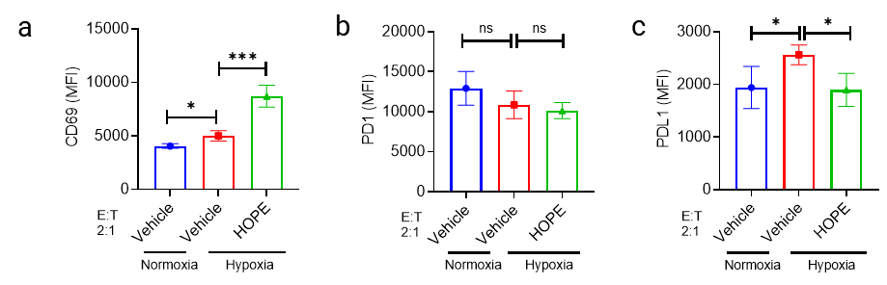

Supplementary Fig. S6 | Flow Cytometric Analysis of CAR T cell activation and exhaustion following HOPE treatment under hypoxia. Quantification of the flow cytometry analysis of CAR T cell activation i.e., CD69 (a) and exhaustion i.e., PD1 (b) and PDL1(c) markers. Data are represented as mean ± s.d (n = 3). *P < 0.05, **P < 0.01, ***P < 0.001, ns non-significant. Significance was determined by one way ANOVA test followed by Tukey’s post-hoc multiple comparisons test.

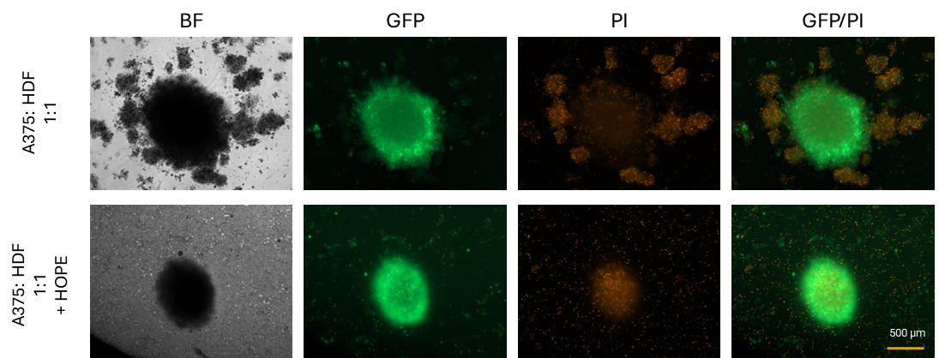

Supplementary Fig. S7 | Live–dead viability staining of A375‐CD19‐GFP/HDF tumor spheroids after CAR19-NKT cell infiltration under hypoxia ± HOPE.
CAR19‐NKT cells were co‐cultured with A375-GFP/HDF spheroids for 24 h under hypoxia in the absence (top row) or presence (bottom row) of HOPE. Spheroids were then stained with Propidium Iodide (PI, dead cells, red) and imaged by confocal microscopy. Scale bar 500 µm.

Supplementary Fig. S8 | Tumor growth curves (volume) over time. Significance was determined by a two-tailed, unpaired t-test. Data are represented as mean ± s.d. (n = 5). ***P < 0.001, ns non-significant.

