Journal of Pest Control

Investigation of the nematicidal mechanisms of cover crop-derived extracts on pest (Meloidogyne incognita) and beneficial (Panagrellus redivivus) nematode species under laboratory conditions
Dóra Sára Selmeczi, Márta Ladányi, Ferenc Tóth, Renáta Petrikovszki*

* Corresponding author: Petrikovszki.Renata@uni-mate.hu Department of Zoology and Ecology, Institute for Wildlife Management and Nature Conservation, Hungarian University of Agriculture and Life Sciences (MATE), 2100 Gödöllő, Hungary

Supplementary Information

Selective nematicidal activity

A graphical method was employed to evaluate the selective efficacy of various plant extracts against the plant-parasitic nematode Meloidogyne incognita and the non-target nematode Panagrellus redivivus. The objective was to identify extracts that maximize mortality in the pest species while minimizing collateral damage to the beneficial organism.
The evaluation utilized a two-dimensional scatter plot, with the mortality percentage of the pest, M. incognita, represented on the X-axis, and the mortality percentage of the beneficial organism, P. redivivus, on the Y-axis Fig. S1). This graphical representation allows for the simultaneous assessment of both desired toxicity and undesired side effects. For the purpose of this study, the most effective extracts are those located in the lower-right quadrant of the graph, which corresponds to high mortality for M. incognita (greater than 50%) and low mortality for P. redivivus (less than 50%).
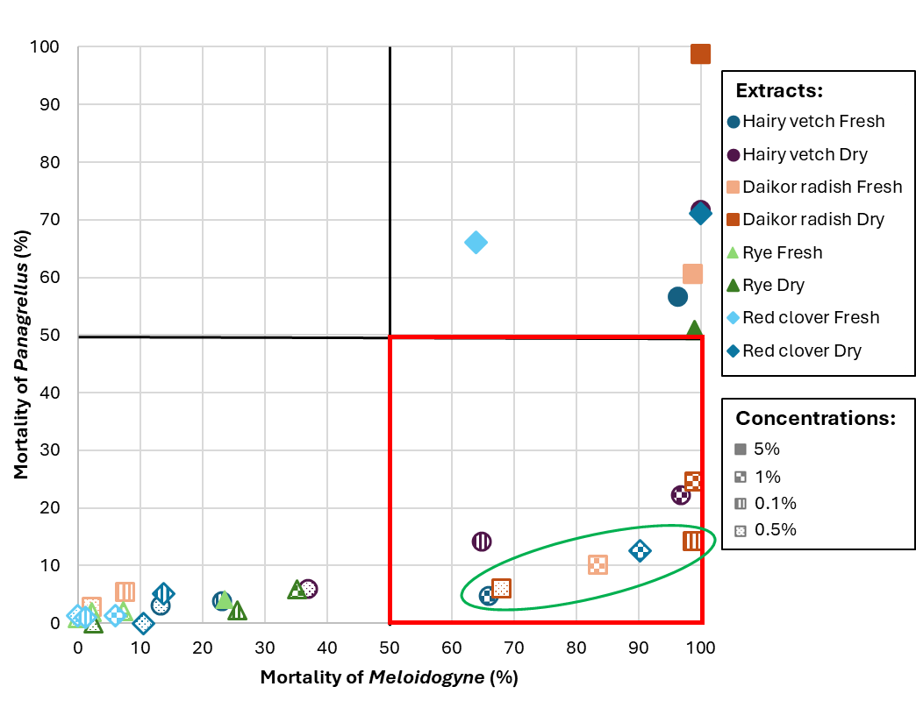
Fig. S1 Scatter plot with the mortality percentage of the pest, M. incognita, represented on the X-axis, and the mortality percentage of the beneficial organism, P. redivivus, on the Y-axis. The different colours and shapes indicate different extracts, while different patterns indicate the different concentrations. The most effective extracts are those located in the lower-right quadrant and the five extracts highlighted within the green oval on the graph, are considered optimal results
To systematically compare the extracts within this target quadrant, a partial ordering criterion was established: an extract 'A' is considered superior to an extract 'B' if it demonstrates both higher mortality for M. incognita and lower mortality for P. redivivus.
Analysis of the eight extracts situated in the lower-right quadrant revealed that three could be excluded as they were suboptimal compared to at least one other treatment based on the defined criterion. The remaining five extracts, highlighted within the green oval on the graph, are considered optimal results under this partial ordering, as no single one is demonstrably superior to any other across both metrics.
The selection of the "best" extract from this optimal set is contingent on specific strategic priorities:
- For maximal pest control: If the primary goal is to achieve the highest possible mortality of M. incognita, with less concern for effects on P. redivivus (provided its mortality remains below 15%), the 0.5% dry Daikon radish extract is the most effective choice. This extract resulted in a mortality rate approaching 99% for the pest nematode.
- For minimal non-target impact: If the main priority is the preservation of the beneficial nematode population, the 1% dry Hairy vetch extract and the 0.1% dry Daikon radish extract are the preferred options. These extracts kept the mortality of P. redivivus below 6% while still achieving over 65% mortality in the target pest.
- For a balanced approach: For applications requiring a balance of high efficacy against the pest and low harm to the beneficial organism, the 1% fresh Hairy vetch extract and the 1% fresh Daikon radish extract present the most balanced solutions. Both achieved pest mortality rates of between 83% and 90%, with mortality for the beneficial organism maintained between 10% and 12.5%.

Selective nematode repellency
Similarly, to evaluate the selective repellent properties of various plant extracts, a two-dimensional graphical comparison was conducted (Fig. S2). This analysis aimed to identify extracts that most effectively repel the plant-parasitic nematode Meloidogyne while simultaneously minimizing any repellent effect on the beneficial nematode Panagrellus.
The repellent activity of the extracts is represented in a scatter plot where the X-axis indicates the "Area choice of Meloidogyne," and the Y-axis represents the "Area choice of Panagrellus." In this context, a lower "Area choice" value signifies a stronger repellent effect, as the nematodes avoid the area treated with the extract. Conversely, a higher value indicates a weaker repellent or even an attractive effect.
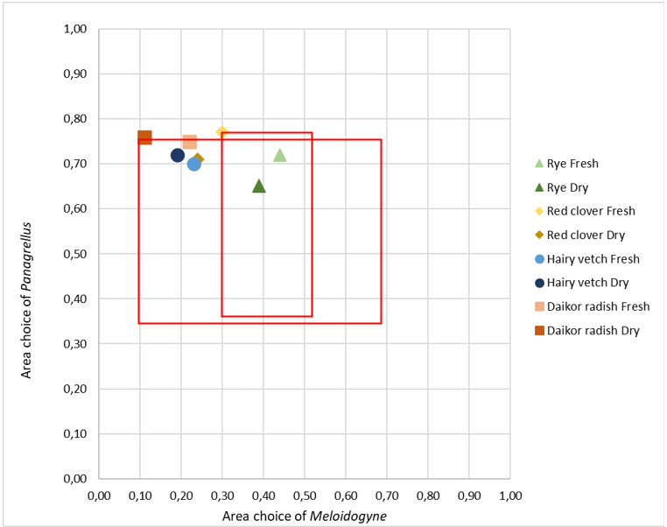
Fig. S2 Scatter plot with the area choice of the pest, M. incognita, represented on the X-axis, and the area choice of the beneficial organism, P. redivivus, on the Y-axis. The different colours and shapes indicate different extracts. The less effective extracts are those located in the lower-right rectangles of the two treatments (dry extract of Daikon radish and the fresh extract of Red clover) for which no single superior alternative exists)
The ideal extract for selective pest management would therefore be located in the upper-left region of the plot. This position corresponds to a low area choice for the pest nematode (Meloidogyne) and a high area choice for the beneficial nematode (Panagrellus), indicating strong, targeted repellency.
To systematically compare the treatments, a partial ordering criterion was established: an extract 'A' is considered superior to an extract 'B' if it is both more repellent to Meloidogyne (i.e., has a lower X-value) and less repellent to Panagrellus (i.e., has a higher Y-value).
Based on this criterion, an analysis of the plotted data points allows for the identification of an optimal set of treatments for which no single superior alternative exists.
The dry extract of Daikon radish and the fresh extract of Red clover emerge as the two non-dominated, optimal solutions. All other tested extracts were found to be suboptimal compared to at least one of these two. The choice between these two optimal extracts depends on the primary strategic goal of the application
- For maximum pest repellency: If the main objective is to achieve the most potent possible repellent effect against the pest Meloidogyne, the dry extract of Daikon radish is the unequivocal choice. It registered the lowest area choice value for the pest (0.11), indicating a very strong repellent action and the highest area choice for the Panagrellus (0.76).
- For maximum attraction of beneficials: If the priority is to create an environment that is most favorable to the beneficial Panagrellus population, the Fresh extract of Red clover is the preferred option. It achieved the highest area choice value for this nematode (approximately 0.77), signifying it is the least repellent, and potentially even attractive, to the beneficial species. However, while the fresh Red clover extract is technically optimal for minimizing impact on Panagrellus, the dry Daikon radish extract represents a more pragmatically effective solution. It provides a nearly equivalent, high level of safety for the beneficial nematode while delivering a far superior repellent action (0.30) against the target pest, Meloidogyne.

This graphical analysis demonstrates that the ideal plant extract for nematode control depends on the specific objectives of the application. Moreover, it also effectively disentangles the dual objectives of pest repellency and beneficial organism safety.
In summary, for applications prioritizing maximal pest control and repellency, the dry extract of Daikon radish emerges as the most effective and strategically sound choice, representing the overall optimal solution among the tested substances.

