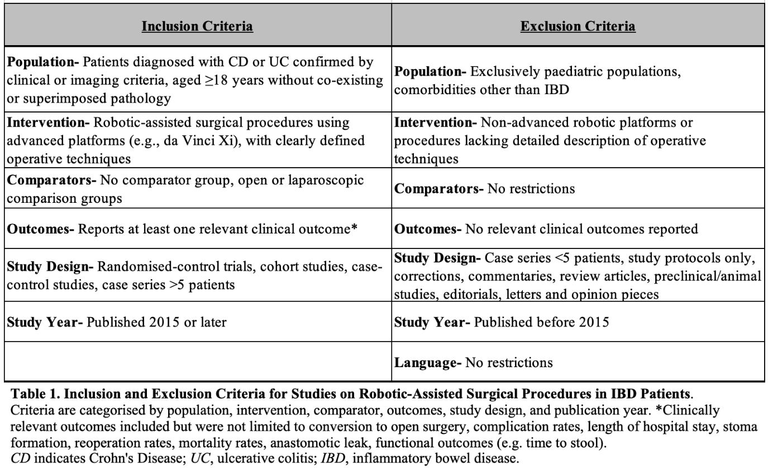
Table 1 Inclusion and exclusion criteria for systematic review studies on robotic-assisted surgical procedures in IBD patients. Criteria are categorised by population, intervention, comparator, outcomes, study design, and publication year *Clinically relevant outcomes included but were not limited to conversion to open surgery, complication rates, length of hospital stay, stoma formation, reoperation rates, mortality rates, anastomotic leak, functional outcomes (e.g. time to stool). CD indicates Crohn's Disease; UC, ulcerative colitis; IBD, inflammatory bowel disease

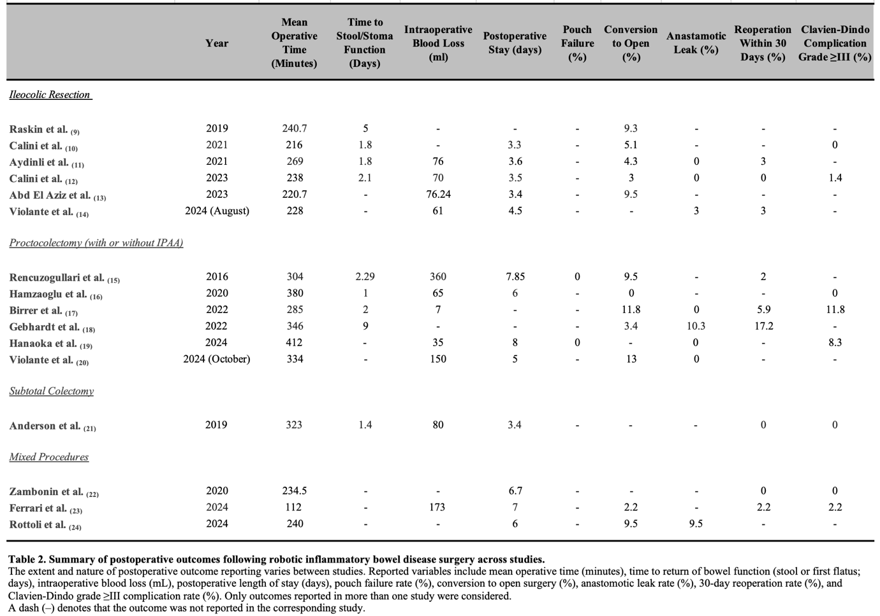
Table 2 Summary of postoperative outcomes following robotic inflammatory bowel disease surgery across studies.
The extent and nature of postoperative outcome reporting varies between studies. Reported variables include mean operative time (minutes), time to return of bowel function (stool or first flatus; days), intraoperative blood loss (mL), postoperative length of stay (days), pouch failure rate (%), conversion to open surgery (%), anastomotic leak rate (%), 30-day reoperation rate (%), and Clavien-Dindo grade ≥III complication rate (%). Only outcomes reported in more than one study were considered.
A dash (–) denotes that the outcome was not reported in the corresponding study.

