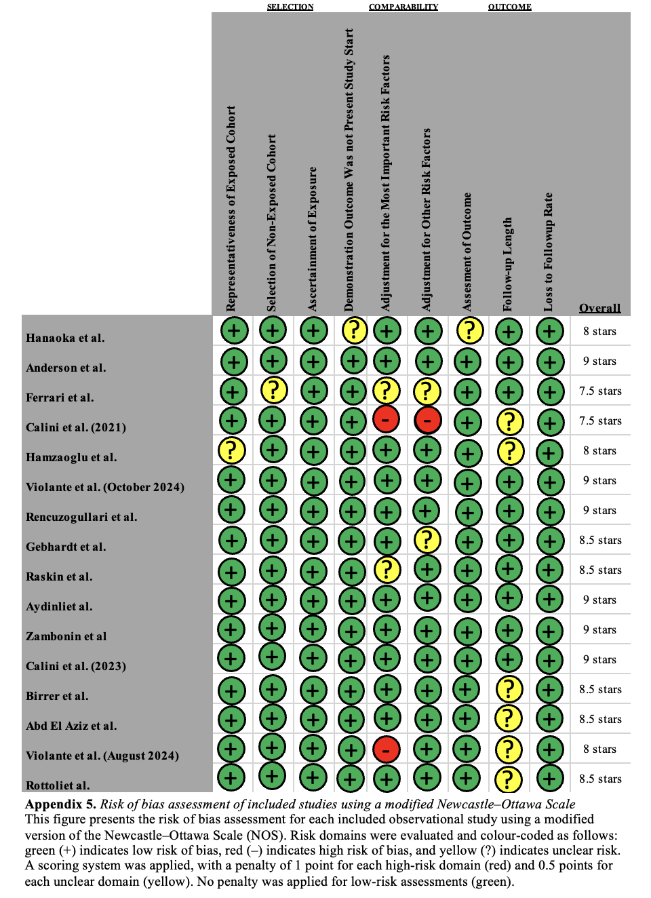
Appendix 1: Newcastle-Ottawa Scale (NOS) Quality Assessment

