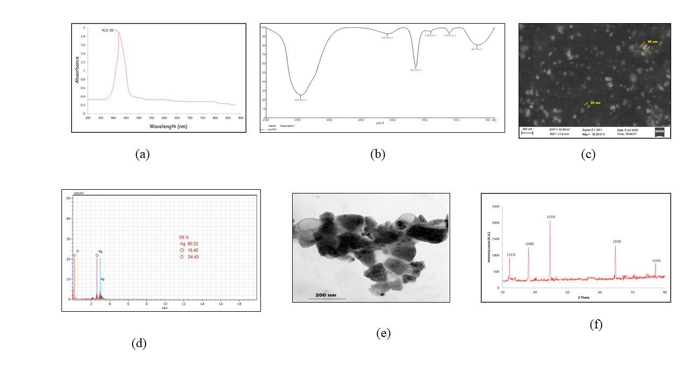
Supplementary figure 1: Characterization of synthesized AgNPs using Cymodocea serrulata – (a) UV- vis spectrum of AgNPs, (b) FT-IR spectrum of AgNPS, (c) SEM analysis of AgNPs, (d) EDX spectrum of AgNPs, (e) TEM analysis of AgNPs, (f) XRD pattern of AgNPs

2(a)
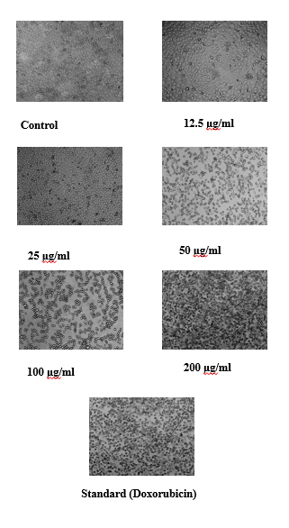
2(b)
Supplementary figure 2(a): Cell viability (%) of MCF-7 cell line on the dose-dependent treatment of AgNPs; 2(b): The morphological changes of MCF-7 cells treated with AgNPs

