Appendix

Descriptive statistics:
Table A1. Descriptive statistics (2000–2024; five-country panel).
 | count | unique | top | freq | mean | std | min | 25% | 50% | 75% | max
country | 125 | 5 | Bangladesh | 25 | NaN | NaN | NaN | NaN | NaN | NaN | NaN
country_iso3 | 125 | 5 | BGD | 25 | NaN | NaN | NaN | NaN | NaN | NaN | NaN
year | 125.0 | NaN | NaN | NaN | 2012.0 | 7.240121 | 2000.0 | 2006.0 | 2012.0 | 2018.0 | 2024.0
female_employment_industry | 125.0 | NaN | NaN | NaN | 12.788989 | 3.904953 | 7.793243 | 9.970811 | 11.613068 | 16.457092 | 23.708614
female_employment_services | 125.0 | NaN | NaN | NaN | 63.576701 | 24.651495 | 19.387657 | 43.39257 | 77.911236 | 84.382576 | 87.694766
female_employment_agriculture | 125.0 | NaN | NaN | NaN | 23.634308 | 24.302504 | 3.19102 | 4.591487 | 5.202819 | 48.642516 | 71.588942
female_wage_workers | 125.0 | NaN | NaN | NaN | 53.691361 | 23.543442 | 18.766653 | 25.613939 | 65.648961 | 75.439419 | 77.840405
female_vulnerable_employment | 125.0 | NaN | NaN | NaN | 44.083756 | 23.756091 | 19.890894 | 22.174326 | 31.960652 | 72.19039 | 81.044408
female_self_employed | 125.0 | NaN | NaN | NaN | 46.308631 | 23.543444 | 22.159595 | 24.560581 | 34.351039 | 74.386071 | 81.23325
female_employment_ratio_15plus | 125.0 | NaN | NaN | NaN | 45.792528 | 12.070551 | 27.143 | 37.634 | 42.309 | 51.019 | 69.318
female_unemployment_rate | 125.0 | NaN | NaN | NaN | 7.209176 | 3.945884 | 2.725 | 3.908 | 6.628 | 9.447 | 21.018
gdp_per_capita_const2015 | 125.0 | NaN | NaN | NaN | 7825.433803 | 5835.377107 | 620.560473 | 1413.941425 | 9575.934378 | 12252.844107 | 18958.603329
openness_gdp | 125.0 | NaN | NaN | NaN | 52.451726 | 14.799501 | 26.271447 | 40.327385 | 53.309044 | 62.162387 | 88.826935
urban_pop_share | 125.0 | NaN | NaN | NaN | 63.33596 | 29.373136 | 19.892 | 29.002 | 78.405 | 87.564 | 95.852
female_secondary_gross | 125.0 | NaN | NaN | NaN | 83.565652 | 25.631564 | 39.168892 | 54.715061 | 90.221878 | 104.821289 | 128.742966
wbl_index | 125.0 | NaN | NaN | NaN | 70.49 | 15.579891 | 38.125 | 51.875 | 75.0 | 83.75 | 88.75

Correlation matrix (Pearson):
 | female_employment_industry | female_employment_services | female_employment_agriculture | female_wage_workers | female_vulnerable_employment | female_self_employed | female_employment_ratio_15plus | female_unemployment_rate | gdp_per_capita_const2015 | openness_gdp | urban_pop_share | female_secondary_gross | wbl_index
female_employment_industry | 1.000000 | -0.167943 | 0.009674 | 0.030829 | -0.005799 | -0.030829 | -0.621090 | -0.209025 | -0.122383 | -0.027742 | 0.045124 | 0.021522 | -0.187610
female_employment_services | -0.167943 | 1.000000 | -0.987375 | 0.927721 | -0.937293 | -0.927721 | 0.077668 | 0.458252 | 0.900938 | 0.655554 | 0.911030 | 0.831823 | 0.797309
female_employment_agriculture | 0.009674 | -0.987375 | 1.000000 | -0.945997 | 0.951685 | 0.945997 | 0.021014 | -0.431247 | -0.894212 | -0.660510 | -0.931363 | -0.847226 | -0.778613
female_wage_workers | 0.030829 | 0.927721 | -0.945997 | 1.000000 | -0.998436 | -1.000000 | -0.236511 | 0.560611 | 0.932748 | 0.617697 | 0.991211 | 0.920035 | 0.605138
female_vulnerable_employment | -0.005799 | -0.937293 | 0.951685 | -0.998436 | 1.000000 | 0.998436 | 0.195722 | -0.547965 | -0.933981 | -0.638429 | -0.987840 | -0.914358 | -0.613904
female_self_employed | -0.030829 | -0.927721 | 0.945997 | -1.000000 | 0.998436 | 1.000000 | 0.236511 | -0.560612 | -0.932748 | -0.617697 | -0.991211 | -0.920035 | -0.605138
female_employment_ratio_15plus | -0.621090 | 0.077668 | 0.021014 | -0.236511 | 0.195722 | 0.236511 | 1.000000 | -0.301293 | -0.084419 | 0.034787 | -0.259589 | -0.194787 | 0.396222
female_unemployment_rate | -0.209025 | 0.458252 | -0.431247 | 0.560611 | -0.547965 | -0.560612 | -0.301293 | 1.000000 | 0.482799 | 0.081886 | 0.580684 | 0.536278 | 0.100315
gdp_per_capita_const2015 | -0.122383 | 0.900938 | -0.894212 | 0.932748 | -0.933981 | -0.932748 | -0.084419 | 0.482799 | 1.000000 | 0.538156 | 0.952142 | 0.931090 | 0.667695
openness_gdp | -0.027742 | 0.655554 | -0.660510 | 0.617697 | -0.638429 | -0.617697 | 0.034787 | 0.081886 | 0.538156 | 1.000000 | 0.587369 | 0.503555 | 0.485220
urban_pop_share | 0.045124 | 0.911030 | -0.931363 | 0.991211 | -0.987840 | -0.991211 | -0.259589 | 0.580684 | 0.952142 | 0.587369 | 1.000000 | 0.939282 | 0.595861
female_secondary_gross | 0.021522 | 0.831823 | -0.847226 | 0.920035 | -0.914358 | -0.920035 | -0.194787 | 0.536278 | 0.931090 | 0.503555 | 0.939282 | 1.000000 | 0.638605
wbl_index | -0.187610 | 0.797309 | -0.778613 | 0.605138 | -0.613904 | -0.605138 | 0.396222 | 0.100315 | 0.667695 | 0.485220 | 0.595861 | 0.638605 | 1.000000
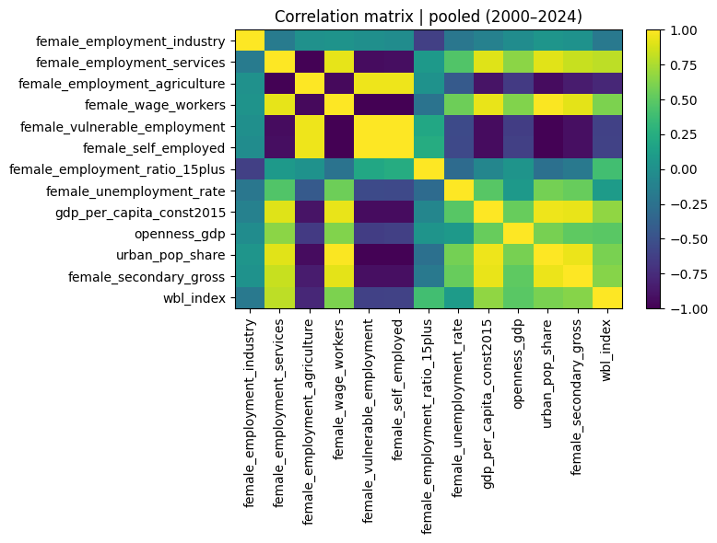
Table A2. Variable definitions and data sources (WDI codes; WBL; ILO/EPZ).
Variable | Definition | Source
0 | female_employment_industry | Female employment in industry (% of female emp... | WDI code: SL.IND.EMPL.FE.ZS
1 | gdp_per_capita_const2015 | GDP per capita, constant 2015 US$ | WDI code: NY.GDP.PCAP.KD
2 | openness_gdp | Trade openness: exports + imports (% of GDP) | WDI code: NE.TRD.GNFS.ZS
3 | urban_pop_share | Urban population (% of total population) | WDI code: SP.URB.TOTL.IN.ZS
4 | female_secondary_gross | Gross female secondary enrollment (%) | WDI code: SE.SEC.ENRR.FE
5 | wbl_index | Women, Business and the Law index (0–100) | World Bank WBL Database
6 | epz_dummy | Dummy = 1 if country is EPZ-intensive (Banglad... | ILO (Boyenge 2007; Milberg & Amengual 2008)

