Supplementary Material to:
Validating therapy decisions by reasons for therapy switch in relapsing-remitting multiple sclerosis

Anna Maria Sakr,^{1,2} Joachim Havla,³ and Ulrich Mansmann^{1,2}

Authors’ affiliation:
- Institute for Medical Information Processing, Biometry and Epidemiology (IBE), Faculty of Medicine, LMU Munich, 81377, Germany
- Pettenkofer School of Public Health, Faculty of Medicine, LMU Munich, 81377, Germany
- Institute of Clinical Neuroimmunology, University Hospital, LMU Munich, 81377, Germany

Authors’ identification:
Anna Maria Sakr https://orcid.org/0000-0001-7827-6419
Joachim Havla https://orcid.org/0000-0002-4386-1340
Ulrich Mansmann https://orcid.org/0000-0002-9955-8906

Correspondence to: Ulrich Mansmann
Institute for Medical Information Processing, Biometry and Epidemiology, Faculty of Medicine, LMU Munich, Marchioninistrasse 15, 81377 Munich mansmann@ibe.med.uni-muenchen.de

Submitted to Scientific Reports

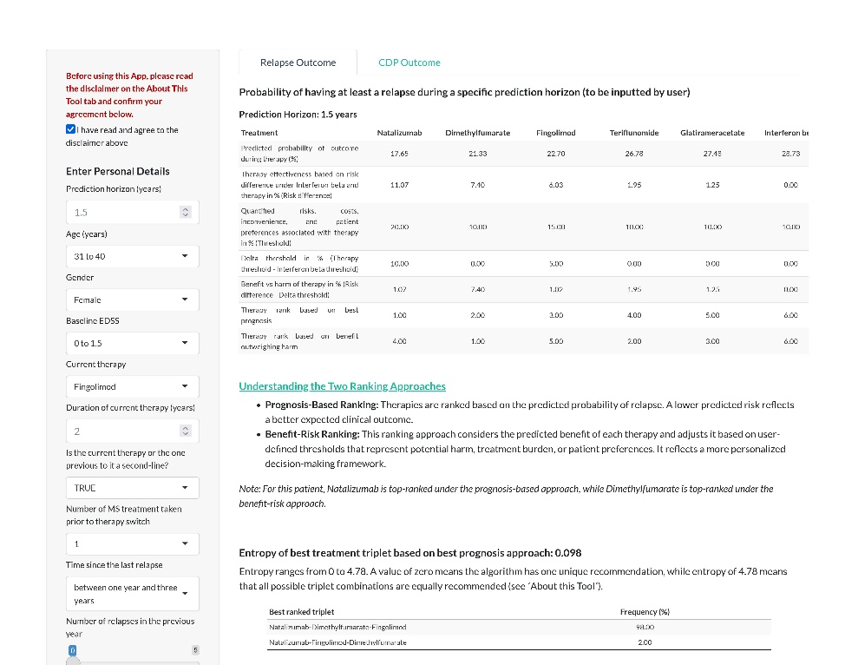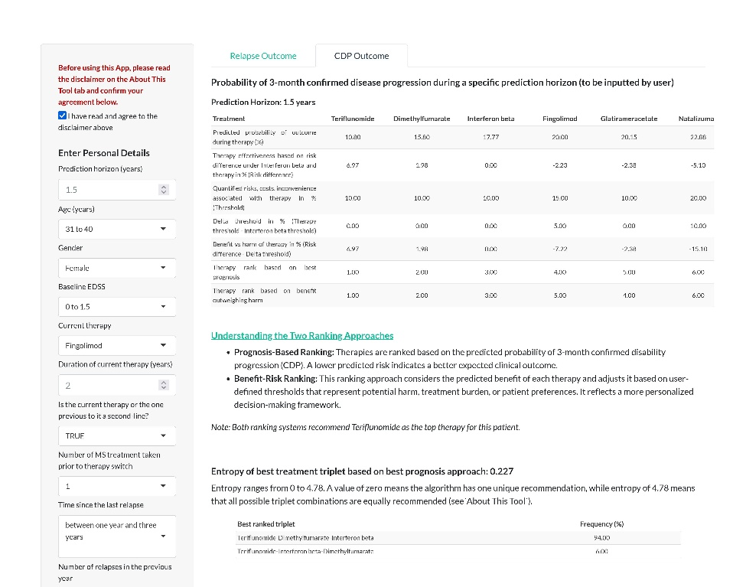
a
b
Supplementary Fig. 1. Shiny App output illustrating individualized treatment recommendations for relapse (left panel a) and confirmed disease progression (3m-CDP; right panel b).

Recommendations are generated based on predicted prognosis and benefit-risk approach described by Chalkou et al¹⁸.
Users can input patient-, disease- and therapy-related characteristics. The underlying models estimate the probability of relapse and 3m-CDP over a defined time-period under six disease-modifying therapies: natalizumab, fingolimod, dimethyl fumarate, teriflunomide, glatiramer acetate, interferon beta 1. The app generates two treatment recommendations per outcome: one based on best prognosis, and another based on weighing the benefit of each therapy with its associated risks threshold—10% for platform, 15% for fingolimod and 20% for natalizumab. In this patient case, the relapse model recommends natalizumab under the best-prognosis approach (predicted relapse probability: 17.65% over 18 months), and dimethyl fumarate under the benefit-risk approach (21.33%). For the 3m-CDP outcome, both approaches agree on teriflunomide (predicted probability: 10.8%). The recommended therapies differ between outcomes, highlighting the complexity of treatment decisions. Additionally, some predicted probabilities are close —e.g., fingolimod and dimethyl fumarate for relapse, or interferon beta and teriflunomide for 3m-CDP—making clear-cut decisions less straightforward. The entropy provides a measure of model recommendation certainty. For the relapse outcome, two triplets are recommended, both with natalizumab ranked first; dimethyl fumarate and fingolimod alternate in second and third positions due similar risk estimates. A similar pattern is observed for the 3m-CDP outcome. These results underscore the importance of incorporating patient preferences and physicians’ expertise to enable optimal treatment selection.
Supplementary Table 1. Comparison of guidelines’ treatment recommendations for the different patient subgroups.
Subgroup | ECTRIMS/EAN recommendations | Actual observed switches and  their alignment with ECTRIM/EAN | AAN recommendations | Notes
Therapy naive | No treatment strategy  R4: For active RRMS, choosing between the wide range of available DMTs (interferon beta-1b, interferon beta-1a -sc, im-, peginterferon beta-1a, glatiramer acetate, teriflunomide, dimethyl fumarate, cladribine, fingolimod, daclizumab, natalizumab, ocrelizumab and alemtuzumab) from the modestly effective to the highly efficacious will depend on the patient characteristics, comorbidities, disease severity/activity, drug safety profile and drug accessibility (consensus statement). | NoDMT to Cat 1 (Escalation)  Assessment not possible | Treatment strategy is only for highly active MS: alemtuzumab, fingolimod, natalizumab.  Starting R5: Counsel about comorbid diseases and concomitant medications as these might interact with DMTs (level B).  Starting R9: Offer DMTs to RRMS patients with recent disease activity (level B).  Starting R12: Counsel men with MS on their reproductive plans before initiating teriflunomide as it has a teratogenic risk from male sperm that can last two years after treatment cessation (level B).  Starting R14: Prescribe Alemtuzumab, fingolimod, natalizumab for MS patients with highly active MS (level B).  Starting R16: May initiate natalizumab in MS patients with positive anti-JCV antibody index above 0.9 only when benefit outweighs serious PML risk (level C). | No information in OFSEP sets on comorbidities or concomitant medications.  Alemtuzumab has been used only rarely since the 2019 recommendation by the European Medicines Agency restricting its use to second-line therapy, following updates to its safety profile  No stratification of patients by disease activity within the reason of switch-defined subgroups.  No information in OFSEP set on anti-JCV antibody index.  Guideline do not offer outcome-specific recommendations (i.e., prioritising relapse or 3m-CDP), rather for RRMS (whose disease activity is defined by relapses or MRI activity) and PPMS patients.
Drug holiday | No treatment strategy | NoDMT to Cat 1 (Escalation)  Assessment not possible | No treatment strategy  Stopping R1: In people with RRMS who are stable on DMT and want to discontinue therapy, clinicians should counsel people regarding the need for ongoing follow-up and periodic re-evaluation of the decision to discontinue DMT (level B). | Both guidelines suggest continuing therapy if patient is stable without safety or tolerability issues, but do not mention a treatment strategy after having discontinued a therapy.
 |  |  |  | Tables continues on next page
Lack of efficacy | Treatment strategy: escalation recommended if patient treated with low efficacy therapies and horizontal switch if treated with highly efficacious therapies.  R14: Offer a more efficacious drug to patients treated with interferon or glatiramer acetate who show evidence of disease activity (strong).  R15: Consult patient when deciding on which drug to switch to and consider several factors as for therapy naive (consensus statement).  R16: When treatment with a highly efficacious drug is stopped, either due to inefficacy or safety concerns, consider starting another highly efficacious drug, accounting for: disease activity, half-life and biological activity of previous drug, and potential for resumed or rebound disease activity especially with natalizumab (consensus statement). | cat 1 to cat 2  cat 2 to cat 3  cat 3 to cat 2  (Escalation or high efficacy to high efficacy)  Practice aligns with guidelines | No treatment strategy  Switching R1: Because disease activity may develop after DMT start but before it becomes effective, discuss switching DMTs if DMT is used long enough for it to have full effect, and patient was adherent to it, and experiences at least a relapse or at least two MRI lesions or increased disability over a one-year period of DMT use (level B). | No information in OFSEP data on patient adherence.
Intolerance | No treatment strategy | cat 1 to cat 1 (mainly injectable to oral)  cat 2 to cat 1 (DMF, TERI) or to cat 3  cat 3 to cat 2  Assessment not possible | Treatment strategy: change to oral therapy or low frequency injectables.  Switching R3-R4: Discuss a change to noninjectable or less frequently injectable DMTs for MS patients with intolerable injection discomfort or fatigue or AEs that negatively influence adherence (level B).  Switching R5: Clinicians should discuss switching DMT or reducing dosage when there are persistent laboratory abnormalities (level B).
Personal  convenience | No treatment strategy | cat 1 to (cat 1 or cat 2)  (mainly injectable to oral)  Assessment not possible
 |  |  |  | Table continues on next page
Serious  adverse events | Treatment strategy: horizontal switch if treated with highly efficacious therapies.  R16: When treatment with a highly efficacious drug is stopped, either due to inefficacy or safety concerns, consider starting another highly efficacious drug, accounting for: disease activity, half-life and biological activity of previous drug, and potential for rebound disease activity especially with natalizumab (consensus statement). | cat 2 to (cat 1 or cat 3)  cat 1 to cat 1  cat 3 to (cat 1 or cat 2)  Practice partially aligns with guidelines | Treatment strategy: For PML at risk patients, de-escalation to lower risk DMT  Switching R6: Counsel patients on risk of PML with natalizumab, fingolimod, rituximab, ocrelizumab, dimethyl fumarate and discuss switching to DMT with lower PML risk with patients taking natalizumab who are or become JCV-antibody positive with index above 0.9 while treated (level B).  Switching R7: if a patient with MS develops a malignancy while using a DMT, clinicians should promptly discuss switching to an alternate DMT especially for people using azathioprine, methotrexate, mycophenolate, cyclophosphamide fingolimod, teriflunomide, alemtuzumab, or dimethyl fumarate. People with MS with serious infections potentially linked to their DMT should switch DMTs (level B). | No information in OFSEP data on anti-JCV antibody index.
Programmed  stop | Treatment strategy: horizontal switch if treated with highly efficacious therapies.  R16: When treatment with a highly efficacious drug is stopped, either due to inefficacy or safety concerns, consider starting another highly efficacious drug, accounting for: disease activity, half-life and biological activity of previous drug, and potential for rebound disease activity especially with natalizumab (consensus statement).  R17: Consider possibility of resumed disease activity when stopping treatment, particularly with natalizumab (weak). | cat 3 to cat 2  cat 2 to cat 3  cat 1 to cat 1  Practice aligns with guidelines | Treatment strategy only for those treated with natalizumab.  Switching R9: natalizumab may be discontinued because of PML fear or pregnancy planning. This increases the risk of rebound disease activity within 6 months after discontinuation. Limited data on subsequent therapy. If subsequent chosen therapy is fingolimod (for reasons other than pregnancy or pregnancy planning), it should be started within eight to 12 weeks to reduce rebound activity (level B). | All therapies in the analysis set are started within 12 weeks from the end of the previous therapy, but the reason for the programmed stop is not known. It can be assumed that it is out of fear from PML in those switching from natalizumab, fingolimod, and dimethyl fumarate (66%, 3.6%, 2.9% respectively).
 |  |  |  | Table continues on next page
Pregnancy  desire | Treatment strategy: stop or de-escalate (interferon or glatiramer acetate until pregnancy occurs if high risk of disease reactivation), or natalizumab or alemtuzumab (during pregnancy if high disease activity).  R19: Advise all women of childbearing potential that DMTs are not licensed during pregnancy, except glatiramer acetate 20mg/mL (consensus statement).  R20: For women planning pregnancy and have a high risk of disease reactivation, consider using interferon or glatiramer acetate until pregnancy is confirmed (weak).  R21: Advice pregnancy delay if persistent high disease activity, otherwise consider natalizumab use throughout pregnancy with discussion of its implications. Otherwise, treatment with alemtuzumab possible in planned pregnancy in very active cases, given that a 4-month is strictly observed from the last infusion until conception (weak). | (cat 1 or cat 2 or cat 3) to (GA or IF or NA)  (GA or TERI) to DMF  (De-escalation)  Practice mostly aligns with guidelines | Treatment strategy: stop therapy  Switching R10: Stop DMT before conception for planned pregnancies, or if accidental exposure during pregnancy occurs, and do not initiate DMTs during pregnancy unless risk of disease activity outweighs DMT risk during pregnancy. According to FDA recommendation: avoid teriflunomide during pregnancy, inform physician if pregnancy occurs while on glatiramer acetate (level B). | No information in OFSEP data on whether patients got pregnant and if so, no information is given on the pregnancy trimester, possibly leading to patient’s misclassification in case pregnancy never occurred.  Alemtuzumab is not included in study DMTs.

Abbreviations: ECTRIMS: European Committee for Treatment and Research in Multiple Sclerosis, EAN: European academy of neurology; cat: category of therapy according to German society of neurology (cat 1 are platform therapies, cat 2 is fingolimod and cat 3 natalizumab), AAN: American academy of neurology; R: recommendation; DMTs: disease-modifying therapies; RRMS: relapsing-remitting multiple sclerosis; AEs: adverse events; JCV: John Cunningham virus; PML: Progressive Multifocal Leukoencephalopathy; PPMS: primary progressive MS.
The above recommendations were extracted from the guidelines (Montalban et al.²², Rae-Grant et al.²³), by with their strength based on their underlying evidence. For the ECTRIMS/EAN, published in January 2018, the recommendations are based on the quality of evidence, the balance between health benefits and harms of the studied questions and the agreement of at least 80% of committee members on them. The recommendations are either strong, weak or consensus statements. The latter indicates lack of sufficient evidence to support a formal statement. The AAN guidelines published in April 2018, assessed the level of evidence based on the Delphi process and formulated recommendations with respect to starting, switching or stopping DMTs. The assigned levels of strength were A, B, C correspond to high, moderate, and low level of confidence in inference and evidence respectively.
Supplementary Table 2. Safety intervals (or washout periods) for disease modifying therapy switches

 | Switch to
Switch from | Natalizumab | Fingolimod | Dimethyl fumarate | Teriflunomide | Glatiramer  acetate | Interferon  beta 1A
Natalizumab | - | ≥ 6-8 wks | ≥ 4-6 wks | ≥ 6-8 wks | ≥ 6-8 wks | ≥ 4 wks
Fingolimod | ≥ 4 wks | - | ≥ 4 wks | ≥ 4 wks | ≥ 4 wks | ≥ 4 wks
Dimethyl fumarate | NN | NN | - | NN | NN | NN
Teriflunomide | ≥ 3.5 mths or active washout | ≥ 4 wks &  active washout | ≥ 4 wks | - | ≥ 4 wks | ≥ 4 wks
Glatiramer  acetate | NN | NN | NN | NN | - | NN
Interferon  beta 1A | NN | NN | NN | NN | NN | -

Abbreviations: NN: not necessary; mnths Months; wks Weeks; Active washout is elimination of TERI with Colestyramine.
According to the German Multiple Sclerosis Quality Handbook (Qualitätshandbuch für MS, NMOSD, MOGAD), therapy switches between disease-modifying therapies require minimum safety intervals ranging mostly from 4 to 8 weeks, and for teriflunomide up to 3.5 months. By defining drug holidays as gaps of ≥3 months, we distinguish unplanned or clinically significant treatment breaks from routine washout periods. Gaps shorter than 3 months are therefore considered part of expected safety intervals rather than true interruptions.

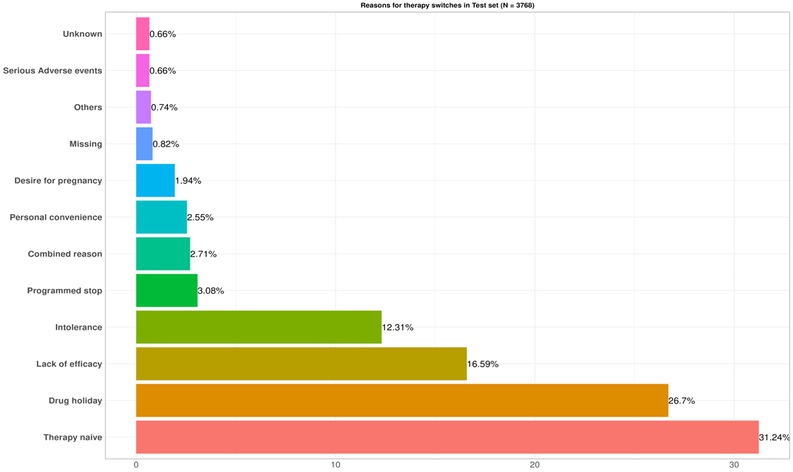
Supplementary Fig. 2. Reasons for therapy switches in overall validation set with N = 3768 (cycles started from 2017 till 2021).

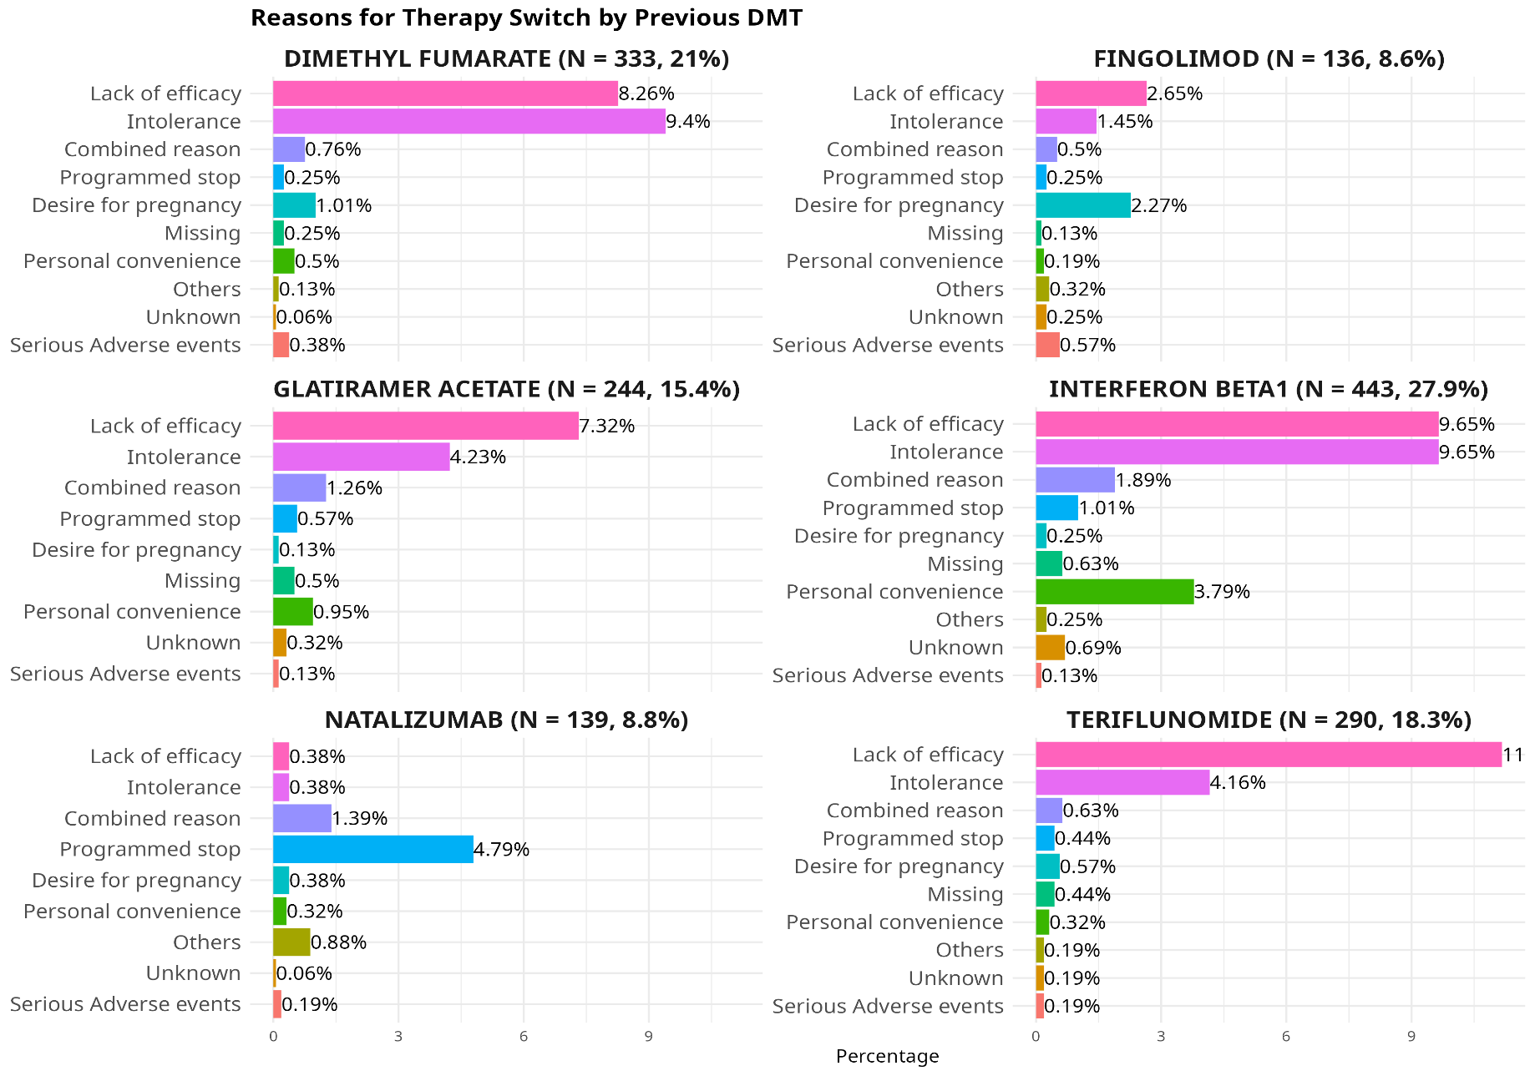
Supplementary Fig. 3. Reasons for therapy switches by disease-modifying therapy (DMT) in the overall validation set among receivers of a previous DMT.
Supplementary Table 3. Summary of actual switches stratified by the current therapy (therapy switched from).
 | Current therapy (previous therapy)
Characteristic | DMF  (N = 337) | IF  (N = 448) | GA  (N = 251) | TERI  (N = 287) | FTY  (N = 131) | NAT  (N = 137) | NoDMT  (N = 2183)
Switch Reason
Drug holiday | 0 (0%) | 0 (0%) | 0 (0%) | 0 (0%) | 0 (0%) | 0 (0%) | 1006 (46%)
Intolerance | 159 (47%) | 177 (40%) | 82 (33%) | 72 (25%) | 29 (22%) | 19 (14%) | 0 (0%)
Lack of efficacy | 138 (41%) | 169 (38%) | 128 (51%) | 184 (64%) | 47 (36%) | 8 (5.8%) | 0 (0%)
Personal convenience | 11 (3.3%) | 76 (17%) | 24 (9.6%) | 7 (2.4%) | 3 (2.3%) | 5 (3.6%) | 0 (0%)
Desire for pregnancy | 19 (5.6%) | 4 (0.9%) | 3 (1.2%) | 12 (4.2%) | 37 (28%) | 10 (7.3%) | 0 (0%)
Programmed stop | 4 (1.2%) | 19 (4.2%) | 12 (4.8%) | 7 (2.4%) | 5 (3.8%) | 90 (66%) | 0 (0%)
Serious adverse events | 6 (1.8%) | 3 (0.7%) | 2 (0.8%) | 5 (1.7%) | 10 (7.6%) | 5 (3.6%) | 0 (0%)
Therapy naive | 0 (0%) | 0 (0%) | 0 (0%) | 0 (0%) | 0 (0%) | 0 (0%) | 1,177 (54%)
Index therapy
(New therapy)
DMF | 0 (0%) | 109 (24%) | 57 (23%) | 61 (21%) | 16 (12%) | 11 (8.0%) | 480 (22%)
IF | 23 (6.8%) | 0 (0%) | 20 (8.0%) | 17 (5.9%) | 11 (8.4%) | 2 (1.5%) | 215 (9.8%)
GA | 53 (16%) | 30 (6.7%) | 0 (0%) | 27 (9.4%) | 20 (15%) | 13 (9.5%) | 396 (18%)
TERI | 82 (24%) | 163 (36%) | 67 (27%) | 0 (0%) | 9 (6.9%) | 1 (0.7%) | 634 (29%)
FTY | 109 (32%) | 99 (22%) | 72 (29%) | 124 (43%) | 0 (0%) | 110 (80%) | 254 (12%)
NAT | 70 (21%) | 47 (10%) | 35 (14%) | 58 (20%) | 75 (57%) | 0 (0%) | 204 (9.3%)
Current duration | 1.76  (0.04, 0.78, 3.19, 6.53) | 4.53  (0.08, 1.45, 8.30, 22.05) | 1.89  (0.04, 0.76, 4.97, 17.40) | 1.83  (0.16, 0.93, 2.53, 7.14) | 2.42  (0.07, 1.11, 4.12, 8.15) | 2.75  (0.12, 1.50, 6.61, 10.53) | 1.22  (0.25, 0.68, 3.50, 51.82)
Index duration | 1.30  (0.01, 0.58, 2.39, 4.71) | 1.63  (0.01, 0.81, 2.66, 4.85) | 1.18  (0.01, 0.54, 2.16, 4.80) | 1.50  (0.01, 0.84, 2.69, 4.62) | 0.94  (0.05, 0.58, 1.69, 4.55) | 1.55  (0.01, 0.60, 3.04, 4.79) | 1.24  (0.00, 0.55, 2.33, 4.87)

Abbreviations: N (perc); continuous in years: median (min, IQR, max); IF interferon beta1; GA glatiramer acetate; TERI teriflunomide; DMF dimethyl fumarate; FTY fingolimod; NAT natalizumab; NoDMT No disease-modifying therapy.

 | Index therapy (new therapy)
Characteristic | DMF  (N = 734) | IF  (N = 288) | GA  (N = 539) | TERI  (N = 956) | FTY  (N = 768) | NAT  (N = 489)
Switch Reason
Drug holiday | 195 (27%) | 116 (40%) | 141 (26%) | 261 (27%) | 170 (22%) | 123 (25%)
Intolerance | 123 (17%) | 40 (14%) | 69 (13%) | 214 (22%) | 67 (8.7%) | 25 (5.1%)
Lack of efficacy | 68 (9.3%) | 6 (2.1%) | 8 (1.5%) | 27 (2.8%) | 341 (44%) | 224 (46%)
Personal convenience | 35 (4.8%) | 6 (2.1%) | 6 (1.1%) | 64 (6.7%) | 13 (1.7%) | 2 (0.4%)
Pregnancy | 5 (0.7%) | 14 (4.9%) | 50 (9.3%) | 0 (0%) | 0 (0%) | 16 (3.3%)
Programmed stop | 14 (1.9%) | 3 (1.0%) | 6 (1.1%) | 12 (1.3%) | 90 (12%) | 12 (2.5%)
Serious adverse events | 9 (1.2%) | 4 (1.4%) | 4 (0.7%) | 5 (0.5%) | 3 (0.4%) | 6 (1.2%)
Therapy naive | 285 (39%) | 99 (34%) | 255 (47%) | 373 (39%) | 84 (11%) | 81 (17%)
Current therapy
(previous therapy)
DMF | 0 (0%) | 23 (8.0%) | 53 (9.8%) | 82 (8.6%) | 109 (14%) | 70 (14%)
IF | 109 (15%) | 0 (0%) | 30 (5.6%) | 163 (17%) | 99 (13%) | 47 (9.6%)
GA | 57 (7.8%) | 20 (6.9%) | 0 (0%) | 67 (7.0%) | 72 (9.4%) | 35 (7.2%)
TERI | 61 (8.3%) | 17 (5.9%) | 27 (5.0%) | 0 (0%) | 124 (16%) | 58 (12%)
FTY | 16 (2.2%) | 11 (3.8%) | 20 (3.7%) | 9 (0.9%) | 0 (0%) | 75 (15%)
NAT | 11 (1.5%) | 2 (0.7%) | 13 (2.4%) | 1 (0.1%) | 110 (14%) | 0 (0%)
NoDMT | 480 (65%) | 215 (75%) | 396 (73%) | 634 (66%) | 254 (33%) | 204 (42%)
Current duration | 1.45  (0.16, 0.74, 4.29, 42.07) | 1.12  (0.04, 0.67, 2.52, 31.30) | 1.38  (0.04, 0.69, 3.23, 37.61) | 1.99  (0.04, 0.79, 6.29, 51.82) | 1.99  (0.06, 0.97, 4.23, 30.05) | 1.41  (0.07, 0.78, 3.15, 19.25)
Index duration | 1.16  (0.01, 0.51, 2.19, 4.68) | 1.05  (0.02, 0.53, 2.07, 4.87) | 0.96  (0.01, 0.46, 1.97, 4.73) | 1.32  (0.00, 0.57, 2.44, 4.85) | 1.68  (0.01, 0.92, 2.80, 4.80) | 1.44  (0.01, 0.64, 2.45, 4.65)
Supplementary Table 4. Summary of actual switches stratified by the index therapy (therapy switched to).

Abbreviations: N (perc); continuous in years: median (min, IQR, max); IF interferon beta1; GA glatiramer acetate; TERI teriflunomide; DMF dimethyl fumarate; FTY fingolimod; NAT natalizumab; NoDMT No disease-modifying therapy

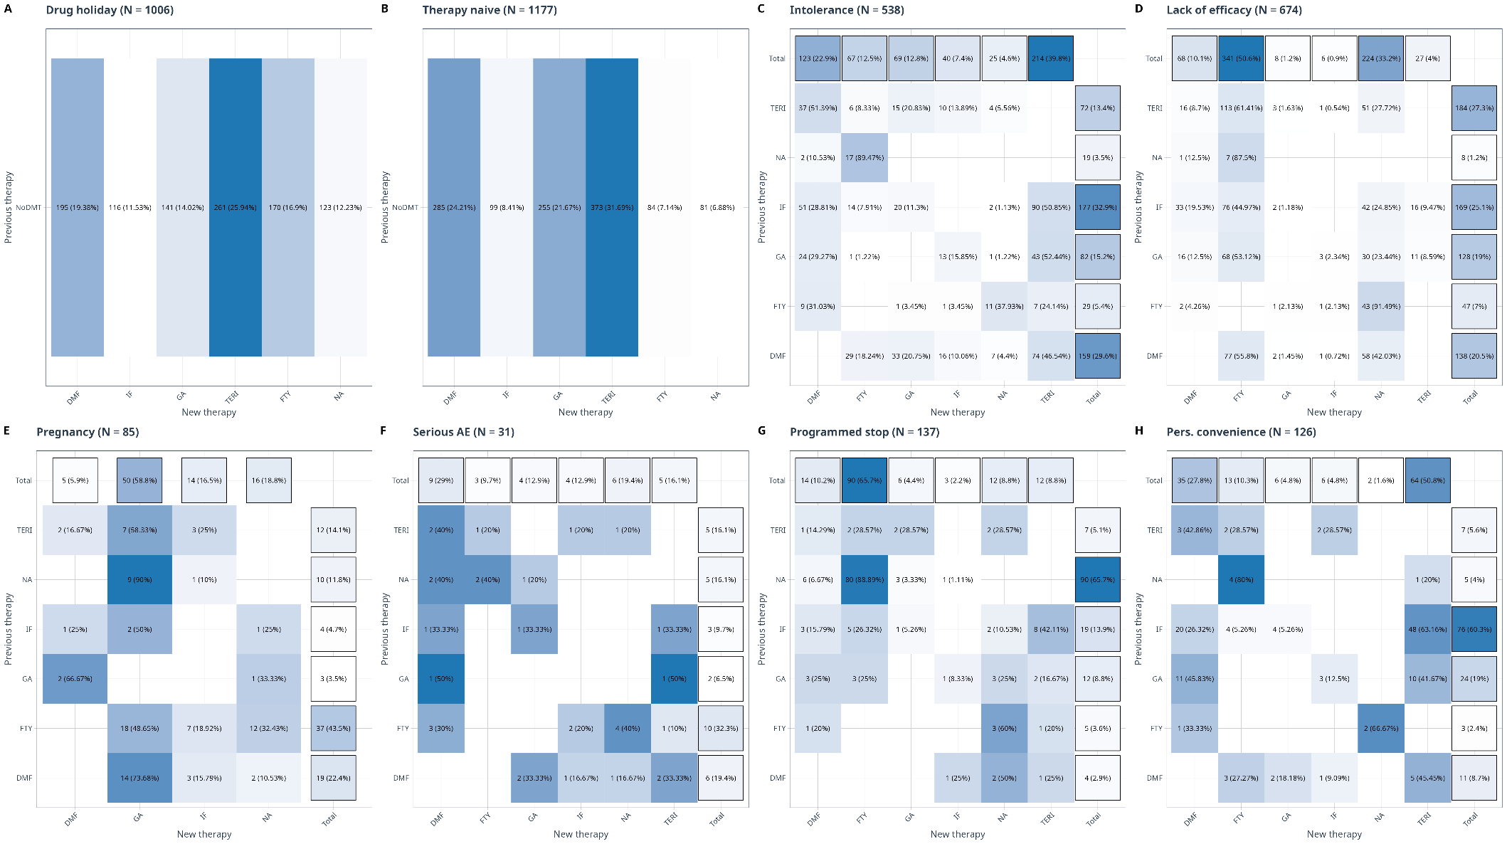
Supplementary Fig. 4. Actual therapy switches in the eight subgroups (SG) defined by the reason for therapy switch.

Abbreviations: N (perc); IF interferon beta1; GA glatiramer acetate; TERI teriflunomide; DMF dimethyl fumarate; FTY fingolimod; NAT natalizumab; NoDMT No disease-modifying therapy.
Patients in the lack of efficacy SG mainly switched to FTY (51%) or NA (33%), while those in the intolerance SG favoured TERI (40%) or DMF (23%). Patients treated with FTY (5%) mostly switched to NA (40%) or DMF (31%), and those treated with NA (3.5%) switched to FTY (89%) or DMF (11%). The serious adverse event (AE) SG predominantly involved switches from FTY (32%) to NA (40%), DMF (30%), or IF (20%) and from DMF (19%) to GA (33%) or TERI 33%). In the personal convenience SG, patients mainly switched from IF (60%) and GA (19%) to TERI (51%) and DMF (28%). The desire for pregnancy SG switched mainly to GA (60%) and from GA to DMF (6%), with zero switch to FTY or TERI. In the programmed stop SG, the main switch was from NA to FTY (89%). Finally, the drug holiday SG primarily resumed therapy with TERI (26%), DMF (19%), or FTY (17%), while the therapy naive SG commonly initiated therapy with TERI (32%), DMF (24%), or GA (22%).
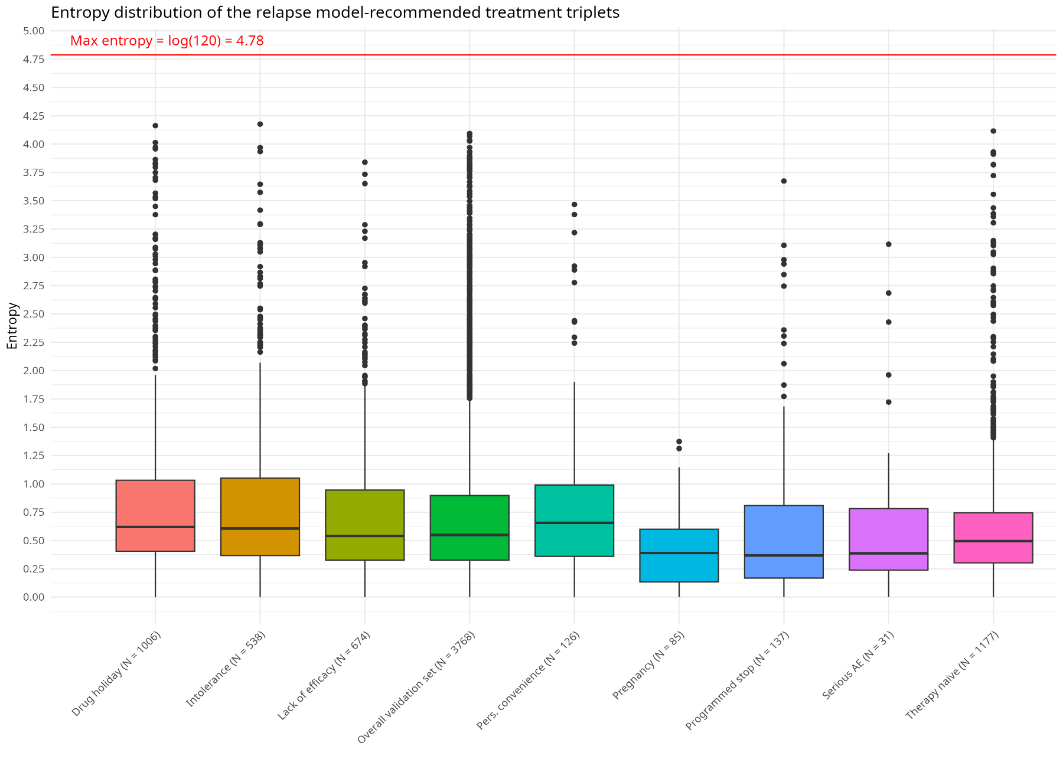
Supplementary Fig. 5. Distribution of entropy for the relapse model-recommended treatment triplet in the overall validation set and across reason of switch subgroups.
Abbreviations: Pers.: Personal; AE: Adverse Events; Pregnancy: Pregnancy desire.
The red line shows the maximum entropy of 4.78 which indicates that the algorithm provides imprecise recommendations, where all treatment triplets ranking is equally probable. To estimate entropy, we predicted the outcome 100 times for a randomly selected patient set. The lower the entropy, the more precise the algorithm’s recommendations are. For one patient, the more homogeneous the treatment recommendations are, or the bigger the difference in the proportion of the recommended treatment triplets, the lower the entropy. For example, out of the 100 recommendations created by the model for one patient 98 were (NA, FTY, DMF) and 2 were (NA, DMF, FTY) with entropy of 0.098. A more heterogeneous case had out of 100 created recommendations, 85 times (NA, FTY, TERI), 11 times (NA, FTY, GA), and 4 times (NA, FTY, DMF) resulting in an entropy of 0.5. Another patient with entropy of 1.55 had 36 times (NA, FTY, DMF), 32 times (NA, FTY, TERI), and 32 samples comprising six other treatment triplets. A highly heterogeneous case, with 51 different triplets within 100 samples, had an entropy of 3.65.

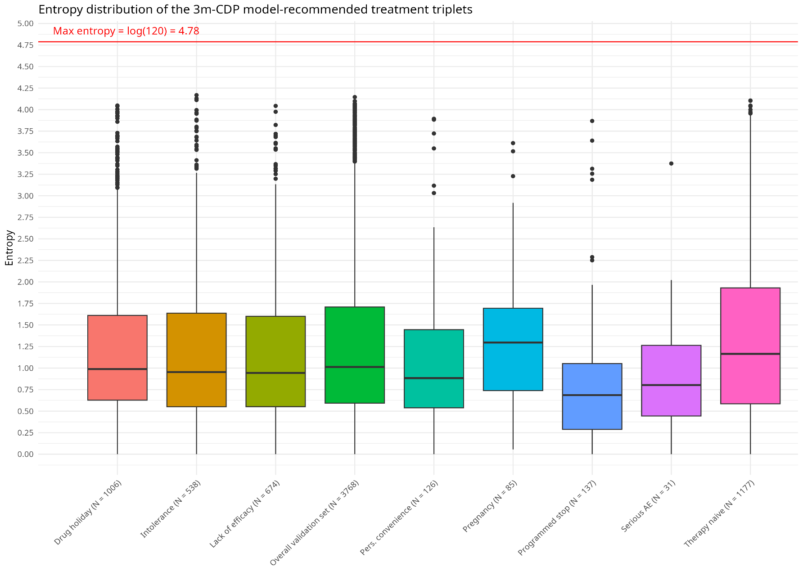
Supplementary Fig. 6. Distribution of entropy for the 3m-CDP model-recommended treatment triplet in the overall validation set and across reason of switch subgroups.
Abbreviations: Pers.: Personal; AE: Adverse Events; Pregnancy: Pregnancy desire.
The red line shows the maximum entropy of 4.78 which indicates that the algorithm provides imprecise recommendations, where all combination of the three best- ranked therapies are equally probable.

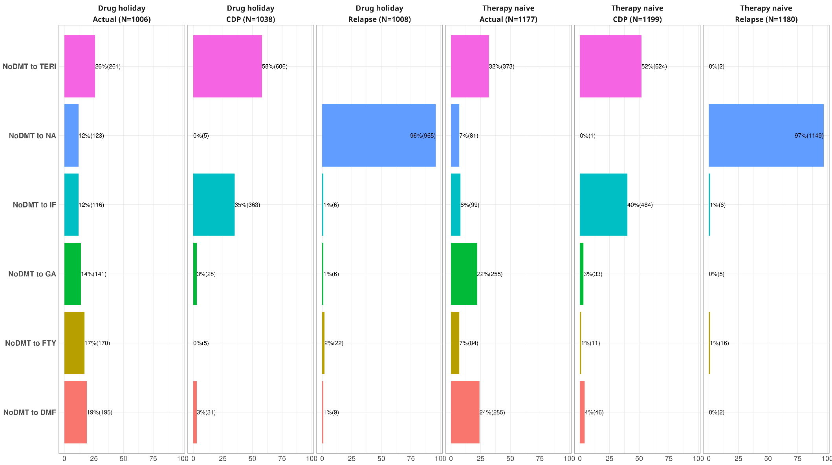

Supplementary Fig. 7. Actual switches and individual treatment recommendations for the 3m-CDP and relapse outcomes in the drug holiday and therapy naive subgroups (based on best prognosis approach).

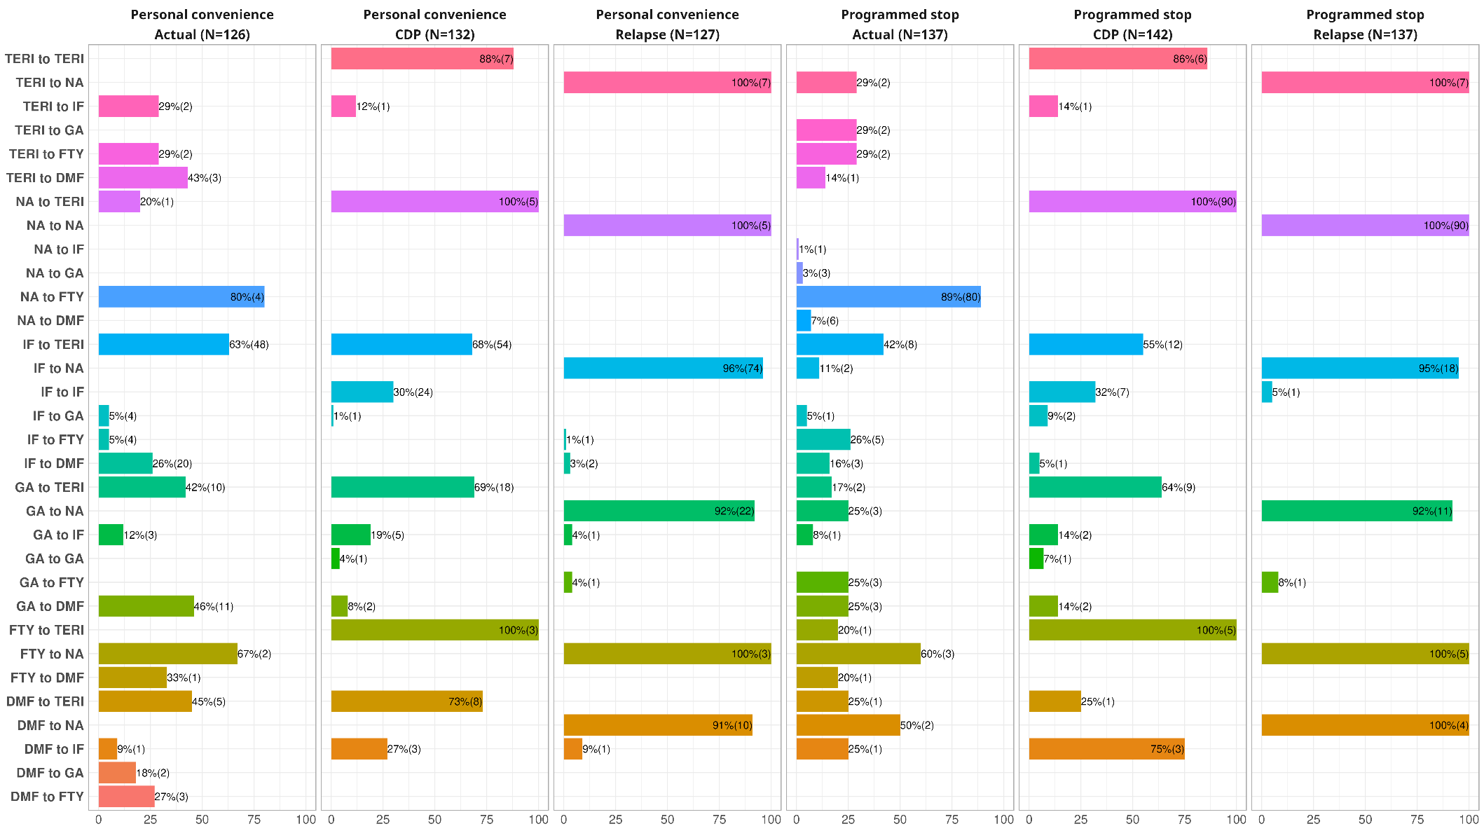

Supplementary Fig. 8. Actual switches and individual treatment recommendations for the 3m-CDP and relapse outcomes in the personal convenience and programmed stop subgroups (based on best prognosis approach).
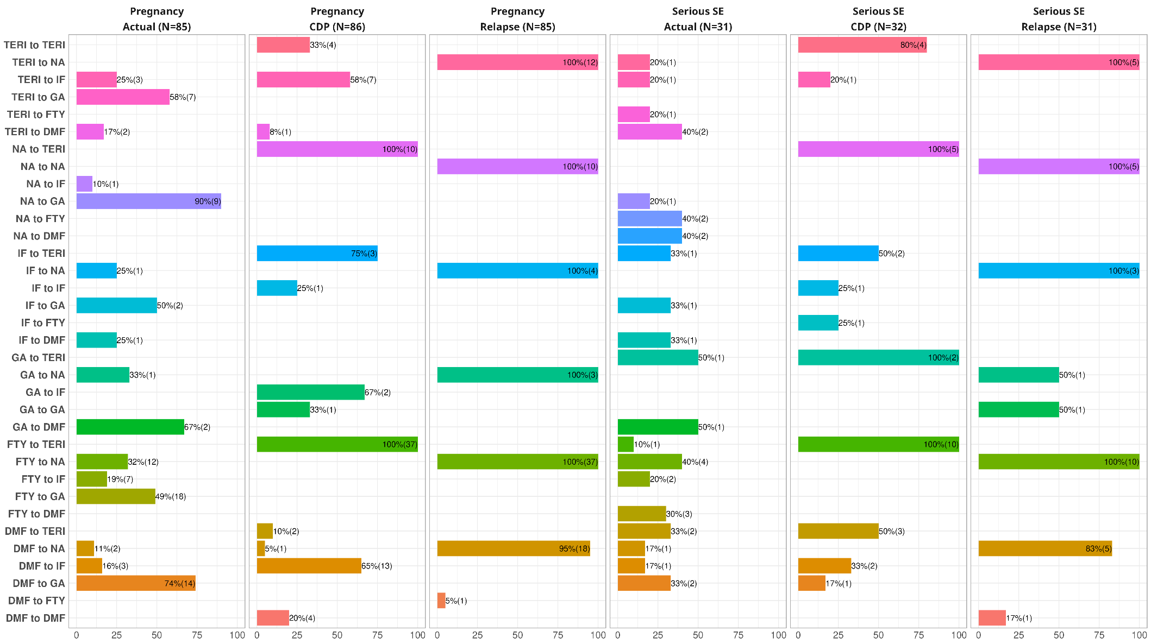

Supplementary Fig. 9. Actual switches and individual treatment recommendations for the 3m-CDP and relapse outcomes in the desire for pregnancy and serious side effects subgroups (based on best prognosis approach).
Supplementary Table 5. Agreement between the therapy recommendations for the 3m-CDP and relapse recalibrated models based on the best prognosis approach and an
equivalence margin of 1%.
 | Relapse | 3m-CDP
Switch Reason |  | Cat 1 | Cat 2 | Cat 3 | Sum
Drug holiday (N = 1006)  Cohen’s kappa = -0.01 | Cat 1 | 186 | 40 | 1 | 227
Drug holiday (N = 1006)  Cohen’s kappa = -0.01 | Cat 2 | 177 | 22 | 0 | 199
Drug holiday (N = 1006)  Cohen’s kappa = -0.01 | Cat 3 | 878 | 43 | 15 | 936
Drug holiday (N = 1006)  Cohen’s kappa = -0.01 | Sum | 1241 | 105 | 16 | 1362
Therapy naive (N = 1177)  Cohen’s kappa = 0 | cat1 | 140 | 25 | 1 | 166
Therapy naive (N = 1177)  Cohen’s kappa = 0 | cat2 | 193 | 32 | 0 | 225
Therapy naive (N = 1177)  Cohen’s kappa = 0 | cat3 | 1016 | 58 | 14 | 1088
Therapy naive (N = 1177)  Cohen’s kappa = 0 | Sum | 1349 | 115 | 15 | 1479
Intolerance (N = 538)  Cohen’s kappa = -0.01 | cat1 | 118 | 26 | 0 | 144
Intolerance (N = 538)  Cohen’s kappa = -0.01 | cat2 | 118 | 15 | 0 | 133
Intolerance (N = 538)  Cohen’s kappa = -0.01 | cat3 | 454 | 23 | 11 | 488
Intolerance (N = 538)  Cohen’s kappa = -0.01 | Sum | 690 | 64 | 11 | 765
Lack of efficacy (N = 674)  Cohen’s kappa = 0 | cat1 | 60 | 10 | 0 | 70
Lack of efficacy (N = 674)  Cohen’s kappa = 0 | cat2 | 63 | 8 | 0 | 71
Lack of efficacy (N = 674)  Cohen’s kappa = 0 | cat3 | 611 | 24 | 4 | 639
Lack of efficacy (N = 674)  Cohen’s kappa = 0 | Sum | 734 | 42 | 4 | 780
Pregnancy (N = 85)  Cohen’s kappa = -0.03 | cat1 | 5 | 3 | 0 | 8
Pregnancy (N = 85)  Cohen’s kappa = -0.03 | cat2 | 10 | 0 | 0 | 10
Pregnancy (N = 85)  Cohen’s kappa = -0.03 | cat3 | 77 | 7 | 0 | 84
Pregnancy (N = 85)  Cohen’s kappa = -0.03 | Sum | 92 | 10 | 0 | 102
Serious adverse events (N = 31)  Cohen’s kappa = 0.05 | cat1 | 10 | 0 | 0 | 10
Serious adverse events (N = 31)  Cohen’s kappa = 0.05 | cat2 | 4 | 1 | 0 | 5
Serious adverse events (N = 31)  Cohen’s kappa = 0.05 | cat3 | 27 | 0 | 1 | 28
Serious adverse events (N = 31)  Cohen’s kappa = 0.05 | Sum | 41 | 1 | 1 | 43
Programmed stop (N = 137)  Cohen’s kappa = 0.01 | cat1 | 23 | 3 | 0 | 26
Programmed stop (N = 137)  Cohen’s kappa = 0.01 | cat2 | 9 | 3 | 0 | 12
Programmed stop (N = 137)  Cohen’s kappa = 0.01 | cat3 | 124 | 3 | 1 | 128
Programmed stop (N = 137)  Cohen’s kappa = 0.01 | Sum | 156 | 9 | 1 | 166
Personal convenience (N = 126)  Cohen’s kappa = 0.01 | cat1 | 21 | 2 | 0 | 23
Personal convenience (N = 126)  Cohen’s kappa = 0.01 | cat2 | 25 | 3 | 0 | 28
Personal convenience (N = 126)  Cohen’s kappa = 0.01 | cat3 | 102 | 7 | 3 | 112
Personal convenience (N = 126)  Cohen’s kappa = 0.01 | Sum | 148 | 12 | 3 | 163
Abbreviations: 3m-CDP confirmed disease progression at 3 months, N Number of patients, Cat: Category, Categories are adopted according to the German society of Neurology (DGN) with Cat 1: Interferon beta1, Glatirameracetate, Dimethylfumarate, Teriflunomide, Cat 2: Fingolimod, Cat 3: Natalizumab.
For each outcome, a therapy recommendation is generated based on the best prognosis ±1% (i.e., the highest probability to be relapse-free or 3m-CDP-free under a certain therapy or therapies under which the risk differed by 1%). Thus, the sum of recommended therapies per subgroup exceeds the number of patients because a patient could have more than one recommended therapy.

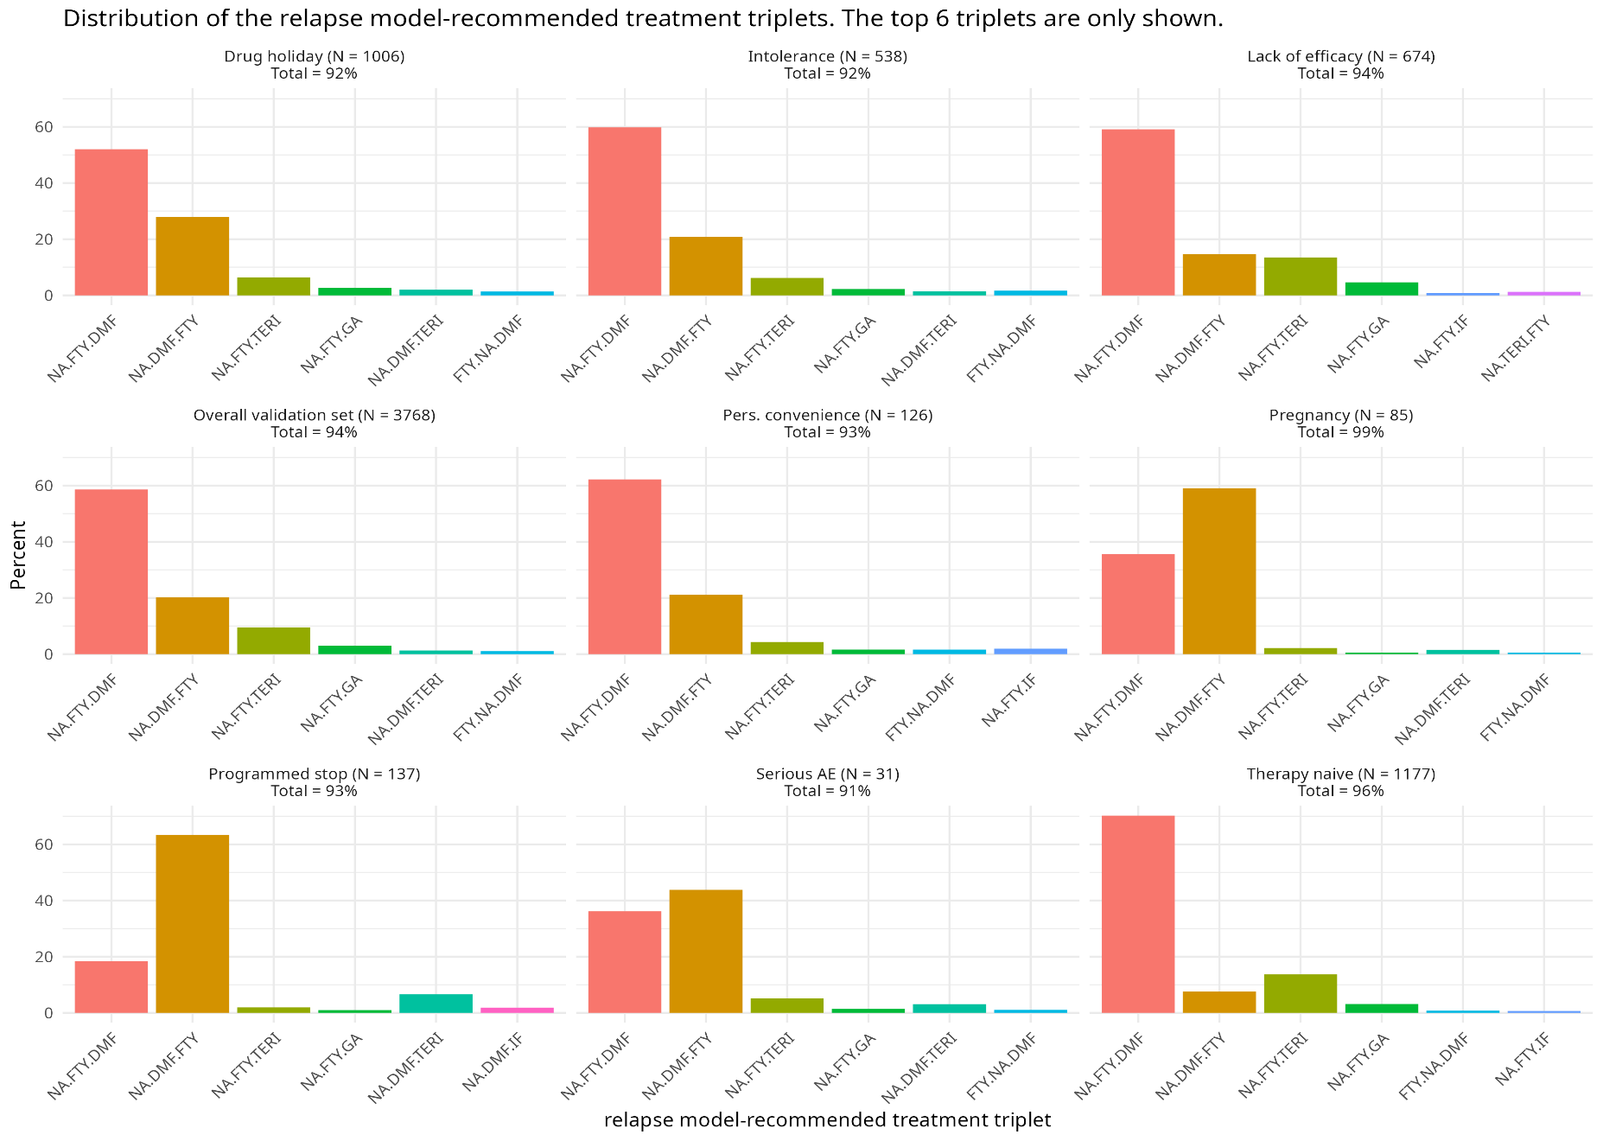

Supplementary Fig. 10. Distribution of the model recommended treatment triplets for the relapse outcome in the overall validation set and in the reason of switch subgroups. Shown here are the top six triplets. Abbreviations: Pers.: Personal; AE: Adverse Events; Pregnancy: desire for pregnancy.
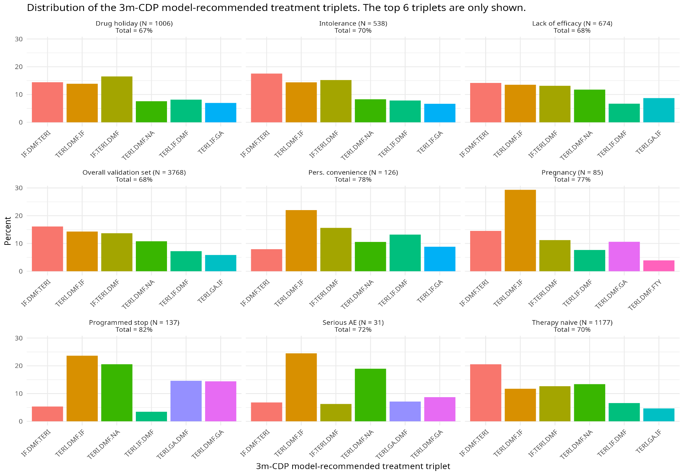
Supplementary Fig. 11. Distribution of the model recommended treatment triplets for the 3m-CDP outcome in the overall validation set and in the reason of switch subgroups. Shown here are the top six triplets.
Abbreviations: Pers.: Personal; AE: Adverse Events; Pregnancy: desire for pregnancy.
Supplementary Table 6. Performance of the original models in the overall validation set and in the reason of switch subgroups.
Outcome | Performance measure  (95% CI) | Overall validation set (N=3768) | Drug holiday (N=1006) | Therapy naive (N=1177) | Intolerance (N=538) | Lack of efficacy (N=674) | Desire for  Pregnancy (N=85) | Serious adverse events  (N=31) | Programmed stop  (N=137) | Personal  convenience (N=126)
3m-CDP | Calibration  intercept | -0.078  (-0.197; 0.041) | -0.047  (-0.288; 0.194) | 0.035  (-0.172; 0.242) | -0.088  (-0.418; 0.243) | -0.192  (-0.458; 0.074) | -0.386  (-1.314; 0.543) | -0.279  (-1.523; 0.965) | -0.576  (-1.215; 0.063) | -0.131  (-0.831; 0.569)
3m-CDP | Calibration  slope | 1.09  (0.942; 1.239) | 1.07  (0.770; 1.369) | 1.134  (0.876; 1.391) | 1.092  (0.691; 1.492) | 1.155  (0.776; 1.535) | 1.061  (-0.053; 2.175) | 1.111  (-0.442; 2.665) | 0.990  (0.226; 1.754) | 1.093  (0.225; 1.961)
3m-CDP | C-index | 0.777  (0.754; 0.798) | 0.774  (0.726; 0.816) | 0.786  (0.748; 0.819) | 0.789  (0.719; 0.846) | 0.752  (0.694; 0.802) | 0.752  (0.512; 0.898) | 0.774  (0.443; 0.936) | 0.768  (0.656; 0.852) | 0.780  (0.523; 0.919)
3m-CDP | MSE | 0.072 | 0.066 | 0.077 | 0.065 | 0.080 | 0.053 | 0.081 | 0.076 | 0.059
3m-CDP | RRMSE (%) | 96 | 97 | 96 | 96 | 97 | 98 | 94 | 101 | 94
3m-CDP | Predicted  proportion  (range) | 0.09  (0 to 0.57) | 0.08  (0 to 0.39) | 0.09  (0 to 0.49) | 0.08  (0 to 0.5) | 0.11  (0 to 0.57) | 0.08  (0 to 0.31) | 0.12  (0 to 0.38) | 0.13  (0 to 0.47) | 0.08  (0 to 0.28)
3m-CDP | Observed  proportion  (range) | 0.08  (0 to 1) | 0.08  (0 to 1) | 0.09  (0 to 1) | 0.08  (0 to 1) | 0.09  (0 to 1) | 0.06  (0 to 1) | 0.10  (0 to 1) | 0.08  (0 to 1) | 0.07  (0 to 1)
Number of  Relapses | Calibration  intercept | -0.386  (-0.479; -0.293) | -0.385  (-0.566; -0.204) | -0.191  (-0.353; -0.028) | -0.388  (-0.638; -0.139) | -0.716  (-0.948; -0.484) | 0.103  (-0.416; 0.622) | -0.396  (-1.391; 0.599) | -0.843  (-1.337; -0.349) | -0.616  (-1.157; -0.075)
Number of  Relapses | Calibration  slope | 0.502  (0.411; 0.594) | 0.455  (0.285; 0.624) | 0.447  (0.289; 0.605) | 0.695  (0.425; 0.965) | 0.574  (0.318; 0.829) | 1.223  (0.483; 1.963) | 0.273  (-0.386; 0.931) | 0.152  (-0.246; 0.55) | 0.500  (-0.029; 1.029)
Number of  Relapses | C-index | 0.639  (0.616; 0.662) | 0.631  (0.585; 0.674) | 0.621  (0.579; 0.661) | 0.687  (0.632; 0.736) | 0.639  (0.580; 0.694) | 0.764  (0.636; 0.858) | 0.607  (0.326; 0.831) | 0.542  (0.41; 0.669) | 0.62  (0.473; 0.748)
Number of  Relapses | MSE | 0.326 | 0.321 | 0.29 | 0.293 | 0.347 | 0.532 | 1.034 | 0.547 | 0.319
Number of  Relapses | RRMSE (%) | 113 | 113 | 104 | 112 | 122 | 97 | 136 | 150 | 127
Number of  Relapses | Mean  predicted  (range) | 0.32  (0 to 4.48) | 0.32  (0 to 2.72) | 0.28  (0 to 1.99) | 0.31  (0 to 2.58) | 0.37  (0 to 4.52) | 0.4  (0.01 to 1.73) | 0.53  (0 to 3.39) | 0.49  (0 to 2.19) | 0.34  (0 to 2.54)
Number of  Relapses | Mean  observed  (range) | 0.2  (0 to 4) | 0.2  (0 to 4) | 0.21  (0 to 4) | 0.18  (0 to 3) | 0.17  (0 to 3) | 0.38  (0 to 4) | 0.32  (0 to 3) | 0.19  (0 to 3) | 0.16  (0 to 3)
Abbreviations: CI Confidence interval; 3m-CDP confirmed disease progression at 3 months; SE side effects; Cal. Calibration; MSE mean-squared error; RRMSE relative root MSE.

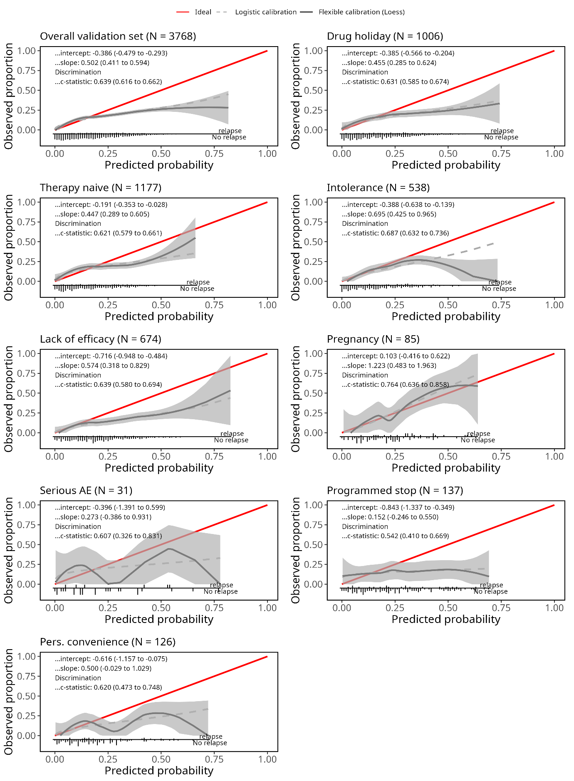

Supplementary Fig. 12. Original relapse model calibration plots in the overall validation set and the eight reason for switch subgroups.

The plots show the predicted probability versus the observed proportion of having at least a relapse. The shaded area around the curve represents the 95% confidence interval. At the bottom of each graph, the predicted probability to relapse is also shown for those who had at least a relapse and those who did not have any relapse.

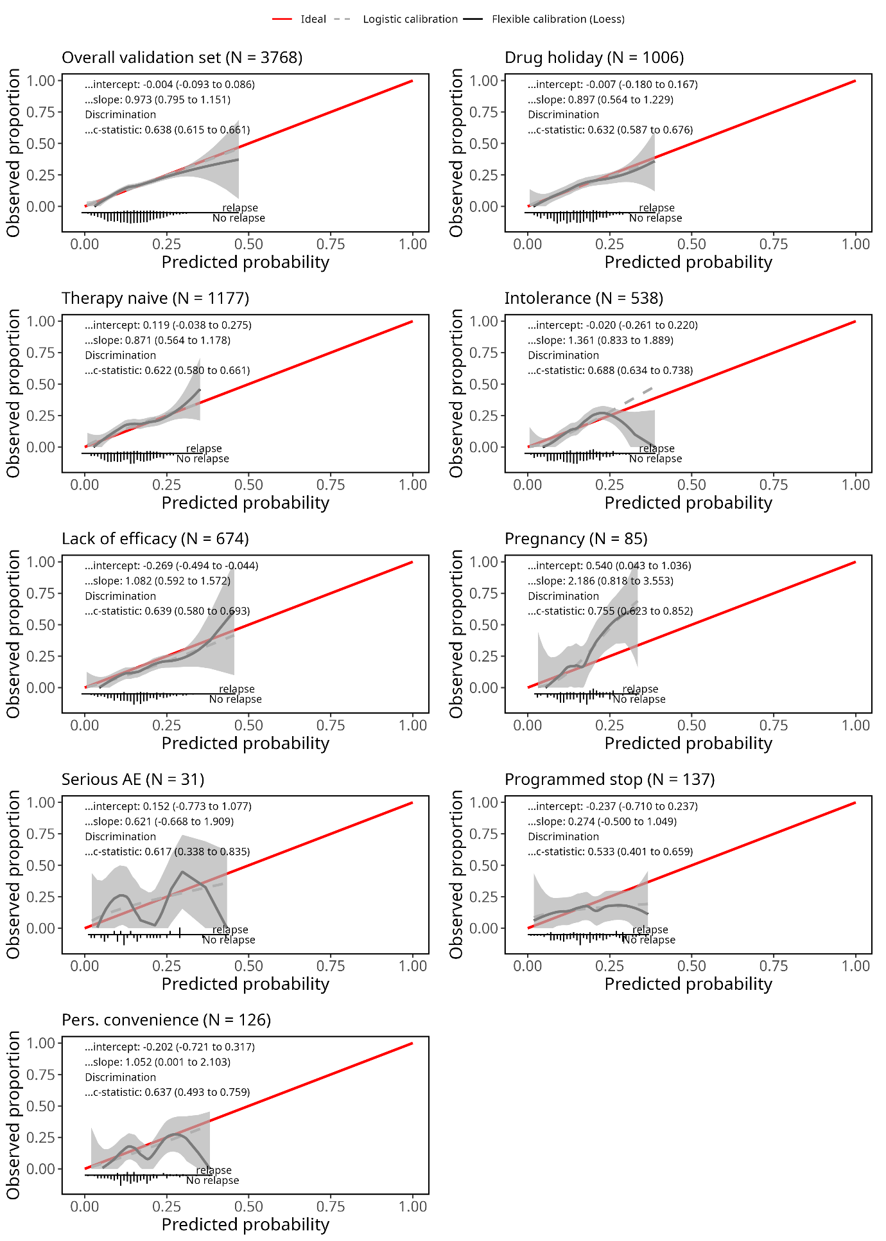
Supplementary Fig. 13. Recalibrated relapse model calibration plots in the overall validation set and the eight reason for switch subgroups (SG).
The plots show the predicted probability versus the observed proportion of having at least a relapse. The shaded area around the curve represents the 95% confidence interval. At the bottom of each graph, the predicted probability to relapse is also shown for those who had at least a relapse and those who did not have any relapse. The model slightly overpredicted the average number of relapses in the lack of efficacy, programmed stop and personal convenience SGs (reflected by a calibration intercept below 0) and slightly underpredicted it in the pregnancy, serious SE and therapy naive SGs (intercept above 0). Despite good intercept and slope, the calibration curve for the intolerance SG showed some extreme predictions. As for discrimination, the C-index remained at 0.638 (95% CI 0.615 to 0.661), indicating a 63.8% probability that given a pair of patients, the model would predict higher probability of relapsing for the one who relapses and lower probability for the one who does not.

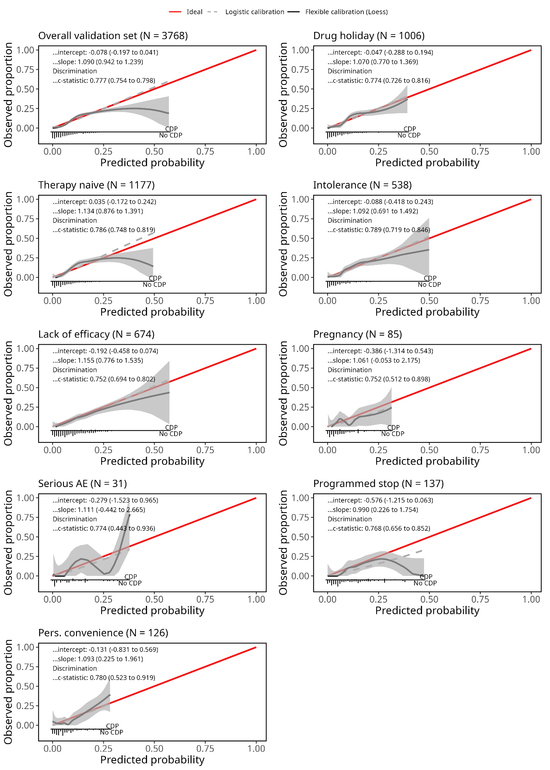Supplementary Fig. 14. Original 3m-CDP model calibration plots in the overall validation set and the eight reason for switch subgroups.
The plots show the predicted probability versus the observed proportion of having 3m-CDP. The shaded area around the curve represents the 95% confidence interval. At the bottom of each graph, the predicted probability to 3m-CDP is also shown for those with 3m-CDP and those without 3m-CDP.

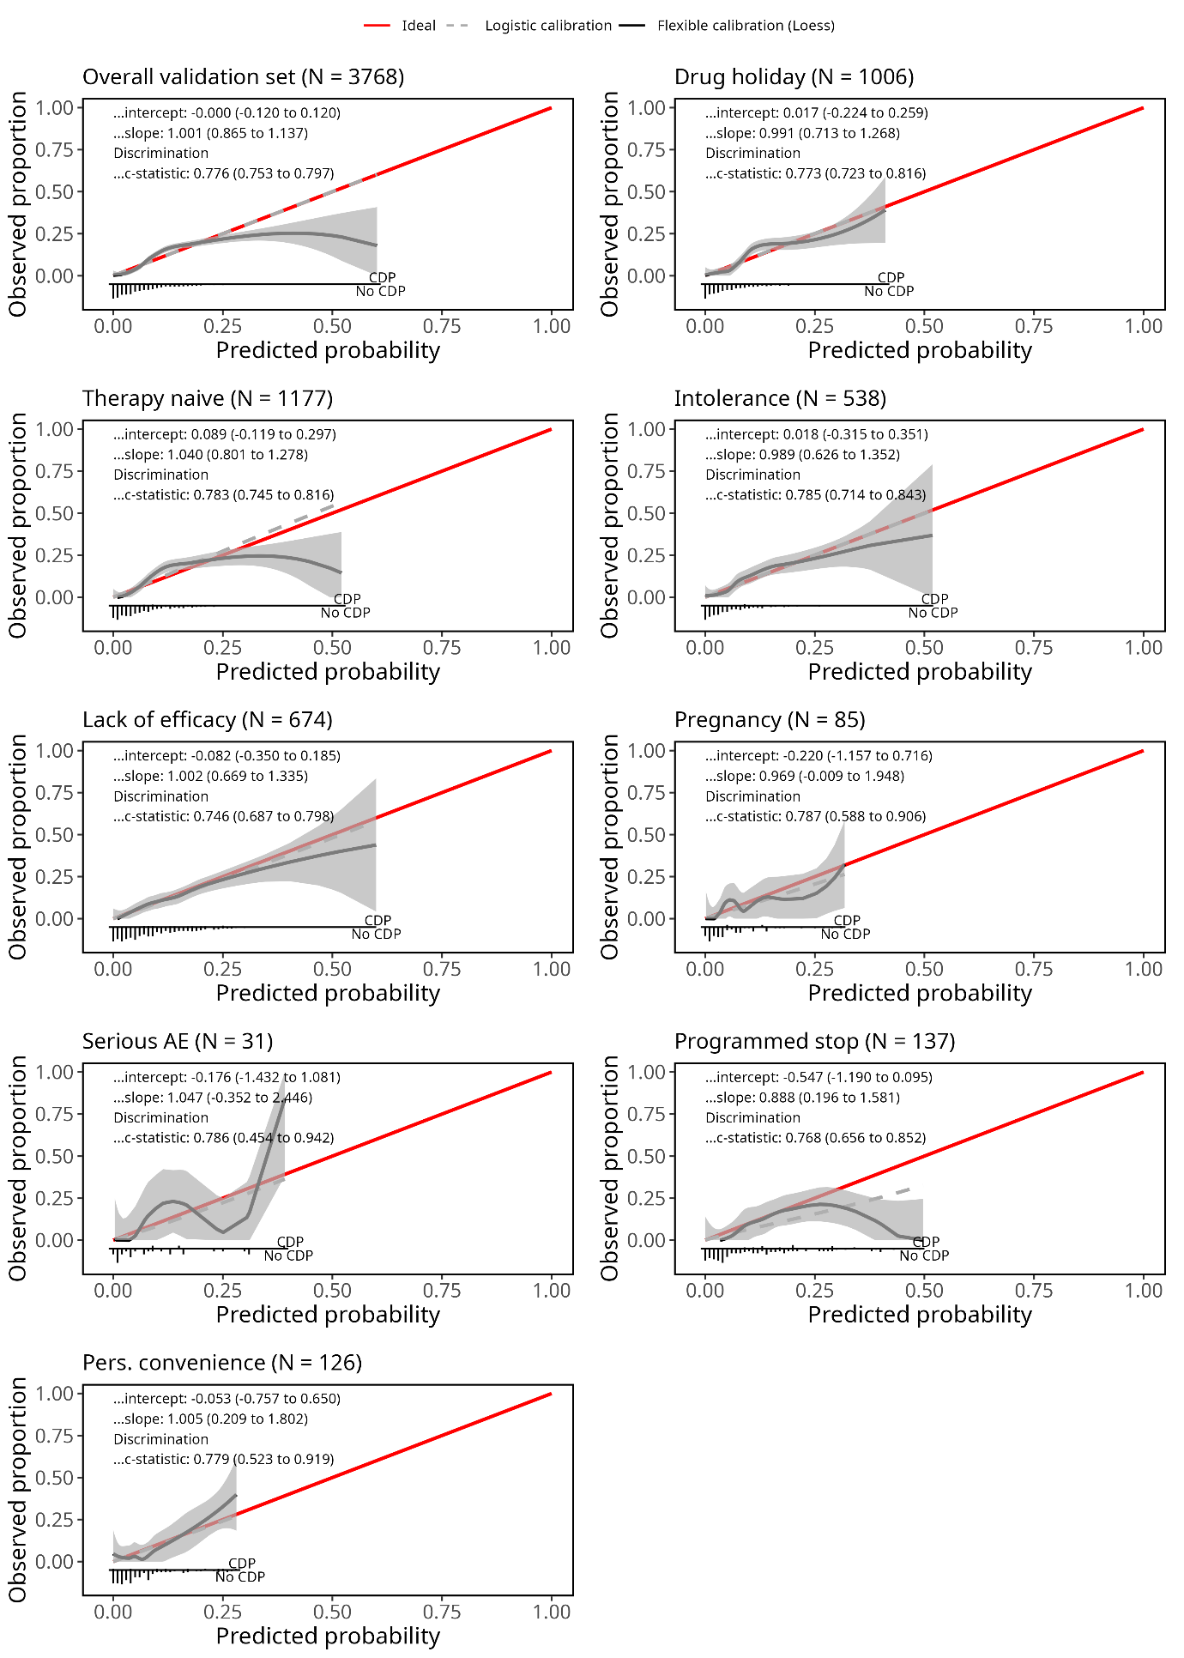
Supplementary Fig. 15. Recalibrated 3m-CDP model calibration plots in the overall validation set and the eight reason for switch subgroups.
The plots show the predicted probability versus the observed proportion of having 3m-CDP. The shaded area around the curve represents the 95% confidence interval. At the bottom of each graph, the predicted probability to 3m-CDP is also shown for those with 3m-CDP and those without 3m-CDP. The calibration curves in the overall set, therapy naive, and programmed stop SGs revealed some extreme predictions for higher predicted probabilities. The average risk of 3m-CDP occurrence was overestimated in the programmed stop, lack of efficacy, pregnancy and serious SE SGs and is reflected by a calibration intercept below 0 in these SGs. The calibration slope in all SGs was close to 1 indicating no overly extreme or overly moderate predictions.
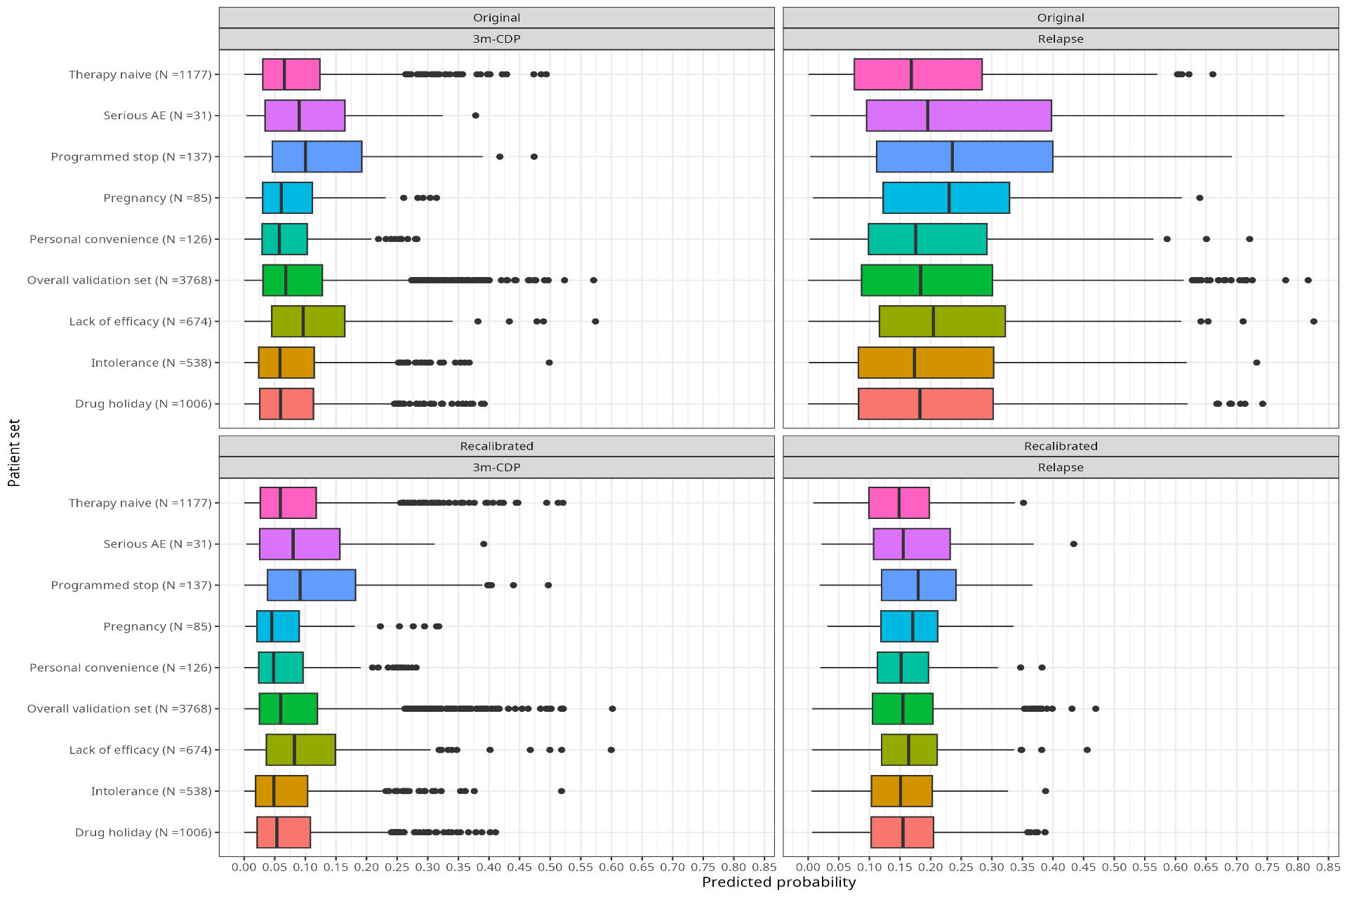Supplementary Fig. 16. Distribution of the predicted probabilities of relapse and 3m-CDP for the original and recalibrated models in the overall validation set and the reason for switch subgroups.
For the relapse outcome, recalibration halved the model’s coefficients, leading to smaller predictions that were similar across the SGs with slightly higher median probabilities to relapse observed for the programmed stop, pregnancy and lack of efficacy SGs. For the 3m-CDP outcome, the distribution of predicted probabilities was similar across the overall set and SGs, except for the programmed stop, serious SE and lack of efficacy SGs, which had slightly higher median probabilities of 3m-CDP occurrence.
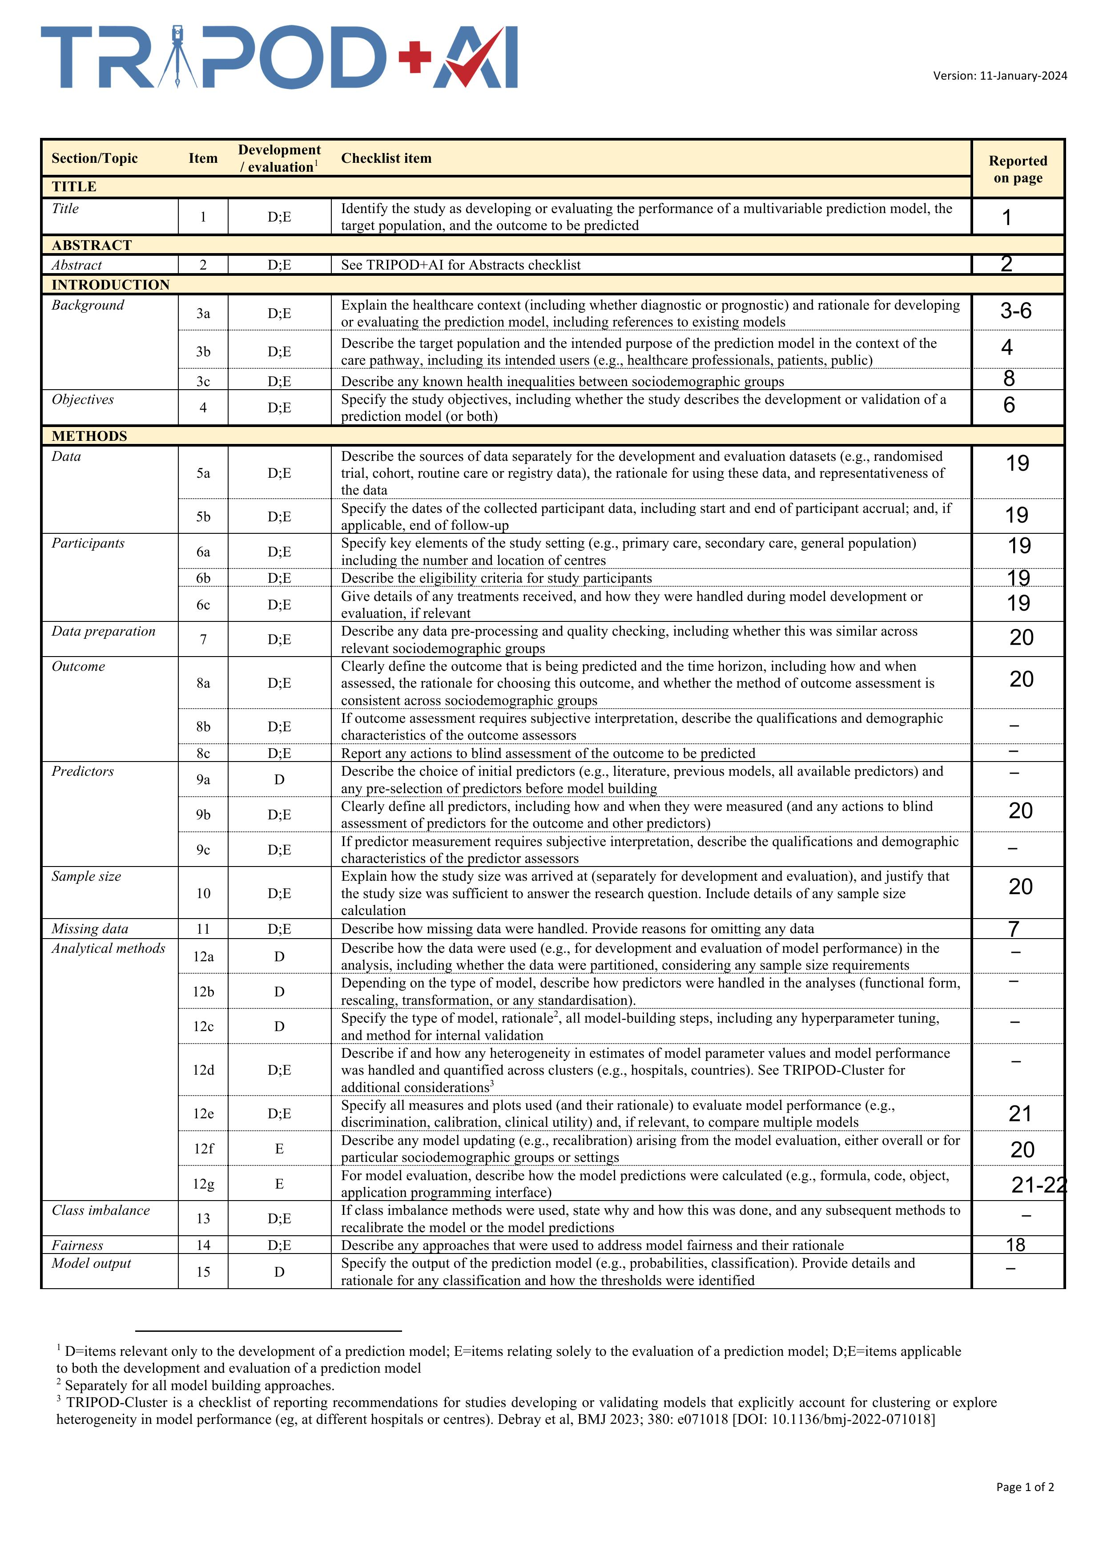

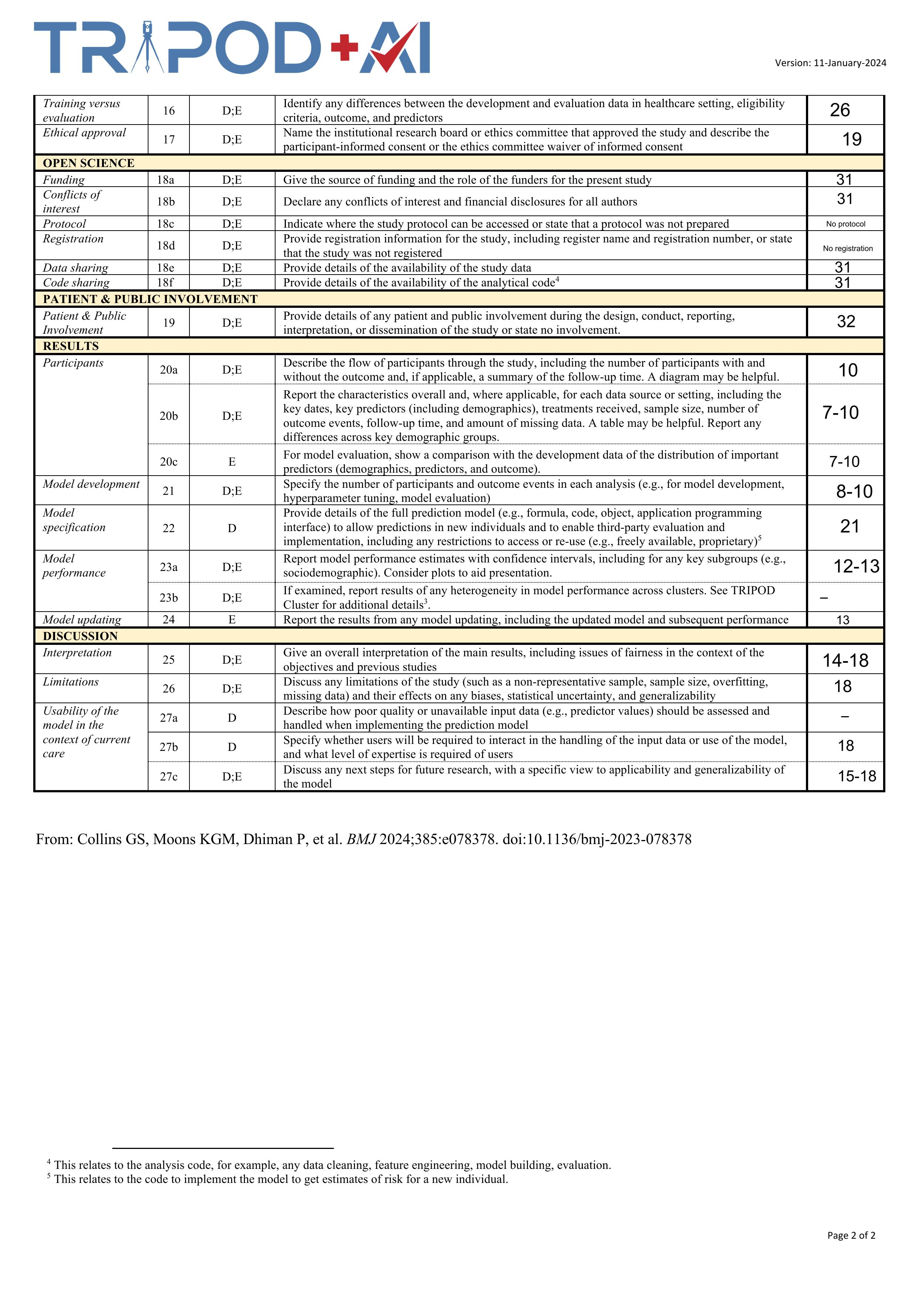
Supplementary Fig. 17 TRIPOD+AI Checklist

