Supplementary Material

Behavioral and Sociodemographic Determinants of Poor Self-Rated Health Among U.S. Adults: An Interpretable Machine Learning Analysis

Table S1. Detailed Information About Selected Variables from the Behavioral Risk Factor Surveillance System, 2023
Feature | Description | Values
_LLCPWT | Final weight assigned to each respondent: Land-line and cell-phone data (Raking derived weight)
GENHLTH | Would you say that in general your health is: | 1: Excellent, 2: Very good, 3: Good,  4: Fair, 5: Poor
SEXVAR | Indicate sex of respondent | 1: Male, 2: Female
_AGEG5YR | Fourteen-level age category | 1: 18–24, increasing in 5-year intervals up to 13: >80, 14: Don’t know/Refused/Missing
MARITAL | Are you . . . (marital status) | 1: Married, 2: Divorced, 3: Widowed,  4: Separated, 5: Never married, 6: Unmarried couple
_IMPRACE | Imputed race/ethnicity value | 1: White, 2: Black, 3: Asian, 4: American Indian or Alaskan Native,  5: Hispanic, 6: Other race
EDUCA | Level of education completed | 1: Never attended, 2: Elementary,  3: Some high school, 4: High school graduate, 5: Some college, 6: College graduate
EMPLOY1 | Are you currently…? | 1: Employed, 2: Self-employed, 3: No work >1 y, 4: No work <1 y,  5: Homemaker, 6: Student, 7: Retired, 8: Unable to work
INCOME3 | What is your annual household income from all sources? | 1: <$10 K, 2: $10–$15 K, 3: $15–$20 K, 4: $20–$25 K, 5:  $25–$35 K, 6: $35–$50 K, 7: $50–$75 K, 8: $75 K-$100k, 9: $100k-$150k,  10: $150k-$200k, 11: >$200k
_RFSMOK3 | Adults who are current smokers | 1: No, 2: Yes
_RFDRHV8 | Heavy drinkers (adult men having more than 14 drinks per week and adult women having more than 7 drinks per week) | 1: No, 2: Yes
EXERANY2 | Engagement in physical exercise during past month (excluding work-related activity) | 1: Yes, 2: No
_BMI5CAT | Four-categories of Body Mass Index (BMI) | 1: Underweight, 2: Normal weight,  3: Overweight, 4: Obese
DIABETE4 | Have you ever been told you have diabetes? | 1: Yes, 2: Yes, but during pregnancy,  3: No, 4: Prediabetes or borderline
CVDINFR4 | Have you ever been told you had a heart attack, also called a myocardial infarction? | 1: Yes, 2: No
CVDSTRK3 | Have you ever been told you had a stroke | 1: Yes, 2: No
CHCOCNC1 | Have you ever been told you had melanoma or any other types of cancer? | 1: Yes, 2: No
MENTHLTH | Number of days in the past 30 days when mental health was reported as not good (including stress, depression, and emotional problems) | 1-30: Number of days, 88: None
ADDEPEV3 | Have you ever been told you had a depressive disorder (including depression, major depression, dysthymia, or minor depression)? | 1: Yes, 2: No
_HLTHPL1 | Adults who had some form of health insurance | 1: Have some form of insurance,  2: Do not have
PERSDOC3 | Do you have one person (or a group of doctors) that you think of as your personal health care provider? | 1: Yes, only one, 2: Yes, more than one, 3: No
CHECKUP1 | About how long has it been since you last visited a doctor for a routine checkup? | 1: <1 y, 2: <2 y, 3: <5 y, 4: >5 y, 8: Never

Table S2. Summary statistics of the final dataset after preprocessing (n = 302,125)
Variable | Count (n) | Proportion (%)
General health (Target variable)
Poor | 53,945 | 17.86
Good | 248,180 | 82.14
Sex
Male | 144,485 | 47.82
Female | 157,640 | 52.18
Age (year)
18-29 | 29,608 | 9.79
30-39 | 39,136 | 12.95
40-49 | 42,486 | 14.06
50-59 | 49,679 | 16.44
60-69 | 64,257 | 21.26
70-79 | 53,911 | 17.84
>80 | 23,048 | 7.62
Race/Ethnicity
White | 228,542 | 75.64
Black | 22,139 | 7.32
Asian | 7,981 | 2.64
American Indian/Alaskan Native | 4,660 | 1.54
Hispanic | 27,977 | 9.26
Other race | 10,826 | 3.58
Education level
Grade 1 through 11 | 14,014 | 4.63
Grade 12 or GED (High school graduate) | 68,862 | 22.79
College 1-3 years | 80,836 | 26.75
College 4+ years (College graduate) | 138,413 | 45.81
Annual household income (USD)
<10,000 | 7,213 | 2.38
10,000 to < 15,000 | 7,894 | 2.61
15,000 to < 20,000 | 10,398 | 3.44
20,000 to < 25,000 | 14,936 | 4.94
25,000 to < 35,000 | 32,084 | 10.61
35,000 to < 50,000 | 40,700 | 13.47
50,000 to < 75,000 | 51,018 | 16.88
75,000 to < 100,000 | 43,995 | 14.56
100,000 to < 150,000 | 47,355 | 15.67
150,000 to < 200,000 | 22,133 | 7.32
>200,000 | 24,399 | 8.07
Employment
Employed | 163,838 | 54.22
Unemployed/Retired/homemaker/student | 138,287 | 45.77
Marital Status
Married | 162,634 | 53.83
Divorced, Widowed, Separated | 75,182 | 24.88
Never Married, Member of an unmarried couple | 64,309 | 21.28
Body mass index
Underweight | 4,296 | 1.42
Normal weight | 82,261 | 27.22
Overweight | 115,797 | 38.32
Obese | 99,771 | 33.02
Exercise
Yes | 232,640 | 77.01
No | 69,485 | 23.00
Smoker
Yes | 33,200 | 10.98
No | 268,925 | 89.01
Heavy drinkers
Yes | 19,439 | 6.43
No | 282,686 | 93.56
Diabetes
Yes | 41,668 | 13.79
Pre-diabetes | 7,275 | 2.40
No | 253,182 | 83.80
Heart attack
Yes | 16,017 | 5.30
No | 286,108 | 94.69
Stroke
Yes | 12,240 | 4.05
No | 289,885 | 95.94
Melanoma or any other types of cancer
Yes | 35,858 | 11.86
No | 266,267 | 88.13
Depression
Yes | 64,561 | 21.36
No | 237,564 | 78.63
Number of days mental health not good
15–30 | 39,016 | 12.91
8–14 | 16,088 | 5.32
1–7 | 68,651 | 22.72
0 | 178370 | 59.04
Health Insurance
Yes | 287,550 | 95.17
No | 14,575 | 4.82
Personal healthcare provider
Yes | 268,203 | 88.77
No | 33,922 | 11.22
How long since last routine checkup
Regular (<1 year) | 246,082 | 81.45
Irregular (>1 year or never) | 56,043 | 18.54

Table S3. Correlation matrix. Spearman correlation matrix of ordinal predictors, with correlation coefficients annotated. No pairs exceeded the predefined threshold for high collinearity (|ρ| ≥ 0.8).
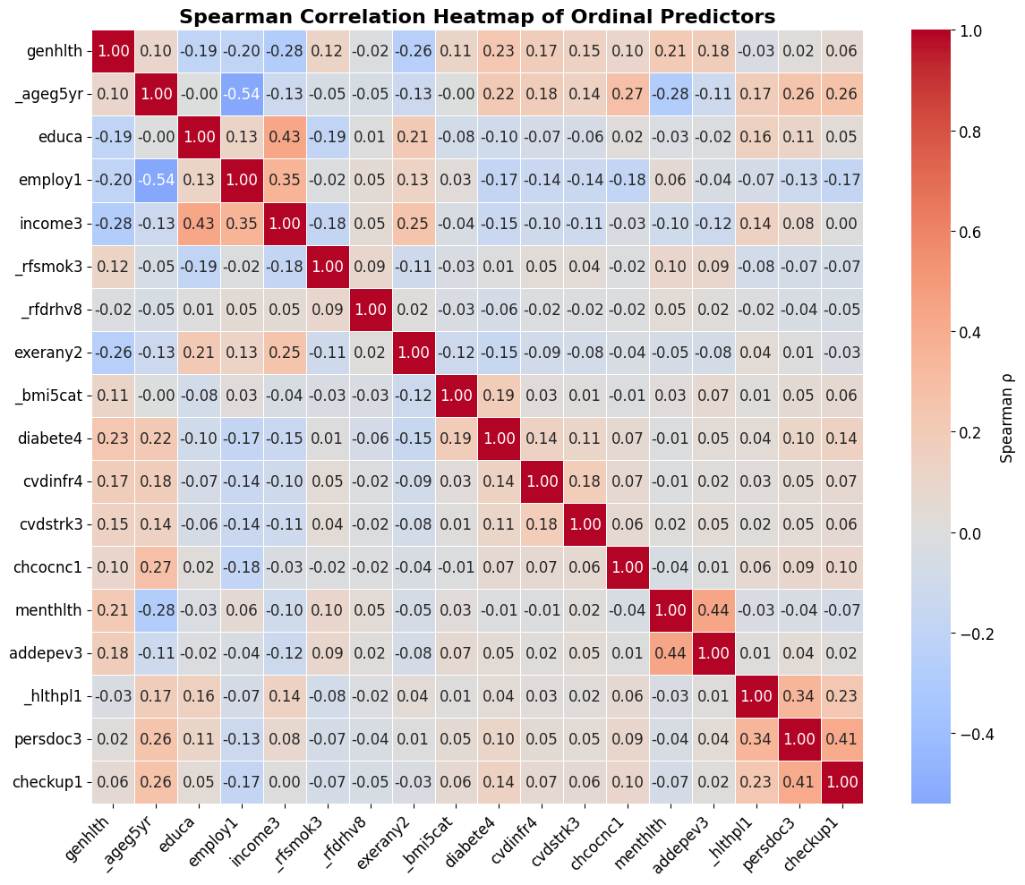

Table S4. Cramér’s V of nominal features. No pairs exceeded the predefined threshold for high collinearity (V >= 0.5).
Variable Pair | Cramér's V
_imprace vs marital | 0.139044
_imprace vs sexvar | 0.043850
marital vs sexvar | 0.124935

Table S5
Model Specifications. All models were implemented in Python (version 3.12.11).
Model | Implementation | Key Hyperparameters | Class Imbalance Handling | Notes
Logistic Regression (LR) | sklearn.linear_model.LogisticRegression | max_iter = 2000;  solver = 'lbfgs';  class_weight = 'balanced';  n_jobs = -1 | class_weight = 'balanced' | Chosen for interpretability; regular logistic regression with balanced weighting.
Random Forest (RF) | sklearn.ensemble.RandomForestClassifier | n_estimators = 200;  max_depth = 20;  min_samples_split = 2;  min_samples_leaf = 2;  class_weight = 'balanced';  random_state = 42;  n_jobs = -1 | class_weight = 'balanced' | Depth limited to prevent overfitting; balanced weighting addresses class imbalance.
Extreme Gradient Boosting (XGB) | xgboost.XGBClassifier | n_estimators = 200;  learning_rate = 0.1;  max_depth = 5;  subsample = 0.8;  colsample_bytree = 0.8;  reg_lambda = 1;  reg_alpha = 0;  scale_pos_weight = (neg/pos);  eval_metric='logloss';  random_state = 42;  verbosity = 0 | scale_pos_weight ratio computed from training data | Moderate tree depth to balance bias–variance; tuned for stability.
Light Gradient Boosting Machine (LGBM) | lightgbm.LGBMClassifier | n_estimators = 200;  learning_rate = 0.1;  max_depth = -1;  num_leaves = 31;  subsample = 0.8;  colsample_bytree = 0.8;  reg_lambda = 1.0;  reg_alpha = 0.0;  scale_pos_weight = (neg/pos);  random_state = 42;  n_jobs = -1;  verbose = -1 | scale_pos_weight ratio computed from training data | Used LightGBM for its efficiency with large datasets and support for imbalance handling.
Additional Details:
- Feature Encoding: Categorical variables (_imprace, marital, sexvar) were one-hot encoded using pd.get_dummies() with drop_first=True.
- Train-Test Split: Data split in an 80:20 ratio (random_state=42), ensuring no data leakage.
- Evaluation Metrics: Sensitivity, Specificity, Accuracy, ROC-AUC, and PR-AUC were computed on the test set.
- Positive Class Weight Ratio: scale_pos_weight = (number of negative samples) / (number of positive samples) was applied to the gradient boosting models to offset class imbalance.

Table S6. Full list of association between covariates with poor self-rated health, behavioral risk factor surveillance system, 2023.
Variable | Unadjusted |  | Adjusted
Variable | Odds Ratio (95% Confidence Interval)
Sex
Male | 0.91 (0.913 – 0.915) |  | 1.24 (1.236 – 1.238)
Female | 1 [Reference]
Age (year)
18-29 | 0.92 (0.914 – 0.917) |  | 0.79 (0.788 – 0.791)
30-39 | 1 [Reference]
40-49 | 1.28 (1.280 – 1.283) |  | 1.31 (1.305 – 1.310)
50-59 | 1.68 (1.679 – 1.684) |  | 1.56 (1.557 – 1.562)
60-69 | 1.92 (1.921 – 1.926) |  | 1.49 (1.488 – 1.493)
70-79 | 2.05 (2.045 – 2.051) |  | 1.46 (1.454 – 1.460)
>80 | 2.40 (2.398 – 2.408) |  | 1.67 (1.665 – 1.673)
Race/Ethnicity
White | 1 [Reference]
Black | 1.46 (1.461 – 1.465) |  | 1.30 (1.296 – 1.300)
Asian | 0.66 (0.654 – 0.657) |  | 1.34 (1.336 – 1.343)
American Indian/Alaskan Native | 1.80 (1.796 – 1.809) |  | 1.33 (1.325 – 1.336)
Hispanic | 1.69 (1.684 – 1.687) |  | 1.43 (1.427 – 1.431)
Other race | 1.31 (1.306 – 1.311) |  | 1.23 (1.225 – 1.230)
Education Level
Never attended school or only kindergarten | 4.58 (4.551 – 4.615) |  | 3.31 (3.280 – 3.331)
Grades 1 - 8 (Elementary) | 3.09 (3.085 – 3.096) |  | 2.26 (2.259 – 2.269)
Grades 9 - 11 (Some high school) | 2.08 (2.080 – 2.086) |  | 1.48 (1.482 – 1.487)
Grade 12 or GED (High school graduate) | 1 [Reference]
College 1 year to 3 years | 0.79 (0.791 – 0.793) |  | 0.86 (0.862 – 0.864)
College 4 years or more (College graduate) | 0.37 (0.370 – 0.371) |  | 0.67 (0.672 – 0.674)
Annual household income (USD)
<10,000 | 5.19 (5.177 – 5.199) |  | 2.26 (2.251 – 2.263)
10,000 to < 15,000 | 5.86 (5.848 – 5.875) |  | 2.31 (2.300 – 2.313)
15,000 to < 20,000 | 4.69 (4.684 – 4.703) |  | 2.08 (2.072 – 2.082)
20,000 to < 25,000 | 4.07 (4.063 – 4.079) |  | 2.02 (2.014 – 2.022)
25,000 to < 35,000 | 2.80 (2.794 – 2.803) |  | 1.65 (1.650 – 1.656)
35,000 to < 50,000 | 1.99 (1.986 – 1.992) |  | 1.39 (1.387 – 1.392)
50,000 to < 75,000 | 1.36 (1.359 – 1.364) |  | 1.11 (1.107 – 1.111)
75,000 to < 100,000 | 1 [Reference]
100,000 to < 150,000 | 0.74 (0.743 – 0.746) |  | 0.86 (0.854 – 0.858)
150,000 to < 200,000 | 0.57 (0.568 – 0.571) |  | 0.74 (0.741 – 0.745)
>200,000 | 0.43 (0.431 – 0.433) |  | 0.65 (0.650 – 0.653)
Employment Status
Yes (Employed for wages, Self-employed) | 1 [Reference]
No (Out of work, homemaker, student, retired, unable) | 2.77 (2.767 - 2.771) |  | 1.50 (1.498 – 1.502)
Marital Status
Married | 1 [Reference]
Divorced, Widowed, Separated | 2.10 (2.098 – 2.102) |  | 0.98 (0.974 – 0.977)
Never Married, Member of an unmarried couple | 1.20 (1.200 – 1.202) |  | 1.07 (1.073 – 1.076)
Exercise
Yes | 1 [Reference]
No | 3.58 (3.573 – 3.580) |  | 1.99 (1.990 – 1.994)
Smoker
Yes | 2.11 (2.115 -2.120) |  | 1.26 (1.259 – 1.263)
No | 1 [Reference]
Heavy drinkers
Yes | 0.87 (0.872 – 0.875) |  | 0.96 (0.961 – 0.965)
No | 1 [Reference]
Body mass index
Normal weight | 1 [Reference]
Underweight | 2.20 (2.189 – 2.202) | 1.67 (1.662 – 1.674)
Overweight | 1.25 (1.247 – 1.250) | 1.10 (1.101 – 1.104)
Obese | 2.30 (2.296 – 2.301) | 1.70 (1.697 – 1.701)
Diabetes
Yes | 4.23 (4.225 – 4.234) |  | 2.43 (2.431 – 2.437)
Pre-diabetes or borderline diabetes | 2.69 (2.685 – 2.696) |  | 1.59 (1.590 – 1.597)
No | 1 [Reference]
Heart attack
Yes | 4.44 (4.439 – 4.452) |  | 2.08 (2.076 – 2.084)
No | 1 [Reference]
Stroke
Yes | 4.45 (4.439 – 4.455) |  | 1.96 (1.953 – 1.962)
No | 1 [Reference]
Melanoma or any other types of cancer
Yes | 2.01 (2.010 – 2.015) |  | 1.75 (1.744 – 1.749)
No | 1 [Reference]
Number of days mental health not good (days)
15–30 | 4.39 (4.389 – 4.397) |  | 4.23 (4.227 – 4.239)
8–14 | 1.93 (1.923 – 1.929) |  | 2.33 (2.324 – 2.333)
1–7 | 1.09 (1.092 – 1.094) |  | 1.53 (1.532 – 1.536)
0 | 1 [Reference]
Depressive disorder
Yes | 2.69 (2.690 – 2.695) |  | 1.56 (1.559 – 1.562)
No | 1 [Reference]
Health insurance
Yes | 1 [Reference]
No | 1.58 (1.577 – 1.581) |  | 1.19 (1.186 – 1.190)
Personal health care provider
Yes | 1 [Reference]
No | 0.94 (0.944 – 0.946) |  | 0.92 (0.922 – 0.925)
How long since last routine checkup
Regular (<1 year) | 1 [Reference]
Irregular (>1 year or never) | 0.77 (0.769 – 0.771) |  | 0.97 (0.971 – 0.974)

Table S7. TRIPOD-AI Checklist for “Behavioral and Sociodemographic Determinants of Poor Self-Rated Health in U.S. Adults.”
Section/Topic | Item | TRIPOD-AI Checklist Description | Where Addressed in Manuscript
Title and Abstract | 1 | Identify the study as developing and/or validating an AI-based multivariable prediction model, and specify the target population and outcome. | Title and Abstract identify the study as developing interpretable ML-based models to predict poor SRH in U.S. adults using BRFSS 2023 data.
Background and Objectives | 2a | Explain the medical or public health context, rationale for developing or validating the model, and references to existing models. | Section 1. Introduction describes SRH as a validated health measure and reviews prior ML work with interpretability and fairness limitations.
 | 2b | Specify the study objectives and whether the model is for development, validation, or both. | Section 1. Final paragraph of Introduction clearly lists four study aims: identifying predictors, comparing ML models, interpreting results, and contextualizing findings within SDOH.
Source of Data | 3a | Describe the study design or source of data (e.g., randomized trial, cohort, registry) separately for development and validation datasets, if applicable. | Section 2.1. BRFSS 2023, a nationally representative cross-sectional survey of U.S. adults.
 | 3b | Specify key dates, including start and end of data collection. | BRFSS 2023 dataset specified; data collected throughout 2023 by CDC.
Participants | 4a | Describe study setting, locations, and eligibility criteria. | Section 2.1 and 2.2. Respondents aged ≥18 years from all U.S. states and territories; exclusions for missing or invalid SRH responses.
 | 4b | Indicate the number of participants and outcome events in each dataset. | Section 2.1 and 2.2. Analytic sample n = 302,125; 17% reported poor SRH.
Outcome | 5a | Define the outcome, how and when it was assessed. | Section 2.1 and 2.2. SRH assessed via standard CDC item, dichotomized as poor (fair/poor) vs. good (good/very good/excellent).
 | 5b | Report any pre-processing steps applied to the outcome (e.g., transformations, categorizations). | Section 2.2.
Predictors | 6a | Define all predictors and how they were measured. | Section 2.2 and Appendix A describe sociodemographic, behavioral, and clinical variables.
 | 6b | Report any pre-processing steps for predictors (e.g., encoding, normalization). | Section 2.2. Categorical variables one-hot encoded; continuous features standardized.
Sample Size | 7 | Explain how sample size was determined. | Based on all eligible BRFSS 2023 respondents with complete data; large sample ensures sufficient power for ML training.
Missing Data | 8 | Describe how missing data were handled (e.g., complete-case, imputation). | Section 2.2. Listwise deletion of missing or invalid responses.
Model Development | 9a | Specify how predictors were handled during model development. | Section 2.2 and 2.3. One-hot encoding applied for categorical variables; For oversampling, SMOTE-NC was applied.
 | 9b | Specify type of model, all model-building procedures, and method for selecting predictors. | Section 2.3. Logistic Regression, Random Forest, XGBoost, and LightGBM applied with all predictors included.
 | 9c | Describe how hyperparameters were tuned. | Section 2.3 and Supplementary table S4 (Appendix B).
 | 9d | Describe methods for handling data imbalance. | Section 2.3. SMOTENC oversampling and algorithmic class-weighting employed.
 | 9e | Specify software packages and versions used. | Section 2. Google Colab; Python 3.11; scikit-learn, XGBoost, LightGBM, SHAP, statsmodels libraries etc.
Model Performance and Validation | 10a | Specify all performance metrics used to evaluate the model. | Section 2.3. Sensitivity, specificity, ROC-AUC, PR-AUC, F1, and calibration metrics reported.
 | 10b | Describe internal and/or external validation methods. | Section 2.3. Internal validation through 80:20 train–test split and 5-fold cross-validation.
 | 10c | Report calibration assessment and methods used. | Section 2.3. Isotonic regression used for probability calibration; calibration results presented.
 | 10d | Report any uncertainty measures (e.g., confidence intervals). | Section 2.5. Logistic regression odds ratios with 95% CI reported. ML metrics reported as point estimates.
Model Explainability and Fairness | 11a | Describe explainability or interpretability methods. | Section 2.4 and 3.3. SHAP (Shapley Additive Explanations) used to quantify predictor contributions and directions.
 | 11b | Report subgroup analyses or fairness evaluations, if conducted. | Section 2.3.1 and 3.2. Subgroup analyses across age, income, education, and race/ethnicity performed.
Results: Participants | 12a | Report participant flow and numbers at each stage. | Section 3. Participant flow described; exclusions for missing SRH.
 | 12b | Provide summary characteristics of participants. | Section 2.1 and Table 1 reports descriptive statistics by SRH category.
Results: Model Performance | 13 | Report model performance metrics and calibration results. | Section 3.1. Model metrics summarized in Table 2 and Figure 1-3; calibration results presented.
Discussion | 14a | Discuss limitations of the study, including sources of bias. | Section 4.5. Limitations subsection acknowledges cross-sectional design, survey weighting constraints, and generalizability limits.
 | 14b | Discuss model performance and interpretability in context of prior evidence. | Section 4.2. Compares findings to previous ML-SRH studies and highlights interpretability advantages.
Implications | 15 | Discuss potential clinical or public health use and future work. | Section 4.4 Emphasizes policy relevance under Social Determinants of Health framework.
Funding and Conflicts | 16 | Report funding sources and potential conflicts of interest. | Declared at end of manuscript: no funding; no competing interests.
This checklist is based on the official TRIPOD-AI (Transparent Reporting of a multivariable prediction model for Individual Prognosis or Diagnosis – Artificial Intelligence extension). Each item has been contextualized for this study.

