Supplementary Table 1. The siRNAs were purchased from Horizon Discovery in a 96-well plate format. To ensure target specificity and potency all siRNAs were ordered as ON-TARGETplus SMARTpool siRNAs, comprising a pooled mixture of four distinct siRNAs targeting the gene of interest.

Gene Symbol | Pool Catalogue Number |  | Gene Symbol | Pool Catalogue Number
ON-TARGETplus Non-targeting Control | D-001810-10 |  | PIKFYVE | L-005058-00
LRRK2 | L-006323-00 |  | COL6A3 | L-003646-00
VPS35 | L-010894-00 |  | FSTL1 | L-013615-00
PPM1H | L-027012-00 |  | ERBIN | L-031861-02
FRA10AC1 | L-016002-00 |  | TECPR1 | L-021273-02
PIK3C2A | L-006771-00 |  | NUP205 | L-010646-00
ACADS | L-010041-00 |  | SQSTM1 | L-010230-00
MAP1A | L-013482-00 |  | CKAP4 | L-012755-01
BLM | L-007287-00 |  | PRC1 | L-019491-00
CDK12 | L-004031-00 |  | PSMB6 | L-006020-00
FMNL1 | L-019176-00 |  | PRMT7 | L-010160-00
NMNAT1 | L-008951-00 |  | POMGNT1 | L-021087-01
ARID1A | L-017263-00 |  | TNRC6B | L-024575-00
CTTNBP2NL | L-013834-02 |  | USP39 | L-006087-00
GFM1 | L-013685-01 |  | ARMC8 | L-018876-00
AP2M1 | L-008170-00 |  | EIF5A2 | L-019191-01
WHSC1 | L-006571-01 |  | PRKDC | L-005030-00
WDR36 | L-017004-01 |  | KIAA0100 | L-023289-01
TAPBP | L-017387-00 |  | DSG2 | L-011645-00
TCAF2 | L-018080-00 |  | F5 | L-007897-00
GALT | L-010327-00 |  | TTN | L-005395-00
SLC7A6OS | L-014798-02 |  | ERICH1 | L-025827-02
LSM14A | L-013920-02 |  | ENGASE | L-013743-00
ATRIP | L-180657-00 |  | HEATR1 | L-015939-02
KIAA0368 | L-026188-00 |  | ME2 | L-009461-01
SETX | L-021420-00 |  | PIGN | L-012463-00
NUP210 | L-017529-01 |  | FBL | L-011269-00
SLC30A9 | L-007530-02 |  | HIRA | L-013610-00
RPAP2 | L-014461-02 |  | TIMM50 | L-023692-00
LRIG2 | L-021251-01 |  | KIAA1109 | L-028249-00
USP36 | L-006084-00 |  | HUWE1 | L-007185-00
NUP153 | L-005283-00 |  | SGK223 | L-025870-00
TXNDC17 | L-015928-02 |  | CCZ1 | L-021482-02
ZNF407 | L-021101-02 |  | HDAC6 | L-003499-00
NUDCD1 | L-018185-01 |  | NAT10 | L-014402-00
PITPNM1 | L-019888-01 |  | EIF4G2 | L-011263-00
MKL2 | L-019279-00 |  | ALG9 | L-014430-01
GPS2 | L-004329-00 |  | HECTD4 | L-018270-01
ITGA2B | L-008001-00 |  | SGPP1 | L-014653-00
SBNO2 | L-004743-01 |  | XYLT1 | L-013749-00
ACADM | L-008111-00 |  | GOSR2 | L-010980-00
CTBS | L-019796-01 |  | KRI1 | L-012870-01
RAB3GAP2 | L-032255-00 |  | SHC1 | L-018841-00
ZMYND8 | L-017354-00 |  | INTS7 | L-013972-00
TRAPPC12 | L-016861-02 |  | CENPF | L-003253-00
UBR3 | L-016653-00 |  | GNPAT | L-009894-00
IQSEC1 | L-006458-00 |  | DSCAM | L-015993-00
USP19 | L-006068-00 |  | ADSL | L-010986-00
RPL26L1 | L-012864-02 |  | C2orf69 | L-018633-01
PCM1 | L-005165-00 |  | SLC30A6 | L-007527-02
RAB11FIP1 | L-015968-00 |  | HPS3 | L-017309-00
GTF3C2 | L-019620-00 |  | CP | L-009303-00
HDLBP | L-019956-00 |  | TLR6 | L-005156-00
PLS1 | L-011356-01 |  | FAM105A | L-020519-01
ITPK1 | L-006741-00 |  | ITPR3 | L-006209-00
ENOSF1 | L-020894-01 |  | GRB10 | L-015313-00
PATJ | L-012112-01 |  | SNX29 | L-030590-01
OBSCN | L-027177-00 |  | LGALS3BP | L-008016-02
PPP6R2 | L-021331-01 |  | ALOX12B | L-009025-00
CNNM3 | L-019438-00 |  | DNAJB1 | L-012735-01
HK3 | L-006736-00 |  | CCDC93 | L-016945-02
SMG6 | L-017845-01 |  | PSMD14 | L-006024-00
MED16 | L-003736-00 |  | HARS2 | L-013411-02
NECAP2 | L-016111-01 |  | FYB | L-020174-00
IREB2 | L-022281-01 |  | PDIA4 | L-019249-00
TOP3A | L-005279-00 |  | CD22 | L-019501-00
QPCTL | L-005875-00 |  | ALDH4A1 | L-008120-00
TNIP3 | L-016578-00 |  | TRIM33 | L-005392-00
INCENP | L-006823-02 |  | ENO1 | L-004034-00
ABCA1 | L-004128-00 |  | MAPK8IP3 | L-003596-00
MAP4 | L-011724-01 |  | DLGAP4 | L-009452-01
ANK3 | L-011207-00 |  | CHD6 | L-017349-00
JMJD1C | L-012686-00 |  | SRSF6 | L-016067-01
GNPTAB | L-031144-02 |  | EP300 | L-003486-00
PDIA3 | L-003674-00 |  | MFSD10 | L-016015-01
TEX2 | L-017117-02 |  | WASH1 | L-190043-00
OSBPL1A | L-008350-00 |  | Fam21 | L-029678-01
ZBTB17 | L-012659-00 |  | CCDC53 | L-020900-02
EXOC8 | L-018001-01 |  | WASHC4 | L-026919-01
STX16 | L-019468-01 |  | WASHC5 | L-021222-02

Supplementary Table 2. Antibodies utilized in the study.

Antibody | Company | Catalog No. | Host | Dilution
Primary Antibodies
pRab10-Thr73 | Abcam | ab241060 | Rabbit | 1:1000
total Rab10 | Nanotools (Biomol) | 0680-100 | Mouse | 1:500
pSer935-LRRK2 | Abcam | ab133450 | Rabbit | 1:1000
total LRRK2 (C-terminal) | Antibodies inc. /NeuroMab | 75-253 | Mouse | 1:1000
GAPDH | Santa Cruz Biotechnology | sc-32233 | Mouse | 1:10 000
Alpha-Tubulin | Cell Signalling Technologies | 3873S | Mouse | 1:1000
Glucocerebrosidase (C-terminal) | Sigma Aldrich | G4171 | Rabbit | 1:1000
Secondary Antibodies
Anti-Mouse IRDye 680RD | LICOR | 926-68070 | Goat | 1:10 000
Anti-Rabbit IRDye 800CW | LICOR | 926-32211 | Goat | 1:10 000
Anti-Goat IRDye 680LT | LICOR | 926-68024 | Donkey | 1:10 000
Anti-Rabbit IRDye 800CW | LICOR | 926-32213 | Donkey | 1:10 000
Anti-Rat IRDye 680LT | LICOR | 926-68029 | Goat | 1:10 000

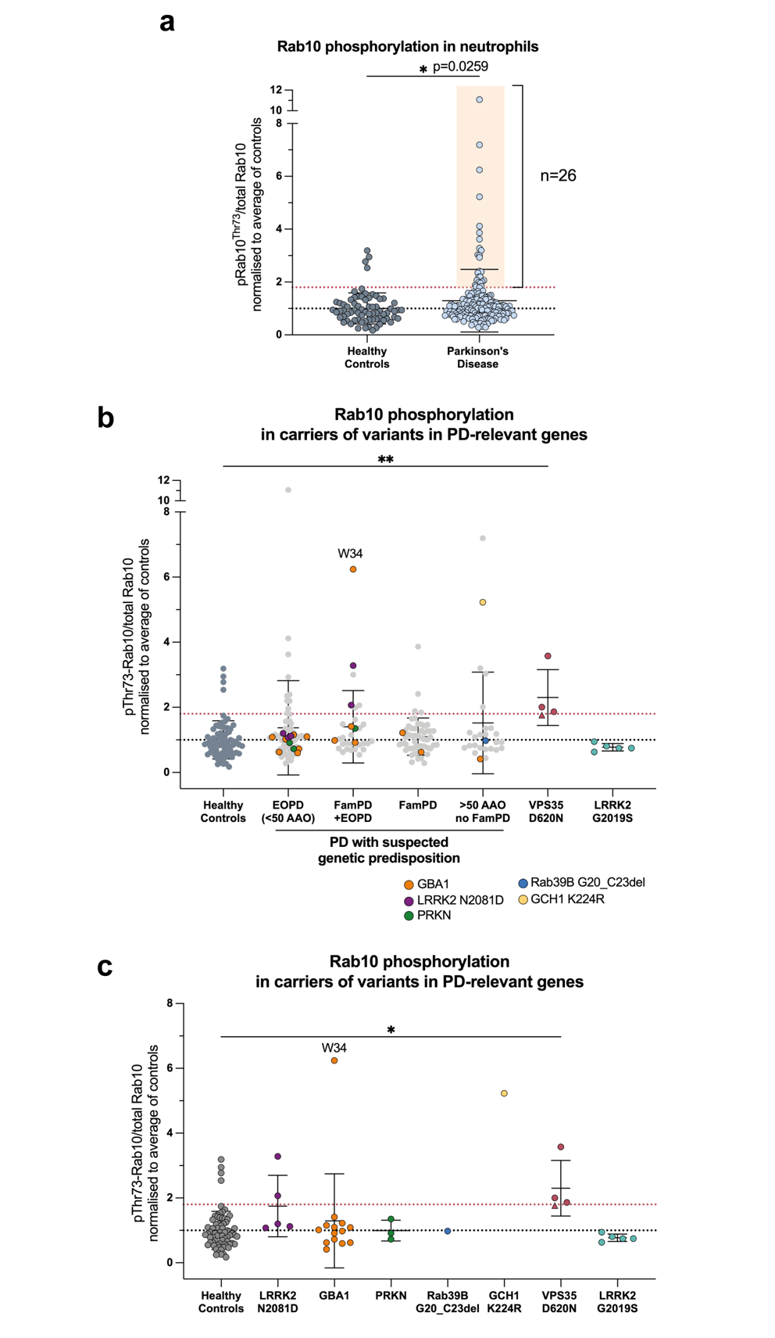
Supplementary Figure 1. LRRK2-dependent Rab10 phosphorylation levels in neutrophils of study's participants. (a) LRRK2-dependent Rab10 phosphorylation levels in neutrophils of the PD patient group (n=178) with VPS35 p.D620N carriers excluded compared to the healthy control group (n=71), as analysed by Western Blotting. Statistical analysis: Mann Whitney’s two-tailed test, *p < 0.05 (b) pRab10/total Rab10 levels across all clinical groups with individuals carrying variants in genes associated with PD highlighted in indicated colours. (c) Summarized pRab10 / total Rab10 levels of carriers with variants in PD-relevant genes categorized within their respective groups. The non-manifesting VPS35 p.D620N carrier is marked with a triangle. Each group was compared to healthy controls (n=71). Statistical analysis: Kruskal-Wallis test followed by Dunn’s post hoc test with Bonferroni correction, *p < 0.05, **p < 0.01. All values were normalized to the mean of healthy controls (y=1) represented as mean ± SD. Red dotted line at y=1.8 represents the lowest pRab10 value from VPS35 p.D620N participant.
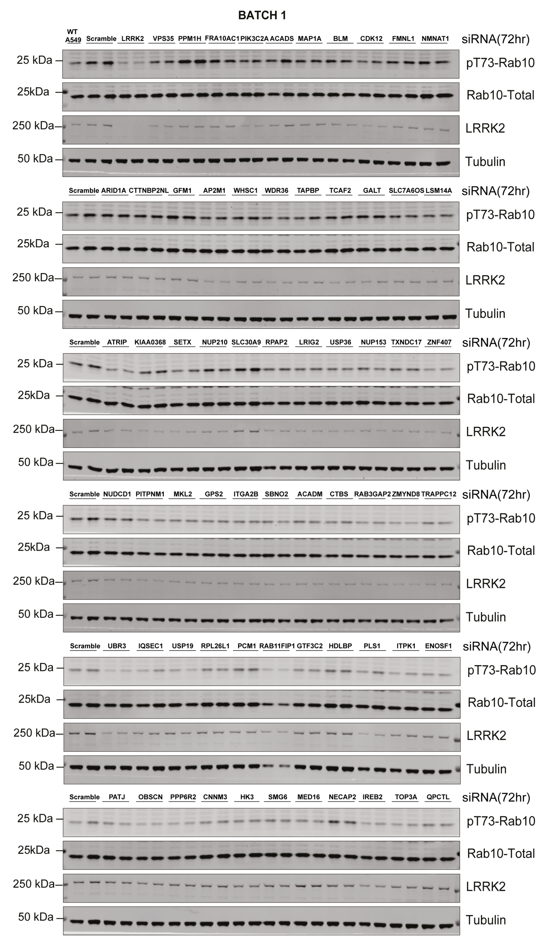
Supplementary Figure 2a
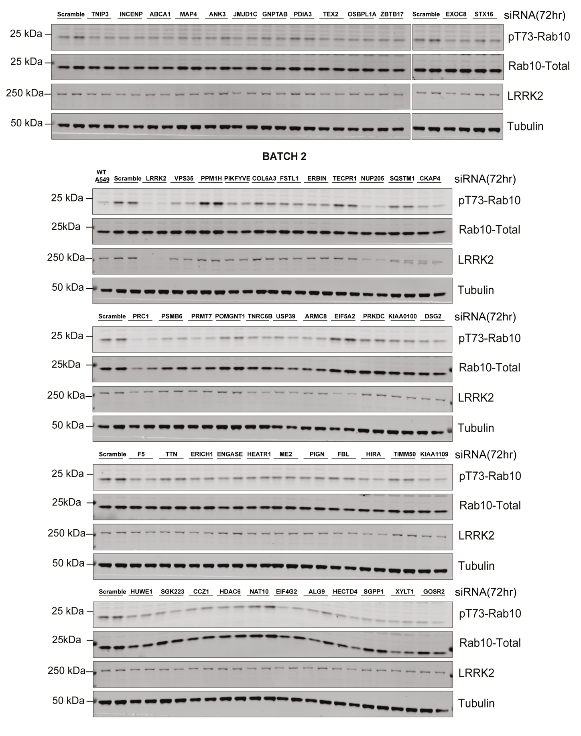
Supplementary Figure 2b
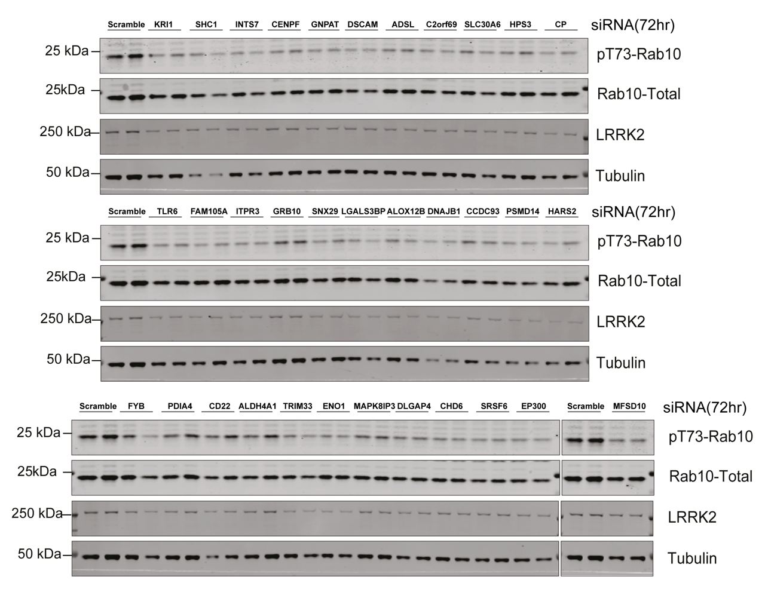
Supplementary Figure 2c
Supplementary Figure 2a-c. Representative immunoblots of a single biological replicate from the siRNA Screen. A549 cells were transfected with indicated siRNAs targeting prioritized genes for 72 hours. 20μg of each lysate was subjected to immunoblot analysis with membranes probed with indicated antibodies and developed using LICOR Odyssey CLx imaging system. Each lane represents cells coming from a different dish of cells.

Supplementary Figure 3. Quantified total LRRK2 protein levels from the siRNA screen. Bar chart illustrating mean total LRRK2/Tubulin levels for individual siRNAs with values for each replicate included. LRRK2 levels are ranked to correspond with the descending order of the pRab10/total Rab10 levels. In white are marked outliers excluded from the overall ranking of pRab10/total Rab10 values due to impaired sample quality. Each data point represents cells coming from a different dish of cells. Error bars represent ±SD.

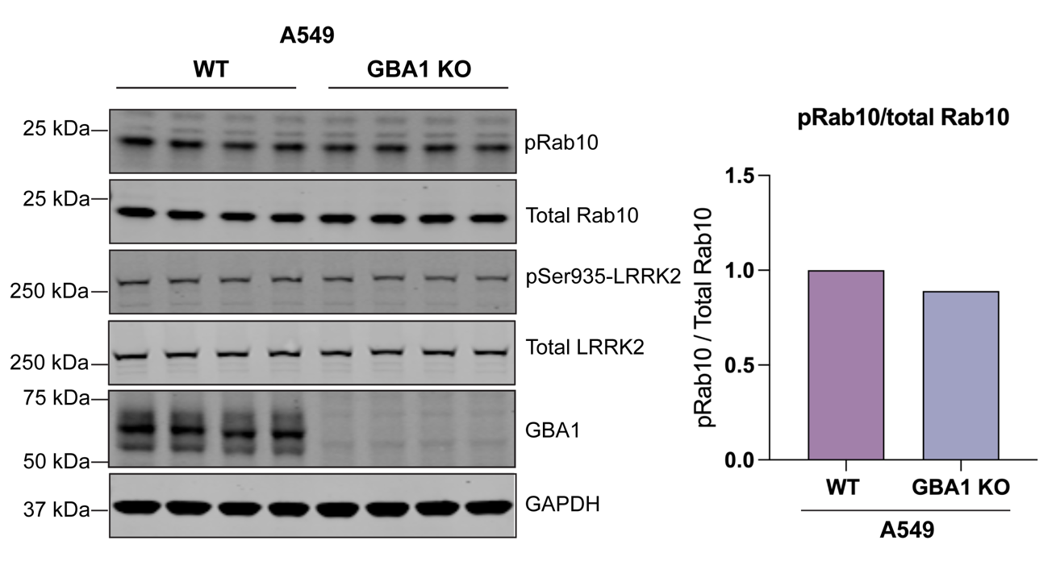
Supplementary Figure 4. GBA1 knock-out in A549 cells does not impact LRRK2-dependent Rab10^{Thr73} phosphorylation. GBA1 was knocked out using CRISPR / Cas9 mediated gene targeting with GBA1 wild-type protein being retrovirally transduced back to the cells. (a) The samples were analysed by immunoblotting with 20μg of each lysate loaded in quadruplets. Membranes probed with indicated antibodies and developed using LICOR Odyssey CLx imaging system. (b) Rab10 phosphorylation was quantified and presented as pRab10 / total Rab10. The values from quadruple loading were averaged and normalized to GBA1 WT control.

