Supporting Information

Preparation of an Electrochemical Sensor Based on the Surface Molecular Imprinting Technique and Its Application in the Detection of Proteins
Menggai Jia^{1,a}, Yingqi Li^{1,a}, Ziyao Qinª, Longwei Liª, Ling Pengª, Molin Yang^{b}, Beibei Hu*^{,a}, Zhiwei Li**^{,a}, Shiguo Sun***^{,c}
a College of Chemical and Pharmaceutical Engineering, Hebei University of Science and Technology, 26 Yuxiang Road, Shijiazhuang 050018, P. R. China
b Dermatology Department, the Fourth Hospital of Hebei Medical University, 12 Jiankang Road, Shijiazhuang 050018, P. R. China
c Shaanxi Key Laboratory of Natural Products & Chemical Biology, College of Chemistry & Pharmacy, Northwest A&F University, Yangling, Shaanxi 712100, P.R. China
*Corresponding author: Beibei Hu
College of Chemical and Pharmaceutical Engineering, Hebei University of Science and Technology, 26 Yuxiang Road, Shijiazhuang 050018, P. R. China
E-mail: hub2018@hebust.edu.cn (Beibei Hu).
Tel: +86-311-81668390 Fax: +86-311-81668390
**Corresponding author: Shiguo Sun
Shaanxi Key Laboratory of Natural Products & Chemical Biology, College of Chemistry & Pharmacy, Northwest A&F University, Yangling, Shaanxi 712100, P.R. China
E-mail: sunsg@nwsuaf.edu.cn.
Tel: +86-311-81668391 Fax: +86-311-81668391
***Corresponding author: Zhiwei Li
College of Chemical and Pharmaceutical Engineering, Hebei University of Science and Technology, 26 Yuxiang Road, Shijiazhuang 050018, P. R. China
E-mail: lizhizwei@hebust.edu.cn (Zhiwei Li).
Tel: +86-311-81668391 Fax: +86-311-81668391
1 These authors contributed equally to this work.

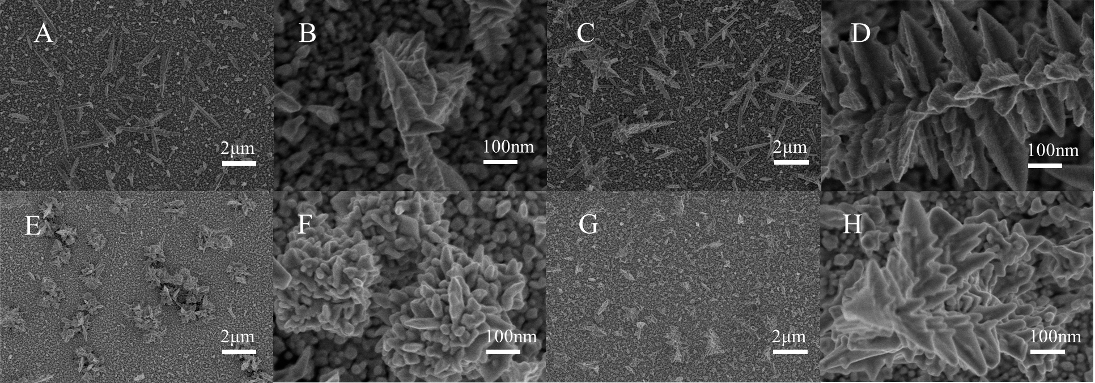
Fig. S1. SEM images of MIP/NIP/AuNPs/GCE sensors. Pre-elution MIP (A-B); Post-elution MIP (C-D); Pre-elution NIP (E-F); Post-elution NIP (G-H).
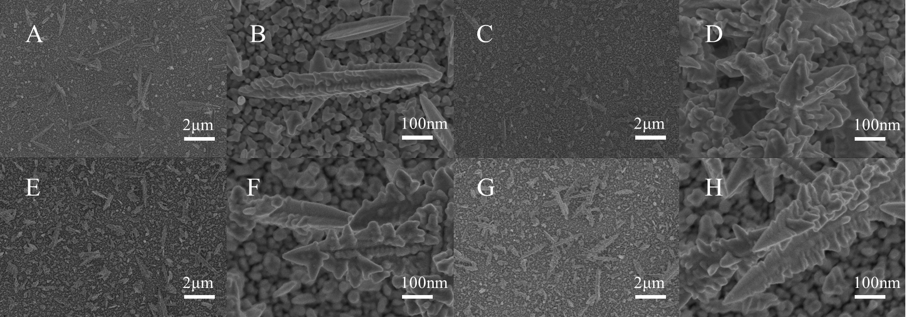
Fig. S2. SEM images of the MIP/NIP/GA@CS/AuNPs/GCE sensor. MIP (A-B), Post-elution of MIP (C-D), Pre-elution of NIP (E-F), Post-elution of NIP (G-H).
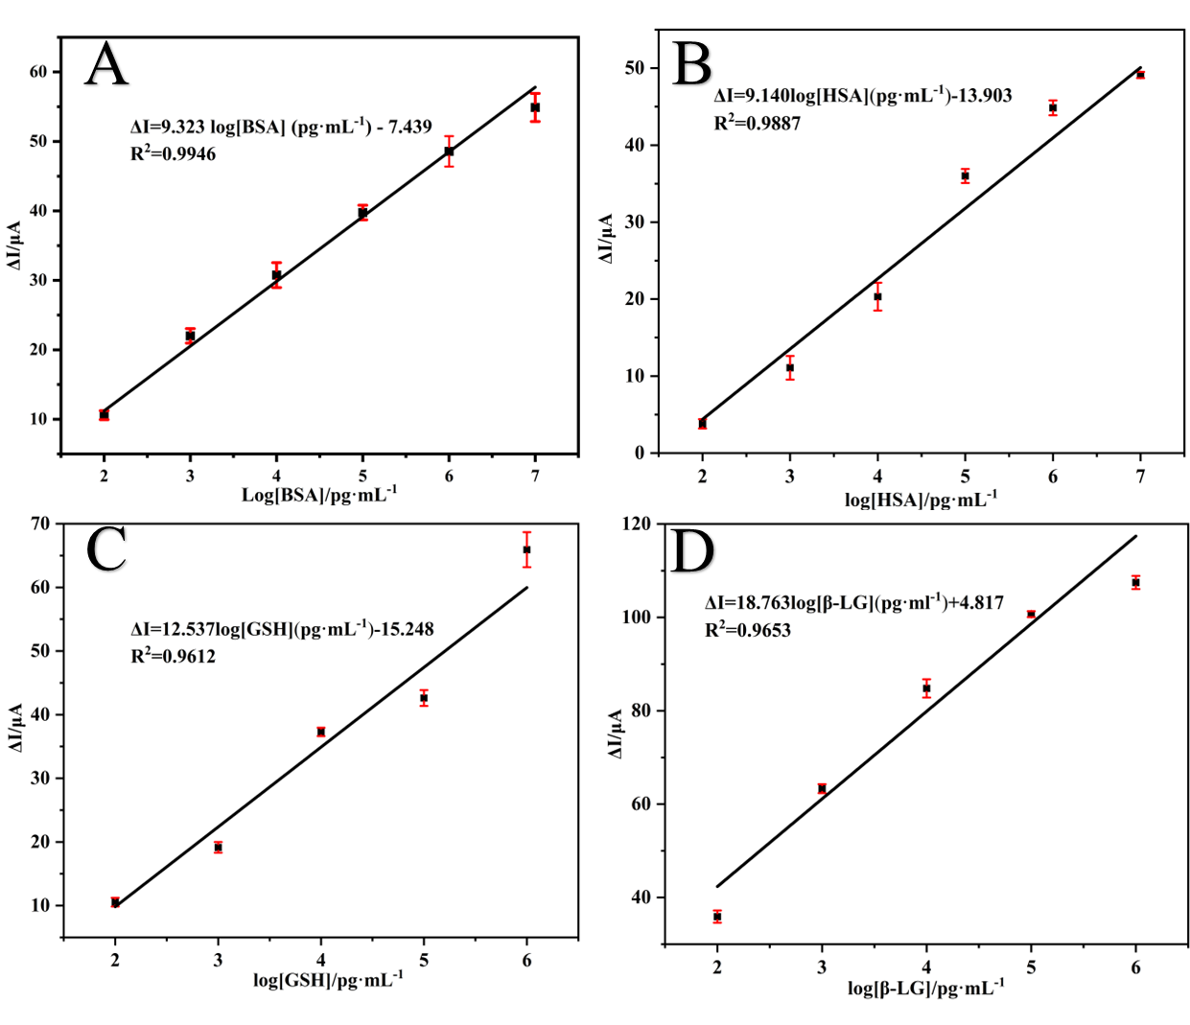
Fig. S3. Standard curves of BSA(A), HSA(B), GSH(C), and β-LG(D) detected by MIP/AuNPs/GCE sensor respectively.
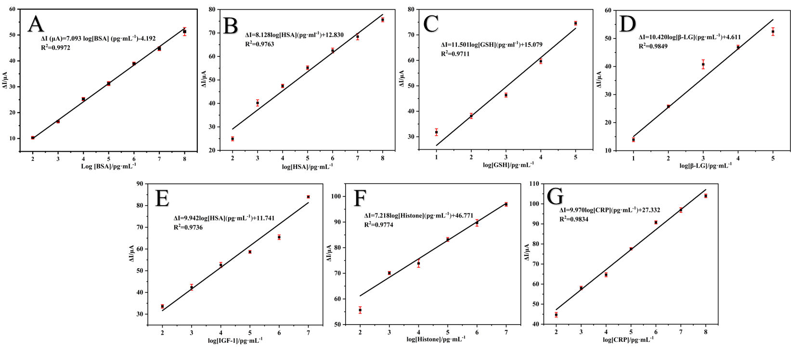
Fig. S4. Standard curves of BSA(A), HSA(B), GSH(C), β-LG(D), IGF-1(E), Histone(F) and CRP(G) detected by MIP/GA@CS/AuNPs/GCE sensor respectively.
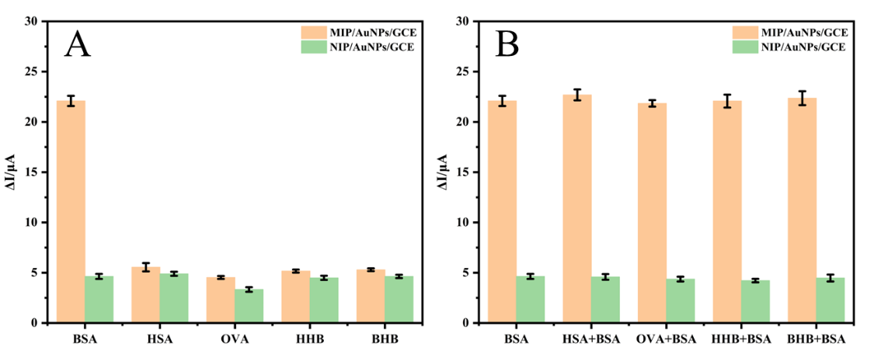
Fig. S5. The conventional selectivity analysis(A) and interference selectivity analysis(B) of MIP/AuNPs/GCE and NIP/AuNPs/GCE. The concentration ratio of BSA to interfering protein was 1:100.

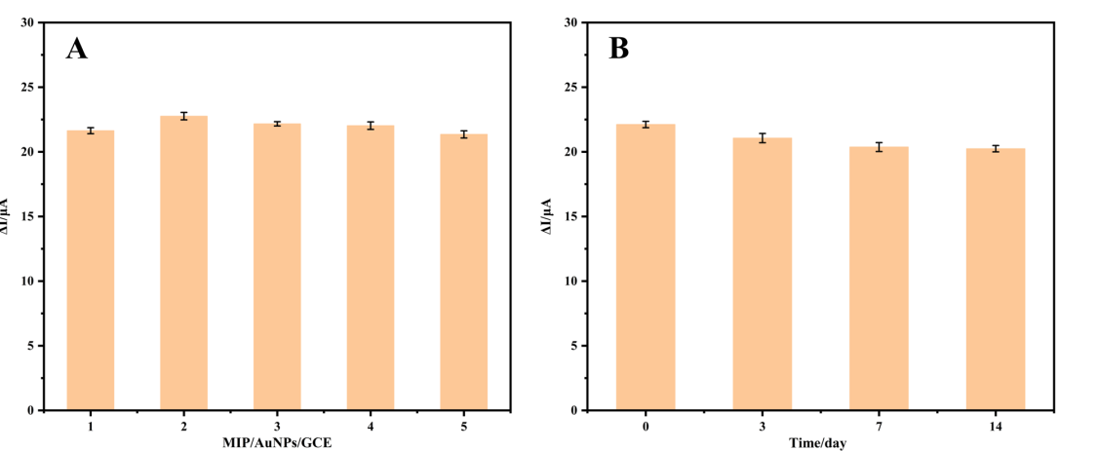
Fig. S6. The repeatability(A) and long-term stability(B) of MIP/AuNPs/GCE.

