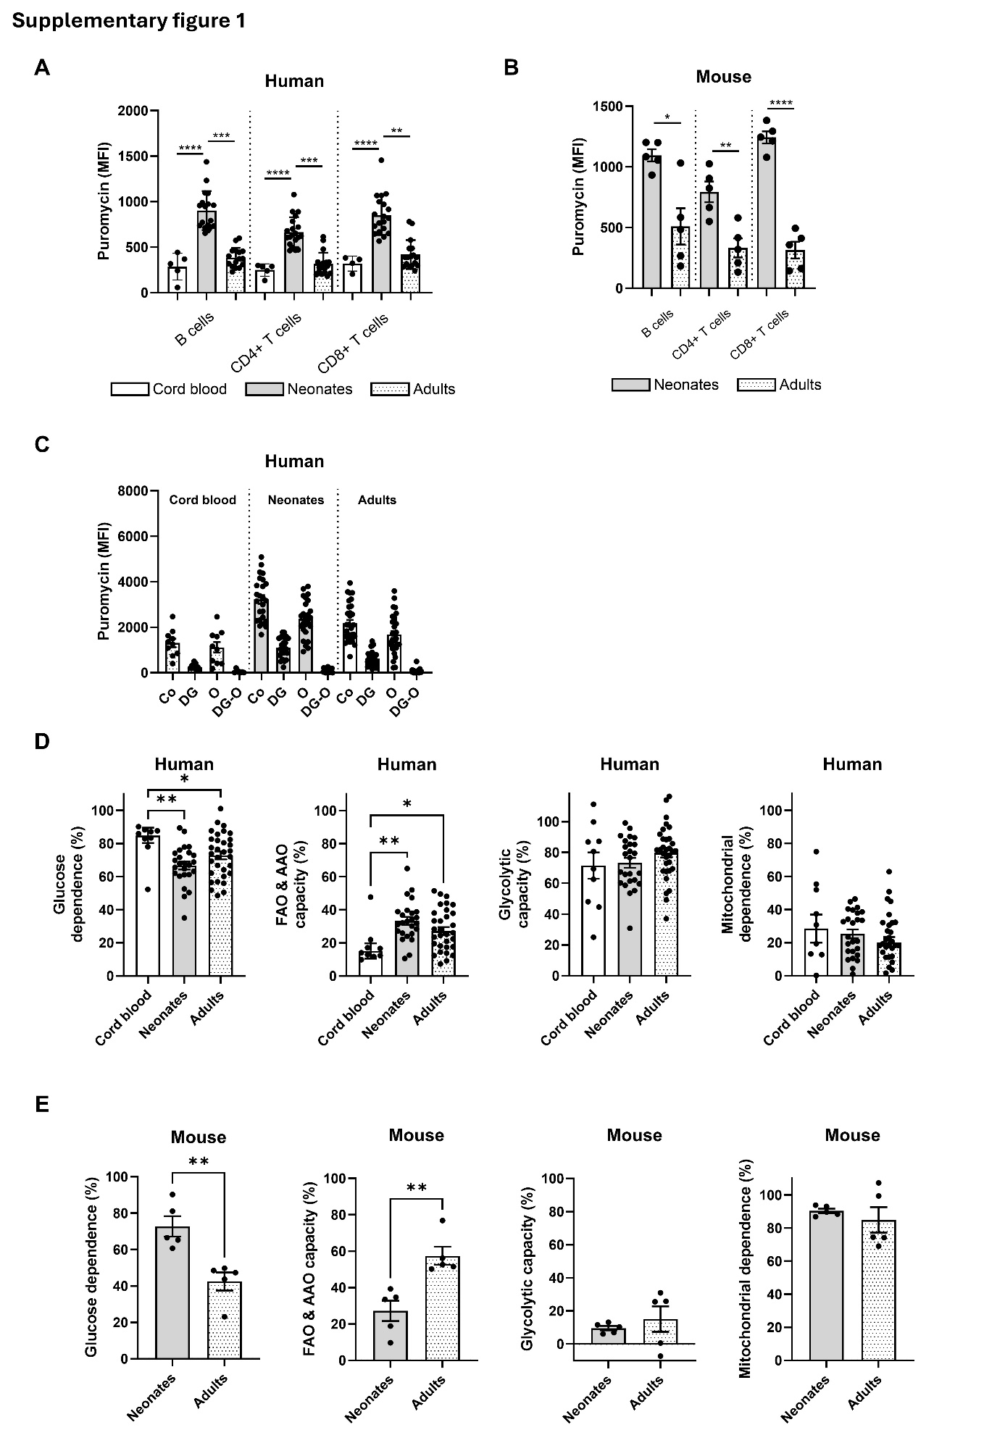

Supplementary figure 1: Neonatal B cells and T cells are metabolically more active directly after birth. (A) Metabolic activity of human CD19⁺ B cells, CD4⁺ T and CD8⁺ T cells measured by puromycin incorporation (MFI) using flow cytometry (cord blood n = 4-5, neonates (0-20 days old) n = 18-20, adults n = 16-18). (B) Metabolic activity of murine B220⁺ B cells, CD4⁺ T and CD8⁺ T cells measured by puromycin incorporation (MFI) using flow cytometry (n = 5) (C) Puromycin incorporation in human CD14⁺ monocytes after inhibiting glucose uptake using 2-Deoxy-D-glucose (2-DG) or oxidative phosphorylation using oligomycin (O) or a combination (DGO) using flow cytometry (cord blood n = 10, neonates (0-20 days old) n = 25, adults n = 32). (D/E) Glucose dependence (%), fatty acid and amino acid oxidation capacity (%), glycolytic capacity (%) and mitochondrial dependence (%) calculated by combining the data of the inhibitors 2-deoxy-glucose and oligomycin and the net protein biosynthesis in human CD14⁺ monocytes (cord blood n = 10, neonates (0-20 days old) n = 25, adults n = 32) (D) and murine Ly-6C⁺ monocytes (n = 5) (E). Graphs show individual patient/mouse data with the bars representing mean±SEM. Kruskal-Wallis test with Dunn´s multiple comparisons test (A), Welch´s test (B, E), ordinary one-way ANOVA with Tukey´s multiple comparisons test (D).

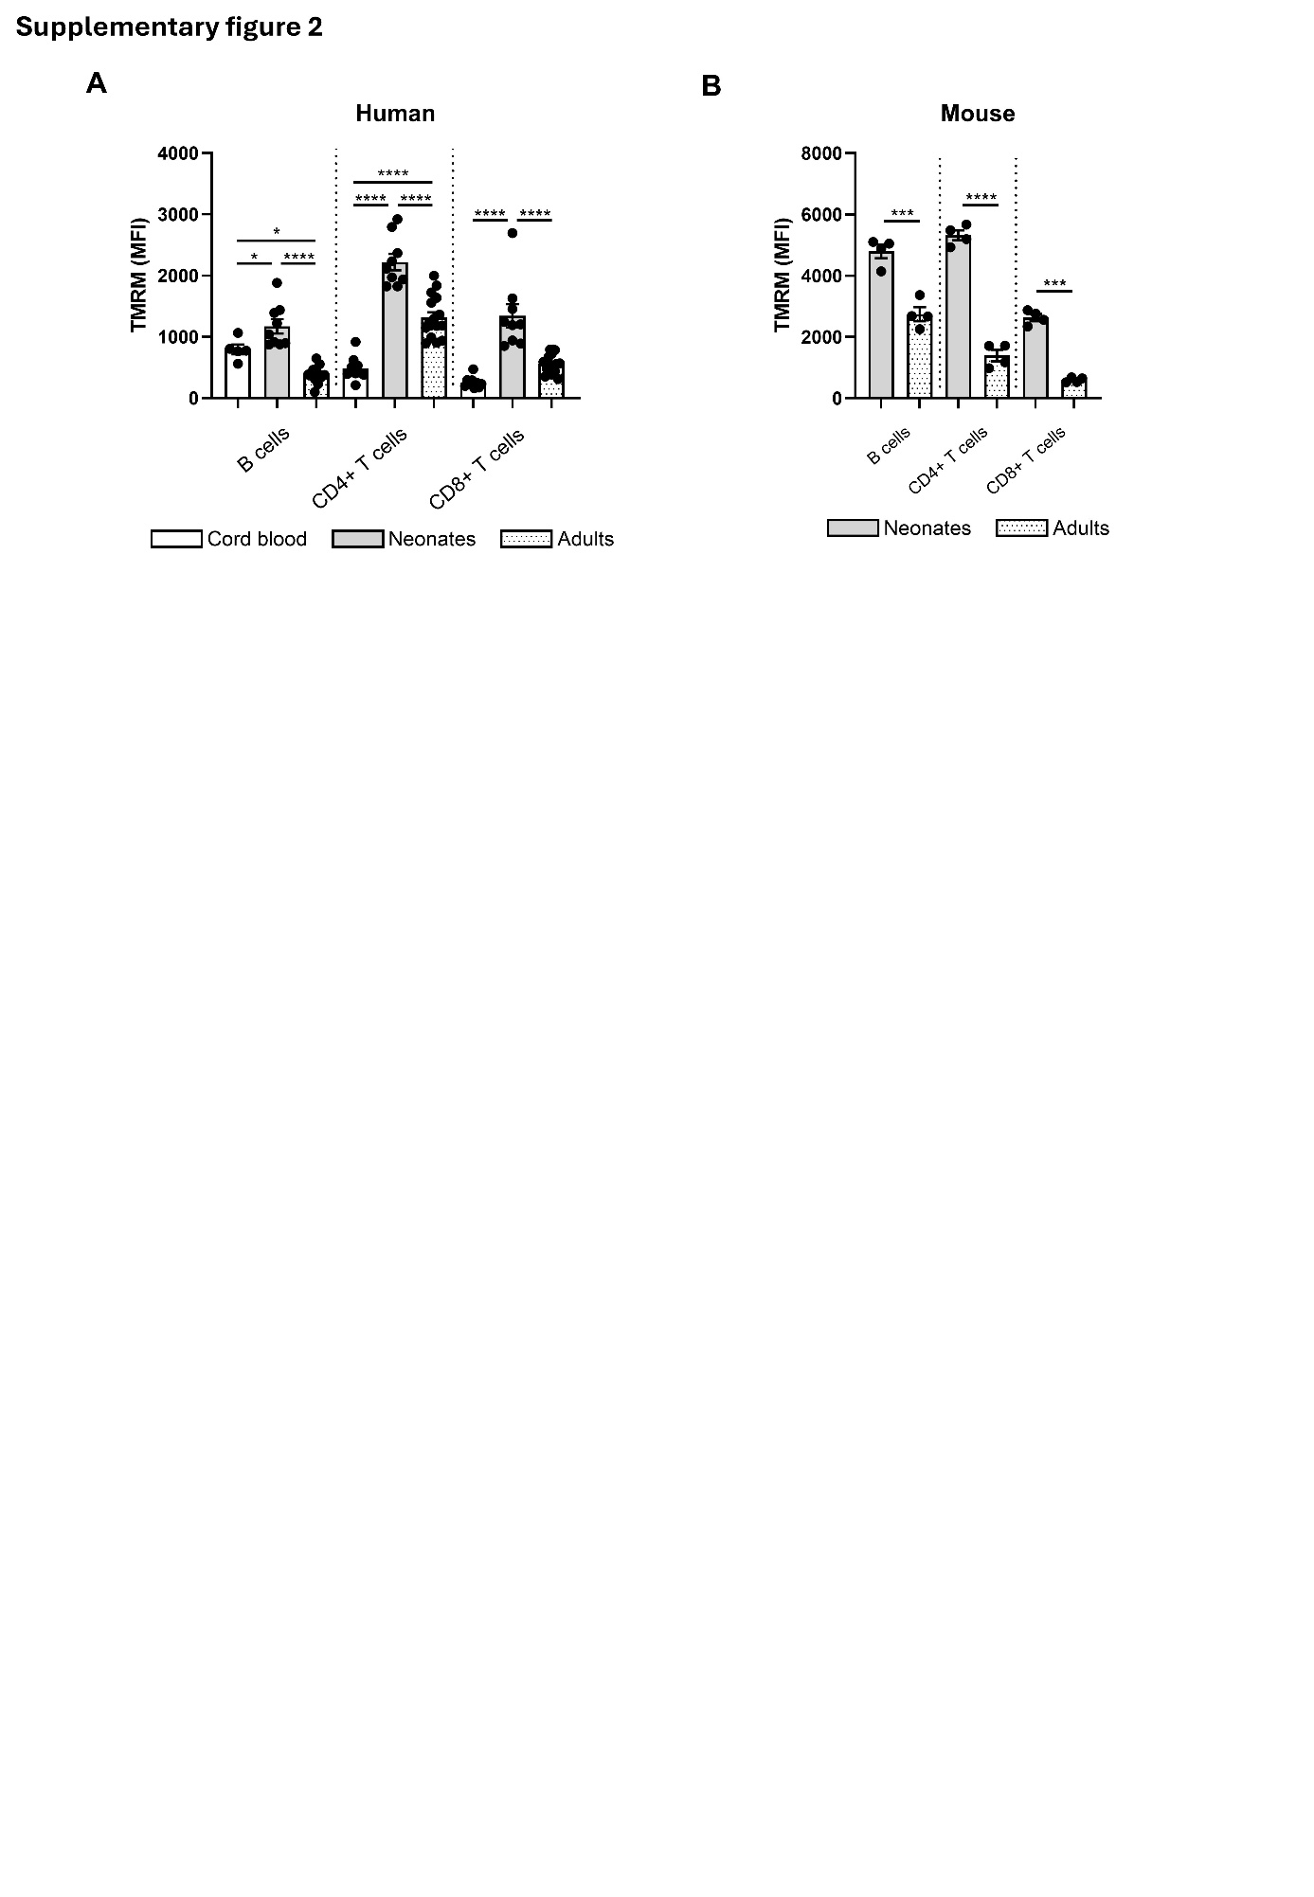

Supplementary figure 2: Neonatal B cells and T cells show enhanced mitochondrial activity directly after birth. Tetramethylrhodamine Methyl Ester (TMRM) was measured by flow cytometry to analyse mitochondrial membrane potential (ΔΨm). (A) Comparison of human CD19⁺ B cells, CD4⁺ and CD8⁺ T cells obtained from cord, neonatal and adults blood (for B cells: cord blood n = 5, neonates (0-20 days old) n = 9, adults n = 12, for T cells: cord blood n = 9, neonates (0-20 days old) n = 9, adults n = 16). (B) Comparison of murine B220⁺ B cells, CD4⁺ and CD8⁺ T cells in blood from neonates (6-8 days old, n = 4) and adults (12+ weeks old, n = 4). Graphs show individual patient/mouse data with the bars representing mean±SEM. Ordinary one-way ANOVA with Tukey´s multiple comparisons test (A), Welch´s test (B).

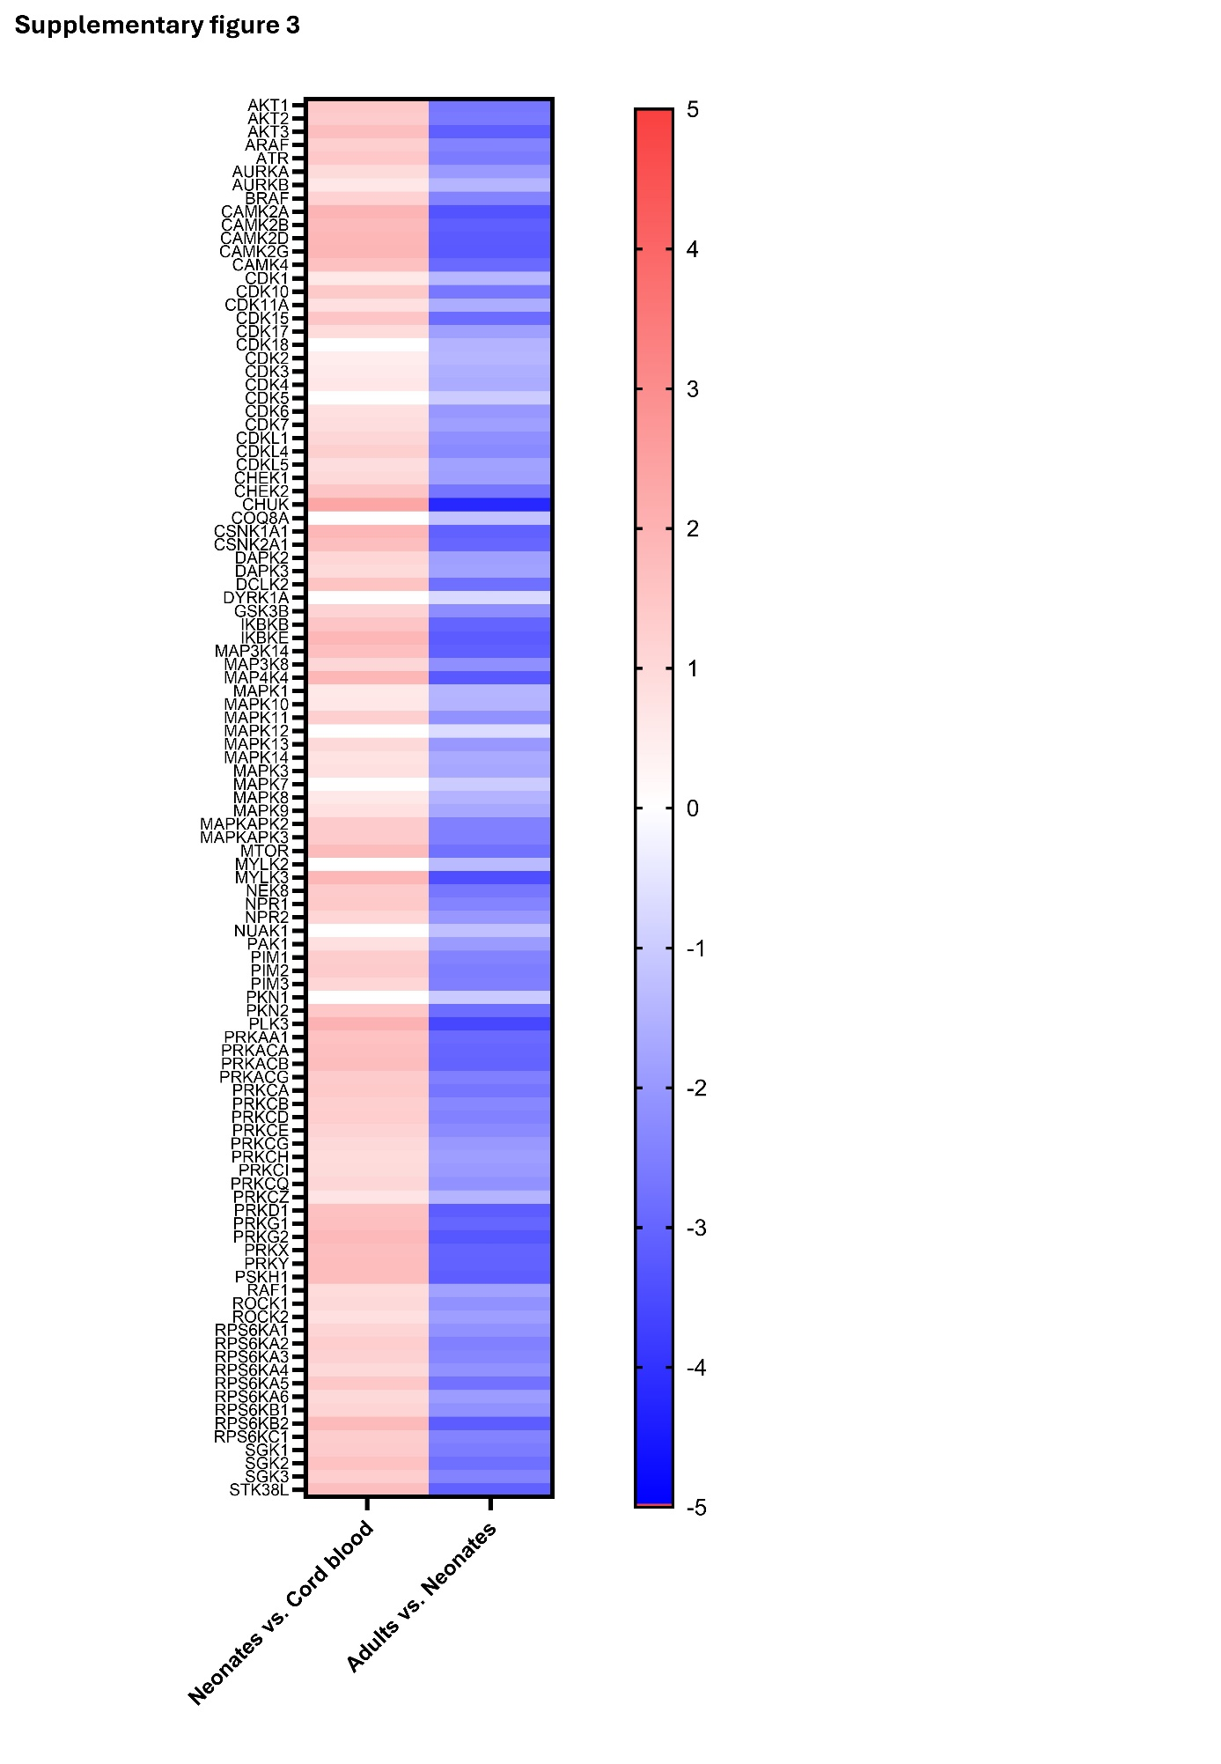

Supplementary figure 3: Overall kinase activity is elevated within the first week after birth. Heatmap of Serine-Threonine kinase (STK) activity showing effect size (mean kinase statistic) in plasma from cord, postnatal peripheral (1-7 days old), and adult blood, sorted alphabetically. Six biological replicates were included per group.

Supplementary table 1
