Supplementary Information

Exhaled-Breath Volatile Fingerprints Detect Early-Stage COPD and Stratify Disease Severity
Jianlin Cheng^{1,2,3}, Wei Chen⁴, Yuanhang Jia⁴, Wei Song¹, Sha Liu⁴, Xiaowu Tang⁴, Jianqiang Zeng^{1,2}, Yanli Zhang^{1,2}, Ping’an Peng¹, Xinming Wang^{1,2,*}
¹State Key Laboratory of Advanced Environmental Technology and Guangdong Key Laboratory of Environmental Protection and Resources Utilization, Guangzhou Institute of Geochemistry, Chinese Academy of Sciences, Guangzhou 510640, China
²College of Resources and Environment, University of Chinese Academy of Sciences, Beijing 100049, China
³College of Public Health, Hengyang Medical School, University of South China, Hengyang 421001, China
⁴Department of Respiratory and Critical Care Medicine, the Second Affiliated Hospital, Hengyang Medical School, University of South China, Hengyang 421001, China
*Correspondence: Xinming Wang (wangxm@gig.ac.cn)

Contents
• Supplementary Tables S1–S9
• Supplementary Figures S1–S6
• Study protocol and additional methods

Supplementary Tables
Table S1 | Performance of eight machine-learning classifiers for COPD prediction in the internal validation set.
Discrimination and classification metrics for decision tree (DT), k-nearest neighbours (KNN), LightGBM (LGBM), logistic regression (LR), naïve Bayes (NBM), random forest (RF), support vector machine (SVM) and XGBoost (XGB) trained on the 16-compound VOC panel in the derivation cohort and evaluated in the internal validation set. Metrics include area under the receiver-operating-characteristic curve (AUC), sensitivity, specificity, positive predictive value (PPV), negative predictive value (NPV), accuracy and F1-score.
Predictive models | AUC | Sensitivity | Specificity | PPV | NPV | Accuracy | F1 score
XGB | 0.996 | 0.974 | 0.939 | 0.958 | 0.963 | 0.957 | 0.966
RF | 0.995 | 1.000 | 0.890 | 0.929 | 1.000 | 0.945 | 0.963
KNN | 0.955 | 0.974 | 0.866 | 0.912 | 0.959 | 0.920 | 0.942
DT | 0.949 | 0.916 | 0.900 | 0.932 | 0.878 | 0.908 | 0.924
LR | 0.934 | 0.957 | 0.756 | 0.848 | 0.925 | 0.857 | 0.900
SVM | 0.927 | 0.957 | 0.768 | 0.855 | 0.926 | 0.863 | 0.903
NBM | 0.860 | 0.855 | 0.671 | 0.787 | 0.764 | 0.763 | 0.820
LGBM | 0.638 | 0.598 | 0.622 | 0.693 | 0.520 | 0.610 | 0.642

Table S2 | Performance of eight machine-learning classifiers in the external validation cohort.
Diagnostic performance of the same eight classifiers applied to the external cohort (Cohort 2) using the locked 16-compound VOC fingerprint. Reported metrics are AUC, sensitivity, specificity, PPV, NPV, accuracy and F1-score
Model | AUC | Sensitivity | Specificity | PPV | NPV | Accuracy | F1 score
SVM | 0.865 | 0.763 | 0.809 | 0.851 | 0.705 | 0.786 | 0.804
KNN | 0.851 | 0.742 | 0.838 | 0.867 | 0.695 | 0.790 | 0.800
RF | 0.832 | 0.526 | 0.868 | 0.850 | 0.562 | 0.697 | 0.650
LR | 0.829 | 0.711 | 0.765 | 0.812 | 0.650 | 0.738 | 0.758
XGB | 0.819 | 0.577 | 0.868 | 0.862 | 0.590 | 0.722 | 0.691
NBM | 0.766 | 0.649 | 0.750 | 0.787 | 0.600 | 0.700 | 0.712
LGBM | 0.716 | 0.619 | 0.721 | 0.759 | 0.570 | 0.670 | 0.682
DT | 0.687 | 0.865 | 0.540 | 0.464 | 0.897 | 0.703 | 0.604

Table S3 | DeLong test for pairwise AUC differences in the internal validation set.
Pairwise comparisons of AUCs between all machine-learning models in the internal validation set using DeLong’s test. For each baseline–new model pair, the table reports AUCs, AUC difference and P value.
Baseline model-New model | Baseline model | New model | Difference of AUC | P
XGB-RF | 0.996 | 0.995 | 0.001 | 0.621
XGB-KNN | 0.996 | 0.955 | 0.041 | 0.0101
XGB-DT | 0.996 | 0.949 | 0.047 | 0.00201
XGB-LR | 0.996 | 0.934 | 0.062 | 0.000563
XGB-SVM | 0.996 | 0.927 | 0.069 | 0.000302
XGB-NBM | 0.996 | 0.860 | 0.136 | < 0.0001
XGB-LGBM | 0.996 | 0.638 | 0.358 | < 0.0001
RF-KNN | 0.995 | 0.955 | 0.040 | 0.0118
RF-DT | 0.995 | 0.949 | 0.046 | 0.00314
RF-LR | 0.995 | 0.934 | 0.061 | 0.000678
RF-SVM | 0.995 | 0.927 | 0.068 | 0.000297
RF-NBM | 0.995 | 0.860 | 0.135 | < 0.0001
RF-LGBM | 0.995 | 0.638 | 0.357 | < 0.0001
KNN-DT | 0.955 | 0.949 | 0.006 | 0.767
KNN-LR | 0.955 | 0.934 | 0.021 | 0.380
KNN-SVM | 0.955 | 0.927 | 0.028 | 0.113
KNN-NBM | 0.955 | 0.860 | 0.095 | 0.0289
KNN-LGBM | 0.955 | 0.638 | 0.317 | < 0.0001
DT-LR | 0.949 | 0.934 | 0.015 | 0.532
DT-SVM | 0.949 | 0.927 | 0.022 | 0.344
DT-NBM | 0.949 | 0.860 | 0.089 | 0.0598
DT-LGBM | 0.949 | 0.638 | 0.311 | < 0.0001
LR-SVM | 0.934 | 0.927 | 0.007 | 0.792
LR-NBM | 0.934 | 0.860 | 0.074 | 0.248
LR-LGBM | 0.934 | 0.638 | 0.296 | < 0.0001
SVM-NBM | 0.927 | 0.860 | 0.067 | 0.425
SVM-LGBM | 0.927 | 0.638 | 0.289 | < 0.0001
NBM-LGBM | 0.860 | 0.638 | 0.222 | < 0.0001

Table S4 | Performance of eight machine-learning models combining VOC ions with basic clinical risk factors.
Diagnostic performance in the internal validation set when age, sex, BMI and smoking status are added to the 16-compound VOC panel as predictors. Metrics include AUC, sensitivity, specificity, PPV, NPV, accuracy and F1-score.
Model | AUC | Sensitivity | Specificity | PPV | NPV | Accuracy | F1 score
XGB | 0.995 | 0.983 | 0.951 | 0.966 | 0.975 | 0.967 | 0.975
RF | 0.992 | 0.974 | 0.902 | 0.934 | 0.961 | 0.938 | 0.954
DT | 0.949 | 0.916 | 0.900 | 0.932 | 0.878 | 0.908 | 0.924
LR | 0.941 | 0.872 | 0.817 | 0.872 | 0.817 | 0.844 | 0.872
SVM | 0.936 | 0.957 | 0.768 | 0.855 | 0.926 | 0.863 | 0.903
KNN | 0.909 | 0.932 | 0.805 | 0.872 | 0.892 | 0.868 | 0.901
NBM | 0.872 | 0.829 | 0.695 | 0.795 | 0.740 | 0.762 | 0.812
LGBM | 0.648 | 0.590 | 0.610 | 0.683 | 0.510 | 0.600 | 0.633

Table S5 | Performance of the KNN classifier for GOLD I–IV COPD prediction in internal and external validation sets.
Discrimination and classification metrics for the 16-DM/KNN model by GOLD stage (I–IV) in the internal validation set and in the external cohort. AUC, sensitivity, specificity, PPV, NPV, accuracy and F1-score are reported for each stage and for grouped stages (for example GOLD I+II, GOLD III+IV)
Model | AUC | Sensitivity | Specificity | PPV | NPV | Accuracy | F1 score
Internal validation set
GOLD I | 0.941 | 0.867 | 0.866 | 0.542 | 0.973 | 0.866 | 0.667
GOLD II | 0.960 | 1.000 | 0.866 | 0.825 | 1.000 | 0.933 | 0.904
GOLD Ⅲ | 0.956 | 0.971 | 0.866 | 0.756 | 0.986 | 0.919 | 0.850
GOLD Ⅳ | 0.961 | 1.000 | 0.866 | 0.577 | 1.000 | 0.933 | 0.732
External validation set
GOLD I+II | 0.861 | 0.717 | 0.838 | 0.776 | 0.792 | 0.778 | 0.745
GOLD I | 0.783 | 0.333 | 0.838 | 0.154 | 0.934 | 0.586 | 0.211
GOLD II | 0.870 | 0.766 | 0.838 | 0.766 | 0.838 | 0.802 | 0.766
GOLD Ⅲ+Ⅳ | 0.839 | 0.773 | 0.838 | 0.756 | 0.851 | 0.805 | 0.764
GOLD Ⅲ | 0.823 | 0.735 | 0.838 | 0.694 | 0.864 | 0.787 | 0.714
GOLD Ⅳ | 0.893 | 0.900 | 0.838 | 0.450 | 0.983 | 0.869 | 0.600

Table S6 | Performance of logistic regression for COPD severity grading.
Macro- and micro-averaged performance of the 11-compound logistic-regression model (11-CM) for GOLD I–IV classification in training and validation sets of COPD cases, including AUC, sensitivity, specificity, Youden index, and positive and negative likelihood ratios.
Predictive models | AUC | Sensitivity | Specificity | Youden | Positive | Negative

Training set
GOLD Ⅰ | 0.875 | 0.840 | 0.770 | 0.600 | 3.580 | 0.210
GOLD Ⅱ | 0.805 | 0.900 | 0.530 | 0.430 | 1.910 | 0.180
GOLD Ⅲ | 0.806 | 0.650 | 0.800 | 0.450 | 3.200 | 0.430
GOLD Ⅳ | 0.789 | 0.580 | 0.870 | 0.450 | 4.410 | 0.480
Macro | 0.819 | 0.690 | 0.760 | 0.450 | 2.870 | 0.410
Micro | 0.854 | 0.790 | 0.770 | 0.560 | 3.490 | 0.270

Validation set
GOLD Ⅰ | 0.827 | 0.650 | 0.930 | 0.580 | 9.350 | 0.380
GOLD Ⅱ | 0.787 | 0.760 | 0.690 | 0.450 | 2.430 | 0.350
GOLD Ⅲ | 0.792 | 0.900 | 0.580 | 0.480 | 2.150 | 0.180
GOLD Ⅳ | 0.840 | 0.860 | 0.760 | 0.620 | 3.600 | 0.190
Macro | 0.811 | 0.790 | 0.670 | 0.460 | 2.380 | 0.310
Micro | 0.849 | 0.880 | 0.680 | 0.560 | 2.750 | 0.170

Table S7 | Putative chemical identities of the 11 VOC ions used for COPD grading.
Tentative assignments for the 11 VOC ions comprising the severity model, including m/z, candidate compound name, molecular weight and molecular formula. Annotations are based on accurate mass, the Human Breathomics Database and prior literature.
m/z | Volatile organic compounds | Molecular weight | Molecular formula
31 | Formaldehyde | 30.0106 | CH₂O
35 | Hydrogen sulfide | 33.9877 | H₂S
42 | Acetonitrile | 41.0265 | C₂H₃N
77 | 1,3-Propanediol | 76.0524 | C₃H₈O₂
80 | Pyridine | 79.0422 | C₅H₅N
84 | 3(5)-Aminopyrazole | 83.0483 | C₃H₅N₃
93 | 1,2,3-Propanetriol | 92.0473 | C₃H₈O₃
132 | Leucine | 131.0946 | C₆H₁₃NO₂
136 | Adenine | 135.0545 | C₅H₅N₅
158 | 1-Decanamine | 157.1830 | C₁₀H₂₃N
268 | Adenosine | 267.0968 | C₁₀H₁₃N₅O₄

Table S8 | Putative chemical identities of the 16 VOC ions used for COPD diagnosis.
Tentative annotations for the 16 VOC ions in the diagnostic fingerprint, including m/z, potential structures, molecular weight and formula. Several m/z values have multiple plausible candidates.
m/z | Volatile organic compounds | Molecular weight | Molecular formula
78 | Methyl nitrate | 77.0113 | CH₃NO₃
86 | Thiazole | 85.0164 | C₃H₃NO₂
 | Piperidine | 85.0891 | C₅H₁₁N
90 | Alanine | 89.0477 | C₃H₇NO₂
104 | Benzonitrile | 103.0422 | C₇H₅N
 | Benzene, isocyano- | 103.0422 | C₇H₅N
 | Methyl dimethylcarbamate | 103.0633 | C₄H₉NO₂
117 | - Hydroxy-4-methylpentan-2-one | 116.0837 | C₆H₁₂O₂
120 | Threonine | 119.0582 | C₄H₉NO₃
124 | - (CH3OCH2)-pyridine | 123.0684 | C₇H₉NO
134 | Aspartic acid | 133.0375 | C₄H₇NO₄
151 | Benzoic acid, 3-methyl-, methyl ester | 150.0681 | C₉H₁₀O₂
153 | Methyl salicylate | 152.0473 | C₈H₈O₃
170 | Pyridine, pentafluoro- | 168.9951 | C₅F₅N
218 | N,N-Dimethyl-p-trifluorobenzmide | 217.0714 | C₁₀H₁₀F₃NO
234 | N,N-Dimethylbenzenamine, 2,4-di-t-butyl | 233.2143 | C₁₆H₂₇N
238 | Benzene,1,1’-(1,1,2,2-tetramethyl-1,2-ethanediyl)bis- | 239.1800 | C₁₈H₂₂
246 | Benzenamine, N,N-diphenyl- | 245.1204 | C₁₈H₁₅N
265 | Trans-1,4-dibenzylcyclohexane | 264.1878 | C₂₀H₂₄

Table S9 | Calibration parameters for 29 VOC standards.
Standard curves, correlation coefficients (R²), limits of detection (LOD) and instrument sensitivities for 29 VOC species used to calibrate the PTR–ToF–MS.
m/z | Chemical formula | Suggested compounds | Standard curve | Correlation coefficient (R²) | LOD  (ppb) | Sensitivity (cps/ppb)
28.010 | CHN | Hydrocyanic acid | y=6.400x+77.382 | 0.9988 | 3.7 | 6.4
31.010 | HCHO | Formaldehyde | y=7.347x+29.108 | 0.9942 | 2.4 | 7.3
33.024 | CH₃OH | Methyl alcohol | y=20.635x-87.425 | 0.9897 | 1.3 | 20.6
42.016 | CH₃CN | Acetonitrile | y=41.322x-39.310 | 0.9971 | 4.2 | 41.3
45.016 | C₂H₄O | Acetaldehyde | y=42.471x-17.522 | 0.9998 | 0.6 | 42.5
57.040 | C₃H₄O | Acrolein | y=54.832x-166.740 | 0.9961 | 0.7 | 54.8
59.080 | C₃H₆O | Acetone | y=56.717x-56.650 | 0.9998 | 0.5 | 56.7
61.095 | C₃H₈O | Isopropanol | y=38.985x-37.714 | 0.9997 | 0.8 | 38.9
69.074 | C₄H₄O | Furan | y=56.797x-27.338 | 0.9999 | 0.3 | 56.8
69.120 | C₅H₈ | Isoprene | y=56.608x-27.020 | 0.9999 | 0.3 | 56.6
71.039 | C₄H₆O | Ethyl methyl ketone | y=41.965x-120.580 | 0.9986 | 0.6 | 41.9
73.110 | C₄H₈O | Methyl vinyl ketone (MVK) | y=66.687x-60.415 | 0.9995 | 0.6 | 66.7
75.080 | C₃H₆O₂ | Hydroxyacetone | y=16.384x-189.820 | 0.8808 | 1.1 | 16.4
79.110 | C₆H₆ | Benzene | y=40.291x-6.916 | 0.9995 | 0.3 | 40.3
87.134 | C₅H₁₀O | 2-Pentanone | y=38.663x-65.283 | 0.9993 | 0.5 | 38.7
93.140 | C₇H₈ | Toluene | y=53.702x-107.400 | 0.9995 | 0.3 | 53.7
95.111 | C₆H₅OH | Phenol | y=43.324x-399.390 | 0.9463 | 0.3 | 43.3
97.084 | C₅H₄O₂ | Furfuraldehyde | y=86.417x-660.300 | 0.9783 | 0.2 | 86.4
101.160 | C₆H₁₂O | Isobutyl methyl ketone | y=32.012x-57.300 | 0.9994 | 0.7 | 32.0
105.150 | C₈H₈ | phenylethylene | y=62.978x-262.710 | 0.9971 | 0.4 | 62.9
107.165 | C₈H₁₀ | o-xylene(8CI) | y=59.217x-176.990 | 0.9979 | 0.3 | 59.2
109.138 | C₇H₈O | m-Cresol | y=37.191x-412.360 | 0.8984 | 0.4 | 37.2
113.557 | C₆H₅Cl | Chlorobenzene | y=52.639x-157.590 | 0.9988 | 0.2 | 52.6
121.192 | C₉H₁₂ | 1,2,4-Trimethylbenzene | y=71.276x-425.880 | 0.9905 | 0.2 | 71.2
125.130 | C₇H₈O₂ | Guaiacol | y=56.534x-555.320 | 0.9381 | 0.2 | 56.5
129.174 | C₁₀H₈ | Naphthalene | y=59.438x-492.010 | 0.9639 | 0.2 | 59.4
137.234 | C₁₀H₁₆ | Copaene(6CI) | y=29.504x-111.690 | 0.9980 | 0.4 | 29.5
147.002 | C₆H₄Cl₂ | 1,3-Dichlorobenzene | y=51.339x-318.130 | 0.9894 | 0.4 | 51.3
181.447 | C₆H₃Cl₃ | 1,3,5-Trichlorobenzene | y=30.929x-290.160 | 0.9425 | 0.4 | 30.9

Supplementary Figures

Figure S1 | LASSO-based selection of VOC predictors.
a, LASSO coefficient profiles for the 65 COPD-associated VOC ions. Each coloured line tracks the coefficient for one ion as the regularisation parameter λ increases. b, Ten-fold cross-validation to select λ; the curve shows binomial deviance versus log(λ). The vertical dashed line marks the optimal λ (0.0151; log(λ) = −4.103), at which 16 non-zero coefficients define the diagnostic VOC fingerprint.
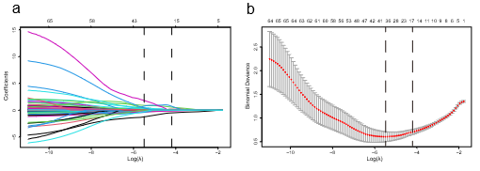

Figure S2 | Performance of machine-learning models in training and validation sets.
a–c, ROC curves for eight machine-learning models (XGB, RF, KNN, DT, LR, SVM, NB and LGBM) in the training, internal validation and external validation sets, respectively. d–f, Calibration curves showing agreement between predicted and observed COPD risk for each model in the same three datasets. g–i, Radar plots summarising AUC, sensitivity, specificity, PPV, NPV, accuracy and F1-score for all models. j–l, Decision-curve analysis (DCA) for the eight models in training, internal validation and external validation sets, illustrating net benefit across threshold probabilities from 0.05 to 1.00.
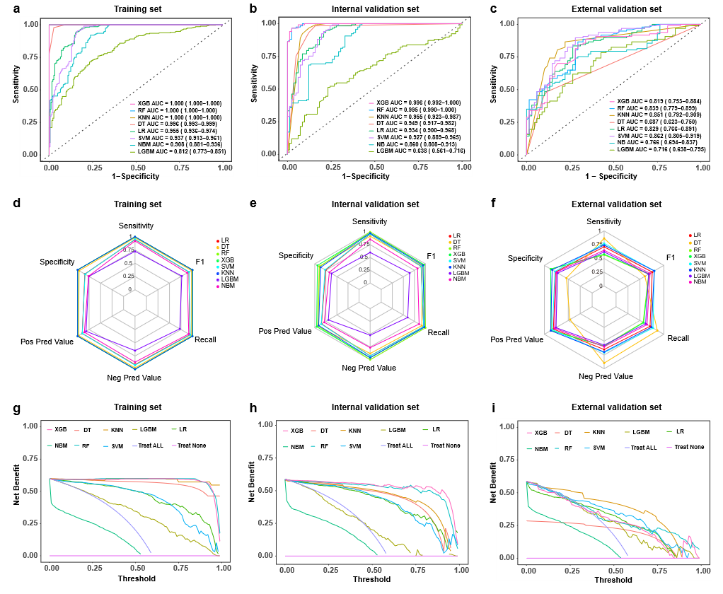

Figure S3 | Hosmer–Lemeshow calibration assessment for eight machine-learning models.
Hosmer–Lemeshow plots for XGB (a), RF (b), KNN (c), DT (d), LR (e), SVM (f), NB (g) and LGBM (h) in training and test datasets. Each panel shows grouped predicted probabilities versus observed event rates, mean absolute error (MAE) and p value from the Hosmer–Lemeshow test; larger p values indicate better calibration.
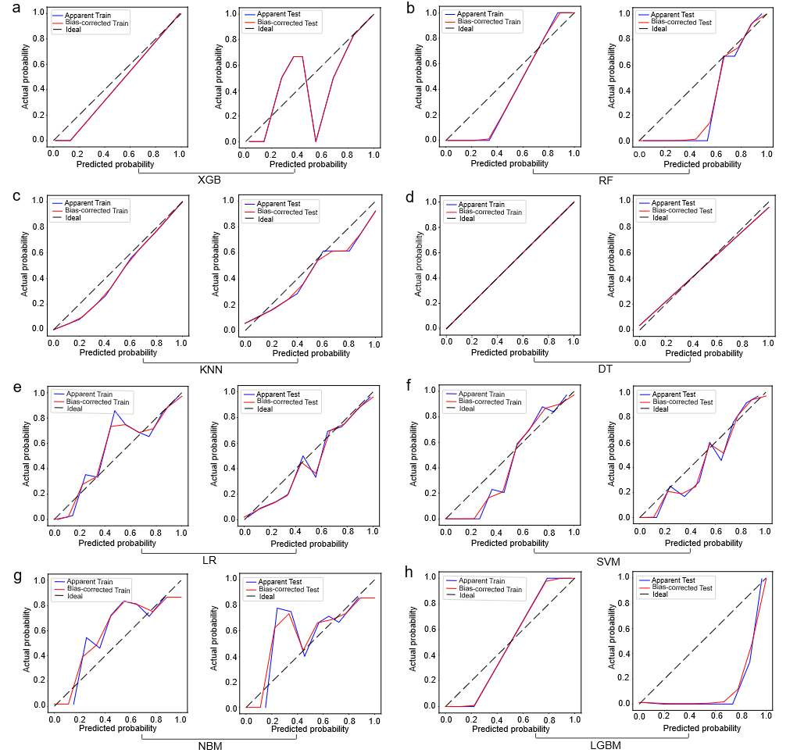
Figure S4 | Benchmarking the 16-DM model against other algorithms in MetaboAnalyst.
ROC curves comparing the 16-compound VOC classifier to models built using MetaboAnalyst (linear SVM, PLS-DA, RF, LR) for the training set, internal validation set and external validation cohort. Performance is quantified by AUC and visualised for all algorithms on matched splits.
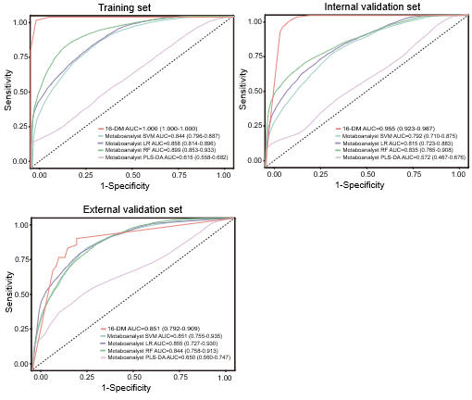

Figure S5 | Global and local explanation of the diagnostic model using SHAP.
a, SHAP summary dot plot ranking VOC ions by mean absolute SHAP value. Each dot represents one patient; colour denotes feature value (red, high; blue, low) and position along the x-axis indicates contribution to the COPD prediction. b, SHAP waterfall plot for a representative COPD patient, showing how each VOC ion shifts the base prediction towards COPD or non-COPD. Red bars indicate features increasing risk; blue bars indicate protective contributions. c, SHAP dependence plots for selected ions (for example m/z 78, 104, 124, 170, 234, 239 and 265), showing how feature values relate to SHAP values and hence to model output.
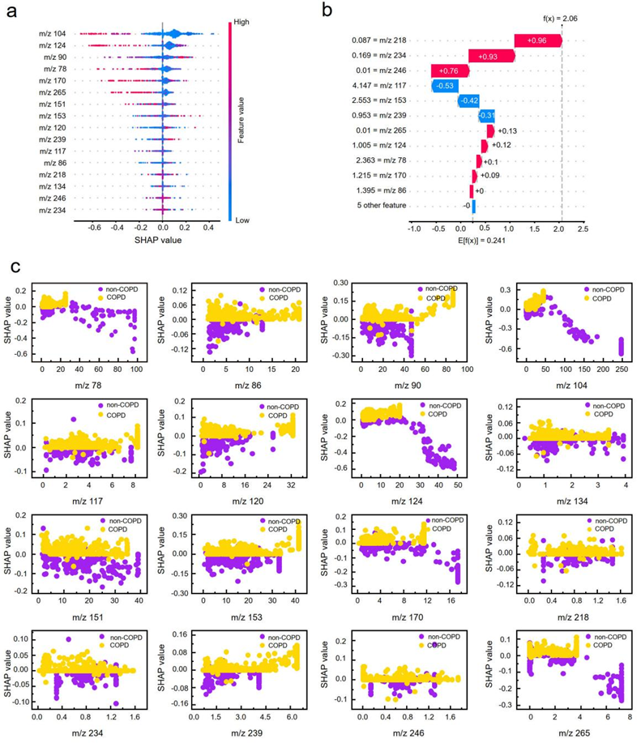

Figure S6 | Distribution and discriminative power of the 16 diagnostic VOC ions.
a, Violin plots of log₁₀-transformed signal intensities for the 16 VOC ions across non-COPD and COPD subgroups (GOLD I–IV) in Cohort 1. Black dots denote medians; dashed lines indicate the 25th and 75th percentiles. P values are from two-sided Kruskal–Wallis tests. b,c, AUCs for individual VOC ions and for the combined 16-ion panel in the internal validation set (b) and external validation cohort (c). Single ions have AUCs <0.79, whereas the combined 16-ion model approaches or exceeds AUC 0.95 internally and performs well externally.
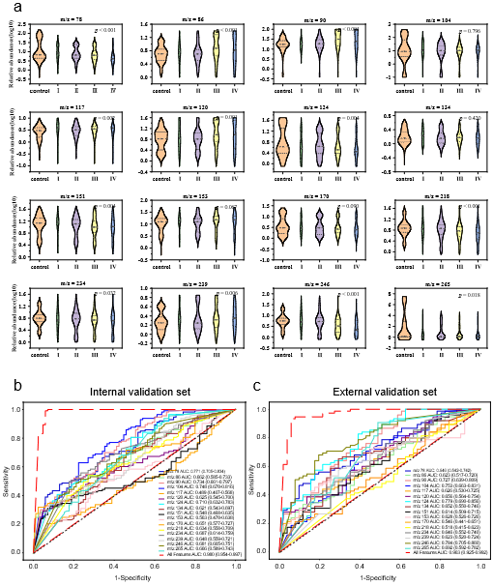

Study protocol and additional methods

Trial summary
Study type. Prospective, observational, double-centre case–control study.
Medical context. Diagnosis and staging of chronic obstructive pulmonary disease (COPD) using exhaled-breath VOC profiles and machine learning.
Study population. Adults aged 40–80 years with spirometry-confirmed COPD or non-COPD controls recruited from two campuses (“new” and “east”) of the Second Affiliated Hospital of Hengyang Medical School, University of South China.
Centres. Two campuses of a single tertiary institution: the Second Affiliated Hospital of the University of South China (new and east campuses).
Procedures. Eligible participants were consecutively enrolled. For each participant, clinical data and exhaled-breath samples were collected. VOC ions were measured by PTR–ToF–MS. Based on these VOC features and standardised clinical prediction model procedures, multiple machine-learning models were developed and internally and externally validated. The SHapley Additive exPlanations (SHAP) method was used to rank feature importance and interpret the final model.
Sample size. In total, 825 participants were analysed (planned ≈830): 660 in the derivation cohort (Cohort 1) and 165 in the external validation cohort (Cohort 2).
Outcomes.
- Primary outcome: AUC for COPD prediction.
- Secondary outcomes: sensitivity, specificity, PPV, NPV, accuracy, F1-score, calibration metrics and net benefit from DCA.

2. Study design
This double-centre, prospective clinical study aimed to develop and validate interpretable machine-learning models for predicting COPD status and grading disease severity using exhaled-breath VOC fingerprints.
Participants were recruited between March 2022 and December 2024 from the new and east campuses of the Second Affiliated Hospital of the University of South China. All participants underwent pre- and post-bronchodilator spirometry performed by certified personnel following the GOLD 2025 report. COPD was defined as a post-bronchodilator FEV₁/FVC ratio below the lower limit of normal (fifth percentile). Participants with ≥12% and ≥200 mL improvement in FEV₁ after bronchodilator who still had FEV₁/FVC below the lower limit of normal were also classified as COPD. Two senior physicians independently adjudicated COPD status and GOLD stage while blinded to breath data; disagreements were resolved by a third physician.
Cohort 1 (N₁ = 660; derivation cohort) was obtained from the new campus and used for model development and internal validation. Cohort 2 (N₂ = 165; external cohort) was obtained from the east campus and used solely for external validation.
Trial diagram:
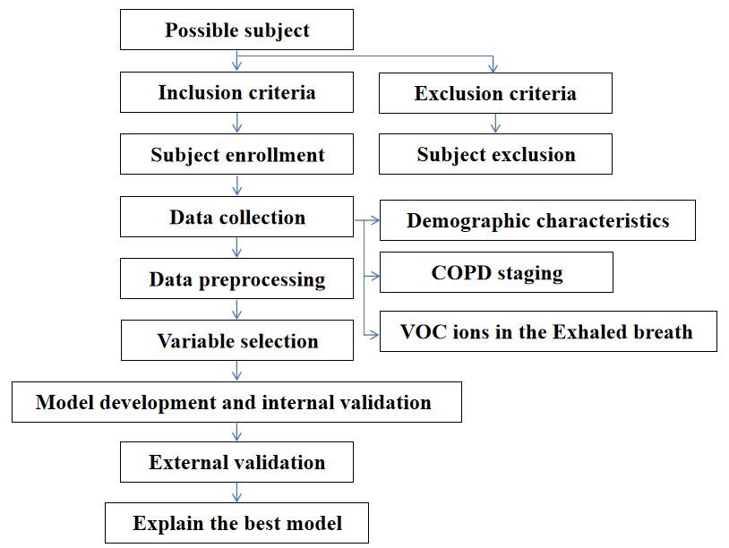

3. Study objectives and hypotheses

Primary objective.
To evaluate the AUC of multiple machine-learning models in discriminating COPD from non-COPD using exhaled-breath VOC ions.
Hypothesis H1: at least one model will achieve AUC > 0.80 for COPD prediction.

Secondary objectives.
To compare performance metrics (AUC, sensitivity, specificity, PPV, NPV, accuracy, F1-score, calibration and net benefit) across different machine-learning models in training, internal validation and external validation datasets.
Hypothesis H2: the k-nearest neighbours (KNN) model will provide superior overall performance in both training and validation datasets.
To evaluate specificity, sensitivity, PPV and NPV of each model at clinically relevant thresholds.
To build and validate an interpretable model for GOLD I–IV severity grading among COPD patients using VOC ions.

4. Background and rationale
COPD is a leading cause of death worldwide, with rising prevalence driven by ageing populations and continued exposure to tobacco smoke and air pollution (Adeloye et al. 2022; Global Initiative for Chronic Obstructive Lung Disease. 2025). A substantial proportion of cases (up to 70%) remain undiagnosed until persistent airflow limitation is present (Lamprecht et al. 2015; Labonté et al. 2016; Diab et al. 2018; Aaron et al. 2024), leaving a substantial window in which timely intervention could attenuate future acute care for exacerbations and reduce societal and economic burden (Rennard and Drummond 2015; Koo et al. 2020; Huynh et al. 2022).
Existing case-finding strategies rely heavily on spirometry, which, although indispensable for diagnosis and staging, requires equipment, trained personnel and patient cooperation, and is not easily deployed at population scale or in primary care.
Blood- and sputum-based biomarker studies have identified numerous candidates, but none has entered routine practice, partly because COPD is pathophysiologically heterogeneous and spans multiple inflammatory endotypes and environmental exposures. There is a need for more comprehensive, scalable prediction models that capture disease-related signal beyond single circulating markers.
Exhaled breath is an attractive matrix for such models: VOCs reflect systemic metabolism, oxidative stress and host–microbiome interactions and can be measured non-invasively in real time. This study prospectively developed and validated VOC-based machine-learning models, with explicit internal and external validation and interpretable explanations, to support earlier COPD case-finding and severity grading.

5. Eligibility criteria

Inclusion criteria
(1) Age 40-80 years;
(2) For COPD cases: diagnosis consistent with GOLD 2025 criteria (Global Initiative for Chronic Obstructive Lung Disease. 2025) based on post-bronchodilator spirometry.;
(3) For non-COPD controls: no diagnosis of chronic respiratory disease and normal spirometry.
(4) Provision of written informed consent.

Exclusion criteria
(1) Refusal to participate.
(2) Life-threatening comorbid illness.
(3) Other respiratory diseases, including lung cancer, active tuberculosis, pulmonary infections or bronchial asthma.
(4) Missing or invalid pulmonary function test data.

6. Data collection and identifiers
Demographic and clinical variables were extracted from electronic medical records at the time of recruitment. These included age, sex, height, weight (for BMI calculation), smoking status, pre- and post-bronchodilator FEV₁, FVC, FEV₁/FVC, and GOLD stage (I–IV) according to the GOLD 2025 report.
Each participant was assigned a unique study ID (0001–0830) used throughout breath sampling, PTR–ToF–MS analysis and data processing, ensuring that all data remained de-identified in analysis datasets. Baseline characteristics are summarised in the main-text Table 1.

7. Variables and outcomes

7.1 Variables

Demographic variables

age, sex, smoking, height, weight, and BMI

Clinical Variables

Pre- and Post-bronchodilator FEV₁, FVC, FEV₁/FVC; GOLD stage (I–IV).

Breathomics variables
- Full VOC matrix: 500 m/z channels (20–440) from PTR–ToF–MS.
- Feature sets used for modelling:

65 COPD-associated VOC ions (univariate screening).

16 ions comprising the diagnostic fingerprint (16-DM).

11 ions comprising the severity fingerprint (11-CM).

7.2 Outcomes and evaluation metrics
The primary outcome was COPD status (COPD vs non-COPD). Secondary outcomes included GOLD I–IV stage among COPD patients.
Quantitative performance metrics were defined as follows:
- ROC curve and AUC. ROC curves plot sensitivity (true positive rate) versus 1–specificity (false positive rate) across classification thresholds. The AUC summarises discrimination; AUC = 0.5 indicates no discrimination, AUC = 1.0 indicates perfect discrimination.
- Sensitivity (true positive rate). TP/(TP+FN); proportion of COPD cases correctly classified as COPD.
- Specificity (true negative rate). TN/(TN+FP); proportion of non-COPD controls correctly classified as non-COPD.
- PPV and NPV. PPV = TP/(TP+FP); NPV = TN/(TN+FN); probabilities that positive and negative predictions are correct.
- Accuracy. (TP+TN)/(TP+TN+FP+FN); overall proportion correctly classified.
- F1-score. Harmonic mean of precision and recall, useful for imbalanced datasets.
- Brier score. Mean squared difference between predicted probabilities and observed outcomes; lower values indicate better calibration.

8. Data preprocessing and feature selection
We used a standardised pipeline to preprocess VOC data and select features, applied separately within derivation and validation sets to avoid information leakage.
Preprocessing steps
- Detection filtering (80% rule). For each m/z, we evaluated the proportion of samples with detectable signal in each group. VOC ions detected in <80% of samples in either group were removed, leaving 226 robust ions.
- Handling non-detects. For retained ions, occasional non-detects (<20%) were imputed at 50% of the method detection limit (MDL).
- Outlier handling. Outliers for continuous variables were identified using the 1.5×IQR rule and truncated to the corresponding lower or upper cut-off, bringing them closer to the main distribution while preserving rank.
- Univariate screening. In the derivation cohort, univariate logistic regression (COPD vs non-COPD) was performed for each ion; 65 ions with P < 0.05 were retained as candidate features.
Feature selection
Least absolute shrinkage and selection operator (LASSO) logistic regression with ten-fold cross-validation was used to derive sparse VOC panels:
- A 16-ion diagnostic panel (16-DM) associated with COPD risk.
- An 11-ion panel (11-CM) associated with GOLD stage among COPD cases.
The regularisation parameter λ was chosen by minimising cross-validated deviance.

9. Model selection, training and evaluation

9.1 Model families
We pre-specified eight commonly used machine-learning algorithms spanning linear, tree-based, distance-based and ensemble methods:
- Logistic regression (LR)
- Decision tree (DT)
- Random forest (RF)
- k-nearest neighbours (KNN)
- Support vector machine (SVM)
- Naïve Bayes (NB)
- XGBoost (XGB)
- LightGBM (LGBM)

9.2 Training and hyperparameter tuning
Models were trained using the 16-DM fingerprint in Cohort 1. Hyperparameters were tuned using grid search with cross-validation (typically ten-fold) implemented in the caret ecosystem. Briefly:
- LR: regularisation parameters (L1/L2) tuned.
- DT: maximum depth and minimum split size tuned to reduce overfitting.
- RF: number of trees, maximum depth and split criteria tuned.
- KNN: number of neighbours and distance metric (e.g. Euclidean, Manhattan) tuned.
- SVM: penalty parameter C and kernel type (linear, RBF) tuned.
- NB: distributional assumptions (e.g. Gaussian vs Bernoulli) chosen from data.
- XGB & LGBM: learning rate, maximum depth, subsampling ratios and other tree and leaf parameters tuned to optimise generalisation.
9.3 Evaluation metrics and model comparison
Primary and secondary metrics (AUC, sensitivity, specificity, PPV, NPV, accuracy, F1-score, Brier score) were calculated as defined above. Calibration was assessed with calibration curves and the Hosmer–Lemeshow test. DeLong’s test was used to compare AUCs between models. Decision-curve analysis (DCA) was performed to quantify net benefit relative to “treat all” and “treat none” strategies across threshold probabilities from 0.05 to 1.00.
Models were first evaluated in the internal hold-out set (Cohort 1). The best-performing diagnostic model (KNN with the 16-DM fingerprint) was then frozen and applied unchanged to the external Cohort 2 to assess generalisability. We also repeated analyses after adding age, sex, BMI and smoking to quantify the incremental value of clinical covariates, and benchmarked the 16-DM models against standard MetaboAnalyst workflows (linear SVM, PLS-DA, RF, LR).

10. Model interpretation (SHAP)
To improve transparency and interpretability, we applied SHapley Additive exPlanations (SHAP) to the locked diagnostic model. SHAP values decompose each prediction into additive feature contributions based on game-theoretic Shapley values.
- Global interpretation. We calculated mean absolute SHAP values to obtain global feature rankings, identifying the VOC ions that most strongly influenced COPD predictions across the cohort.
- Local interpretation. We computed SHAP values for each patient to show how individual VOC profiles shifted the predicted probability towards COPD or non-COPD. These were visualised using summary plots, dependence plots and waterfall plots, highlighting how lower or higher intensities at specific m/z values drove each prediction.

11. Sample size justification and timeline

11.1 Sample size calculation
Sample size was guided by power calculations for AUC. Assuming improvement from AUC 0.60 (null) to AUC 0.80 (alternative), two-sided α = 0.05 and 85% power, a total of approximately 825 participants, with 660 in the derivation cohort and 165 in the external validation cohort, was deemed sufficient to:
- support feature selection and model fitting with adequate events per variable, and
- estimate AUC and other performance metrics in the external cohort with reasonable precision.

11.2 Rationale for sample size
The chosen sample size:
- ensures that the derivation cohort (660 participants, 393 COPD and 267 non-COPD) is large enough for robust model development and hyperparameter optimisation, reducing overfitting;
- provides an independent external cohort (165 participants, 97 COPD and 68 non-COPD) sufficient to characterise model generalisation and estimate performance metrics (including AUC, sensitivity and specificity).

11.3 Timeline
September 2022 – September 2024: Recruitment, spirometry and breath sampling at both campuses; extraction of clinical variables.
November 2024 – June 2025: Data preprocessing, feature selection, model development, internal and external validation, SHAP analysis and manuscript preparation.

12. Confidentiality and data sharing
All data generated during the study were treated as confidential and stored under unique study IDs. Identifiable information was retained only at the clinical sites and was not included in analysis files.
De-identified participant data (clinical variables and VOC matrices), along with the full study protocol, will be made available to the scientific community after publication on reasonable request to the corresponding author, subject to a data-use agreement and, where applicable, institutional review board approval.

References
Aaron, S. D et al. Early diagnosis and treatment of COPD and asthma-a randomized, controlled trial. N. Engl. J. Med. 390, 2061-2073 (2024).
Adeloye, D. et al. Global, regional, and national prevalence of, and risk factors for, chronic obstructive pulmonary disease (COPD) in 2019: a systematic review and modelling analysis. Lancet Respir Med. 10, 447-458. (2022).
Bijlsma, S. et al. Large-scale human metabolomics studies: a strategy for data (pre-) processing and validation. Anal. Chem. 78, 567–574 (2006).
Diab, N. et al. Underdiagnosis and overdiagnosis of chronic obstructive pulmonary disease. Am. J. Respir. Crit. Care Med. 198, 1130–1139 (2018).
Global Initiative for Chronic Obstructive Lung Disease (GOLD). Global strategy for the diagnosis, management, and prevention of chronic obstructive pulmonary disease: 2025 report. (GOLD, 2025). (https://goldcopd.org/2025-gold-report/).
Hou, F. et al. Development and validation of an interpretable machine learning model for predicting the risk of distant metastasis in papillary thyroid cancer: a multicenter study. eClinicalMedicine 77, 102913 (2024).
Huynh, C. et al. Derivation and validation of the UCAP-Q case-finding questionnaire to detect undiagnosed asthma and COPD. Eur. Respir. J. 60, 2103243 (2022).
Koo, M. M. et al. Presenting symptoms of cancer and stage at diagnosis: evidence from a cross-sectional, population-based study. Lancet Oncol. 21, 73-79 (2020).
Labonté, L. E. et al. Undiagnosed chronic obstructive pulmonary disease contributes to the burden of health care use. Data from the CanCOLD study. Am. J. Respir. Crit. Care Med. 194, 285-298 (2016).
Lamprecht, B. et al. Determinants of underdiagnosis of COPD in national and international surveys. Chest 148, 971-985 (2015).
Rennard, S. I. & Drummond, M. B. Early chronic obstructive pulmonary disease: definition, assessment, and prevention. Lancet 385, 1778–1788 (2015).

