SUPPLEMENTARY MATERIALS
Materials and Methods
Antinutritional factors
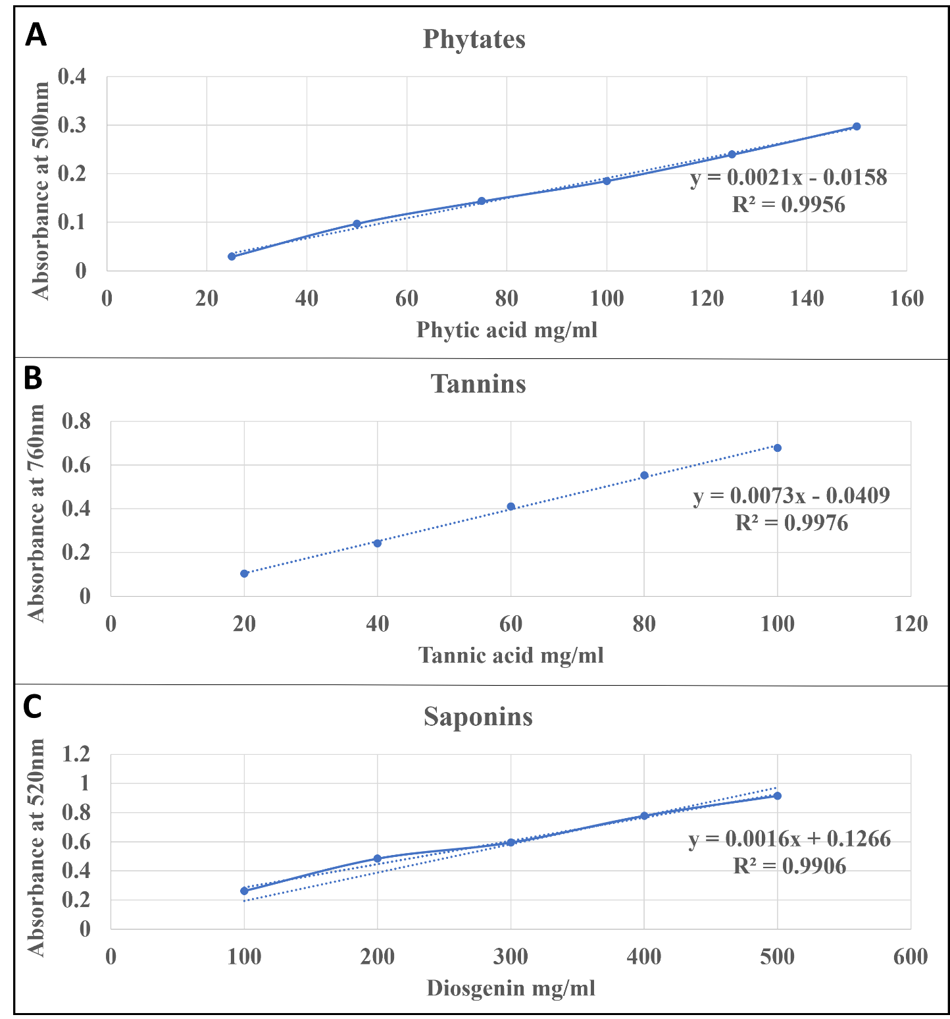
Fig 1: Standard graph for antinutritional factors

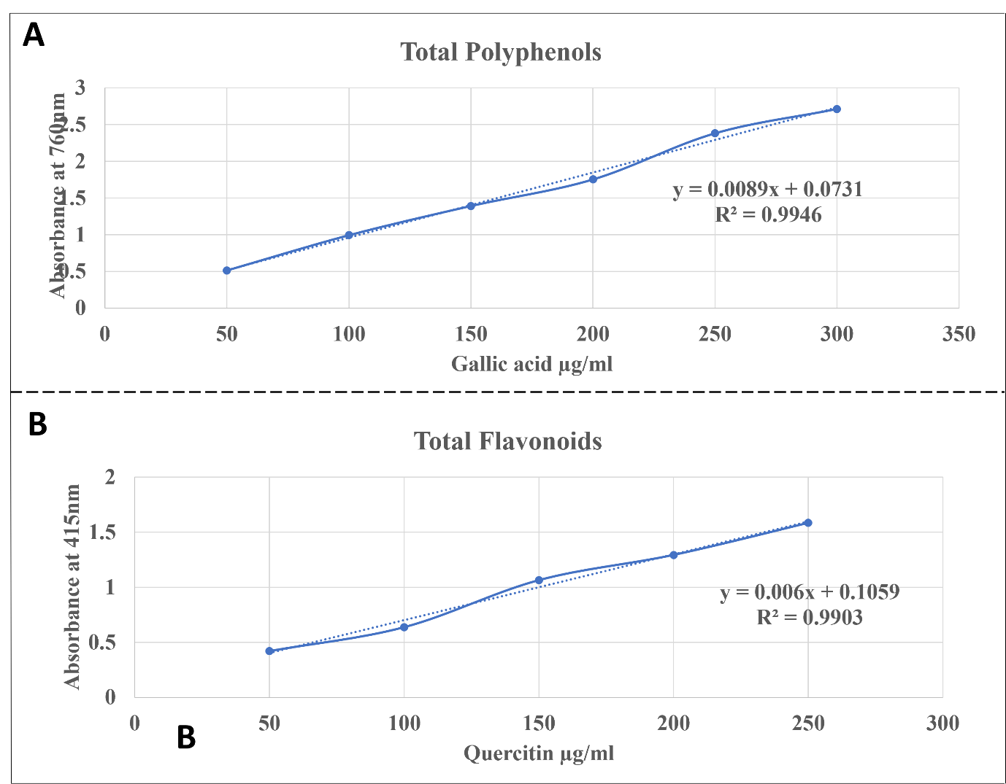
Fig 2: Standard graph for Phytochemicals (TPC & TFC)
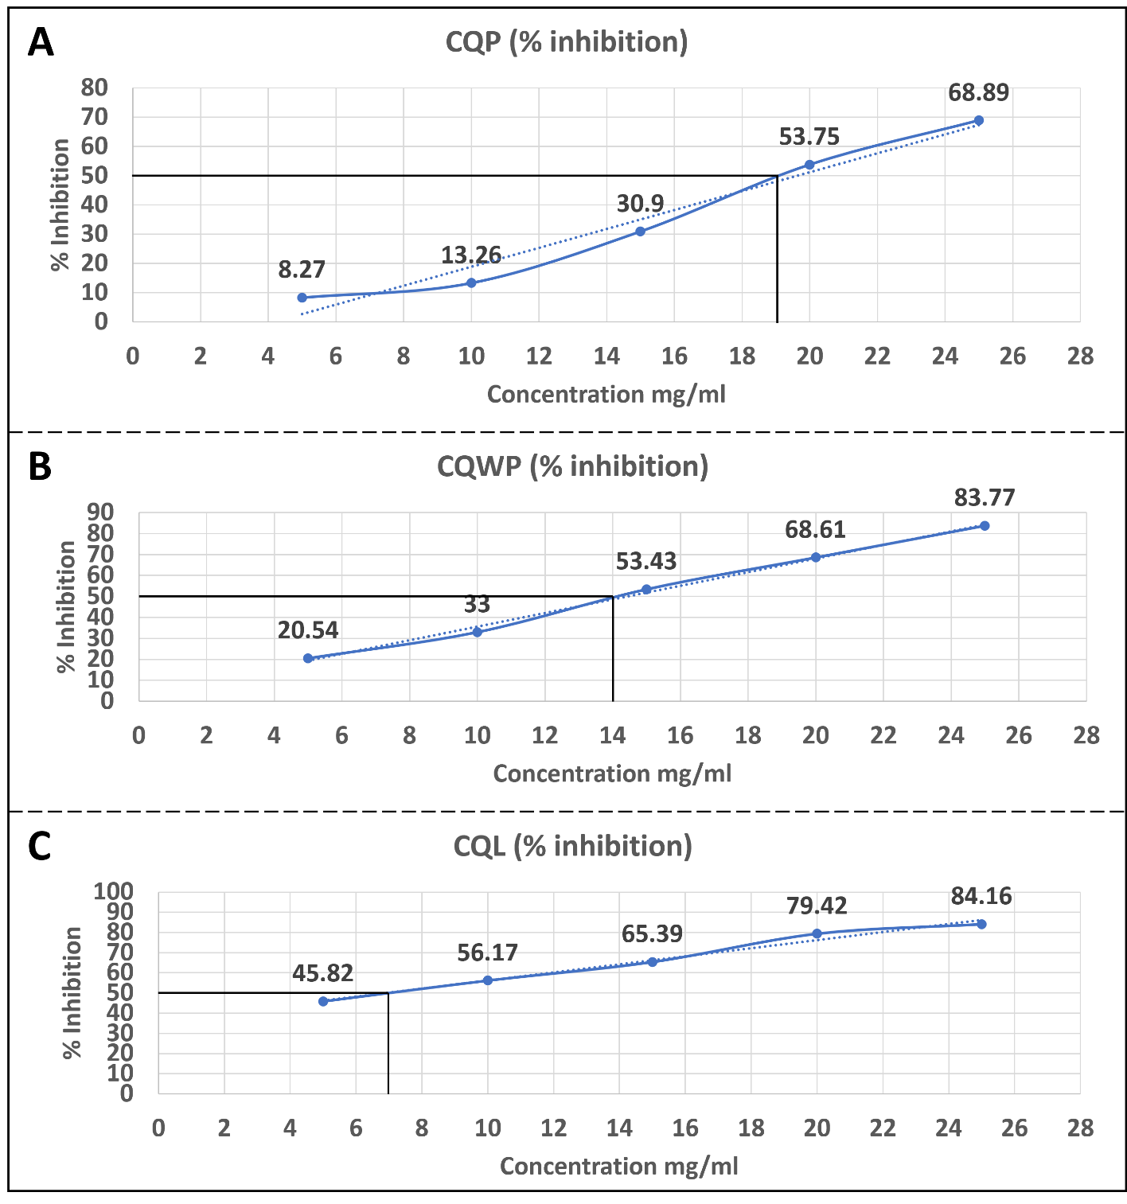
Fig 3: IC50 Concentration of veldt grape aerial parts

