Supplemental File

Resistin forms a network with inflammatory cytokines and endothelial damage markers and provides prognostic and therapeutic information for COVID-19
Takeshi Ebihara, Hisatake Matsumoto, Tsunehiro Matsubara, Yuki Togami, Shunichiro Nakao, Hiroshi Matsuura, Takashi Kojima, Fuminori Sugihara, Daisuke Okuzaki, Haruhiko Hirata, Hitoshi Yamamura and Hiroshi Ogura

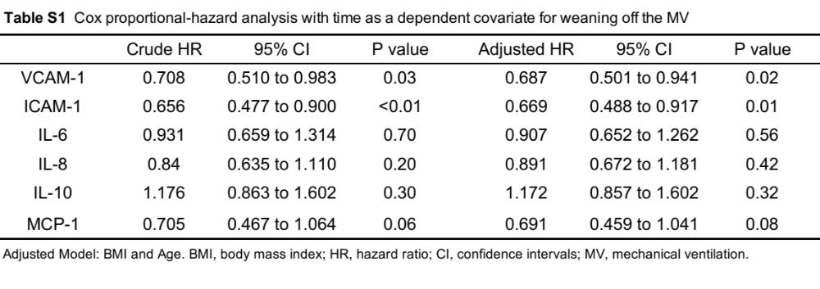

Figure S1
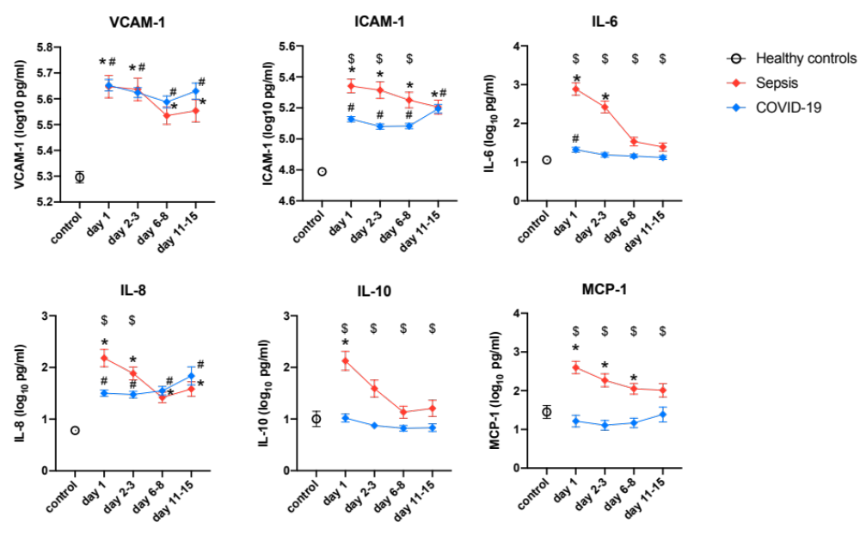

Fig. S1. Changes in the levels of 4 cytokines and 2 endothelial damage markers in the Osaka cohort. The cytokine and endothelial damage marker levels were transformed to common logarithm values to normalize the data distribution. All data are expressed as the mean ± SE. * indicates a statistically significant difference in cytokines or endothelial damage markers between control and sepsis patients. # indicates a statistically significant difference between control and COVID-19 patients on each day (p<0.05). $ indicates a statistically significant difference between sepsis patients and COVID-19 patients. SE, standard error; COVID-19, coronavirus disease 2019; ICAM-1, intercellular adhesion molecule 1; VCAM-1, vascular cell adhesion molecule-1; IL, interleukin; MCP, monocyte chemotactic protein

Figure S2

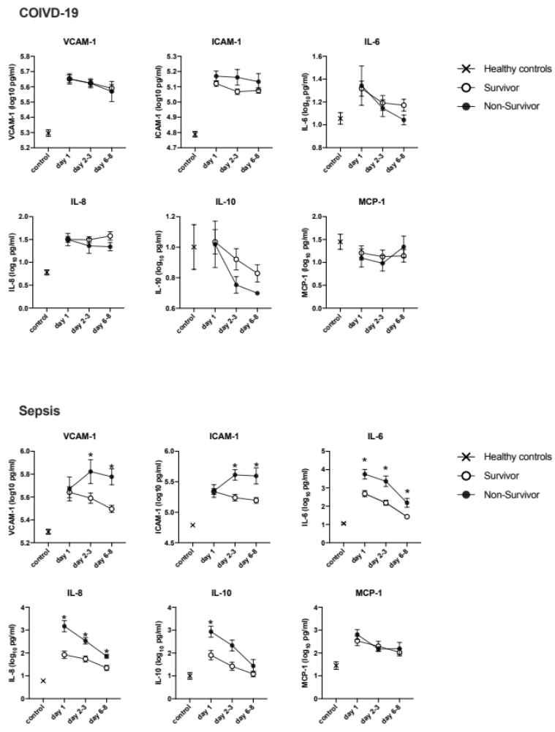

Fig. S2. Changes in the levels of 4 cytokines and 2 endothelial damage markers in survivors and non-survivors in the Osaka cohort. The cytokine and endothelial damage marker levels were transformed to common logarithm values to normalize the data distribution. All data are expressed as the mean ± SE. The levels of cytokines and endothelial damage markers in survivors and non-survivors on each day are shown for the patients with sepsis and COVID-19. * indicates a statistically significant difference between survivors and non-survivors (p<0.05) on each day. SE, standard error; COVID-19, coronavirus disease 2019; ICAM-1, intercellular adhesion molecule 1; VCAM-1, vascular cell adhesion molecule-1; IL, interleukin; MCP, monocyte chemotactic protein.

Figure S3
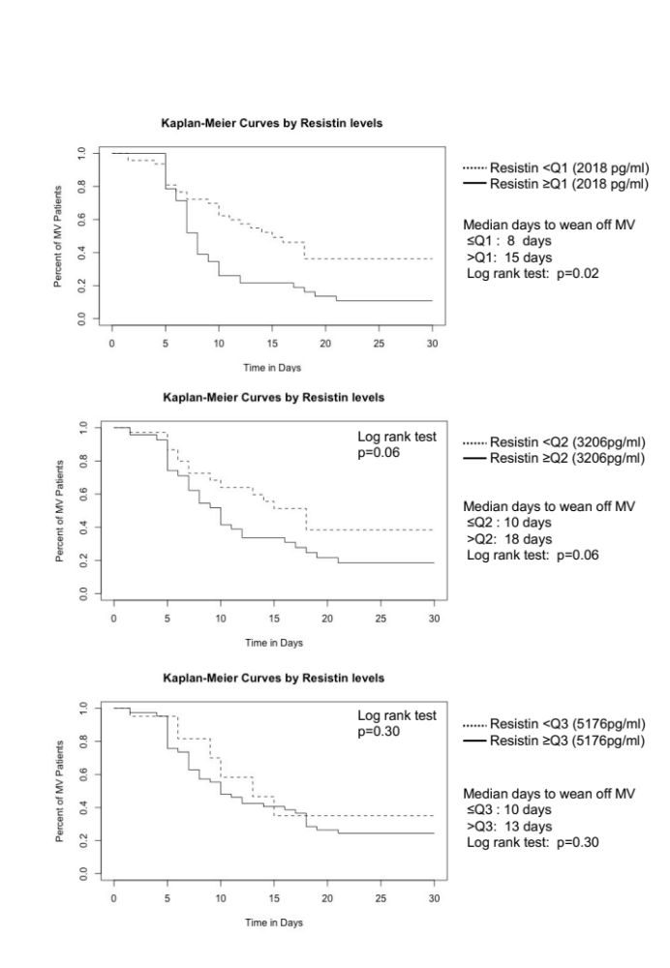
Fig. S3. Kaplan-Meier curves (log-rank test) for weaning from MV. Patients were divided into two groups according to the quartile of their resistin level. The median time to wean off MV was significantly shorter in patients with a resistin level in the first quartile (2018 pg/ml) or lower in comparison to those with higher resistin levels (median 8 days vs. 15 days, p=0.02). MV, mechanical ventilation.
Figure S4

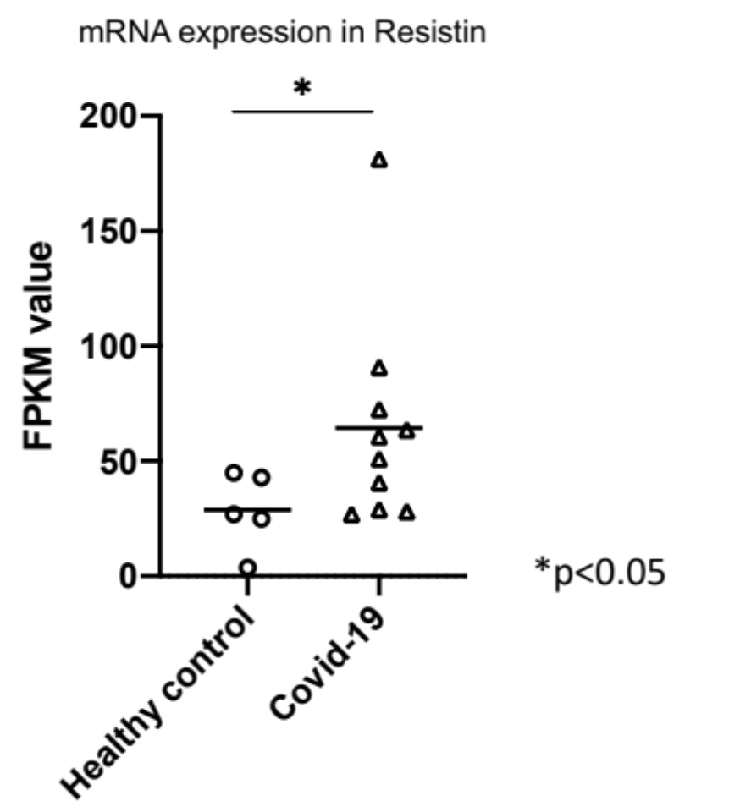

Fig. S4. The mRNA expression of resistin. Total RNA of whole blood cells was isolated and quantified by RNA-Seq as described in the Materials and Methods. * indicates statistically significant differences between healthy controls and COVID-19 patients. COVID-19, coronavirus disease 2019; FPKM, fragments per kilobase of exon per million reads mapped.

