Discerning the painter’s hand: machine learning on surface topography

SUPPLEMENTARY INFORMATION

Connoisseurship, technical art history, and workshop practices
The primary method of determining the attribution of a painting, and thus its value, is through expert connoisseurship. Connoisseurship, as an art historical methodology, involves the evaluation and appreciation of an object’s quality, the determination of the time and place of its execution, and the identification of the artist, if possible. A key component of connoisseurship is the close study of the object in question, as the materiality of the work is critical to a proper attribution. Establishing as much as you can of the origin of an object is a crucial first step to deeper, more comprehensive scholarly study.
Western art connoisseurship has a long and richly complex history, stemming from classical antiquity and Renaissance writers on art. [24] It was not until the second half of the 19th century that a more scientific and rigorous employment of connoisseurship was developed. One of the most famous 19th century connoisseurs was Giovanni Morelli, who utilized his background in comparative anatomy and medicine to adapt principles of classification from the natural sciences to the study of paintings. Morelli’s method scrutinized seemingly minor, or ‘subconscious,’ painted details, such as ears and fingernails, to detect the ‘hands’ of the artist. [25] Morelli’s most famous successor was Bernard Berenson, who built upon Morelli’s method to incorporate other types of evidence, including the artist’s style and influence of their geographical region [26]. While connoisseurship continued to be refined by scholars, art dealers, and collectors into the 20th century, it was still an imperfect process as it was completely reliant on the ‘eye’ and honesty of the expert.
Since the early 20th century, there has been an increasing utilization of characterization methods to provide new evidence related to attribution and the condition of the object. [27] Common technical methods utilized by conservation scientists and conservators include X-radiography, infrared reflectography (IRR), cross-sectional analysis, and dendrochronology. [28] Over the last several decades, numerous technical collaborations have been formed to investigate paintings attributed to notable artists such as Hieronymus Bosch [29] and Rembrandt [30]. The inclusion of ingenious new applications, in conjunction with traditional art historical methods, has changed our views and understanding of standard artistic practices, including issues of materials and techniques and details about the precise nature of collaboration. Modern technical tools have also proven proficient at assessing fakes, adding to their worth in appraising the market value of an object.
Even with the inclusion of advanced technologies, scholars continue to face numerous obstacles when assessing the details surrounding the creation of an object. A particular challenge that our collaboration focuses on is the historic use of workshops by artists. [31] The workshop enabled a master or primary artist to increase their output and offer a range of products. The resulting paintings could span the range from master-only production to nearly workshop-only with slight retouching by the named artist, and they were often valued accordingly. Due to the frequent lack of primary textual evidence, it is often difficult to determine how each workshop was structured and who was a part of these endeavors. In addition to a primary or master artist, workshops could include specialized or traveling artists, apprentices, engravers, and others. Many workshop apprentices would later become successful and influential artists in their own right, such as Anthony van Dyck, who apprenticed in the workshop of Rubens.
These limitations to assessing attribution create conflict when the attribution is closely tied to the apparent value of objects in the art market. For example, the Salvator Mundi attributed to Leonardo da Vinci sold at auction in 2017 for $450.3 million has yet to be publicly displayed as planned due to the contentious debate among specialists as to whether it is an autographed da Vinci or workshop product. [32] In March 2021, a painting attributed to the ‘circle’ of 17th-century Spanish painter José de Ribera and valued at $1,800 USD was removed from an auction in Spain over the potential that it may, in fact, be a long lost, but well documented Caravaggio painting. [33] If the painting is attributed to the enigmatic early modern artist, the painting will likely sell for millions at auction.
Details of ensemble learning
We created ensembles of 10-100 different trained networks depending on the patch size to make final predictions. Specifically, when the patches are of side-length 10 pixels, we trained 10 different networks to calculate ensemble accuracy. For patches of side-length 20 pixels, we trained 20 different networks. For patches of side-length 40 pixels, we trained 2 groups of 20 different networks. For patches of side-length 80 pixels, we trained 4 groups of 20 different networks. And for patches of side-length 100, 120, 140, 160, 180, 200 224, 250, 300, 350, 400, 500, 600, 700, 800, 900, 1000, 1100, and 1200 pixels, we trained 5 groups of 20 different networks to get 5 ensemble accuracies. Errors, when present, were calculated using different ensemble accuracies. Results in Fig. 3C were predicted by an ensemble of 100 different trained networks.

Supplementary figures
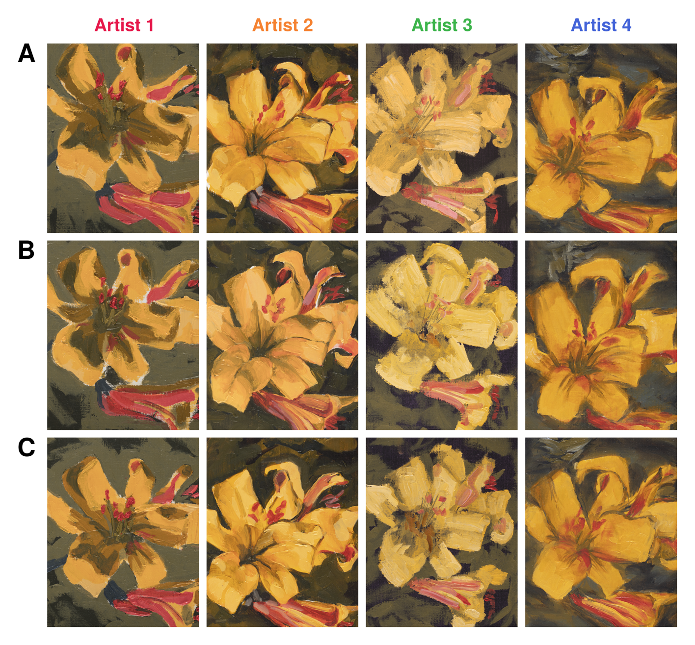
Figure S1. A) Test paintings from each artist. B-C) Training paintings from each artist.

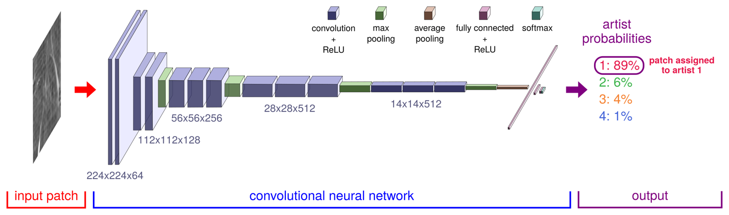
Figure S2. Schematic of the convolutional neural network architecture.

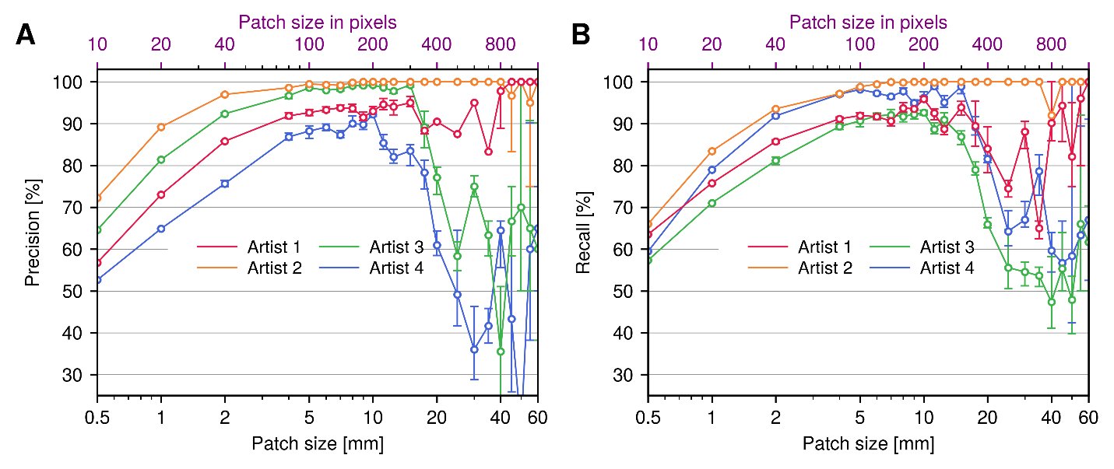Figure S3. Patch size versus A) precision and B) recall for each artist.

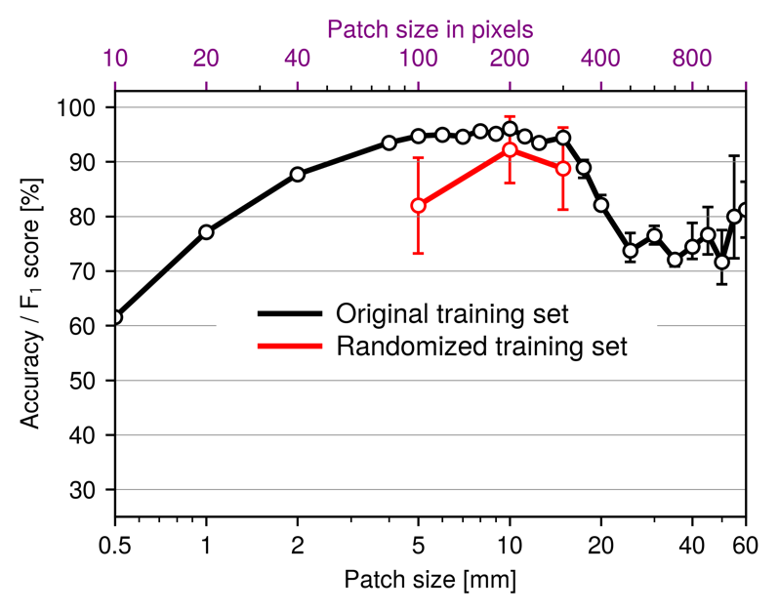
Figure S4. Mean accuracy versus patch size for the original choice of training set used in the main text (black curve), versus the mean results from a random selection of 10 alternative training sets (red curve), corresponding to different choices of which two out of three paintings from each artist to use for training.

