Supplementary Material for the Manuscript
Source Identification and Health Risks of Heavy Metals in Huixian Karst Wetland Sediments: A Multi-Model Approach
Kun Dong^{a,b,c}, Jiayu Yang^{a,b,c}, Haixiang Li^{a,b,c}, Sze-Mun Lam^{a,b,c,d}, Jin-Chung Sin^{a,b,c,d}, Yufeng Xu^{a,b,c,}, Dunqiu Wang^{a,b,c,}*

ª College of Environmental Science and Engineering, Guilin University of Technology, Guilin 541006, China
^{b} Engineering Research Center of Watershed Protection and Green Development, University of Guangxi, Guilin University of Technology, Guilin, 541006, China
^{c} Guangxi Engineering Research Center of Comprehensive Treatment for Agricultural Non-Point Source Pollution, Guilin University of Technology, Guilin, 541006, China
^{d} Faculty of Engineering and Green Technology, Universiti Tunku Abdul Rahman, Jalan Universiti, Bandar Barat, 31900 Kampar, Perak, Malaysia

* Corresponding authors
Dunqiu Wang− College of Environmental Science and Engineering, Guilin University of Technology, Guilin 541006, China
Email: wangdunqiu@glut.edu.cn

Keywords: Health risk assessment, Wetland sediment, Pollution Source Analysis, Heavy Metal Pollution
The supporting information contains 2 texts (Text S1 – S2), 3 tables (Table S1 – S3), and 2 figures (Figure S1 – S2).
Contents

Texts
Text S1 A comparison of sediments from Huixian Karst Wetland and Bosten Lake Wetland.
Text S2 Heavy metal concentrations in wetlands.
Text S3 Geo-accumulation index(I_{geo})

Tables
Table S1 Characteristics of Heavy Metal Content in Sediments of Huixian Karst Wetland and Bosten Lake Wetland.
Table S2 Distribution map of sampling points in the study area.
Table S3 Summary Statistics of Non-Carcinogenic and Carcinogenic Risks Based on Monte Carlo Models.

Figures
Figure S1 Figure d. Box plots of heavy metal geo-accumulation Index (Ig_{eo}) (a) and concentrations (b) in sediment.

Text S1 A comparison of sediments from Huixian Karst Wetland and Bosten Lake Wetland.
Significant differences were observed when comparing the Huixian Wetland with China's largest inland freshwater lake wetland, Bosten Lake. The comparison revealed that the average concentrations of As, Cr, Cu, Hg, Ni, Pb, and Zn in surface sediments of the Huixian Wetland and Bosten Lake were 1.70, 65.00, 25.63, 0.026, 22.14, 37.63, and 69.82 mg/kg, respectively. In contrast, the mean concentrations of the corresponding elements in the study area were 43.06, 157.75, 41.06, 0.31, 51.63, 53.31, and 238.0 mg/kg. Comparisons reveal that arsenic (As) concentrations in the study area are 25.3 times higher than those in Bosten Lake, chromium (Cr) is 2.4 times higher, copper (Cu) is 1.6 times higher, mercury (Hg) is 11.9 times higher, nickel (Ni) is 2.3 times higher, lead (Pb) is 1.4 times higher, and zinc (Zn) is 3.4 times higher. This indicates that heavy metal pollution levels in the study area are significantly higher than those in the Bosten Lake wetland. Studies on river sediments in the Chaohu Lake basin indicate average concentrations of As, Cr, Cu, Hg, Ni, Pb, and Zn at 11, 63.5, 32.9, 0.087, 28.7, 31.5, and 103 mg/kg, respectively. Except for Zn, all heavy metal concentrations in the study area were significantly higher than those in the Chaohu Lake basin. The As and Hg concentrations in the study area were 3.9 times and 3.6 times higher than those in the Chaohu Lake basin(Wang Kai et al., 2025), respectively, as shown in the Table S1.

Text S2 Heavy Metal Concentrations in Wetlands.
The average concentrations of the heavy metals in the sediments followed the order of Zn > Cr > Pb > Ni > As > Cu > Hg. Compared to the background values of soil elements in Guangxi, 38.8% of the sampling sites had As concentrations lower than the background value(Shuncun, Bo et al. 2022). Cr and Zn concentrations exceeded the background values, with mean concentrations 1.92 and 3.15 times the background levels, respectively. The mean concentrations of As, Cu, Ni, Pb, and Hg mean concentrations were 2.10, 1.47, 1.94, 2.22, and 1.54 times the background values, respectively. The enrichment levels of all elements in this study significantly exceeded the local background values. This finding is consistent with the conclusion reported by Huang et al. regarding widespread heavy metal enrichment in the region due to anthropogenic activities, thereby providing compelling evidence of pollution (Huang, Rad et al. 2020). In comparison to the background values of Chinese river sediments, the mean concentrations of As, Cu, Zn, Pb, Ni, Hg, and Cr were 0.64, 1.78, 2.92, 2.24, 2.31, 3.55, and 9.00 times the corresponding background values, respectively. The exceedance rate of Cr was 100%, whereas the relative concentrations of As, Cu, Ni, and Pb were relatively lower. The heavy metals Hg, Zn, Pb, and Cr in the sediments exhibited moderate variations (15% < C_{v} < 35%), whereas As, Cu, and Ni showed strong variations (C_{V} > 36%); this indicates an uneven spatial distribution of As, Cu, and Ni concentrations, suggesting potential point-source pollution and the input of exogenous contaminants.

Text S3 Geo-accumulation index(I_{geo})
I_{geo} is a geochemical criterion that classifies soil pollution levels, this be calculated using the following equation:
(5)
C_{i} represents the measured concentration (mg/kg) of heavy metals in the soil, and B_{i} is the geochemical background value of the corresponding heavy metal. In this study, the background values of soil elements in the Guangxi Province were selected to calculation I_{geo}.
The I_{geo} has been widely used to quantitatively assess the degree of contamination of heavy metals and other pollutants in sediments or soils(Liu, Wang et al. 2018). The median I_{geo} values for the different metals followed the order of Zn (1.130) > Pb (0.623) > Cr (0.352) > As (0.268) > Ni (0.247) > Hg (0.138) > Cu (-0.398). Most I_{geo} values for Hg, As, and Cu were below those of Class 2, indicating that the sediments were not to moderately polluted by these elements. Variations in land use patterns, human activities, pollution history, and pollutant discharge contribute to different levels of soil contamination. Zn exhibited a relatively high pollution level, with 72.2% of samples showing moderate contamination. Most of the sampling sites (83.3%) showed that heavy metal pollution levels in the soil ranging from unpolluted to moderately polluted. However, Zn demonstrated a certain degree of moderate contamination, accounting for 72.2% of samples. Some sampling points for Cu and Hg remained at an unpolluted level, representing 66.7% and 27.7% of the sites, respectively. Meanwhile, As, Cu, and Ni were primarily classified into the unpolluted and moderately polluted categories, covering 90.7% of the sampling sites. The elevated I_{geo} values of Zn in this study suggest that its presence may be associated with human activities. Boxplots of the I_{geo} and concentrations of heavy metals in the sediment samples are shown in Figure S1 (a-b).

Table S1 Characteristics of Heavy Metal Content in Sediments of Huixian Karst Wetland and Bosten Lake Wetland.

 | Huixian Karst Wetland |  |  |  |  |  |  | Bosten Lake Wetlandª
项目 | As | Cr | Cu | Hg | Ni | Pb | Zn | As | Cr | Cu | Hg | Ni | Pb | Zn
Minimum Value/(mg/kg) | 8.69 | 87.20 | 15.70 | 0.12 | 15.60 | 23.10 | 115.40 | 0.49 | 32.00 | 7.00 | 0.006 | 11.00 | 20.00 | 34.00
Maximum Value/(mg/kg) | 137.30 | 254.70 | 142.00 | 0.50 | 80.00 | 75.60 | 318.60 | 5.43 | 117.00 | 62.00 | 0.050 | 40.00 | 79.00 | 142.00
Median/(mg/kg) | 23.90 | 156.00 | 31.40 | 0.33 | 46.70 | 54.30 | 243.20 | 1.23 | 57.00 | 22.00 | 0.026 | 21.00 | 37.00 | 67.50
Mean(mg/kg) | 43.06 | 157.75 | 41.06 | 0.31 | 51.63 | 53.31 | 238.00 | 1.70 | 65.00 | 25.63 | 0.026 | 22.14 | 37.63 | 69.82
Standard Deviation | 59.22 | 35.11 | 29.67 | 0.09 | 20.19 | 14.10 | 50.92 | 1.29 | 25.28 | 14.24 | 0.015 | 6.66 | 11.79 | 23.11
Coefficient of Variation C_{v}(%) | 137.53 | 35.11 | 72.27 | 32.48 | 39.12 | 26.44 | 21.39 | 75.59 | 38.90 | 55.54 | 57.82 | 30.07 | 31.34 | 33.11
Guangxi（XinJiang） Soil Background Values/(mg/kg) | 20.50 | 82.10 | 27.80 | 0.20 | 26.60 | 24.00 | 75.60 | 11.2 | 49.30 | 26.70 | 0.017 | 26.60 | 19.40 | 68.80
Background Values of Chinese River Sediments/(mg/kg) | 9.00 | 54.00 | 20.00 | 0.03 | 23.00 | 23.00 | 67.00 | 9.00 | 54.00 | 20.00 | 0.034 | 23.00 | 23.00 | 67.00
Toxicity Coefficient | 10 | 2 | 5 | 40 | 5 | 5 | 1 | 10 | 2 | 5 | 50 | 5 | 5 | 1
Distribution Type | log-  normal | log-  normal | log-  normal | negative binomial distribution | log-normal | logistic distribution | log-normal | log-normal | negative binomial distribution | negative binomial distribution | log-normal | binomial distribution | binomial distribution | negative binomial distribution
Notes: ª(Wang Kai et al., 2025)

Table S2 Distribution map of sampling points in the study area.
Field  Numbers | 1 | 2 | 3 | 4 | 5 | 6 | 7 | 8 | 9 | 10 | 11 | 12 | 13 | 14 | 15 | 16 | 17 | 18
Number of Samples | 3 | 3 | 4 | 3 | 3 | 3 | 3 | 4 | 3 | 4 | 3 | 3 | 3 | 3 | 4 | 3 | 3 | 3

Table S3 Summary Statistics of Non-Carcinogenic and Carcinogenic Risks Based on Monte Carlo Models.
 | Mean(median) |  | SD |  | 5%(95%)percentile
 | Adults | Children | Adults | Children | Adults | Children
HQ_{As} | 1.99E-02 | 2.66E-01 | 8.68E-03 | 9.27E-02 | 7.56E-03 | 1.31E-01
HQ_{Cu} | 3.07E-04 | 4.06E-03 | 1.39E-04 | 1.55E-03 | 1.1E-04 | 1.81E-03
HQ_{Cr} | 3.97E-02 | 4.41E-01 | 1.99E-02 | 2.55E-01 | 1.40E-02 | 1.46E-01
HQ_{Hg} | 9.68E-05 | 1.18E-03 | 6.22E-05 | 7.57E-04 | 3.11E-05 | 4.09E-04
HQ_{Ni} | 8.21E-04 | 1.02E-02 | 2.93E-04 | 2.95E-03 | 3.83E-04 | 5.87E-03
HQ_{Pb} | 4.2E-03 | 5.37E-02 | 1.81E-03 | 2.06E-02 | 1.63E-03 | 2.51E-02
HQ_{Zn} | 1.29E-04 | 1.67E-03 | 5.17E-05 | 5.55E-04 | 5.47E-05 | 8.76E-04
HI | 6.57E-02 | 7.83E-01 | 2.61E-02 | 3.17E-01 | 2.94E-02 | 3.76E-01
CR_{As} | 3.08E-06 | 1.03E-05 | 1.34E-06 | 3.58E-06 | 1.17E-06 | 5.06E-06
CR_{Cr} | 1.73E-05 | 4.88E-05 | 8.39E-06 | 2.66E-05 | 6.43E-06 | 1.76E-05
CR_{Ni} | 1.85E-05 | 5.43E-05 | 7.93E-06 | 2.52E-05 | 7.66E-06 | 2.31E-05
CR_{Pb} | 3.04E-08 | 1.05E-07 | 1.43E-08 | 3.76E-08 | 9.92E-09 | 5.08E-08
TCR | 3.92E-05 | 1.14E-04 | 1.61E-05 | 5.13E-05 | 1.7E-05 | 5.04E-05

Notes: (Zhang, Jiang et al. 2024)

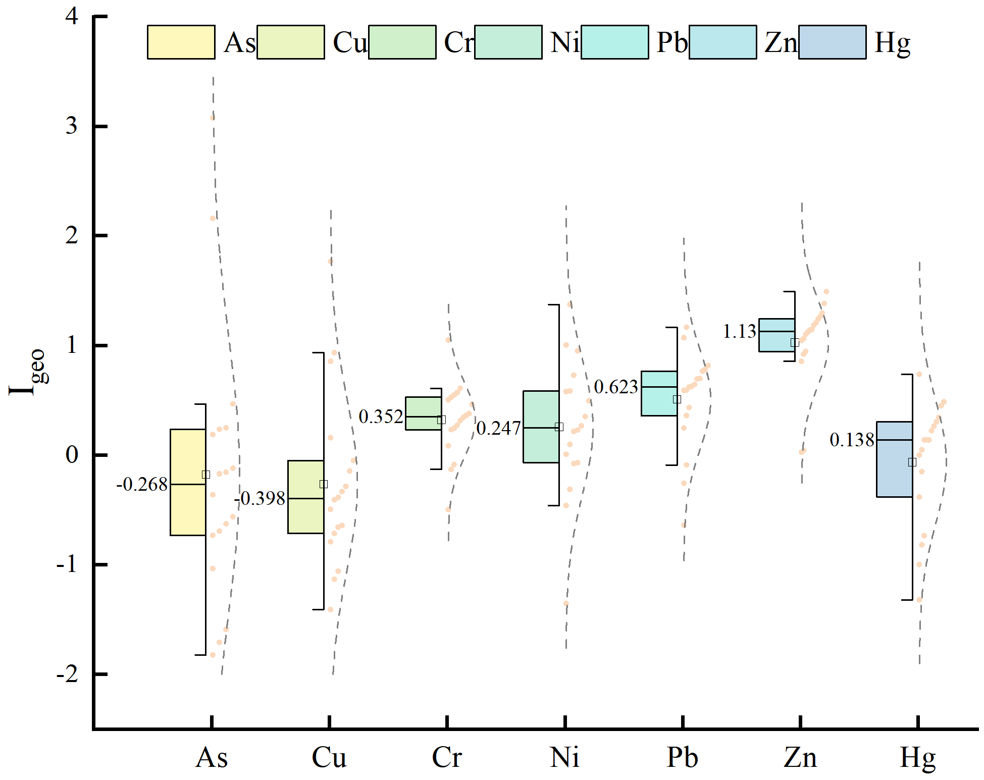

(a) (b)

Figure S1 Box plots of heavy metal geo-accumulation Index (I_{geo}) (a) and concentrations (b) in sediment.

References
- Wang, K., Dilinuer, A., Li, P. Characteristics of Heavy Metal Pollution and Risk Assessment in Sediments of Bosten Lake Wetland. Journal of Lake Sciences, 2025, 37(3): 860-873.
- Zhang, Y., Jiang, B., Gao. Z., et al. Health risk assessment of soil heavy metals in a typical mining town in north China based on Monte Carlo simulation coupled with Positive matrix factorization model. Environmental Research, 2024, 251: 118696.
- Zhang, S., Chen, B., Du, J., et al. Distribution, Assessment, and Source of Heavy Metals in Sediments of the Qinjiang River, China. International Journal of Environmental Research and Public Health, 2022, 19(15): 9140.
- Huang, L., S. Rad., L. Xu., et al. Heavy Metals Distribution, Sources, and Ecological Risk Assessment in Huixian Wetland, South China. Water, 2020, 12(2): 431.
- Liu, J., Wang, J., Xiao, F., et al. Geochemical dispersal of thallium and accompanying metals in sediment profiles from a smelter-impacted area in South China. Applied Geochemistry, 2018, 88: 239-246.

