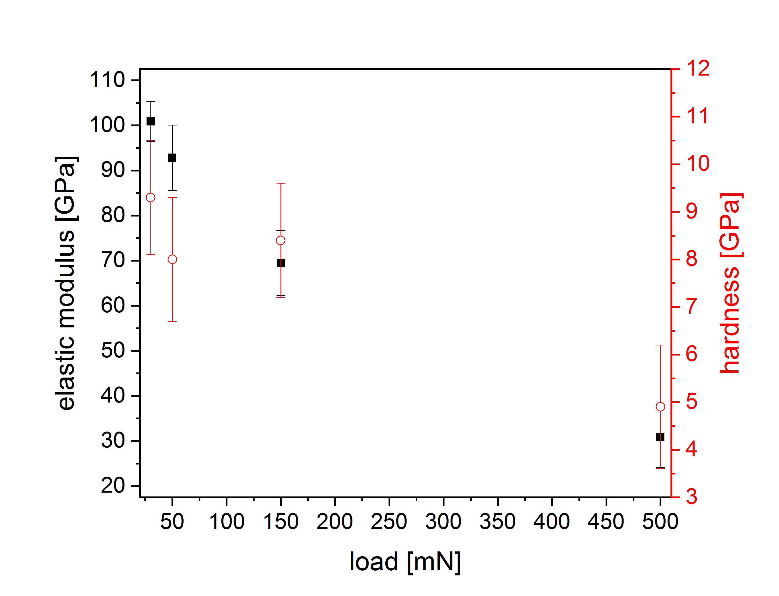
Figure SuppInfo1 Elastic modulus and hardness results of the specimen LATP:2F0.5Si as a function of load. The strong decrease of the properties is related to the limited thickness of the sample and, therefore, the compliance of the embedding material.

